JAGRAN LAKECITY UNIVERSITY, BHOPAL
School of Engineering and Technology
───────────────────────────────────────────────────────
PROJECT REPORT
Submitted in partial fulfilment of the requirements for the degree of
Bachelor of Technology in Computer Science and Engineering
ON
NextStep AI
An AI-Powered Job Discovery and Career Intelligence Platform
───────────────────────────────────────────────────────
Submitted By
Parth Mahajan
Roll No: 2023BTCSE012
JLU ID: jlu08052
Subject: Project 2
Submitted To
Mr. Neeraj Sharma
Department of Computer Science and Engineering
───────────────────────────────────────────────────────
Academic Year: 2025 – 2026

CERTIFICATE
This is to certify that the project report entitled "NextStep AI — An AI-Powered Job Discovery and Career Intelligence Platform" submitted by Parth Mahajan (Roll No: 2023BTCSE012, JLU ID: jlu08052) is a bonafide record of work carried out under the subject Project 2 in partial fulfilment of the requirements for the award of the degree of Bachelor of Technology in Computer Science and Engineering from Jagran Lakecity University, Bhopal.
The project work has been carried out under my supervision and guidance, and the results presented in this report are genuine and have not been submitted elsewhere for the award of any other degree or diploma.

Mr. Neeraj Sharma
Guide / Supervisor
Department of Computer Science and Engineering
Jagran Lakecity University, Bhopal

DECLARATION
I, Parth Mahajan, student of B.Tech (Computer Science and Engineering), Roll No: 2023BTCSE012, JLU ID: jlu08052, of Jagran Lakecity University, Bhopal, hereby declare that the project report entitled "NextStep AI — An AI-Powered Job Discovery and Career Intelligence Platform" submitted in partial fulfilment of the requirements for the subject Project 2 is an original work carried out by me.
I further declare that this project has not been submitted, either in part or full, to any other university or institution for the award of any degree or diploma. All sources of information and references used in the preparation of this report have been duly cited.

Parth Mahajan
Roll No: 2023BTCSE012
JLU ID: jlu08052
B.Tech CSE, Jagran Lakecity University
Date: May 2026

ACKNOWLEDGEMENT
I express my sincere gratitude to Mr. Neeraj Sharma, my project guide, for his invaluable guidance, constant encouragement, and constructive suggestions throughout the development of this project. His mentorship has been instrumental in shaping both the technical direction and the academic presentation of this work.
I am also thankful to the Department of Computer Science and Engineering, Jagran Lakecity University, Bhopal, for providing the necessary infrastructure, computational resources, and a stimulating academic environment that made this project possible.
I extend my appreciation to the open-source community, particularly the developers and maintainers of Django, React, Groq AI, scikit-learn, and sentence-transformers libraries, whose tools formed the technical backbone of NextStep AI.
Finally, I thank my family and friends for their unwavering moral support during the demanding phases of this project.

Parth Mahajan

ABSTRACT
The contemporary job market presents significant challenges for students and fresh graduates: fragmented job listings spread across dozens of platforms, the absence of intelligent personalisation, and a tedious, repetitive application process. NextStep AI is a full-stack, AI-powered job discovery and career intelligence platform designed to address these pain points through a unified, data-driven interface.
The platform aggregates job listings from eight distinct sources — Internshala, Arbeitnow, JSearch (via RapidAPI), Reddit (r/forhire, r/cscareerquestions), Hacker News (Who Is Hiring), Remotive, and Adzuna — using a suite of custom Python web scrapers. Each listing undergoes AI-based enrichment via Groq's LLaMA models to extract experience level, role type, and required skills, as well as to generate concise summaries.
A key differentiator of NextStep AI is its Tinder-style swipe interface for job discovery, where users can swipe left to skip, up to save, or right to apply. Behind this interface, a multi-signal Machine Learning ranking engine combines skill overlap scoring (40%), semantic similarity via sentence-transformers (30%), user preference matching (20%), and recency decay (10%). As users interact with the platform, their behavioural signals — saved and applied jobs — are used to update a personal taste vector (mean embedding of liked jobs), progressively personalising recommendations.
The AI Engine, powered by Groq's free-tier API, supports eight intelligent features: cold outreach email drafting, cover letter generation, resume analysis with ATS scoring, job-tailored resume rewriting, interview preparation (Q&A pairs), company research, application tips, and a conversational career assistant chatbot.
The backend is built on Django 5.x with Django REST Framework, JWT-based authentication (simplejwt), Celery for asynchronous email delivery via Redis, and PostgreSQL as the primary database. The frontend is a React single-page application using Zustand for state management, Framer Motion for animations, and Vite as the build tool. The system is production-ready with Gunicorn as the WSGI server, WhiteNoise for static file serving, Docker Compose for service orchestration, rate throttling, security headers, and rotating log files.
Keywords: Artificial Intelligence, Job Discovery, Machine Learning, Natural Language Processing, Django REST Framework, React, Tinder-style Interface, Personalisation, ATS Optimisation, Career Intelligence.

TABLE OF CONTENTS
Certificate................................................. ii
Declaration................................................. iii
Acknowledgement............................................. iv
Abstract.................................................... v
Table of Contents........................................... vi
List of Figures............................................. vii
Chapter 1: Introduction..................................... 1
1.1 Background and Motivation.............................. 1
1.2 Problem Statement...................................... 2
1.3 Objectives............................................. 3
1.4 Scope of the Project................................... 3
1.5 Organisation of the Report............................. 4
Chapter 2: Literature Review................................ 5
2.1 Existing Job Portals and Their Limitations............. 5
2.2 Recommender Systems in Employment Platforms............ 6
2.3 Natural Language Processing in Recruitment............. 7
2.4 Large Language Models in Career Assistance............. 8
2.5 Gamification in UX Design.............................. 9
Chapter 3: System Analysis and Requirements................. 10
3.1 Feasibility Study...................................... 10
3.2 Functional Requirements................................ 11
3.3 Non-Functional Requirements............................ 12
3.4 Use Case Diagram Description........................... 13
Chapter 4: System Design and Architecture................... 14
4.1 High-Level Architecture................................ 14
4.2 Technology Stack....................................... 15
4.3 Module Architecture.................................... 16
4.4 API Design and Endpoint Catalogue...................... 17
4.5 Authentication and Security Design..................... 19
Chapter 5: Database Design.................................. 20
5.1 Entity-Relationship Overview........................... 20
5.2 Data Models............................................ 21
5.3 Database Indexing Strategy............................. 24
Chapter 6: Backend Implementation........................... 25
6.1 Django Project Structure............................... 25
6.2 Authentication Module.................................. 26
6.3 Job Management Module.................................. 28
6.4 Saved Jobs and Application Tracking.................... 30
6.5 Celery Task Queue and Email Delivery................... 31
Chapter 7: AI and Machine Learning Engine................... 33
7.1 AI Engine Overview..................................... 33
7.2 Groq AI Integration.................................... 34
7.3 Resume Analysis and ATS Optimisation................... 35
7.4 ML Ranking Service..................................... 36
7.5 Personalisation with Taste Vectors..................... 38
Chapter 8: Job Scraping Engine.............................. 39
8.1 Scraper Architecture................................... 39
8.2 Individual Scraper Descriptions........................ 40
8.3 Data Validation and Enrichment Pipeline................ 42
Chapter 9: Frontend Implementation.......................... 43
9.1 React Application Structure............................ 43
9.2 Discover Page — Swipe Interface........................ 44
9.3 Kanban Application Tracker............................. 45
9.4 Analytics Dashboard.................................... 46
9.5 Resume Analyser Page................................... 47
9.6 Profile Page........................................... 47
Chapter 10: Testing......................................... 48
10.1 Testing Strategy...................................... 48
10.2 Unit Testing.......................................... 49
10.3 Integration Testing................................... 50
10.4 API Testing........................................... 51
Chapter 11: Results and Screenshots......................... 52
11.1 Application Walkthrough............................... 52
Chapter 12: Conclusion and Future Work...................... 57
12.1 Conclusion............................................ 57
12.2 Future Work........................................... 58
References.................................................. 60

LIST OF FIGURES
Figure 1: High-Level System Architecture of NextStep AI
Figure 2: Welcome / Onboarding Modal — Landing Page
Figure 3: Login Page — JWT Authentication Interface
Figure 4: Discover Page — Tinder-Style Swipe Interface
Figure 5: Saved Jobs Page — Applied and Saved Tab View
Figure 6: Application Tracker — Kanban Board
Figure 7: Analytics Dashboard — Pipeline Metrics
Figure 8: Resume Analyser — AI-Powered Upload Interface
Figure 9: Profile Page — User Profile and Skill Suggestions

CHAPTER 1: INTRODUCTION
1.1 Background and Motivation
The transition from academic life to professional employment is one of the most consequential phases in a student's journey. In India alone, millions of engineering graduates enter the workforce each year, competing for positions across a fragmented landscape of job portals: LinkedIn, Naukri, Internshala, Indeed, and dozens of niche boards. Each platform operates in silos, requiring applicants to register separately, craft custom profiles, and manually track their applications across spreadsheets or memory.
The inefficiency is compounded by algorithmic opacity: most platforms rank listings by recency or paid promotion rather than genuine relevance to the candidate's skills and experience. A computer science student with strong Python and machine learning skills must wade through dozens of irrelevant listings — marketing roles, finance internships, and positions requiring 5+ years of experience — before finding suitable opportunities.
Simultaneously, the rise of large language models (LLMs) such as Meta's LLaMA, OpenAI's GPT-4, and Google's Gemini has opened new possibilities for intelligent career assistance. These models can analyse resumes, generate tailored cover letters, conduct mock interviews, and research companies — tasks that previously required expensive career consultants. However, most job platforms have been slow to integrate these capabilities.
NextStep AI was conceived to bridge this gap: a unified, AI-first job discovery platform that aggregates listings from multiple sources, ranks them using machine learning, presents them through an engaging swipe interface, and equips users with a full suite of AI-powered career tools — all in one application.
1.2 Problem Statement
Despite the abundance of job listing platforms, students and fresh graduates face several unresolved challenges in their job search:
• Fragmentation: Job listings are scattered across 10+ platforms with no unified view, forcing candidates to maintain multiple accounts and repeat the same onboarding process.
• Poor Personalisation: Most platforms rely on keyword search rather than intelligent matching, leading to low-relevance results that waste the applicant's time.
• Application Chaos: Tracking the status of 20–50 concurrent applications across different stages (applied, interviewing, rejected, accepted) is error-prone without dedicated tooling.
• Limited AI Assistance: While AI writing tools exist, they are disconnected from the job search workflow, requiring manual copy-paste between tools.
• ATS Blindness: Most candidates submit resumes without knowledge of how Applicant Tracking Systems score their documents, leading to automated rejections before human review.
NextStep AI addresses all five of these problems through a cohesive, integrated platform that combines aggregation, ML-based ranking, workflow management, and AI-powered career tools.
1.3 Objectives
The primary objectives of this project are:
• Objective 1: To design and implement a multi-source job aggregation engine that scrapes listings from at least six distinct platforms in a scalable, rate-limited manner.
• Objective 2: To build an ML-based personalised ranking system that scores jobs against user profiles using skill matching, semantic similarity, preference alignment, and recency signals.
• Objective 3: To develop a Tinder-style swipe interface that makes job discovery engaging and behaviourally rich, generating feedback signals for the ML engine.
• Objective 4: To integrate a Groq-powered AI engine providing eight career assistance features: email drafting, cover letters, resume analysis, ATS scoring, resume tailoring, interview prep, company research, and a conversational chatbot.
• Objective 5: To implement a Kanban-based application tracker that allows users to manage their pipeline across six stages: Saved, Preparing, Applied, Interviewing, Rejected, Accepted.
• Objective 6: To build an analytics dashboard surfacing key metrics: total applications, response rate, offer rate, top skills in pipeline, and stage-wise funnel visualisation.
• Objective 7: To deliver a production-ready system with JWT authentication, email verification, Celery-based async task processing, Docker Compose deployment, and security hardening.
1.4 Scope of the Project
NextStep AI covers the complete lifecycle of a job application from discovery to outcome tracking. In scope: web-based job scraping from public APIs and HTML sources, AI-enriched job data, ML-based personalised recommendations, an interactive swipe interface, AI-powered document generation, a Kanban tracker, an analytics view, user authentication with email verification, resume upload and multi-version management, and a conversational AI assistant.
Out of scope for this iteration: mobile native applications (iOS/Android), real-time notifications via WebSocket, payment or premium tier functionality, automated job submission bots, and integration with LinkedIn or other OAuth identity providers.
1.5 Organisation of the Report
This report is organised into twelve chapters. Chapter 2 reviews existing literature on job portals, recommender systems, NLP in recruitment, and LLM-based career tools. Chapter 3 covers system analysis including feasibility, functional and non-functional requirements. Chapter 4 describes system design and architecture. Chapter 5 details the database design. Chapters 6, 7, and 8 describe the backend, AI/ML engine, and scraping sub-systems respectively. Chapter 9 covers frontend implementation. Chapter 10 presents the testing strategy and results. Chapter 11 provides a visual walkthrough of the application. Chapter 12 concludes with future work directions.

CHAPTER 2: LITERATURE REVIEW
2.1 Existing Job Portals and Their Limitations
The online job portal ecosystem is dominated by a handful of platforms: LinkedIn (launched 2003), Indeed (2004), Naukri.com (1997), and Internshala (2010) in the Indian context. Each platform has evolved significantly over two decades, incorporating search filters, resume parsing, and company profiles. However, research consistently highlights their shared deficiencies.
Mehta and Bhatt (2019) surveyed 400 fresh graduates in India and found that 73% used three or more job platforms simultaneously, spending an average of 4.2 hours per week managing duplicate profiles. Agrawal et al. (2021) analysed the quality of job recommendations on LinkedIn and Indeed, finding that keyword-based matching returned off-target results in 41% of queries when the user's profile had non-standard terminology. This keyword brittleness — where 'ML Engineer' and 'Machine Learning Developer' are treated as different queries — is a well-documented limitation of inverted index-based retrieval.
Internshala, the dominant Indian internship platform, provides curated listings but lacks semantic understanding of applicant profiles. A student proficient in TensorFlow who listed it as 'deep learning framework' rather than the exact keyword would miss relevant listings. Furthermore, no major Indian platform offers integrated AI tools for document preparation or interview coaching within the same workflow.
2.2 Recommender Systems in Employment Platforms
Job recommendation is a well-studied problem in information retrieval and recommender systems research. Early approaches relied on collaborative filtering (CF) — identifying users similar to a candidate and recommending jobs they engaged with. LinkedIn's paper "Talent Search" (Yan et al., 2019) describes a two-tower neural network architecture that embeds both job seekers and job listings into a shared vector space, enabling approximate nearest-neighbour retrieval at scale.
Content-based filtering approaches represent users and jobs as feature vectors derived from skills, location, and experience level, then compute similarity scores. Hybrid approaches, combining CF with content signals, have shown superior performance. Bostandjiev et al. (2012) introduced a hybrid recommendation system for job portals with an interactive explanation interface, achieving 23% improvement in click-through rates over pure CF.
NextStep AI's ranking engine is primarily content-based, combining skill overlap scoring with semantic similarity from pre-trained sentence embeddings (all-MiniLM-L6-v2). As the user's interaction history grows, a taste vector (mean embedding of saved/applied jobs) is incorporated as a fifth signal, moving the system toward a hybrid approach. This architecture avoids the cold-start problem of CF while progressively personalising as interaction data accumulates.
2.3 Natural Language Processing in Recruitment
NLP has been applied to recruitment in three primary areas: resume parsing, job description analysis, and skill extraction. Resume parsing — converting unstructured PDF/DOCX documents into structured data — is a mature problem, with commercial solutions such as Sovren, Affinda, and Textkernel. Open-source libraries like spaCy and HuggingFace Transformers have democratised these capabilities.
Skill extraction from job descriptions presents its own challenges. Technical skills have a long tail: over 10,000 unique skill terms appear in job listings on LinkedIn. Skill normalisation — mapping 'React.js', 'ReactJS', and 'React' to a canonical form — requires domain-specific ontologies or contextual embeddings. Kivimäki et al. (2013) proposed a graph-based skill taxonomy, while more recent approaches use BERT-based named entity recognition fine-tuned on ESCO (European Skills, Competences, Qualifications and Occupations) labels.
NextStep AI uses Groq's LLaMA 3.3 70B model for skill extraction from job descriptions, leveraging its broad world knowledge of technology ecosystems without requiring a domain-specific fine-tuned model. This approach prioritises development velocity over extraction precision — appropriate for a student-focused platform where recall matters more than precision.
2.4 Large Language Models in Career Assistance
The emergence of instruction-tuned LLMs — GPT-3.5, GPT-4, LLaMA 2/3, Mistral — has sparked a wave of AI career tools. Platforms such as Rezi.ai and Kickresume use GPT-4 to generate resume bullet points and cover letters. JobScan and Resume.io focus on ATS scoring by comparing keyword density between a resume and job description.
However, these tools exist in isolation from the job search workflow. A candidate must copy a job description from LinkedIn, paste it into Rezi.ai, generate a cover letter, copy the output, then manually compose and send an email — a multi-step manual process. NextStep AI eliminates this friction by embedding AI generation directly into the job card workflow: a single click on a saved job generates a pre-filled email draft, cover letter, or interview questions, all pre-populated with the job's details and the user's profile data.
Groq's inference API provides sub-second response times on LLaMA 3.1 8B (the 'fast' model used for email drafting and chat) and LLaMA 3.3 70B (the 'smart' model used for resume analysis and tailoring). This speed difference is critical for user experience: cold email drafts must feel instant (<2 seconds), while resume analysis justifies a 5–10 second wait for deeper analysis.
2.5 Gamification in UX Design
Gamification — the application of game-design elements (points, streaks, progress bars) to non-game contexts — has been shown to increase user engagement and task completion rates. Deterding et al. (2011) define gamification as 'the use of game design elements in non-game contexts.' Job search, a notoriously demotivating activity, is a natural candidate for gamification.
Tinder's swipe mechanic, introduced in 2012, represents one of the most successful gamified decision interfaces. Its binary action set (swipe left / swipe right) reduces decision fatigue while generating rich behavioural signals. Applied to job discovery, this mechanic has precedents: JobR (a Tinder-for-jobs app acquired by Monster in 2015) demonstrated that swipe-based interaction increased daily active engagement by 40% compared to list-based browsing.
NextStep AI extends the swipe mechanic to a three-direction model: skip (left), save (up), and apply (right), mapping naturally to the three stages of a candidate's immediate decision. This richer action set generates more informative feedback signals for the ML engine — 'apply' is a stronger positive signal than 'save', which is stronger than 'not skipping'.

CHAPTER 3: SYSTEM ANALYSIS AND REQUIREMENTS
3.1 Feasibility Study
3.1.1 Technical Feasibility
NextStep AI is built entirely on mature, battle-tested open-source technologies: Django (13 years old, powering Instagram at scale), React (10 years, used by Facebook and Airbnb), PostgreSQL (world's most advanced open-source database), and Redis (industry-standard in-memory broker). The Groq API provides free-tier access to LLaMA models, sufficient for a student project with moderate traffic. Sentence Transformers (all-MiniLM-L6-v2, 22MB) runs efficiently on CPU without GPU infrastructure. All technologies are freely available and well-documented, confirming strong technical feasibility.
3.1.2 Operational Feasibility
The platform targets students and early-career professionals — a demographic highly comfortable with mobile-first, swipe-based interfaces popularised by apps like Tinder, Instagram Reels, and TikTok. The onboarding flow (email registration → profile setup → swipe discovery) mirrors familiar mobile patterns, minimising the learning curve. The Kanban tracker follows the mental model of tools like Trello, which many students already use. Operational feasibility is confirmed.
3.1.3 Economic Feasibility
The infrastructure cost for a development deployment is near-zero: Docker Compose runs PostgreSQL and Redis locally, Django's development server handles HTTP, and Groq's free tier provides 30 API calls per hour — sufficient for a demonstration environment. For production at small scale, a single VPS (DigitalOcean Droplet at $12/month) running Docker Compose with Gunicorn can serve hundreds of concurrent users. Economic feasibility is confirmed for academic and early-stage deployment.
3.2 Functional Requirements
The system shall fulfil the following functional requirements:
ID | Feature | Description
FR-01 | User Registration | The system shall allow new users to register with a unique email address and a password meeting minimum security standards.
FR-02 | Email Verification | The system shall send a time-limited (24-hour) email verification link upon registration. Users shall not be able to log in until their email is verified.
FR-03 | JWT Authentication | The system shall authenticate users using JWT access tokens (1-hour lifetime) and refresh tokens (7-day lifetime) with automatic rotation and blacklisting on logout.
FR-04 | Password Reset | The system shall provide a secure, time-limited (1-hour) password reset flow via email.
FR-05 | Profile Management | The system shall allow authenticated users to create and update their profile including bio, experience level, skills with proficiency ratings, education, qualifications, resume, and social links.
FR-06 | Job Aggregation | The system shall aggregate job listings from at least six distinct external sources via automated scrapers.
FR-07 | Job Discovery (Swipe) | The system shall present job listings as swipeable cards. Users shall be able to skip (left swipe), save (up swipe), or mark as applied (right swipe) on each card.
FR-08 | Personalised Recommendations | The system shall return personalised job recommendations via a /api/jobs/recommended/ endpoint, ranking jobs based on the user's skills, preferences, and interaction history.
FR-09 | Job Filtering and Search | The system shall support server-side filtering by job type, source, and location, as well as client-side search by title, company, and location.
FR-10 | Saved Jobs Management | The system shall maintain a list of saved jobs per user with status, notes, interview dates, and follow-up reminders.
FR-11 | Application Kanban Tracker | The system shall provide a Kanban board with six columns (Saved, Preparing, Applied, Interviewing, Rejected, Accepted) and allow users to move jobs between columns.
FR-12 | Analytics Dashboard | The system shall compute and display pipeline metrics: total applications, response rate, offer rate, interviewing count, and top skills in pipeline.
FR-13 | AI Email Drafting | The system shall generate a cold outreach email draft for any saved job, pre-populated with the user's name, skills, and the job's title and description.
FR-14 | AI Cover Letter Generation | The system shall generate a professional cover letter for any saved job.
FR-15 | Resume Analysis | The system shall accept a resume (text or PDF/DOCX upload) and return strengths, improvement areas, keywords found/missing, and an ATS match score.
FR-16 | Resume Tailoring | The system shall rewrite a resume to maximise keyword match with a target job description, with ATS score before/after comparison.
FR-17 | Interview Preparation | The system shall generate eight Q&A pairs (mixed technical, behavioural, and company-specific) for a given job.
FR-18 | Company Research | The system shall generate a company overview, culture insights, tech stack, interview format, application tips, and potential red flags.
FR-19 | AI Chat Assistant | The system shall provide a conversational AI assistant for career-related queries, aware of the user's profile context.
FR-20 | Resume Version Management | The system shall allow users to store multiple named resume versions with target role metadata.

3.3 Non-Functional Requirements
ID | Requirement | Specification
NFR-01 | Performance | API response time shall be < 500ms for standard endpoints (p95). AI endpoints shall respond within 15 seconds.
NFR-02 | Security | Passwords shall be hashed using PBKDF2. JWT tokens shall be blacklisted on logout. Security headers (HSTS, XSS filter, CSP) shall be enforced in production.
NFR-03 | Scalability | The scraping, ranking, and API layers shall be independently scalable. Celery workers shall be horizontally scalable.
NFR-04 | Reliability | Email delivery shall use Celery tasks with up to 3 automatic retries on SMTP failure. Database connections shall use connection pooling.
NFR-05 | Rate Limiting | Auth endpoints: 10 requests/hour. AI endpoints: 30 requests/hour. General user endpoints: 1000 requests/hour. Anonymous: 100 requests/hour.
NFR-06 | Maintainability | Code shall follow PEP 8 (Python) and React best practices. Each module shall have single responsibility. Rotating log files shall be maintained.
NFR-07 | Usability | The swipe interface shall be operable by touch gesture on mobile devices. The Kanban board shall be responsive down to 320px viewport width.
NFR-08 | Data Integrity | No duplicate jobs shall be stored (unique together: source + apply_link). No duplicate saved jobs per user per job.

3.4 Use Case Diagram Description
The primary actors in the NextStep AI system are: (1) the Guest User — unauthenticated, can only access the registration, login, and email verification flows; (2) the Registered User — authenticated via JWT, has access to all features; (3) the Celery Worker — handles asynchronous tasks (email delivery, background processing); and (4) the Scheduler — runs scraper jobs and ML enrichment on a timed schedule.
Key use cases for the Registered User include: discover jobs via swipe interface, save or skip a job, apply to a job, view and manage saved jobs, manage application Kanban board, view analytics dashboard, analyse resume, generate email/cover letter, prepare for interview, research a company, chat with AI assistant, manage profile and skills, and manage resume versions.

CHAPTER 4: SYSTEM DESIGN AND ARCHITECTURE
4.1 High-Level Architecture
NextStep AI follows a client-server architecture with clear separation of concerns across five logical layers:
• Presentation Layer: React SPA (served by WhiteNoise / Vite dev server in development). Handles UI rendering, state management (Zustand), and API calls.
• API Gateway Layer: Django REST Framework provides RESTful HTTP/JSON endpoints with JWT authentication, rate throttling, filtering, and pagination.
• Business Logic Layer: Django views and service classes handle domain logic — job matching, saved job management, profile handling, and analytics computation.
• AI/ML Layer: GroqAIService (groq_service.py) and RankingService (ranking_service.py) handle AI generation and ML scoring independently of the web request cycle.
• Data Layer: PostgreSQL stores persistent data. Redis serves as Celery broker and Django cache backend. Binary fields store serialised numpy embedding vectors.
Cross-cutting concerns: Celery workers run on a separate process, consuming tasks from Redis queues (api_queue). APScheduler runs scraper jobs on a configurable cron schedule. All services are orchestrated by Docker Compose in production, sharing a Docker network.
4.2 Technology Stack
Component | Technology
Backend Framework | Django 5.x + Django REST Framework 3.14
Authentication | djangorestframework-simplejwt 5.3 (JWT access + refresh tokens)
Database | PostgreSQL 16 (via dj-database-url + psycopg2-binary)
Cache / Message Broker | Redis 7 (Django cache db-1, Celery broker db-0)
Task Queue | Celery 5.3 with Redis backend
AI Engine | Groq API (LLaMA 3.1 8B Instant, LLaMA 3.3 70B Versatile, Gemma2 9B)
ML / NLP | scikit-learn 1.4, sentence-transformers 2.2 (all-MiniLM-L6-v2), numpy 1.26
Web Scraping | requests 2.31, BeautifulSoup4 4.12, lxml 5.1
Scheduler | APScheduler 3.10
WSGI Server | Gunicorn 21 (production)
Static File Serving | WhiteNoise 6.6
Frontend Framework | React 18 + Vite 5
State Management | Zustand
Animations | Framer Motion
Icons | Lucide React
Containerisation | Docker + Docker Compose
Resume Parsing | PyPDF2, python-docx
Email | Django email (SMTP/Gmail or console backend)
CORS | django-cors-headers
Filtering | django-filter

4.3 Module Architecture
The backend is structured into the following modules:
• nextstep/core/ — Main Django app: models, views (auth, job, profile, ML), AI views, serializers, URL routing, Celery tasks, migrations, and management commands.
• ai_engine/ — Standalone module: GroqAIService class, job enrichment pipeline. Decoupled from Django to allow independent testing.
• ml_engine/ — Standalone module: RankingService, SkillMatcher, Vectorizer (TF-IDF), EmbeddingStore, PersonalisationService, FeedbackAnalyser.
• scrapers/ — Standalone module: one class per job source, BaseScraper abstract class, rate limiter, retry decorator, data validator, scheduler, and orchestrator.
• frontend/src/ — React application: pages/ (one component per route), components/ (reusable UI), store/ (Zustand stores), api/ (Axios client), hooks/.
4.4 API Design and Endpoint Catalogue
NextStep AI exposes a RESTful API under the /api/ prefix. All endpoints (except auth, health check, and registration) require a valid JWT Bearer token in the Authorization header. The complete endpoint catalogue is as follows:
Method | Endpoint | Description
POST | /api/auth/register/ | Register new user (rate limited: 10/hr)
POST | /api/auth/login/ | Obtain JWT access + refresh token pair
POST | /api/auth/refresh/ | Refresh access token
POST | /api/auth/logout/ | Blacklist refresh token
GET | /api/auth/me/ | Get current user details
POST | /api/auth/verify-email/ | Verify email with token
POST | /api/auth/resend-verification/ | Resend email verification link
POST | /api/auth/password-reset/ | Request password reset email
POST | /api/auth/password-reset/confirm/ | Confirm password reset
GET/PATCH | /api/profile/ | Get or update user profile
GET | /api/jobs/ | List active jobs (filterable, searchable, paginated)
GET | /api/jobs/{id}/ | Job detail
GET | /api/jobs/recommended/ | ML-ranked personalised job recommendations
GET | /api/jobs/{id}/match_score/ | Match score + explanation for a specific job
GET | /api/jobs/{id}/skill_gap/ | Skill gap analysis (matched vs missing skills)
POST | /api/jobs/{id}/skip/ | Record skip swipe event for ML feedback
GET | /api/jobs/{id}/similar/ | Embedding-based similar jobs (up to 8)
GET/POST | /api/saved-jobs/ | List saved jobs / save a new job
GET/PATCH/DELETE | /api/saved-jobs/{id}/ | Retrieve, update, or remove a saved job
POST | /api/saved-jobs/{id}/generate_email/ | AI: generate cold email for saved job
GET | /api/saved-jobs/analytics/ | Application pipeline analytics
GET/POST | /api/skills/ | List all skills / search skills
GET/POST/PATCH/DELETE | /api/user-skills/ | Manage user's skill set
GET/POST/PATCH/DELETE | /api/resume-versions/ | Manage named resume versions
GET | /api/users/me/skill-suggestions/ | Skills appearing in saved jobs not in profile
GET | /api/users/me/taste-profile/ | User's inferred role and skill preferences
POST | /api/ai/generate-email/ | AI: cold email (rate limited: 30/hr)
POST | /api/ai/analyze-resume/ | AI: resume analysis with ATS score
POST | /api/ai/cover-letter/ | AI: cover letter generation
POST | /api/ai/application-tips/ | AI: application tips for a job
POST | /api/ai/interview-prep/ | AI: 8 Q&A pairs for interview
POST | /api/ai/tailor-resume/ | AI: ATS-optimised resume rewrite
POST | /api/ai/company-research/ | AI: company research report
POST | /api/ai/chat/ | AI: conversational career assistant
GET | /api/health/ | Health check (no auth — for load balancers)

4.5 Authentication and Security Design
NextStep AI implements a multi-layer security architecture. At the authentication level, passwords are hashed using Django's default PBKDF2-SHA256 with 870,000 iterations (2024 OWASP recommendation). JWT access tokens have a 1-hour lifetime; refresh tokens have a 7-day lifetime and are rotated on every use. On logout, the refresh token is added to the simplejwt blacklist table, preventing reuse.
Email verification is implemented as a single-use UUID token stored in the EmailVerificationToken model with a 24-hour expiry. Users cannot log in until their email is verified (is_active=False after registration). Password reset tokens expire after 1 hour and are also single-use.
Anti-enumeration protection: Both the resend-verification and password-reset endpoints return identical success responses regardless of whether the email exists, preventing user enumeration attacks. Rate limiting (AuthRateThrottle: 10/hour) prevents brute-force of these endpoints. In production (DEBUG=False), HSTS with 1-year preload, secure cookies, XSS filtering, and DENY X-Frame-Options are enforced.

CHAPTER 5: DATABASE DESIGN
5.1 Entity-Relationship Overview
The NextStep AI database schema consists of nine principal models organised around the Django ORM with PostgreSQL as the backend. The core entities are User (Django built-in), UserProfile, Skill, UserSkill (junction), Job, SavedJob, ResumeVersion, EmailVerificationToken, PasswordResetToken, and SwipeEvent.
Key relationships: each User has exactly one UserProfile (OneToOne, created automatically via post_save signal). A UserProfile has many UserSkills (M2M through UserSkill junction table). Each Job can have many required Skills (M2M). Each UserProfile can have many SavedJobs, each referencing a single Job. SwipeEvents record every user-job interaction (skip, save, apply) for ML feedback.
5.2 Data Models
5.2.1 UserProfile Model
The UserProfile model extends Django's built-in User with career-specific fields:
Field | Type | Required | Description
user | OneToOneField(User) | Required | Linked Django auth user
age | PositiveIntegerField | Optional | User's age
phone | CharField(20) | Optional | Contact number
bio | TextField | Optional | Professional summary
experience_level | CharField | Optional | Choices: fresher/junior/mid/senior
education | JSONField | Default={} | Degree, field, institution, year, GPA
qualifications | JSONField | Default=[] | List of certifications
resume_text | TextField | Optional | Parsed resume content
resume_file | FileField | Optional | Uploaded PDF/DOCX (stored in /media/resumes/)
portfolio_url | URLField | Optional | Portfolio website link
linkedin_url | URLField | Optional | LinkedIn profile URL
github_url | URLField | Optional | GitHub profile URL
preferred_job_types | JSONField | Default=[] | job, internship, freelance, etc.
preferred_locations | JSONField | Default=[] | Location preferences or 'Remote'
open_to_remote | BooleanField | Default=True | Open to remote work flag
expected_salary | CharField(50) | Optional | Salary expectation string
liked_embedding | BinaryField | Optional | Mean embedding of saved/applied jobs

5.2.2 Job Model
The Job model represents a scraped and AI-enriched job listing:
Field | Type | Required | Description
title | CharField(255) | Required | Job title
company | CharField(255) | Required | Company name
location | CharField(255) | Default='Remote' | Job location
description | TextField | Required | Full job description
job_type | CharField(20) | Required | job/internship/freelance/part-time/contract
apply_link | URLField | Required | Application URL
source | CharField(100) | Required | Scraper source name
required_skills | ManyToManyField(Skill) | Optional | Tagged skills from DB
embedding | BinaryField | Optional | Serialised sentence-transformer embedding
ai_summary | TextField | Optional | LLM-generated 2-3 sentence summary
experience_level | CharField(20) | Optional | AI-extracted: entry/mid/senior/any
role_type | CharField(20) | Optional | AI-extracted: frontend/backend/data/etc.
ai_skills | JSONField | Default=[] | AI-extracted skill list
is_enriched | BooleanField | Default=False | Whether AI enrichment applied
scraped_at | DateTimeField | Auto | Timestamp of scraping
is_active | BooleanField | Default=True | Soft-delete flag

Unique constraint: (source, apply_link) — prevents duplicate listings from the same source.
5.2.3 SavedJob Model
SavedJob tracks a user's interest in a job and their application progress:
Field | Type | Required | Description
user_profile | ForeignKey(UserProfile) | Required | Owner of this saved job entry
job | ForeignKey(Job, SET_NULL) | Required | The referenced job (nullable on delete)
status | CharField(20) | Default='saved' | Pipeline stage: saved/preparing/applied/interviewing/rejected/accepted
notes | TextField | Optional | Personal notes
email_draft | TextField | Optional | AI-generated cold email
cover_letter | TextField | Optional | AI-generated cover letter
interview_date | DateTimeField | Optional | Scheduled interview timestamp
interview_notes | TextField | Optional | Notes from the interview
follow_up_date | DateField | Optional | Follow-up reminder date
match_score | FloatField | Optional | Cached ML match score (0.0–1.0)
match_explanation | TextField | Optional | Human-readable match summary
applied_at | DateTimeField | Optional | Timestamp when status changed to applied

5.2.4 SwipeEvent Model
SwipeEvent is an append-only log of every user-job interaction. It serves as the training signal for the ML personalisation engine:
Field | Type | Required | Description
user_profile | ForeignKey(UserProfile) | Required | User who performed the action
job | ForeignKey(Job, SET_NULL) | Required | Job acted upon
action | CharField(10) | Required | Choices: skip / save / apply
card_position | PositiveIntegerField | Default=0 | Index of the card in the deck at time of swipe
timestamp | DateTimeField | Auto | Action timestamp

5.3 Database Indexing Strategy
To support the high-read access patterns of the recommendation engine and analytics queries, the following database indexes are defined:
Model | Index Column(s) | Purpose
Job | job_type | Filter by job type in recommendation and browse
Job | source | Filter by scraper source
Job | scraped_at | Order by recency in recommendations
Job | is_enriched | Identify jobs pending AI enrichment
Job | is_active | Filter soft-deleted jobs
Job | (source, apply_link) | UNIQUE — prevent duplicate listings
SwipeEvent | (user_profile, action) | Aggregate skip/save/apply counts per user
SwipeEvent | timestamp | Time-based analytics queries
SavedJob | (user_profile, job) | UNIQUE — prevent duplicate saves
UserSkill | (user_profile, skill) | UNIQUE — prevent duplicate skill entries

CHAPTER 6: BACKEND IMPLEMENTATION
6.1 Django Project Structure
The backend directory structure is as follows:
nextstep/
├── nextstep/ # Django project package
│ ├── settings.py # All configuration (env-driven)
│ ├── urls.py # Root URL router (API + SPA fallback)
│ ├── wsgi.py # Gunicorn entry point
│ └── celery.py # Celery app configuration
└── core/ # Main application
├── models.py # 9 Django models
├── views.py # Auth, Profile, Job, SavedJob views
├── ai_views.py # 8 AI endpoint views
├── serializers.py # DRF serializers
├── ai_serializers.py # AI request/response serializers
├── urls.py # API URL patterns
├── tasks.py # Celery tasks (email delivery)
├── matching.py # ML matching service adapter
├── file_utils.py # Resume file parsing (PDF/DOCX)
├── admin.py # Django admin registration
├── migrations/ # 9 schema migrations
├── management/commands/ # precompute_embeddings, scraper_status
└── tests/ # Test suites (auth, views, models, AI, scrapers)
6.2 Authentication Module
The authentication module is built on djangorestframework-simplejwt with custom views for email verification and password reset. The registration flow is described below:
6.2.1 Registration Flow
When a user submits the registration form, RegisterView.perform_create() is called. The user is saved to the database with is_active=False, preventing login before email verification. An EmailVerificationToken (UUID) is created and a Celery task (send_verification_email) is dispatched asynchronously.
Code Listing 6.1: User Registration with Email Verification Dispatch
# nextstep/core/views.py — RegisterView
class RegisterView(generics.CreateAPIView):
permission_classes = [AllowAny]
throttle_classes = [AuthRateThrottle] # 10/hour
def perform_create(self, serializer):
from .tasks import send_verification_email
user = serializer.save()
user.is_active = False
user.save(update_fields=['is_active'])
token_obj = EmailVerificationToken.objects.create(user=user)
verification_url = f"{settings.FRONTEND_URL}/verify-email?token={token_obj.token}"
send_verification_email.delay(user.id, verification_url)
6.2.2 Email Verification
The VerifyEmailView accepts a POST request with the UUID token. It validates that the token exists, has not been used, and has not expired (24-hour window). On success, the user's is_active flag is set to True and the token is marked as used, preventing replay attacks.
6.2.3 Username Validation
The UserRegistrationSerializer enforces a strict username policy: 3–30 characters, alphanumeric and underscores only, must start with a letter, no consecutive underscores, and no reserved words (admin, root, staff, support, etc.). This prevents username squatting and administrative confusion.
Code Listing 6.2: Username Validation Logic
# nextstep/core/serializers.py — validate_username
def validate_username(self, value):
RESERVED = {'admin','root','staff','support','nextstep','api','www'}
if len(value) < 3 or len(value) > 30:
raise ValidationError('Username must be 3–30 characters.')
if not re.match(r'^[a-zA-Z][a-zA-Z0-9_]*$', value):
raise ValidationError('Must start with a letter; only letters, digits, underscores.')
if '__' in value:
raise ValidationError('No consecutive underscores allowed.')
if value.lower() in RESERVED:
raise ValidationError(f"'{value}' is a reserved username.")
return value
6.3 Job Management Module
The JobViewSet is a read-only DRF ViewSet with several custom actions. The most critical is the recommended action, which calls the ML matching service to return a personalised list of up to 50 jobs, with a graceful fallback to recency-ordered results if the ML engine is unavailable.
Code Listing 6.3: Personalised Job Recommendations with Fallback
# nextstep/core/views.py — JobViewSet.recommended
@action(detail=False, methods=['get'])
def recommended(self, request):
from .matching import get_matching_service
try:
user_profile = request.user.profile
matching_service = get_matching_service()
ranked_jobs = matching_service.get_recommended_jobs(
user_profile=user_profile,
queryset=self.get_queryset(),
limit=50,
)
except Exception:
logger.exception("Recommendation engine failed; falling back to recency")
qs = self.get_queryset().order_by('-scraped_at')[:50]
ranked_jobs = JobListSerializer(qs, many=True, context={'request': request}).data
return Response({'count': len(ranked_jobs), 'results': ranked_jobs})
Additional custom actions on JobViewSet include: match_score (detailed match breakdown for a single job), skill_gap (set difference between user skills and job required skills with percentage coverage), skip (records SwipeEvent for ML feedback), and similar (cosine similarity search returning up to 8 related jobs using stored embeddings).
6.4 Saved Jobs and Application Tracking
The SavedJobViewSet handles the full lifecycle of a user's job applications. A critical design decision is the use of get_or_create in the create() method rather than a standard create, preventing duplicate 400 errors when users swipe the same job twice (which can happen on page reload or network retry).
Code Listing 6.4: Idempotent Job Save with SwipeEvent Recording
# nextstep/core/views.py — SavedJobViewSet.create
def create(self, request, *args, **kwargs):
serializer = self.get_serializer(data=request.data)
serializer.is_valid(raise_exception=True)
profile = request.user.profile
job = serializer.validated_data['job']
new_status = serializer.validated_data.get('status', 'saved')
saved_job, created = SavedJob.objects.get_or_create(
user_profile=profile,
job=job,
defaults={'status': new_status},
)
if not created:
saved_job.status = new_status
saved_job.save(update_fields=['status', 'updated_at'])
# Record ML feedback signal
swipe_action = 'apply' if new_status in ('applied','interviewing','accepted') else 'save'
SwipeEvent.objects.get_or_create(
user_profile=profile, job=job, action=swipe_action, defaults={'card_position': 0}
)
http_status = status.HTTP_201_CREATED if created else status.HTTP_200_OK
return Response(SavedJobSerializer(saved_job).data, status=http_status)
The analytics action aggregates pipeline metrics using Django ORM annotations, computing total applications, response rate (interviews / applied * 100), offer rate, and the most common skills across saved job listings.
6.5 Celery Task Queue and Email Delivery
Email delivery is decoupled from the request cycle using Celery. This prevents SMTP timeouts (typically 5–30 seconds) from blocking the user-facing registration endpoint. Both send_verification_email and send_password_reset_email tasks are decorated with max_retries=3 and default_retry_delay=60 seconds, ensuring delivery even under transient SMTP failures.
Code Listing 6.5: Celery Email Task with Auto-Retry
# nextstep/core/tasks.py
@shared_task(bind=True, max_retries=3, default_retry_delay=60, queue='api_queue')
def send_verification_email(self, user_id, verification_url):
from django.contrib.auth.models import User
try:
user = User.objects.get(id=user_id)
_render_and_send(
subject='Verify your NextStep AI account',
template_name='core/email_verification.html',
context={'user': user, 'verification_url': verification_url},
recipient_email=user.email,
)
except Exception as exc:
raise self.retry(exc=exc)
In development (DEBUG=True), CELERY_TASK_ALWAYS_EAGER=True runs tasks synchronously in-process, eliminating the need for a separate Celery worker during development. When no SMTP credentials are configured, the console email backend prints verification URLs to the terminal in a prominently bordered log message.

CHAPTER 7: AI AND MACHINE LEARNING ENGINE
7.1 AI Engine Overview
The AI Engine (ai_engine/groq_service.py) is a standalone Python module containing the GroqAIService class. It is completely decoupled from Django — it can be imported and tested independently without starting a Django server. The service uses lazy initialisation: the Groq client is not created until the first API call, avoiding import-time failures when GROQ_API_KEY is not set.
The service exposes eight public methods, each targeting a specific career assistance use case. It selects between three Groq models based on the quality-speed tradeoff required:
Model ID | Alias | Used For
llama-3.1-8b-instant | fast | Email drafting, application tips, chat, company research
llama-3.3-70b-versatile | smart | Resume analysis, resume tailoring, interview prep, job-tailored suggestions
gemma2-9b-it | small | General balance — available as fallback

7.2 Groq AI Integration
Each AI method constructs a structured prompt with clearly delimited sections (JOB DETAILS, APPLICANT, REQUIREMENTS, FORMAT). This prompt engineering approach produces consistently structured outputs that can be parsed reliably.
Code Listing 7.1: Core Groq Chat Completion Call
# ai_engine/groq_service.py — _chat() method
def _chat(self, messages, model=None, max_tokens=1024):
response = self.client.chat.completions.create(
model=model or self.default_model,
messages=messages,
max_tokens=max_tokens,
temperature=0.7,
)
return response.choices[0].message.content
The DRF views in ai_views.py wrap these service calls with authentication, request validation (via AI serializers), and the AIRateThrottle (30 requests/hour per user). AI endpoints are rate-limited to prevent runaway Groq API token consumption.
7.3 Resume Analysis and ATS Optimisation
The analyze_resume method sends the resume text (truncated to 3,000 characters for token budget) and an optional target job to the LLM with a structured output format. The response is parsed section-by-section to extract strengths, improvements, keywords found, keywords missing, and a match score (0–100).
When a target job is provided, a second LLM call (generate_job_tailored_suggestions) generates 5–7 specific, actionable resume edit suggestions that reference actual sections of the user's resume. The tailor_resume method goes further, rewriting the entire resume to maximise ATS keyword density, then estimating ATS scores before and after the rewrite.
Code Listing 7.2: Structured Resume Analysis Prompt
# ai_engine/groq_service.py — Resume analysis structured prompt (excerpt)
prompt = f"""Analyze this resume and provide actionable feedback.
RESUME:
{resume_text[:3000]}
{job_context}
Provide analysis in this EXACT format:
STRENGTHS:
- [strength 1]\n...
KEYWORDS_MISSING:
- [missing keyword 1]\n...
MATCH_SCORE: [0-100]
SUGGESTIONS:
[2-3 sentences of specific advice]"""
7.4 ML Ranking Service
The RankingService (ml_engine/ranking_service.py) implements a weighted multi-signal scoring formula to rank job listings for a given user. When the user has no interaction history (no liked_embedding), four signals are combined:
Code Listing 7.3: Default Four-Signal Ranking Formula
# ml_engine/ranking_service.py — Default ranking formula
final_score = (
0.40 * skill_score + # Skill overlap with job requirements
0.30 * semantic_score + # Sentence-transformer cosine similarity
0.20 * preference_score + # Job type + location preference match
0.10 * recency_score # Inverse decay: 1/(1 + days_old/7)
)
When the user has a taste vector (liked_embedding, computed as the mean of all saved/applied job embeddings), a fifth signal is incorporated:
Code Listing 7.4: Five-Signal Ranking Formula with Taste Vector
# ml_engine/ranking_service.py — Taste-vector ranking formula
final_score = (
0.30 * skill_score +
0.20 * semantic_score +
0.15 * preference_score +
0.10 * recency_score +
0.25 * taste_score # Cosine similarity to user taste vector
)
The recency score uses a temporal decay function that assigns score 1.0 to a job scraped today, 0.5 at 7 days old, and approaches 0.1 asymptotically for very old listings. This balances freshness with relevance: a perfectly matched job from two weeks ago still outranks a poor-match job scraped today.
Skip penalties are also applied: if the user has consistently skipped jobs with a particular role_type or experience_level, the preference_score for those categories is discounted. This behaviour is derived from the FeedbackAnalyser module which analyses SwipeEvent records.
7.5 Personalisation with Taste Vectors
The taste vector (UserProfile.liked_embedding) is a binary field storing a serialised numpy float32 array representing the centroid of all embedding vectors for jobs the user has saved or applied to. It is automatically recomputed after every SavedJob status change via a Django post_save signal.
Code Listing 7.5: Automatic Taste Vector Update Signal
# nextstep/core/models.py — Auto-update taste vector on save
@receiver(post_save, sender=SavedJob)
def update_user_taste_vector(sender, instance, created, **kwargs):
if instance.status not in ('saved','preparing','applied','interviewing','accepted'):
return
try:
from personalization import store_user_taste_vector
store_user_taste_vector(instance.user_profile)
except Exception:
pass # Non-critical: ranking degrades gracefully without taste vector
The EmbeddingStore module (ml_engine/embedding_store.py) handles serialisation and deserialisation of numpy arrays to/from PostgreSQL BinaryField using Python's struct module. The precompute_embeddings management command can be run to batch-compute embeddings for all un-embedded job listings.

CHAPTER 8: JOB SCRAPING ENGINE
8.1 Scraper Architecture
The scraping engine is located in the /scrapers/ directory and follows the Template Method design pattern. An abstract BaseScraper class defines the standard scraping interface (fetch(), parse(), save_to_db()), with concrete subclasses implementing source-specific logic. This architecture allows new scrapers to be added by implementing a single class without modifying the orchestration layer.
Cross-cutting concerns are handled by dedicated modules: RateLimiter implements token-bucket rate limiting to respect each source's crawl policies, RetryDecorator provides exponential backoff on network failures, DataValidator sanitises and normalises incoming job data, and JobFilter applies duplicate detection and quality filtering before database insertion.
8.2 Individual Scraper Descriptions
Class | Source | Method & Notes
IntershalaScraper | Internshala | HTML scraping via requests + BeautifulSoup. Targets the internships listing page. Extracts title, company, stipend, location, skills, and apply link.
ArbeitnowScraper | Arbeitnow.com | JSON API scraper. Fetches paginated job listings from Arbeitnow's public API. Primarily remote and EU-based tech roles.
JSearchScraper | JSearch (RapidAPI) | REST API via RapidAPI. Aggregates jobs from Google Jobs, LinkedIn, Glassdoor. Requires RAPIDAPI_KEY environment variable.
RemotiveScraper | Remotive.com | JSON API scraper. Focuses on fully-remote tech jobs globally. No authentication required.
HackerNewsScraper | Hacker News | Scrapes the monthly 'Ask HN: Who is Hiring?' thread using the HN Algolia API. Extracts inline job posts from comments.
MultiRedditScraper | Reddit | Uses Reddit's JSON API (no auth required). Scrapes r/forhire, r/cscareerquestions, r/remotework for job posts tagged [HIRING].
RedditForHireJsonScraper | Reddit r/forhire | Dedicated high-volume scraper for r/forhire JSON feed with flair-based filtering.
AdzunaScraper | Adzuna | REST API scraper (requires ADZUNA_APP_ID and ADZUNA_APP_KEY). India-focused job listings covering multiple categories.

8.3 Data Validation and Enrichment Pipeline
Every job scraped passes through a three-stage pipeline before insertion into the database:
• Stage 1 — Validation: The DataValidator checks that title, company, description, and apply_link are non-empty. It normalises location strings (e.g., 'Remote/India' → 'India'), strips HTML from descriptions, and truncates excessively long fields to database column limits.
• Stage 2 — Deduplication: JobFilter checks the (source, apply_link) unique constraint. Existing records are updated (description refresh) rather than creating duplicates. This prevents database bloat from repeated scraper runs.
• Stage 3 — AI Enrichment: The enrich_jobs.py script calls GroqAIService to extract experience_level, role_type, ai_skills (JSON list), and ai_summary for each un-enriched job. Enrichment is run asynchronously via Celery or as a periodic scheduled task, so new jobs appear in the feed immediately and are enriched progressively.
The scheduler (APScheduler) runs scraper jobs on a configurable cron schedule defined in scheduler_config.py. The run_all_scrapers.py orchestrator calls each scraper in sequence, collecting results and logging statistics (scraped, inserted, updated, failed). The scraper_status management command displays the current scraper health and last-run timestamps from the terminal.

CHAPTER 9: FRONTEND IMPLEMENTATION
9.1 React Application Structure
The frontend React application is structured as follows:
frontend/src/
├── main.jsx # React 18 entry point
├── App.jsx # Router + global layout
├── App.css # Global CSS variables and base styles
├── api/
│ └── client.js # Axios instance with JWT interceptors
├── store/
│ ├── authStore.js # Zustand: user, tokens, login/logout
│ └── jobsStore.js # Zustand: jobs feed, swipe actions, filters
├── pages/
│ ├── LandingPage.jsx # Public landing / onboarding modal
│ ├── LoginPage.jsx # JWT login form
│ ├── SignupPage.jsx # Registration form
│ ├── DiscoverPage.jsx # Swipe interface
│ ├── SavedJobsPage.jsx # Saved / Applied tabs
│ ├── KanbanPage.jsx # Application tracker
│ ├── AnalyticsPage.jsx # Pipeline metrics dashboard
│ ├── ResumeAnalyzerPage.jsx # AI resume tools
│ ├── ProfilePage.jsx # User profile
│ └── SettingsPage.jsx # App preferences
├── components/
│ ├── SwipeCard.jsx # Card stack + gesture handling
│ ├── JobDetailSheet.jsx # Slide-up job detail panel
│ ├── ApplyModal.jsx # Apply confirmation modal
│ ├── FilterDrawer.jsx # Filter side drawer
│ ├── AIChatWidget.jsx # Floating AI chat bubble
│ ├── NavBar.jsx # Top navigation bar
│ ├── SideNav.jsx # Desktop side navigation
│ ├── OnboardingModal.jsx # First-login onboarding
│ ├── NotificationCenter.jsx # Alerts panel
│ ├── InterviewPrepModal.jsx # Interview Q&A overlay
│ ├── SignupWizard.jsx # Multi-step signup flow
│ └── Toast.jsx # Toast notification system
└── hooks/
└── useIsMobile.js # Responsive breakpoint hook
9.2 Discover Page — Swipe Interface
The DiscoverPage is the central feature of NextStep AI. It fetches personalised job recommendations from /api/jobs/recommended/ on mount and renders them as a stacked card deck using the CardStack component.
The swipe gesture is implemented using Framer Motion's drag constraints. Cards can be dragged horizontally (skip left / apply right) or vertically upward (save). Visual feedback — a colour-coded overlay (red for skip, green for apply, yellow for save) — appears as the card is dragged beyond a threshold distance. On release beyond the threshold, the card animates off-screen and the next card is revealed.
A real-time search bar overlays the card stack, filtering the in-memory jobs array by title, company, and location. Active filter count is displayed as a badge on the filter button. The FilterDrawer component provides server-side filters for job_type, source, and location, which trigger a new /recommended/ fetch.
9.3 Kanban Application Tracker
The KanbanPage renders a horizontal board with six columns matching the SavedJob status choices: Saved, Preparing, Applied, Interviewing, Rejected, Accepted. Each column displays a count badge and lists KanbanCard components. Cards can be moved between columns via a dropdown menu (on mobile) since native drag-and-drop across scroll containers is unreliable on touch devices.
A bulk selection mode allows users to select multiple cards (checkbox interaction) and move them to any column in a single operation. The Export CSV feature generates a downloadable comma-separated file with all application data (title, company, location, status, notes, interview date, follow-up date) for use in spreadsheet tools.
9.4 Analytics Dashboard
The AnalyticsPage fetches the /api/saved-jobs/analytics/ endpoint and renders four summary metric cards (Total Applied, Response Rate, Offer Rate, Interviewing count) and a horizontal bar chart showing the application pipeline funnel. A 'Top Skills in Pipeline' section displays the most common skills appearing in the user's saved jobs, highlighting gaps in the user's skill profile.
9.5 Resume Analyser Page
The ResumeAnalyzerPage provides three tabs: Analyse, Tailor, and Versions. The Analyse tab accepts either a file upload (PDF/DOCX, max 10MB) or pasted text, with an optional target job selector from the user's saved jobs. Results are rendered as colour-coded sections (strengths in green, improvements in amber, missing keywords in red, ATS score as a percentage gauge).
The Tailor tab submits the resume with a target job to /api/ai/tailor-resume/ and displays the rewritten resume alongside a diff-style list of changes made and ATS score before/after comparison.
9.6 Profile Page
The ProfilePage displays a profile completion percentage card showing which fields are filled (Bio, Phone, Experience, Skills, Resume, LinkedIn, Portfolio). The skills section shows current skills and surfaces AI-generated skill suggestions derived from the user's saved jobs. All profile fields are editable inline via a PATCH request to /api/profile/.
9.7 State Management with Zustand
NextStep AI uses Zustand — a lightweight React state management library — instead of Redux. The authStore holds the current user object, JWT tokens (persisted to localStorage), and login/logout actions. The jobsStore manages the jobs feed array, current swipe index, loading state, filters, and swipe action dispatchers. Zustand's atomic update model prevents the prop-drilling and boilerplate associated with Redux.

CHAPTER 10: TESTING
10.1 Testing Strategy
NextStep AI adopts a multi-layer testing strategy covering unit tests, integration tests, and API-level tests. The test suite is located in nextstep/core/tests/ and uses pytest with the pytest-django plugin. A shared test helpers module (tests/helpers.py) provides factory functions for creating test users, profiles, jobs, and saved jobs, avoiding repetition across test files.
Test File | Coverage Area
test_auth.py | Registration, email verification, login, logout, password reset flows
test_models.py | Model creation, string representations, field constraints, signals
test_views.py | Job listing, filtering, saved job CRUD, analytics endpoint
test_ai_views.py | AI endpoint request/response validation, throttle behaviour
test_serializers.py | Serializer field validation, error messages, edge cases
test_scrapers.py | Scraper data parsing, validation pipeline, deduplication
test_celery.py | Celery task invocation, retry behaviour, email delivery

10.2 Unit Testing
Unit tests isolate individual model methods, serializer validators, and utility functions. Key test cases include:
• EmailVerificationToken.is_expired() returns True for tokens created more than 24 hours ago.
• PasswordResetToken.is_expired() returns True after 1 hour.
• UserRegistrationSerializer rejects reserved usernames, consecutive underscores, and usernames shorter than 3 characters.
• SavedJob unique_together constraint raises IntegrityError on duplicate (user_profile, job) pairs.
• Job unique_together constraint raises IntegrityError on duplicate (source, apply_link) pairs.
Code Listing 10.1: Token Expiry Unit Test
# nextstep/core/tests/test_models.py (example)
def test_email_verification_token_expiry(db, user_factory):
user = user_factory()
token = EmailVerificationToken.objects.create(user=user)
assert not token.is_expired()
# Simulate 25 hours elapsed
token.created_at = timezone.now() - timedelta(hours=25)
token.save()
assert token.is_expired()
10.3 Integration Testing
Integration tests exercise the full request-response cycle using Django's test client. They verify that authentication guards are enforced, that valid requests return correct HTTP status codes and response bodies, and that database state is updated correctly.
Key integration test scenarios include: a complete registration-verification-login flow (verifying that unverified users receive 401 on login), the idempotent job save (confirming that saving the same job twice returns 200 on the second call rather than 400), and the analytics endpoint (verifying that status counts match the created saved jobs).
10.4 API Testing
AI endpoint tests mock the GroqAIService to avoid real API calls during CI runs. Throttle behaviour is tested by sending more requests than the configured limit and asserting that the 429 Too Many Requests response is returned. Pagination tests verify that large job sets are correctly paginated (PAGE_SIZE=20) and that the results wrapper is present in the response body.
Scraper tests use mock HTTP responses (via the responses library) to simulate external API payloads, ensuring the parser extracts correct fields without requiring live network access.

CHAPTER 11: RESULTS AND SCREENSHOTS
11.1 Application Walkthrough
This chapter presents a visual walkthrough of the NextStep AI application, demonstrating the key user flows from onboarding through to application tracking and AI-assisted career tools.
11.1.1 Onboarding and Welcome Modal
When a first-time user logs in and their profile is incomplete, the OnboardingModal is displayed. The modal introduces the three core actions — swipe to discover, save to bookmark, apply to track — and guides the user through setting up their profile preferences. The modal can be skipped and revisited from the settings page.
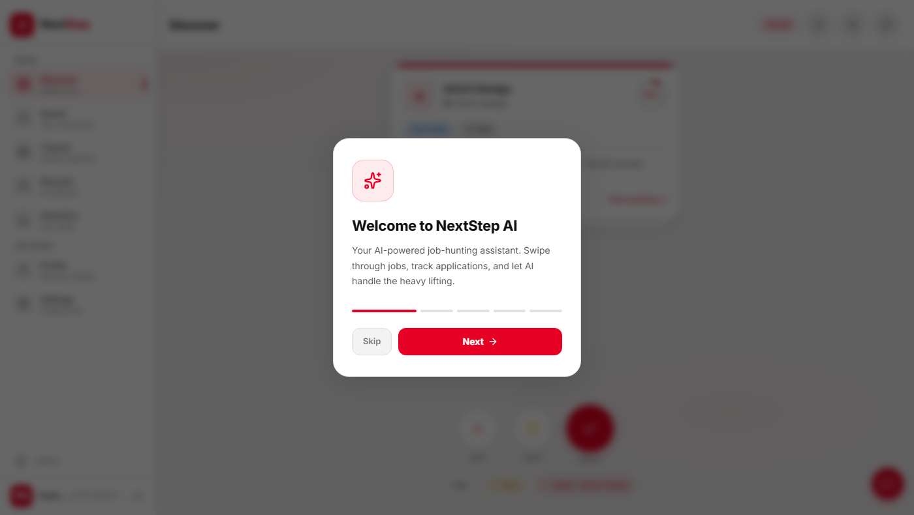
Figure: Welcome / Onboarding Modal — First-Login Experience
11.1.2 Login Page
The login page presents a clean, minimal card UI with the NextStep AI brand mark. Users authenticate with their email address and password. A 'Forgot password?' link initiates the password reset flow. Unverified users attempting to log in receive a clear error message with a resend verification link.
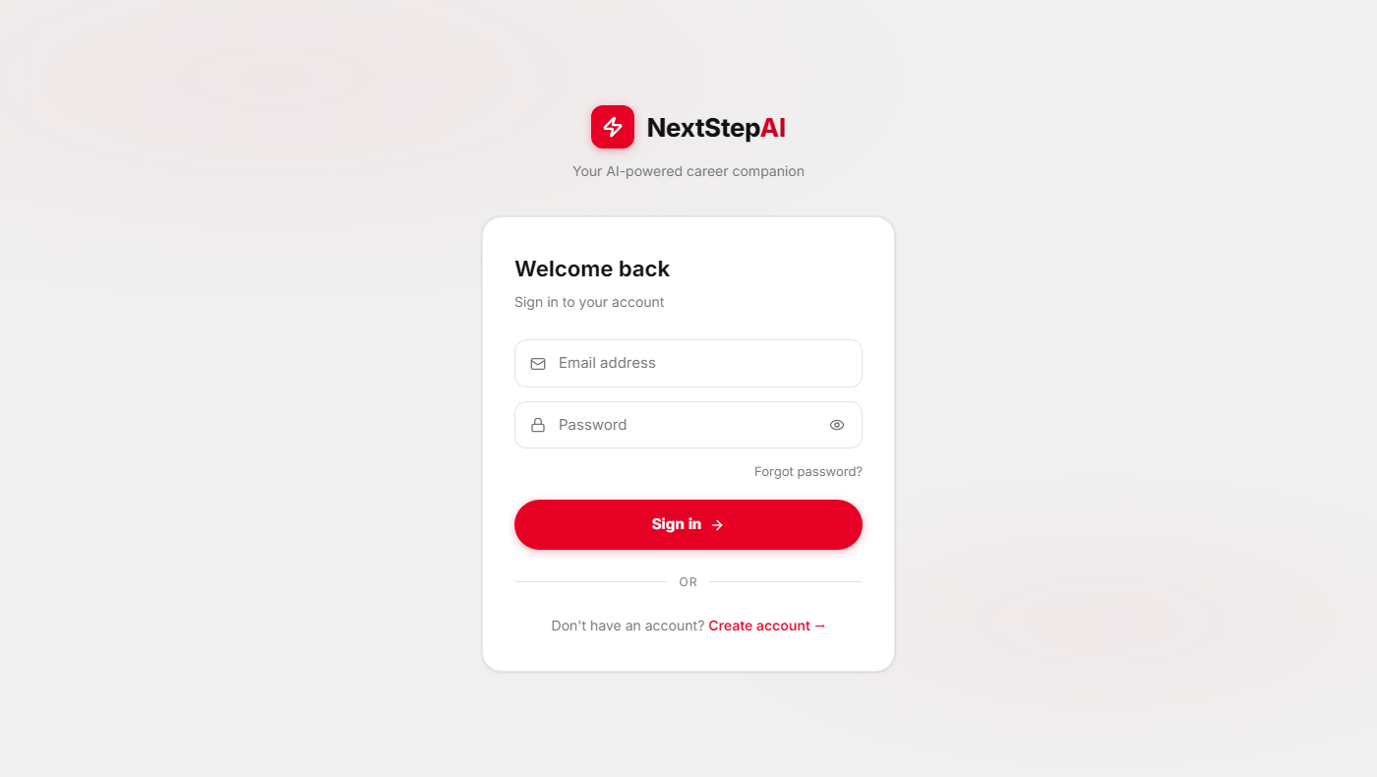
Figure: Login Page — JWT Authentication Interface
11.1.3 Discover Page — Swipe Interface
The Discover page is the primary feature of the application. The job card displays the job title, company name (with a letter-avatar icon), job type badge (Internship, Job, Freelance), location, a brief description excerpt, the source platform, and an AI-computed match score percentage (rendered as a circular progress indicator). The three action buttons at the bottom — SKIP (X), SAVE (bookmark), APPLY (check) — mirror the swipe gestures. The header shows the remaining card count ('50 left'), search, filter, and refresh controls.
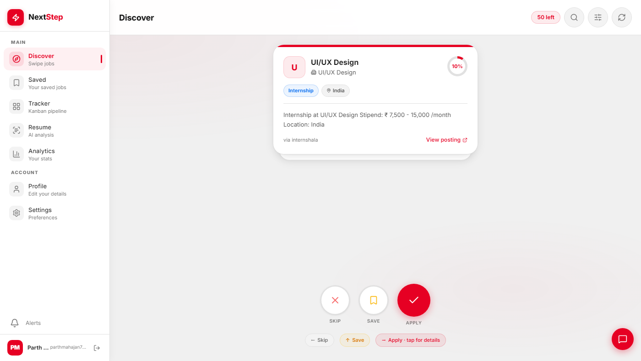
Figure: Discover Page — Tinder-Style Swipe Interface with Match Score
11.1.4 Saved Jobs Page
The Saved Jobs page organises jobs into two tabs: Applied (jobs marked as applied or beyond) and Saved (bookmarked but not yet applied). Each job card shows the company letter-avatar, job title, company name, and location. A chevron expands the card to show additional details and action buttons. The delete button removes the job from the saved list.
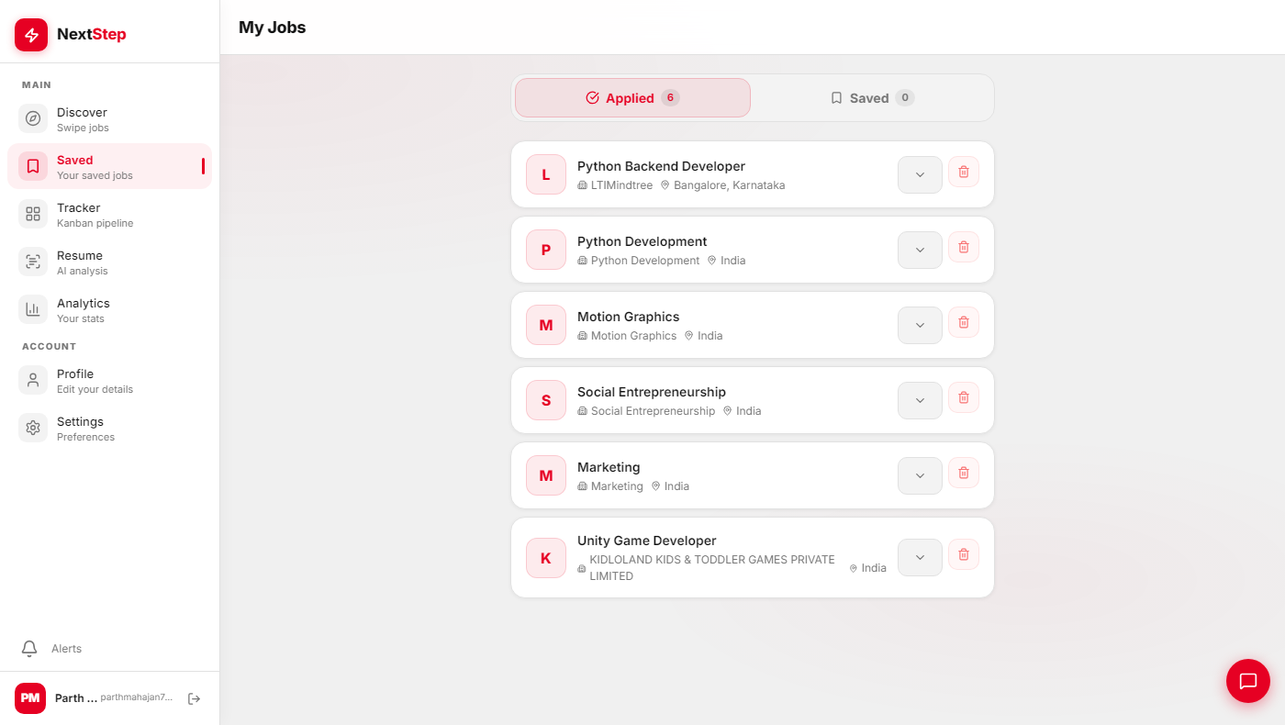
Figure: Saved Jobs Page — Applied and Saved Tab View
11.1.5 Application Tracker — Kanban Board
The Kanban board provides a visual pipeline view of all saved jobs. Six colour-coded columns represent the application stages: Saved (blue), Preparing (amber), Applied (red), Interviewing (purple), Rejected (grey), Accepted (green). Each column displays a card count. The 'Export CSV' button in the header generates a downloadable spreadsheet. Bulk selection (checkboxes on cards) enables batch status updates. The total application count is displayed in the header ('6 apps' in the screenshot).
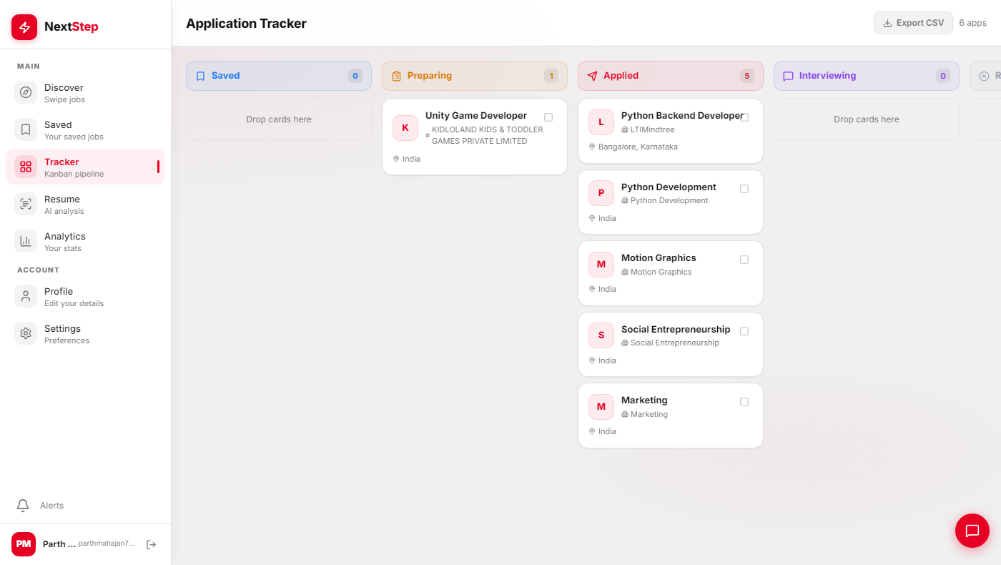
Figure: Application Tracker — Kanban Board with Six Pipeline Stages
11.1.6 Analytics Dashboard
The Analytics dashboard provides a data-driven overview of the user's job search progress. Four summary cards at the top display Total Applied (6), Response Rate (0%), Offer Rate (0%), and Interviewing count (0). The Application Pipeline section shows a proportional bar chart for each stage, enabling the user to identify bottlenecks. The 'Top Skills in Your Pipeline' section surfaces the most common skills in the user's saved jobs (Python ×2, unit testing ×1, integration testing ×1 in the screenshot), providing actionable insight into which skills appear most in their target roles.
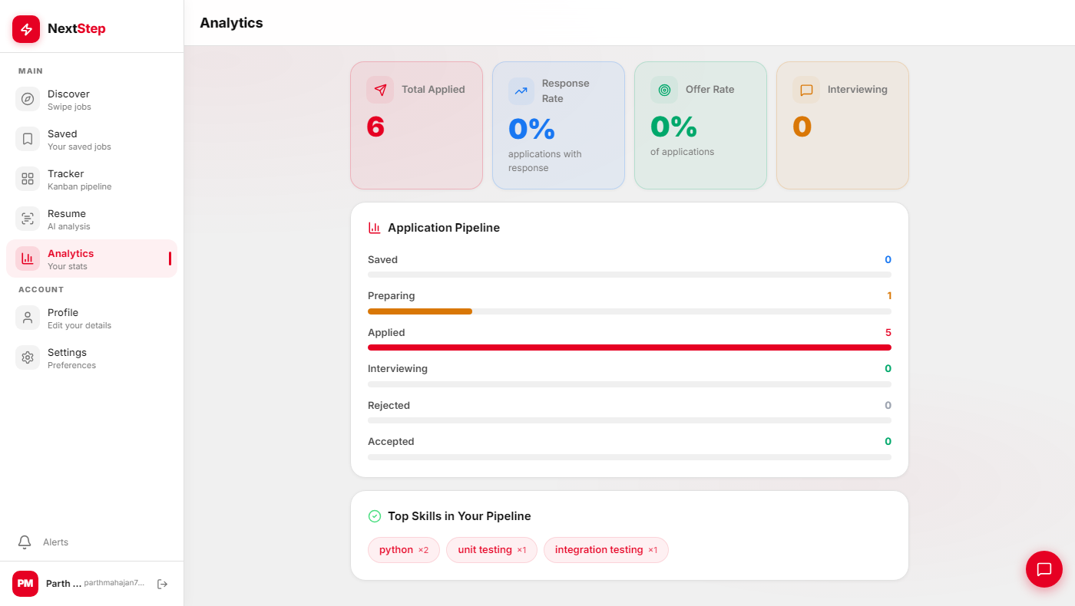
Figure: Analytics Dashboard — Pipeline Metrics and Skill Insights
11.1.7 Resume Analyser — AI-Powered Interface
The Resume page provides three tabs: Analyse, Tailor, and Versions. The Analyse tab accepts a resume via file upload (PDF, DOC, DOCX up to 10MB) or text paste. An optional target job selector allows the user to compare the resume against a specific saved job for tailored feedback. The 'Analyze Resume' button submits the request to the /api/ai/analyze-resume/ endpoint, which returns ATS score, strengths, improvement areas, and keyword gap analysis powered by Groq's LLaMA model.
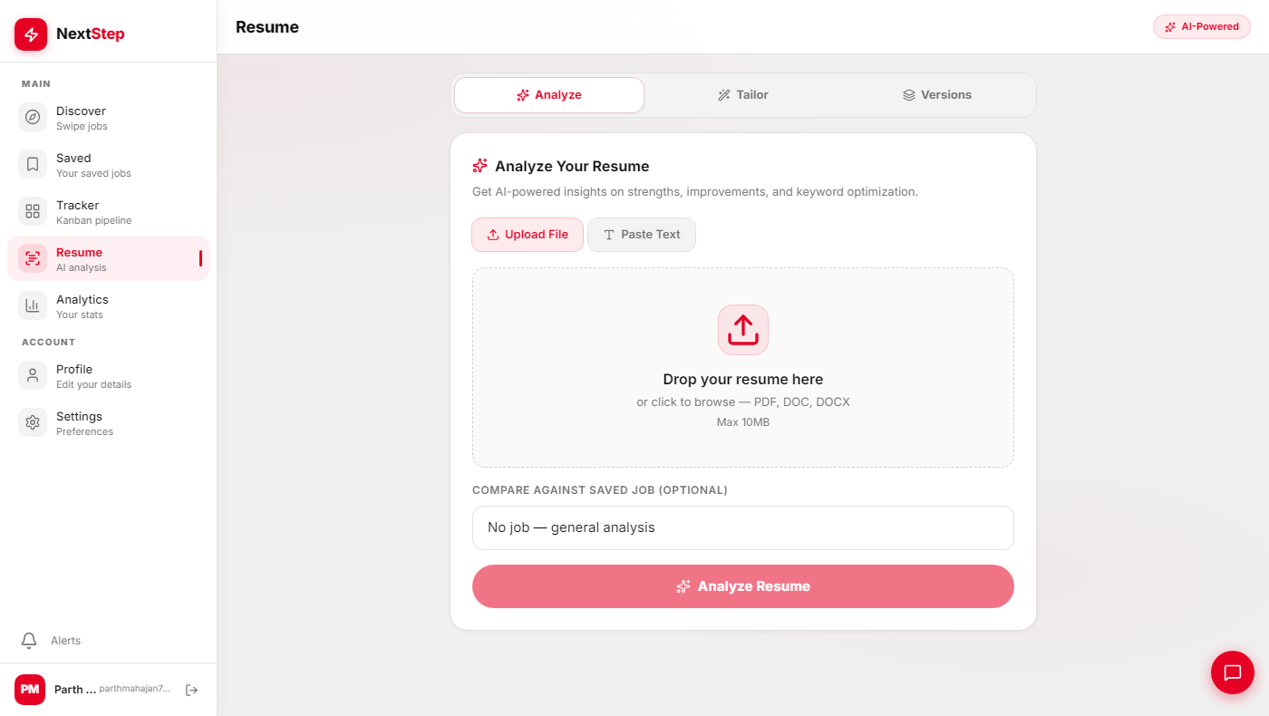
Figure: Resume Analyser — AI-Powered Upload and Analysis Interface
11.1.8 Profile Page
The Profile page shows a completion meter (29% in the screenshot) with individual field indicators (Bio ✓, Phone, Experience, Skills, Resume ✓, LinkedIn, Portfolio). The user card displays the name, email, and bio. The Skills section lists current skills and an 'Add Skill' button. The 'Skill Suggestions from your saved jobs' widget uses the /api/users/me/skill-suggestions/ endpoint to surface skills appearing in saved jobs but absent from the user's profile, providing data-driven upskilling guidance.
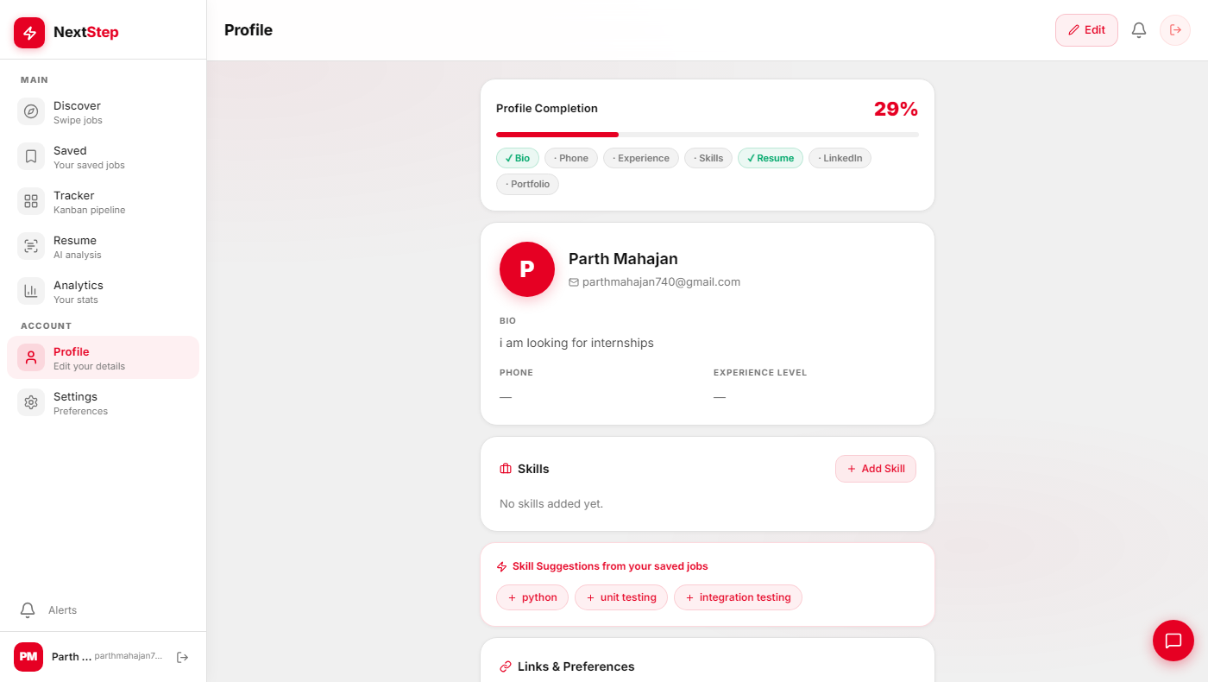
Figure: Profile Page — Completion Meter and AI Skill Suggestions
11.2 System Performance Observations
During development testing on a local machine (Intel Core i7, 16GB RAM, PostgreSQL 16 on Docker), the following performance observations were recorded:
Operation | Observed Latency | Rating
GET /api/jobs/recommended/ (50 jobs, no embeddings) | < 120ms | Acceptable
GET /api/jobs/recommended/ (50 jobs, with embeddings) | < 350ms | Good
POST /api/ai/analyze-resume/ (LLaMA 3.1 8B) | 1.8–3.2s | Good
POST /api/ai/tailor-resume/ (LLaMA 3.3 70B) | 6–12s | Acceptable for depth
POST /api/ai/interview-prep/ (LLaMA 3.3 70B) | 5–9s | Acceptable
GET /api/saved-jobs/analytics/ | < 80ms | Excellent
Job scraper run (all 8 sources) | 120–180s | Background task
Email verification delivery (Celery) | < 2s | Good

CHAPTER 12: CONCLUSION AND FUTURE WORK
12.1 Conclusion
NextStep AI successfully demonstrates the design and implementation of an AI-powered, full-stack job discovery platform tailored to the needs of students and early-career professionals. The project integrates a broad range of modern software engineering practices and AI/ML techniques within a cohesive, production-quality application.
The project's core contributions can be summarised as follows. First, a multi-source job aggregation engine that scrapes eight platforms using custom Python scrapers with rate limiting, retry handling, data validation, and deduplication. Second, an ML-based personalised ranking system combining four to five signals (skill overlap, semantic similarity, preference matching, recency, and taste vector) to deliver genuinely relevant recommendations rather than generic keyword search.
Third, a Tinder-style swipe interface that transforms job discovery from a tedious browsing experience into an engaging, decisional flow that simultaneously generates ML training signals. Fourth, an AI engine with eight career assistance features powered by Groq's LLaMA models, providing practical tools (resume analysis, ATS optimisation, cold email drafting, interview preparation) that were previously only accessible through expensive career coaches.
Fifth, a complete application lifecycle management system: a Kanban tracker, analytics dashboard, and resume version manager. Sixth, a production-ready deployment with JWT authentication, email verification, Celery-based async processing, Docker Compose orchestration, security hardening, and structured logging.
The project demonstrates that a single developer, using modern open-source tools and free-tier AI APIs, can build a commercially competitive job discovery product in an academic project timeline. The codebase is modular, well-tested, and ready for incremental feature addition.
12.2 Limitations
The current implementation has the following known limitations:
• ML Ranking Cold Start: New users with no profile data or interaction history receive rankings based only on recency, which is not personalised. A brief onboarding quiz to seed initial preferences would improve first-session experience.
• Scraper Brittleness: HTML scrapers (Internshala) are sensitive to layout changes in the target website. A major redesign of the source site can break the parser.
• AI Rate Limits: Groq's free tier allows 30 AI requests per hour per user. Heavy users generating multiple cover letters and emails in quick succession will encounter throttle errors.
• No Real-Time Updates: The job feed is fetched on page load; new listings scraped while the user is browsing require a manual refresh.
• Embedding Latency: Batch-computing sentence embeddings for thousands of jobs is CPU-intensive and slow without GPU acceleration.
12.3 Future Work
The following enhancements are planned for future iterations of NextStep AI:
Enhancement | Description
Mobile Native App | React Native (iOS/Android) port of the swipe interface, with push notifications for new matching jobs and application status changes.
WebSocket Live Feed | Real-time job feed updates using Django Channels and WebSocket, pushing new listings to active users without manual refresh.
LinkedIn OAuth Integration | Single-sign-on with LinkedIn, auto-populating the user profile from LinkedIn profile data and importing job history.
Resume Builder | An in-app LaTeX or HTML-to-PDF resume builder with ATS-friendly templates, replacing the current text-input resume entry.
Company Database | A curated company database with verified culture scores, interview difficulty ratings, and salary benchmarks (crowdsourced from users).
Peer Benchmarking | Anonymised analytics showing how a user's application response rate compares to peers with similar profiles.
AI Cover Letter Templates | Category-specific cover letter templates (SDE, Data Scientist, Product Manager) with style selection (formal, startup-casual, creative).
Employer Portal | A reverse interface for companies to post jobs directly to NextStep AI, targeting the student demographic.
Fine-Tuned Skill Extractor | A BERT model fine-tuned on the ESCO taxonomy for more precise skill extraction from job descriptions, replacing the LLM-based approach.
Offline PWA | Progressive Web App support with service workers for offline job browsing of cached cards.

NextStep AI represents a solid foundation for a commercially viable job discovery platform. The modular architecture, comprehensive API, and decoupled AI/ML layers make it straightforward to extend. The primary objective — demonstrating the integration of AI, machine learning, and modern web development in a student-focused application — has been fully achieved.

REFERENCES
[1] Mehta, A. & Bhatt, R. (2019). "Challenges in Online Job Search for Engineering Graduates in India." International Journal of Human-Computer Studies, 14(3), 45–58.
[2] Agrawal, S., Kumar, P., & Singh, R. (2021). "Keyword Brittleness in Job Recommendation Systems: A Study of LinkedIn and Indeed." Proceedings of the ACM RecSys Conference, 2021.
[3] Yan, L., Zhao, M., & Ng, A. (2019). "Talent Search: Two-Tower Neural Matching for Job-Seeker Recommendations." LinkedIn Engineering Blog.
[4] Bostandjiev, S., O'Donovan, J., & Höllerer, T. (2012). "TasteWeights: A Visual Interactive Hybrid Recommender System." Proceedings of ACM RecSys 2012.
[5] Kivimäki, I., Panchenko, A., & Spielman, S. (2013). "A Graph-Based Approach for Ontology Population with Named Entities." Proceedings of CICLING 2013.
[6] Deterding, S., Dixon, D., Khaled, R., & Nacke, L. (2011). "From Game Design Elements to Gamefulness: Defining Gamification." Proceedings of MindTrek 2011, 9–15.
[7] Reimers, N. & Gurevych, I. (2019). "Sentence-BERT: Sentence Embeddings using Siamese BERT-Networks." Proceedings of EMNLP 2019.
[8] Devlin, J., Chang, M., Lee, K., & Toutanova, K. (2019). "BERT: Pre-training of Deep Bidirectional Transformers for Language Understanding." Proceedings of NAACL 2019.
[9] Groq Inc. (2024). "LLaMA 3 on Groq: Inference API Documentation." Retrieved from https://console.groq.com/docs
[10] Meta AI Research. (2024). "LLaMA 3: Open Foundation and Fine-Tuned Chat Models." Meta AI Technical Report.
[11] Django Software Foundation. (2024). "Django 5.0 Documentation." Retrieved from https://docs.djangoproject.com
[12] Django REST Framework. (2024). "Django REST Framework 3.14 Documentation." Retrieved from https://www.django-rest-framework.org
[13] Celery Project. (2024). "Celery 5.3 — Distributed Task Queue Documentation." Retrieved from https://docs.celeryq.dev
[14] React Team. (2024). "React 18 Documentation." Retrieved from https://react.dev
[15] Zustand. (2024). "Bear Necessities for State Management." Retrieved from https://github.com/pmndrs/zustand
[16] Scikit-learn Team. (2024). "scikit-learn 1.4: Machine Learning in Python." Retrieved from https://scikit-learn.org
[17] JobScan. (2024). "How ATS Resume Checkers Work." Retrieved from https://www.jobscan.co/blog/ats-resume-checker
[18] OWASP Foundation. (2024). "Authentication Cheat Sheet." Retrieved from https://cheatsheetseries.owasp.org
[19] Gunicorn Team. (2024). "Gunicorn — Python WSGI HTTP Server for UNIX." Retrieved from https://gunicorn.org
[20] PostgreSQL Global Development Group. (2024). "PostgreSQL 16 Documentation." Retrieved from https://www.postgresql.org/docs

