Day1:19/04/2021

Day work

**Microcontroller**

 It is a unit which contains CPU integrated with both the input and output devices

Ex : computer

**Microprocessor**

      It is a unit which contains only the CPU

It is a part of micro controller

Ex : CPU

ARDUINO

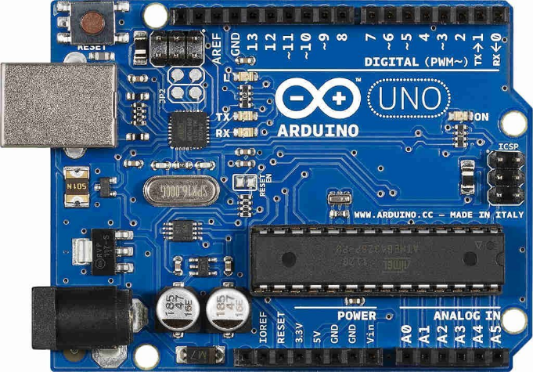

It is an open source platform which is integrates both hardware and software

It contains of circuit board(hardware)

It can be programmed using Arduino IDE (software)

There are so many types of Arduino boards we are using Arduino Uno

Components

**Power usb**

It is used to input power to the board through usb from computer

**Power jack**

It is used to input power to board through any ac external supply

**Voltage regulator**

It helps in having control over the voltage passing through the board

**Crystal oscillator**

It helps in maintaining the time delay. It also displays the frequency

**Reset (button)**

There are two ways to reset the board either directly by button or by the external button

**Pins**

          Power pins -3.3v,5v to input power

          GND -ground pin to ground the circuit

           Vin -another port to input power

**Analog pins**

It is used to for analog sensing

It has 6 inputs from A0 toA5

**Micro controller**

It is the brain of the board

**LED**

it is used to check if the input program is working perfectly. When the programming is done it glows. Tx ,Rx

**Digital pins**

It is used to measure in 0s ,1s

Totally 14 Pins are there is which 6 are for PWM

***Setting up of the board and installing Arduino IDE***

Coding -structures, values, functions

Void setup()

The code written below this function runs only once

Void loop()

 The code written below this function runs repeatedly

Node MCU esp8266

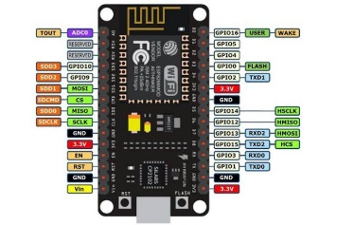

It is another open source platform like the above one

It is based on wi-fi connectivity

It is cheap

The programming can be done using Arduino IDE

**Components**

Power pin - to input power to the board

GND -the ground pin

GPIO pins-they are 12 types of pins for the general purpose input output .

RST -this button is used to reset the board

Power LED -

IT Is used to check if the input program is working perfectly. When the programming is done it glows. Tx ,Rx

Setting up of the board and installing Arduino IDE

Coding -structures, values, functions

Void setup()

The code written below this function runs only once

Void loop()

 The code written below this function runs repeatedly

Home work

1. Difference between Arduino and node MCU

|  |  |
| --- | --- |
| ARDUINO | NODEMCU |
| It can be powered using 3.3v,5v | It can be powered only upto 3.3v |
| No WiFi module | It has WiFi module |
| Very big in size and costly compared to the other | Very small, cheap compared to the other |

1. Pins of Arduino

* Power pins
* GND PIN
* ANALOG PINS
* DIGITAL PINS
* Vin Pin
* ICSP  PINS
* Reset
* AREF

1. PINS OF NODEMCU

* GPIO PINS
* GND PIN
* Power pin VCC
* Tx, Rx
* RST (reset)
* Chip enable pin

1. Difference between  digital and analog pins

      DIGITAL PINS

* It has only 0s and 1s
* It is represented by numbers 1,2,3….
* Led is used in digital because only two options
* The devices which have only two possibilities are connected

     ANALOG PINS

* it has all values including 0 and 1 transient
* It is represented by combination of numbers, alphabets A0,A1,......
* Motor used in analog as it can have a transient options to regulate it
* The devices which have infinite possibilities are connected

20/04/2021 - holiday

Day 2 -21/042021

Day work

 Q/a session

1.Despite using many boards,why do we only use Arduino boards for doing projects?

It is easy to use, ready to upload the program using Arduino IDE . It is less expensive, it is an open source platform

2.Considering that you are doing a project,What will you choose a Microcontroller or a Microprocessor?

It depends on each and every project to choose any one from the both. If we need Input and output devices to be in one we use micro controller

It is better to use microprocessor if we want to manually select the wanted input, output devices for the project

3.What is the use of the Shield in the Arduino board?

Sheilds are a kind of circuit boards used to increase the extra functionality of Arduino boards , provides accessibility to use more options

Day work

Sensors

A device which detects the change in any physical state in the environment like temperature which sometimes even human cannot detect

We are going to see about ultrasonic sensors, infrared sensor, PIR sensor

Ultrasonic sensors(sounds)

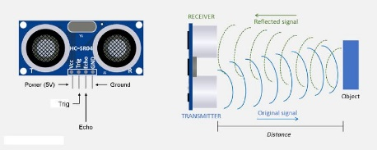

Ultrasonic sensors works based on the principle of ultrasonic sounds . These sounds are of the frequency greater than 20000hz , which is greater than the audible range of humans

It has square type of waves. It has a wide range of sensitivity upto 13m. It operates on 5v.

Components:

* VCC PIN
* TRIG(transmitter)
* ECHO(receiver)
* GND

***WORKING***

* The transmitter which first converts the electrical signals into ultrasounds and then it sends out and when an object is hit
* The sounds are reflected and the echo receive the sounds
* The 8 bit sonic burst pulse waves allows the receiver to differentiate the transmitted waves from each other
* A sound wave of atleast 10us ,330m/s is produced.
* The sensor measures the output in terms of distance using
* Distance=speed*time
* And the distance that is found will be sum of the back and forth motion
* So the distance is to be divided by 2

***Disadvantages***

* If any other absorbing instrument is present then the reciever will not receive the transmitted waves
* It cannot travel more than 13m
* If the sensor is kept at bottom the obstacles are the top cannot be sensed

***IR SENSORS (light)***

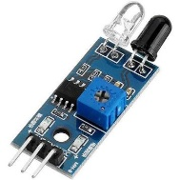

These are motion detected sensors used to detect based on motion of humans, animals

It is used in obstacle detection, industrial safety, proximity sensors…..

**Components**

1. 3 pins
   * VCC - to connect to 5v pin in ARDUINO
   * GND
   * Out-output pin

     2.IR LED to emit light(white generally emit light)

     3. Photodiode, photo transistor-to absorb light(black generally absorbs light)

   4.LM 358 Opamp

             It is used as voltage comparator to check the threshold voltage, photo diode resistor voltage

    5.Resistor it is used to fix the distance range at which the object should be detected

***Disadvantages :***

* If there is any object in the line of communication the sensor will not work
* It can detect objects upto 20cm only

PIR SENSORS (passive):

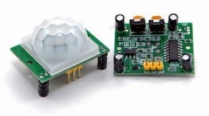

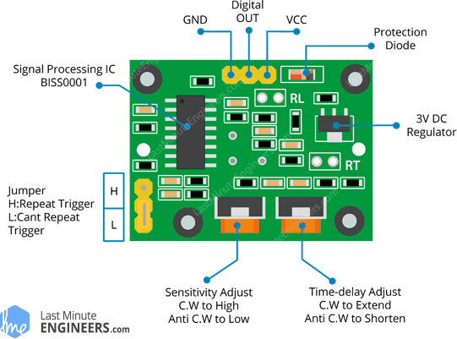

It doesn't have a transmitter it has only

Receiver

It works on the principle that every object above 0k radiates energy in the form of infrared waves which can be sensed by the receiver

***Components***

* 3 pins

               1. VCC - to connect to 5v pin in ARDUINO

                 2.GND

                 3. Out-output pin

* 2 triggers

     1.  Repeatable h-untill the sensor detects movement the output to be high

    2.   Irrepeatable L- output will be high till the given time of potentiometer

* 2 potentiometers
* One to modify the sensitivity upto 7m 120 degree
* Other to modify the time from 3s to 300s
* RT-thermistor,RL-LDR
* Fresnel lens is used to focus the all infrared rays to the sensor(pyroelectric)

***Working***

it first intercepts one half of the PIR sensor, which causes a positive differential change between the two halves. When the warm body leaves the sensing area, the reverse happens, whereby the sensor generates a negative differential change. The corresponding pulse of signals results in the sensor setting its output pin high.

Home work

1.Why do we use potentiometer in IR sensor module?

Potentiometer is used to change the voltage and get the output according to the requirement

2.Why do we have a resistor in the IR sensor module?

Resistor  is used to fix the distance range at which the object should be detected

Day 3 -22/04/2021

Relaxation holiday

Day 4- 23/042021

assessment

Day 5- 24/04/2021

Relaxation holiday

Day 6-25/042021

Tinker cad

Day work

***Some basic components***

***Explanation***

***Some circuits explained***

***Simulation***

***Glowing of led***

***Home work***

***1.Arduino codes***

***2. Building an IR SENSOR***

***3. Blinking an LED using relay***

Day 7-26/04/2021

Day work

**Beginning with what do need to build a robot**

**To control the motion, direction of robot we need DC motors and to control these motors we need L298N DC MOTOR DRIVER**

**L298N DC MOTOR DRIVER**

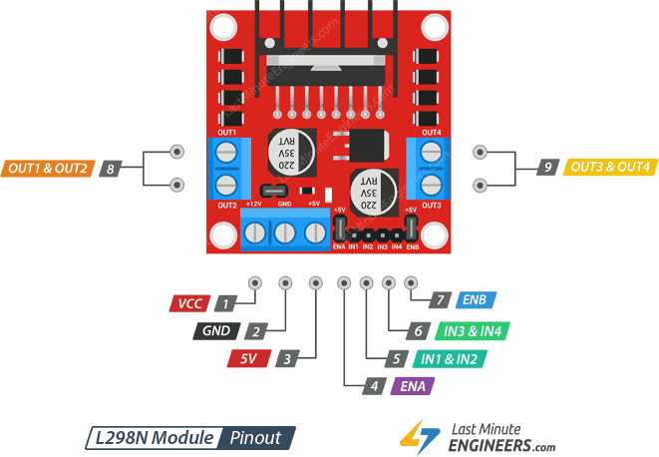

Components

1. **Power supply pins**

             : it is used to supply power to the motors ranging from 5v-35v .

We need to supply extra 2v  than motor’s actual voltage requirement, in order to get maximum speed out of your motor as the 2v is the voltage drop.

* VCC 12v pin-power input can be 5v to 35v
* GND PIN
* 5V PIN-power input can be 5v to 7v.
* Additional parts relating power

1. 5v EN jumper(a black thing above 3pins)
2. On board 5v regulator near the right motor

                       When the jumper is in place the 5v regulator is enabled in this case the 5v imput acts as output and produces  5v. When the jumper is removed the 5v regulator is off and the voltage supplied now can be more than 12v.

    2. **OUT1,OUT2, OUT 3,OUT4:**

             These are the pins for connecting 2 motors.

**3.IN1,IN2,IN3,IN4**:

            IN1 and IN2 pins control the spinning direction of the motor A while IN3 and IN4 control motor B.

**4.SPEED CONTROL PINS:**

         ENA(1st),ENB(2nd) : turning on this will make the motor move at the atmost speed and turning off this will make the motor stop

But using PWM we can control the speed

**5.L298 CHIp**: it is the big black part at the top of the board. Which is used in controlling the 2 motors

CONTROLLING OF DC MOTOR

1.PWM -FOR CONTROLLING THE SPEED

2.H-BRIDGE -FOR CONTROLLING ROTATION DIRECTION

1. PWM

Using PWM speed of a DC MOTOR can be controlled by varying input voltage

The average voltage is proportional to the width of the pulses known as Duty Cycle.

When the duty cycle represented in graph increases due to increase in average voltage then the motor has a increased speed.

When the duty cycle represented in the graph decrease due to decrease in average voltage then the motor has decreasing speed

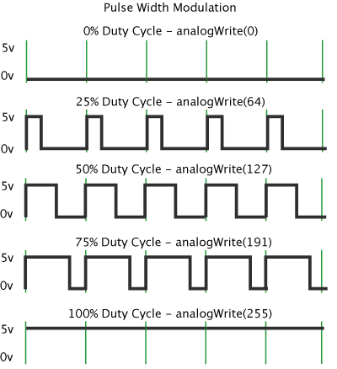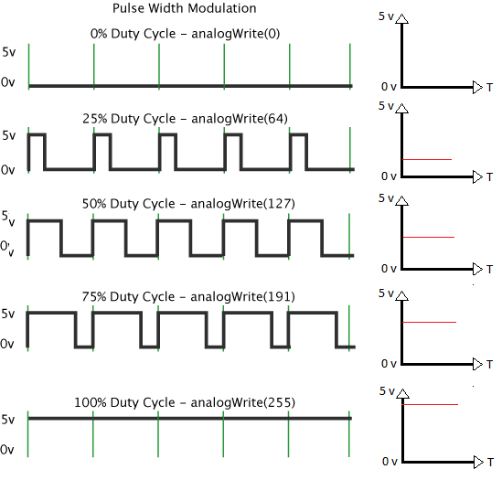

1. H-BRIDGE TO CONTROL THE DIRECTION

 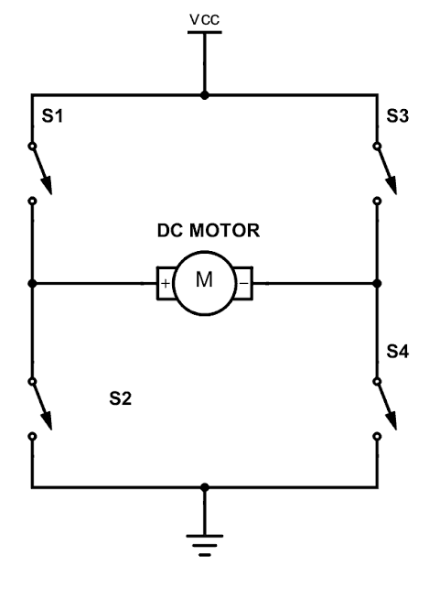

The DC motor’s spinning direction can be controlled by changing polarity of its input voltage

A H bridge Contains 4 switches S1,S2,S3,S4.

When the switches S1,S4 are closed it flows clockwise and the robot moves forward (high to low)

When the switches S2,S3 are closed it flows  anti clockwise and the robot moves backward(low to high)

HOMEWORK

1. What is fwd?

Day 8-27/04/2021

Preparation holiday

Day 9-28/04/2021

Preparation holiday

Day 10-29/04/2021

DAY WORK

SERVO MOTORS,LED,LCD

*Very good Parthiban*

*The doc is perfect💥*

* *Phani Tulasi*