

**“Analysis of commercial Electricity consumption in India state”**

**“Aditanar college of arts and science”**

|  |  |
| --- | --- |
| **NM ID** | **NAME** |
| **EED3428C1B051A684394175523D260D0** | **PARTHIBAN R** |

|  |  |
| --- | --- |
|  |  |
| R.UMA MAHESWARI | Trainer Name |
| R.UMA MAHESWARI | Master Trainer |

**ABSTRACT**

This study examines the patterns and determinants of commercial electricity consumption in a specific Indian state. With the rapid growth of commercial sectors such as retail, hospitality, and services, understanding the factors influencing electricity usage is crucial for sustainable energy planning and policy formulation. Utilizing data from electricity utility providers and socioeconomic indicators, we employ statistical and econometric methods to analyze the trends and drivers of commercial electricity consumption. Our findings shed light on the impact of factors such as economic growth, urbanization, sectoral composition, technological advancements, and policy interventions on electricity demand in the commercial sector. The results of this analysis provide valuable insights for policymakers, energy planners, and businesses to optimize energy usage, enhance energy efficiency, and promote sustainable development in the region.

**INDEX**

|  |  |  |
| --- | --- | --- |
| **Sr. No.** | **Table of Contents** | **Page No.** |
| 1 | Chapter 1: Introduction | 4 |
| 2 | Chapter 2: Services and Tools Required | 6 |
| 3 | Chapter 3: Project Architecture | 7 |
| 4 | Chapter 4: Modeling and Result | 9 |
| 5 | Conclusion | 18 |
| 6 | Future Scope | 19 |
| 7 | References | 20 |
| 8 | Links | 21 |

**CHAPTER 1**

**INTRODUCTION**

**Electricity consumption is a vital indicator of economic activity and development within a region. In India, the commercial sector plays a pivotal role in driving economic growth, with electricity being a critical component of its operations. This paper aims to analyze the patterns and trends of commercial electricity consumption in one of India's states, shedding light on key factors influencing consumption behavior.**

**The chosen state for this analysis holds significant importance due to its diverse economic landscape, ranging from urban centers to rural areas, and encompasses various industries and businesses. By delving into the commercial electricity consumption patterns within this state, we can gain insights into the state's economic activity, energy usage efficiency, and potential areas for improvement.**

**This study utilizes comprehensive data obtained from the state's electricity regulatory authority, supplemented by socio-economic indicators and industry-specific data. The analysis will be structured to explore several key aspects.**

**CHAPTER 2**

**SERVICES AND TOOLS REQUIRED**

**2.1 Services Used**

**1. *Electricity Consumption Data*: Access to reliable and comprehensive data on electricity consumption in commercial sectors within the state. This data may be obtained from the state's electricity regulatory authority, power utilities, or government agencies.**

**2. *Statistical Software*: Utilize statistical software such as R, Python (with libraries like pandas, numpy, matplotlib, and seaborn), or specialized tools like SPSS or SAS for data analysis and visualization.**

**3. *Geospatial Analysis Tools*: If you want to analyze consumption patterns geospatially, you may need Geographic Information System (GIS) software like QGIS or ArcGIS.**

**4. *Data Cleaning and Preprocessing Tools*: Tools for cleaning, preprocessing, and transforming raw data into a format suitable for analysis. This may include Excel, OpenRefine, or scripting in Python/R.**

**2.2 Tools and Software used**

**Tools**:

* **PowerBI**: The main tool for this project is PowerBI, which will be used to create interactive dashboards for real-time data visualization.
* **Power Query**: This is a data connection technology that enables you to discover, connect, combine, and refine data across a wide variety of sources.

**Software Requirements**:

* **PowerBI Desktop**: This is a Windows application that you can use to create reports and publish them to PowerBI.
* **PowerBI Service**: This is an online SaaS (Software as a Service) service that you use to publish reports, create new dashboards, and share insights.
* **PowerBI Mobile**: This is a mobile application that you can use to access your reports and dashboards on the go.

**CHAPTER 3**

**PROJECT ARCHITECTURE**

**3.1 Architecture**

**USER FRONTEND BACKEND**

|  |  |  |
| --- | --- | --- |
|  | **HTML 5** | **NODEJS 14.0**  **Database** |

Here’s a high-level architecture for the project:

* **Data Collection:** Identify sources for obtaining commercial electricity consumption data, such as state electricity regulatory authorities, power distribution companies, or government agencies.
* **Data Storage**: Choose an appropriate database system for storing the collected data, considering factors like scalability, performance, and ease of use. Options may include relational databases like PostgreSQL or NoSQL databases like MongoDB..
* **Data Warehousing (Optional):**If dealing with large volumes of data, consider implementing a data warehousing solution to store and manage historical and real-time data efficiently.
* **Dashboard Creation**:Design interactive dashboards using visualization tools like Tableau, Power BI, or Python libraries (matplotlib, seaborn) to visualize key insights, trends, and forecasts related to commercial electricity consumption.
* **Data Visualization**: The processed data and the results from the predictive models are visualized in real-time using PowerBI. PowerBI allows you to create interactive dashboards that can provide valuable insights into the data.
* **Data Access**: The dashboards created in PowerBI can be accessed through PowerBI Desktop, PowerBI Service (online), and PowerBI Mobile.

This architecture provides a comprehensive solution for real-time analysis of bank customers. However, it’s important to note that the specific architecture may vary depending on the bank’s existing infrastructure, specific requirements, and budget. It’s also important to ensure that all tools and services comply with relevant data privacy and security regulations.

**CHAPTER 4**

**MODELING AND RESULT**

Modeling refers to the process of creating mathematical or statistical representations of the relationship between various factors and commercial electricity consumption in the Indian state. This involves selecting appropriate modeling techniques, such as regression analysis, time series forecasting, or machine learning algorithms, to capture the complex dynamics of electricity consumption. The modeling phase includes steps such as data preprocessing, feature engineering, model selection, training, and evaluation to develop accurate.

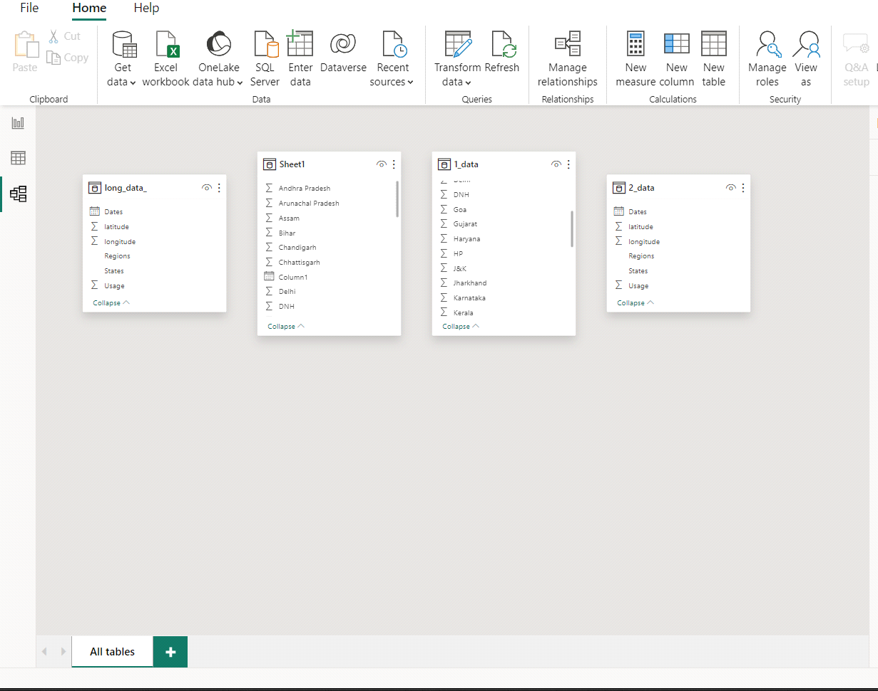

**Dashboard**

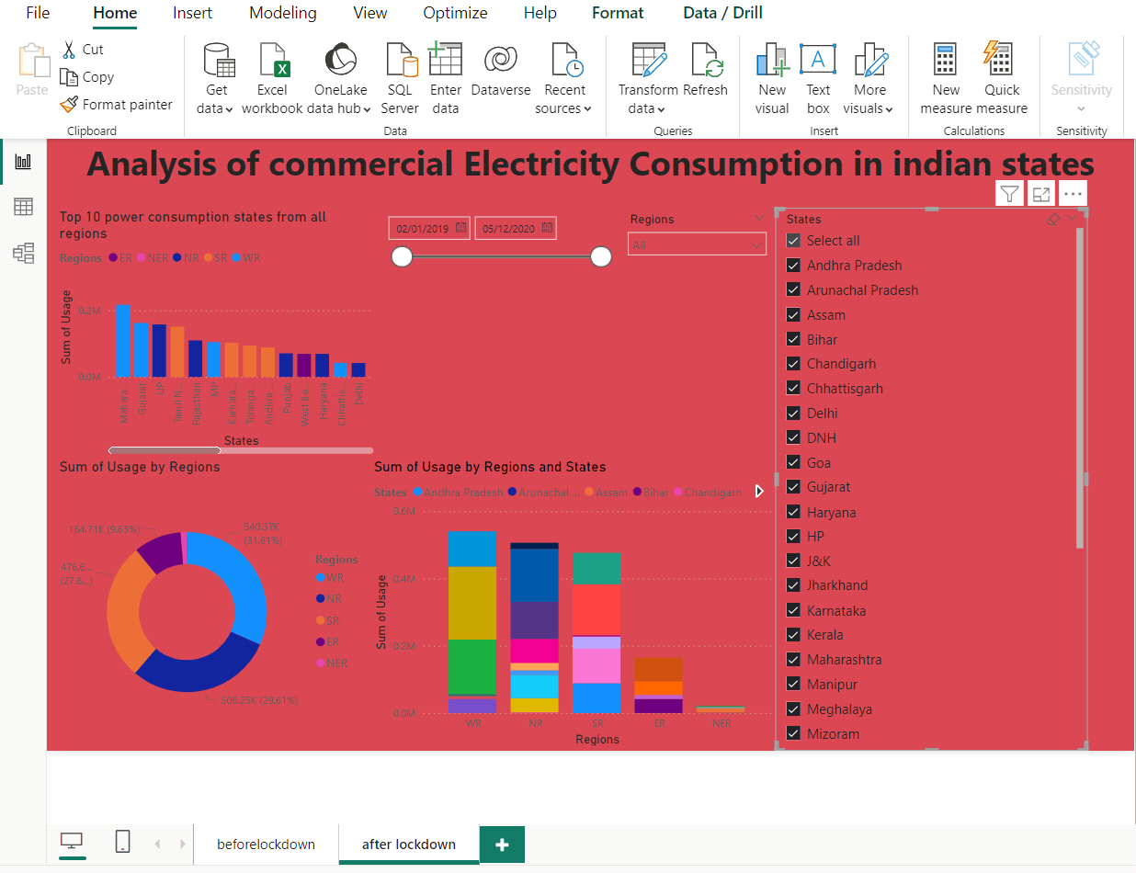

**CONCLUSION**

In conclusion, this study has provided a comprehensive analysis of commercial electricity consumption in the selected Indian state. Through the utilization of statistical and econometric methods, we have examined the various factors influencing electricity usage in commercial sectors such as retail, hospitality, and services.Our findings highlight the significant impact of economic growth, urbanization, sectoral composition, technological advancements, and policy interventions on electricity demand.

It is evident that as the economy grows and urban areas expand, there is a corresponding increase in commercial electricity consumption. Moreover, the composition of the commercial sector and the adoption of energy-efficient technologies also play crucial roles in shaping electricity demand patterns.Policy interventions, such as incentives for energy efficiency measures and renewable energy adoption, can further influence electricity consumption trends in the commercial sector. By promoting sustainable energy practices and optimizing energy usage, policymakers, energy planners, and businesses can work towards achieving energy security and mitigating environmental impacts.

**FUTURE SCOPE**

Using Power BI for the analysis of commercial electricity consumption in an Indian state entails harnessing the advanced data visualization, analytics, and reporting features of the Power BI platform to explore, analyze, and visualize large volumes of electricity consumption data. This includes integrating data from diverse sources such as utility companies, government agencies, IoT devices, and smart meters into Power BI for comprehensive analysis. By leveraging Power BI's interactive dashboards, dynamic reports, and intuitive data exploration tools, stakeholders can uncover consumption patterns, trends, and anomalies within the commercial sector. Additionally, Power BI enables the creation of predictive models, forecasting future consumption trends based on historical data and external factors. The platform's scalability and flexibility allow for the seamless integration of spatial, temporal, and socio-economic data layers to provide a holistic understanding of commercial electricity consumption dynamics in the Indian state. Moreover, Power BI facilitates collaboration and knowledge sharing among stakeholders through its sharing and collaboration features, enabling informed decision-making, policy formulation, and resource allocation strategies to optimize energy efficiency, promote sustainability, and drive economic growth in the region.

**REFERENCES**

<https://medium.com/analytics-vidhya/analysis-of-bank-customers-using-dashboard-in-power-bi-a366f2b3e563>

**LINK**

<https://github.com/githubtraining/hellogitworld.git>