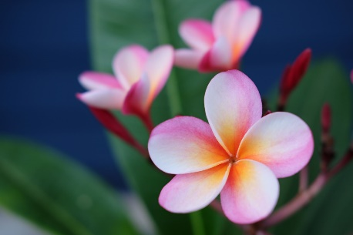

===========================================================================

**sfgsfgfsg**

Dear Parthi,

How r you,

You have to pay Rs. 200