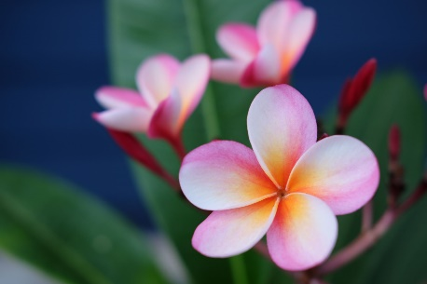

===========================================================================

**sfgsfgfsg**

Dear Raja,

How r you,

You have to pay Rs. 100