Project Synopsis
Credit Card Fraud Detection Using Anomaly Detection
Project No. P_202 · Digital-Data-AI / AIML · Academic Year 2025–26
Project Title | Credit Card Fraud Detection Using Anomaly Detection
Project No. | P_202
Domain | Digital-Data-AI / AIML
Difficulty | Advanced
Duration | 4 Weeks
Format | Individual Project
Learner Name | Parthik Patel
Roll Number | 2400320100794
College / Campus | ABES Engineering College, Ghaziabad · B.Tech CSE, III Year
Mentor Name | Ankit Mishra
Submission Date | 01 November 2026
1. Problem Statement
Banks and the teams that review card payments have to find stolen-card spending inside a much larger stream of ordinary purchases. In the two days of European card transactions studied here, only 492 of 284,807 payments are fraud, about 0.17 percent. The fraud pattern also changes, so a fixed rule book, or a classifier that has only seen old fraud, misses new cases. At the same time, blocking a genuine payment denies a real customer.
The loss happens at authorisation time: a missed fraud is money gone, and a false alarm is a customer who cannot pay. I treat fraud as an anomaly. The model learns what normal spending looks like, gives each new transaction an anomaly score, and sends only the unusual ones to a person for review.
2. Proposed Solution and Approach
I built a local detection pipeline in Python, matching the working prototype asked for in the project brief. The notebook loads the public ULB credit-card file, removes duplicate rows, and scales Time and Amount with a RobustScaler fitted on the training split only. It then trains an Isolation Forest without using the fraud label. The fraud label is used only afterwards, on a validation split, to choose the score threshold that gives the best F1.
On the same split I also train Local Outlier Factor, and a Logistic Regression model whose training pipeline uses SMOTE. Those two models are for comparison. They show what a second anomaly detector and a supervised baseline can do when labelled fraud is available. The app does not load them.
The fitted Isolation Forest and the scaler are saved as models/fraud_model.pkl and models/scaler.pkl. The tuned threshold is stored on the model. app.py is a one-page Streamlit application. The user types one transaction, loads a real sample from the dataset, or uploads a CSV with the same columns. The app scales the input and shows Fraud or Normal, the anomaly score, and the threshold.
The brief also names an autoencoder. This version does not train one. Isolation Forest is the model the application serves, because it trains on the full training split on a normal laptop. An autoencoder is a sensible next model, not part of this submission.
3. System Architecture
The system has two stages and no login, database, or payment-gateway connection. The developer runs the notebook once. After that, the user only talks to app.py. Figure 1 shows the context diagram (DFD Level 0) and the block diagram of that flow.
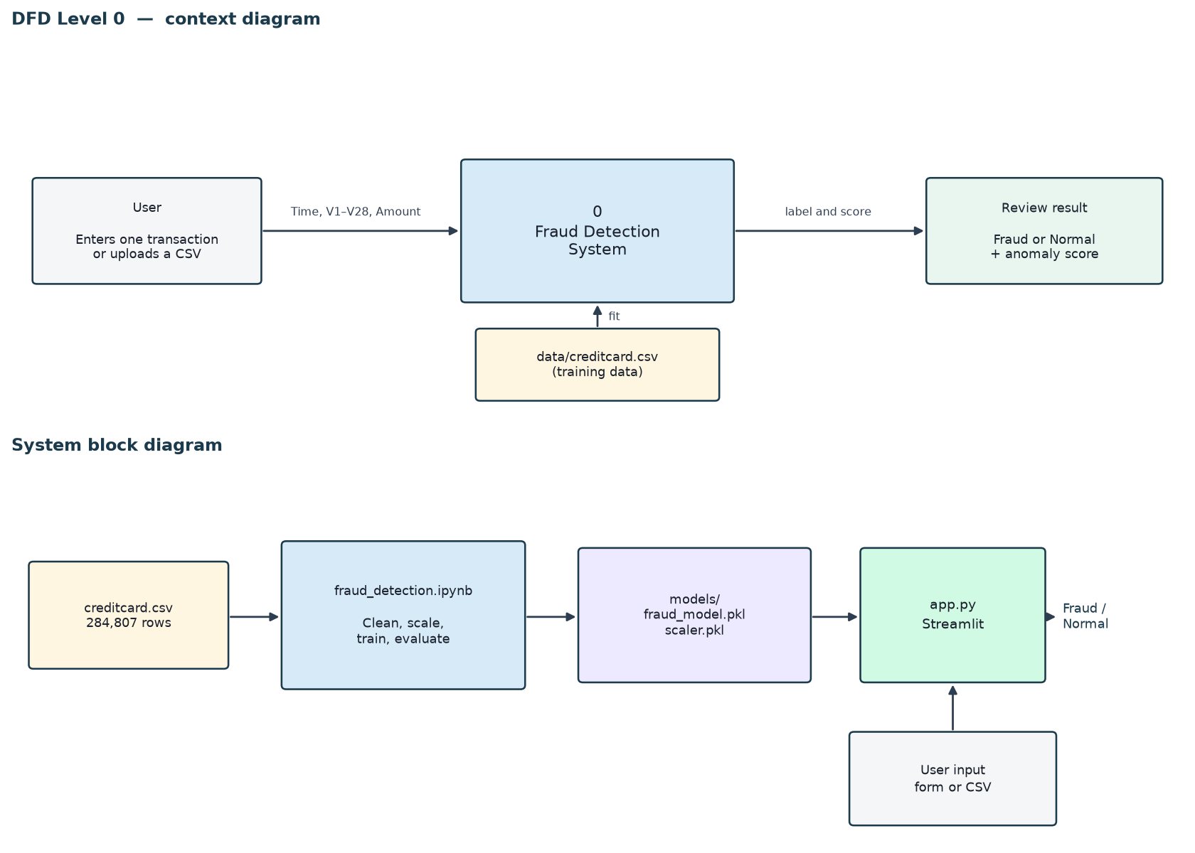
Figure 1. DFD Level 0 and the system block diagram.
Training uses a stratified split so each part keeps the same fraud rate: 60 percent train, 20 percent validation, 20 percent test. The detectors never see the labels while they fit. The threshold is chosen on the validation split. The test split is used once, for the numbers in Section 6.
The project folder follows the structure below.
data/creditcard.csv
notebooks/fraud_detection.ipynb
models/fraud_model.pkl
models/scaler.pkl
app.py
requirements.txt
README.md
4. Technology Stack
Frontend / UI | Streamlit, in app.py. One page: a transaction form, sample buttons, and a CSV upload.
Backend / logic | Python. Training and evaluation run in notebooks/fraud_detection.ipynb. Scoring runs inside app.py. There is no separate server and no database.
Database | None. The dataset is data/creditcard.csv. The fitted objects are models/fraud_model.pkl and models/scaler.pkl.
AI / ML | scikit-learn (RobustScaler, Isolation Forest, Local Outlier Factor, Logistic Regression) and imbalanced-learn (SMOTE, used only for the supervised baseline).
Visualisation | Matplotlib and Seaborn, inside the notebook (class balance, amount and time by class, precision–recall curves, confusion matrices, score distributions).
Hardware | A normal laptop. Training and prediction use the CPU. No GPU and no special device.
The brief lists SQL, Java/Spring, REST APIs, and TensorFlow as possible tools. This prototype does not use them. Prediction stays inside the Streamlit page, and both anomaly detectors are scikit-learn models. That keeps the four-week system small enough to train, test, and demonstrate on one machine.
5. Dataset Used
Dataset file name | data/creditcard.csv
Source | ULB Machine Learning Group and Worldline, public credit-card fraud dataset (the Kaggle link given in the project brief).
Number of rows | 284,807 raw transactions. 1,081 exact duplicate rows were removed. 0 rows had missing values. 283,726 rows remain, of which 473 are fraud.
Number of columns | 31
Key columns | Time (seconds since the first transaction), Amount, V1, V2, and Class (1 = fraud, 0 = legitimate). V1 to V28 are anonymised principal components supplied with the dataset.
Additional data collected | None.
The project brief also describes a generated file, dataset.csv, with columns such as merchant, location, and card type. Those fields are not in the public ULB file, and fields like location would be personal data. I used the real dataset cited in the brief instead. The application does not store the transactions a user types or uploads.
6. Key Results and Metrics
The untouched test split has 56,746 transactions, 95 of them fraud. The three metrics below are for the deployed Isolation Forest. The comparison models are in the same table so the result can be read in context.
• Metric 1 — ROC-AUC: 0.938. The model ranks fraud well above normal traffic without using labels while it fits.
• Metric 2 — Recall: 0.389. It catches 37 of the 95 test frauds. Precision is 0.192, so the same threshold raises 156 false alarms.
• Metric 3 — F1 score: 0.257. PR-AUC is 0.172. The threshold was chosen for the best validation F1, not for the highest accuracy.

Model | Precision | Recall | F1 | PR-AUC | ROC-AUC | Frauds caught | False alarms
Isolation Forest (deployed) | 0.192 | 0.389 | 0.257 | 0.172 | 0.938 | 37 / 95 | 156
Local Outlier Factor | 0.346 | 0.379 | 0.362 | 0.216 | 0.942 | 36 / 95 | 68
SMOTE + Logistic Regression | 0.885 | 0.726 | 0.798 | 0.688 | 0.958 | 69 / 95 | 9
Table 1. Test-set metrics. Accuracy is omitted on purpose: predicting “legitimate” for every row already scores 99.83 percent.
Local Outlier Factor is the stronger unsupervised model on this test set. At a similar recall it raises 68 false alarms rather than 156, and its F1 is 0.362. The SMOTE baseline is stronger still when labelled fraud exists (F1 0.798, 69 of 95 frauds, 9 false alarms). That baseline can only recognise fraud patterns it has already been shown. The anomaly detectors do not need those labels to fit, so they remain useful when a new kind of fraud appears.
Business value: a reviewer looks at a short list of unusual payments instead of every payment. A single prediction returns in well under two seconds. The threshold is a review setting. A flagged transaction should go to a person. It should not decline the payment by itself, because a false positive blocks a real customer.
7. Challenges Faced and How Resolved
Challenge 1: Almost every row is legitimate, so a model can look successful while catching no fraud. Resolution: I did not use accuracy as a success measure. I trained the anomaly detectors without labels, chose each threshold on the validation split by F1, and reported precision, recall, F1, PR-AUC, and ROC-AUC on a test split that played no part in that choice.
Challenge 2: Local Outlier Factor in novelty mode does not fit comfortably on the full training split of about 170,000 rows on a laptop. Resolution: LOF is fitted on a random sample of 20,000 training rows and kept in the notebook for comparison. Isolation Forest, with 300 trees, is fitted on the full training split and is the model saved for the app.
8. References
1. Dal Pozzolo, A., Caelen, O., Johnson, R. A., and Bontempi, G. (2015). Calibrating probability with undersampling for unbalanced classification. IEEE Symposium Series on Computational Intelligence. Dataset: https://www.kaggle.com/datasets/mlg-ulb/creditcardfraud
2. Liu, F. T., Ting, K. M., and Zhou, Z.-H. (2008). Isolation Forest. Proceedings of the IEEE International Conference on Data Mining (ICDM).
3. Breunig, M. M., Kriegel, H.-P., Ng, R. T., and Sander, J. (2000). LOF: Identifying density-based local outliers. Proceedings of ACM SIGMOD.
4. Chawla, N. V., Bowyer, K. W., Hall, L. O., and Kegelmeyer, W. P. (2002). SMOTE: Synthetic Minority Over-sampling Technique. Journal of Artificial Intelligence Research, 16, 321–357.
5. Pedregosa, F., et al. (2011). Scikit-learn: Machine learning in Python. Journal of Machine Learning Research, 12, 2825–2830.
6. IEEE Std 830-1998. IEEE Recommended Practice for Software Requirements Specifications.
7. HCLTech Career Shaper Programme, Project Brief No. 32, Credit Card Fraud Detection Using Anomaly Detection, Academic Year 2025–26.
9. Ethical Compliance Declaration
I have read the points below against this project. I will tick each box and sign when I submit. The notes state what the system actually does, so the declaration matches the build.
☐ All dataset usage complies with the source terms. The file is the public ULB / Worldline credit-card research dataset cited in the brief and in reference 1. It is used here for academic study.
☐ No personally identifiable information is stored. V1 to V28 are anonymised principal components. The app does not keep a copy of typed or uploaded transactions, and it has no user accounts.
☐ AI tools used for code or writing are disclosed in the Appendix.
☐ Where the Digital Personal Data Protection Act, 2023 applies, this project does not collect customer data. Fairness across demographic groups cannot be measured, because the released features contain no demographic attributes. A live bank deployment would have to test that separately.
Fraud models affect whether a person can pay. The threshold in this project is tuned for F1, which is a study setting. A bank would choose its own trade-off. Flagged transactions are risk signals for human review, not automatic declines.
Parthik Patel Roll No. 2400320100794 Mentor: Ankit Mishra

