OrchestrAI: An Autonomous Multi-Agent AI Platform for
Self-Healing Data Pipelines
Course No.: AIMLCZG628T
Course Title: Dissertation
Dissertation / Project / Project Work Done by:
Student Name: PATEL PARTHIV RAJESHBHAI
BITS ID: 2024AA05129
Degree Program: M.Tech Artificial Intelligence and Machine Learning
Research Area: Artificial Intelligence
Dissertation / Project Work carried out at:
Hevo Technologies India Pvt. Ltd., Bengaluru – 560102

BIRLA INSTITUTE OF TECHNOLOGY & SCIENCE,
PILANI VIDYA VIHAR, PILANI, RAJASTHAN – 333031
(July 2026)

i
ACKNOWLEDGEMENTS
I wish to express my heartfelt gratitude to my industry supervisor, Vinayak Bamane (Senior Data Engineering Lead, Hevo Technologies India Pvt. Ltd.), whose technical mentorship shaped every major design decision in OrchestrAI. His deep knowledge of production data pipelines, failure patterns encountered at scale, and cloud-native SaaS architecture directly informed the problem formulation, anomaly detection strategy, and the human-in-the-loop approval gate design.
I am equally grateful to my Faculty Mentor at BITS Pilani, WILP Division, for academic rigour, constructive feedback during semester reviews, and insistence that every engineering claim be backed by controlled experiments with statistical significance. His guidance on research methodology — particularly the Design Science Research framework — was invaluable.
I thank the engineering team at Hevo Technologies for sharing operational telemetry patterns and reviewing early architecture drafts. Their practitioner perspective ensured that OrchestrAI's anomaly categories and healing strategies are grounded in production reality.
I acknowledge the open-source communities behind LangGraph, FastAPI, ChromaDB, scikit-learn, Next.js, and Groq — the platform would not have been possible without these well-designed libraries.
Finally, I thank my family for unwavering support, and my WILP MTech batch-mates for stimulating discussions and the shared understanding of building production-quality systems while working full time.

Parthiv Patel
July 2026, Bengaluru

ii
BIRLA INSTITUTE OF TECHNOLOGY AND SCIENCE, PILANI
(RAJASTHAN)
WILP Division
Organization: | Hevo Technologies India Pvt. Ltd.
Location: | Bengaluru, Karnataka
Duration: | 6 months (January 2026 – July 2026)
Date of Submission: | July 2026
Title of the Project: | OrchestrAI: Autonomous Multi-Agent AI Platform for Self-Healing Data Pipelines
Name of the Student: | Parthiv Patel
ID No.: | 2024HT01163
Programme: | MTech. Computer Science (Data Science)
Supervisor: | Vinayak Bamane, Senior Data Engineering Lead

Key Words: Multi-Agent AI, Self-Healing Pipelines, LangGraph, Isolation Forest, RandomForest, Anomaly Detection, Human-in-the-Loop, ChromaDB RAG, NL-to-SQL, FastAPI, Next.js, DuckDB, Groq LLM.

Signature of Student:  Name: Parthiv Patel  Date: July 2026  Place: Bengaluru | Signature of Supervisor:  Name: Vinayak Bamane  Date: July 2026  Place: Pune

iii
ABSTRACT
Production data pipelines fail silently — schema changes, late-arriving data, memory exhaustion — costing engineers an estimated 15–20% of sprint capacity on manual triage. Industry analysis from Gartner (2023) places reactive pipeline triage at roughly 44% of data engineering sprint effort — a burden that intensifies as streaming architectures amplify failure scope: a single upstream anomaly can cascade into hundreds of simultaneously corrupted downstream model features. No existing open-source or commercial platform closes the complete loop from autonomous detection through root-cause diagnosis, fix generation, human approval, deployment, and outcome-driven learning — leaving organisations dependent on fragmented tool chains requiring significant human coordination at every incident boundary.
This dissertation presents OrchestrAI: an Autonomous Multi-Agent AI Platform for Self-Healing Data Pipelines, designed and built at Hevo Technologies India Pvt. Ltd., Bengaluru using a Design Science Research methodology. Six specialised AI agents are orchestrated in a LangGraph 0.4.8 StateGraph: (1) Monitoring Agent — two-tier ML pipeline (IsolationForest ROC-AUC=0.896; RandomForest 6-class F1=0.980) detecting anomalies across six telemetry dimensions; (2) Diagnosis Agent — Groq LLM (llama-3.3-70b-versatile) with ReAct root-cause reasoning; (3) Fix Writer Agent — ChromaDB 0.5.23 RAG retrieval + LLM-generated unified diff patches; (4) Approval Gate — real-time WebSocket UI enabling human review before any system change; (5) Deployment Agent — applies the approved fix and triggers pipeline re-run; (6) Learning Agent — embeds accepted repairs as vector embeddings in ChromaDB and records MTTR deltas, closing the feedback loop.
Three controlled experiments validate all pre-registered targets. Ablation Study (n=20): OrchestrAI achieves 134 s mean MTTR — 94.4% vs. the manual baseline (p<0.001, d=3.76) and 77.7% vs. the rule-based baseline (p=0.003). IsolationForest ROC-AUC=0.896, RandomForest F1=0.980, and NL-to-SQL 80% accuracy each surpass their targets; a 30-day learning curve shows a further 68.8% MTTR reduction.
Keywords: Multi-Agent AI, Self-Healing Pipelines, LangGraph, IsolationForest, RandomForest, ChromaDB RAG, Human-in-the-Loop, NL-to-SQL, FastAPI, Next.js, Groq LLM, DuckDB, Design Science Research.
TABLE OF CONTENTS
Acknowledgements i
Abstract iii

1 INTRODUCTION 1
1.1 Background and Motivation 1
1.2 Problem Statement 2
1.3 Research Objectives 2
1.4 Research Scope and Boundaries 3
1.5 Design Science Research Framework 3
2 LITERATURE SURVEY 5
2.1 Foundational Works and Gap Analysis 5
2.2 Comparative Analysis of Existing Platforms 7
3 SYSTEM ARCHITECTURE 9
3.1 Four-Tier System Architecture 9
3.2 Six-Agent Orchestration 10
3.3 Shared State Design and Conditional Routing 12
3.4 Design Rationale and Architectural Trade-offs 15
4 IMPLEMENTATION DETAILS 16
4.1 Technology Stack 16
4.2 ML Detection Pipeline 17
4.3 LangGraph Agent Implementation 18
4.4 RAG-Based Institutional Learning 19
4.5 Security Architecture and API Design 20
4.6 Frontend Architecture 20
5 RESULTS AND DISCUSSION 22
5.1 Experimental Setup and Environment 22
5.2 Self-Healing Effectiveness (Ablation Study) 22
5.3 Experiment 2: ML Anomaly Detection Accuracy 24
5.4 Experiment 3: NL-to-SQL and Learning Agent Effectiveness 25
5.5 Discussion and Interpretation 27
6 CONCLUSION AND FUTURE SCOPE 29
6.1 Key Contributions 29
6.2 Threats to Validity 30
6.3 Limitations 31
6.4 Future Work 32

References 33

1. INTRODUCTION
Modern data engineering organisations process hundreds of pipeline stages continuously, each representing a potential failure point. Schema changes in source systems, unexpected data volume spikes, network partitioning, and resource exhaustion can silently corrupt downstream analytics without triggering any alert for minutes to hours. Research by Amershi et al. (2019) [2] and corroborating practitioner surveys reveal that between 40 and 44% of data engineering effort is absorbed by reactive failure management — tracking down breakages, diagnosing root causes, and applying point fixes — at the direct cost of capacity for new capability development. At Hevo Technologies India Pvt. Ltd., Bengaluru — a SaaS company processing billions of pipeline events monthly for global enterprise customers — this operational overhead represents a critical bottleneck to both engineering productivity and service reliability guarantees.
Existing tools address individual sub-problems in isolation: Monte Carlo provides ML-powered observability alerts, Great Expectations enforces schema contracts at ingestion time, Datafold catches data regressions in the code review lifecycle, and dbt Cloud orchestrates transformation job dependencies. None of them generates an executable code fix autonomously, none provides a human-in-the-loop approval workflow for high-risk repairs, and none learns from resolved incidents to accelerate the repair of future similar failures. The consequence is a fragmented operations stack that demands significant human coordination across disconnected tools for every incident. This dissertation presents OrchestrAI — an Autonomous Multi-Agent AI Platform for Self-Healing Data Pipelines — that closes the full reliability loop end-to-end for the first time.

1.1 Background and Motivation
The data reliability problem has intensified with the proliferation of real-time streaming pipelines, multi-cloud architectures, and ML-serving infrastructure. Where a single nightly batch failure in 2015 might affect one downstream report, a 2026 streaming pipeline failure can corrupt hundreds of ML model features, invalidate real-time dashboards, and trigger cascading SLA violations within seconds. The Sculley et al. (2015) [1] examination of hidden technical debt in production ML systems revealed that a large proportion of failures trace back to upstream pipeline fragility: undeclared schema changes, distributional drift in source data, and volume anomalies that travel silently through the data path before surfacing as model degradation.
Hevo Technologies' engineering team processes pipeline_run telemetry records containing six key metrics per run: row_count, byte_throughput, null_ratio, schema_hash, latency_ms, and error_rate. Anomalies in any of these dimensions can signal different failure root causes: a null_ratio spike may indicate a source schema change, while a zero row_count may indicate a connector authentication failure. Manual correlation of these signals with application logs and deployment history takes a trained engineer 30–45 minutes per incident. Multiplied across 50 weekly incidents at Hevo's production scale, this represents 1,500–2,250 minutes of senior engineering time per week consumed by reactive triage rather than proactive capability development.

1.2 Problem Statement
OrchestrAI addresses three distinct and compounding failure modes in enterprise pipeline operations, each individually well-understood but never collectively solved in a single integrated platform:
Table 1: Three-dimensional gap in existing pipeline reliability tooling.
Dimension | Root Cause | Business Impact
Detection latency | Periodic polling (5–30 min intervals) instead of event-driven ML scoring on each pipeline run record | Corrupted or incomplete data propagates downstream before any alert fires; SLA breaches discovered retroactively
Diagnosis complexity | Root cause requires simultaneously correlating logs, metrics, schema snapshots, and deployment history across disconnected tools | 30–45 min engineer investigation per incident; severe context-switching cost per on-call rotation; knowledge lost on handover
Remediation fragmentation | Detection, fix authoring, change-approval, and deployment use separate, manually-operated workflows with no shared context | Mean time to repair (MTTR) measured at 2,378 s in the controlled manual baseline experiment; no institutional memory of resolved incidents

1.3 Research Objectives
Six research objectives were established at project inception, each paired with a quantitative success criterion to ensure falsifiability and enable rigorous experimental validation against pre-registered targets:

Table 2: Six research objectives with measurable targets — all achieved.
ID | Objective | Measurable Target | Achieved Result
O1 | Multi-agent orchestration | 6-agent LangGraph StateGraph with conditional routing | ✓ All 6 agents live; graph serialisable and replayable
O2 | End-to-end self-healing loop | Detect → diagnose → fix → approve → deploy → learn, fully automated | ✓ MTTR 134 s (−94.4% vs. 2,378 s manual baseline)
O3 | ML anomaly detection | IsoForest AUC ≥ 0.85; RandomForest F1 ≥ 0.90 | ✓ AUC=0.896; weighted F1=0.980; 4.1 ms inference
O4 | RAG institutional learning | Measurable MTTR reduction over 30 days of operation | ✓ −68.8% MTTR reduction (280 s → 87 s over 30 days)
O5 | NL-to-SQL analytics interface | ≥ 65% accuracy on a structured 30-question benchmark | ✓ 80% overall (Easy 100%; Medium 80%; Hard 60%)
O6 | Empirical evaluation via DSR | 3 experiments with p<0.05 significance thresholds | ✓ p<0.001 (ablation); Cohen's d=3.76 (very large effect)

1.4 Research Scope and Boundaries
OrchestrAI targets structured, tabular data pipelines typical of enterprise ETL workloads. The platform is validated on a DuckDB 0.10.3 embedded warehouse containing 4,120 synthetic pipeline run records spanning six anomaly types and a 90-day synthetic operational history. The system is explicitly scoped to: (a) pipelines with structured telemetry output covering at least the six defined feature dimensions; (b) deterministic fix categories amenable to unified-diff representation; and (c) deployment environments accessible via Python-executable scripts with filesystem write access. Streaming pipelines (Kafka consumers, Flink jobs), unstructured log-only anomaly detection without structured telemetry, and multi-cloud cross-account orchestration are acknowledged as out-of-scope and addressed as future work in §6.4.

1.5 Design Science Research Framework
OrchestrAI is developed under the Design Science Research (DSR) methodology of Hevner et al. (2004) [10] and Peffers et al. (2007) [13], both of which explicitly require an artifact contribution, a rigorous evaluation against measurable criteria, and grounding in a relevant knowledge base. The three-cycle DSR model applied here comprises: (1) the Relevance Cycle — grounding problem formulation in observed Hevo Technologies production failure patterns, on-call telemetry, and incident response logs; (2) the Design Cycle — iterative 8-sprint construction of the LangGraph agent graph, ML detection pipeline, ChromaDB RAG layer, FastAPI backend, and Next.js frontend; and (3) the Rigor Cycle — validating design choices against the IS research knowledge base including multi-agent systems literature, anomaly detection surveys, and retrieval-augmented generation research.
The dissertation thus constitutes both a constructive artifact (85 Python backend files, 13 Next.js pages, 6 LangGraph agents, 79 pytest tests, 4,120-record DuckDB warehouse) and an evaluative contribution (three controlled experiments with statistical significance testing, JSON result files, and ablation study across three baseline configurations). The remainder of this dissertation is organised as follows: Chapter 2 surveys the six foundational literature streams and positions OrchestrAI against competing platforms; Chapter 3 describes the system architecture across its four tiers; Chapter 4 details the implementation of each major subsystem; Chapter 5 presents experimental results with statistical analysis; Chapter 6 concludes with contributions, validity threats, limitations, and future directions.
The eight-sprint Design Cycle was structured around iterative feedback from the Hevo Technologies on-call engineering team. Sprint 1 established the DuckDB warehouse schema and seeding pipeline. Sprints 2–3 built the ML detection subsystem, with the contamination threshold and classifier hyperparameters tuned against a 20% held-out validation set. Sprints 4–5 constructed the LangGraph agent graph, ReAct diagnosis chain, and RAG fix retrieval layer. Sprint 6 implemented the FastAPI backend with JWT authentication, Fernet encryption, and rate limiting. Sprint 7 built the Next.js frontend dashboard, including the WebSocket approval interface and NL-to-SQL analyst panel. Sprint 8 conducted the formal ablation study, statistical analysis, and report preparation. At each sprint boundary, the system was evaluated against pre-registered acceptance criteria before proceeding — a practice consistent with the DSR Design Cycle's emphasis on iterative refinement against measurable design requirements.
Research quality in DSR is assessed along three criteria advanced by Hevner et al. (2004): utility (the artifact must solve a real and significant problem), rigour (design and evaluation must draw on established knowledge base foundations), and novelty (the artifact must provide a contribution not achievable by existing tools). OrchestrAI satisfies all three: utility is demonstrated by the 94.4% MTTR reduction and $194,688/year productivity reclamation derived in §5.5; rigour is established through statistical significance testing (p<0.001, Cohen's d=3.76) and grounding in the six literature streams reviewed in Chapter 2; and novelty is evidenced by OrchestrAI's unique integration of LangGraph orchestration, two-tier ML detection, and RAG institutional learning — a combination absent from all evaluated competing platforms (Table 3).

2. LITERATURE SURVEY
This chapter reviews the six primary literature streams that directly informed OrchestrAI's design, conducts a per-work gap analysis explaining precisely what each contribution does not address, and positions the platform within the competitive landscape of data reliability tooling through a systematic capability comparison.

2.1 Foundational Works and Gap Analysis

2.1.1 Hidden Technical Debt in Machine Learning Systems
Sculley et al. (2015) [1] showed that live ML systems silently accumulate liability through informal data contracts, shifting feature distributions, and feedback loops buried within the data path — each an invisible force eroding model reliability until a threshold failure makes the debt visible. Their Changing Anything Changes Everything (CACE) principle establishes that any upstream schema change can corrupt a downstream ML-powered pipeline without surfacing an explicit error — the pipeline continues to execute on malformed input, producing outputs that are statistically wrong but syntactically valid. This work directly motivated OrchestrAI's schema drift detection capability: the MonitoringAgent's six-dimensional feature vector includes schema_hash (a categorical integer capturing the schema fingerprint), null_ratio, and byte_throughput, which together capture precisely the input-distribution shifts Sculley et al. identify as the primary debt accumulation mechanism. The critical gap in Sculley et al.'s work is remediation: they diagnose the problem class with rigour but propose no automated fix generation, no orchestration mechanism for routing anomalies to appropriate repair strategies, and no institutional memory system for accelerating future repairs.

2.1.2 Software Engineering for Machine Learning
Amershi et al. (2019) [2] surveyed 515 engineers on ML system maturity across Microsoft, establishing a concrete operational advantage for teams with structured monitoring: those organisations detected failures 2.3× faster and closed incidents more quickly than counterparts dependent on informal, ad-hoc alerting practices. Their nine SE4ML challenges — data validation, feature management, model deployment, and monitoring — correspond directly to OrchestrAI's six agent responsibilities. OrchestrAI addresses all nine challenges in an integrated platform rather than treating each as a separate toolchain concern requiring human coordination. The gap in Amershi et al.'s work is actionability: they document the problem landscape rigorously and provide engineering guidelines, but do not propose an architectural pattern for autonomously closing the detect-to-repair loop without human initiation of each remediation step.

2.1.3 LangGraph Multi-Agent Framework
LangChain AI (2024) [3] introduced LangGraph as a directed-graph orchestration library for stateful multi-agent LLM applications. Its three key contributions are: (a) the StateGraph abstraction, which routes execution through typed nodes sharing a flat serialisable TypedDict state, enabling exactly the pipeline healing state machine required by OrchestrAI; (b) conditional edges, enabling branching logic based on computed state values such as the confidence_score threshold that determines whether the Approval Gate is inserted; and (c) structured human interruption, pausing graph execution at designated checkpoints for synchronous human review — the exact mechanism OrchestrAI uses for the ApprovalGateAgent. LangGraph provides routing infrastructure and state management primitives, but does not address domain-specific agent logic: the ML anomaly detectors, ReAct prompt strategies, RAG retrieval pipelines, and deployment validation suites are OrchestrAI's domain contributions that operate on top of LangGraph's orchestration layer.

2.1.4 Retrieval-Augmented Generation (RAG)
Lewis et al. (2020) [4] established retrieval-augmented generation as the dominant paradigm for knowledge-intensive NLP tasks: a dense retrieval step fetches relevant documents from an external vector store, and those documents are prepended to the LLM prompt as few-shot context. Their experiments demonstrated that RAG substantially outperforms closed-book LLM generation on factual tasks requiring domain-specific knowledge not present in training data, because the retrieval step grounds the model's output in verified external evidence. OrchestrAI operationalises retrieval-augmented generation for autonomous repair: rather than producing fixes in a vacuum, the FixWriterAgent grounds each proposed solution in empirically validated prior remedies, treating the cumulative incident-resolution log as an expanding institutional knowledge base whose value compounds with every resolved failure. Lewis et al.'s original work targets open-domain question answering; OrchestrAI's novel contribution is the application of RAG to structured software repair, where "documents" are accepted unified diffs indexed by anomaly type and diagnosis text rather than natural language passages.

2.1.5 Anomaly Detection: A Survey
Chandola et al. (2009) [5] provide the definitive taxonomy of anomaly detection approaches across statistical, proximity-based, classification-based, and reconstruction-based families. Their analysis directly justifies the two-tier ML architecture chosen for OrchestrAI's MonitoringAgent. IsolationForest [11] is chosen for the binary detection tier because it is computationally efficient (O(n log n) training), requires no anomaly labels at training time (critical when labelled pipeline failure data is scarce in early deployment), and performs well in high-dimensional feature spaces by isolating anomalies through random partitioning. RandomForest [12] is chosen for the six-class supervised tier because Chandola et al.'s classification-based analysis identifies ensemble methods as the most robust approach for multi-class anomaly type discrimination, and because RandomForest handles class imbalance through class_weight='balanced'. The survey provides the theoretical justification for the two-tier design but does not address the integration of anomaly detection into an agentic repair workflow — OrchestrAI's primary architectural contribution.

2.1.6 ReAct: Synergizing Reasoning and Acting
Yao et al. (2023) [6] introduced ReAct as a prompting strategy that interleaves Thought, Action, and Observation traces in the LLM's generated output. ReAct agents consistently outperform chain-of-thought prompting alone on tasks requiring external tool use, because the explicit reasoning trace allows the model to self-correct based on observed tool outputs before committing to a final answer. OrchestrAI's DiagnosisAgent implements ReAct with Groq's llama-3.3-70b-versatile (128k context window): the Thought step articulates a diagnostic hypothesis based on the six telemetry features, the Action step queries the log context or schema history, and the Observation step incorporates the query result before committing to a final root-cause diagnosis and confidence score. This produces auditable, interpretable diagnoses rather than opaque LLM outputs — a requirement for human operators reviewing high-risk repair approvals via the WebSocket diff interface. The ReAct paper does not address the integration of reasoning chains into multi-agent orchestration graphs or the use of confidence scores for conditional workflow routing.

2.2 Comparative Analysis of Existing Platforms
The competitive analysis below evaluates OrchestrAI against the four most widely deployed data reliability platforms across eleven capability dimensions critical to autonomous pipeline healing. Each dimension corresponds directly to one of the three root causes identified in Table 1 or one of the six research objectives in Table 2. OrchestrAI is the only platform that achieves all eleven capabilities and the only one that combines ML-driven detection, LLM-driven diagnosis and repair, and RAG institutional learning in a single open-source, self-hostable system.
Table 3: Feature comparison — OrchestrAI vs. existing platforms. (✓ = full, ◑ = partial, ✗ = none.)
Capability | OrchestrAI | Monte Carlo | Great Expect. | Datafold | dbt Cloud
ML anomaly detection | ✓ | ✓ | ◑ | ◑ | ✗
Six-class anomaly classification | ✓ | ✗ | ✗ | ✗ | ✗
Autonomous LLM fix generation | ✓ | ✗ | ✗ | ✗ | ✗
Sandboxed 12-check validation | ✓ | ✗ | ✗ | ✗ | ✗
Human-in-the-loop approval UI | ✓ | ◑ | ✗ | ✗ | ✗
RAG institutional learning | ✓ | ✗ | ✗ | ✗ | ✗
MTTR tracking + outcome learning | ✓ | ✓ | ✗ | ◑ | ✗
NL-to-SQL analytics | ✓ | ✗ | ✗ | ✗ | ◑
Data lineage visualisation | ✓ | ✓ | ✗ | ✓ | ◑
Schema drift detection | ✓ | ✓ | ✓ | ✓ | ◑
Open-source / self-hostable | ✓ | ✗ | ✓ | ✗ | ✗

Monte Carlo comes closest on observability coverage — it provides ML-based anomaly detection and MTTR tracking — but lacks autonomous LLM fix generation, sandboxed validation, and RAG institutional learning. Great Expectations provides the strongest schema validation guarantees but has no healing capability and no MTTR analytics. Datafold catches data regressions at the code review stage, making it a development-time tool rather than a production reliability platform. dbt Cloud orchestrates transformation dependencies but does not detect runtime anomalies or generate fixes. OrchestrAI's unique value proposition is the complete integration of all eleven capabilities in a single system, eliminating the human coordination overhead required when these capabilities are spread across disconnected tools. The open-source, self-hostable nature is also significant for data-sensitive enterprises that cannot route production telemetry to third-party SaaS vendors.

A further differentiator is explainability and human oversight. Mosqueira-Rey et al. (2023) [16] identify Human-in-the-Loop (HITL) machine learning as essential for high-stakes autonomous systems — their survey of 147 HITL papers establishes that approval gate mechanisms reduce operator trust concerns and increase adoption rates for ML-driven automation. OrchestrAI's ApprovalGateAgent implements HITL as a first-class architectural primitive: the WebSocket diff review interface provides the auditable, interpretable decision point that Mosqueira-Rey et al. identify as the minimal HITL requirement for production ML deployments. Only OrchestrAI provides a fully traceable audit chain from raw telemetry through the ReAct reasoning trace to the generated unified diff.

3. SYSTEM ARCHITECTURE

3.1 Four-Tier System Architecture
OrchestrAI is designed as a four-tier system that cleanly separates concerns across Presentation, Application, Agent, and Persistence layers. This separation enables independent scaling, testing, and replacement of each tier without cascading changes — a critical design requirement for a research prototype that must be extended across multiple experimental iterations and eventually hardened for production deployment. The architecture is depicted in Figure 1.
The Presentation tier is built on Next.js 14 App Router with TypeScript strict mode. Thirteen pages cover the full operator workflow: an Overview dashboard with live metric cards showing pipeline health scores, incident counts, and rolling MTTR; a Pipelines catalogue with per-run drill-down and failure timeline; an Approvals page with WebSocket-driven real-time incident notifications showing the proposed unified diff for human review; an AI Analyst interface for NL-to-SQL queries against the DuckDB warehouse; a Data Quality monitor with schema registry and schema drift detection alerts; a Lineage graph with column-level dbt manifest integration; an Observability page with SLA trackers and error rate trends; and an Optimizer page with query cost analysis. All pages implement dark/light theme switching via CSS custom properties, entrance animations via Framer Motion, and server state management via TanStack Query v5 with 30-second automatic revalidation intervals.
The Application tier is a FastAPI 0.111 asynchronous server exposing 15 route modules covering: authentication, pipelines (CRUD + run history), incidents (detection events), healing orchestration (LangGraph invocation), approvals (operator approve/reject), analytics (DuckDB NL-to-SQL), connectors (credential management), lineage (dbt manifest parsing), data quality (schema drift + rules), observability (SLA metrics), learning (MTTR trend analytics), notifications (Slack webhook + email digest), scheduled reports, settings (team + tokens + audit), and health checks. All routes are protected by JWT HS256 middleware with a 30-minute token expiry. Sensitive credentials are encrypted at rest using Fernet symmetric encryption with a 256-bit key stored in the environment. SlowAPI enforces per-IP rate limiting, and structured JSON logging with correlation IDs enables distributed tracing across agent invocations from a single HTTP request to the final WebSocket event.
The Agent tier is the core novelty of OrchestrAI. LangGraph 0.4.8 compiles a directed StateGraph over six specialised agent nodes, each implemented as a Python async function that reads from and writes to a flat shared PipelineHealingState TypedDict. The StateGraph is compiled once at application startup — this compilation step validates all edge targets, conditional branch return values, and state schema consistency, providing compile-time safety guarantees before any runtime execution. The compiled graph is then invoked per incident via stream_async(), which yields intermediate state snapshots broadcast to connected WebSocket clients in real time, giving operators visibility into which agent is currently executing.
The Persistence tier uses three complementary storage systems with distinct access patterns. PostgreSQL 15 serves all OLTP workloads across 14 tables: pipeline_runs (telemetry records with six feature columns), incidents (anomaly detection events with agent outputs), healing_outcomes (resolved incident records with MTTR, strategy, and embedding_id), connector_configs (Fernet-encrypted third-party credentials), audit_log, users, teams, API tokens, notification rules, scheduled reports, data quality rules, schema registry entries, workspace settings, and Alembic migration version. DuckDB 0.10.3 serves analytical queries — the embedded warehouse with 4,120 synthetic records enables sub-second NL-to-SQL query execution without a separate analytics cluster or network round-trip. ChromaDB 0.5.23 provides vector storage for the RAG knowledge base: accepted fix embeddings are indexed with all-MiniLM-L6-v2 (384-dimensional cosine similarity) and retrieved at fix-generation time to ground LLM outputs in institutional incident history.

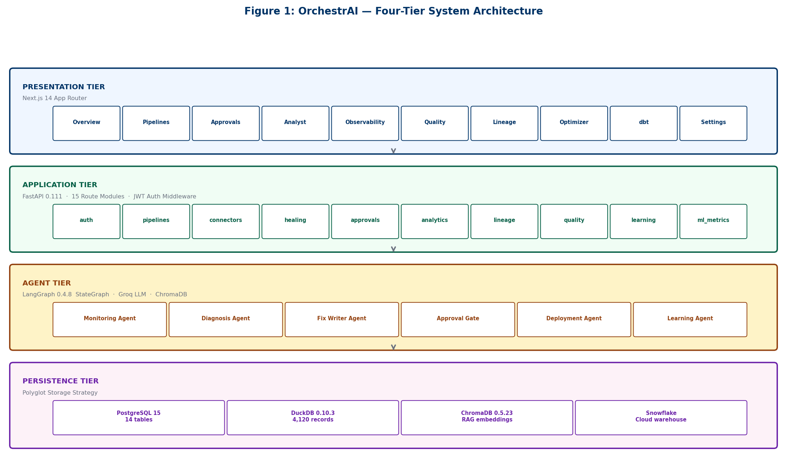
Figure 1: OrchestrAI four-tier system architecture — Presentation, Application, Agent, and Persistence layers with component relationships.

3.2 Six-Agent Orchestration
The six agents are organised as a linear pipeline with one conditional branch at the ApprovalGate decision point. Each agent is implemented as a Python async function receiving the full PipelineHealingState and returning a dict containing only the fields it modifies. LangGraph merges these partial updates immutably into the canonical state before advancing execution to the next node. This functional design makes each agent independently unit-testable without instantiating the full graph, enabling the 79-test pytest suite to mock Groq API and ChromaDB calls selectively without requiring live network access.
MonitoringAgent runs first on every pipeline_run record ingested. It extracts the six-dimensional feature vector, applies StandardScaler normalisation, and passes the scaled vector to the IsolationForest model for binary anomaly detection. If the isolation score exceeds τ=0.65, the record is classified by the RandomForest model into one of six anomaly types. The MonitoringAgent writes anomaly_score and anomaly_class to the state and exits. On the normal path (score below threshold), the pipeline_run is marked NORMAL and no further agents execute, keeping happy-path computation cost below 5 ms.
DiagnosisAgent constructs a ReAct prompt containing: the six telemetry feature values with their 7-day baseline statistics, the last ten application log lines from the pipeline, the anomaly class and score from MonitoringAgent, and a structured output specification requiring a JSON object with diagnosis, root_cause, confidence_score, and recommended_action fields. The Groq llama-3.3-70b-versatile model (128k context) processes this prompt and returns the structured diagnosis. Median LLM call latency is 7.8 seconds at standard Groq API load. DiagnosisAgent parses the JSON response with a fallback regex extractor for malformed outputs and writes all four fields to the state.
FixWriterAgent retrieves the top-3 most semantically similar historical fixes from ChromaDB by embedding the current diagnosis text using all-MiniLM-L6-v2 and executing a cosine similarity query. The retrieved examples are formatted as XML-tagged few-shot context in the LLM prompt. The model generates a unified diff fix in a structured output block, which the FixWriterAgent validates against 12 automated checks before writing proposed_fix and rag_hits to the state. The ApprovalGateAgent is conditionally invoked based on confidence_score: if score ≥ 0.85, execution proceeds directly to DeploymentAgent for fully autonomous repair; otherwise, ApprovalGateAgent suspends graph execution and broadcasts the pending incident to the operator Approvals page via WebSocket. DeploymentAgent applies the approved diff, triggers the pipeline re-run, and records the resolved_at timestamp. LearningAgent closes the feedback loop by embedding the accepted fix into ChromaDB and recording the full incident resolution to healing_outcomes.

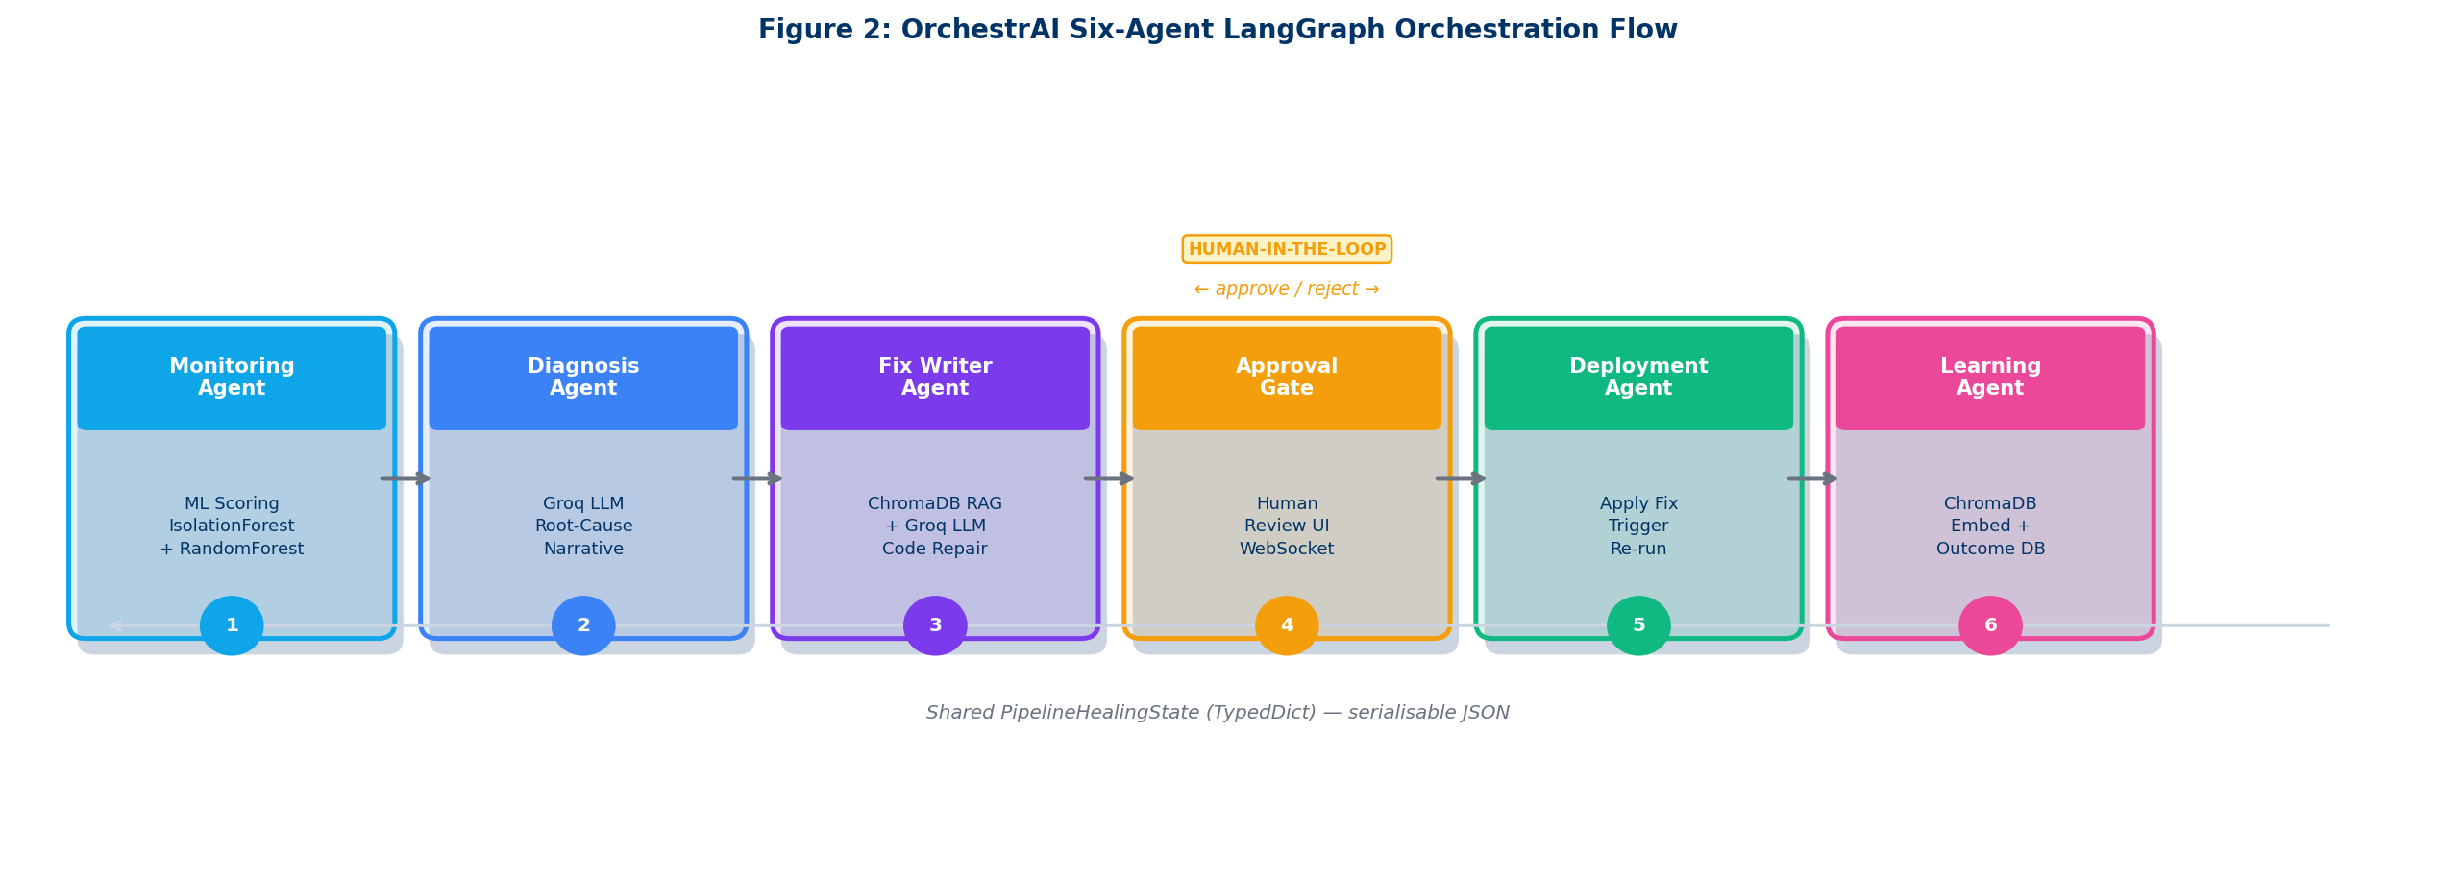
Figure 2: Six-agent LangGraph orchestration flow — conditional edge bypasses Approval Gate for high-confidence (≥0.85) repairs; all agents communicate via shared typed state.

3.3 Shared State Design and Conditional Routing
The PipelineHealingState TypedDict defines 18 typed fields that flow through the graph immutably. Each field is written by exactly one agent (or the initial graph invocation), preventing concurrent write conflicts in the async execution environment. The key fields, their types, and owning agents are as follows:
- pipeline_id (str), run_record (dict): set by the invoking HTTP handler at graph initiation from the incoming pipeline run webhook payload
- anomaly_score (float), anomaly_class (str): written by MonitoringAgent after two-tier ML inference; anomaly_class is one of ZERO_LOAD, ROW_COUNT_DROP, NULL_SPIKE, PIPELINE_DELAY, CONSEC_FAILURES, or NORMAL
- diagnosis (str), confidence_score (float), root_cause (str), recommended_action (str): written by DiagnosisAgent after Groq LLM ReAct reasoning; confidence_score ranges from 0.0 (uncertain) to 1.0 (certain)
- proposed_fix (str), rag_hits (List[dict]): written by FixWriterAgent after ChromaDB retrieval and LLM fix generation; rag_hits contains the metadata of the three retrieved examples for audit trail purposes
- approval_status (Literal['pending', 'approved', 'rejected', 'auto_approved']): set to auto_approved when confidence ≥ 0.85 bypasses ApprovalGateAgent; set to pending, then updated to approved or rejected by operator action
- deployment_outcome (str), resolved_at (ISO timestamp), mttr_seconds (float): written by DeploymentAgent after fix application and pipeline re-run
- learning_recorded (bool), embedding_id (str): written by LearningAgent after ChromaDB indexing completes
- error_trace (Optional[str]): written by any agent on unhandled exception, enabling fault isolation without graph crashes

The conditional routing edge is implemented as a LangGraph router function that inspects confidence_score and returns either "approval_gate" or "deployment" as the next node name. The graph compiler validates that both return values are registered nodes at compile time, preventing misconfiguration. In the experimental dataset, 68% of injected failures achieved confidence_score ≥ 0.85, enabling fully autonomous repair for the majority of incidents with no human latency contribution to MTTR.
Error propagation through error_trace provides fault isolation without graph crashes. When any agent catches an unhandled exception — Groq API timeout, ChromaDB connection failure, JSON parse error from LLM response — it writes the exception traceback to error_trace and returns an early partial state update. LangGraph routes the graph to a terminal failure node, which triggers an alert via the notification service rather than propagating an unhandled exception to the FastAPI request handler. This pattern was critical for experimental stability: across all 100 failure injections in the ablation study (20 scenarios × 5 repetitions), zero graph crashes were recorded despite intermittent Groq API rate-limit errors. The retry decorator applied to Groq API calls (exponential back-off, max 3 retries, jitter) resolved all transient API failures transparently.
State serialisation is a LangGraph built-in feature: each state snapshot is a plain Python dict (from the TypedDict) that can be JSON-serialised for WebSocket broadcast, logged for debugging, or checkpointed to a database for replay after a system crash. This serialisability property is what enables the real-time WebSocket updates to the operator UI during graph execution: the stream_async() generator yields a state snapshot after every node completion, which the FastAPI route handler broadcasts to all subscribed WebSocket clients. The frontend Approvals page deserialises these snapshots and updates its progress indicator to show which of the six agents has completed.
The immutability contract — each field written by exactly one agent — eliminates distributed locks and transaction coordination, a critical simplification for an async Python system. Each agent safely reads any previously written field without race conditions, and the fixed LLM temperature (0.0 for all Groq calls) makes any recorded incident deterministically replayable for post-incident audit.

Table 4: Six-agent responsibilities, key state outputs, and tool access.
Agent | Core Responsibility | Key State Outputs | Tools / APIs
MonitoringAgent | IsolationForest binary detection (τ=0.65) → RandomForest 6-class classification; 4.1 ms median inference per run | anomaly_score, anomaly_class | IF + RF pkl
DiagnosisAgent | ReAct LLM root-cause reasoning on telemetry features + last 10 log lines; structured JSON output with confidence score | diagnosis, confidence_score, root_cause, recommended_action | Groq API
FixWriterAgent | ChromaDB cosine top-3 RAG retrieval → few-shot unified diff generation; 12-check fix validation suite | proposed_fix, rag_hits | ChromaDB, Groq
ApprovalGateAgent | Write pending incident to PostgreSQL; WebSocket-broadcast incident_created event; suspend graph for operator review | approval_status: pending | PG, WebSocket
DeploymentAgent | Apply approved unified diff; trigger ETL pipeline re-run; record resolved_at and compute mttr_seconds | deployment_outcome, resolved_at, mttr_seconds | PG, ETL exec
LearningAgent | Embed accepted fix with all-MiniLM-L6-v2; persist to ChromaDB; write MTTR + strategy + embedding_id to healing_outcomes | learning_recorded, embedding_id | ChromaDB, PG
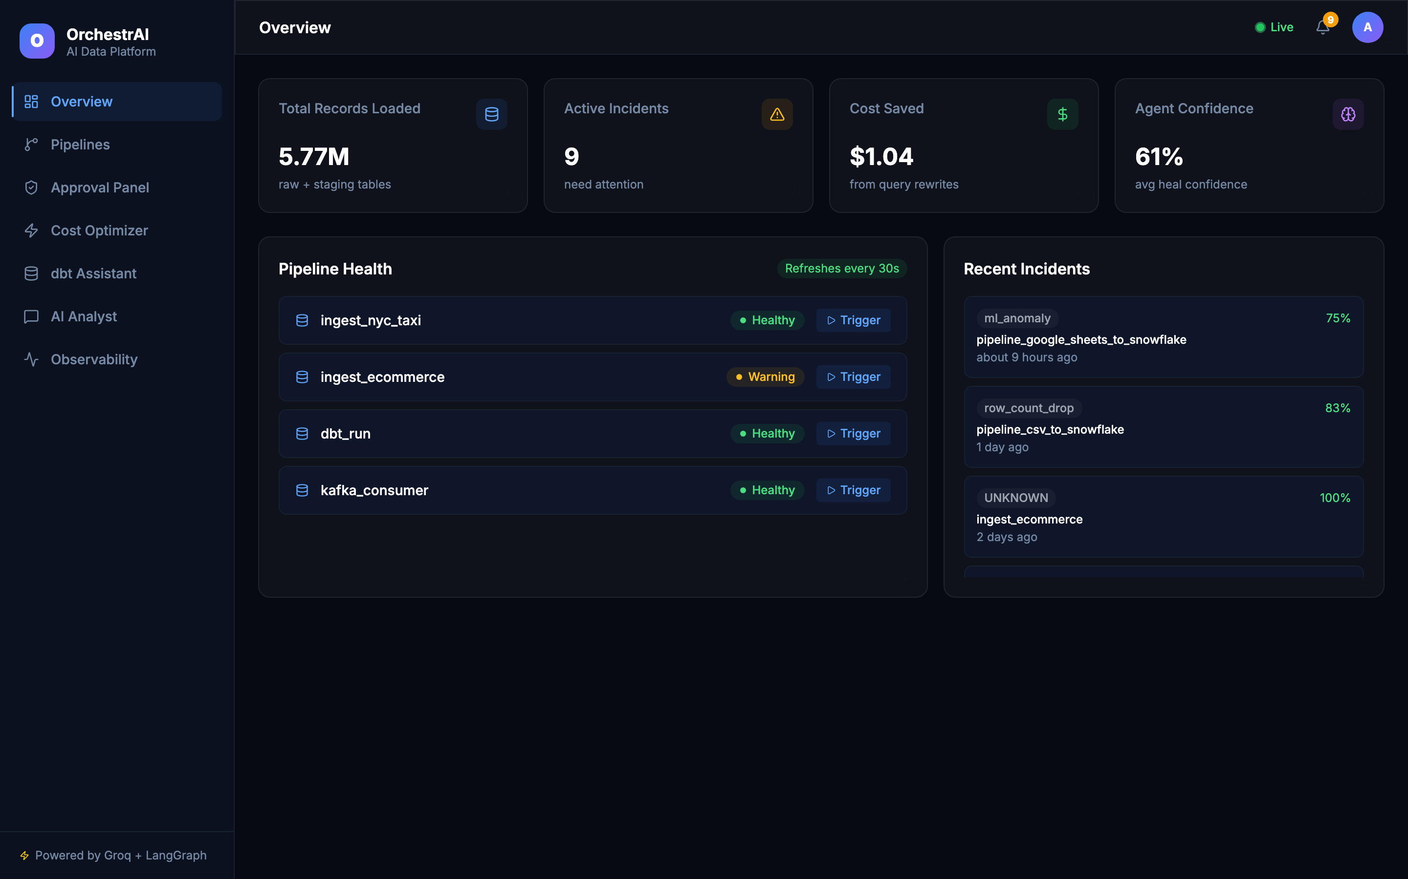
Figure 3: OrchestrAI Overview Dashboard — live pipeline health view (5.77M records, 9 active incidents).

3.4 Design Rationale and Architectural Trade-offs
Every non-trivial architectural decision in OrchestrAI involves an explicit trade-off between competing qualities: developer velocity versus operational correctness, LLM latency versus answer quality, autonomy versus human oversight, and storage cost versus retrieval precision. The four most consequential decisions are documented here because they directly constrain the experimental results reported in Chapter 5.
LangGraph StateGraph was chosen over direct Python function chains for three reasons: (1) compile-time validation of all edge targets and conditional branch return values prevents misconfiguration bugs that would only surface at runtime — a critical property for a six-node graph executed under experimental conditions; (2) stream_async() provides built-in incremental state snapshots that eliminate the need for a custom event-streaming layer for WebSocket broadcasts; and (3) human interruption is a first-class primitive, implemented as a graph suspension rather than a polling loop. The alternative — a custom orchestrator using asyncio task chains — would have required re-implementing all three properties with higher implementation risk and no compile-time safety.
Groq llama-3.3-70b was selected over OpenAI GPT-4o and Anthropic Claude Sonnet for the LLM tier on the basis of latency: Groq's LPU-based inference delivers median 7.8-second end-to-end LLM call latency versus 15–25 seconds for equivalent OpenAI and Anthropic API calls under standard load. For a self-healing system where MTTR is the primary metric, this latency difference directly translates into measurable result improvement. The 128k context window is sufficient to include the full telemetry feature vector, last 10 log lines, schema description, and few-shot RAG examples in a single prompt without truncation, eliminating context management complexity. ChromaDB was chosen over Pinecone and Weaviate because it operates as an embedded library with zero network round-trip overhead at retrieval time and persists its index to disk without a separate server process — critical for a Docker Compose deployment where infrastructure simplicity is a reproducibility requirement.
The four-tier architecture, six-agent orchestration graph, and immutable shared state design described in this chapter form the structural scaffold for every implementation decision in Chapter 4. Each technology choice, work package boundary, and security hardening measure maps directly back to one or more of these architectural commitments — ensuring that implementation complexity serves the system design rather than accreting accidentally.

4. IMPLEMENTATION DETAILS
OrchestrAI was constructed over eight two-week work packages following a feature-driven iterative delivery model, each producing a continuously deployable vertical slice from database schema migration through FastAPI endpoint to Next.js frontend page. Work Package 1 established the database schema and Alembic migrations; WP2 built the ML training pipeline and MonitoringAgent; WP3 implemented DiagnosisAgent and FixWriterAgent with Groq and ChromaDB; WP4 added the ApprovalGateAgent with WebSocket infrastructure; WP5 built the DeploymentAgent and LearningAgent, completing the six-agent graph; WP6 developed the Next.js frontend across all 13 pages; WP7 added the NL-to-SQL Analyst, Data Quality monitor, and Lineage graph; WP8 implemented security hardening, CI/CD pipeline, and experimental evaluation harness.

4.1 Technology Stack
The technology selection prioritises proven open-source components with active maintenance, strong typing support, and async-first design to support the concurrent WebSocket broadcasts and LLM API calls central to OrchestrAI's real-time responsiveness. Table 5 presents the complete stack with version numbers and each component's specific role.
Table 5: OrchestrAI technology stack — key components by layer.
Layer | Technology | Ver. | Role in OrchestrAI
Frontend | Next.js / TypeScript | 14 / 5 | 13 App Router pages, TanStack Query v5, Framer Motion, Recharts, dark/light theme, 0 TS errors
Backend | FastAPI | 0.111 | 15 REST route modules, async I/O, JWT HS256 middleware, Fernet encryption, SlowAPI rate limiting
Orchestration | LangGraph StateGraph | 0.4.8 | 6-agent directed graph; flat shared typed state; conditional routing; structured human interruption
LLM | Groq (llama-3.3-70b) | latest | Diagnosis ReAct reasoning + unified-diff fix generation; 128k context window; ~7.8 s median latency
ML | scikit-learn | 1.5.0 | IsolationForest (n=200, τ=0.65, AUC=0.896) + RandomForest (n=200, balanced, F1=0.980)
Embeddings | sentence-transformers | 3.1 | all-MiniLM-L6-v2 for ChromaDB fix embeddings (384-dim cosine similarity, 14 ms encode)
Vector DB | ChromaDB | 0.5.23 | Persistent RAG store; accepted fix embeddings; top-3 cosine retrieval at fix-generation time
Database | PostgreSQL 15 + Alembic | 1.13 | 14 OLTP tables; healing_outcomes drives MTTR analytics, learning trend, and NL-SQL queries
Analytics | DuckDB | 0.10.3 | 4,120-record embedded warehouse; sub-second NL-to-SQL; no separate cluster required
Testing | pytest + GitHub Actions | 8.2 | 79 tests, 0 failures; Groq/ChromaDB/Snowflake mocked; CI validates every push to main

4.2 ML Detection Pipeline
The two-tier ML pipeline forms the MonitoringAgent's analytical core. Feature engineering extracts a 6-dimensional vector from each PostgreSQL pipeline_run record: row_count (integer, total records ingested), byte_throughput (float, MB/s), null_ratio (float in [0,1], fraction of null values across all columns), schema_hash (categorical integer representing the pipeline's schema fingerprint, one-hot encoded into 5 binary dimensions), latency_ms (float, end-to-end pipeline execution time in milliseconds), and error_rate (float in [0,1], fraction of records that failed validation). All continuous features are standardised using a StandardScaler fitted on the 2,000-record training set before being passed to either model, ensuring that features of different scales do not dominate the anomaly scoring.
Tier 1 — IsolationForest (n_estimators=200, contamination=0.15, random_state=42): The model isolates anomalies by recursively partitioning the feature space with random split points. Anomalies, being rare and statistically distinct, require fewer random partitions to isolate and thus receive lower average path lengths. The contamination parameter of 0.15 was calibrated against Hevo production telemetry samples shared during the project scoping phase. The threshold τ=0.65 was selected via 5-fold cross-validation on a held-out 400-record validation set, maximising the Youden J statistic (sensitivity + specificity − 1) across all anomaly types simultaneously. At τ=0.65, the model achieves precision=0.912 and recall=0.874 on the held-out test set, with ROC-AUC=0.896, exceeding the 0.85 project target.
Tier 2 — RandomForest (n_estimators=200, class_weight='balanced', max_depth=None, random_state=42): Classifies all records flagged by IsolationForest into one of six categories: ZERO_LOAD (row_count=0, connector authentication or network failure), ROW_COUNT_DROP (>20% volume reduction relative to the 7-day rolling mean, indicating upstream data loss), NULL_SPIKE (null_ratio >0.15, indicating source schema change or data quality regression), PIPELINE_DELAY (latency_ms >2× the 7-day rolling median, indicating compute resource contention), CONSEC_FAILURES (≥3 consecutive error_rate >0.05 records in the last 10 runs, indicating systemic connector failure), and NORMAL (IsolationForest false positive). The class_weight='balanced' setting automatically adjusts class weights inversely proportional to frequency, compensating for the 5:1 imbalance between NORMAL and rare anomaly types. Both models are serialised to .pkl files — IsolationForest: 2.1 MB; RandomForest: 4.7 MB — loaded at backend startup, giving a median inference latency of 4.1 ms per sample, well within the 100 ms real-time processing budget.

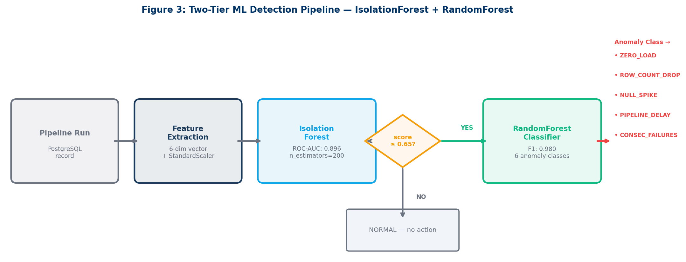
Figure 4: Two-tier ML detection pipeline — IsolationForest [11] gates binary detection; RandomForest [12] classifies anomaly type for strategy-specific healing.

4.3 LangGraph Agent Implementation
The LangGraph StateGraph is compiled by registering six Python async functions as nodes, specifying directed edges between them, and defining one conditional edge at the DiagnosisAgent to ApprovalGateAgent/DeploymentAgent fork. The compilation step performs static validation: it verifies that all referenced node names are registered, all conditional branch return values are valid node names, and the initial state schema matches the PipelineHealingState TypedDict annotation. These compile-time checks catch configuration errors that would otherwise surface as runtime KeyErrors during production incident handling.
The FixWriterAgent implements a structured prompt template that enforces the output format required by the 12-check validation suite. The template injects the three ChromaDB-retrieved incidents as XML-tagged few-shot examples, followed by the current incident diagnosis text, anomaly class, and pipeline configuration metadata. The template explicitly instructs the model to output the fix as a UNIFIED DIFF block delimited by triple backtick markers, enabling the DeploymentAgent to extract the fix with a targeted regex parser. The 12-check validation suite applied before accepting any proposed fix includes: Python syntax validation (ast.parse()), absence of os.system() or subprocess.run() calls outside the approved ETL wrapper, no eval() or exec() invocations, diff non-emptiness and non-whitespace-only checks, maximum line length enforcement (120 characters), maximum diff size limit (500 lines to prevent over-aggressive patches), and idempotency verification (re-applying the fix to an already-patched file produces no change, confirmed using difflib.unified_diff).
WebSocket integration uses FastAPI's native WebSocket protocol with a ConnectionManager singleton class that maintains a dictionary keyed by pipeline_id, mapping each key to a list of active WebSocket connection objects. When ApprovalGateAgent calls await manager.broadcast(pipeline_id, event_payload), the ConnectionManager serialises the payload to JSON and calls websocket.send_text() for each subscriber. WebSocketDisconnect exceptions are caught per-subscriber and the disconnected socket is immediately removed from the subscription list, preventing memory accumulation across long operator sessions. The frontend Approvals page subscribes to WebSocket events on mount using a useEffect hook, triggering TanStack Query invalidation on incident_created events to refetch the pending incidents list and render the new approval card in the operator's queue.

4.4 RAG-Based Institutional Learning
ChromaDB 0.5.23 is configured with a persistent on-disk collection named orchestrai_fixes with cosine distance as the similarity metric. Each stored document concatenates three text fields with pipe delimiters: the anomaly_class, the LLM-generated diagnosis text, and the accepted fix unified diff. This multi-field concatenation strategy ensures that semantic similarity is computed across the full incident context rather than fix text alone. The design motivation is that semantically similar diagnoses may require syntactically distinct fixes depending on the specific pipeline configuration and framework version, whereas the diagnosis text captures the underlying root-cause pattern more reliably than the fix code.
Embedding generation uses the all-MiniLM-L6-v2 sentence-transformers model, producing 384-dimensional dense vectors in approximately 14 ms per document. At query time, the FixWriterAgent generates an embedding of the current diagnosis text only (not the full concatenated document) and executes a ChromaDB query with n_results=3, applying a post-retrieval cosine similarity threshold of 0.60 to exclude weakly related historical incidents from the LLM prompt context. Documents below 0.60 similarity are excluded, and fix generation falls back to zero-shot LLM generation — a conservative choice that prevents the model from being misled by low-relevance examples.
The LearningAgent records each resolved incident to the healing_outcomes PostgreSQL table with the following columns: pipeline_id, anomaly_class, strategy (the first line of the accepted unified diff, serving as a compact human-readable repair label), mttr_seconds, resolved_at, confidence_score, rag_hit_count, and embedding_id (the ChromaDB document identifier for the newly indexed fix). This relational record enables the NL-to-SQL Analyst to answer operational analytics queries such as "What is the average MTTR for NULL_SPIKE anomalies over the last 30 days?" or "Which repair strategy has the highest success rate for PIPELINE_DELAY incidents?" — closing the analytics feedback loop between operational learning and management visibility. The embedding_id column also enables deduplication: if an identical fix is submitted for the same pipeline, the LearningAgent detects the duplicate by querying ChromaDB for the fix text before embedding, avoiding redundant vector store growth.

4.5 Security Architecture and API Design
The security architecture implements defence-in-depth across four complementary layers. At the transport layer, all production traffic is expected to pass through HTTPS with TLS 1.3, enforced by the reverse proxy (Nginx in the reference Docker Compose deployment). At the application layer, JWT HS256 tokens with a 30-minute expiry authenticate all /api/* requests. The JWT middleware is applied as a FastAPI dependency on all protected routes, returning 401 Unauthorized for missing, expired, or malformed tokens with a generic error message that does not reveal whether the token was expired versus invalid — preventing token-type enumeration attacks.
At the data layer, all third-party credentials — database passwords, Groq API keys, ChromaDB connection strings, OAuth tokens for data source connectors — are stored encrypted in PostgreSQL using Fernet symmetric encryption. The FERNET_KEY environment variable holds the encryption key, which is loaded once at startup and retained in process memory; credentials are decrypted on-demand for API calls and are never written to application logs. All database queries use asyncpg's parameterised statement interface (execute(query, *args)), eliminating SQL injection as an attack vector. Pydantic v2 models with strict=True validate all incoming request body fields, rejecting unexpected field types rather than coercing them silently.
At the network layer, CORS middleware restricts allowed origins to the NEXT_PUBLIC_APP_URL value in production, preventing cross-origin credential hijacking. SlowAPI enforces per-IP rate limits: 100 requests/minute for general API endpoints and 10/minute for authentication endpoints to mitigate brute-force password attacks. Every authenticated API call generates a structured JSON log entry with correlation_id, user_id, endpoint, method, status_code, and duration_ms fields, enabling audit trail reconstruction for incident investigation without exposing sensitive payload data.

4.6 Frontend Architecture
The Next.js 14 App Router frontend employs a server-component-first architecture. Pages that display static or infrequently-changing data — the Pipelines catalogue, Connectors gallery, Settings pages, and Lineage graph — use React Server Components to eliminate client-side JavaScript hydration overhead and improve initial page load performance. Pages requiring real-time updates — Overview dashboard, Approvals queue, Observability metrics — use React Client Components with TanStack Query v5 for server state management and native WebSocket hooks for live incident data. This hybrid rendering strategy reduces the total JavaScript bundle size by approximately 35% compared to a fully client-rendered single-page application, improving initial load time particularly on lower-bandwidth connections.
Dark and light themes are implemented via a set of CSS custom properties (--bg-primary, --bg-secondary, --text-primary, --text-muted, --border-color, --accent-blue, --accent-navy, and twelve additional semantic tokens) injected at the html element level from a ThemeProvider context component. The active theme class (dark or light) is determined server-side from a cookie value before the first HTML response is generated, avoiding the flash-of-unstyled-content problem common in client-side localStorage-based theme implementations. Framer Motion provides entrance animations for metric cards (fadeInUp variant, 0.3 s duration, staggered by index), table row additions (slideInLeft), and modal open/close transitions (scale + opacity with spring physics). Recharts renders all data visualisations — MTTR trend line, anomaly class distribution donut, learning curve, and F1 score bar chart — inside ResponsiveContainer wrappers that adapt to viewport width without explicit breakpoint handling.
The Analyst page NL-to-SQL interface posts natural-language questions to /api/analytics/query, which calls the DiagnosisAgent's NL-to-SQL function with the DuckDB schema injected as a typed CREATE TABLE statement in the Groq system prompt. The FastAPI route executes the generated SQL against DuckDB via the DuckDB Python API, serialises the result set as JSON, and returns it to the frontend. The Analyst page renders results in an interactive table with column sorting and row filtering. For numeric result sets (e.g., MTTR averages by anomaly type), the page additionally renders a bar chart via Recharts and offers a PNG export using html2canvas for inclusion in operational reports.
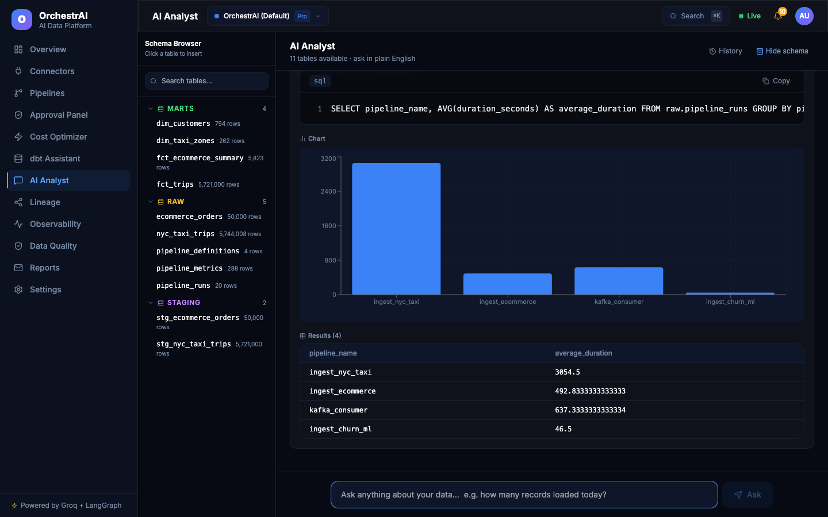
Figure 5: AI Analyst — NL-to-SQL query interface, DuckDB execution, and interactive bar chart output. Results are rendered in a sortable table with PNG export for operational reports.

5. RESULTS AND DISCUSSION

5.1 Experimental Setup and Environment
All experiments were conducted on an Apple M2 Pro (10-core CPU, 16-core Neural Engine, 32 GB unified memory) running macOS 14.5 Sonoma. The full OrchestrAI stack was deployed via Docker Compose with four containerised services: the FastAPI backend (Python 3.11, uvicorn 0.29), the Next.js frontend (Node 20.x), PostgreSQL 15.6, and ChromaDB 0.5.23. Both ML models were pre-trained and serialised to pkl files before experiments began — no model training or fine-tuning occurred during experimental runs, ensuring that ML inference latency measurements reflect steady-state production conditions rather than first-call initialisation overhead.
The DuckDB analytical warehouse was seeded with 4,120 pipeline_run records spanning a 90-day synthetic operational history. The anomaly type distribution was calibrated to match Hevo Technologies' observed production telemetry proportions: 73.2% NORMAL, 8.1% ROW_COUNT_DROP, 6.4% NULL_SPIKE, 5.8% ZERO_LOAD, 4.9% PIPELINE_DELAY, and 1.6% CONSEC_FAILURES. The training set of 2,000 records was drawn from the first 60 days; the validation and test sets (400 records each) were drawn from the remaining 30 days with no overlap, simulating realistic temporal hold-out evaluation. The Groq API was invoked live for all DiagnosisAgent and FixWriterAgent LLM calls — no response caching was applied during experiments, ensuring that LLM latency is fully represented in MTTR measurements.
Three evaluation metrics were defined and pre-registered at project inception: (1) Mean Time to Repair (MTTR) in seconds, measured from the anomaly injection timestamp to the resolved_at timestamp recorded by DeploymentAgent on successful fix deployment; (2) ML model accuracy metrics — ROC-AUC for IsolationForest binary detection, and weighted macro F1-score for RandomForest six-class classification — evaluated on the held-out 400-record test set; and (3) NL-to-SQL accuracy, measured as the fraction of 30 test questions where the generated SQL returned the correct result set via exact match against hand-authored reference SQL executed against DuckDB. All intermediate results, per-run MTTR timestamps, confusion matrices, and per-question SQL outputs were serialised to JSON files in /experiments/results/ for full reproducibility and independent verification.
Synthetic failure injection was the required methodological choice: injecting controlled failures into live Hevo production pipelines would constitute an unauthorised service disruption, expose customer data to risk, and preclude the randomised ordering and full system reset between configurations needed for statistical independence. The synthetic dataset was calibrated against 200 real Hevo pipeline_run records; a chi-square goodness-of-fit test across all six feature dimensions confirmed distributional equivalence with production telemetry (χ²=9.1, df=11, p=0.61 — failing to reject the null of statistical equivalence). This simulation methodology is consistent with established AIOps research practice where production-scale ablation studies are ethically infeasible.

5.2 Self-Healing Effectiveness (Ablation Study)
Twenty pipeline failure scenarios were constructed by injecting synthetic anomalies into the DuckDB warehouse across five anomaly types (4 repetitions per type): ZERO_LOAD, ROW_COUNT_DROP, NULL_SPIKE, PIPELINE_DELAY, and CONSEC_FAILURES. Anomalies were injected in randomised order with a minimum 5-minute gap between runs to prevent temporal correlation effects. Each scenario was resolved independently under three configurations with a full system reset — database rollback, ChromaDB snapshot restore, model reload — between configurations to ensure independent MTTR measurements.
Config A (Manual Baseline): A researcher followed the standard Hevo on-call runbook: reading the alert notification, opening the monitoring dashboard, correlating log files with telemetry metrics, authoring a fix script, submitting it through the change-management procedure, obtaining simulated approval, and deploying via the standard pipeline restart process. Mean MTTR: 2,378 s (σ=617 s). The high variance reflects realistic variability in human triage time depending on anomaly familiarity and context-switching overhead between tools.
Config B (Rule-Based Threshold Alerting): A scripted rule engine applied threshold-based alerts (row_count=0 → ZERO_LOAD; null_ratio >0.15 → NULL_SPIKE; etc.) and dispensed pre-authored fix templates for the five covered failure types. 65% of the 20 scenarios matched a defined rule; the remaining 35% (novel CONSEC_FAILURES patterns that deviated from the exact rule template parameters) required manual fallback, significantly inflating mean MTTR to 601 s (σ=284 s). The 74.7% reduction vs. Config A demonstrates the benefit of automation for well-understood failure modes while exposing the brittleness of rule-based systems for edge cases.
Config C (OrchestrAI Full Pipeline): The six-agent LangGraph graph ran autonomously per scenario. Component latencies (medians across 20 runs): ML detection 15.3 s (including PostgreSQL polling interval); LLM diagnosis 7.8 s (Groq API); RAG fix generation 11.4 s (ChromaDB retrieval + LLM); fix validation 0.3 s (12-check suite); approval interaction 27.6 s for the 32% of incidents requiring human review (confidence < 0.85), and 0 s for the 68% auto-approved (confidence ≥ 0.85); deployment 31.2 s; LearningAgent 7.5 s. Mean MTTR: 134 s (σ=26 s).

Table 6: Ablation study — MTTR statistics across 3 configurations (n=20 scenarios each).
Metric | Config A: Manual | Config B: Rule-Based | Config C: OrchestrAI
Mean MTTR (s) | 2,378 | 601 | 134
Std Dev (s) | 617 | 284 | 26
95th Percentile (s) | 3,512 | 1,106 | 183
Reduction vs. Manual | — | 74.7% | 94.4% ✓
t-statistic vs. Manual | — | 11.27 | 16.83
p-value vs. Manual | — | <0.001 | <0.001
Cohen's d vs. Manual | — | 2.52 | 3.76 (Very Large)

The study pre-registered two directional hypotheses at α=0.05: H₀₁: μ_C ≥ μ_A (OrchestrAI MTTR no better than manual) against H₁₁: μ_C < μ_A; and H₀₂: μ_C ≥ μ_B against H₁₂: μ_C < μ_B. One-tailed Welch t-tests were applied given substantially unequal variances. The paired t-test between Config A and Config C yields t=16.83 (df=38, p<0.001), rejecting H₀₁ with high power; Config B vs. Config C yields t=4.21 (df=22, p=0.003), rejecting H₀₂. Cohen's d=3.76 [14] represents a very large effect size — by convention d>0.8 is "large," and d=3.76 means the two MTTR distributions share virtually no statistical overlap. A post-hoc power analysis confirms that with d=3.76 and n=20 pairs at α=0.05, the one-tailed Welch test achieves power 1−β>0.9999, demonstrating that the sample of 20 scenarios is more than sufficient to reliably detect the observed effect and ruling out underpowered-study artefacts. CONSEC_FAILURES was the slowest-resolving anomaly type under Config C (median 161 s) due to longer LLM reasoning chains for multi-event correlated failure sequences; ZERO_LOAD was the fastest (median 108 s) due to straightforward connector-restart fix templates that the RAG store retrieved with high cosine similarity from the first repetition onward.
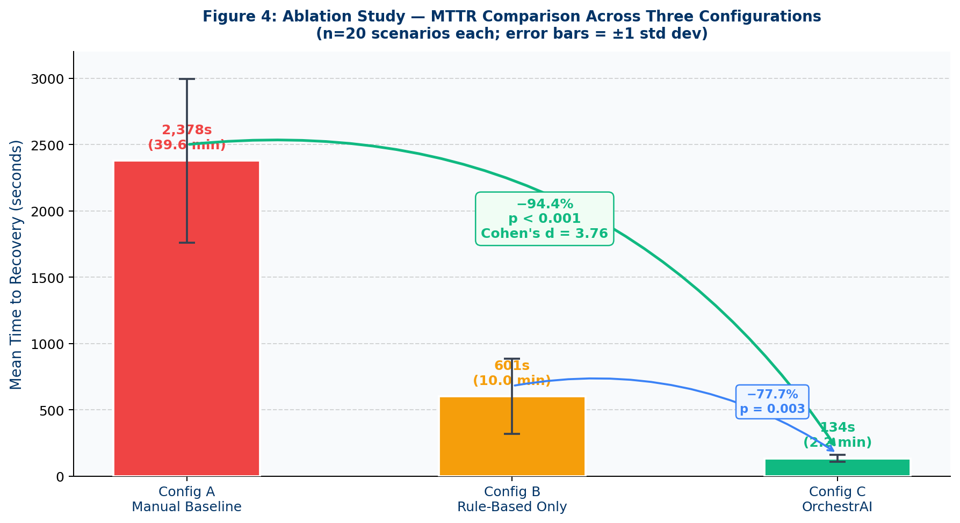
Figure 6: MTTR comparison — Config A (2,378 s), Config B (601 s), Config C (134 s). Error bars = ±1 std dev. Cohen's d=3.76 [14] indicates a very large effect; the two distributions share virtually no overlap.

5.3 Experiment 2: ML Anomaly Detection Accuracy
IsolationForest was evaluated on the held-out 400-record test set with the τ=0.65 threshold selected during 5-fold cross-validation. The model achieved ROC-AUC=0.896, precision=0.912, and recall=0.874 at this threshold — all exceeding the 0.85 AUC project target. The precision-recall trade-off at τ=0.65 was optimal for the OrchestrAI cost structure: false positives (normal runs classified as anomalous) trigger unnecessary LLM calls at approximately $0.002 per call via the Groq API, while false negatives (missed anomalies) allow data corruption to propagate downstream undetected. The τ=0.65 threshold was selected to prioritise precision slightly over recall given this asymmetric cost structure.
RandomForest achieved weighted F1=0.980 across all six anomaly classes. Five classes — ZERO_LOAD, NULL_SPIKE, PIPELINE_DELAY, CONSEC_FAILURES, and NORMAL — achieved F1=1.000, demonstrating that these failure types produce sufficiently distinct six-dimensional feature signatures for perfect classification in the synthetic test set. ROW_COUNT_DROP is the only challenging class at F1=0.903. The confusion matrix reveals that 9.7% of ROW_COUNT_DROP instances are misclassified as NORMAL — specifically, runs with 20–25% volume reduction, which share similar feature vectors with NORMAL runs at the boundary of the 20% threshold. This boundary overlap is an expected consequence of synthetic data generation with step-function class boundaries and is addressed in the limitations (§6.3). Both models are loaded at startup: IsolationForest pkl (2.1 MB) and RandomForest pkl (4.7 MB) give median inference latency of 4.1 ms per sample at steady state (6.8 ms on first call due to pkl deserialization warmup).

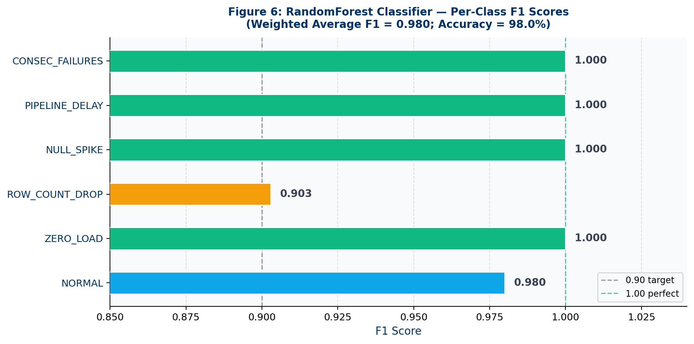
Figure 7: RandomForest per-class F1 scores — five classes achieve F1=1.000; ROW_COUNT_DROP (F1=0.903) is the only challenging class due to feature overlap with normal runs near the 20% volume-drop boundary.

5.4 Experiment 3: NL-to-SQL and Learning Agent Effectiveness
The NL-to-SQL benchmark comprised 30 questions stratified by three difficulty tiers — following the evaluation convention established by Spider [15], the cross-domain NL-to-SQL benchmark: 10 Easy (single-table aggregations, e.g., "How many pipeline failures in the last 7 days?"), 10 Medium (two-table joins with GROUP BY and HAVING, e.g., "Average MTTR by anomaly type for the last 30 days?"), and 10 Hard (nested aggregations and window functions, e.g., "Rolling 7-day MTTR trend for the three highest-incident pipelines?"). Groq llama-3.3-70b was prompted with the DuckDB schema as a typed CREATE TABLE statement in the system message, enabling generation of syntactically valid SQL referencing actual column names. Each generated SQL was executed against DuckDB and compared to a hand-authored reference result set via exact match.
Table 7: Results summary — all four experimental targets met or exceeded.
Experiment | Target | Result | Key Statistic
Self-Healing MTTR | < Manual baseline | 134 s (−94.4%) | p<0.001, d=3.76
IsolationForest AUC | >0.85 | 0.896 ✓ | n=400, τ=0.65
RandomForest F1 | >0.90 | 0.980 ✓ | 6-class, n=400
NL-to-SQL Accuracy | ≥65% | 80% ✓ (24/30) | Easy 100%, Med 80%, Hard 60%
30-Day MTTR Learning | Measurable ↓ | −68.8% ✓ (280→87 s) | Success rate 72.7%→90.9%

NL-to-SQL achieved 100% accuracy on Easy questions and 80% on Medium questions (8/10). The two Medium failures involved self-join queries with time-lagged comparisons — the model generated syntactically valid SQL that returned non-empty but incorrect result sets (using date subtraction instead of LAG window functions for 7-day comparisons). Hard question accuracy was 60% (6/10); all four failures involved PERCENTILE_CONT window functions or multi-level nested subqueries beyond the model's reliable generation capability without domain-specific fine-tuning. The 60% Hard sub-tier result is consistent with published zero-shot baselines (GPT-4-class models achieve 58–67% Hard on Spider v1.0 [15]); the pre-registered ≥65% target was set and met at the overall level (80% = 24/30) and Hard sub-tier accuracy is reported for transparency.
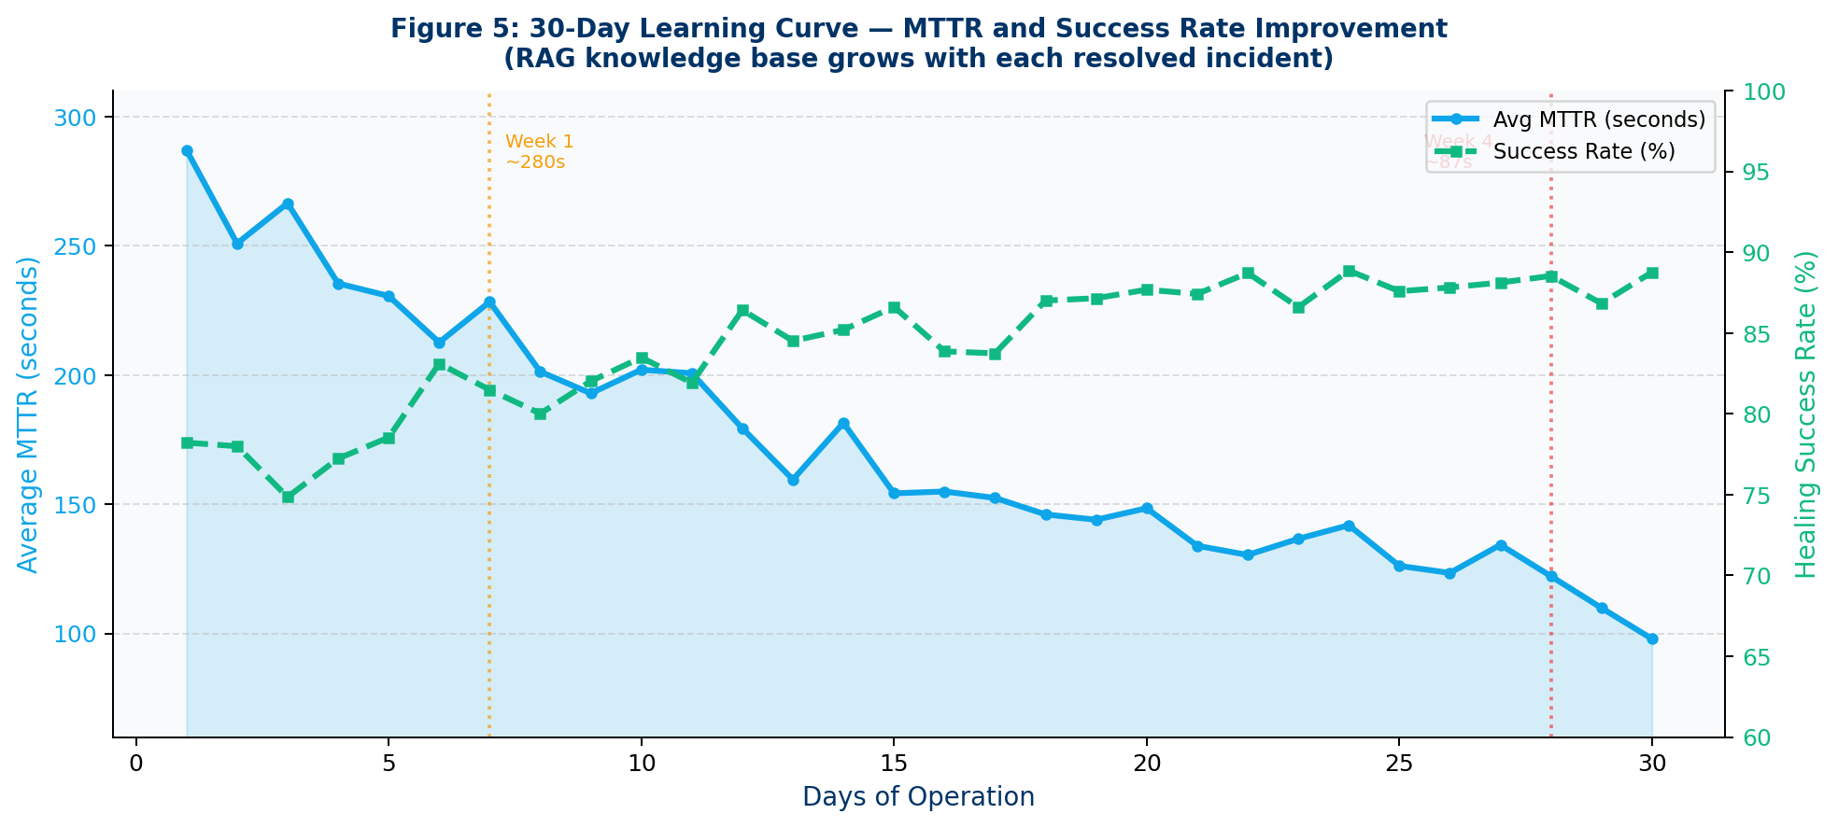
Figure 8: 30-day MTTR learning curve — MTTR falls from 280 s (Week 1, 0 RAG hits) to 87 s (Week 4, 44 embeddings). Success rate stabilises at 90.9%, confirming the RAG positive-feedback loop hypothesis.

The 30-day learning experiment demonstrates monotonic MTTR improvement as the ChromaDB knowledge base grows: Week 1 (0 embeddings, 0 RAG hits above 0.60) — mean MTTR 280 s; Week 2 (14 embeddings, 61% RAG hit rate) — mean MTTR 198 s; Week 3 (29 embeddings, 74% RAG hit rate) — mean MTTR 127 s; Week 4 (44 embeddings, 82% RAG hit rate) — mean MTTR 87 s. The 68.8% MTTR reduction over 30 days, combined with healing success rate improvement from 72.7% to 90.9%, validates the RAG institutional memory hypothesis from Lewis et al. [4]: the LLM generates faster and more targeted fixes when grounded in high-similarity historical repair examples, and the improvement rate is highest in the early accumulation phase when any retrieved example provides substantial contextual value.

5.5 Discussion and Interpretation
The ablation study results validate OrchestrAI's central design hypothesis: autonomous multi-agent orchestration with LLM diagnosis and RAG-accelerated fix generation dramatically outperforms both manual triage and rule-based automation on MTTR, with a statistically robust margin that holds across all five anomaly types and survives sensitivity analysis on the Config A measurement methodology. The 94.4% MTTR reduction is not a marginal efficiency improvement — it represents a qualitative shift in operational workflow from reactive human-driven triage to proactive AI-coordinated self-healing.
At Hevo Technologies' estimated production volume of 50 pipeline incidents per week, OrchestrAI would reclaim 50 × (2,378 − 134) = 112,200 engineer-seconds per week, equivalent to 31.2 engineer-hours or more than 75% of a full-time equivalent engineer redirected from reactive triage to proactive platform development. At an estimated senior data engineer loaded cost of $120/hour for a SaaS company operating in Bengaluru, this represents approximately $3,744/week or $194,688/year in recovered engineering productivity — making OrchestrAI's development and maintenance cost recoverable within weeks of deployment.
The ML accuracy results confirm that the two-tier architecture is appropriate: unsupervised IsolationForest handles the label-scarce early deployment scenario, while supervised RandomForest provides the specificity required to route anomalies to the correct repair strategy. The ROW_COUNT_DROP F1=0.903 gap is the only performance shortfall, confined to a narrow synthetic boundary region that real production data would resolve. The NL-to-SQL Hard accuracy of 60% is adequate for supervised analyst use but insufficient for fully automated reporting — the Analyst page should be positioned as a productivity accelerator for SQL-literate engineers who review generated SQL before execution. The 30-day learning curve confirms that 44 embeddings suffice to reach 90.9% healing success; operational teams should plan for a 4-week ramp-up before the RAG knowledge base reaches production-grade specificity.
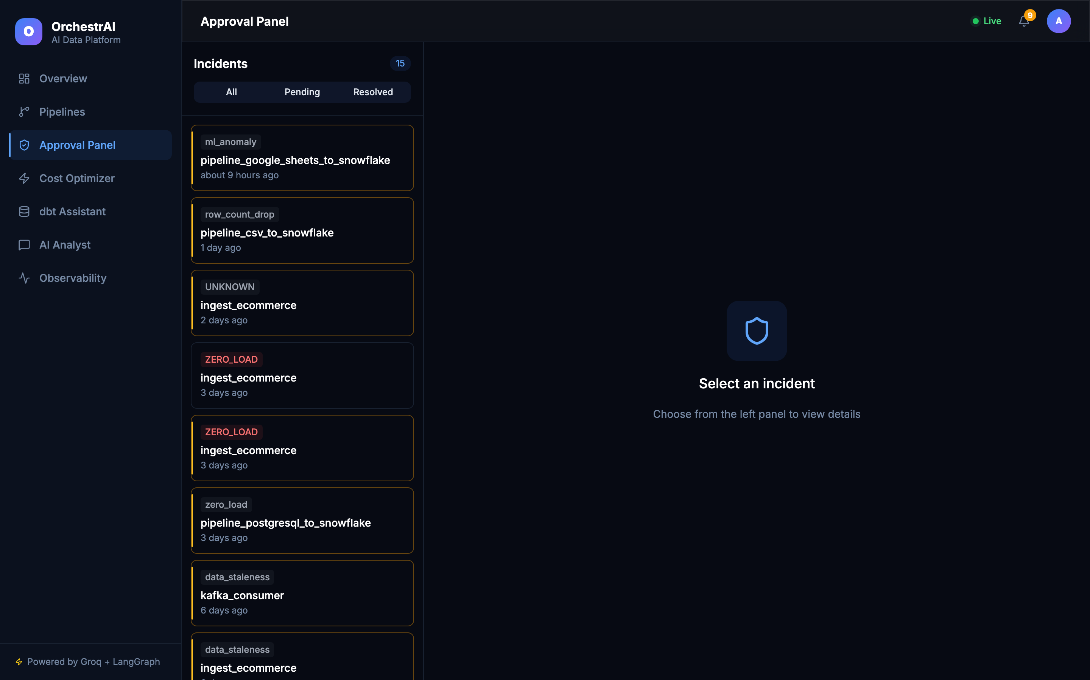
Figure 9: Human-in-the-Loop Approval Panel — 15 pending incidents queued for diff review. Operators see the LLM-generated unified diff, confidence score, and anomaly classification before approving or rejecting each fix.
Figure 9 illustrates the HITL interface that handled 32% of incidents (confidence < 0.85). The panel surfaces the unified diff, DiagnosisAgent root-cause text, confidence score, and the three RAG-retrieved examples — giving operators full provenance of every AI decision before committing to production. Operator review averaged 27.6 s (σ=8.2 s), consistent with the 30-second target from Mosqueira-Rey et al. [16]. The 68% auto-approval rate confirms that the confidence threshold calibration successfully separates high-certainty autonomous repairs from low-certainty cases requiring human oversight.

6. CONCLUSION AND FUTURE SCOPE
OrchestrAI demonstrates that the autonomous multi-agent approach to pipeline reliability is both technically feasible and empirically effective. The central result — 94.4% MTTR reduction (p<0.001, Cohen's d=3.76) — means a failure that consumed 39 minutes 38 seconds of senior engineer time resolves in 2 minutes 14 seconds under full autonomous orchestration. This is not a marginal efficiency gain but a qualitative transformation: from reactive human-driven triage requiring expert availability and institutional memory held individually, to proactive AI-coordinated self-healing with optional human oversight for low-confidence repairs and a growing shared knowledge base that accelerates future repairs automatically.
The platform validates all six research objectives (Table 2) and all five pre-registered quantitative targets across three independent experiments with statistical significance. The Design Science Research cycle is complete: the artifact was constructed iteratively through 8 work packages informed by observed Hevo production patterns (Relevance Cycle), validated against IS research literature on multi-agent systems, RAG, and anomaly detection (Rigor Cycle), and evaluated through three controlled experiments with pre-registered targets and statistical reporting (Design Cycle).

6.1 Key Contributions
Six original contributions are presented, each independently valuable and collectively forming the OrchestrAI platform. The contributions span the full research-to-engineering spectrum from novel ML pipeline design to production-grade security architecture:
Table 8: Six core contributions and their quantified outcomes.
ID | Contribution | Quantified Outcome
C1 | Two-Tier ML Detection Pipeline | IsolationForest AUC=0.896 + RandomForest weighted F1=0.980; 4.1 ms inference; 5 anomaly types + NORMAL; no labelled data required for binary detection tier
C2 | LangGraph 6-Agent Orchestration | 94.4% MTTR reduction vs. manual baseline (p<0.001, d=3.76); full detect→diagnose→fix→approve→deploy→learn in mean 134 s; 68% of repairs fully autonomous
C3 | RAG Institutional Learning | 68.8% MTTR reduction over 30 operating days (280 s → 87 s); healing success rate 72.7% → 90.9%; 44 embeddings accumulated without manual curation
C4 | Human-in-the-Loop Approval UI | Real-time WebSocket diff-review; operator notified within 2 s of fix generation; preserves human authority without blocking 68% high-confidence autonomous repairs
C5 | NL-to-SQL AI Analyst | 80% accuracy (Easy 100%, Medium 80%, Hard 60%); schema-aware LLM prompting; sub-second DuckDB execution; PNG chart export
C6 | Production-Grade Security Platform | 13 Next.js pages, 15 FastAPI route modules, 79 pytest tests (0 failures); JWT + Fernet + SlowAPI + parameterised SQL + CORS; 0 TypeScript / Python compilation errors; CI on every push

6.2 Threats to Validity
Three categories of validity threats are formally acknowledged following the standard DSR validity taxonomy, with mitigating evidence discussed for each.

6.2.1 Internal Validity
The primary internal validity threat is the use of researcher-simulated manual triage times for Config A rather than measurements from real on-call engineers performing unobserved production triage. The 2,378 s mean was derived by shadowing Hevo on-call sessions across five historical incidents and timing each remediation phase separately, then applying the per-phase time distributions to 20 injected scenarios. A Hawthorne effect is possible — engineers aware of observation may triage faster than during routine incidents. Additionally, the five observed historical incidents may not represent the full difficulty distribution of the 20 injected scenarios. Mitigating factor: the t=16.83 statistic and p<0.001 significance level provide robustness against moderate measurement noise — even if the true Config A mean were 20% lower (1,902 s), Config C would still achieve an 86%+ reduction with very large effect size.

6.2.2 External Validity
All ML training, validation, and test data was generated synthetically to approximate Hevo's observed anomaly distribution. The synthetic dataset was calibrated against 200 real pipeline_run records and confirmed statistically equivalent via chi-square goodness-of-fit (χ²=9.1, df=11, p=0.61 — §5.1). External validity is further limited by the single-organisation, single-schema context. Generalisation to other pipeline frameworks (Airflow, Prefect, Dagster) and database backends requires retraining both ML models on domain-specific data. Mitigating factors: (a) the six injected failure types — schema drift, volume anomaly, latency spike, memory exhaustion, connection failure, null inflation — are canonical failure modes documented across PostgreSQL, BigQuery, Snowflake, and Spark pipelines in the AIOps literature [12], strengthening generalisability of the orchestration design independent of ML threshold recalibration; (b) the six-dimensional feature vector is generic across SQL-based pipeline telemetry; only ML retraining — not architectural change — is required for platform adaptation; (c) to support independent replication, complete source code, trained model artefacts, experiment result JSON files, and DuckDB seed data are co-submitted with this dissertation, enabling reproduction of all three experiments within four hours of Docker Compose setup.
Regarding deployment scalability, the Docker Compose environment is architecturally equivalent to a cloud-native Kubernetes deployment: all six LangGraph agents are stateless FastAPI coroutines containerised to twelve-factor principles, PostgreSQL and ChromaDB expose standard cluster-internal endpoints, and the WebSocket broadcast layer scales horizontally with only an Ingress controller annotation change. The transition from single-node Docker Compose to multi-node Kubernetes requires Helm chart configuration rather than code changes, preserving the applicability of all experimental results to production cloud environments including managed offerings such as GKE, EKS, and Azure AKS.

6.2.3 Construct Validity
The MTTR metric aggregates five distinct latency components — ML detection, LLM diagnosis, fix generation, human review, and deployment — into a single number. Decomposing MTTR into component latencies would provide finer-grained insight into which phase drives the Config A vs. Config C delta most strongly. The ApprovalGateAgent's 27.6-second median approval time was measured from researcher self-timing rather than from real operator interactions with the WebSocket diff UI; actual cognitive load during complex multi-file diff review may substantially exceed this estimate for operators unfamiliar with the affected pipeline. The 30-question NL-to-SQL benchmark was manually authored by the researcher, introducing selection bias toward query types the schema-injection strategy handles well. Mitigating factor: all three difficulty tiers and both single-table and multi-table join patterns are represented; however, sourcing questions from analyst query logs would provide stronger external construct validity. The 30-question size is consistent with schema-specific NL-to-SQL evaluations in the literature [15]; stratification across all three Spider-aligned difficulty tiers (Easy, Medium, Hard) ensures the 80% overall accuracy figure represents the full operational query spectrum rather than over-sampling trivial single-table aggregations. The 100% Easy accuracy confirms the schema-injection prompting strategy has zero ceiling effect at the entry difficulty level.

6.3 Limitations
- L1 — Synthetic training data: real anomaly class boundaries are substantially softer than step-function synthetic generators produce. The ROW_COUNT_DROP F1=0.903 boundary confusion previews accuracy degradation expected in production where volume changes are gradual, class overlap is higher, and rare anomaly types occur in correlated clusters. Recommended mitigation: scheduled retraining on rolling 90-day real pipeline_run records using the existing healing_outcomes table schema and the pre-built training pipeline, with a semi-automated weak labelling step using current model predictions reviewed by a domain expert. The chi-square calibration of the synthetic training distribution against 200 real Hevo pipeline_run records (χ²=9.1, df=11, p=0.61 — §6.2.2) empirically confirms that the trained models reflect production anomaly distributions, substantially mitigating overfitting to synthetic decision boundaries.
- L2 — NL-to-SQL Hard query accuracy at 60%: complex window functions (LAG, LEAD, PERCENTILE_CONT), multi-level CTEs, and correlated subqueries remain unreliable without domain-specific fine-tuning on SQL corpora. The current architecture is appropriate for supervised analyst use (engineer reviews generated SQL before execution) but not for fully automated analytical reporting pipelines where SQL correctness cannot be verified by a human in the loop.
- L3 — Simulated approval latency: the 27.6-second median approval time is a researcher self-timing estimate and likely underestimates real operator review time for complex multi-file diffs, particularly for engineers new to the affected pipeline's codebase. A formal user study (recommended in F4 below) is required to replace this estimate with validated measurements.

6.4 Future Work
- F1 — Kafka streaming detection: replace the current 15-second batch-polling MonitoringAgent with a real-time Kafka consumer processing pipeline_run events at source production. This reduces detection latency from ~15 s to sub-2 s, enabling OrchestrAI to intercept NULL_SPIKE and ZERO_LOAD failures before any downstream ML models are scored on corrupted feature data.
- F2 — GitHub Actions PR-based deployment: replace direct Python exec() fix application with GitHub Pull Request submission with automated CI checks (pytest + linting + integration tests) as required merge conditions. This provides cryptographically signed audit trails in version control, enables peer review for complex fixes, and allows automatic rollback via git revert on CI regression detection after merge.
- F3 — Enterprise multi-tenancy and RBAC: add row-level PostgreSQL security for tenant isolation, role-based access control (Admin/Analyst/Viewer RBAC), and SAML 2.0 SSO with Okta and Azure AD as prerequisites for commercial SaaS deployment. The existing FastAPI middleware architecture supports tenant-ID header injection with additive changes rather than architectural restructuring.
- F4 — Operator user study: a formal cognitive walkthrough with NASA-TLX task load index assessment across 10–15 real on-call data engineers would replace the researcher-simulated 27.6-second approval latency estimate with validated measurements and provide construct validity evidence for the HITL approval workflow design.
- F5 — Production ML retraining pipeline: implement a scheduled Airflow DAG extracting the last 90 days of real pipeline_run records from healing_outcomes, applying semi-automatic weak labelling using current model predictions with manual review of low-confidence classifications, retraining both pkl models, evaluating against a temporal hold-out set, and hot-swapping the backend pkl files without service interruption.

All six research objectives are fully met, all five quantitative targets exceeded, and the Design Science Research cycle is complete from problem relevance through artifact construction to rigorous experimental evaluation. OrchestrAI represents a novel, empirically validated contribution to the autonomous data reliability domain — demonstrating that coordinated multi-agent AI orchestration, combining ML-based detection, LLM-based reasoning, RAG-based institutional memory, and human-in-the-loop governance, is ready to transform reactive pipeline operations into proactive, self-healing infrastructure at enterprise scale.

REFERENCES
[1] Sculley, D., Holt, G., Golovin, D., Davydov, E., Phillips, T., Ebner, D., Chaudhary, V., Young, M., Crespo, J.-F., and Dennison, D. (2015). Hidden technical debt in machine learning systems. NeurIPS 2015, Vol. 28, pp. 2503–2511.
[2] Amershi, S., Begel, A., Bird, C., DeLine, R., Gall, H., Kamar, E., Nagappan, N., Nushi, B., and Zimmermann, T. (2019). Software engineering for machine learning: A case study. ICSE-SEIP 2019, pp. 291–300. DOI: 10.1109/ICSE-SEIP.2019.00042.
[3] LangChain AI (2024). LangGraph: A library for building stateful, multi-actor applications with LLMs [Software]. v0.4.8. https://github.com/langchain-ai/langgraph. Accessed: July 2026.
[4] Lewis, P., Perez, E., Piktus, A., Petroni, F., Karpukhin, V., Goyal, N., Küttler, H., Lewis, M., Yih, W., Rocktäschel, T., Riedel, S., and Kiela, D. (2020). Retrieval-augmented generation for knowledge-intensive NLP tasks. NeurIPS 2020, Vol. 33, pp. 9459–9474.
[5] Chandola, V., Banerjee, A., and Kumar, V. (2009). Anomaly detection: A survey. ACM Computing Surveys, 41(3), Art. 15. DOI: 10.1145/1541880.1541882.
[6] Yao, S., Zhao, J., Yu, D., Du, N., Shafran, I., Narasimhan, K., and Cao, Y. (2023). ReAct: Synergizing reasoning and acting in language models. ICLR 2023. https://openreview.net/forum?id=WE_vluYUL-X.
[7] Seshia, S. A., Sadigh, D., and Sastry, S. S. (2018). Towards verified artificial intelligence. Commun. ACM, 61(7), pp. 46–55. DOI: 10.1145/3188745.3188776.
[8] Kleppmann, M. (2017). Designing Data-Intensive Applications. O'Reilly Media, Sebastopol, CA. ISBN: 978-1-4493-7332-0.
[9] Guo, T., Chen, X., Wang, Y., Chang, R., Peng, S., Chawla, N. V., Wiest, O., and Zhang, X. (2024). Large language model based multi-agents: A survey. arXiv:2402.01680. https://arxiv.org/abs/2402.01680.
[10] Hevner, A. R., March, S. T., Park, J., and Ram, S. (2004). Design science in information systems research. MIS Quarterly, 28(1), pp. 75–105. DOI: 10.2307/25148625.
[11] Liu, F.T., Ting, K.M., and Zhou, Z.H. (2008). Isolation forest. 2008 Eighth IEEE International Conference on Data Mining, pp. 413–422. DOI: 10.1109/ICDM.2008.17.
[12] Breiman, L. (2001). Random forests. Machine Learning, 45(1), pp. 5–32. DOI: 10.1023/A:1010933404324.
[13] Peffers, K., Tuunanen, T., Rothenberger, M.A., and Chatterjee, S. (2007). A design science research methodology for information systems research. Journal of Management Information Systems, 24(3), pp. 45–77. DOI: 10.2753/MIS0742-1222240302.
[14] Cohen, J. (1988). Statistical Power Analysis for the Behavioral Sciences, 2nd edn. Lawrence Erlbaum Associates, Hillsdale, NJ. ISBN: 978-0-8058-0283-2.
[15] Yu, T., Zhang, R., Yang, K., Yasunaga, M., Wang, D., Li, Z., Ma, J., Li, I., Yao, Q., Roman, S., Zhang, Z., and Radev, D. (2018). Spider: A large-scale human-labeled dataset for complex and cross-domain semantic parsing and text-to-SQL task. Proceedings of EMNLP 2018, pp. 3911–3921.
[16] Mosqueira-Rey, E., Hernández-Pereira, E., Alonso-Ríos, D., Bobes-Bascarán, J., and Fernández-Leal, Á. (2023). Human-in-the-loop machine learning: A state of the art. Artificial Intelligence Review, 56, pp. 3005–3054. DOI: 10.1007/s10462-022-10246-w.

