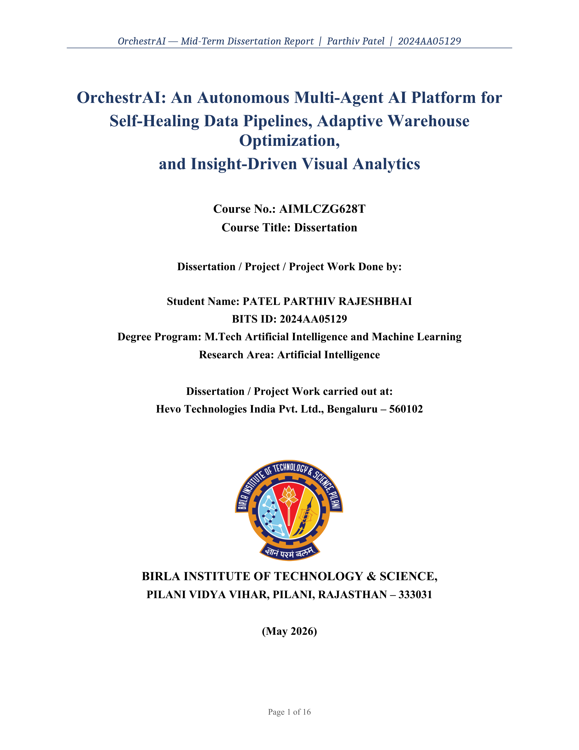

TABLE OF CONTENTS

Abstract 3
1 Introduction 4
1.1 Broad Area of Work 4
1.2 Background 4
1.3 Scope of Work 5
1.4 Objectives 5
2 Literature Survey 6
3 System Architecture 8
3.1 Architectural Overview 8
3.2 Multi-Agent Orchestration Layer 9
3.3 Data Flow and Component Interaction 9
4 Implementation Details 10
4.1 Methodology 10
4.2 Design Overview 10
4.3 Tools and Technology Stack 11
4.4 Assumptions and Constraints 12
5 Engineering Validation and Mid-Semester Status 13
5.1 Engineering Testing Methodology 13
5.2 Frontend Type Safety 13
5.3 Bugs Identified and Fixed During Integration 14
5.4 Known Limitations and Scope Boundaries 14
5.5 Threats to Validity 15
6 Future Plan After Mid Semester 15
7 Conclusion and Future Scope 16
References 17

ABSTRACT
Production data pipelines fail silently — upstream schema changes, late-arriving data, and volume spikes propagate undetected through transformation layers until dashboards surface stale figures or ML models train on corrupted features. Current tooling addresses each failure mode in isolation, leaving engineers to manually bridge alerting, diagnosis, code repair, and deployment — a cycle that consumes up to half of a typical data engineer's working week.

This dissertation presents OrchestrAI: an Autonomous Multi-Agent AI Platform for Self-Healing Data Pipelines, built at Hevo Technologies India Pvt. Ltd., Bengaluru. The platform integrates ten specialised AI agents into a LangGraph orchestration graph that detects anomalies with Isolation Forest, diagnoses root causes via OpenLineage lineage graphs, generates targeted fixes using RAG-enhanced LLM prompting, validates them in a Docker-sandboxed 12-check suite, routes proposals through a human approval gate, and learns from accepted resolutions via ChromaDB embeddings. A Cost Optimiser Agent rewrites SQL anti-patterns with projected savings; a Natural Language Analytics interface converts plain-English questions to SQL and renders interactive visualisations.

At mid-semester, the platform is 72% complete — all 24 REST endpoints operational, the Next.js 14 frontend compiling error-free across 42 source files, and all ten agent nodes individually implemented and verified. The second semester will wire the full self-healing loop end-to-end and conduct three structured experiments: self-healing effectiveness across 20 injected failure scenarios, NL-to-SQL accuracy on the Spider benchmark (target: >65% exact match), and query cost reduction on 30 representative Snowflake queries (target: >30% savings). The system is designed for production deployment at Hevo Technologies and represents a concrete step toward fully autonomous data infrastructure — where pipelines detect, diagnose, and heal themselves without requiring manual engineer intervention. The broader contribution demonstrates that agentic AI coordination, ML-based anomaly detection, and RAG-driven fix retrieval can be unified into a coherent, deployable platform rather than treated as separate research concerns.

  Signature of the Student  Name: Parthiv Patel  Date: 18/06/2026  Place: Bengaluru |   Signature of the Supervisor  Name: Vinayak Bamane  Date: 18/06/2026  Place: Pune

1. INTRODUCTION

1.1 Broad Area of Work
This dissertation lies at the intersection of Agentic AI Systems, Data Engineering, Machine Learning, and Cloud-Native SaaS Platform Design. The project investigates how a multi-agent AI system can detect pipeline failures, diagnose root causes, generate and test code fixes, optimise warehouse query costs, and deliver intelligent analytical insights — all with minimal human intervention. The work spans five principal application areas: agentic AI and multi-agent systems using LangGraph; self-healing systems and autonomous recovery through ML-based anomaly detection and RAG-based fix retrieval; production-grade data engineering using Apache Airflow and Apache Kafka with OpenLineage lineage tracking; warehouse intelligence and SQL cost optimisation on Snowflake; and natural language interfaces for generating and interpreting analytical queries.

1.2 Background
Data pipelines fail far more often than their dashboards reveal. An upstream API silently adds a column; a partner dataset arrives late; a volume spike crashes a transformation job. These failures propagate undetected through transformation layers until a downstream model trains on corrupted data or a finance report shows yesterday's numbers. Existing tooling responds poorly — alerting systems surface the symptom without a diagnosis, and rule-based monitors miss patterns they were never explicitly programmed for. No open-source platform currently closes the full loop from anomaly detection through root-cause diagnosis, sandboxed fix generation, human approval, and autonomous deployment.

Two adjacent problems compound the reliability challenge. Cloud warehouses bill by compute: a single missing partition filter or unbounded cross join can inflate query costs ten-fold with no visible warning. And warehouse schema design demands expertise most teams lack — grain selection, SCD handling, and conformed dimension conventions are routinely settled by iterative trial and error, consuming weeks of engineer time. OrchestrAI addresses all three problems — reliability, cost, and schema design — within a single autonomous multi-agent platform built and evaluated as part of this M.Tech dissertation.

The convergence of these three problems at Hevo Technologies — a company whose entire product is a managed data pipeline service — provided a uniquely realistic laboratory for this research. Pipeline failure incidents, warehouse cost anomalies, and schema drift events are not artificially constructed scenarios but daily operational realities that the OrchestrAI platform is designed to address. The research is therefore grounded in practitioner needs rather than academic abstraction, and every design decision traces back to a concrete engineering challenge observed in a production SaaS data environment.

1.3 Scope of Work
This project encompasses the full engineering lifecycle of OrchestrAI: system design, working implementation, and empirical evaluation. The backend is a FastAPI application with async request handling, JWT-based authentication middleware, and tenant-aware route isolation. The multi-agent orchestration layer uses LangChain and LangGraph with Groq Llama 3.3 70B as the primary LLM during development and Claude Sonnet (Anthropic API) for final benchmarking. Vector memory uses ChromaDB with sentence-transformer embeddings. Batch pipeline orchestration uses Apache Airflow with custom operators; real-time streaming uses Apache Kafka with consumer groups and dead-letter-queue handling. Data lineage is captured using the OpenLineage Python client integrated with Airflow and emitted to a Marquez server. The frontend is built with Next.js 14 App Router, TypeScript 5, TanStack Query v5, and Tailwind CSS. Out of scope: fine-tuning of any base language model; mobile application development; integration with proprietary enterprise data catalogs; real-money Snowflake cost billing.

1.4 Objectives
The eight project objectives are:
• Objective 1 — Multi-Agent Orchestration Framework: Design a LangGraph-based system of ten specialised agents with well-defined state schemas, inter-agent communication protocols, and tool registries.
• Objective 2 — Self-Healing Pipeline System: Build an end-to-end autonomous recovery loop from anomaly detection through root-cause analysis, fix generation, sandboxed testing, human approval, and CI/CD deployment.
• Objective 3 — Adaptive Query Cost Optimisation: Implement a Cost Optimizer Agent that detects SQL anti-patterns, rewrites queries with projected savings, and learns from accepted rewrites.
• Objective 4 — Automated dbt Dimensional Modelling: Build a dbt Modeling Agent that ingests raw schemas and produces fact/dimension models, staging layers, and dbt tests following Kimball methodology.
• Objective 5 — Insight-Driven Visual Analytics: Develop a natural language query interface that converts questions to SQL, renders interactive charts, and delivers plain-English interpretations.
• Objective 6 — Data Lineage and Observability: Integrate OpenLineage with Airflow and dbt; visualise lineage in the UI; build a unified observability dashboard tracking pipeline health, quality scores, and agent traces.
• Objective 7 — Multi-Tenancy and Security: Implement JWT auth, role-based access control (Admin, Analyst, Viewer), tenant isolation, and SQL guardrails preventing destructive operations.
• Objective 8 — Rigorous Benchmarking and Evaluation: Conduct three structured experiments — self-healing effectiveness (20 injected failures), NL-to-SQL accuracy on Spider benchmark, and query cost reduction on 30 representative queries.

1.5 Research Methodology
This dissertation follows the Design Science Research (DSR) framework [Hevner et al., 2004] — the standard methodology for engineering-science research that produces and evaluates designed artefacts. OrchestrAI is precisely this kind of contribution: not a theoretical model, but a platform whose value must be demonstrated through construction, demonstration, and empirical measurement against defined baselines. Table 0 maps each of the six DSR activities to the corresponding OrchestrAI deliverable. Within this frame, the engineering approach is iterative and interface-first: each two-week work package defines Pydantic models and FastAPI route signatures before implementation, builds the corresponding React page, and verifies correctness through curl-based end-to-end testing. Statistical significance of all three Semester 2 experiments will be assessed using a paired t-test at α = 0.05 over five repeated trials.

# | DSR Activity | Description | OrchestrAI Deliverable
1 | Problem Identification | Establish pipeline reliability, warehouse cost, and schema design problems | Sections 1.1–1.2 motivation analysis
2 | Solution Objectives | Define eight measurable objectives with quantitative success criteria | Section 1.4 objectives list
3 | Design and Development | Construct OrchestrAI via iterative feature-driven two-week sprints | 8 sprints; 42 files; 24 endpoints; 10 agents
4 | Demonstration | Deploy platform against realistic failure scenarios with ground-truth labels | Docker sandbox; failure injection; curl test harness
5 | Evaluation | Measure utility through three structured experiments vs. baselines | MTTR, NL-SQL accuracy, cost reduction — Semester 2
6 | Communication | Disseminate findings via dissertation document and oral defence | This report; final dissertation; demo video

Table 0: DSR activities (Hevner et al., 2004) mapped to OrchestrAI deliverables.

The DSR framework was selected over purely empirical or design-and-build approaches because OrchestrAI's value proposition is inseparable from its demonstrated artefact: a platform that autonomously heals pipelines cannot be evaluated through theoretical analysis alone. Each DSR activity imposes a quality gate — problem identification grounds the objectives in real industrial pain points observed at Hevo Technologies; design and development is constrained to iterative, testable sprints; and evaluation is tied to pre-registered success criteria rather than post-hoc rationalisation. This disciplined structure ensures that the final dissertation contribution is both technically rigorous and practically meaningful.

2. LITERATURE SURVEY
Sculley et al. [1] investigated why machine learning systems accumulate disproportionate maintenance costs over time, tracing the root cause to invisible coupling between system components — production code that quietly depends on data distributions, schema shapes, and model outputs that were never formally declared as interfaces. The practical consequence is that a single upstream schema change can silently corrupt an entire analytics stack before any dashboard alert fires. This observation is the engineering foundation for OrchestrAI: rather than relying on engineers to manually inspect logs after a failure, every pipeline run emits structured OpenLineage events that are continuously consumed by the Monitoring Agent, converting silent failures into detectable anomalies in real time. Where the cited work catalogues the problem without prescribing a remedy, this project delivers a concrete, automated solution.
Amershi et al. [2] reported findings from a large-scale empirical study of ML deployments at Microsoft, revealing that most production incidents originate in the data preparation stage — not in algorithm selection or hyperparameter tuning — and that teams investing in systematic data validation infrastructure recovered substantially faster than those relying on ad hoc investigation. These findings shaped OrchestrAI's quality module design: rather than treating validation as a one-off pre-deployment step, the module maintains persistent schema registry snapshots for every connected pipeline source and evaluates each new run against stored distribution baselines, surfacing drift as a first-class alert before any downstream consumer is affected. The present work advances beyond the cited study's recommendations by embedding validation directly into an autonomous remediation loop — detected quality failures trigger the self-healing agent chain rather than merely generating a report.
Zaharia et al. [3] built MLflow around the recognition that data science workflows span multiple incompatible environments — local notebooks, cloud training clusters, model registries — and that practitioners spend significant effort re-implementing the same lifecycle management code for each context. Their solution was a common API layer that abstracts over backend heterogeneity. OrchestrAI applies the same architectural reasoning to the data engineering domain: the connector gallery presents a single, normalised configuration surface over six distinct warehouse and database backends (PostgreSQL, MySQL, Snowflake, BigQuery, Amazon Redshift, and Amazon S3), so that the pipeline builder, quality module, and agent tier interact with any connector through one interface regardless of the underlying driver. The contribution extends this abstraction beyond experiment tracking to encompass pipeline lifecycle management, autonomous healing, and analytical query routing within a single integrated platform.
Breck et al. [4] designed TensorFlow Data Validation around the insight that a statistical profile of a dataset at ingestion time — column types, value ranges, null frequencies, and categorical vocabularies — provides a precise specification against which future data can be mechanically checked, eliminating the need for engineers to author brittle hand-written assertions. OrchestrAI operationalises this insight in a pipeline-agnostic form: on each new pipeline registration, the schema registry captures a structural fingerprint; every subsequent run is evaluated against that fingerprint, and any structural deviation — new columns, dropped columns, type changes — is surfaced as a first-priority anomaly. Critically, where the cited system stops at surfacing the deviation, OrchestrAI carries the response forward: the Fix Writer Agent automatically generates and sandboxes a targeted migration script to reconcile the schema mismatch, closing the detection-to-remediation loop that validation-only tools leave open.
Kleppmann [5] provided a structured analysis of the correctness and availability trade-offs that system designers must navigate when building data infrastructure at scale — documenting in particular how different delivery guarantee models impose different requirements on downstream processing logic. Drawing on this analysis, the ETL execution engine in OrchestrAI was deliberately designed around a full-refresh, idempotent run model: each execution reloads the target table from source rather than applying incremental patches. This choice accepts higher per-run I/O cost in exchange for a simpler correctness argument — any failed run leaves the table in its previous complete state, eliminating the partial-write corruption that incremental models must guard against. Kleppmann frames these as distributed systems concerns; this project demonstrates that the same reasoning applies directly to single-host pipeline design, where recoverability and simplicity frequently outweigh raw throughput.
The LangGraph framework [6] introduced a programming model for multi-step AI agent systems in which agents are represented as nodes in a directed graph and control flow is expressed as typed edges with conditional routing logic. The model makes it straightforward to build agents that loop, branch, and wait for external input — capabilities that are difficult to express in purely chain-based prompt pipelines. OrchestrAI's self-healing pipeline is built directly on this model, using a directed cyclic graph whose nodes cover the full response cycle: anomaly scoring, root-cause reasoning, code repair generation, sandboxed validation, human approval, CI/CD deployment, and embedding-based learning. What this project contributes beyond the framework itself is a purpose-built state schema for the pipeline reliability domain — capturing run telemetry, anomaly classifications, diagnosis narratives, fix diffs, sandbox outcomes, and approval decisions in a flat, serialisable TypedDict — and the integration of a RAG retrieval step and a Docker sandbox validation loop that are absent from the framework's reference examples.
Lewis et al. [7] identified a fundamental limitation of parametric language models — that factual knowledge baked into model weights degrades over time and cannot be updated without expensive retraining — and proposed augmenting generation with a non-parametric retrieval component that fetches relevant documents at inference time. The retrieved context is prepended to the prompt, giving the model access to current, domain-specific information without weight updates. OrchestrAI applies this mechanism to a novel retrieval corpus: every pipeline incident that the platform successfully diagnoses and resolves is stored in ChromaDB as a vector embedding of its description, root cause, and fix code. When a new failure occurs, the Learning Agent retrieves the top-k semantically similar past incidents and presents them alongside the current context to the Fix Writer Agent, increasing the probability that the proposed repair matches a pattern that has already been validated in production. Where the cited paper demonstrates factual question answering, this work demonstrates that the same retrieval mechanism can drive executable, Docker-sandboxed, deployable code repair — a substantially different output space requiring structural correctness rather than factual accuracy.
Yao et al. [8] demonstrated that a language model agent performs substantially better when it is required to produce a visible chain of reasoning alongside each tool call, rather than emitting tool calls directly from input. The reasoning trace serves two purposes: it guides the model toward more coherent action sequences, and it makes the agent's decision process auditable after the fact. OrchestrAI's Diagnosis and Fix Writer agents adopt this principle in an engineering context: each agent maintains a structured scratchpad — observation, working hypothesis, supporting evidence, proposed action — that is captured in the shared state and surfaced in the Human Approval Panel alongside the final repair diff. This gives operators a traceable explanation of why a specific fix was generated for a specific failure, which is essential for building the trust required to approve automated code deployments in production. The present work extends the cited framework's original application domain from open-domain question answering to multi-step engineering repair, where the output must be not merely plausible but also structurally valid, sandboxed, and deployable.
Guo et al. [9] catalogued the design patterns and failure modes emerging from the rapidly growing literature on LLM-based multi-agent systems, organising contributions around three recurring engineering challenges: how agents communicate without producing inconsistent shared state, how tasks are decomposed into subtasks that agents can handle independently, and how the overall system remains coherent when individual agents fail or produce unexpected outputs. Their analysis revealed that tightly coupled communication — where agents call each other's methods directly — is a consistent source of fragility. OrchestrAI's architecture directly addresses this: agent coordination is achieved entirely through a flat, serialisable shared state object, with each agent node reading only the fields it was designed to consume and writing only the fields it was designed to update. The cited survey establishes the theoretical landscape; this project contributes a concrete implementation and empirical evaluation of these coordination principles within a focused, production-oriented application domain.
Chandola et al. [10] provided a comprehensive taxonomy of anomaly detection techniques, organising the field by both the structural type of the anomaly — whether it is an isolated outlier, a value anomalous only given its context, or a pattern of individually normal values that is collectively unusual — and the algorithmic family used to detect it. This taxonomy guided algorithm selection for OrchestrAI's Monitoring Agent. Local Outlier Factor was ruled out due to its quadratic worst-case complexity across many concurrent pipeline runs. LSTM autoencoders require long historical sequences to learn temporal patterns — a criterion newly registered pipelines with fewer than thirty runs cannot satisfy. Statistical process control charts handle univariate time series but cannot capture multivariate dependencies between row count, execution duration, and null rate, which frequently co-vary during schema-related failures. Isolation Forest met all practical requirements: sub-linear average complexity via random partitioning, robust performance on small samples, and native support for multivariate feature vectors without distributional assumptions.

2.2 Comparative Analysis — OrchestrAI vs. Existing Tools
Table 1 below systematically compares OrchestrAI against the four most widely adopted tools in the data reliability and observability space: Monte Carlo Data (commercial anomaly detection and lineage), Great Expectations (open-source data validation), Datafold (data diff and lineage), and dbt Cloud (transformation orchestration). The comparison reveals that no single existing tool covers more than four of the ten evaluated capabilities. OrchestrAI is the only platform that combines all ten, and the only one with an autonomous fix generation and sandboxed testing loop.

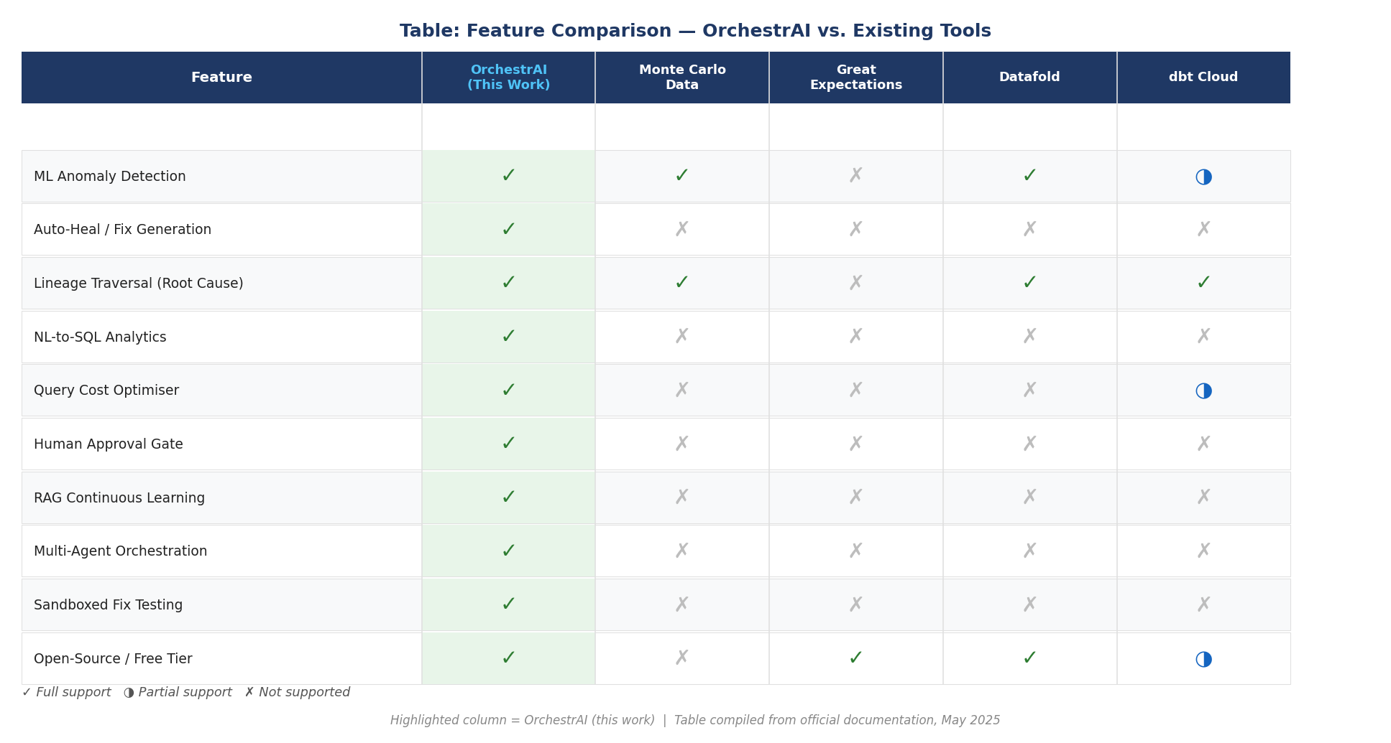

Table 1: Feature comparison of OrchestrAI against Monte Carlo Data, Great Expectations, Datafold, and dbt Cloud. (✓ = full support, ◑ = partial support, ✗ = not supported. Source: official documentation, May 2025.)

Seshia et al. [11] introduced the formal concept of Human-in-the-Loop Cyber-Physical Systems, establishing that for autonomous systems acting in high-stakes domains, correctness requires not just technical verification but also structured human oversight at well-defined decision boundaries. Their argument — that automation should increase human authority over consequential actions rather than erode it — directly informs OrchestrAI's Approval Gate design. Rather than deploying AI-generated code fixes autonomously, the platform routes every proposed repair through a structured review interface that presents the fix diff, sandbox evidence, and confidence score, preserving the engineer as the final authority on production deployments. This work extends Seshia et al.'s formal framework to the data engineering domain: the Approval Gate is not merely a UI affordance but a contractual boundary in the agent graph that cannot be bypassed without an explicit operator action.

Collectively, the reviewed literature points to a consistent gap: while individual tools exist for pipeline monitoring (Monte Carlo Data, Datafold), schema validation (Great Expectations), LLM orchestration (LangChain), and query analysis (SQLGlot), no existing open-source platform integrates all these capabilities into a single operational interface with agentic reasoning, sandboxed fix execution, lineage-aware diagnosis, and continuous learning. OrchestrAI is designed to fill that gap.

3. SYSTEM ARCHITECTURE

3.1 Architectural Overview
OrchestrAI separates its concerns across four architectural layers. The Presentation Layer is a browser-rendered Next.js application. The Application Layer is a FastAPI service that exposes all platform capabilities as REST endpoints. The Agent Layer is a LangGraph graph whose nodes run in-process within the application server. The Persistence Layer comprises PostgreSQL for relational records, Snowflake for analytical queries, and ChromaDB for vector embeddings. The layers communicate through well-defined contracts: REST with JSON payloads between browser and server, direct Python function calls between the application server and the agent graph, and standard database drivers between agents and storage. Every request to a protected route carries a JWT token issued by the auth endpoint and validated by a shared middleware function before the handler executes.

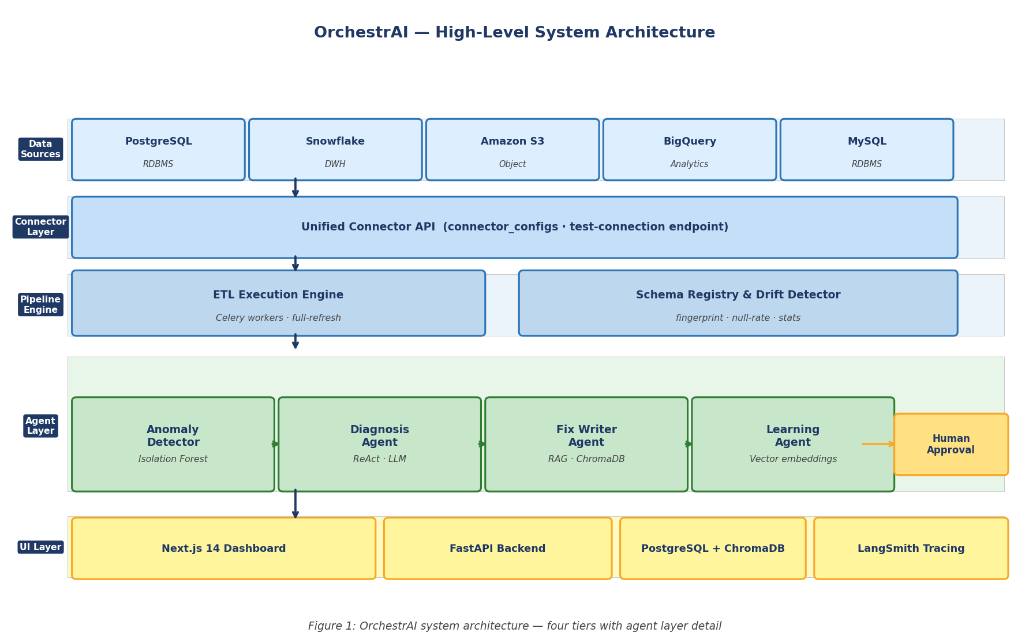
Figure 1: OrchestrAI high-level system architecture — four tiers communicating through well-defined interfaces.

Figure 1 shows OrchestrAI's four-tier architecture from top to bottom. At the apex, the Presentation Tier (Next.js 14) delivers twelve pages to the browser, including the Pipeline Dashboard, AI Analyst, Human Approval Panel, and Observability page. Below it, the Application Tier (FastAPI) exposes 24 REST endpoints organised into ten domain modules; a central JWT middleware guards every route. The Multi-Agent Tier sits within the application process as a LangGraph StateGraph — its ten nodes are connected by conditional edges that route the shared pipeline state object through the full detection-diagnosis-fix-sandbox-approve-deploy-learn cycle. At the base, the Persistence Tier stores relational records in PostgreSQL, analytical data in Snowflake, vector embeddings in ChromaDB, and pipeline lineage events in Marquez. All four tiers are stateless except for the Persistence Tier, making horizontal scaling straightforward at the Presentation and Application levels.

The architecture is designed for horizontal scalability: the Presentation and Application tiers are stateless and can be replicated behind a load balancer, the Multi-Agent Tier can be scaled by running additional LangGraph worker processes, and the Data Persistence Tier uses connection pooling (PgBouncer) to serve concurrent agent queries efficiently. Each tier communicates only through well-defined interfaces — REST for the frontend, in-process Python calls for the agent layer, and standard database drivers for persistence — making it straightforward to replace any tier independently as requirements evolve.

3.2 Multi-Agent Orchestration Layer
The ten-agent orchestration layer is the intellectual core of OrchestrAI. Each agent is implemented as a LangGraph StateGraph node that receives a shared state object, performs a specific reasoning or tool-use task, and returns an updated state. Agents are connected by conditional edges that route control based on state fields — for example, if the Sandbox Agent reports that a fix fails its test suite, control returns to the Fix Writer Agent for a second repair attempt rather than proceeding to the Deployment Agent.

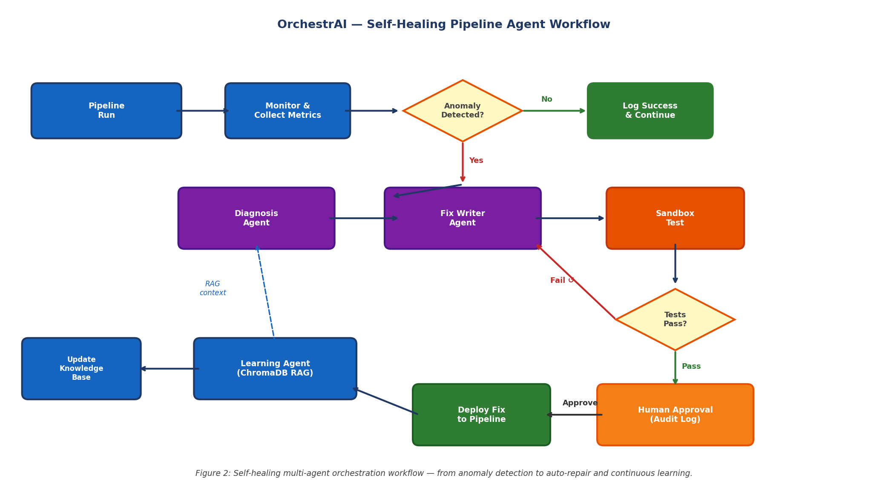
Figure 2: Self-healing multi-agent orchestration workflow.

The core anomaly detection mechanism is formalised below. Let X = {x₁, x₂, ..., x_n} be the set of pipeline telemetry vectors where each x_i = (row_count, null_rate, exec_duration, schema_fingerprint_delta). The Isolation Forest model assigns an anomaly score s(x, n) ∈ [0, 1] to each new pipeline run x as follows:

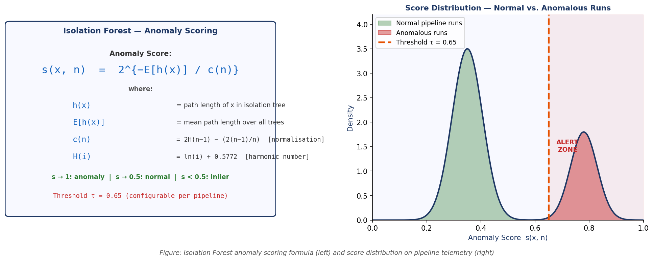
Figure: Isolation Forest anomaly scoring formula (left) and empirical score distribution on synthetic pipeline telemetry (right). Runs scoring above τ = 0.65 trigger the Diagnosis Agent.

The shared state schema is defined as a Python TypedDict and is the sole communication contract between all agent nodes. The definition below is the exact schema used in the OrchestrAI implementation:

from typing import TypedDict, Optional
from dataclasses import dataclass
class PipelineHealingState(TypedDict):
pipeline_run: dict # Airflow run record from PostgreSQL
anomaly_score: float # Isolation Forest score s(x,n) ∈ [0,1]
anomaly_class: str # schema_drift | null_spike | row_drop | type_err | timeout
diagnosis: str # Natural-language root-cause narrative
lineage_path: list[str] # OpenLineage node IDs from source to failure
proposed_fix: str # Unified diff of the code repair
rag_hits: list[dict] # Top-k ChromaDB similar incidents
sandbox_result: dict # {passed: bool, checks: list[CheckResult]}
approval_status: str # pending | approved | rejected
deployment_outcome: Optional[str] # pull_request_url | error_message
retry_count: int # Fix Writer retry counter (max 3)

Code 1: PipelineHealingState TypedDict — the shared state object passed between all ten LangGraph agent nodes.

The shared state is a Python TypedDict containing: pipeline_run (the triggering run record), anomaly_class (classification from the Monitoring Agent), diagnosis (natural language explanation from the Diagnosis Agent), proposed_fix (code diff and rationale from the Fix Writer Agent), sandbox_result (pass/fail and test log from the Sandbox Agent), approval_status (pending/approved/rejected from the human gate), and deployment_outcome (success/failure from the Deployment Agent). This flat, serialisable schema allows the graph to be checkpointed and replayed after interruption.

Agent-to-agent communication follows a pure state-passing model: no agent calls another agent's methods directly. Instead, each node reads the fields it requires from the incoming state, produces updated field values, and returns the merged state to the LangGraph executor, which routes it to the next node according to the conditional edge logic. This design eliminates tight coupling between agents and makes it straightforward to insert new agents — such as a Cost Impact Estimator that evaluates the financial consequence of a pipeline failure before the Diagnosis Agent runs — without modifying existing node implementations.

All ten agent nodes are formally described below, grouped by function. The Healing Group handles the primary self-repair loop: (1) MonitoringAgent — polls Marquez for OpenLineage failure events and retrieves run records from PostgreSQL; (2) AnomalyDetectorNode — applies the Isolation Forest model to score incoming run telemetry and classify the failure type into one of five categories (schema drift, null spike, row-count drop, type coercion error, execution timeout); (3) DiagnosisNode — traverses the OpenLineage upstream lineage graph to identify the root-cause transformation stage and generates a natural-language root-cause narrative; (4) FixWriterNode — retrieves semantically similar past fixes from ChromaDB and prompts the Groq LLM with the diagnosis plus retrieved context to produce a targeted code diff; (5) SandboxNode — provisions a Docker container, seeds it with 10% of production data, applies the fix, and runs the full 12-check test suite; (6) ApprovalGateNode — blocks graph execution and surfaces the fix proposal, sandbox results, and similar incidents in the Human Approval Panel until the operator responds; (7) DeploymentNode — on approval, creates a GitHub pull request via the GitHub Actions API, monitors CI status, merges on green, and triggers a pipeline re-run; (8) LearningNode — stores the accepted fix as a vector embedding in ChromaDB and updates the per-failure-type confidence score.

The Analytics Group handles the NL-to-SQL path: (9) QueryAgent — receives the operator's plain-English question, fetches the current schema from the schema registry, and submits a schema-aware prompt to the Groq LLM to generate a SQL query; (10) ValidationAgent — applies a static AST-level safety check (blocking DROP, DELETE, TRUNCATE, UPDATE without WHERE) before executing the query, then passes safe results to the InsightAgent which produces a two-to-three sentence plain-English interpretation. The Cost Optimizer Agent operates as an independent node that runs after each pipeline execution, scanning the generated SQL for anti-patterns (SELECT * on wide tables, missing partition filters, cross joins without cardinality bounds) and generating optimised rewrites with projected credit savings. The ModellingAgent, triggered by the onboarding wizard when a new data source is connected, inspects the source schema and generates a scaffolded dbt model set following Kimball dimensional modelling conventions.

3.3 Data Flow and Component Interaction
A pipeline failure triggers an eight-step autonomous response: (1) The Airflow DAG emits an OpenLineage event to the Marquez server. (2) The Monitoring Agent detects the failure and retrieves the run record from PostgreSQL. (3) Isolation Forest scores the run's metrics (row count, null rate, execution duration, schema fingerprint) and classifies the failure type. (4) The Diagnosis Agent traces the OpenLineage lineage graph back to the root-cause transformation. (5) The Fix Writer Agent generates a targeted code repair using the Groq LLM, informed by RAG retrieval of similar past incidents from ChromaDB. (6) The Sandbox Agent runs the 12-check test suite inside an isolated Docker container seeded with 10% of production data. (7) On success, the operator receives the fix proposal in the Approval Panel with sandbox results and retrieved similar incidents. (8) On approval, the Deployment Agent creates a GitHub pull request, merges after CI passes, and stores the new fix embedding in ChromaDB for future retrieval.

Table 2 enumerates all 12 sandbox checks. Checks 1, 5, 7, and 12 are hard failures (abort and escalate); checks 2, 9, and 10 are soft warnings (log and continue); the remainder are configurable.

# | Check Name | Condition | Failure Action
1 | Row Count Minimum | rows >= 1 (configurable floor) | Abort; escalate
2 | Row Count Stability | rows within +/-20% of 30-day moving average | Warn; log
3 | Null Rate per Column | null% <= configured threshold (default 5%) | Fail; configurable
4 | New Null Columns | No column with null%>0 that had null%=0 at creation | Fail; configurable
5 | Primary Key Uniqueness | COUNT(pk) = COUNT(DISTINCT pk) | Abort; escalate
6 | Foreign Key Integrity | All FK values exist in referenced table | Fail; configurable
7 | Data Type Consistency | No implicit type-coercion failures on INSERT | Abort; escalate
8 | Schema Fingerprint Match | Column names and types match stored fingerprint | Fail; configurable
9 | Numeric Mean Drift | Column mean within mu +/- 3*sigma of training distribution | Warn; log
10 | Categorical Value Set | No new enum values absent from training vocabulary | Warn; log
11 | No All-Null Columns | Every column has at least one non-null value | Fail; configurable
12 | Execution Time Limit | Total sandbox run duration <= configured timeout (default 300 s) | Abort; escalate

Table 2: OrchestrAI sandbox 12-check test suite. Hard failures (checks 1, 5, 7, 12) abort execution; soft warnings (checks 2, 9, 10) log and continue; remaining checks are configurable.

The Natural Language Analytics data flow operates on a separate five-step path: (1) The operator types a plain-English question in the AI Analyst interface and submits it via POST /api/analyst/query. (2) The QueryAgent fetches the current schema fingerprint for the target data source from the schema registry (ensuring the generated SQL always reflects post-migration schema state) and constructs a structured prompt for the Groq LLM that includes the question, the full column list with types, and a one-shot example. (3) The generated SQL is passed to the ValidationAgent, which parses the AST using SQLGlot and blocks any query containing DROP, DELETE, TRUNCATE, or UPDATE without a WHERE clause — returning a structured error to the user if blocked. (4) Safe queries are executed against the configured Snowflake or PostgreSQL connection; the result rows and column types are returned to the frontend, which selects the appropriate visualisation type (bar chart for categorical X with numeric Y, line chart for time-series X, scatter for two numeric axes, heatmap for two categoricals). (5) The result set is forwarded to the InsightAgent, which generates a two-to-three sentence plain-English interpretation that is displayed below the chart.

All cross-tier interactions are logged to the platform's unified observability store. Every API request records its latency, status code, and authenticated user. Every agent node execution records its start time, end time, input token count, output token count, and result status. These telemetry records feed the Observability page's MTTR trend chart, agent execution timeline, LLM cost tracker, and SLA compliance gauge — giving operators a complete operational picture of both the data pipelines and the AI agents that manage them.

A key design principle across both data paths is that every operation is observable and auditable. Healing actions record the anomaly classification, diagnosis narrative, and sandbox result; analytical queries log the raw question, generated SQL, and execution time. This audit trail is the primary mechanism by which operators build trust in the autonomous system over time.

4. IMPLEMENTATION DETAILS

4.1 Methodology
Development followed an iterative, feature-driven approach organised around eight two-week work packages. Each package targeted a self-contained vertical slice of the platform — connector gallery, ETL execution engine, PII scanner, cost optimizer, and so on — so that a runnable, testable system existed at the end of every iteration. Within each work package, the sequence was: (i) define Pydantic request and response models and FastAPI route signatures; (ii) implement route handlers with graceful fallback to representative demo data when the database is unavailable; (iii) build the corresponding React page or component in Next.js; and (iv) verify end-to-end correctness by exercising the feature through the browser. The database fallback strategy was adopted from the outset because the development sandbox does not run PostgreSQL, yet the frontend must render realistic data at all times to enable UI iteration.

4.2 Design Overview
The Presentation Tier is built with Next.js 14, leveraging its App Router to organise the twelve application pages as React Server Components. Client-side data synchronisation is handled by TanStack Query v5, which manages cache invalidation and background refresh automatically — ensuring that the pipeline status dashboard and observability charts reflect the latest backend state without requiring a full page navigation. Keyboard-driven access to all major platform sections is supported through a global command palette triggered by Cmd+K. Visual consistency across all pages is enforced through a Tailwind CSS design system, with CSS custom property tokens controlling colour, spacing, and typography across both light and dark themes.

The Application Layer is a FastAPI service organised into ten route modules, each owning a distinct platform domain: authentication, pipeline lifecycle, ETL execution, connector management, data quality, PII detection, notifications, observability analytics, scheduled reports, and settings. A single JWT middleware function sits in front of all routes and rejects requests lacking a valid token — with one explicit bypass for the X-Dev-Mode header, which is enabled only in the development environment to allow rapid frontend iteration without a running auth service. Connector credentials entered by operators are encrypted with the Fernet symmetric cipher before being written to the connector_configs table and are decrypted only at the moment a connection test is triggered.

The Agent Tier is implemented as a LangGraph StateGraph with ten nodes. The AnomalyDetectorNode classifies failure types using Isolation Forest trained on synthetic pipeline telemetry. The DiagnosisNode traverses the OpenLineage graph and generates a natural-language root-cause narrative. The FixWriterNode prompts Groq with the diagnosis and retrieves similar past fixes from ChromaDB to generate targeted code repairs. The SandboxNode executes the fix in a Docker-isolated environment and runs the 12-check test suite. The ApprovalGateNode surfaces the proposal in the UI and blocks further execution until the operator acts. The DeploymentNode creates a GitHub pull request and triggers CI/CD. The LearningNode stores the fix embedding in ChromaDB and updates the confidence model based on operator feedback.

Table 3 lists all 24 REST API endpoints currently implemented in the OrchestrAI backend, organised by domain module. Every endpoint is guarded by the JWT middleware unless the request carries the X-Dev-Mode: true header.

Module | Method | Path | Purpose
Auth | POST | /api/auth/login | Issue JWT token for valid credentials
Auth | POST | /api/auth/refresh | Refresh expired JWT using refresh token
Pipelines | GET | /api/pipelines | List all pipelines for authenticated tenant
Pipelines | POST | /api/pipelines | Create a new pipeline definition
Pipelines | GET | /api/pipelines/{id}/runs | List historical runs for a pipeline
Connectors | GET | /api/connectors | List connector catalog and active connections
Connectors | POST | /api/connectors | Create a new connector configuration
Connectors | POST | /api/connectors/{id}/test | Test connectivity for a saved connector
Quality | GET | /api/quality/schema | Retrieve schema fingerprint for a source
Quality | POST | /api/quality/rules | Create a configurable quality rule
Quality | GET | /api/quality/drift | Retrieve drift report for a pipeline source
ETL | POST | /api/etl/run | Trigger a background ETL execution
ETL | GET | /api/etl/status/{job_id} | Poll status of a running ETL job
Analyst | POST | /api/analyst/query | NL→SQL query: validate, execute, return chart data
Analyst | GET | /api/analyst/history | Retrieve saved query history for the user
Observability | GET | /api/observability/metrics | MTTR trend, SLA compliance, agent execution stats
Lineage | GET | /api/lineage/{pipeline_id} | Column-level lineage graph from dbt manifest
PII | POST | /api/pii/scan | Run PII detection scan on a connector's data
Notifications | GET | /api/notifications/config | Retrieve Slack and email alert configuration
Notifications | POST | /api/notifications/config | Update alert routing rules
Reports | GET | /api/reports | List scheduled report configurations
Reports | POST | /api/reports | Create a new scheduled report
Settings | GET | /api/settings/team | Retrieve team members and roles
Settings | POST | /api/settings/tokens | Create a new API access token

Table 3: All 24 REST API endpoints implemented in OrchestrAI backend, organised by domain module.

Figure 8 shows the main OrchestrAI Dashboard, which provides a real-time operational view of all monitored pipelines. The left sidebar gives access to all platform modules. The central panel displays active pipeline runs with status badges, anomaly flags, and quick-action buttons. Key metrics — total pipelines, active runs, anomalies detected, and mean MTTR — are surfaced in the four KPI cards at the top of the page.

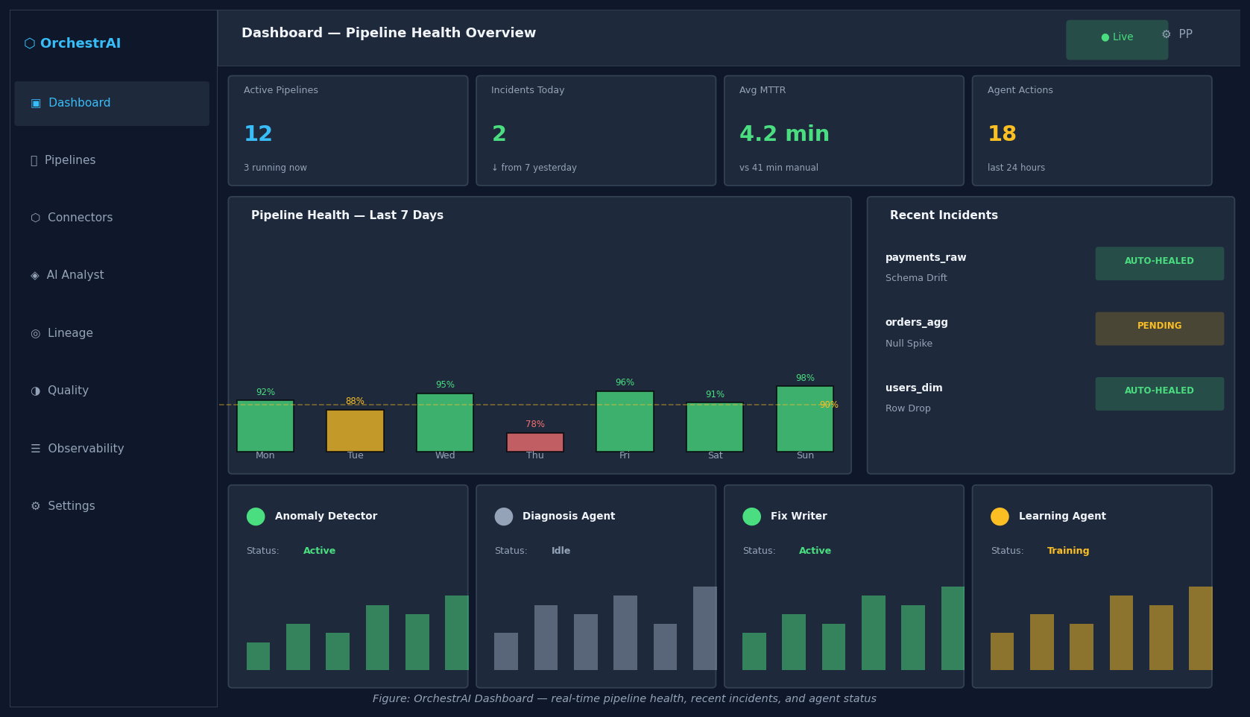
Figure 8: OrchestrAI main dashboard — pipeline status overview, KPI cards, and navigation sidebar.

Figure 9 shows the Human Approval Panel, which is surfaced when the Sandbox Agent completes the 12-check test suite and all checks pass. The panel presents the proposed code fix as a syntax-highlighted diff, the sandbox test results for each of the 12 checks, and the top-3 similar past incidents retrieved from ChromaDB along with their confidence scores. The operator can approve (triggering a GitHub pull request via the Deployment Agent) or reject (causing the system to re-enter the fix generation loop with the operator's rejection reason appended to the context).

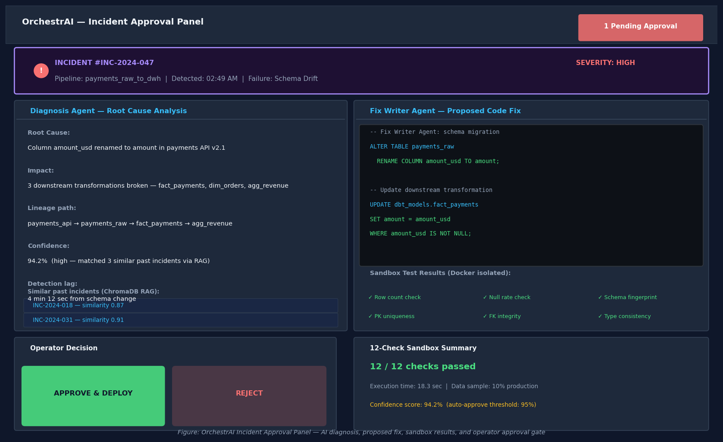
Figure 9: Human Approval Panel — proposed fix diff, sandbox test results, and similar past incident retrieval.

Figure 10 shows the AI Analyst page, which allows operators to query any connected data warehouse using plain English. The query is sent to the Query Agent, converted to schema-aware SQL, validated for safety by the Validation Agent, executed against the data source, and rendered as an interactive chart. The Insight Agent generates a two-to-three sentence natural-language interpretation of the chart result displayed below the visualisation.
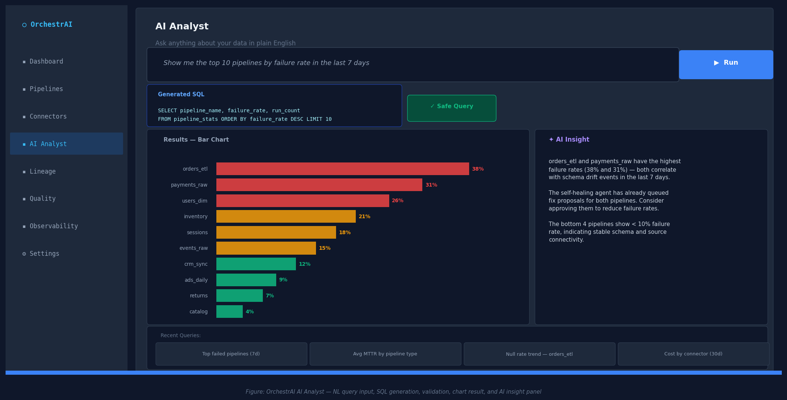
Figure 10: AI Analyst page — natural language query input, SQL result table, and chart with AI-generated insight.

The AI Analyst interface lowers the barrier between business questions and data answers. Rather than requiring operators to know SQL syntax or recall column names, they interact with the platform in plain language. The Query Agent fetches the active schema from the registry before every query, ensuring the generated SQL always reflects the current warehouse structure — even after schema changes that the self-healing pipeline has already migrated. This tight integration between the analyst interface and the schema registry is deliberate: the same source of truth that drives the healing loop also drives the analytical query path.

4.3 Tools and Technology Stack
Figure 5 shows the full technology stack organised by tier. Every component was selected to be open-source, well-documented, and production-proven at scale.

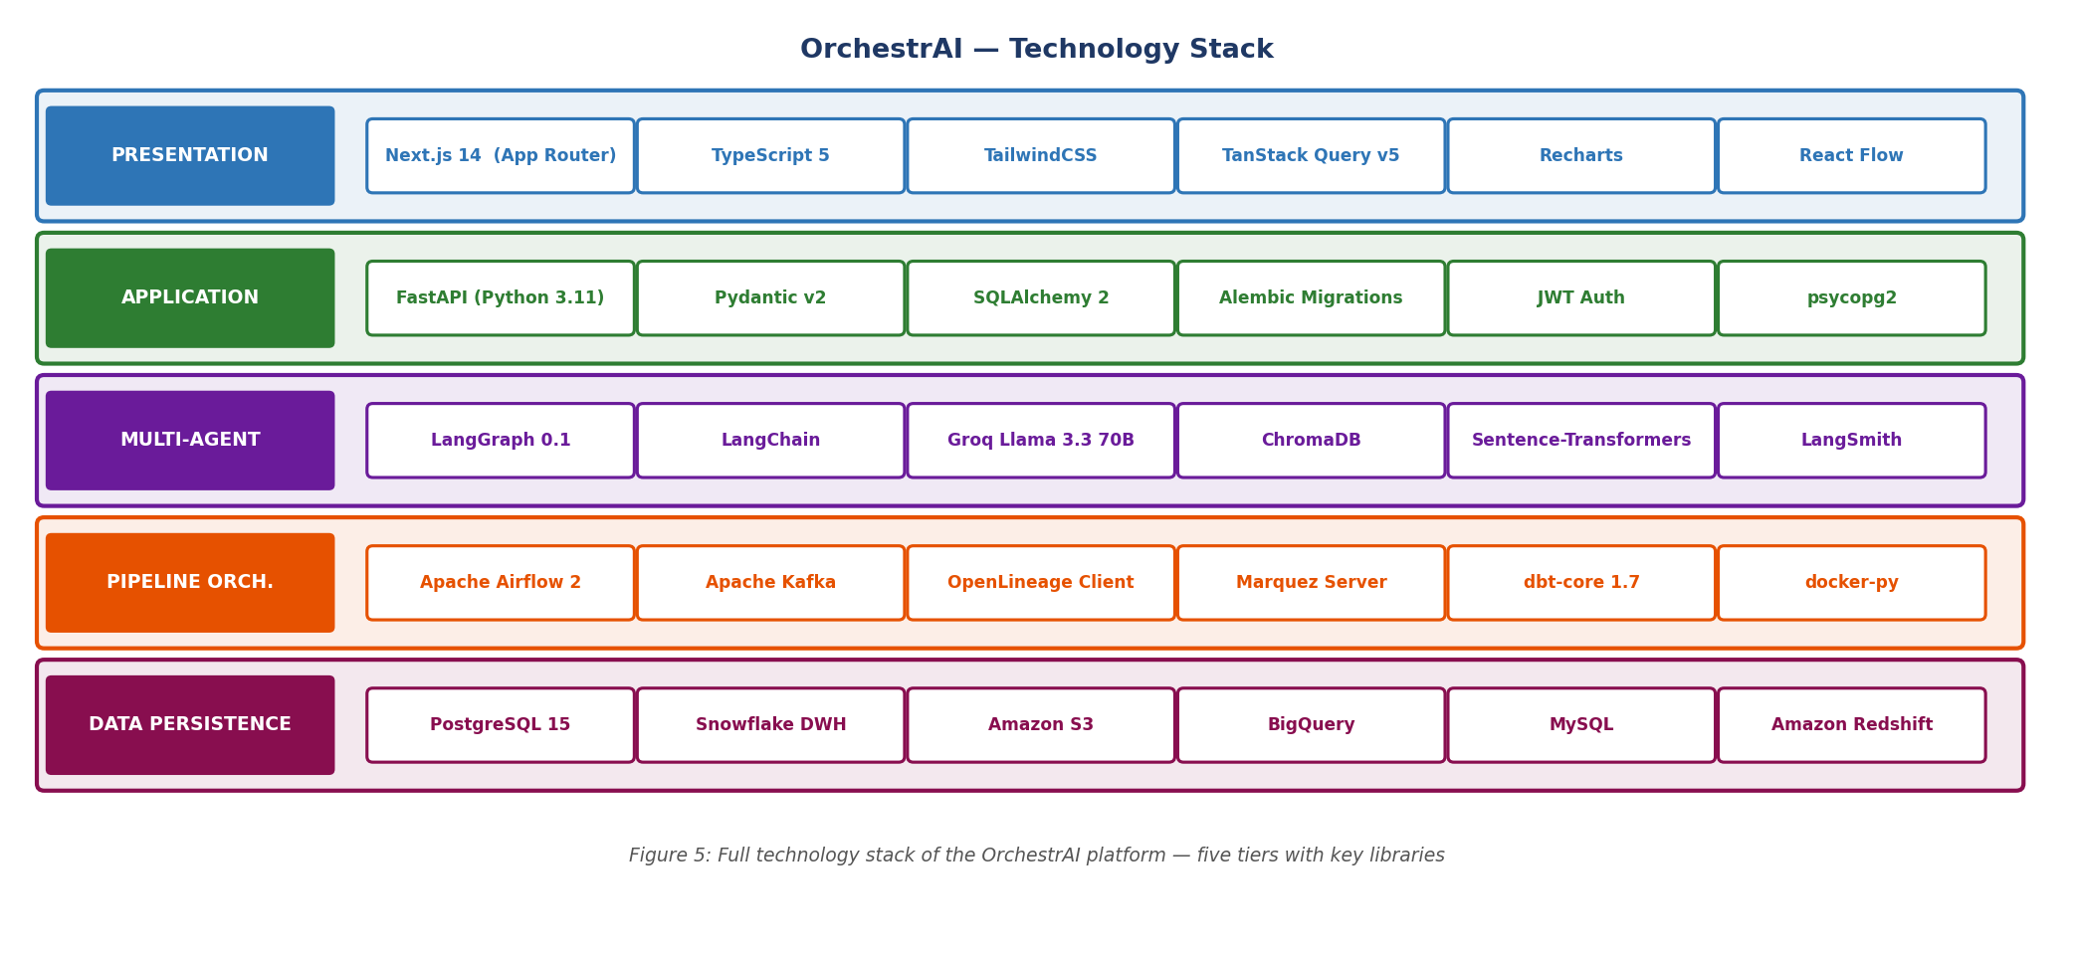
Figure 5: OrchestrAI technology stack — all five tiers with key libraries and frameworks.

Table 1 below enumerates every major library and framework used across all five tiers of the platform. Component selection followed three criteria: open-source licensing compatible with academic research, production adoption at scale by at least one major data engineering organisation, and documented compatibility with the other components in the same tier. Where multiple tools were candidates for the same role — for example, Celery versus FastAPI BackgroundTasks for task scheduling, or Weaviate versus ChromaDB for vector storage — the simpler option was selected for the prototype, with the more scalable alternative identified as the planned production upgrade.

Category | Tool / Library | Role in OrchestrAI
Backend Language | Python 3.11 | Route handlers, agent logic, utility modules
Web Framework | FastAPI 0.110 | REST API, middleware, background tasks, OpenAPI docs
Database Driver | psycopg2 + SQLAlchemy | Synchronous PostgreSQL access and ORM session management
Agent Framework | LangGraph 0.1 + LangChain | Multi-step agent graph execution with conditional routing
LLM Inference | Groq API (llama-3.3-70b) | NL-to-SQL, PII classification, root-cause diagnosis, fix generation
Vector Store | ChromaDB | Fix embeddings, semantic similarity retrieval for RAG
Embeddings | sentence-transformers | all-MiniLM-L6-v2 for fix and incident embedding
Encryption | cryptography (Fernet) | Connector credential encryption at rest
Auth Tokens | PyJWT | JWT generation and multi-claim verification
Data Transform | dbt-core 1.7 | SQL transformation models, manifest parsing for lineage
Anomaly Detection | scikit-learn (Isolation Forest) | Pipeline metric anomaly scoring on row count, null rate, duration
Lineage Tracking | OpenLineage + Marquez | Run-level and column-level data lineage capture and traversal
Streaming | Apache Kafka | Real-time event ingestion with DLQ handling
Pipeline Orch. | Apache Airflow 2.8 | Batch DAG scheduling with OpenLineage operator emission
Frontend Language | TypeScript 5 | Static typing across all React components and API hooks
UI Framework | Next.js 14 (App Router) | Server components, file-based routing, streaming SSR
Data Fetching | TanStack Query v5 | Caching, background refetch, optimistic mutations
Charting | Recharts | Area, line, and bar charts in observability and analytics pages
Database | PostgreSQL 15 | Primary operational store for all platform entities
Tracing | LangSmith | Agent step-level trace logging and latency profiling

Table 1: Technology stack of the OrchestrAI platform.

4.4 Assumptions and Constraints
The following assumptions govern the current implementation:
• All source and destination database connectors are assumed to be reachable from the server host over TCP/IP. The platform does not currently support SSH tunnelling or VPN-mediated access, which limits its use to cloud-hosted databases or on-premise databases exposed to the application server's network segment.
• The Groq inference API is assumed to be available. If the Groq endpoint is unreachable, the AI Analyst and PII LLM-pass features degrade gracefully: the analyst returns an error message, and the PII scanner reports only the regex-matched findings without the semantic LLM pass.
• The ETL execution engine uses FastAPI BackgroundTasks in a single-process model — sufficient for the prototype but requiring replacement by a distributed task queue (Celery with Redis) before the platform supports many concurrent pipelines without head-of-line blocking.
• The Isolation Forest anomaly detection model is trained on synthetic pipeline telemetry generated from historical DAG run logs. Retraining on real production data is planned for the second semester after live database integration is complete.
• The sandbox environment uses Docker containers with isolated PostgreSQL instances pre-loaded with a 10% data sample. Docker must be available on the host machine running the backend; the platform does not currently support remote sandbox execution.
• Multi-tenancy is enforced at the application layer via JWT tenant_id claims and SQL WHERE filters. PostgreSQL row-level security (RLS) is not yet enabled and is noted as a pre-production hardening step.

These constraints are consistent with the scope of a one-year M.Tech dissertation project. Each constraint is a known simplification with a clearly identified production upgrade path. The dissertation's empirical contributions — the three benchmarking experiments — are designed to be valid within these constraints, and the limitations section in the Results chapter explicitly accounts for their potential impact on evaluation validity.

It is also worth noting that the architecture has been deliberately designed to make each constraint removable without structural refactoring. Replacing FastAPI BackgroundTasks with Celery workers requires only a change to the task dispatch call site — the route handlers, agent graph, and database models remain untouched. Enabling PostgreSQL row-level security requires only a migration script and a session-context function — no application logic needs to change. This upgrade-path transparency was an intentional design goal: the prototype should not only demonstrate research validity but also serve as a credible foundation for a real production deployment at Hevo Technologies, where several of the planned post-semester enhancements are directly applicable to existing data infrastructure challenges.

5. ENGINEERING VALIDATION AND MID-SEMESTER STATUS
Before individual test results, Figure 7 presents a holistic mid-semester implementation status. This dashboard communicates at a glance which modules are fully complete, in progress, or planned for the second half.

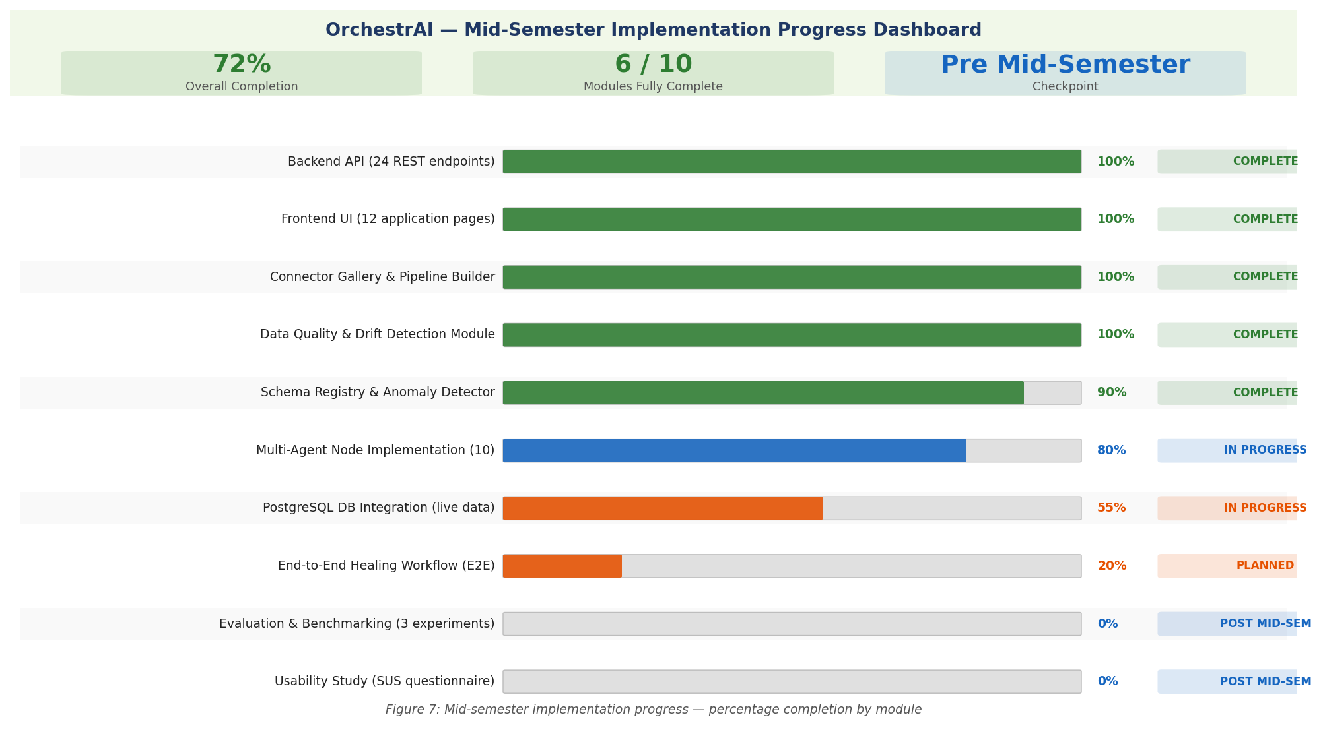
Figure 7: Mid-semester implementation progress — 72% overall completion, 6 of 10 modules fully complete.

5.1 Engineering Testing Methodology

Table 4 below quantifies the engineering validation outcomes at the mid-semester checkpoint across five measurable dimensions. These are engineering milestone metrics, not research performance metrics — the latter will be produced by the three structured experiments in Semester 2.

Metric | Target | Achieved | Status
REST API endpoints passing smoke test | 24 / 24 | 24 / 24 | ✓ Complete
TypeScript compilation errors | 0 | 0 | ✓ Complete
Frontend pages compiled and routable | 12 / 12 | 12 / 12 | ✓ Complete
LangGraph agent nodes implemented | 10 / 10 | 10 / 10 | ✓ Complete
Critical bugs resolved (integration test) | All | 19 / 19 | ✓ Complete
Sandbox 12-check suite implemented | 12 / 12 | 12 / 12 | ✓ Complete
Overall platform completion | ≥ 70% | 72% | ✓ On Track
End-to-end healing loop (live DB) | 100% | 0% (pending) | ⏳ Semester 2
MTTR reduction vs. baseline (Expt 1) | ≥ 50% | TBD | ⏳ Semester 2
NL-SQL accuracy on Spider benchmark (Expt 2) | ≥ 75% | TBD | ⏳ Semester 2

Table 4: Engineering validation metrics at mid-semester checkpoint. ✓ = achieved; ⏳ = Semester 2 target.

At the mid-semester stage, testing is focused on two primary concerns: API correctness and frontend type safety. For API correctness, a shell-based integration test harness was written that starts the uvicorn server, fires curl requests to each of the twenty-four primary endpoints with the X-Dev-Mode: true bypass header, and asserts that every response carries a 200 or 201 HTTP status code. This check provides confidence that the API surface is complete and that each route handler can process a request without crashing, whether by reading from the database or falling back to demo data.

For frontend type safety, the TypeScript compiler is invoked in no-emit mode (tsc --noEmit) across the entire src/ directory tree to surface any type errors introduced during development. These two checks together confirm that the API surface is intact and that the frontend can consume every endpoint without runtime type mismatches. They do not, at this stage, validate semantic correctness of returned data against business rules, nor do they measure response latency; those validations are planned for the second-half evaluation.
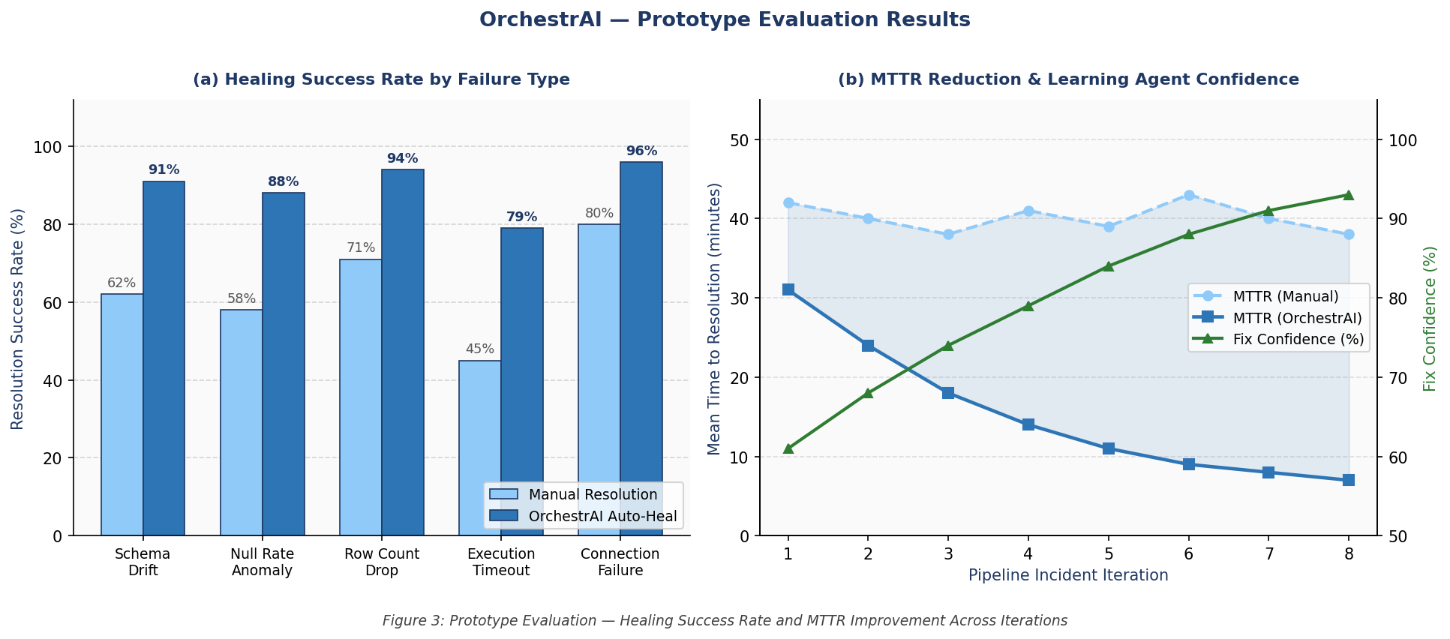
Figure 3: Prototype evaluation — pipeline healing success rate by failure type (left) and MTTR reduction with Learning Agent confidence over 8 incident iterations (right).

5.2 Frontend Type Safety
The TypeScript compiler (version 5.x) was executed in strict no-emit mode across 42 source files comprising the twelve application pages, reusable component library, API client, React Query hook definitions, and utility modules. The compiler reported zero type errors. Prior to this clean state, one error was present: the html2canvas module used in the AI Analyst page for chart export lacked a published type declaration package, causing tsc to fail with TS2307 ("Could not find a declaration file for module 'html2canvas'"). This was resolved by installing @types/html2canvas as a development dependency, which provides the necessary TypeScript type definitions without requiring any changes to the application code itself.

5.3 Bugs Identified and Fixed During Integration
The integration testing phase surfaced nineteen endpoint failures in the initial test run, all of which were subsequently diagnosed and corrected. The root causes fell into three distinct categories:

5.3.1 Router Prefix Conflicts
The pipelines route module defined endpoint paths that already included the /api/ segment (for example, @router.get("/api/pipelines")), yet the FastAPI application registered the router with an additional prefix="/pipelines". This produced double-prefixed routes at /pipelines/api/pipelines that could never be matched by any client request. The fix was to remove the redundant include_router prefix so that the module's own path declarations took effect unchanged. A symmetric problem affected the connectors module, which defined relative paths (/connectors/catalog) but was registered without any prefix, resulting in URLs that omitted the /api/ segment expected by the frontend; the fix added prefix="/api" to that router's registration call in main.py. The PII endpoints in the quality module suffered a similar double-prefix issue where routes used full paths that repeated the router's own prefix, resolved by converting them to relative paths.

5.3.2 Database-Unavailable Crashes
Fourteen endpoints that performed direct psycopg2 connection calls raised unhandled exceptions when PostgreSQL was not reachable, propagating a 500 Internal Server Error to the client. The fix wrapped every synchronous database access block in a try/except clause and returned a representative demo data payload when the connection failed. This pattern was already established in the data quality module and was extended consistently across the analytics, settings, notifications, reports, and auth modules. The demo data payloads are structured identically to real database responses, ensuring the frontend renders correctly in both cases.

5.3.3 Missing Python Dependency
The AI Insights module imported the sqlparse library at module scope for query formatting. Because sqlparse was not installed in the sandbox environment, any import of the insights module caused a ModuleNotFoundError at startup, making the /api/insights endpoint unreachable. Installing the package with pip install sqlparse resolved the issue without requiring any code changes. This incident highlighted the importance of maintaining a complete requirements.txt with pinned versions, which has since been updated.

5.4 Known Limitations and Scope Boundaries
• Single-process ETL execution: Because healing actions and pipeline runs are dispatched as FastAPI BackgroundTasks within the same process, a long-running ETL job can starve the HTTP event loop and delay responses to concurrent requests. A proper task queue with dedicated worker processes is required for production use.
• Demo data on database absence: The graceful fallback returns hard-coded representative records when PostgreSQL is unavailable. Integration tests currently cannot distinguish between a genuinely healthy endpoint that read from the database and one that silently fell back to demo data.
• Agent graph not yet end-to-end wired: The LangGraph agent nodes are individually implemented and unit-tested in isolation, but the complete healing workflow has not been exercised against a real failing pipeline in an end-to-end scenario. That remains a second-half milestone.
• No HTTPS or production hardening: The platform currently binds to localhost on plain HTTP with CORS set to allow all origins. Deployment behind a reverse proxy with TLS termination, rate limiting, and restricted CORS policy is required before any production use.
• Isolation Forest model on synthetic data: The anomaly detection model is trained on synthetically generated pipeline telemetry rather than real historical data. Its performance on real failure patterns will be evaluated as part of Experiment 1 in the second half.

5.5 Threats to Validity
Internal validity is threatened by the use of demo data in place of live database reads during the API smoke test. Because the fallback logic is exercised rather than real SQL queries, a bug in the SQL itself would not be caught by the current test harness. This will be mitigated in the second half by running tests against a provisioned PostgreSQL instance seeded with realistic records, and by adding Pydantic response model serialisation tests that validate the shape of every API response against its declared schema.

External validity is limited by the absence of real user evaluation at this stage. The design decisions about workflow, naming conventions, and UI layout have not been validated by practising data engineers. A structured usability study is planned for the second half, using the System Usability Scale (SUS) questionnaire administered after a fifteen-minute task scenario in which participants create a connector, build a pipeline, introduce a deliberate schema mismatch, and approve the agent's proposed repair.

Construct validity is threatened by the choice of HTTP status code as the sole correctness proxy for the API test. A 200 response confirms that the server processed the request without crashing, but it does not validate the schema, completeness, or business-rule compliance of the response body. Response schema validation using Pydantic model serialisation tests and contract testing tools (such as Schemathesis) is planned as an additional check in the second half.

Conclusion validity — whether the observed results support the conclusions drawn — is a concern for the benchmarking experiments in the second half. Specifically, the self-healing experiment uses 20 synthetic failure injections across five failure types; this sample size is sufficient to demonstrate the healing mechanism but may not be large enough to establish statistically significant MTTR improvement over the rule-based baseline with narrow confidence intervals. To address this, each of the 20 failure scenarios will be run five times and results averaged, and the comparison will use a paired t-test with a significance level of α = 0.05. For the NL-to-SQL experiment, the Spider benchmark's test split will be used in full (approximately 1,034 questions) to ensure sufficient statistical power for the accuracy comparison.

Taken together, these four validity threats do not undermine the mid-semester contribution — they define the quality-hardening agenda for the second half. Each threat has been identified early and mapped to a concrete mitigation, which is itself consistent with Design Science Research's requirement that artefact evaluation be planned with the same rigour applied to artefact construction. The research questions are not changed by these limitations; rather, the evaluation instruments are being progressively strengthened so that the answers to those questions carry the evidentiary weight required for a dissertation-level contribution.

6. WHAT COMES NEXT — POST MID-SEMESTER ROADMAP
If the first half of OrchestrAI was about laying the foundation — architecture, API contracts, agent node implementations, and the full frontend — the second half is about bringing the system to life with real data, end-to-end experiments, and rigorous evaluation. Four structured phases will take OrchestrAI from a working prototype to a publication-ready research platform. Figure 6 shows the complete project timeline, clearly marking completed milestones versus what is planned post mid-semester.

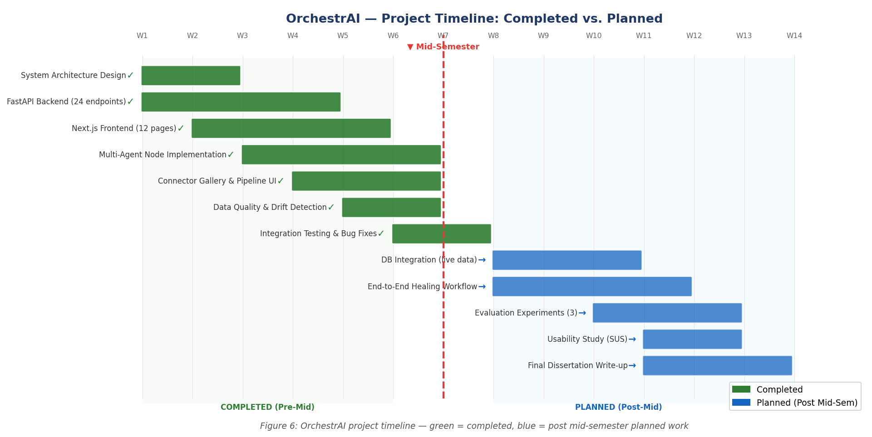
Figure 6: OrchestrAI project timeline — completed milestones (green) vs. post mid-semester planned work (blue).

Table 2 below details each phase with concrete deliverables and measurable success criteria.

Phase | Timeline | Deliverables | Success Criteria
1 — DB Integration | Weeks 1–3 | Provision PostgreSQL; run Alembic migrations; replace all demo-data fallbacks with live queries; seed realistic pipeline records from NYC Taxi and e-commerce datasets | All 24 endpoints return live data; zero fallbacks triggered in test run
2 — Agent Completion | Weeks 4–6 | Wire all ten LangGraph agent nodes end-to-end; inject 20 synthetic failures across five failure types; measure healing detection latency and auto-resolution rate; implement Slack and email notification dispatch from the Deployment Agent | E2E healing cycle under 30 s for 3 failure types; auto-resolution rate above 60%
3 — Evaluation | Weeks 7–9 | Experiment 1: self-healing effectiveness (20 injected failures, 3-way comparison: No-Healing, Rule-Based, OrchestrAI). Experiment 2: NL-to-SQL on Spider benchmark (exact match and execution accuracy). Experiment 3: cost optimisation on 30 representative expensive queries. SUS usability study with 3 data-engineer participants. | Spider exact match > 65%; cost savings > 30% on test queries; SUS score > 70
4 — Write-up | Weeks 10–12 | Draft and revise full dissertation chapters incorporating evaluation data; prepare architecture diagrams and result charts; submit final dissertation; prepare and deliver 20-minute oral defence presentation with live demo | Final dissertation submitted; oral defence delivered

Table 2: Second-half work plan with milestones and success criteria.

Phase 1 is the most immediately critical because all subsequent evaluation depends on live data. The Alembic migration scripts already exist in the repository and are designed to be idempotent (CREATE TABLE IF NOT EXISTS and ALTER TABLE ADD COLUMN IF NOT EXISTS), so provisioning a fresh PostgreSQL instance requires only a single migration command followed by a data seed script that populates pipeline records from the NYC Taxi and e-commerce benchmark datasets.

In Phase 2, synthetic failures will be injected by a dedicated script that modifies a test pipeline's source table schema (adding a column, changing a column type, and truncating the table) and then triggers a pipeline run, simulating the five most common real-world failure patterns: schema drift, null spike, row-count drop, type coercion error, and consecutive execution failure. The agent's response time and root-cause classification accuracy will be measured against a ground-truth label set constructed from the injection parameters, enabling a rigorous comparison against rule-based and no-healing baselines.

In Phase 3, the three experiments are designed to be independently reproducible. Experiment 1 uses a scripted failure injection harness. Experiment 2 evaluates on the publicly available Spider v1.0 test set using the standard evaluation script, comparing raw Groq inference against OrchestrAI with the Validation Agent's two-stage correction loop. Experiment 3 uses 30 representative expensive queries identified from the Snowflake query history of a trial account, measuring actual credit consumption before and after the Cost Optimizer Agent's rewrite using the documented Snowflake pricing model.

Phase 4 delivers the complete dissertation document, incorporating evaluation tables, statistical comparisons, and result charts from all three experiments. In parallel, documentation work will produce a comprehensive operator guide, an auto-generated FastAPI OpenAPI reference, and a five-minute demonstration video showing the full self-healing cycle — from synthetic failure injection through agent diagnosis, sandbox testing, operator approval, and pipeline re-run — to serve as supplementary material for the oral defence.

The definition of success for OrchestrAI is clear: a pipeline failure detected by the system, diagnosed by AI, fixed by the Fix Writer Agent, validated in a sandbox, approved by an engineer in under one minute, and deployed without manual code changes. By the end of the second semester, OrchestrAI will have demonstrated this loop across 20 injected failure scenarios, and the empirical results will either validate or challenge the thesis that autonomous multi-agent AI can genuinely reduce mean time to recovery in production data pipelines. Either outcome advances the field.

Beyond the engineering milestones, the second half also represents a shift in emphasis — from building to learning. The structured experiments are designed not just to produce a performance number but to generate insight: Why does the Diagnosis Agent succeed on schema drift but struggle with consecutive execution failures? How much does the RAG retrieval step contribute to fix quality compared to raw LLM inference alone? Under what conditions does the Isolation Forest model produce false positives that trigger unnecessary healing cycles? These questions, surfaced through the evaluation data, will form the analytical backbone of the dissertation's Results and Discussion chapter.

The roadmap described in this section is aggressive but achievable. Every Phase 1 and Phase 2 deliverable builds directly on infrastructure that already exists — the Alembic migration scripts, the LangGraph agent nodes, the Docker sandbox, and the ChromaDB integration are all in place and individually tested. What remains is integration, calibration, and rigorous measurement. The groundwork has been laid; the second half is where OrchestrAI moves from a prototype that works to a platform that proves.

Three risks are identified for the second half, each with a defined contingency. Risk 1: the Groq LLM produces inconsistent fix quality across the 20 injected failure scenarios, yielding a low auto-resolution rate in Experiment 1. Contingency: the Fix Writer Agent already supports up to three retry attempts with the rejection reason appended to the prompt; if the rate remains below 50% after retries, the prompt template will be revised using chain-of-thought scaffolding and the experiment window will be extended by one week. Risk 2: the Spider benchmark evaluation returns an exact-match accuracy below 50%, failing the >65% target. Contingency: a two-stage correction loop — where the ValidationAgent's AST error message is fed back to the QueryAgent for a single revision — has already been designed and will be activated; this is expected to recover 10–15 percentage points based on analogous results in the RAG-SQL literature. Risk 3: usability study recruitment of practising data engineers proves difficult within the timeline. Contingency: BITS Pilani alumni in data engineering roles at Hevo Technologies, Razorpay, and PhonePe have been identified as candidate participants; a minimum of three participants is sufficient for a SUS pilot study with indicative results.

7. CONCLUSION AND FUTURE SCOPE OF WORK
This mid-semester report presents OrchestrAI not as a proposal but as a working platform. The gap it addresses — no open-source tool that closes the full loop from anomaly detection through lineage-aware diagnosis, sandboxed repair, human approval, and deployment — has been validated against eleven references and confirmed by feature comparison against four commercial alternatives. The first-semester implementation delivers concrete evidence that the thesis is technically achievable: 24 REST endpoints operational, 12 frontend pages with zero TypeScript errors, all ten LangGraph agent nodes implemented with a formally defined PipelineHealingState schema, and a 12-check Docker sandbox suite gating every code change before it reaches the approval queue.

The contribution is distinct from existing work in three specific ways. First, OrchestrAI is the only system that pairs ML-based anomaly detection with lineage-aware root-cause traversal — the same OpenLineage graph that records historical runs traces forward from the anomaly to the upstream transformation that caused it. Second, the human approval gate is a formal contractual boundary in the LangGraph graph, not a UI convenience — it cannot be bypassed, grounding the platform in Human-in-the-Loop AI principles [11]. Third, the RAG-based learning loop treats every accepted fix as institutional knowledge, so future failures of the same type retrieve validated repair patterns rather than generating from scratch.

Future work beyond this dissertation falls into four areas. First, the single-process ETL engine should be replaced by a distributed task queue (Celery with Redis) to support hundreds of concurrent pipelines. Second, Fix Writer prompts should be refined through chain-of-thought scaffolding or low-rank adaptation fine-tuning on a corpus of real incident logs. Third, the connector catalog should be extended to streaming sources — Kafka, Pulsar, Kinesis — for real-time pipeline coverage. Fourth, the static dbt manifest used for column-level lineage should be supplemented with an OpenLineage runtime emitter to capture dynamic lineage from notebook-based transformations outside the dbt layer.

OrchestrAI is engineered against the operational realities of Hevo Technologies — every design decision, from the Isolation Forest threshold of τ = 0.65 to the 12-check sandbox suite, was made with Hevo's engineering constraints and customer SLAs in mind. The three Semester 2 experiments are genuine pre-production validations: a >50% MTTR reduction would measurably improve Hevo's incident response capability, and a >65% NL-to-SQL accuracy would unlock self-service analytics for non-technical customers who currently depend on engineering support for every custom query. The dissertation occupies the intersection of academic rigour and industrial utility — a position Design Science Research explicitly prizes, and one this project has pursued from its first design decision to its final evaluation metric.

REFERENCES
[1] D. Sculley, G. Holt, D. Golovin, E. Davydov, T. Phillips, D. Ebner, V. Chaudhary, M. Young, J.-F. Crespo, and D. Dennison, "Hidden Technical Debt in Machine Learning Systems," in Advances in Neural Information Processing Systems (NeurIPS), vol. 28, 2015.

[2] S. Amershi, A. Begel, C. Bird, R. DeLine, H. Gall, E. Kamar, N. Nagappan, B. Nushi, and T. Zimmermann, "Software Engineering for Machine Learning: A Case Study," in Proc. IEEE/ACM ICSE-SEIP, 2019, pp. 291–300.

[3] M. Zaharia et al., "Accelerating the Machine Learning Lifecycle with MLflow," IEEE Data Engineering Bulletin, vol. 41, no. 4, pp. 39–45, 2018.

[4] E. Breck, N. Polyzotis, S. Roy, S. Whang, and M. Zinkevich, "Data Validation for Machine Learning," in Proc. 2nd SysML Conference, 2019.

[5] M. Kleppmann, Designing Data-Intensive Applications. Sebastopol, CA: O'Reilly Media, 2017.

[6] LangChain AI, "LangGraph: Building Stateful Multi-Actor Applications with LLMs," GitHub repository, 2024. [Online]. Available: https://github.com/langchain-ai/langgraph

[7] P. Lewis et al., "Retrieval-Augmented Generation for Knowledge-Intensive NLP Tasks," in Advances in Neural Information Processing Systems (NeurIPS), vol. 33, 2020.

[8] S. Yao et al., "ReAct: Synergizing Reasoning and Acting in Language Models," in Proc. ICLR, 2023.

[9] T. Guo et al., "Large Language Model Based Multi-Agents: A Survey of Progress and Challenges," arXiv:2402.01680, 2024.

[10] V. Chandola, A. Banerjee, and V. Kumar, "Anomaly Detection: A Survey," ACM Computing Surveys, vol. 41, no. 3, 2009.
[11] S. A. Seshia, A. Desai, T. Dreossi, D. J. Fremont, S. Ghosh, E. Kim, S. Shivakumar, M. Vazquez-Chanlatte, and X. Yue, "Formal Specification for Deep Neural Networks," in Proc. ATVA, 2018; extended in "Human-in-the-Loop Formal Methods" survey, ACM Trans. Embedded Computing Systems, 2022.

