

Wage Manager



Creater: Parthiv Vekaria

Roll No: 23CED035

**INDEX**

|  |  |
| --- | --- |
|  | Pg. No. |
|  |  |
| Introduction | 2 |
| How to Create Invoice | 2 |
| How to Add/Update Product | 4 |
| How to View Report | 5 |

Purposer.

It provide support to manage Invoice at Point Of Sale (POS). It help to manage data redundancy there it provide batter space management, due to all Entity is stored separately and all the attributes are in atomic form in brief all the data is store in 3 Normalized Form without any introduction of structured database, using Directory Management technique. As data is stored digitally, it reduces the physical space required to store paper-based data and increase the confidentiality, who can access the data.

Introduction to Water Manager.

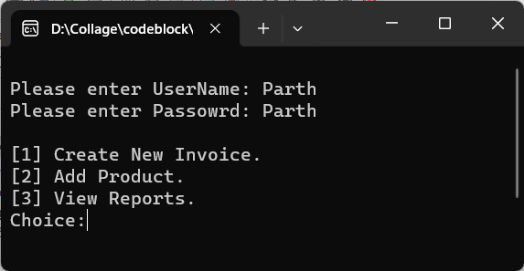At first user will input User name and then password. After inputting the authentation info, if either of info is info is incorrect user want have access and it will mention which info is incorrect.

User will have “3” attempt to try before end of program.

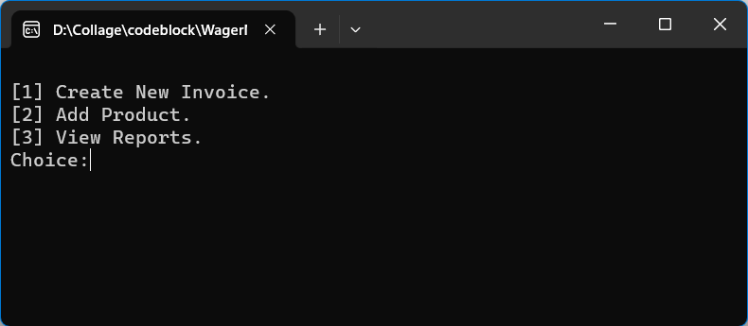The Fig shows the initial view of application after authentation. There are three option given:

1. Create New Invoice.
2. Add Product.
3. View Report.

User is asked to choose one of the option by inputting the integer.

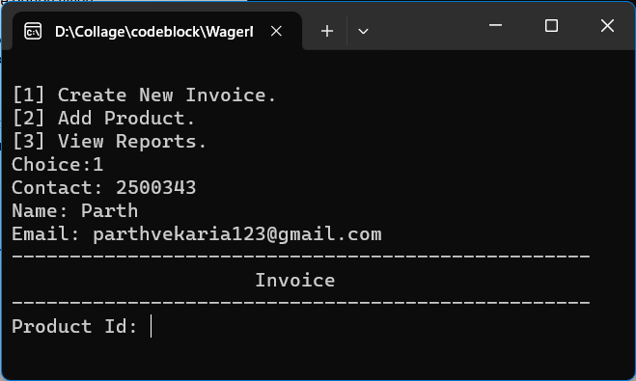Create New Invoice

After choosing the first option it will ask user to input the contact which mandatory.

Scenario 1:

After Inputting the contact if the contact already exist in the system it will automatically 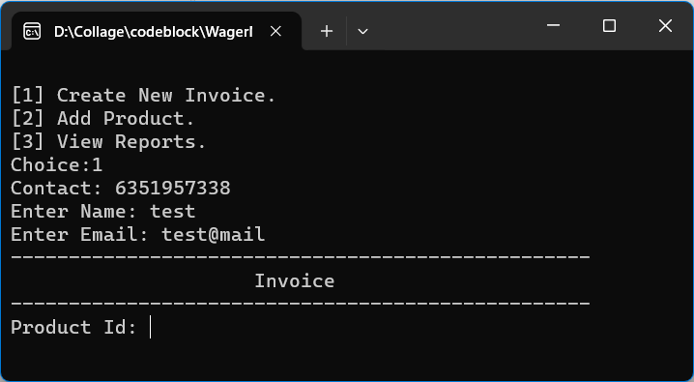list its Name and Email, then it will initiate to produce the invoice, where it will ask user to enter product code to identify the product.

Scenario 2:

After Inputting the contact if the contact does not exist it as the user to enter the name and Email, after inputting the details it will lead to initiate to create invoice.

Introduction to products in invoice.

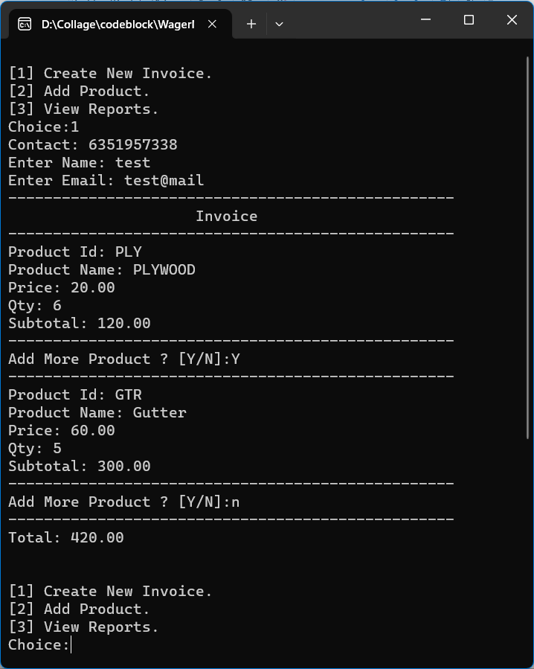Next phase is to enter the product code which can be (barcode number, skew code or any code) that represent the product.

As per the figure the first Product ID: PLY is enter it outputs product details (Name, Price). Then user will be asked to enter Quantity required, next Subtotal is listed.

If Product code entered dose not exist in product list it will output “Product Not Found”.

After that user will be asked if it require to add more product if yes then “Y” in any case. If No then “N” or any char to terminate the invoice.

At the End of the invoice Total is given. The process of choosing option is initiated again.

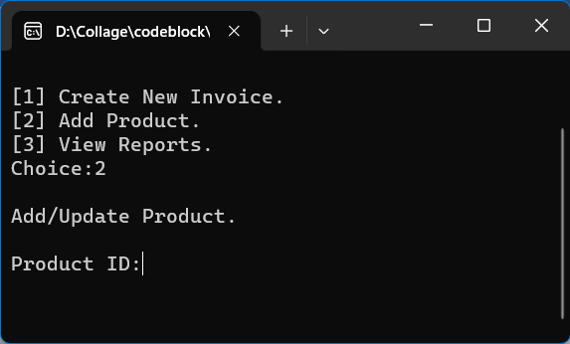Add Product

The Second chooise “Add Product”, the following screen on right will be displayed it will ask to Enter Product ID, To Update or Add New Product.

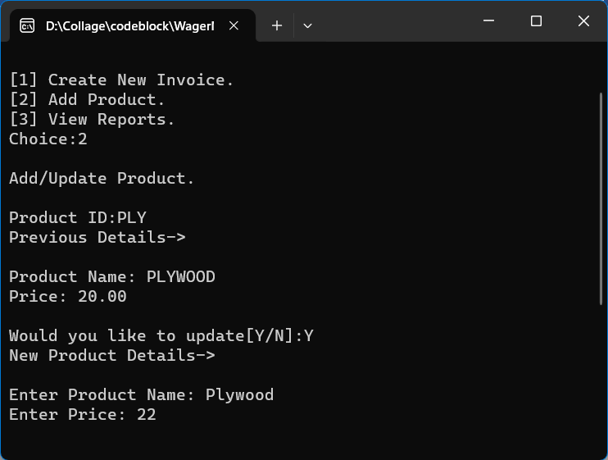 Scenario 1: Existing ID

If user inputs the existing Product Id, It will display existing Product Info and it will be asked if User want to update product info if yes(Y) in any case.

Entre Product Name, Product Price. On Enter product info will be updated.

If No(N) or anyother char it will back to Choices.

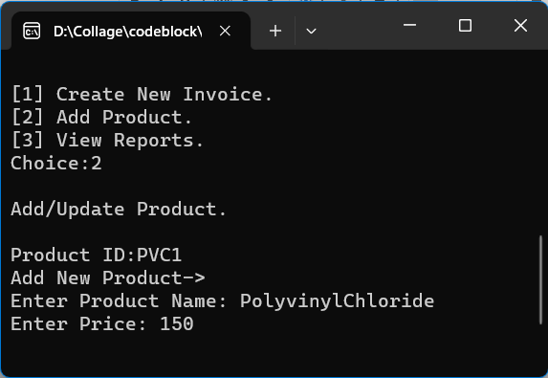Scenario 2: New Product ID

If enetred product Id dose not exist it will ask to enetr product name and product price. The new product is created in database.

show report

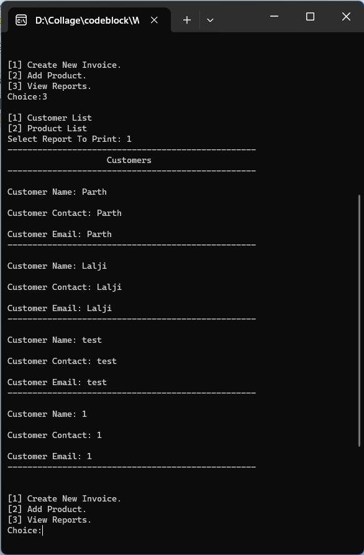

The Third chooise “View Report”, the following screen on right will be displayed it will ask to select report waqnt to View.

Currently Existing Report:

* Customers Info
* Products Info