Synopsis

__________________________________________________
Car Rental Management System: Implement a C program for a car rental service that keeps track of available cars, rental records, and customer details. Users should be able to rent or return cars, check availability, and generate invoices. The file-based storage should maintain rental history.
__________________________________________________

Statement Project Id:47
Student Name : PARTHIV PATWAL
University Roll number :2418723
Section:C-2

• Problem Description:
Car Rental Management System is a program/code to streamline the operations of car rental services. In real life, this system plays a crucial role in automating the process of managing car rentals, handling customer details, and maintaining an organized record of available cars. It allows users to check the availability of vehicles, rent cars, return them, and generate invoices for the rentals.
This system keeps track of rental history, ensuring that the rental business has an accurate record of past transactions, which can be important for auditing, customer service, and maintaining inventory. By storing car rental data in files, the system ensures that the history is preserved even after the program ends or the system restarts.
In practical terms, the Car Rental Management System ensures that:
-->User can easily rent or return cars, knowing the status of available vehicles and also can manage car availability, view rental records, and generate invoices
-->The business can track rental trends, vehicle usage, and revenue efficiently.
This system improves the efficiency of a car rental service, reduces human error, and enhances customer satisfaction, which ultimately leads to better management and business growth.

Steps of Implementation:

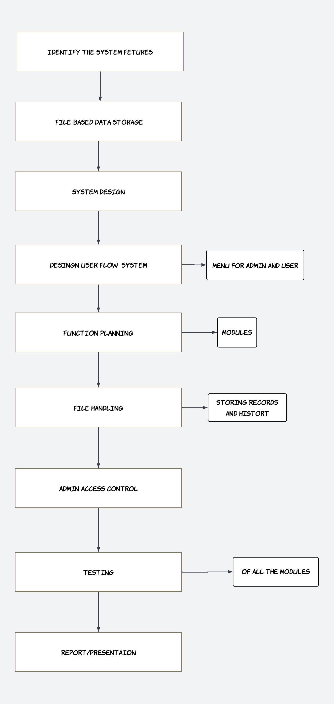
• Proposed Modules
- Admin and user control (separately)
This module will help the admin to do specific functions like adding,modifying,deleting the data,etc. For the user ,only to add the car.
2. RENT a car
This module will help to insert the data in the form of a car and detail. Also it will contain sub-module of Generate invoice, which will generate the bill/invoice.
3. Return the car
This module will help the user to return the car .Also contains sub-module to update the history of the car/data.
4. Check the availability
It will check the availability of the cars.
5. User details
It will display the details of the user(previous data).
6. View rental history
Display all the previous data of rent and the detail of the user too.

• Required topics from the subject:
1.Array
An array is a data structure used to store multiple elements of the same data type in contiguous memory locations.
It allows efficient access using an index, starting from 0.
Arrays help in storing large amounts of data using a single variable name.
Each element in an array is identified by its index.

2.Pointer
A pointer is a variable that stores the memory address of another variable.
It "points to" the location in memory where data is stored.
Pointers are declared using the * symbol (e.g., int *ptr;).
The address-of operator & is used to get the address of a variable (e.g., ptr = &x;).
The dereference operator * is used to access the value at the memory address (e.g., *ptr).
Pointers allow direct memory access and efficient memory usage.

3.Strings
A string is a sequence of characters terminated by a null character \0.
In C, strings are stored as character arrays (e.g., char str[20] = "Hello";).
The null character indicates the end of the string.
Strings can be initialized directly or using functions like gets(), scanf().
Common string functions are in the string.h library (e.g., strlen(), strcpy(), strcmp(), strcat()).

4.File Handling
It allows reading from and writing to files.
In C, it uses the FILE pointer and functions from stdio.h.
To open a file, use fopen("filename", "mode") (e.g., "r", "w", "a").

5.Structure
A structure is a user-defined data type that groups variables of different types.
Defined using the struct keyword (e.g., struct Student { int id; char name[20]; };).
Used to model real-world entities like students, books, employees, etc.
Access structure members using dot operator (.) and pointer operator (->).

Platform Required:
Visual studio (version1.92)

• Books and Link Sources:
Links :
- https://www.youtube.com/watch?v=rQoqCP7LX60&list=PLxgZQoSe9cg1drBnejUaDD9GEJBGQ5hMt

- https://youtu.be/cmGq62c1Ceg?si=KPJw6Lwpb9g9oOK9

Books :

- Computer fundamentals and programming in c by Reema Thareja

- let us c by Yashwant kanetkar

