**REPORT: Drug Similarity Analysis for Autoimmune Pancreatitis**

*Parthiv Rajesh, November 30th 2024*

1. **Problem Statement**

Autoimmune pancreatitis (AIP) is a rare chronic inflammatory condition of the pancreas characterized by its responsiveness to corticosteroid treatment. Prednisone, a corticosteroid, is commonly prescribed for managing AIP. However, exploring similar drugs with structural and chemical properties comparable to prednisone may provide alternative therapeutic options or lead to novel drug discovery. The goal of this project is to identify drugs structurally like prednisone by utilizing 2D and 3D conformers and KNIME for computational analysis.

1. **Approach**

* Disease:
  + The disease chosen for this study is **Autoimmune Pancreatitis**, a condition requiring corticosteroid therapy to reduce inflammation and manage symptoms effectively. Understanding drug alternatives for AIP can expand treatment options and improve patient care.
* Drug:
  + The drug of focus is **prednisone**, a synthetic corticosteroid widely used for its potent anti-inflammatory properties. Prednisone serves as the reference compound for similarity analysis.
* Library:
  + A comprehensive set of drugs from **PubChem** was used as the library for comparison. The library includes drugs with known 2D and 3D conformers to allow structural and chemical similarity analysis.

1. **KNIME – Workflow and Results**

* Input data:
  + PubChem database integration to retrieve 2D and 3D conformers of prednisone and library compounds.
  + Prednisone selected as the reference molecule.
* Data pre-processing:
  + Molecules were converted to standard formats (e.g., SMILES or SDF) for compatibility.
  + Structural normalization was applied via raw data
* Feature Extraction:
  + 2D and 3D molecular descriptors were computed for all compounds in the library using KNIME nodes.
* Similarity Analysis:
  + Structural and chemical similarity scores were calculated using **Tanimoto Coefficients** for 2D similarity and **RMSD** for 3D alignment.
* Visualisation:
  + Results were visualized using scatter plots and heatmaps for better interpretability of similarity relationships.
* Filtering:
  + Compounds with similarity scores above a defined threshold (e.g., Tanimoto > 0.8) were shortlisted as like prednisone.

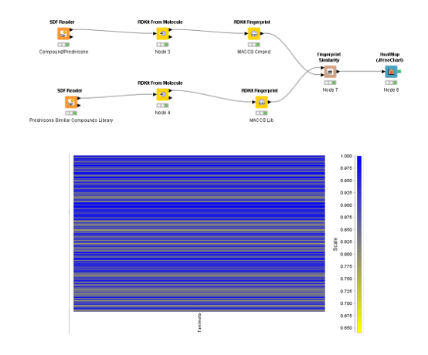

2D Conformer (Workflow and Visualisation)

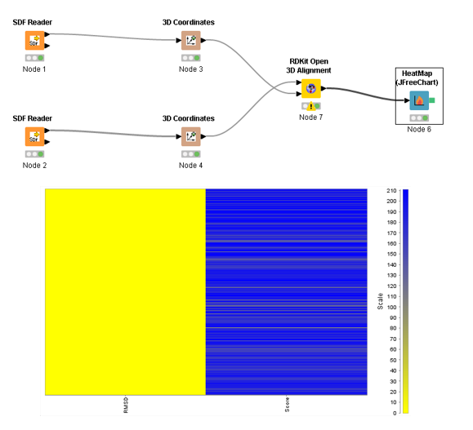

3D Conformer (Workflow and Visualisation)

1. **Results**

* Top Similar Drugs Value Identified:
  + 2D conformer values:
    - Tanimoto Scores: 0.85, 0.90, 0.95, 1.00
  + 3D conformer values:
    - RMSD Scores: 0.00, 0.25,0.50,0.75

1. **Conclusion**

This study highlights how computational tools like KNIME can be utilized to identify potential drug candidates with structural and chemical similarities to prednisone. By combining 2D fingerprint analysis with 3D spatial alignment, the workflow provided a well-rounded approach to evaluating molecular similarities. Several compounds with high similarity scores were identified, indicating potential alternatives to prednisone for the treatment of Autoimmune Pancreatitis.

The findings emphasize the value of integrating both 2D and 3D analyses, as 2D fingerprints efficiently capture structural patterns while 3D alignment adds crucial information about spatial properties. This dual approach enhances the reliability and applicability of the results in real-world pharmacological contexts, such as understanding drug interactions or repurposing compounds.

Overall, the workflow demonstrates the potential of computational methods in streamlining drug discovery and optimizing research efficiency. It also sets a foundation for applying similar methodologies to other diseases and therapeutic compounds in the future.

With all due regards  
Thanking you

Yours sincerely

**Parthiv Rajesh**

@Bversity School of Bioscience

@Bversity+ Community