Assignment No. 2

1.Problem Statement:
Implement constraint satisfaction problem.
The Missionaries and Cannibals problem is a classic puzzle where three missionaries and three cannibals need to cross a river using a boat. The boat can hold up to two people, and it is crucial to ensure that the number of cannibals never exceeds the number of missionaries on either side of the river. The goal is to get all of them safely across without violating this constraint.

2. Objective:
The objective is to develop an interactive solution that allows the user to safely move all missionaries and cannibals across the river, ensuring that at no point on either side of the river do the cannibals outnumber the missionaries. The solution must take user input for boat movement and check for win or loss conditions based on valid transitions.

3. Theory:
The Missionaries and Cannibals problem is categorized as a constraint satisfaction problem (CSP) in AI. Each state of the puzzle is a configuration representing the number of missionaries, cannibals, and the boat's location on either side of the river.

- State-Space Representation:
Each state is represented by the number of missionaries and cannibals on the left side of the river, the number on the right side, and the boat's position (either on the left or right bank). The challenge is to find a sequence of valid transitions from one state to another that results in all the missionaries and cannibals safely crossing the river.

- Constraints:
Boat capacity: The boat can carry at most two people at a time.
Missionary-Cannibal ratio: At any given time, on both sides of the river, the number of missionaries must not be less than the number of cannibals (unless there are no missionaries on that side).

If a state violates these constraints, it leads to an invalid state where cannibals outnumber missionaries, resulting in the loss of the game.

4. Methodology:

The solution can be approached as a user-driven interactive problem where the program takes input from the user to simulate boat movements across the river. The following methodology outlines the steps involved in solving the problem.

Steps:
1. Initial Setup: Start with all three missionaries, three cannibals, and the boat on the left side of the river.
2. User Input: The user is prompted to choose how many missionaries and cannibals (up to two) to move in the boat. The boat moves them to the other side of the river.
3. State Validation: After each move, the program checks whether the new state is valid. A state is invalid if the number of cannibals exceeds the number of missionaries on either side.
4. Win Condition: The game is won when all three missionaries and three cannibals are safely on the right side of the river.
5. Loss Condition: The game is lost if at any point the number of cannibals exceeds the number of missionaries on either side of the river.

5. Algorithm/Working:
1. Initialize Game:
- Set the initial state with 3 missionaries, 3 cannibals, and the boat on the left side of the river.
- Set the right side of the river to 0 missionaries, 0 cannibals, and no boat.

2. User Input:
- Prompt the user to select how many missionaries and cannibals to move (the total must not exceed 2).

3. Move Validation:
- Check if the move is valid:
- Ensure the number of people on the boat is between 1 and 2.
- Ensure that after the move, the number of cannibals does not exceed the number of missionaries on either side.

4. State Update:
- If the move is valid, update the state by moving the selected number of people across the river.

5. Win or Loss Condition:
- Check if all missionaries and cannibals have crossed (win condition).
- If cannibals outnumber missionaries on either side (loss condition).

6. Repeat:
- Continue prompting the user for input until the game is either won or lost.

6. Advantages:
- Interactive Learning: The program allows users to understand the problem through hands-on interaction, promoting learning.
- Reinforces Problem-Solving Skills: By allowing users to test different strategies, it sharpens their ability to solve constraint satisfaction problems.
- Simplicity: The problem is simple to implement using basic control structures like loops and conditional statements.

7. Diagram:
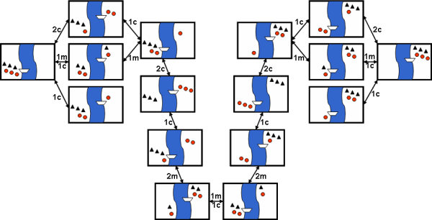

8. Applications:
- Artificial Intelligence: The Missionaries and Cannibals problem is often used as an introductory example in AI to teach state-space search algorithms and constraint satisfaction.
- Game Development: Similar logical constraints are frequently encountered in puzzle game development.
- Education: The problem is a great tool for teaching logical reasoning and decision-making in computer science and AI courses.

9. Conclusion:
In this assignment, the Missionaries and Cannibals problem illustrates how state-space search and constraint satisfaction can be applied to solve complex puzzles. This interactive implementation provides us an excellent opportunity for users to learn and practice making logical decisions under constraints.

