Assignment 8

1.Problem Statement

Implement Backward Chaining Algorithm
The objective of this assignment is to implement the Backward Chaining algorithm, which is used to answer specific queries from a knowledge base. This technique is essential for goal-driven reasoning, allowing systems to infer information based on established facts and rules.

2.Objectives
- Understand the principles of goal-driven reasoning.
- Implement the Backward Chaining algorithm for knowledge inference.

3.Theory

What is Backward Chaining?
Backward Chaining is a reasoning method that starts with a specific goal or query and works backward to determine which facts or rules support that goal. This approach is particularly useful in systems where specific answers are sought from a broader knowledge base.

4. Methodology
- Start with a Goal Query:
  - Define the goal or query that you want to prove or answer based on the existing knowledge base.
- Identify Rules that Can Satisfy the Goal:
  - Examine the rules in the knowledge base to find those that can lead to the goal. A rule is generally structured as "If premises, then conclusion."
- Work Backward to Find Supporting Facts for the Rules:
  - For each rule identified, check if the premises can be satisfied by known facts or other rules. This may involve further queries.
- Continue Until the Goal is Proven or No More Rules Can Be Applied:
  - If the premises are satisfied, the goal is proven. If no more applicable rules can be found, or if the premises cannot be satisfied, the proof fails.

5.Working Principle / Algorithm
Here’s a simple outline of the Backward Chaining algorithm:
- Initialize the Knowledge Base:
  - Represent known facts and inference rules. For example:
    - Facts: F1,F2,…,FnF_1, F_2, \ldots, F_nF1​,F2​,…,Fn​
    - Rules: If AAA then BBB.
- Define the Goal Query:
  - Specify the goal you want to prove (e.g., GGG).
- Check for Known Facts:
  - If GGG is a known fact, return true.
- Search for Relevant Rules:
  - For each rule in the knowledge base, check if GGG matches the conclusion of any rule.
  - If a matching rule is found, recursively apply the algorithm to its premises.
- Return the Result:
  - If all premises are satisfied (i.e., proven true), then GGG is also true. If any premise fails to be satisfied, backtrack and try other rules.

6.Advantages
- Efficiency: Backward chaining is efficient for goal-driven systems, as it focuses only on relevant information needed to prove the goal.
- Dynamic Queries: It allows for dynamic querying, making it flexible for various inquiries based on the knowledge base.

7.Disadvantages / Limitations
- Dynamic Knowledge Handling: May not handle dynamic knowledge well since it relies on existing facts and rules.
- Complexity in Large Knowledge Bases: If the knowledge base is large and complex, determining applicable rules may become computationally intensive.

8.Diagram

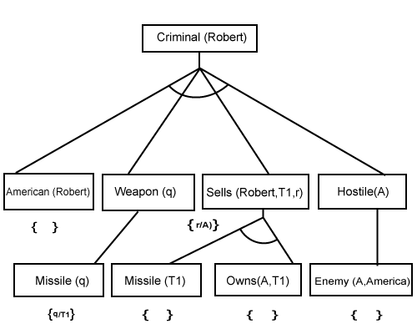

9.Conclusion
Backward chaining is a powerful technique for goal-driven reasoning, effectively answering specific queries from a knowledge base. It emphasizes the necessity of known facts and rules while focusing on proving desired conclusions.

