**User Guide**

Notes:

1. Before build car make sure you build 6 parts & select exact 6 parts.
2. After creating every parts & vehicle deselect everyone and select newly created.
3. Metamask will ask each time for approval for every transaction. You can disable also

* Home Page : Part factory

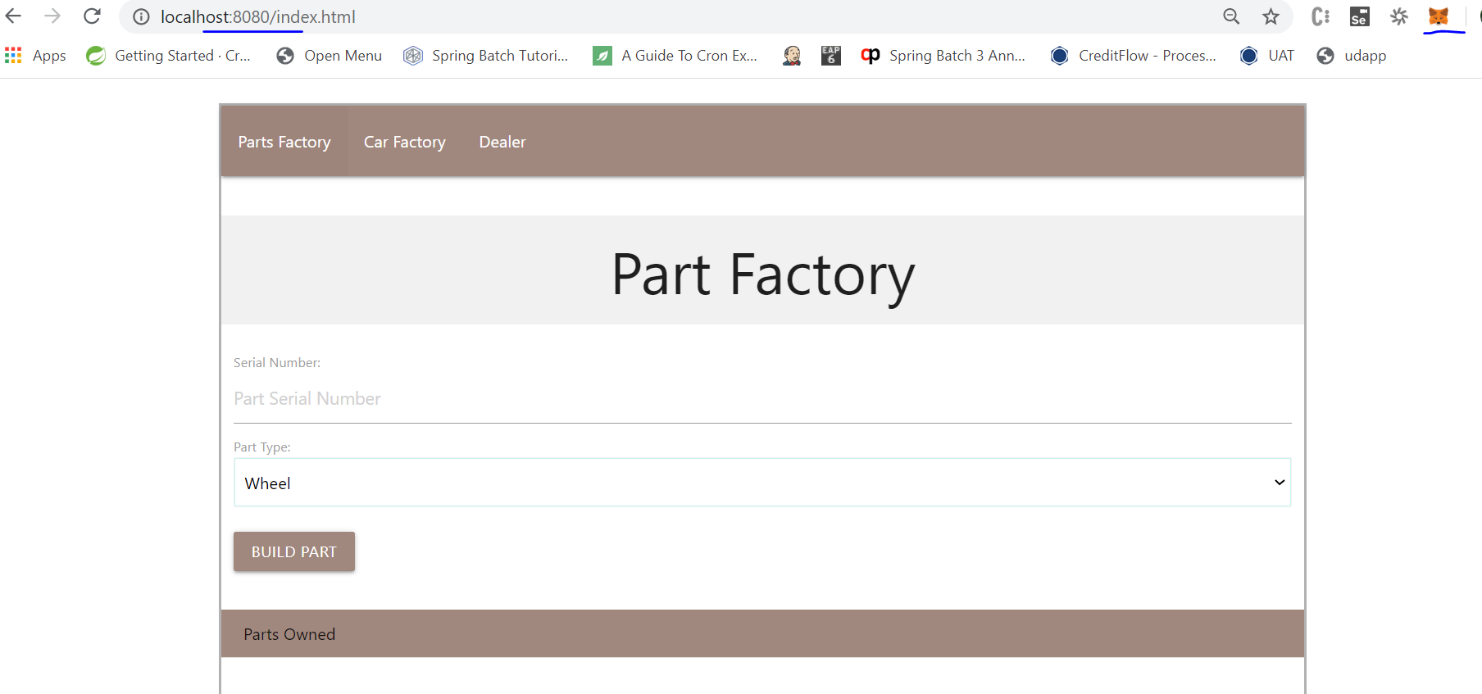

* Select Part type & provide Serial number and click on Build part, you will notification on metamast

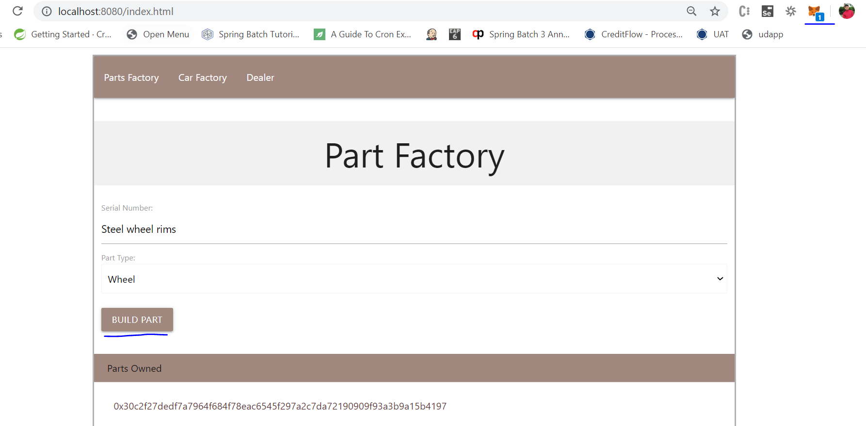

* Approve : Transection from metamast, there you can also see gas fee

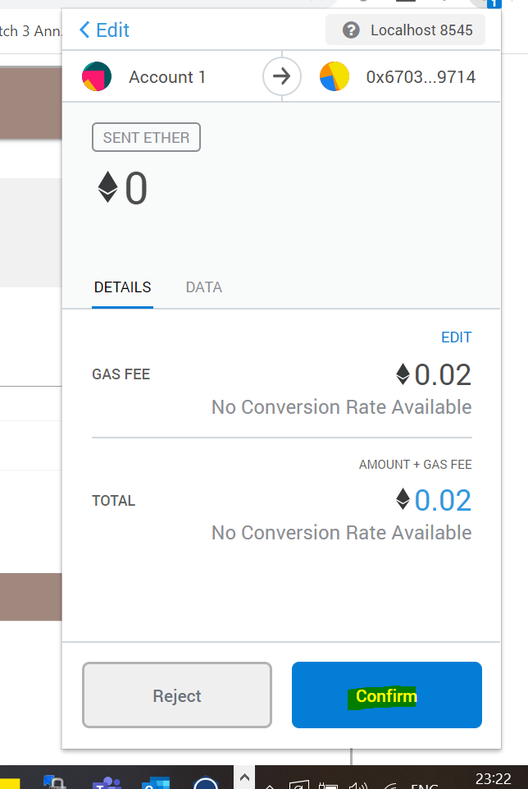

* You can see part created once you select , it will provide information

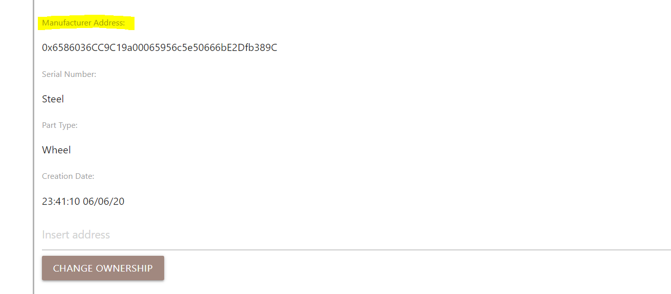

Repeat this for 6 times (basically wheels , engine, body parts & more)

Note: Make sure you unselect all selected item before selecting new item

* Go to Car Factory page with same account, you will see prepopulated parts.

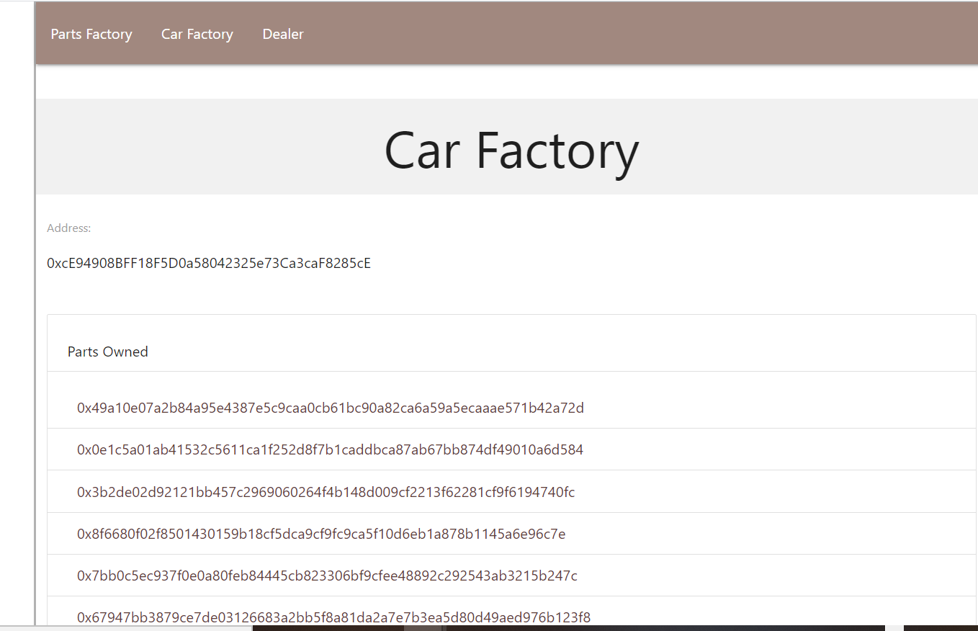

* Make sure you have 6 parts & you only select 6 parts & provide Serial name & select on Build car.

You will **Car Owned** is populated -> once you select , you will see all information

**Make sure you select all parts build , step by step.-> it internally provide ownership with your selected account**

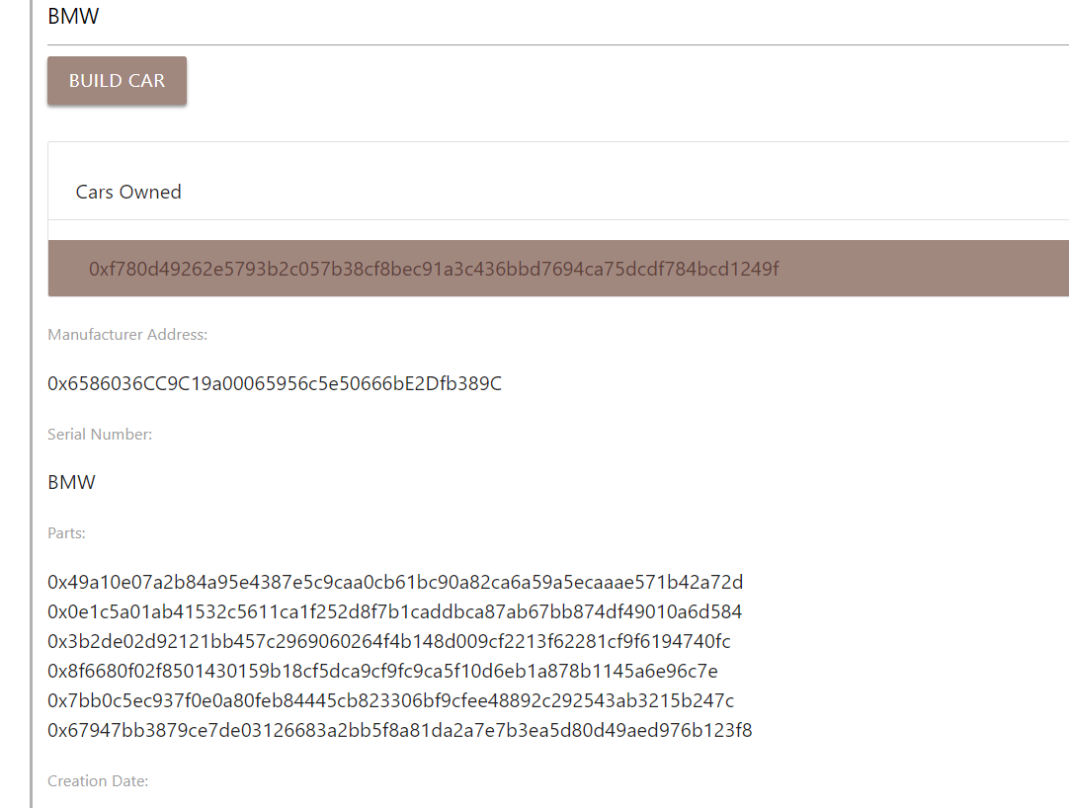

* Create one more part with different account on **Part Factory page**
* Make sure you select that part in **Part Factory page**
* Go to **Car Factory page**
* You will see part populated with one part (you will not see already created parts)

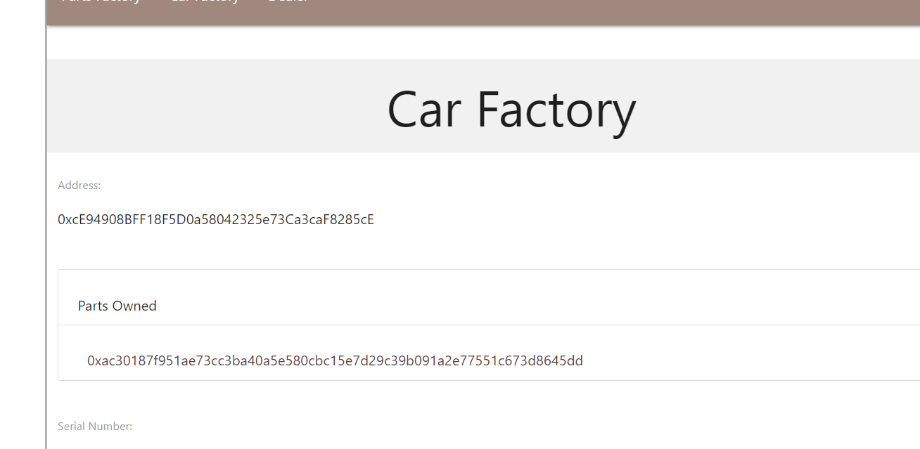

* Now switch account to previously used account with we created 6 parts & refresh page
* You will see all 6 parts but not part created with different account. So it will manage all details as per account wise, Account only see parts or Car build by him not by others

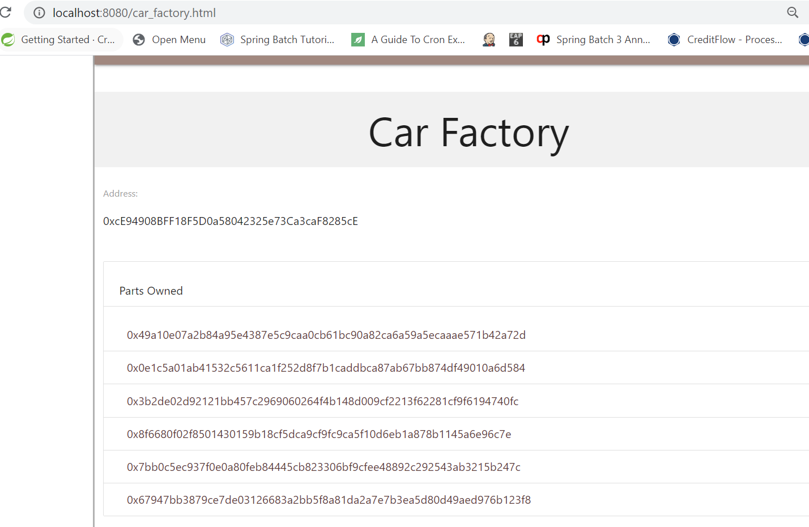

* Lets create ne more part & change ownership to second account(account has one part)
* Go to **Page Factory. -> Keep same account with we have created 6 parts .create new part & select it**

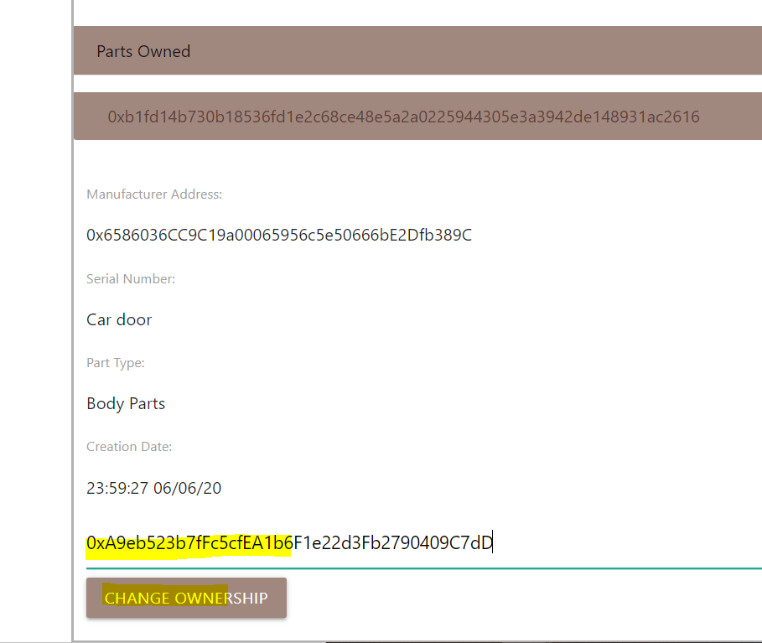

* Provide another account number(the one with we have create one part before) & click on **CHANGE OWNERSHIP** button.
* Now switch to another account and go to **Car Factory page,** you will see 2 account now.
* Ownership is changed successfully

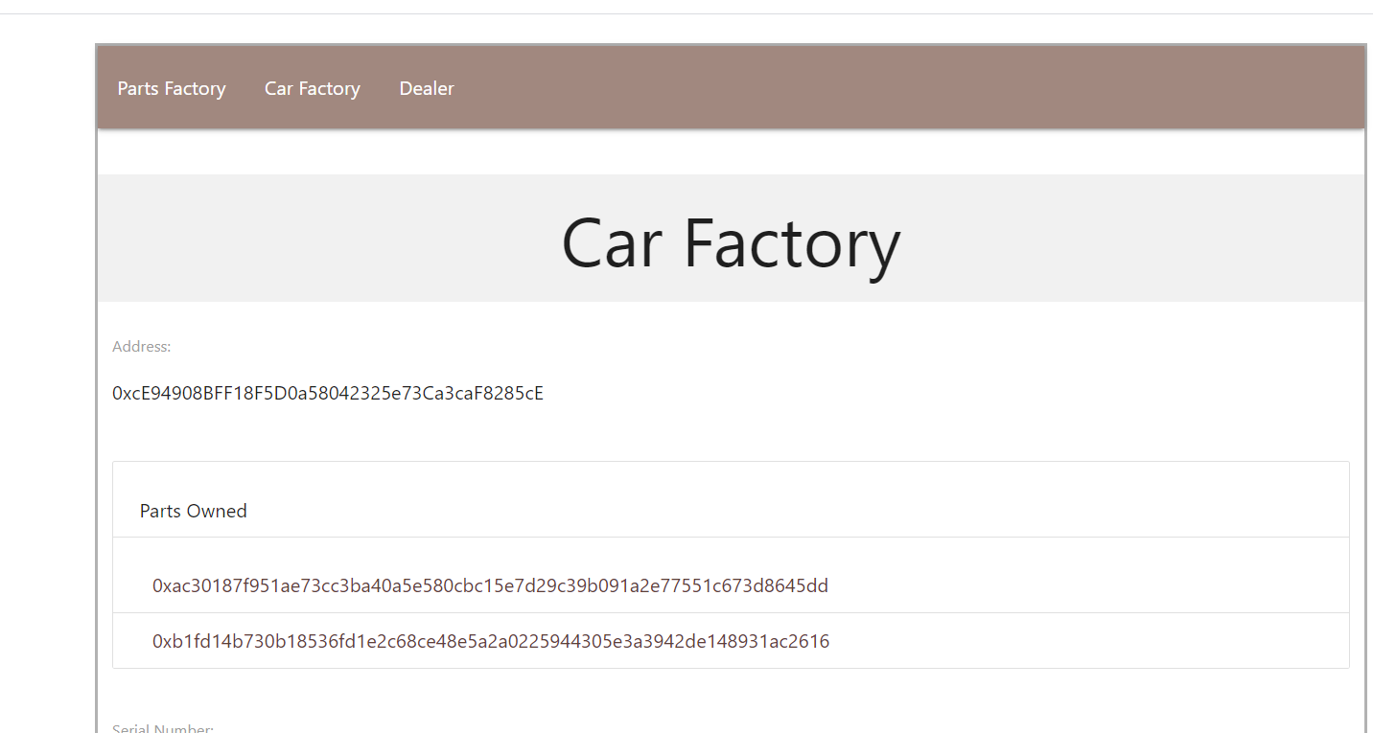

Note : Same can be done with CAR OWNERSHEEP.

* Now go to **Dealer webpage**.
* You will see all page is populated with Car & Parts history

Note : it will also see based on what account we have selected & change ownership.

With Account one we have created 7 parts but for 1 part we have changed ownership

Once you select part , it will show the ownership.

Here I selected 2 parts with one part has changed ownership.

