**Google Tag Manager and Google Analytics Setup Report**

**Objective**

The goal of this task was to set up basic tracking on a website using Google Tag Manager (GTM) and Google Analytics (GA). This includes tracking:

1. Page views.
2. Button click events on a specific button.

**Steps Followed**

**1. Google Tag Manager (GTM) Setup**

* **GTM Container Creation**:  
  Created a GTM container for the project with the name: <<Container Name>>. The GTM snippet was added to the website’s index.html file.
  + **Screenshot**: GTM Tags Overview:  
    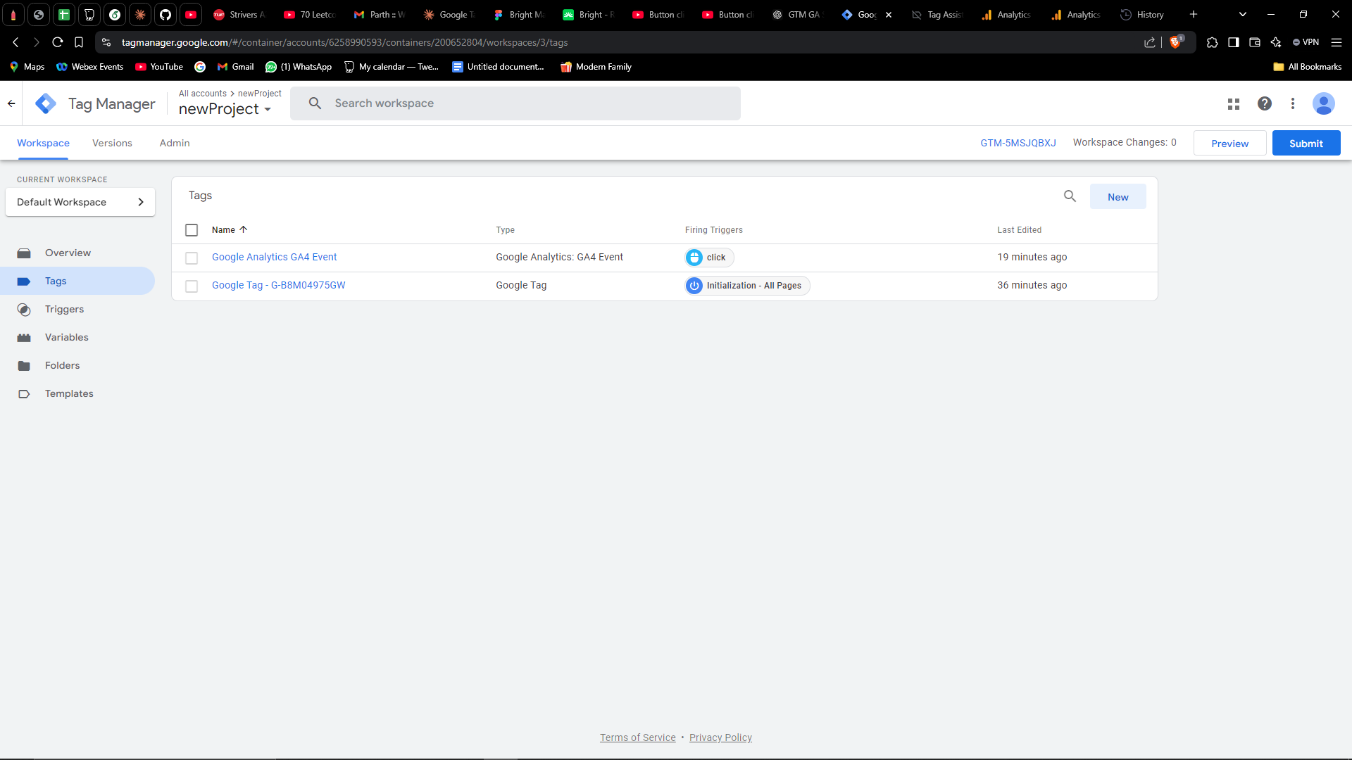
* **Tag and Trigger Configurations**:
  + **GA4 Configuration Tag**:  
    Configured a tag to track **Page Views** on all pages.
    - Trigger: All Pages.
    - Screenshot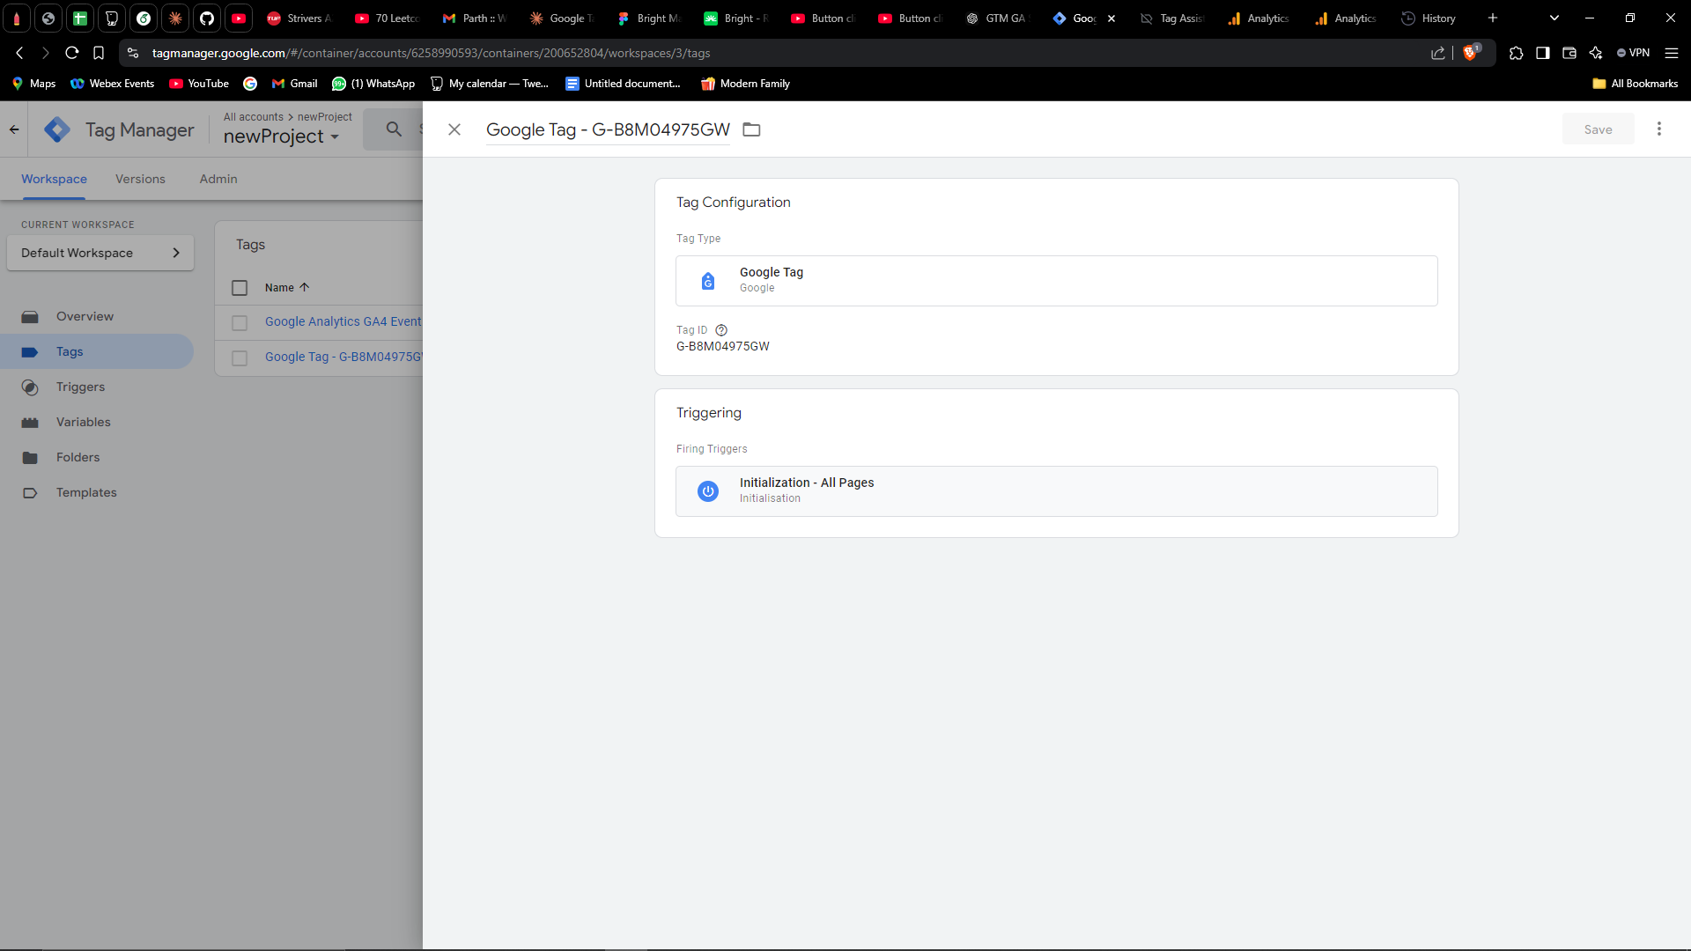
  + **GA4 Event Tag**:  
    Created an event tag to track **Button Clicks** for a specific button.
    - Trigger: A custom **Click - All Elements** trigger targeting the button with the ID test-button.
* Screenshot: 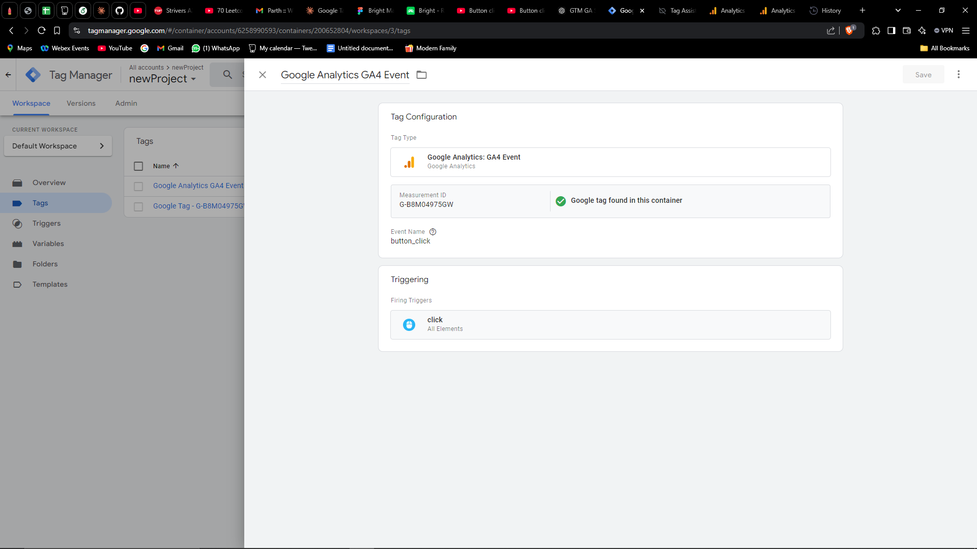
* **Preview Mode Testing**:  
  Used GTM Preview Mode to ensure tags fired correctly when interacting with the local site.
  + Screenshot: Debug Mode showing button click trigger and tags fired:  
    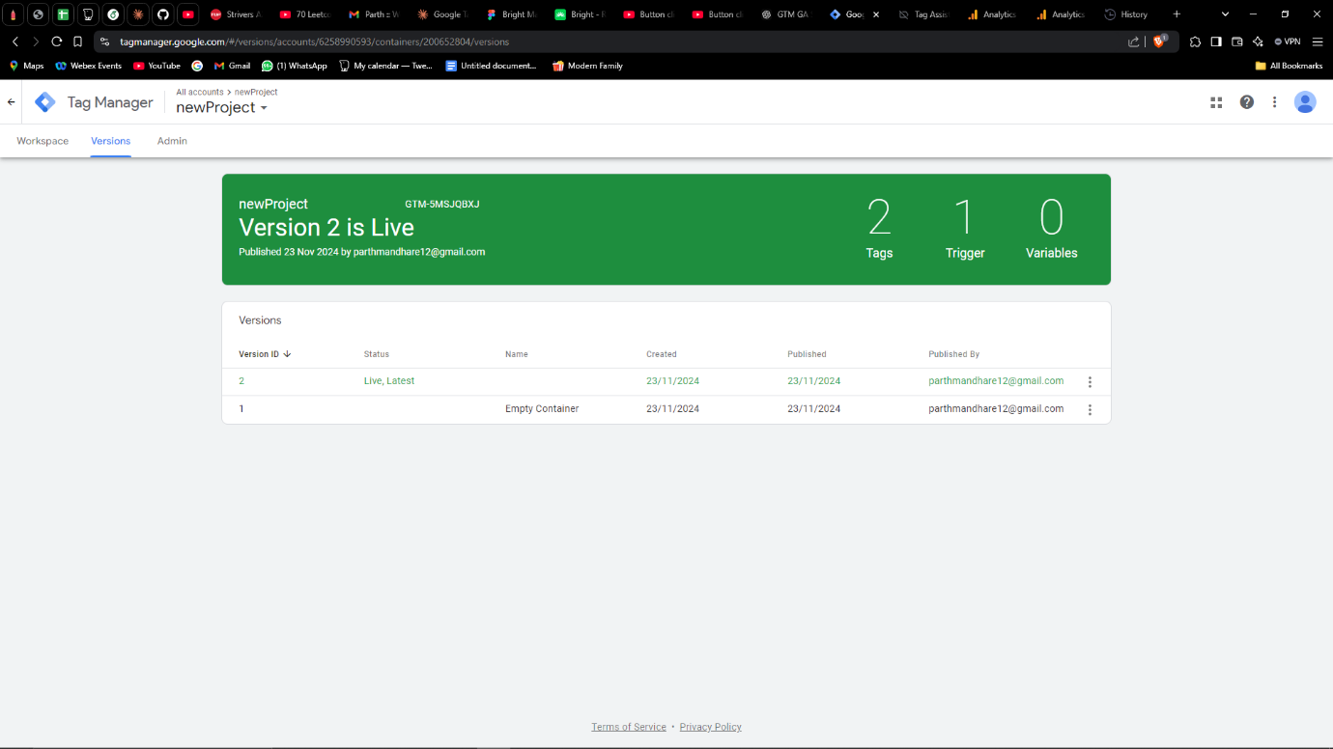

**2. Google Analytics (GA) Setup**

* **GA4 Property Creation**:  
  Created a Google Analytics 4 (GA4) property with the placeholder website URL: http://127.0.0.1:5500/index.html.
* **Web Stream Creation**:  
  Configured a web stream in GA4 and retrieved the **Measurement ID**.
* **Real-Time Event Tracking**:  
  Verified in the Google Analytics Real-Time Report that the following events were successfully tracked:
  + **Page Views**: Tracked when loading the site.
  + **Button Clicks**: Tracked when the specified button was clicked.
  + Screenshot: 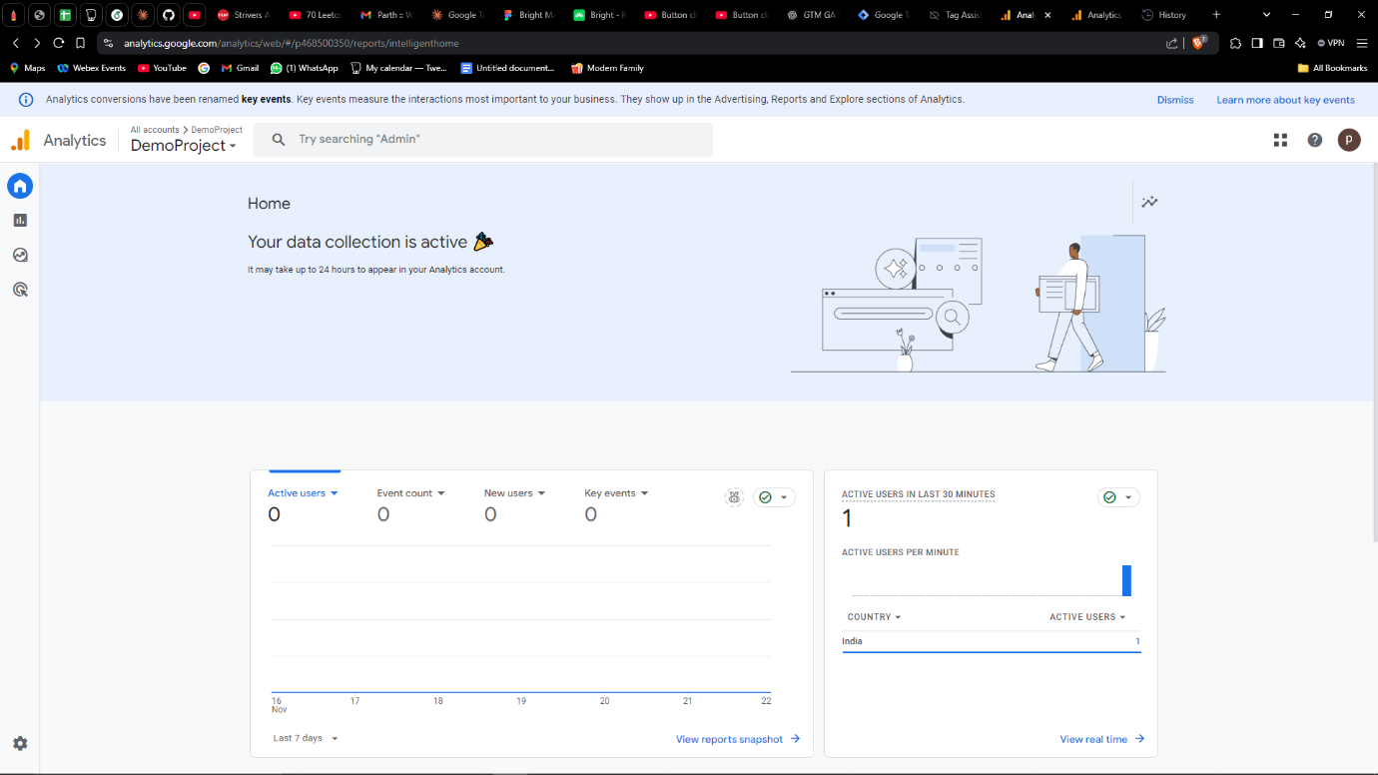

**Results**

The setup was successfully completed, and tracking was verified for:

1. **Page Views**: All page views are logged in Google Analytics.
2. **Button Clicks**: A specific button click event is recorded in Google Analytics when triggered.

**Conclusion**

This task demonstrates the integration of Google Tag Manager and Google Analytics to capture key user interactions on a website. Both page views and custom button click events were successfully tracked and tested locally.