EAST WEST UNIVERSITY

Fall-2022

Department: Computer Science and Engineering

Course Title: Computer Architecture

Course Code: CSE360 Section No: 01

Project Report

Project Name: Microprocessor Based automatic Attendance Recorder

Submitted By:

|  |  |
| --- | --- |
| Name | ID |
| **Mahmudul Islam Partho** | 2019-3-60-027 |
| **Noortaz Ahmed** | 2019-3-60-030 |
| **Marzana Jahan** | 2019-2-60-023 |

Submitted To:

**Md. Sawkat Ali**

**Assistant Professor**

Department of Computer Science and Engineering

East West University

Project Title:

Microprocessor based automatic attendance recorder with RFID system.

Objective:

In this project we implement a microprocessor (8051) based attendance system recorder that we can record to all the student’s attendance who will enter in the classroom through swipe their id card in the RFID system.

Theory:

Using an 8051-microcontroller (model:AT89C51) and LCD Display (model: LM016L) and a radio frequency identification device (RFID) we implement the serial communication device which read the ID number of the students and show alphanumeric Text on the LCD screen. If the students are issued with the RFID tag When the tag is placed near the reader, data is transferred to reader. Reader then transfers data to the microcontroller. After microcontroller checks for the data continuously, if any data is received, microcontroller compares the data in data base and if the tag is authenticated then the microcontroller takes the attendance and show it to the LCD display.

Equipment and Components:

1. 8051 Microcontroller (AT89C51)
2. Alphanumeric 16x2 LCD Display
3. RFID Reader
4. Wire

Design:

Design of Microprocessor based automatic attendance recorder with RFID system

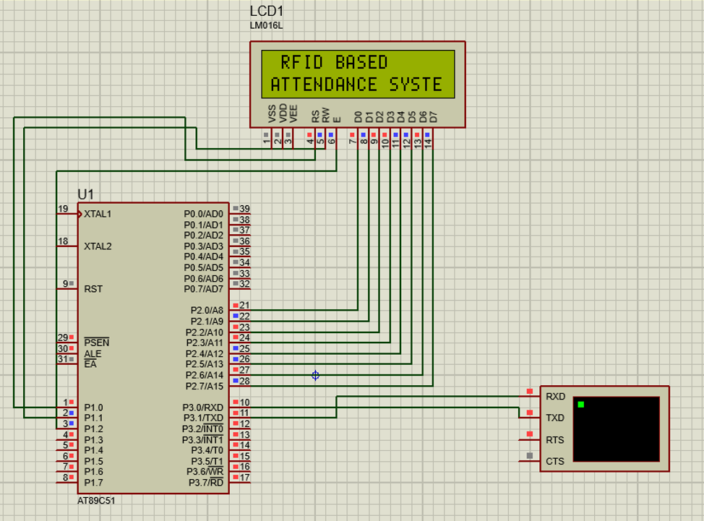

Figure 01: Diagram (This is designed in Proteus 8.13)

Implementation:

➔Implementation Steps:

1. Initialize the LCD
2. Initialize the Serial Communication (9600 Baud Rate)
3. Receive the 13 bytes and check
4. And display them into the LCD Display

In this project, we display only 13 bytes of student id given by our university. But we can take any arbitrary number. If it is matching it can run the motor.

➔The main source code: (Using Keil uVision5 IDE)

#include<reg51.h>

sbit rs=P1^0;

sbit rw=P1^1;

sbit en=P1^2;

void lcddat(unsigned char);

void lcdcmd(unsigned char);

void lcddis(unsigned char *);

void lcd_init();

void serial_init();

void ser_dis(unsigned char *);

void check();

void delay();

unsigned char rfid[13],i;

// Main Function

void main(){

serial_init();

lcd_init();

lcddis(" RFID BASED ");

lcdcmd(0xc0);

lcddis("ATTENDANCE SYSTEM");

ser_dis("3245FR6786B12 - Ali Sir");

ser_dis("2019-3-60-027 - partho");

ser_dis("2019-3-60-030 - Noortaz");

ser_dis("2019-2-60-023 - Marzana");

while(1){

lcdcmd(0x01);

lcddis("SWIPE YOUR CARD");

ser_dis("SWIPE YOUR CARD");

for(i=0;i<13;i++){

while(RI==0);

rfid[i]=SBUF;

RI=0;

SBUF=rfid[i];

while(TI==0);

TI=0;

}

check();

SBUF=0X0D;

while(TI==0);

TI=0;

}

}

// Checker Function

void check(){

if(rfid[0]=='2'&&rfid[1]=='0'&&rfid[2]=='1'&&rfid[3]=='9'&&rfid[4]=='-'&&rfid[5]=='3'&&rfid[6]=='-'&&rfid[7]=='6'&&rfid[8]=='0'&&rfid[9]=='-'&&rfid[10]=='0'&&rfid[11]=='2'&&rfid[12]=='7'){

lcdcmd(0x01);

lcddis("STUDENT");

lcdcmd(0xc0);

lcddis("Partho - PRESENT");

ser_dis(" - Partho PRESENT");

}

else

if(rfid[0]=='3'&&rfid[1]=='2'&&rfid[2]=='4'&&rfid[3]=='5'&&rfid[4]=='F'&&rfid[5]=='R'&&rfid[6]=='6'&&rfid[7]=='7'&&rfid[8]=='8'&&rfid[9]=='6'&&rfid[10]=='B'&&rfid[11]=='1'&&rfid[12]=='2'){

lcdcmd(0x01);

lcddis("Sir");

lcdcmd(0xc0);

lcddis("Ali Sir - PRESENT");

ser_dis(" - Ali Sir PRESENT");

}

else if(rfid[0]=='2'&&rfid[1]=='0'&&rfid[2]=='1'&&rfid[3]=='9'&&rfid[4]=='-'&&rfid[5]=='3'&&rfid[6]=='-'&&rfid[7]=='6'&&rfid[8]=='0'&&rfid[9]=='-'&&rfid[10]=='0'&&rfid[11]=='3'&&rfid[12]=='0'){

lcdcmd(0x01);

lcddis("STUDENT");

lcdcmd(0xc0);

lcddis("Noortaz - PRESENT");

ser_dis(" - Noortaz PRESENT");

}

else if(rfid[0]=='2'&&rfid[1]=='0'&&rfid[2]=='1'&&rfid[3]=='9'&&rfid[4]=='-'&&rfid[5]=='2'&&rfid[6]=='-'&&rfid[7]=='6'&&rfid[8]=='0'&&rfid[9]=='-'&&rfid[10]=='0'&&rfid[11]=='2'&&rfid[12]=='3'){

lcdcmd(0x01);

lcddis("STUDENT");

lcdcmd(0xc0);

lcddis("Marzana - PRESENT");

ser_dis(" - Marzana PRESENT");

}

else{

lcdcmd(0x01);

lcddis("Not valid");

lcdcmd(0xc0);

lcddis("NOT REGISTERED");

ser_dis(" - NOT REGISTERED");

}

}

// LCD initialization function

void lcd_init(){

lcdcmd(0x38);

lcdcmd(0x01);

lcdcmd(0x10);

lcdcmd(0x0c);

lcdcmd(0x80);

}

// LCD common function

void lcdcmd(unsigned char val){

P2=val;

rs=0;

rw=0;

en=1;

delay();

en=0;

}

// LCD data function

void lcddat(unsigned char val){

P2=val;

rs=1;

rw=0;

en=1;

delay();

en=0;

}

// delay or wait function

void delay(){

unsigned int j;

for(j=0;j<16000;j++);

}

// LCD display show function

void lcddis(unsigned char *s){

unsigned char m;

for(m=0;s[m]!='\0';m++){

lcddat(s[m]); }

}

// serial initialization function

void serial_init(){

SCON=0X50;

TMOD=0X20;

TH1=-3;

TR1=1;

}

// serial display show function

void ser_dis(unsigned char *s){

unsigned char v;

for(v=0;s[v]!='\0';v++){

SBUF=s[v];

while(TI==0);

TI=0;

}

SBUF=0x0d;

while(TI==0);

TI=0;

}

Debugging-Test-run:

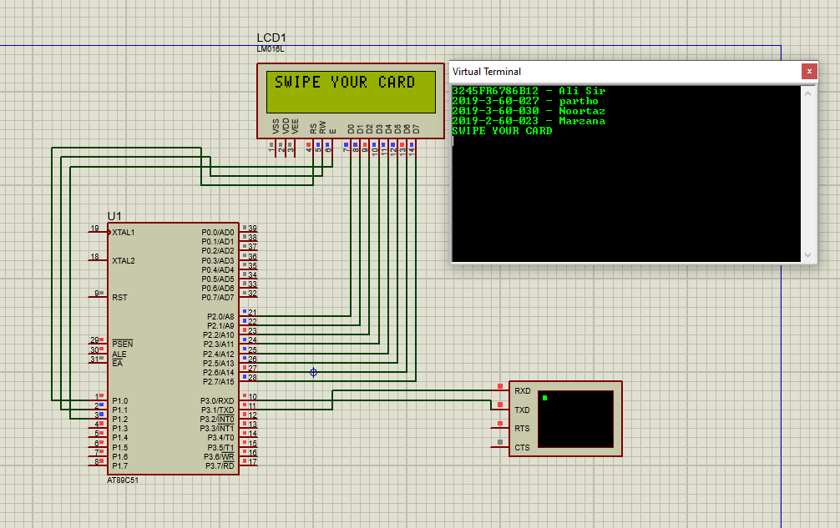

Figure-02: Default run window

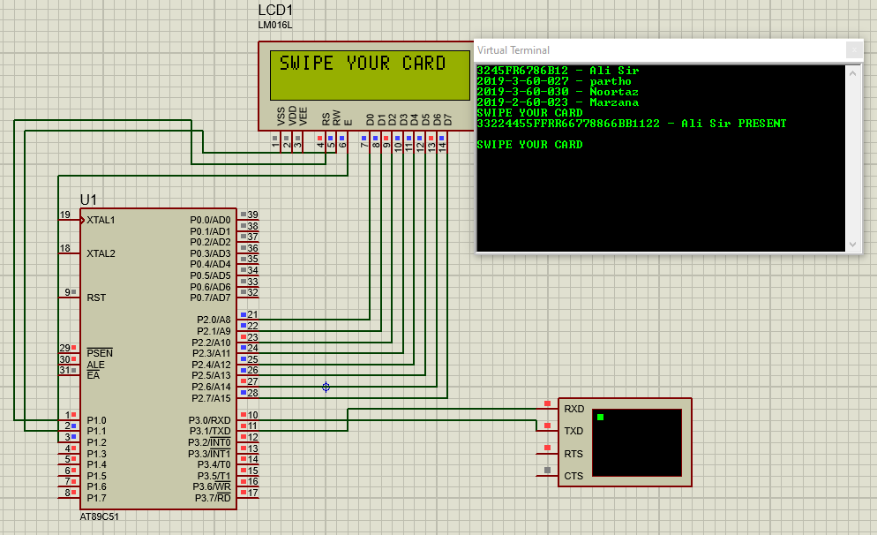

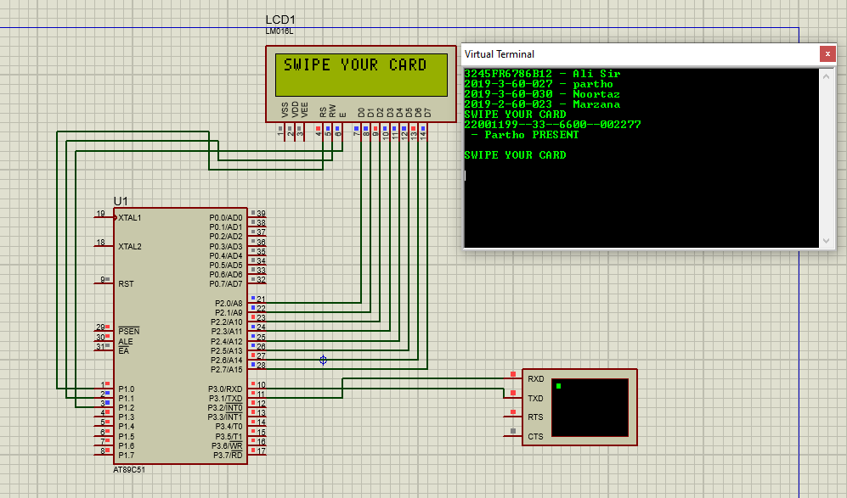

Figure-03: Generating a valid ID and successfully can be seen on Display

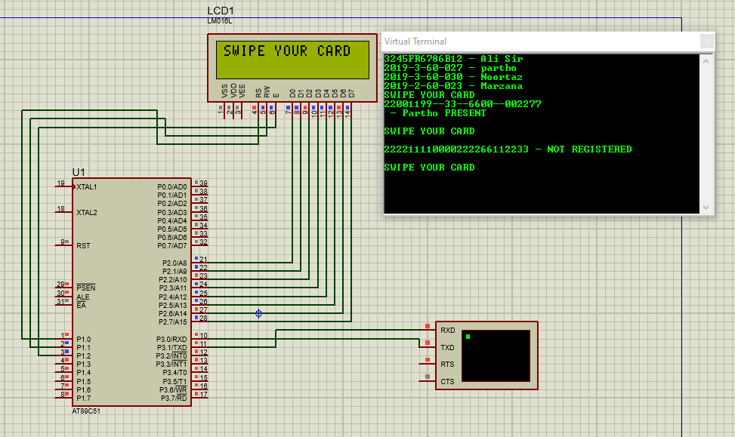

Figure-04: Invalid ID system can recognize and show on the LCD display

Conclusion and Future Improvements:

After all the test run, it is seen that the implemented system run perfectly, and the source code and the design are successfully interconnected to each other and so the system operate the process perfectly.

In the terms of future improvement, if this device can automatically time management system of student attendance and do automatic action with the management time so it will be a futuristic feature for this device.

# Bibliography

References of online Resources/Articles:

1. https://www.camcode.com/asset-tags/what-are-rfid-tags/
2. https://www.circuitstoday.com/rfid-based-attendance-system
3. https://www.projectsof8051.com/rfid-based-attendance-managementsystem/