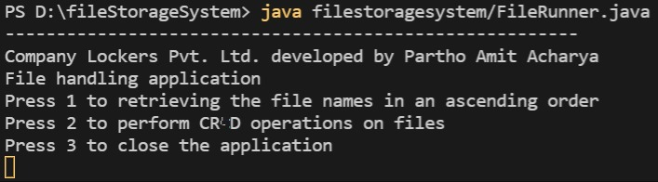

ABOVE PICTURE IS THE OUTPUT OF MY PROGRAM FOR PHASE 1 ASSESSMENT.