**Open Ended Problem**

**Aim : N Queen Problem**

Main

package nqueen;

public class NQUEEN

{

public static void main(String[] args)

{

java.awt.EventQueue.invokeLater(new Runnable() {

public void run() {

new Main_Form().setVisible(true);

}

});

}

}

Main Form

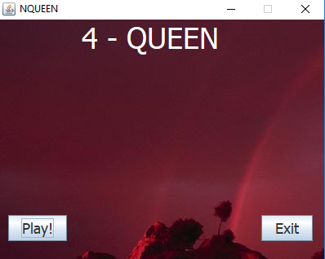

package nqueen;

import javax.swing.JOptionPane;

public class Main_Form extends javax.swing.JFrame

{

public Main_Form()

{

initComponents();

}

queen obj=new queen();

private void ExitActionPerformed(java.awt.event.ActionEvent evt)

{

int val=JOptionPane.showConfirmDialog(this, "Do you want to exit?");

if(val==0)

{

System.exit(0);

}

if(val==1)

{

obj.Restart();

}

}

private void PlayActionPerformed(java.awt.event.ActionEvent evt) {

this.setVisible(false);

User_Change ob=new User_Change();

ob.setVisible(true);

}

public static void main(String args[])

{

java.awt.EventQueue.invokeLater(new Runnable() {

public void run() {

new Main_Form().setVisible(true);

}

});

}

// Variables declaration - do not modify

private javax.swing.JButton Exit;

private javax.swing.JButton Play;

private javax.swing.JLabel jLabel1;

private javax.swing.JLabel jLabel3;

// End of variables declaration

}

About Form

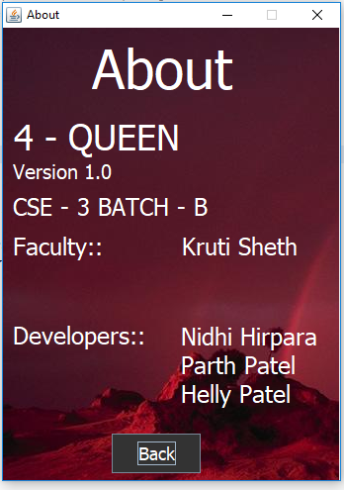

package nqueen;

public class About extends javax.swing.JFrame

{

public About()

{

initComponents();

}

private void jButton1ActionPerformed(java.awt.event.ActionEvent evt)

{

this.setVisible(false);

Pause obj1=new Pause();

obj1.setVisible(true);

}

public static void main(String args[])

{

java.awt.EventQueue.invokeLater(new Runnable() {

public void run() {

new About().setVisible(true);

}

});

}

// Variables declaration - do not modify

private javax.swing.JButton jButton1;

private javax.swing.JLabel jLabel2;

private javax.swing.JLabel jLabel3;

private javax.swing.JLabel jLabel4;

private javax.swing.JLabel jLabel5;

private javax.swing.JLabel jLabel6;

private javax.swing.JLabel jLabel7;

private javax.swing.JLabel jLabel8;

private javax.swing.JLabel jLabel9;

// End of variables declaration

}

Pause Form

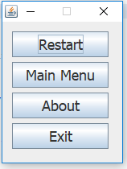 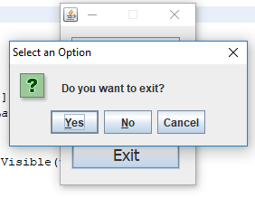

package nqueen;

import javax.swing.JOptionPane;

public class Pause extends javax.swing.JFrame

{

public Pause()

{

initComponents();

}

queen obj=new queen();

private void ResumeActionPerformed(java.awt.event.ActionEvent evt) {

this.setVisible(false);

obj.setVisible(true);

}

private void AboutActionPerformed(java.awt.event.ActionEvent evt) {

this.setVisible(false);

About obj1=new About();

obj1.setVisible(true);

}

private void ExitActionPerformed(java.awt.event.ActionEvent evt) {

int val=JOptionPane.showConfirmDialog(this, "Do you want to exit?");

if(val==0)

{

System.exit(0);

}

if(val==1)

{

obj.Restart();

}

}

private void MainMenuActionPerformed(java.awt.event.ActionEvent evt) {

Main_Form ob=new Main_Form();

ob.setVisible(true);

this.setVisible(false);

}

public static void main(String args[])

{

java.awt.EventQueue.invokeLater(new Runnable() {

public void run() {

new Pause().setVisible(true);

}

});

}

// Variables declaration - do not modify

private javax.swing.JButton About;

private javax.swing.JButton Exit;

private javax.swing.JButton MainMenu;

private javax.swing.JButton Resume;

// End of variables declaration

}

Selection Form

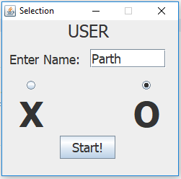 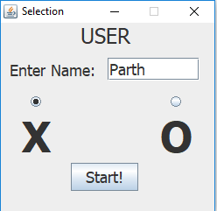

package nqueen;

public class User_Change extends javax.swing.JFrame

{

public User_Change()

{

initComponents();

jLabel6.setVisible(true);

tf1.setVisible(true);

user1x.setVisible(true);

user1o.setVisible(true);

}

public static String user;

public static String v;

public static String v1;

public static String sym;

private void StartActionPerformed(java.awt.event.ActionEvent evt) {

user=tf1.getText();

if(user1x.isSelected()==true)

{

sym="X";

}

if(user1o.isSelected()==true)

{

sym="O";

}

new queen().setVisible(true);

this.setVisible(false);

}

public static void main(String args[])

{

java.awt.EventQueue.invokeLater(new Runnable() {

public void run() {

new User_Change().setVisible(true);

}

});

}

// Variables declaration - do not modify

private javax.swing.JButton Start;

private javax.swing.ButtonGroup buttonGroup1;

private javax.swing.ButtonGroup buttonGroup2;

private javax.swing.JLabel jLabel41;

private javax.swing.JLabel jLabel5;

private javax.swing.JLabel jLabel6;

private javax.swing.JLabel jLabel8;

private javax.swing.JTextField tf1;

private javax.swing.JRadioButton user1o;

private javax.swing.JRadioButton user1x;

// End of variables declaration

}

Game Form

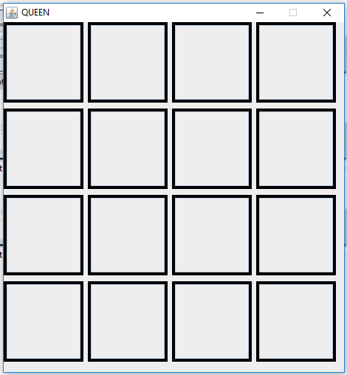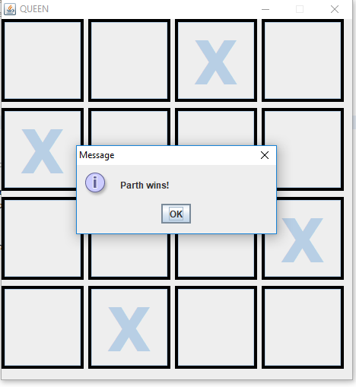

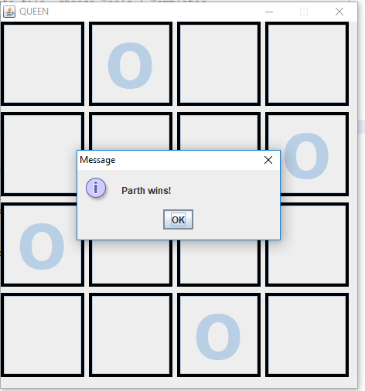

package nqueen;

import java.awt.event.KeyEvent;

import javax.swing.JOptionPane;

public class queen extends javax.swing.JFrame

{

public queen() {

initComponents();

tt11.setEnabled(false);

tt12.setEnabled(false);

tt13.setEnabled(false);

tt14.setEnabled(false);

tt21.setEnabled(false);

tt22.setEnabled(false);

tt23.setEnabled(false);

tt24.setEnabled(false);

tt31.setEnabled(false);

tt32.setEnabled(false);

tt33.setEnabled(false);

tt34.setEnabled(false);

tt41.setEnabled(false);

tt42.setEnabled(false);

tt43.setEnabled(false);

tt44.setEnabled(false);

}

User_Change ob=new User_Change();

String sym=ob.sym;

int t11=0,ft12=0,ft13=0,ft14=0,ft21=0,ft22=0,ft23=0,ft24=0,ft31=0,ft32=0,ft33=0,ft34=0,ft41=0,

int ft42=0,ft43=0,ft44=0,n=0;

String tf11,tf12,tf13,tf14,tf21,tf22,tf23,tf24,tf31,tf32,tf33,tf34,tf41,tf42,tf43,tf44;

public void Restart()

{

n=0;

tt11.setText("");

tt12.setText("");

tt13.setText("");

tt14.setText("");

tt21.setText("");

tt22.setText("");

tt23.setText("");

tt24.setText("");

tt31.setText("");

tt32.setText("");

tt33.setText("");

tt34.setText("");

tt41.setText("");

tt42.setText("");

tt43.setText("");

tt44.setText("");

ft11=0;ft12=0;ft13=0;ft14=0;ft21=0;ft22=0;ft23=0;ft24=0;ft31=0;ft32=0;ft33=0;ft34=0;ft41=0;

ft42=0;ft43=0;ft44=0;

}

public void Get()

{

tf11=tt11.getText();

tf12=tt12.getText();

tf13=tt13.getText();

tf14=tt14.getText();

tf21=tt21.getText();

tf22=tt22.getText();

tf23=tt23.getText();

tf24=tt24.getText();

tf31=tt31.getText();

tf32=tt32.getText();

tf33=tt33.getText();

tf34=tt34.getText();

tf41=tt41.getText();

tf42=tt42.getText();

tf43=tt43.getText();

tf44=tt44.getText();

}

private void tt11MousePressed(java.awt.event.MouseEvent evt) {

Get();

if(ft11==0)

{

tt11.setText(sym);

ft11++;

if(tf12.equals(sym) || tf13.equals(sym) || tf14.equals(sym) || tf21.equals(sym) || tf31.equals(sym) || tf41.equals(sym) || tf22.equals(sym) || tf33.equals(sym) || tf44.equals(sym))

{

JOptionPane.showMessageDialog(this, User_Change.user+" queen can not be placed here");

tt11.setText("");

ft11=0;

}

else if(tf32.equals(sym) && tf24.equals(sym))

{

JOptionPane.showMessageDialog(this, ob.user+" Game Over !!");

Restart();

}

else if(tf23.equals(sym) && tf42.equals(sym))

{

JOptionPane.showMessageDialog(this, ob.user+" Game Over !!");

Restart();

}

else if(tf43.equals(sym) && tf24.equals(sym))

{

JOptionPane.showMessageDialog(this, ob.user+" Game Over !!");

Restart();

}

else if(tf34.equals(sym) && tf42.equals(sym))

{

JOptionPane.showMessageDialog(this, ob.user+" Game Over !!");

Restart();

}

}

}

private void tt12MousePressed(java.awt.event.MouseEvent evt) {

Get();

if(ft12==0)

{

tt12.setText(sym);

ft12++;

if(tf11.equals(sym) || tf13.equals(sym) || tf14.equals(sym) || tf22.equals(sym) || tf32.equals(sym) || tf42.equals(sym) || tf21.equals(sym) || tf23.equals(sym) || tf34.equals(sym))

{

JOptionPane.showMessageDialog(this, ob.user+" queen can not be placed here");

tt12.setText("");

ft12=0;

}

else if(tf31.equals(sym) && tf24.equals(sym) && tf43.equals(sym))

{

JOptionPane.showMessageDialog(this, ob.user+" wins!");

Restart();

}

else if(tf31.equals(sym) && tf44.equals(sym))

{

JOptionPane.showMessageDialog(this, ob.user+" Game Over !!");

Restart();

}

else if(tf33.equals(sym) && tf41.equals(sym))

{

JOptionPane.showMessageDialog(this, ob.user+" Game Over !!");

Restart();

}

else if(tf41.equals(sym) && tf24.equals(sym))

{

JOptionPane.showMessageDialog(this, ob.user+" Game Over !!");

Restart();

}

}

}

private void tt13MousePressed(java.awt.event.MouseEvent evt) {

Get();

if(ft13==0)

{

tt13.setText(sym);

ft13++;

if(tf11.equals(sym) || tf12.equals(sym) || tf14.equals(sym) || tf23.equals(sym) || tf33.equals(sym) || tf43.equals(sym) || tf22.equals(sym) || tf31.equals(sym) || tf24.equals(sym))

{

JOptionPane.showMessageDialog(this, ob.user+" queen can not be placed here");

tt13.setText("");

ft13=0;

}

else if(tf21.equals(sym) && tf34.equals(sym) && tf42.equals(sym))

{

JOptionPane.showMessageDialog(this, ob.user+" wins!");

Restart();

}

else if(tf34.equals(sym) && tf41.equals(sym))

{

JOptionPane.showMessageDialog(this, ob.user+" Game Over !!");

Restart();

}

else if(tf32.equals(sym) && tf44.equals(sym))

{

JOptionPane.showMessageDialog(this, ob.user+" Game Over !!");

Restart();

}

}

}

private void tt14MousePressed(java.awt.event.MouseEvent evt) {

Get();

if(ft14==0)

{

tt14.setText(sym);

ft14++;

if(tf11.equals(sym) || tf12.equals(sym) || tf13.equals(sym) || tf24.equals(sym) || tf34.equals(sym) || tf44.equals(sym) || tf23.equals(sym) || tf32.equals(sym) || tf41.equals(sym))

{

JOptionPane.showMessageDialog(this, ob.user+" queen can not be placed here");

tt14.setText("");

ft14=0;

}

else if(tf21.equals(sym) && tf33.equals(sym))

{

JOptionPane.showMessageDialog(this, ob.user+" Game Over !!");

Restart();

}

else if(tf21.equals(sym) && tf42.equals(sym))

{

JOptionPane.showMessageDialog(this, ob.user+" Game Over !!");

Restart();

}

else if(tf22.equals(sym) && tf43.equals(sym))

{

JOptionPane.showMessageDialog(this, ob.user+" Game Over !!");

Restart();

}

}

}

private void tt21MousePressed(java.awt.event.MouseEvent evt) {

Get();

if(ft21==0)

{

tt21.setText(sym);

ft21++;

if(tf22.equals(sym) || tf23.equals(sym) || tf24.equals(sym) || tf11.equals(sym) || tf31.equals(sym) || tf41.equals(sym) || tf12.equals(sym) || tf32.equals(sym) || tf43.equals(sym))

{

JOptionPane.showMessageDialog(this, ob.user+" queen can not be placed here");

tt21.setText("");

ft21=0;

}

else if(tf13.equals(sym) && tf34.equals(sym) && tf42.equals(sym))

{

JOptionPane.showMessageDialog(this, ob.user+" wins!");

Restart();

}

else if(tf14.equals(sym) && tf33.equals(sym))

{

JOptionPane.showMessageDialog(this, ob.user+" Game Over !!");

Restart();

}

else if(tf14.equals(sym) && tf42.equals(sym))

{

JOptionPane.showMessageDialog(this, ob.user+" Game Over !!");

Restart();

}

}

}

private void tt22MousePressed(java.awt.event.MouseEvent evt) {

Get();

if(ft22==0)

{

tt22.setText(sym);

ft22++;

if(tf21.equals(sym) || tf23.equals(sym) || tf24.equals(sym) || tf12.equals(sym) || tf32.equals(sym) || tf42.equals(sym) || tf11.equals(sym) || tf33.equals(sym) || tf44.equals(sym) || tf31.equals(sym) || tf13.equals(sym))

{

JOptionPane.showMessageDialog(this, ob.user+" queen can not be placed here");

tt22.setText("");

ft22=0;

}

else if(tf14.equals(sym) && tf43.equals(sym))

{

JOptionPane.showMessageDialog(this, ob.user+" Game Over !!");

Restart();

}

}

}

private void tt23MousePressed(java.awt.event.MouseEvent evt) {

Get();

if(ft23==0)

{

tt23.setText(sym);

ft23++;

if(tf21.equals(sym) || tf22.equals(sym) || tf24.equals(sym) || tf13.equals(sym) || tf33.equals(sym) || tf43.equals(sym) || tf14.equals(sym) || tf32.equals(sym) || tf41.equals(sym) || tf12.equals(sym) || tf34.equals(sym))

{

JOptionPane.showMessageDialog(this, ob.user+" queen can not be placed here");

tt23.setText("");

ft23=0;

}

else if(tf11.equals(sym) && tf42.equals(sym))

{

JOptionPane.showMessageDialog(this, ob.user+" Game Over !!");

Restart();

}

}

}

private void tt24MousePressed(java.awt.event.MouseEvent evt) {

Get();

if(ft24==0)

{

tt24.setText(sym);

ft24++;

if(tf21.equals(sym) || tf22.equals(sym) || tf23.equals(sym) || tf14.equals(sym) || tf34.equals(sym) || tf44.equals(sym) || tf13.equals(sym) || tf33.equals(sym) || tf42.equals(sym))

{

JOptionPane.showMessageDialog(this, ob.user+" queen can not be placed here");

tt24.setText("");

ft24=0;

}

else if(tf31.equals(sym) && tf12.equals(sym) && tf43.equals(sym))

{

JOptionPane.showMessageDialog(this, ob.user+" wins!");

Restart();

}

else if(tf32.equals(sym) && tf11.equals(sym))

{

JOptionPane.showMessageDialog(this, ob.user+" Game Over !!");

Restart();

}

else if(tf43.equals(sym) && tf11.equals(sym))

{

JOptionPane.showMessageDialog(this, ob.user+" Game Over !!");

Restart();

}

else if(tf12.equals(sym) && tf41.equals(sym))

{

JOptionPane.showMessageDialog(this, ob.user+" Game Over !!");

Restart();

}

}

}

private void tt31MousePressed(java.awt.event.MouseEvent evt) {

Get();

if(ft31==0)

{

tt31.setText(sym);

ft31++;

if(tf32.equals(sym) || tf33.equals(sym) || tf34.equals(sym) || tf11.equals(sym) || tf21.equals(sym) || tf41.equals(sym) || tf22.equals(sym) || tf13.equals(sym) || tf42.equals(sym))

{

JOptionPane.showMessageDialog(this, ob.user+" queen can not be placed here");

tt31.setText("");

ft31=0;

}

else if(tf12.equals(sym) && tf24.equals(sym) && tf43.equals(sym))

{

JOptionPane.showMessageDialog(this, ob.user+" wins!");

Restart();

}

else if(tf12.equals(sym) && tf44.equals(sym))

{

JOptionPane.showMessageDialog(this, ob.user+" Game Over !!");

Restart();

}

}

}

private void tt32MousePressed(java.awt.event.MouseEvent evt) {

Get();

if(ft32==0)

{

tt32.setText(sym);

ft32++;

if(tf31.equals(sym) || tf33.equals(sym) || tf34.equals(sym) || tf12.equals(sym) || tf22.equals(sym) || tf42.equals(sym) || tf41.equals(sym) || tf23.equals(sym) || tf14.equals(sym) || tf21.equals(sym) || tf43.equals(sym))

{

JOptionPane.showMessageDialog(this, ob.user+" queen can not be placed here");

tt32.setText("");

ft32=0;

}

else if(tf11.equals(sym) && tf24.equals(sym))

{

JOptionPane.showMessageDialog(this, ob.user+" Game Over !!");

Restart();

}

else if(tf44.equals(sym) && tf13.equals(sym))

{

JOptionPane.showMessageDialog(this, ob.user+" Game Over !!");

Restart();

}

}

}

private void tt33MousePressed(java.awt.event.MouseEvent evt) {

Get();

if(ft33==0)

{

tt33.setText(sym);

ft33++;

if(tf31.equals(sym) || tf32.equals(sym) || tf34.equals(sym) || tf13.equals(sym) || tf23.equals(sym) || tf43.equals(sym) || tf11.equals(sym) || tf22.equals(sym) || tf44.equals(sym) || tf24.equals(sym) || tf42.equals(sym))

{

JOptionPane.showMessageDialog(this, ob.user+" queen can not be placed here");

tt33.setText("");

ft33=0;

}

else if(tf21.equals(sym) && tf14.equals(sym))

{

JOptionPane.showMessageDialog(this, ob.user+" Game Over !!");

Restart();

}

else if(tf12.equals(sym) && tf41.equals(sym))

{

JOptionPane.showMessageDialog(this, ob.user+" Game Over !!");

Restart();

}

}

}

private void tt34MousePressed(java.awt.event.MouseEvent evt) {

Get();

if(ft34==0)

{

tt34.setText(sym);

ft34++;

if(tf31.equals(sym) || tf32.equals(sym) || tf33.equals(sym) || tf14.equals(sym) || tf24.equals(sym) || tf44.equals(sym) || tf23.equals(sym) || tf12.equals(sym) || tf43.equals(sym))

{

JOptionPane.showMessageDialog(this, ob.user+" queen can not be placed here");

tt34.setText("");

ft34=0;

}

else if(tf13.equals(sym) && tf21.equals(sym) && tf42.equals(sym))

{

JOptionPane.showMessageDialog(this, ob.user+" wins!");

Restart();

}

else if(tf11.equals(sym) && tf42.equals(sym))

{

JOptionPane.showMessageDialog(this, ob.user+" Game Over !!");

Restart();

}

else if(tf13.equals(sym) && tf41.equals(sym))

{

JOptionPane.showMessageDialog(this, ob.user+" Game Over !!");

Restart();

}

}

}

private void tt41MousePressed(java.awt.event.MouseEvent evt) {

Get();

if(ft41==0)

{

tt41.setText(sym);

ft41++;

if(tf42.equals(sym) || tf43.equals(sym) || tf44.equals(sym) || tf11.equals(sym) || tf21.equals(sym) || tf31.equals(sym) || tf32.equals(sym) || tf23.equals(sym) || tf14.equals(sym))

{

JOptionPane.showMessageDialog(this, ob.user+" queen can not be placed here");

tt41.setText("");

ft41=0;

}

else if(tf12.equals(sym) && tf33.equals(sym))

{

JOptionPane.showMessageDialog(this, ob.user+" Game Over !!");

Restart();

}

else if(tf13.equals(sym) && tf34.equals(sym))

{

JOptionPane.showMessageDialog(this, ob.user+" Game Over !!");

Restart();

}

else if(tf12.equals(sym) && tf24.equals(sym))

{

JOptionPane.showMessageDialog(this, ob.user+" Game Over !!");

Restart();

}

}

}

private void tt42MousePressed(java.awt.event.MouseEvent evt) {

Get();

if(ft42==0)

{

tt42.setText(sym);

ft42++;

if(tf41.equals(sym) || tf43.equals(sym) || tf44.equals(sym) || tf12.equals(sym) || tf22.equals(sym) || tf32.equals(sym) || tf31.equals(sym) || tf33.equals(sym) || tf24.equals(sym))

{

JOptionPane.showMessageDialog(this, ob.user+" queen can not be placed here");

tt42.setText("");

ft42=0;

}

else if(tf13.equals(sym) && tf34.equals(sym) && tf21.equals(sym))

{

JOptionPane.showMessageDialog(this, ob.user+" wins!");

Restart();

}

else if(tf23.equals(sym) && tf11.equals(sym))

{

JOptionPane.showMessageDialog(this, ob.user+" Game Over !!");

Restart();

}

else if(tf21.equals(sym) && tf14.equals(sym))

{

JOptionPane.showMessageDialog(this, ob.user+" Game Over !!");

Restart();

}

else if(tf34.equals(sym) && tf11.equals(sym))

{

JOptionPane.showMessageDialog(this, ob.user+" Game Over !!");

Restart();

}

}

}

private void tt43MousePressed(java.awt.event.MouseEvent evt) {

Get();

if(ft43==0)

{

tt43.setText(sym);

ft43++;

if(tf41.equals(sym) || tf42.equals(sym) || tf44.equals(sym) || tf13.equals(sym) || tf23.equals(sym) || tf33.equals(sym) || tf34.equals(sym) || tf32.equals(sym) || tf21.equals(sym))

{

JOptionPane.showMessageDialog(this, ob.user+" queen can not be placed here");

tt43.setText("");

ft43=0;

}

else if(tf31.equals(sym) && tf24.equals(sym) && tf12.equals(sym))

{

JOptionPane.showMessageDialog(this, ob.user+" wins!");

Restart();

}

else if(tf11.equals(sym) && tf24.equals(sym))

{

JOptionPane.showMessageDialog(this, ob.user+" Game Over !!");

Restart();

}

else if(tf14.equals(sym) && tf22.equals(sym))

{

JOptionPane.showMessageDialog(this, ob.user+" Game Over !!");

Restart();

}

}

}

private void tt44MousePressed(java.awt.event.MouseEvent evt) {

Get();

if(ft44==0)

{

tt44.setText(sym);

ft44++;

if(tf41.equals(sym) || tf42.equals(sym) || tf43.equals(sym) || tf14.equals(sym) || tf24.equals(sym) || tf34.equals(sym) || tf11.equals(sym) || tf22.equals(sym) || tf33.equals(sym))

{

JOptionPane.showMessageDialog(this, ob.user+" queen can not be placed here");

tt44.setText("");

ft44=0;

}

else if(tf12.equals(sym) && tf31.equals(sym))

{

JOptionPane.showMessageDialog(this, ob.user+" Game Over !!");

Restart();

}

else if(tf32.equals(sym) && tf13.equals(sym))

{

JOptionPane.showMessageDialog(this, ob.user+" Game Over !!");

Restart();

}

}

}

private void formKeyPressed(java.awt.event.KeyEvent evt) {

char c=evt.getKeyChar();

if (c== KeyEvent.VK_ESCAPE)

{

Pause obj=new Pause();

obj.setVisible(true);

this.setVisible(false);

evt.consume();

}

}

public static void main(String args[])

{

java.awt.EventQueue.invokeLater(new Runnable() {

public void run() {

new queen().setVisible(true);

}

});

}

// Variables declaration - do not modify

private javax.swing.ButtonGroup buttonGroup1;

private javax.swing.JPanel pp1_1;

private javax.swing.JPanel pp1_2;

private javax.swing.JPanel pp1_3;

private javax.swing.JPanel pp1_4;

private javax.swing.JPanel pp2_1;

private javax.swing.JPanel pp2_2;

private javax.swing.JPanel pp2_3;

private javax.swing.JPanel pp2_4;

private javax.swing.JPanel pp3_1;

private javax.swing.JPanel pp3_2;

private javax.swing.JPanel pp3_3;

private javax.swing.JPanel pp3_4;

private javax.swing.JPanel pp4_1;

private javax.swing.JPanel pp4_2;

private javax.swing.JPanel pp4_3;

private javax.swing.JPanel pp4_4;

private javax.swing.JTextField tt11;

private javax.swing.JTextField tt12;

private javax.swing.JTextField tt13;

private javax.swing.JTextField tt14;

private javax.swing.JTextField tt21;

private javax.swing.JTextField tt22;

private javax.swing.JTextField tt23;

private javax.swing.JTextField tt24;

private javax.swing.JTextField tt31;

private javax.swing.JTextField tt32;

private javax.swing.JTextField tt33;

private javax.swing.JTextField tt34;

private javax.swing.JTextField tt41;

private javax.swing.JTextField tt42;

private javax.swing.JTextField tt43;

private javax.swing.JTextField tt44;

// End of variables declaration

}