NAME: NIRJALA MANDAL
ROLL NO: 23B091
SUBJECT: AEC
CLASS: S.Y.BCA SEM-4
TOPIC: RESPOSIBILITIES OF SOFTWARE DEVELOPMENT TEAM

INTRODUCTION:
Introduction to Software Development Team
A software development team plays a crucial role in designing, building, and maintaining software solutions that meet business and user needs. It consists of skilled professionals such as software engineers, testers, designers, project managers, and DevOps engineers, each contributing their expertise to different phases of the development lifecycle.
The team follows structured methodologies like Agile, Scrum, or Waterfall to ensure efficient project management, timely delivery, and high-quality output. Their responsibilities range from requirement analysis and coding to testing, deployment, and ongoing maintenance.
In today's digital world, an effective software development team is essential for businesses to stay competitive, innovate, and provide seamless user experiences. Their collaboration and technical expertise drive the successful execution of software projects, ensuring reliability, security, and scalability.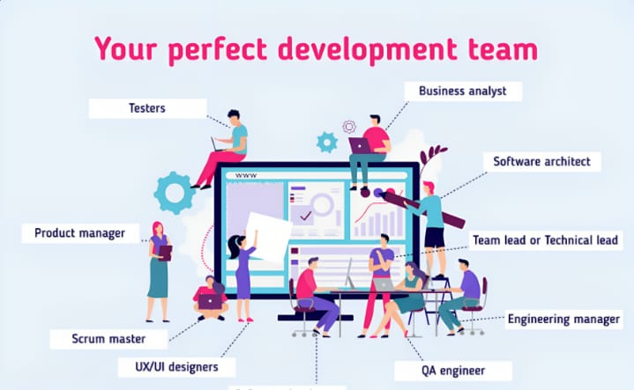
RESPONSIBILITIES
The responsibilities of a software development team vary depending on the project and organization, but generally include:
1.Requirement Analysis :
Understanding client needs, gathering requirements, and defining project scope.

2.System Design – Architecting the software structure, databases, and technology stack.

3.Development & Implementation – Writing clean, efficient, and maintainable code based on design specifications.

4.Testing & Quality Assurance – Conducting unit, integration, and system testing to ensure the software meets requirements and is bug-free.

5.Deployment & Integration – Deploying the software to production and integrating it with other systems.

6.Maintenance & Support – Fixing bugs, updating features, and ensuring the software runs smoothly post-launch.

7.Project Management – Managing timelines, sprints, and deliverables using methodologies like Agile or Scrum.

8.Collaboration & Communication – Working with other teams, including UX/UI designers, DevOps, and stakeholders.

9.Security & Compliance – Ensuring the software follows security best practices and complies with regulations.

10.Documentation – Creating technical documentation for future reference, including API documentation and user guides.
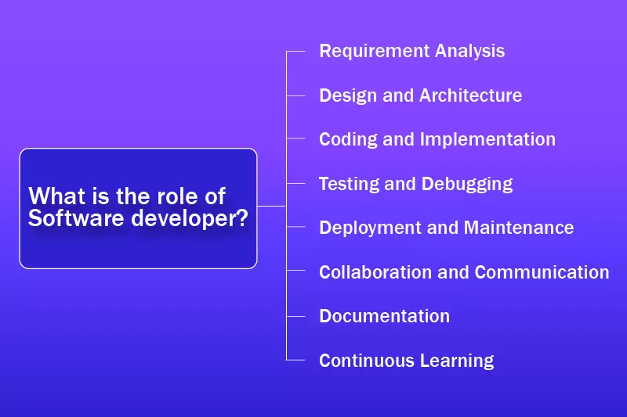

Conclusion
There are different roles with specific responsibilities when it comes to being a good software development team member. It contains specialists like software developers, designers, testers, quality engineers, and more. All these experts have their own specific skills like specialization in programming languages or frameworks, designing tools, and testing methods like performance testing, security testing, & more. A team of all these experts has the same goal to create a perfect solution for the client by fulfilling all the user’s requirements under a pre-decided budget.

