Mangrove Loss Mapping using Remote Sensing and GIS of Mumbai

Region

Submitted By

Mr. Parth Panchal

Mr. Prashant Gehlot

Year: 2017-18

Under the guidance of **Mr. Anand Upadhyay** Submitted in partial fulfilment of the requirements for qualifying B.Sc.-(I.T), Semester-VI Examination

Thakur College of science & commerce, Shyamnarayan Thakur Marg, Thakur Village, Kandivali (E),

Mumbai – 400101.

Thakur Educational Trust’s (Regd.)

**THAKUR COLLEGE OF SCIENCE & COMMERCE**

(NAAC Re-Accredited Grade –A, CGPA -3.10 & ISO 9001:2008 Certified) Shyamnarayan Thakur Marg, Thakur Village, Kandivali (East), Mumbai -400 101.

Tel.: 2846 2565/2887 0627 Fax: 2886 8822

Email: [tcsc@tcsc.org.in](mailto:tcsc@tcsc.org.in) Website: [www.tcsc.org.in](http://www.tcsc.org.in)

## **Certificate**

This is to certify that the project entitled ‘Mangrove loss mapping using Remote Sensing and GIS of Mumbai Region’ Undertaken at the department of Bachelor of Science in Information Technology by Mr. Parth Panchal and Mr. Prashant Gehlot in partial fulfillment of B.Sc. IT (Semester VI) Examination had not been submitted for any other examination and does not form part of any other course undergone by the candidate.

It is further certified that he/she has completed all required phases of the project.

External Examiner Internal Examiner

Project Guide HOD/In-charge/Coordinator

**PREFACE**

As a part of BscIT curriculum and to gain practical knowledge in the field of information technology, we were required to make a project on “**Mangroves Loss mapping using Remote Sensing and GIS of the Mumbai Region**”. The basic objective behind this project was to build up the concept of Remote sensing and gis and also to generate knowledge about software amongst us.

In this project we have used python programming language as a base. Including satellite images made our project even more interactive. Doing this project helped us to enhance our knowledge about remote sensing and gis software. Through this project we got to know about the importance of teamwork and role of devotion towards work.

## 

## 

## 

## 

## 

## 

## 

**ACKNOWLEDGEMENT**

We would like to express our special thanks of gratitude to the professor **Mr. Anand Upadhyay** sir who gave us the golden opportunity to do this project on the topic “**Mangroves Loss mapping using Remote Sensing and GIS of the Mumbai Region**”. It would not have been possible without the kind support and help of many individuals. We would like to extend our sincere thanks to all of them. We are highly indebted to Mr. Anand Upadhyaysir for his guidance and constant supervision as well as for providing necessary information regarding the project and also for his support in completing the project. Our thanks and appreciations also go to my colleague in developing the project in the given time frame and people who have willingly helped us out with their abilities. We take this opportunity to highlight the valuable contribution of Bsc.IT co-ordinator **Prof. Mr. Santosh Singh** and all my professors, my colleagues and especially my parents who have always supported and encouraged, the success of this project of large extent is also dedication to them too.

Parth Panchal 17471

Prashant Gehlot 17478

## 

**TABLE OF CONTENTS**

|  |  |  |
| --- | --- | --- |
| No | Topic | Page No |
|  | Preface | 2 |
|  | Acknowledgement | 3 |
|  | Table of Contents | 4 |
|  | List of Figures | 7 |
|  | Abstract | 9 |
| 1 | Introduction | 11 |
| 2 | Objective | 13 |
| 3 | Research Problem | 14 |
| 4 | Research Solution | 15 |
| 5  5.1  5.2 | Required Platform  Matlab R2017a  QGIS | 16 |
| 6  6.1  6.2  6.3  6.4 | Tools and Techniques  Numpy  Matplotlib  Scipy  Opencv | 17 |
| 7 | Literature review | 18 |
| 8 | Study Area | 19 |
| 9  9.1  9.1.1  9.1.2  9.1.3  9.1.4  9.1.5  9.2 | System Requirements  Software Requirements  Python  Matlab R2017a  Features of Matlab  Qgis 2.14Essen  Features of Qgis  Hardware specification | 20  24 |
| 10  10.1.1  10.1.2  10.2.1  10.2.2  10.2.3  10.3.1  10.3.2  10.3.3  10.4.4 | Algorithm Used  Decision Tree  Decision Tree Algorithm  K nearest Neighbor  Application of KNN  KNN Algorithm  Artificial Neural Network  Neuron  Characteristics of ANN  Algorithm | 25 |
| 11  11.1  11.2 | Data Source  LISS 3 Sensor  LISS 3 Images | 32 |
| 12  12.1  12.2 | Methodology  Preprocessing  Feature Extraction |  |
| 13 | Algorithm Workflow | 38 |
| 14 | Creation of Interactive Map | 39 |
| 15  15.1  15.2 | Accuracy Assessment  Confusion Matrix  Kappa Statistic | 45 |
| 16  16.1  16.2  16.3 | Result and Observations  Accuracy and Kappa-value of Artificial Neural Network  Accuracy and Kappa-value of K-Nearest Neighbour  Accuracy and Kappa-value of Decision Tree | 48 |
| 17  17.1 | Discussions  Accuracy | 55 |
| 18 | Conclusion | 55 |
| 19 | Future Enhancement | 56 |
| 20 | References |  |

**LIST OF FIGURES**

|  |  |  |
| --- | --- | --- |
| Figure no | Topic | Page no |
| 1 | Mangroves in 1972 | 10 |
| 2 | Mangroves in 2017 | 10 |
| 3 | LISS 3 camera | 12 |
| 4 | MATLAB R2107a Interface | 21 |
| 5 | QGIS 2.14 Interface | 23 |
| 6 | Decision tree | 25 |
| 7 | Biological neuron | 29 |
| 8 | Model of an artificial neuron | 30 |
| 9 | LISS 3 Band 2 image | 33 |
| 10 | LISS 3 Band 3 image | 33 |
| 11 | LISS 3 Band 4 image | 33 |
| 12 | LISS 3 Band 5 image | 33 |
| 13 | RGB image of Mumbai region | 34 |
| 14 | Selecting the pixels | 35 |
| 15 | Training sets | 36 |
| 16 | Classified Image | 37 |
| 17 | Algorithm Workflow | 38 |
| 18 | Loading the Raster Image | 39 |
| 19 | Creating a Print Composer | 40 |
| 20 | Raster Image | 41 |
| 21 | Creating layers | 42 |
| 22 | Plotted Points | 42 |
| 23 | Creating a Print Composer | 43 |
| 24 | Map Deployed on the web | 44 |
| 25 | Classification Accuracy Assessment of Artificial neural network | 49 |
| 26 | Classification Accuracy Assessment of K-nearest neighbor classification | 51 |
| 27 | Classification Accuracy Assessment of Decision tree classification | 53 |
| 28 | Overall Classified Area | 54 |

## **Abstract**

A Mangrove is a small tree which grows only in coastal region and is basically found at the edge of water and sea. Mangroves are the home for various aquatic organisms. Mangroves help preventing soil erosion and it also protects people community from natural disasters like tsunami, storms, floods and hurricanes. In India, around 40% of these mangroves are been destroyed in the past decade. The main reason for this destruction is the land for people community. So it is mandatory for conservation of mangroves. In India, West Bengal, Odisha, Andhra Pradesh, Tamil Nadu and Andaman are the places which have the highest amount of mangroves present. Manual surveying of these mangroves takes a lot of time and is not always that we may achieve accurate results from it because there will be no frequent updation of the reports. Remote sensing is the science of making measurements of the earth using sensors on satellites. These sensors collect data in the form of images and provide specialized capabilities for manipulating, analyzing, and visualizing those images.

Remote Sensing technology have been used to detect the changes in mangroves around Mumbai region and to find where are mangroves located in mumbai suburban. Remote sensing is technique of gathering data of an object or phenomenon without getting direct contact with the object.Nowadays Remote sensing is mainly used for classification and the detection of object. Classification process is used to categorized LISS III multiband image  into various land cover classes to create thematic maps.The LISS-III stands for Linear Imaging Self-Scanning Sensor-3. LISS-III data consist of images in four bands. The thematic map is used to create an interactive informative map using GIS.GIS stands for Geographical Information System The purpose of this research is to create an informative map about the changes in mangroves by collecting information from previous researches and to provide possible solutions to protect them.

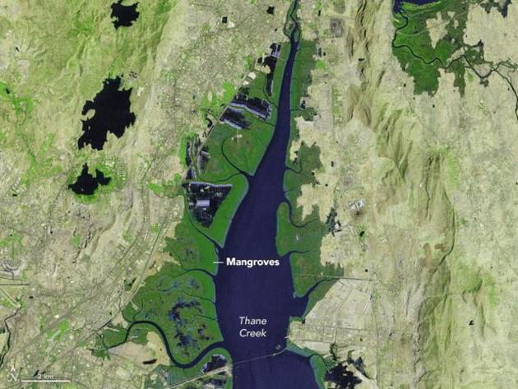

Figure: 1 Mangroves in 1972

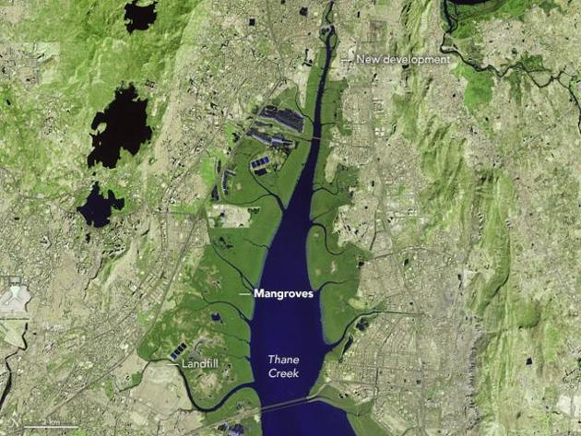

Figure: 2 Mangroves in 2017

**1.Introduction:**

Mangroves ecosystem are highly productive but are extremely fragile and sensitive. Mangrove forests are undergoing constant seasonal, short term, long term changes due to their dynamic nature and to a greater extent, through various natural and biotic influences. Mangrove forest not only protect coastal organism but also protect coast from soil erosion and serve as breeding, feeding and nursery ground for estuarine and marine organisms. Therefore monitoring mangrove habitat from time to time is an essential component in a coastal marine ecological studies and coastal management. The term remote sensing can be broadly defined as obtaining information of the areas on the earth using sensors on satellites or the aircrafts. These sensors collect data in the form of images and provide specialized capabilities for manipulating, analyzing, and visualizing those images. Remote sensors collect data by detecting the energy that is reflected from Earth. Over the last few decades remote sensing technology has been used increasingly by the scientific community to describe and monitor a variety of systems on a global scale. This technology has evolved from pure visual imagery i.e. panchromatic aerial photographs to multi-spectral imagery i.e. Thematic Map. Remote sensing requires an energy source that provides electromagnetic energy. This energy travels from the source to the target where it comes in contact with the atmosphere. Once the energy reaches the target, it interacts with the target. A sensor will detect and record the energy emitted by the target. The energy from the sensor is passed to the processing station in the electronic form. The processed image is then interpreted visually or digitally. This data can be further used to reveal some more information about the target and can assist in solving a particular problem.

There are two types of remote sensing i.e. passive remote sensing and active remote sensing. Passive sensors detect natural energy that is reflected or emitted from the observed object. Passive sensors sense only radiation emitted by the object being viewed or reflected by the object from a source other than the sensor. Reflected sunlight is the most common external source of radiation sensed by passive sensors. Active sensors provide their own energy to illustrate the object. They send a pulse of energy from the sensor to the object and then receive the radiation that is reflected back from that object. The classification algorithm such as regression, artificial neural network and decision tree can be used to classify the image. Classification technique help to find out change in land based on land cover such as forest, development, water and mangroves etc.

The IRS (Indian Remote Sensing) satellites form a large family of Earth observation satellites operated by the Indian space agency. Resourcesat satellites carry a LISS-III sensor as well as a wide field AWiFS sensor. The LISS 3 sensor is an optical sensor working in four spectral bands (green, red, near infrared and shortwave infrared). It covers a 141 km wide swath with a resolution of 23 metres in all spectral bands.

GIS stands for Geographical Information System. GIS is an framework which is used to analyze, create, visualise and find trends in geographical data. It is an integrated system that capture, store, create and visualise geospatial data. GIS is used to create an interactive map from the classified image. The Classified image helps to classify the areas in Mumbai like mangroves, forest, water and development area. These characteristics are expressed by different colours like red, green, blue and yellow respectively. The interactive map will contain the information of changes in mangroves in Mumbai region.

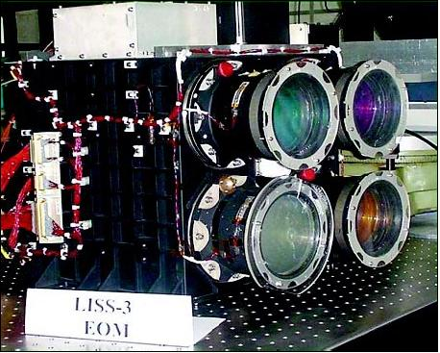

Figure: 3 LISS 3 sensor

**2. Objective**:

The main objective of the project is to categorize the areas of mangroves in Mumbai based on the condition of Mangroves such as healthy and unhealthy from the previous researches. Healthy mangrove areas are the areas where the mangroves are well protected and there is less possibility of degradation of those mangroves. Unhealthy mangroves will be the one which are under depletion and there is a serious need to protect them. The Classified image helps to classify the areas in Mumbai like mangroves, forest, water and development area. These characteristics are expressed by different colours like red, green, blue and yellow respectively. Qgis software helps in displaying the data of those mangroves on the classified image. Pop-ups are used to show healthy and unhealthy areas. The pop-ups express other information of the area of mangroves when they are clicked. The final result of the project is shown on the web by using the QGIS2Web plug-in of qgis software.

**3. Research problems:**

The research is generated because of different problems which are available in current system. The problems are listed below:

1. Manual Survey**:**

The regulating body which are working for the coastal, wetland or mangroves have to do the manual survey of the area and based on that they have to suggest the condition and the health of mangroves which is a very difficult job.

1. Biasing**:**

If the regulating body does the manual survey, there are possibilities that the data they may submit is not a legitimate one. There are possibilities that humans may make changes in the data and submit a wrong report that may lead to a wrong interpretation of the survey.

1. No Frequent Updation:

It is very difficult for the regulating to go and visit different places for their surveys and keep an update of the changes in the mangroves that they already visited or surveyed. To update the survey data for a region, it may take a long time.

1. Track the mangroves:

Once a survey is done and the reports are submitted then there may be a possibility that for a long period of time the region isn’t inspected and if in that time any illegal practices or operations against the mangroves is done by humans then that cannot be tracked till the survey for the region is done once again. So keeping a track of the mangroves after the survey is very difficult.

**4. Research solution:**

In manual survey, the above mentioned problems occur. In order to overcome these problems, an automated system for tracking and inspecting the mangroves is adopted. This technique makes use of Remote Sensing images and GIS to compare the change in the mangroves for a specific region for a particular period of time. Some of the advantages of this system are:

1. Less Time Required:

Using Remote Sensing and GIS for tracking the mangroves takes less time as compared to a manual survey. There is no need of visiting the place of inspection again and again. We just need to use algorithms to compare different images over the time.

1. Accurate Results:

Since this method is automated, there is no possibility of any biasing of the data. Machines provide accurate data without any biased content.

1. Frequent Updation:

As in a manual survey, there is no need of surveying a region again to track the change in the status of mangroves. In this automated system, we just need to apply various algorithms on the variety of images obtained from the satellite of a specific region and generate the reports. It is easier to find changes and get updated data for the mangroves.

1. Track illegal Practices:

Due to frequent updation of the data, the illegal practices or operations on the mangroves can be easily identified and it helps to take action on such illegal practices as soon as possible because in manual survey frequent updation is not possible.

1. **Required Platform:**
2. **Matlab R2017a:**

MATLAB is a numerical computing environment which supports multiple programming languages. MATLAB allows matrix manipulations, plotting of functions and data, implementation of algorithms, creation of user interfaces, and interfacing with programs written in other languages, including C, C++, C#, Java and Python. Matlab is used to assign the pixel values on the map. MATLAB is the easiest and most productive software for engineers and scientists. Whether you’re analyzing data, developing algorithms, or creating models, MATLAB provides an environment that invites exploration and discovery. It combines a high-level language with a desktop environment tuned for iterative engineering and scientific workflows. MATLAB is a fourth-generation high-level programming language and interactive environment for numerical computation, visualization and programming.

1. **QGIS:**

QGIS is a free and open-source cross-platform desktop gis application that supports viewing, editing, and analysis of geospatial data.QGIS is an activity of gis software, allowing users to analyze and edit spatial information, composing and exporting graphical maps. QGIS supports both raster and vector layers. Vector data is stored as point, line, or polygon features. Multiple formats of raster images are supported and the software can generate georeference images. GIS data can be mapped to the web by using QGIS2Web plug-in.

**6.Tools and Techniques:**

The libraries used in the project are:

1. **Numpy:**

NumPy is the fundamental package for scientific computing with Python. It contains a powerful N-dimensional array object, many sophisticated functions, and tools for integrating C/C++ code and is useful in linear algebra, Fourier transform, and random number capabilities. NumPy is also used as an efficient multi-dimensional container of generic data.

1. **Matplotlib:**

Matplotlib is a Python 2D plotting library which produces publication quality figures in a variety of hard copy formats and interactive environments across platforms. Matplotlib can be used in Python scripts, the Python and IPython shell, the jupyter notebook, web application servers, and four graphical user interface toolkits.

1. **Scipy:**

SciPy is an open source Python library used for scientific computing and technical computing. SciPy contains modules for optimization, linear algebra, integration, interpolation, special functions, FFT, signal and image processing, ODE solvers and other tasks common in science and engineering.

1. **Opencv:**

Opencv is a library of Python bindings designed to solve computer vision problems. Opencv makes use of Numpy, which is a highly optimized library for numerical operations with MATLAB-style syntax. All the OpenCV array structures are converted to and from Numpy arrays. This also makes it easier to integrate with other libraries that use Numpy such as SciPy and Matplotlib.

**7.Literature View**

In the year 1999, S. Agatonovic-Kustrin and R. Beresford explained the basic concept of artificial neural network (ANN) with all its applications [1]. In the year 2015, Roya Abedi and Amir Eslam Bonyad had successfully implemented K-nearest neighbor algorithm using IRS-P6 LISS 3 satellite image. They got the accuracy between 80% and 93.94% [2]. In the year 2010, M K Ghose, Ratika Pradhan and Sucheta Sushan Ghose had implemented Decision Tree Classification algorithm using spectral separability matrix using the IRS LISS 3 multispectal images and they got the 98% accuracy using decision tree and 95% using the maximum likelihood classifier [3]. Sahu, Suresh, Murthy and Ravindranath had done the mangrove area assessment in India in which their main focus was to show the implications of the loss of mangroves.They assessed the trends of mangroves area in India during 1987-2013 [4]. In the year 2014, Prabakaran chellamani, Chandra prakash singh and Cushma panigrahy had done health assessment of Indian mangroves using multi temporal remote sensing data. They found that around 38% and 27% of total mangroves in India belong to very-healthy and healthy categories respectively. Mr. Anand Upadhyay, Dr.Santosh kumar Singh, Mr. Aditya Shetty and Mr.Zibreel Siddiqui successfully implemented K-nearest neighbor, Artificial neural network and Decision tree algorithms using the IRP-P6 LISS 3 satellite image. They got the accuracy 97.04%, 95.31% and 99.82% respectively with the kappa value as 0.84, 0.95 and 0.96 respectively [6]. T G Jagtap, A G Untawale and S N Inamdar used remote sensing technique to study the areas of mangroves in Maharashtra. [7]. Kai Liu, Xia Li, Xun Shi and Shugong Wang used Decision tree with remote and GIS to monitor the changes in the mangrove forest[8].

**8. Study Area:**

Mumbai is the land of opportunities. People from all over India come to Mumbai in search of job opportunities. This is the main reason for the growing population of Mumbai. The population of Mumbai was around 18.41 million in 2011. Since then there was a speedy development and population pressure rapidly increased and Mumbai being the coastal area, it took the toll of mangrove land. Major mangroves are seen today in Mumbai along the Vasai Creek, Thane Creek, Manori and Malad, Mahim, Bandra, Versova, Siwari, Mumbai and few more places. Millions of citizens in Mumbai do not treat mangroves in the right way, they simply think that it’s a waste material. Only little people around actually understand how important mangroves are to the quality of lifestyle. In the early 19’s, over 37 sq. km. of mangroves existed in Mumbai, largely in the Thane creek, Mahim, Versova, Gorai and Ghodbunder, with regular patches in places such as Bandra, Malabar Hill and Colaba. Mumbai has probably lost 40% of all its mangroves in the past decade. Around 20 out of the 35 species of true mangroves found in India have been identified along the Maharashtra coast and 15 species of these are found in Mumbai. Our prime area of study in Mumbai region is Vikhroli, Gorai, Airoli, Mulund, Ghansoli, Charkop, Vashi and Versova.

**9. System Requirements:**

**A: Software Requirements:**

**1: Python**:

The programming language used in this project is Python. Python is an interpreted high-level programming language for general-purpose programming. Python features a dynamic type system and automatic memory management. It supports multiple programming paradigms, including object-oriented, imperative, functional and procedural, and has a large and comprehensive standard library. Python is a multi-paradigm programming language. Object-oriented programming and structured programming are fully supported, and many of its features support functional programming. Many other paradigms are supported via extensions, including design by contract and logic programming.Python uses dynamic typing, and a combination of reference counting and a cycle-detecting garbage collector for memory management. It also features dynamic name resolution, which binds method and variable names during program execution.

2: **MATLAB R2017a:**

MATLAB is a high-performance language for technical computing. It integrates computation, visualization, and programming in an easy-to-use environment where problems and solutions are expressed in familiar mathematical notation. Typical uses include:

a. Math and computation

b. Algorithm development

c. Modeling, simulation, and prototyping

d. Data analysis, exploration, and visualization

e. Scientific and engineering graphics

f. Application development, including Graphical User Interface building

MATLAB is an interactive system whose basic data element is an array that does not require dimensioning. This allows you to solve many technical computing problems, especially those with matrix and vector formulations, in a fraction of the time it would take to write a program in a scalar no interactive language such as C or fortran. The name MATLAB stands for matrix laboratory. In university environments, it is the standard instructional tool for introductory and advanced courses in mathematics, engineering, and science. In industry, MATLAB is the tool of choice for high-productivity research, development, and analysis.

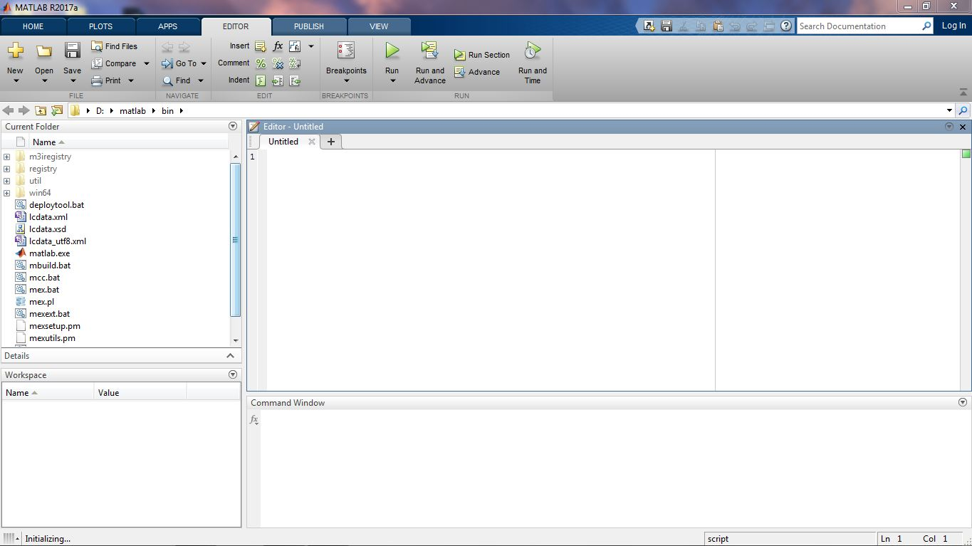

Figure: 4 MATLAB R2107a Interface

**Features of MATLAB:**

1. It is a high-level language for numerical computation, visualization and application development.
2. It also provides an interactive environment for iterative exploration, design and problem solving.
3. It provides vast library of mathematical functions for linear algebra, statistics, Fourier analysis, filtering, optimization, numerical integration and solving ordinary differential equations.
4. It provides built-in graphics for visualizing data and tools for creating custom plots.
5. MATLAB's programming interface gives development tools for improving code quality maintainability and maximizing performance.
6. It provides tools for building applications with custom graphical interfaces.

3: **QGIS 2.14 Essen:**

QGIS is a user friendly Open Source Geographic Information System (GIS) licensed under the GNU General Public License. QGIS is an official project of the Open Source Geospatial Foundation (OSGeo). It runs on Linux, UNIX, Mac OS X, Windows and Android and supports numerous vector, raster, and database formats and functionalities. QGIS provides a continuously growing number of capabilities provided by core functions and plug-in. You can visualize, manage, edit, analyze data, and compose printable maps. QGIS can also be used as a graphical user interface to GRASS.

**Features of QGIS:**

1. QGIS is a freely downloadable open source GIS software suite.
2. Since QGIS is free and open source software, there are no licensing concerns.
3. QGIS is cross-platform and can be installed and run on Windows, Mac, or Linux machines.
4. QGIS has a faster startup time than ArcGIS.
5. Geoprocessing in QGIS takes very less time than in ArcGIS.

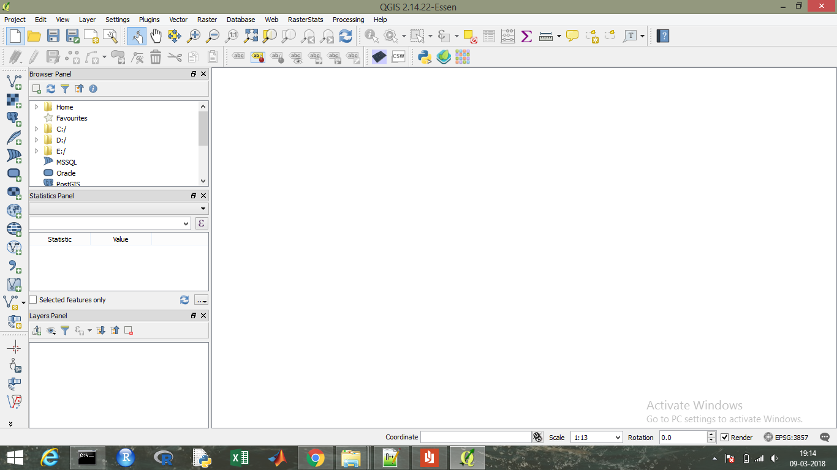

Figure: 5 QGIS 2.14 Interface

**B: Hardware Requirements:**

1: Minimum 4 GB Ram

2: Windows 7 or above

3: Intel Dual Core Processor or above

4: Minimum 1GHz Processor

**10. Algorithms used:**

**10.1 Decision Tree**

A decision tree is defined as a connected, acyclic, undirected graph, with a root node, zero or more internal nodes (all nodes except the root and the leaves), and one or more leaf nodes (terminal nodes with no children), which will be termed as an ordered tree if the children of each node are ordered (normally from left to right). Decision tree is one of the supervised classification methods. It is very powerful and fast classification and prediction method. A tree is termed as univariate, if it splits the node using a single attribute or a multivariate, if it uses several attributes. A binary tree is an ordered tree such that each child of a node is distinguished either as a left child or a right child and no node has more than one left child or more than one right child. For a binary decision tree, the root node and all internal nodes have two child nodes. All non-terminal nodes contain splits. A Decision Tree is built from a training set, which consists of objects, each of which is completely described by a set of attributes and a class label. Attributes are a collection of properties containing all the information about one object. Unlike class, each attribute may have either ordered (integer or a real value) or unordered values (Boolean value).

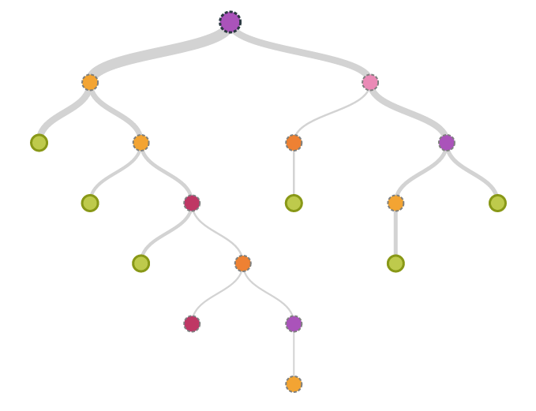

Figure: 6: Decision tree

**10.1.1 Decision tree Algorithm**

Step 1: Let T be the set of training instances.

Step 2: Choose an attribute that best differentiates the instances in T.

Step 3: Create a tree node whose value is the chosen attribute.

• Create child links from this node where each link represents a unique value for the chosen attribute.

• Use the child link values to further subdivide the instances into subclasses.

Step 4: For each subclass created in step 3:

• If the instances in the subclass satisfy predefined criteria or if the set of remaining attribute choices for this path is null, specify the classification for new instances following this decision path.

• If the subclass does not satisfy the criteria and there is at least one attribute to further subdivide the path of the tree, let T be the current set of subclass instances and return to step 2.

**10.2. K-Nearest Neighbor:**

The K-nearest neighbor classification is one of the supervised classification techniques. The KNN classification algorithm is very easy to understand and implementation. It is widely used for remote sensing area mapping. The KNN classification is instance based classification techniques where the algorithm tries to make the instance of different classes based on the provided sample training data sets which is called as learning. In KNN, there is no development of internal model or there is nothing as creation of relationship between the features and classes. It simply creates instances and stores all these instances for prediction of classes. The prediction of each class is based on the voting method of nearest neighbor of each point. There are 5 distance functions used in KNN.

Given an mx-by-n data matrix X, which is treated as mx (1-by-n) row vectors x1, x2, ..., xmx, and my-by-n data matrix Y, which is treated as my (1-by-n) row vectors y1, y2, ...,ymy, the various distances between the vector xs and yt are defined as follows:

a. Euclidean distance: It is the distance between two points in the plane with coordinates. It is the default distance metric.

d2st= (xs−yt) (xs−yt) ′

b. Cityblock distance: It is sum of absolute differences.

dst=Σ_(𝑗=1)^𝑛|xsj−ytj|

c. Cosine distance: One minus the cosine of the included angle between points. It is treated as vectors.

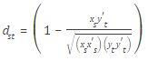

d**.** Correlation distance**:** One minus the sample correlation between points.



e. Hamming distance: It is the percentage of bits that differ and is suitable only for binary data.

dst=(#(xsj≠ytj)/n)

**10.2.2 Applications of KNN:**

Some of the applications of this method are mentioned below:

1. Classification and Interpretation- KNN method can be used in the field of medical, banking, media and legal etc.
2. Problem-solving- KNN can be used for building tools for planning and is also used as learning module in terms of pronunciation.
3. Function learning – dynamic control.
4. Teaching and aiding – help desk, user training.

**10.2.3 KNN Algorithm:**

a. For each training sample, add the sample to the list of training samples.

b. Given a query instance xq ¨ given a query instance x to be classified, q to be classified.

- Let x1, x2….xk denote the k instances from training samples that are nearest to xq.

- Return the class that represents the maximum of the k instances.

**10.3 Artificial Neural Network:**

An artificial neural network is a biologically inspired computational model formed from hundreds of single units, artificial neurons, connected with coefficients (weights) which constitute the neural structure. They are also known as processing elements as they process information. Each processing element has weighted inputs, transfer function and one output. Processing element is essentially an equation which balances inputs and outputs. ANNs are also called connectionist models as the connection weights represent the memory of the system. ANNs are capable of processing extensive amounts of data, however, and making predictions that are sometimes surprisingly accurate.

**10.3.1 Neurons:**

The artificial neuron is the building component of the ANN designed to simulate the function of the biological neuron. The arriving signals, called inputs, multiplied by the connection weights (adjusted) are first summed (combined) and then passed through a transfer function to produce the output for that neuron. The activation function is the weighted sum of the neuron’s inputs and the most commonly used transfer function is the sigmoid function.

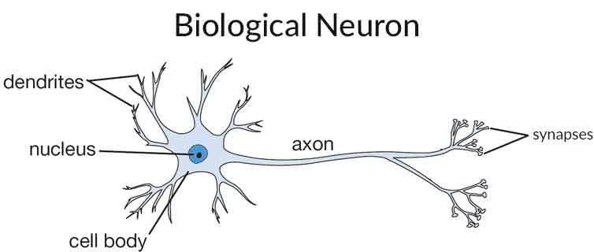

Figure: 7 A Biological Neuron

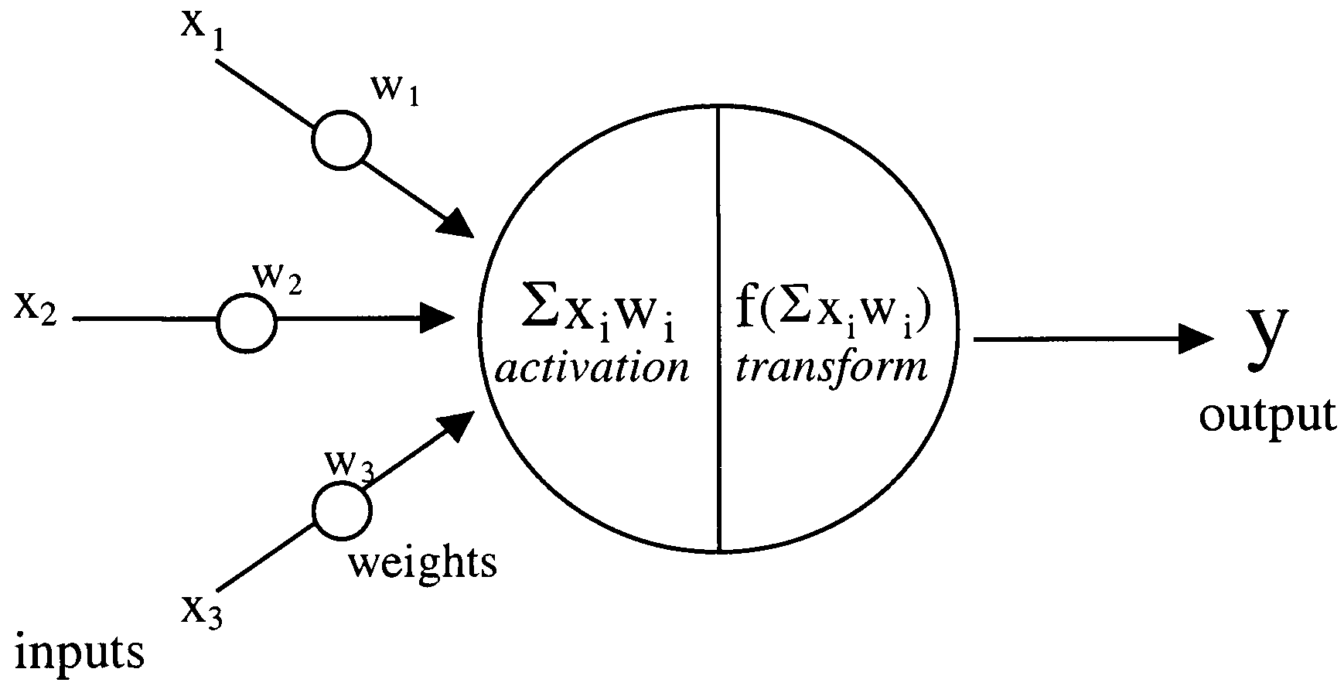

Figure: 8 Model of an artificial neuron

**Pattern recognition**:

Pattern recognition is the assignment of a label to a given input value. Well known application include other typical applications of pattern recognition techniques that are automatic recognition, classification, the automatic recognition of handwritten postal codes on postal envelopes, automatic recognition of images of human faces, or handwriting image extraction from medical forms.

**Clustering/Categorization:**

Categorization is the process in which ideas and objects are recognized, differentiated, and understood. Categorization implies that objects are grouped into categories, usually for some specific purpose. Applications of clustering include data mining, data compression and exploratory data analysis.

**Prediction/Forecasting:**

It has a significant impact on decision making in business, science and engineering. Stock market prediction and weather forecasting are typical application of prediction/forecasting techniques.

**10.3.2 Characteristics of Ann:**

1. The Network Structure of ANN is simple and easy.
2. Parallel Processing Ability.
3. Distributed Memory.
4. Fault Tolerance Ability.
5. ANN is an interconnected system the output of a system is a collective output of various input so the result is summation of all the outputs which comes after processing various inputs.
6. Learning Ability.

**10.3.3 Algorithm:**

Step 1: Applying artificial neural network on dataset.

a. Feed forward neural network with back propagation of error

b. Feed forward neural network using back propagation of error algorithm

c. Training of artificial neural networks

Step 2: Reading the image and converting to array.

Step 3: Reconstructing the image and applying different classes.

Step 4: Calculating accuracy and kappa-value.

**11. Data Source:**

**11.1 Liss-3 sensor:**

LISS 3 camera provides multispectral data in 4 bands. LISS-3 operates in three spectral bands in visible (VIS), near infrared (NIR) and Soft Wavelength infrared (SWIR) with 24 metre spatial resolution and a space of 141 km.The fourth band has a spatial resolution of 70.5m with a ground area of 148 km. The repetitivity 3 of LISS is 24 days.

|  |  |
| --- | --- |
| Specification | LISS-3 |
| Spatial resolution in Nadir | 23.5 m |
| Swath | 141 km |
| Repetitivity | 24 days |
| Spectral Bands | 0.52-0.59 microns(B2)  0.62-0.68 microns(B3)  0.77-0.86 microns(B4)  1.55-1.70 microns(B5) |
| Quantization | 7 Bits SWIR band has 10 bit quantization, selected 7 bits out of 10 bits will be transmitted by the data handling system |
| No. of gains | 4 for B2, B3 and B4. For B5 (Dynamic range obtained by sliding 7 bits out of 10 bits) |
| Primary Application | Land use, Urban planning, biodiversity characterization, Forest survey, wetland mapping, environmental impact, crop acreage and production estimation of major crops and many more. |

**11.2 LISS 3 Images:**

The Liss 3 images of the Mumbai region used in the project are:

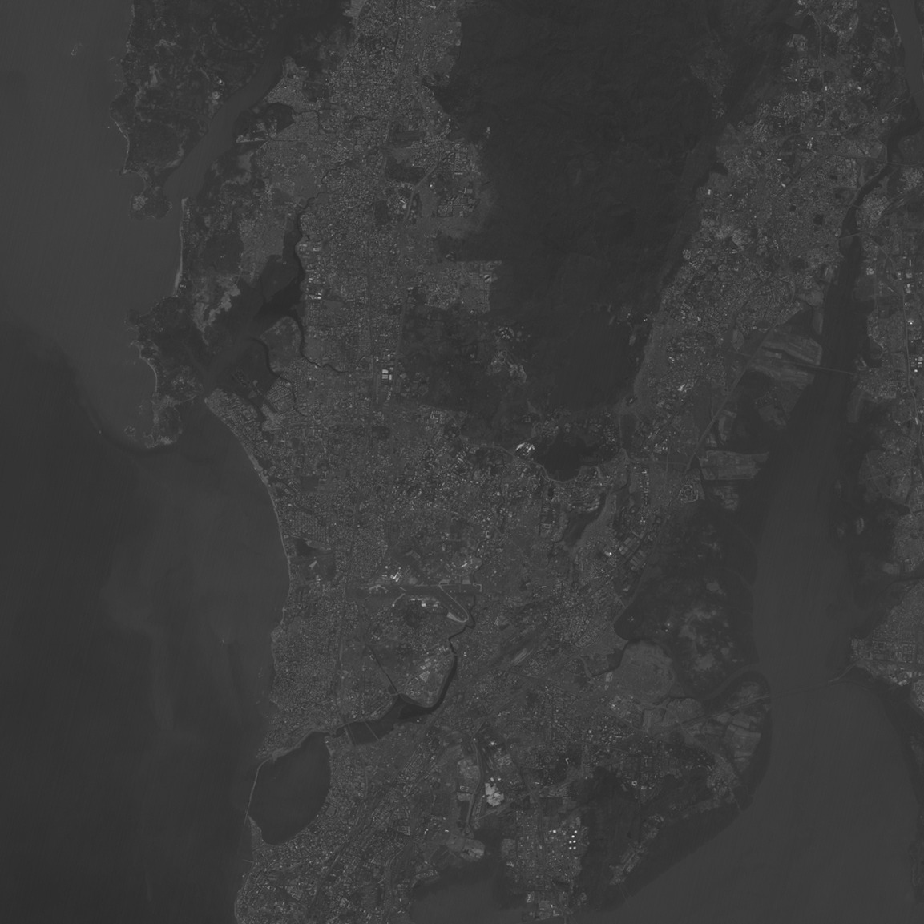 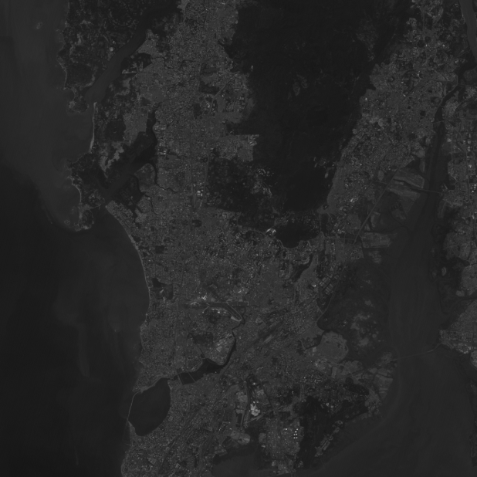

Figure: 9(Band 2) Figure: 10(Band 3)

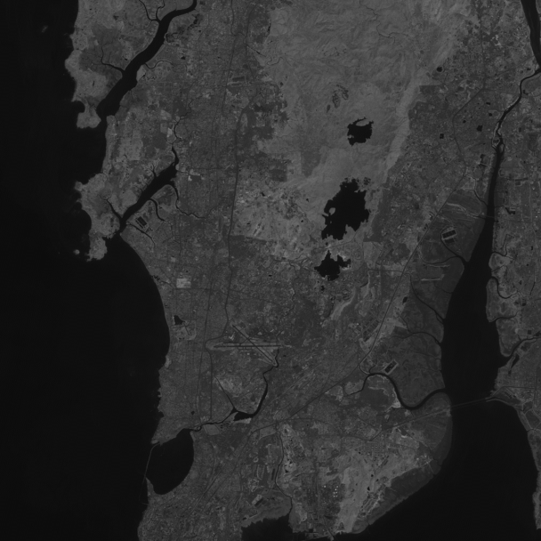 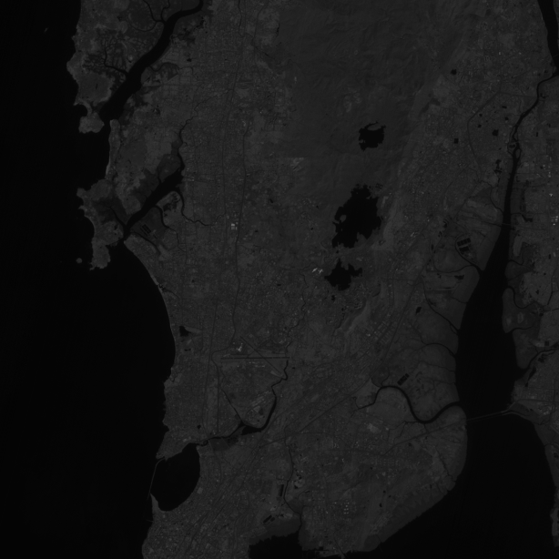

Figure: 11(Band 4) Figure: 12(Band 5)

**12. Methodology:**

**12.1 Preprocessing:**

The Liss 3 images obtained are present in different bands i.e. Band 2, Band 3, Band 4 and Band 5. These bands represent different spectral values. There bands need to be combined to produce the RGB image of the area. This combining of the liss 3 images is done by the merge () in python. The merge () combines the band images (2,3,4) and produces an RGB image.

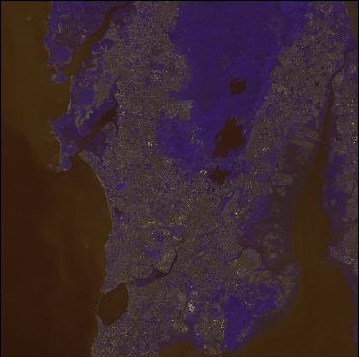

Figure: 13 Liss 3 :RGB image of Mumbai region

**12**.**2. Feature Extraction:**

Digital image classification is the process of assessing pixels to classes. Each pixel is treated as individual unit, and by comparing pixels of unknown and pixels of known identity it is possible to assemble groups of pixels into classes. For assigning the pixel values, matlab software is used. The RGB image obtained by stacking process is used as an input. The pixels can be assigned using impixel (). The impixel () returns the value of pixels in the specified image, where the image can be a grayscale, binary, or RGB image. The impixel () displays the image specified and waits for the user to select the pixels in the image using the mouse. We need to assign the pixel values on the image according to the desired need. In this project, we have created 4 classes in the image i.e. Mangroves, Forest, Water and Development. These classes are represented using different colour i.e. red, green, blue and yellow respectively. A Classified image is created using this classification method. Classified image helps to classify the image based on classes.

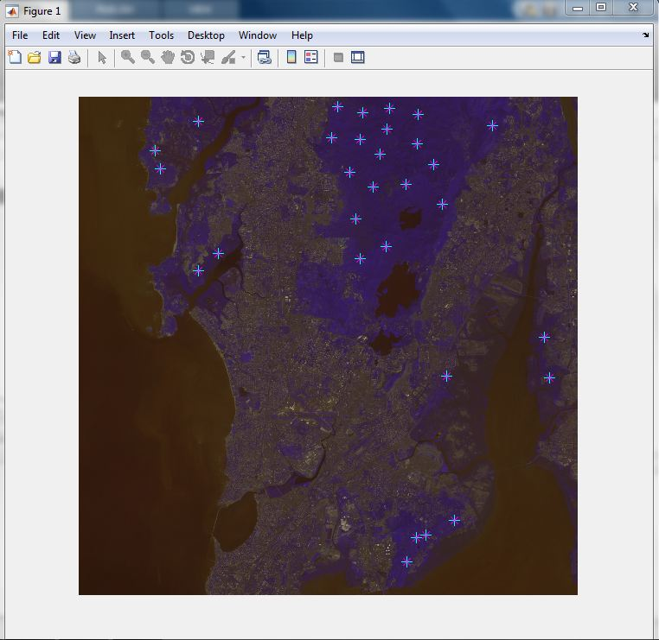

Figure 14: Selecting the pixel values

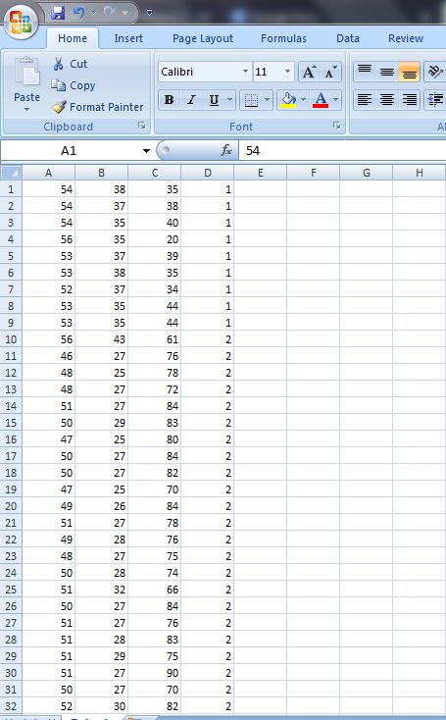

Figure 15: Training Sets

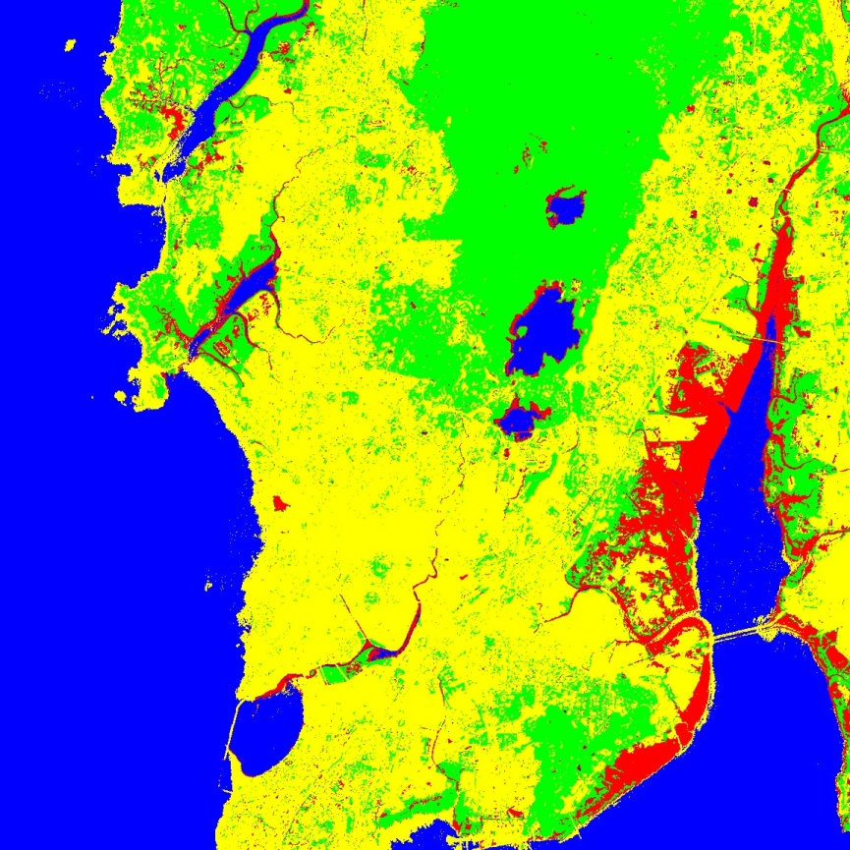

Figure 16: Classified image

|  |  |  |
| --- | --- | --- |
| Class | Colour | Classification |
| 1 | Red | Mangroves |
| 2 | Green | Forest |
| 3 | Blue | Water |
| 4 | Yellow | Development |

13. Algorithm Workflow:

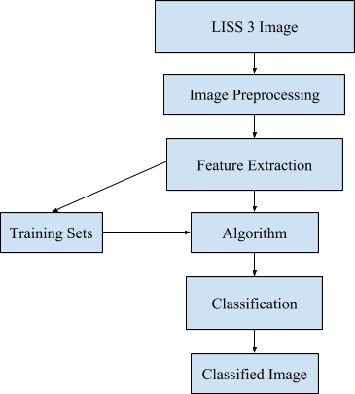

Figure. 17 Algorithm Workflow

**14. Creation of Interactive Map:**

The following are the steps involved in creating an interactive map in QGIS:

**Step 1: Loading the raster image:**

The first step in creating an interactive map is to load the raster image in the QGIS application. The classified image of the Mumbai region is used as the raster image.

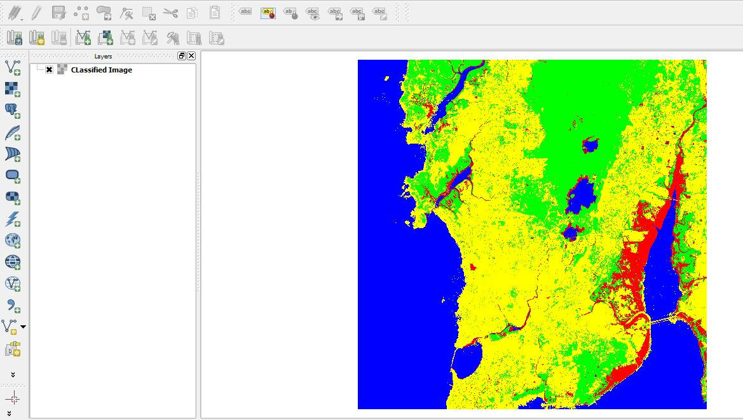

Figure 18:Loading the raster

**Step 2: Create a new Print composer:**

We need to create a print composer from the project menu. Print composer is used to add the map components on the classified image. Map components like legend, north arrow, scale bar, and label can be added. Legend, scale bar, label and the north arrow are added on the classified image.

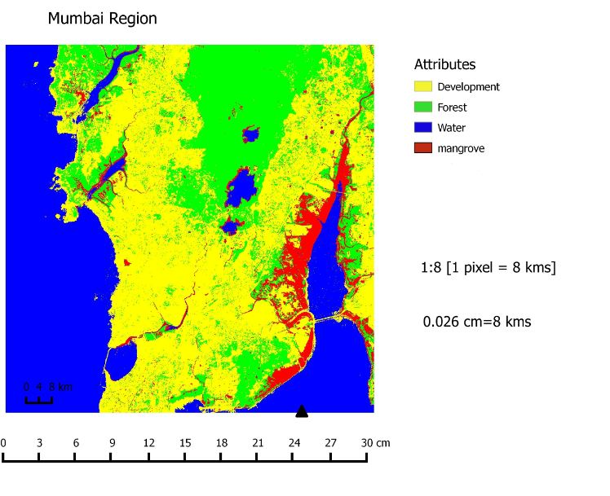

Figure 19:Creating print composer

**Step 3: Saving the raster image:**

The image is saved with all the necessary component added in it.

**Step 4: Open the new raster image:**

The newly created raster image is loaded in the qgis application for further processing.

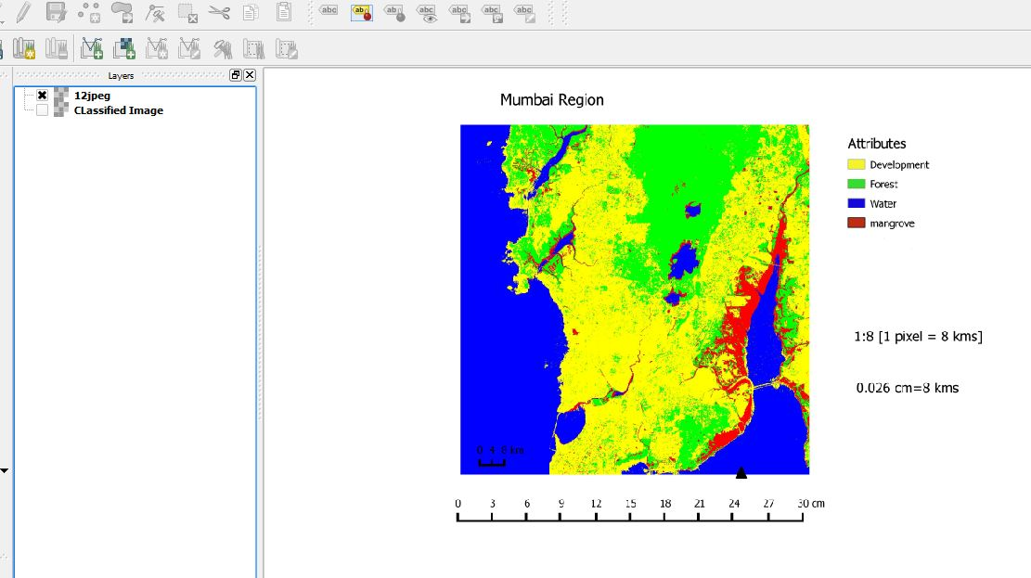

Figure 20: Raster Image

**Step 5: Creating layers:**

The next step is creating point layers. There are two layers to be created i.e. Healthy and Unhealthy. These two layers are point layers which represent a point on the image.

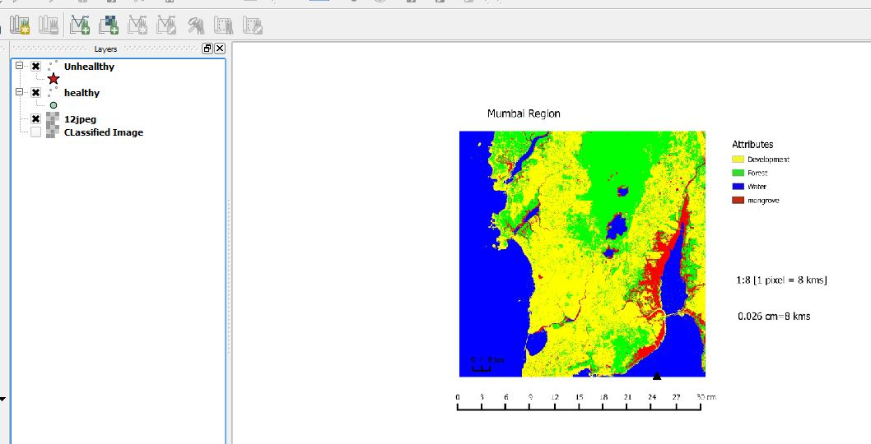

Figure 21: Creating Layers

**Step 6: Plotting the points:**

Two layers are created namely healthy and unhealthy. The two layers specify the conditions of the mangroves in Mumbai. The points are plotted on the image according to the information collected.

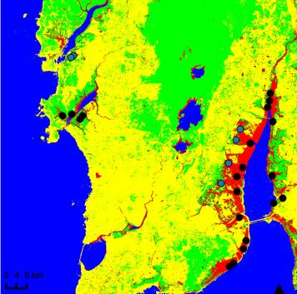

Figure 22: Plotted Points

**Step 7: Creating a print composer:**

A new print composer is created with the changes in the classified image. Two new layers are added in the image i.e. healthy and unhealthy point layers.

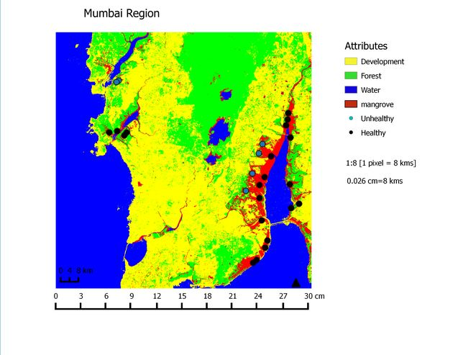

Figure 23: Creating Print Composer

**Step 8: Deploying the map on the web:**

After the complete interactive map is created, we need to deploy it on the web. This can be done by using the QGIS plug-in QGIS2Web. QGIS2Web provides web mapping of the gis data. QGIS2Web uses OpenLayers and Leaflet libraries of the project. After the mapping is complete, the map can be viewed in the web browser which provides the abilities of zooming the map, searching for an particular area and it becomes easier to traverse to the data source that is provided in the point layer.

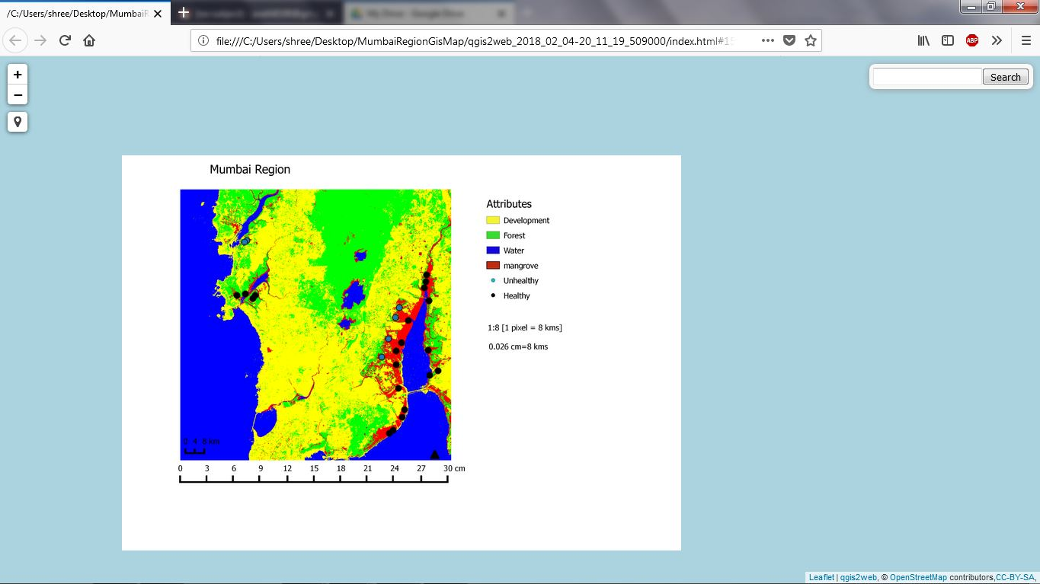

Figure 24: Map Deployed on the web

**15.ACCURACY ASSESSMENT**

**15.1 Confusion matrix:**

A confusion matrix is a table that contains information about actual and predicted classifications done by a classification system. It is used to describe the performance of a classifier on set of test data for which the true values are known.

|  |  |  |  |
| --- | --- | --- | --- |
|  |  | **Predicted** |  |
|  |  |  |  |
|  |  | **Class1** | **Class2** |
|  |  |  |  |
| **Actual** | **Class1** | **A** | **B** |
|  |  |  |  |
|  | **Class2** | **C** | **D** |
|  |  |  |  |

The entries in the confusion matrix have the following meaning in the context of our study:

A is the number of **correct** predictions that an instance is **class1**.

B is the number of **incorrect** predictions that an instance is **class2**.

C is the number of **incorrect** of predictions that an instance **class1.**

D is the number of **correct** predictions that an instance is **class2**.

Several standard terms have been defined for the 2 class matrix:

The **accuracy** is the proportion of the total number of predictions that were correct. It is determined using the equation:



The **true positive rate** is the proportion of positive cases that were correctly identified, as calculated using the equation:



The **false positive rate** is the proportion of negatives cases that were incorrectly classified as positive, as calculated using the equation:



The **true negative rate** is defined as the proportion of negatives cases that were classified correctly, as calculated using the equation:



The **false negative rate** is the proportion of positives cases that were incorrectly classified as negative, as calculated using the equation:



Finally, *precision* (*P*) is the proportion of the predicted positive cases that were correct, as calculated using the equation:

The drawback of this measure is that it does not tell you anything about how well individual classes

were classified. The user and producer accuracy are two widely used measures of class accuracy.

The producer’s accuracy refers to the probability that a certain land-cover of an area on the ground

is classified as such, while the user’s accuracy refers to the probability that a pixel labeled as a

certain land-cover class in the map is really this class.

**15.2 Kappa Statistic**

The Kappa statistic was derived to include measures of class accuracy within an overall measurement of classifier accuracy. It provides a better measure of the accuracy of a classifier than the overall accuracy, since it considers inter-class agreement. The kappa value is calculated using the below formula:



**16. RESULT AND OBSERVATION**

A confusion matrix is an also a tool to summarize accuracy of the classifiers. It basically used for the supervised classification of the data. It consists of the information about classified verses misclassified data in the supervised learning. The diagonal elements in the confusion matrix show the correctly classified data whereas the non-diagonal elements are misclassified data of the classification. So with the help of that the accuracy of the classifier is easily calculated and it will help the algorithm designer to understand the importance and applicability of particular classifier for the specific data.

**16.1 Accuracy and Kappa-value of Artificial Neural Network:**

|  |  |  |  |  |  |  |
| --- | --- | --- | --- | --- | --- | --- |
| Class | Mangroves | Forest | Water | Development | Total | User’s Accuracy |
| Mangroves | 25 | 2 | 0 | 3 | 30 | 83.33 |
| Forest | 6 | 62 | 0 | 13 | 81 | 76.54 |
| Water | 4 | 0 | 119 | 0 | 123 | 96.75 |
| Development | 0 | 2 | 0 | 87 | 89 | 97.75 |
| Total | 35 | 66 | 119 | 103 |  |  |
| Producer’s accuracy | 71.43 | 93.94 | 100 | 84.47 |  | 90.71% |

Accuracy=((25+62+119+87)/323)*100

Accuracy= 90.71%

Kappa value= 0.86

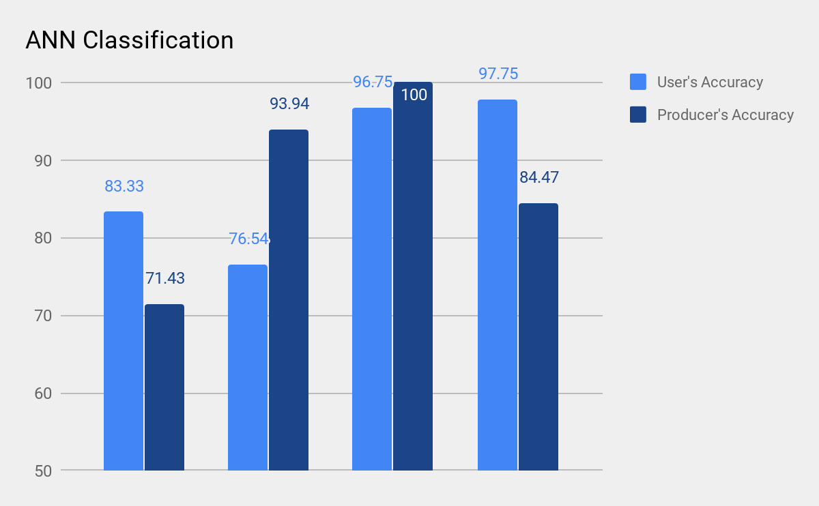

Figure.25Classification Accuracy Assessment of Artificial neural network

The confusion matrix based accuracy assessment of LISS-III satellite image shows that the accuracy of classification using Artificial Neural Network is 90.71%. Similarly kappa coefficient of ANN is 0.86 which is good. The accuracy of the classifiers can be increased by increasing the number of features and sample data.

**16.2 Accuracy and Kappa-value of K-Nearest Neighbor:**

|  |  |  |  |  |  |  |
| --- | --- | --- | --- | --- | --- | --- |
| Class | Mangroves | Forest | Water | Development | Total | User’s Accuracy |
| Mangroves | 27 | 2 | 0 | 0 | 29 | 93.10 |
| Forest | 3 | 61 | 0 | 14 | 78 | 78.20 |
| Water | 4 | 0 | 119 | 0 | 123 | 96.75 |
| Development | 1 | 3 | 0 | 89 | 93 | 95.70 |
| Total | 35 | 66 | 119 | 103 |  |  |
| Producer’s accuracy | 77.14 | 92.42 | 100 | 86.40 |  | 91.64% |

Accuracy=((27+61+119+89)/323)*100

Accuracy= 91.64%

Kappa value= 0.88

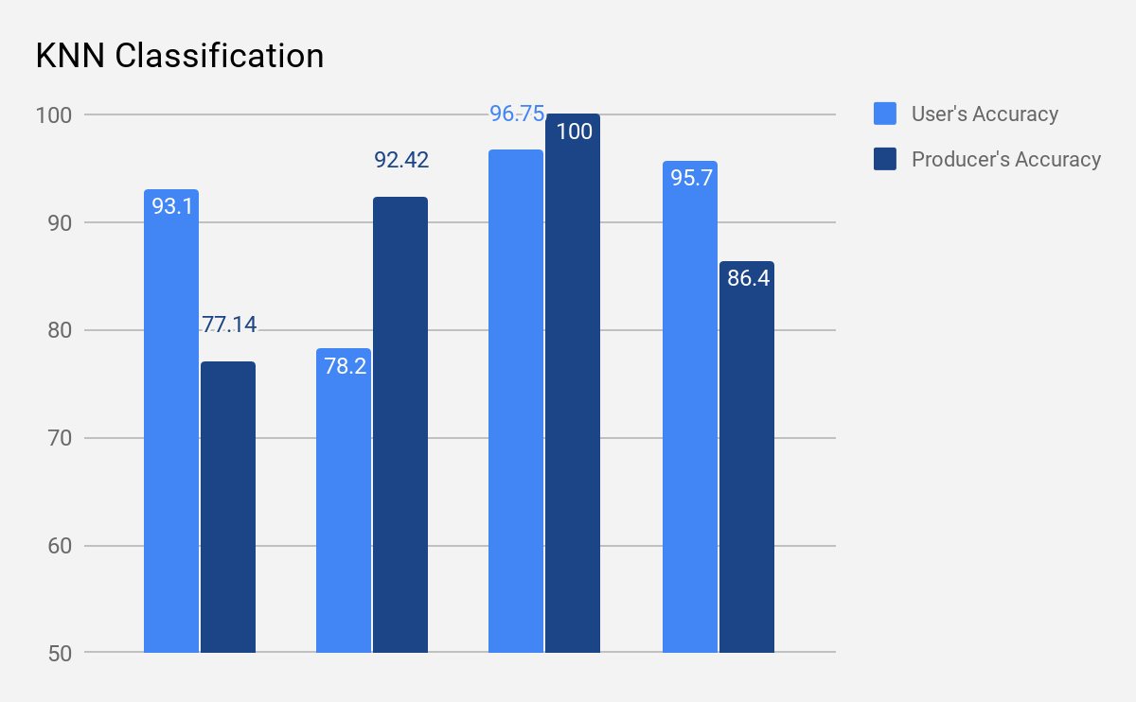

Figure.26Classification Accuracy Assessment of K-nearest neighbor classification

The confusion matrix based accuracy assessment of LISS-III satellite image shows that the accuracy of classification using K-Nearest Neighbor is 91.64%. Similarly kappa coefficient of KNN is 0.88 which is good. The accuracy of the classifiers can be increased by increasing the number of features and sample data.

**16.3 Accuracy and Kappa-value of Decision tree:**

|  |  |  |  |  |  |  |
| --- | --- | --- | --- | --- | --- | --- |
| Class | Mangroves | Forest | Water | Development | Total | User’s Accuracy |
| Mangroves | 26 | 6 | 0 | 5 | 37 | 70.27 |
| Forest | 6 | 54 | 0 | 24 | 84 | 64.28 |
| Water | 3 | 1 | 119 | 0 | 123 | 96.75 |
| Development | 0 | 5 | 0 | 74 | 79 | 93.67 |
| Total | 35 | 66 | 119 | 103 |  |  |
| Producer’s accuracy | 74.29 | 81.81 | 100 | 71.84 |  | 84.52% |

Accuracy=((26+54+119+74)/323)*100

Accuracy= 84.52%

Kappa value= 0.78

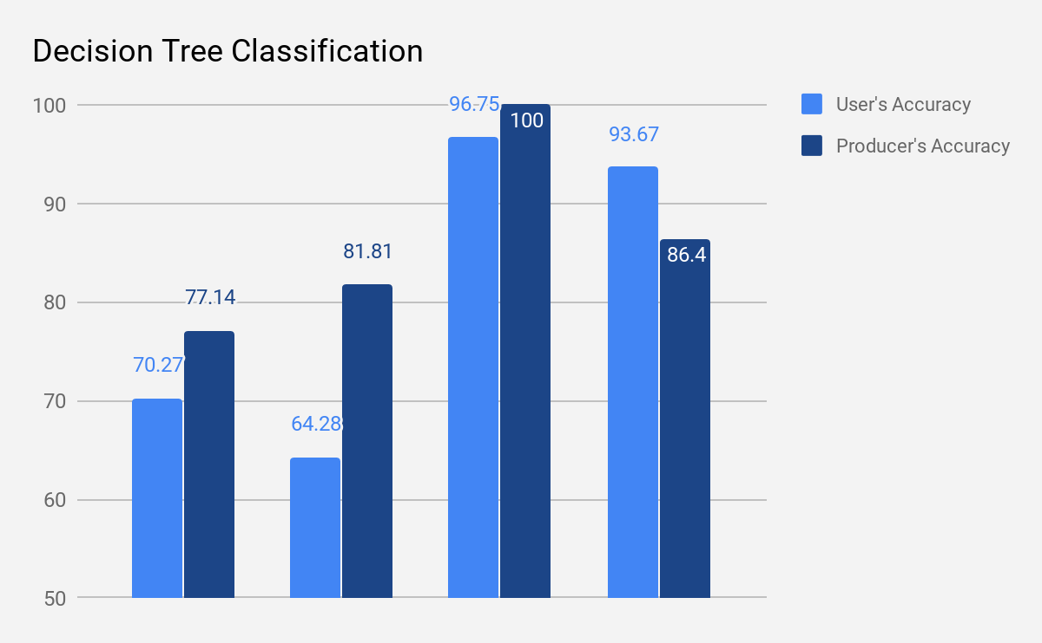

Figure.27Classification Accuracy Assessment of Decision tree classification

The confusion matrix based accuracy assessment of LISS-III satellite image shows that the accuracy of classification using Decision tree is 84.52%.Similarly kappa coefficient of Decision Tree is 0.78 which is good. The accuracy of the classifiers can be increased by increasing the number of features and sample data.

The overall Accuracy and Kappa value are:

|  |  |  |  |
| --- | --- | --- | --- |
| Sr no | Classifier used | Accuracy | Kappa Value |
| 1 | K-Nearest Neighbor | 91.64% | 0.88 |
| 2 | Decision Tree | 84.52% | 0.78 |
| 3 | Artificial Neural Network | 90.71% | 0.86 |

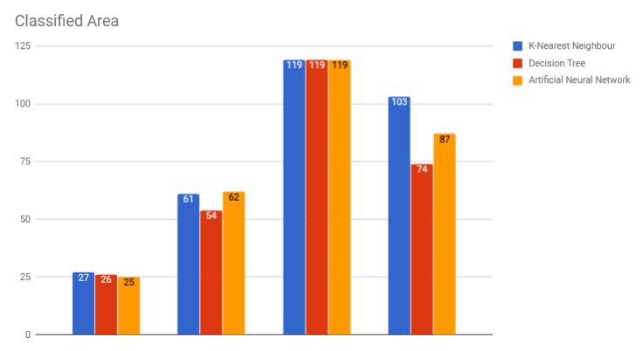

Figure 28: Overall Classified Area

**17. DISCUSSIONS**

**17.1 Accuracy**:

The accuracy assessment of different pixel based approaches, have proved that all the classification techniques have produced results with satisfactory accuracy, which proves that all this techniques are suitable for classifying and mapping the Mangrove area in Mumbai region. By conducting statistical analysis of the accuracies, we find that the KNN based approach has better performance in terms of accuracy and kappa-value as compared to different classifiers implemented.

First of all, we implemented Artificial Neural Network classifier from which the accuracy of 90.71% and its corresponding kappa-value was 0.86 achieved. Then after going through various research paper we got an idea for implementing decision tree. After implementing decision tree classifier we got that the accuracy as 84.52% and its kappa-value as 0.86. After classifying using decision tree we got that the accuracy and kappa-value is more as compared to Artificial Neural Network classifier. With the aim of gaining more accuracy we then implemented KNN. KNN gave us the accuracy of 91.64% with corresponding accuracy as 0.88. The accuracy and kappa-value gained from KNN is more as compared to other two classifiers.

**18. CONCLUSION**

The satellite image based classification of Mangroves is very wide area of study and research and so many peoples are doing research in terms of making efficient algorithm, performance, data handling, training or time. So, here in the same respect the Decision tree, KNN and ANN has been used for classifying LISS-III satellite image and accuracy is calculated using confusion matrix. The results show that the accuracy of the KNN is highest that is 91.64% with the kappa value 0.88. This study also shows that the classification accuracy increases with the increase in the size of the training set but up to a certain limit. Better accuracy can be achieved by increasing the number training samples during learning process. Number of training samples depends on the complexity of the study area. If study area is simple and it consists of well-defined crisp classes then less number of pixels can also give better accuracy.

**19. FUTURE ENHANCEMENT**

The accuracy of the entire process can be increased by classifying the data set with different classifiers. Classifiers like Radial basis network function, Principal component analysis, SVM and LVQ techniques can be used to improve the classification accuracy. In future other statistical parameters are also used to improve classification accuracy. The accuracy can further be improved by using various techniques for classification, such as fuzzy logic and genetic algorithms with all these different feature values.

**20. REFERENCES**

[1] Basic concepts of artificial neural network (ANN) modeling and its application in pharmaceutical research by S. Agatonovic-Kustrin *, R. Beresford School of Pharmacy, University of Otago, PO Box 913, Dunedin, New Zealand Received 25 August 1999; received in revised form 17 September 1999; accepted 23 October 1999.

[2] Roya Abedi, Amir Eslam Bonyad,” Estimation and Mapping Forest Attributes Using “k Nearest Neighbor” Method on IRS-P6 LISS III Satellite Image Data”, ECOLOGIA BALKANICA, Vol. 7, Issue 1 June 2015, pp. 93-102.

[3] Decision Tree Classification of Remotely Sensed Satellite Data using Spectral Separability Matrix

M. K. Ghose, Ratika Pradhan, Sucheta Sushan Ghose Department of Computer Science and Engineering Sikkim Manipal Institute of Technology,Sikkim, INDIA.

[4] Mangrove Area Assessment in India: Implications of Loss of Mangroves, Sahu SC1*, Suresh HS2, Murthy IK1 and Ravindranath NH1.

[5] Assessment of the health status of Indian mangrove ecosystems using multi temporal remote sensing data, prabakaran chellamani, chandra prakash singh & sushma panigrahy.

[6] Mr. Anand Upadhyay, Dr.Santosh kumar Singh, Mr. Aditya Shetty and Mr.Zibreel ,Siddiqui,” Land use and Land cover classification of LISS-III satellite image using KNN and Decision tree”, Proceeding of the 10th INDIACom;3rd International conference on computing for sustainable global development, Organized by BVICAM,16-18 March,2016, IEEEXplore, ISBN:978-93-80544-19-9.

[7] Study of mangrove environment of Maharashtra using remote sensing data, T G Jagtap, A G Untawale and S N Inamdar.

[8] Monitoring mangrove forest changes using remote sensing and gis data with decision-tree learning

Kai Liu, Xia Li, Xun Shi, and Shugong Wang, Guangzhou Institute of Geochemistry, Chinese Academy of Sciences.