This is simple CRUD test application where user can Add, Update or Delete the passengers.

Application UI:

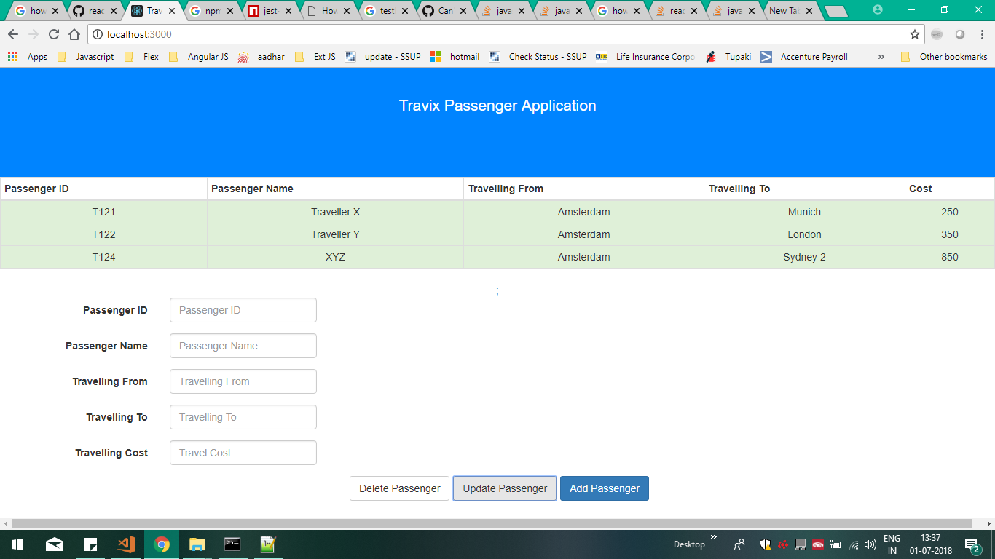

Used Technologies / Tools:

1. React 15+
2. React-Bootstrap
3. Jest
4. Git
5. Redux

How Applications Works:

Using Node Express server bringing passenger details and performing Add, Update or Delete Passenger operations.

**Add Operation:**

User need to enter the data in the provided text controls and once clicks on “Add Passenger” button, Passenger will be added to Table / Grid.

**Update Operation :**

User need to click on the record in the table which needs to be modified, all the row values will be populated in to the text controls and user is allowed to modify and once modified, user needs tp click on “Update Passenger” button and the details immediately will get update in the table / grid.

**Delete Operation:**

User need to click on the record in the table which needs to be modified, all the row values will be populated in to the text controls and once user clicks on “Delete Passenger” button , passenger details will be removed.