HiéraSync AI: A Role-Aware Departmental Coordination System with a Deterministic Calendar Core, a Heuristic Risk Layer, and a Human-in-the-Loop Approval Desk
[Author Name]¹, [Co-author Name]¹, [Guide Name]¹ (1) [Department / Institute Name], [City], [Country] Correspondence: [email] · Date: [submission date]
Body length (measured, not estimated): 8 263 words in sections 1–9, counting table prose and excluding fenced code and the mermaid sources. Per section — Abstract 458 · §1 798 · §2 1 074 · §3 942 · §4 2 229 · §5 732 · §6 1 517 · §7 464 · §8 347 · §9 160. Appendices: A 453 · B 181 · C 233 · D 324 · References 457. Delete this block before submission; it exists so that a reviewer can check the draft against the word limits in your rubric instead of trusting a claim.

Abstract
Departmental coordination in an Indian engineering college is usually run through WhatsApp groups, a shared Excel calendar and paper circular notes signed at the HOD's desk. This paper reports the design, implementation and verification of HiéraSync AI, a web platform that replaces those three channels with one role-scoped system for a single academic department. The backend is FastAPI (36 Python modules, 5 287 lines) over Cloud Firestore, exposing 83 operations in 18 route modules over 16 collections; the frontend is React 19 + Vite + FullCalendar (57 TypeScript/TSX modules, 10 767 lines, 8 129 lines of CSS) behind 16 routed screens and a design-token layer that keeps typography and alignment uniform across them. Ten server-side roles gate every write; the calendar is the primary object, with five activity types, a four-state status flow, ISO-date normalisation on both tiers, and hand-written ICS and CSV export that obey RFC 5545 line folding.
The "AI" layer is deliberately heuristic first, generative second: an additive, capped deadline-risk score, a two-band priority ranking for faculty and a four-class action queue for the HOD are computed from stored documents with no model call at all, and a Gemini request is used only to rewrite the prose of a calendar summary when an API key happens to be configured. Every one of the six /ai routes answers with no key present. Reminders come from a rule engine (APScheduler, 08:00 daily plus a six-hourly sweep) that writes idempotence markers onto the activity document. Two properties that a demo of this kind usually fakes are built in and tested: a Firestore-compatible in-memory double that makes the whole system runnable with no cloud project GET /health reports which mode it is in; and an explicit first-admin bootstrap rule that breaks the "you need a HOD to create the first HOD" deadlock. A case-insensitive email lookup fixes a class of lockouts that no feature test would have caught.
Verification reported here is limited to what the repository can prove: 82 pytest cases (198 assertions) over the API surface, RBAC, both approval queues, the risk model and the reminder jobs, plus 9 node:test cases (46 assertions) over the date and ICS utilities — 91 checks, all passing, in under seven seconds, with no cloud account. Every measured number in this paper comes from that run or from counting the tree. No human-subject study is reported: Appendix A specifies the instrumented protocol (task time, SUS, Kendall's τ between the risk score and an expert ranking, p50/p95 latency at three corpus sizes) to be executed before submission, and §6.4 lists precisely which convincing-sounding claims this draft therefore refuses to make.
Keywords: academic workflow management; department administration; role-based access control; Firestore; explainable heuristics; deadline risk; notification idempotence; RFC 5545; FullCalendar; reproducible evaluation

1. Introduction

1.1 The setting
A small department — one programme, ten to twenty faculty, one HOD desk, one principal's office — runs an outsized amount of its administration by hand. A "course file verification on Thursday" exists in a WhatsApp thread; the person responsible may or may not have seen it. A request for a workshop budget is a printed form that sits in a tray, and whether it moved is only known by asking. A task assigned three weeks ago has no owner-visible clock. When the HOD wants to know who is carrying the most work, somebody rebuilds a spreadsheet. Nothing is wrong with the people in this loop; the medium is what fails — a chat stream has no state, a paper tray has no queue discipline, and a spreadsheet has no owner.
Commercial and research systems address fragments of this. Campus-wide suites treat a department as a reporting unit rather than an actor; research schedulers such as ScheduleMe and Togedule concentrate on the meeting itself; generative assistants for university administration report large workload reductions but assume integrations and a data layer that a small department does not have. §2 positions the work against all three. This paper describes what we built instead: a system scoped to one department, deployable on a free-tier Firestore project, whose "intelligence" is mostly deterministic arithmetic and whose generative component is optional by construction.

1.2 Design stance
Four positions shaped the implementation, and each is testable rather than rhetorical.
Deterministic first. Ranking, escalation and summarisation must be reproducible from stored state, so a reviewer can re-derive any number on screen with no network and no API key. A model is allowed to phrase a finding, never to be the finding. This follows the external evidence rather than taste: the ICAPS survey of LLM-based planners reports that they still trail symbolic solvers on correctness and completeness (§2.2).
State where a message used to be. A reminder is not a chat message; it is a field on the activity document (reminded_at) so that it cannot fire twice. A decision is not a reply; it is a status transition that queues a notification back to the requester.
Visibility is a server rule, not a UI courtesy. Every route resolves the caller from a bearer token and either requires a role or filters by identity in the query; the client's canManage flag only decides whether a button is drawn.
Degradation must be legible. A page showing seeded sample data says so ("Offline preview data"), and /health reports memory (volatile demo data) rather than pretending to be backed by Firestore.

1.3 Contributions
This paper contributes the following, each traceable to code in github.com/Atulgupta07/Hiera_Sync (Appendix B pins the tree and the commands to rebuild it) and, where stated, to an automated check:
A department-scoped coordination data model over a document store: 16 collections covering identity, membership-by-invite-code, calendar activities, tasks with subtasks, two distinct approval queues, notifications, comments, attachments, goals with milestones, per-user preferences and an audit log — with the ten-role model enforced through per-route allow-lists (§4.2, §4.3).
A heuristic, explainable prioritisation layer: an additive capped risk score, a rank formula for "what should I do today", a four-class action queue for the desk, a queue-ranking rule for pending approvals, and a weighted faculty productivity score, each emitting the reasons behind its own number (§4.4). A test suite pins the arithmetic, including its floor and cap.
An optional-LLM boundary: five of six AI endpoints never call a model; the sixth rewrites heuristic facts into prose only when GEMINI_API_KEY is set, and says which source it used (source: heuristic|gemini). The invariant "the /ai prefix works with no credentials" is an executable test (§4.5).
A rule-based reminder engine with per-document idempotence and a two-tier date-normalisation contract, which together make an activity written as "05 August 2026" behave like one written as 2026-08-05 in filters, sorting, the calendar grid and the exported .ics (§4.3, §4.6).
Operational honesty as a feature: an in-memory Firestore-compatible double selected by a real readiness probe, a first-admin bootstrap rule, and case-insensitive credential lookup — three defects that made the system unusable in practice, each fixed and now covered by tests (§6.2).
A verification harness that ships in the repository (82 backend cases, 9 frontend cases) and a written protocol for the user study that has not been run (§6, Appendix A), so the gap between "built" and "evaluated" is explicit rather than papered over.

1.4 Scope and reading order
This is a system paper: it reports design, implementation and software verification. Appendix A is the evaluation instrument to be filled in. Appendix B gives the commands to reproduce everything. Readers who want the comparison with prior work can go straight to §2.6 and Appendix C.

2. Related work

2.1 Department and academic-affairs information systems
The closest published system to ours is the Academic Affairs Management System [1]: role-based dashboards for Employee, HOD, Principal and Admin, a multi-stage document approval chain with real-time status synchronisation, AI-assisted document summarisation, and a React/Tailwind front end. It frames the institutional problem well and is the natural baseline for "what such a system already contains". Its unit of work, however, is a document travelling up a chain. In HiéraSync the unit of work is a dated activity with an owner, and the approval step is one transition on that record rather than the whole data model. Formal document approval workflows in higher education [2] take the more rigorous route of modelling the chain as a business process with rules, validation and an audit trail; we adopt that discipline for state transitions and activity logs, but not for a multi-office signature sequence, which in a single department adds latency without adding assurance. Two studies measure the practical benefit of this class of system: a budget-request tracking and approval platform reported improvements in processing time, error frequency and usability on a validated questionnaire (Cronbach's α = 0.90) [3], and a design-science development of digital academic services reduced a thesis-registration cycle "from several days to minutes" [4]. Commercial and open-source platforms — SAP SLCM, Fedena, OpenEduCat, EduSec — are surveyed within [1]; all are student-record-centric, and their approval modules are record-keeping rather than coordination surfaces. Simpler web implementations of the same problem space — a Django-based student-management system [5] and a layered smart-campus architecture with cloud deployment and secure authentication [6] — are useful as "conventional approach" comparators: relational schemas, no calendar engine, no suggestion layer. A recent AI-enabled information system for challenge-based capstone matching [27] shows the same full-stack pattern applied to a different university unit.

2.2 Calendar and scheduling assistance
Recent scheduling research is largely conversational. ScheduleMe [7] coordinates specialised agents — event creation, availability checking, conflict resolution — under a supervisory agent over Google Calendar, and reports the privacy exposure inherent in sending calendar text to a hosted model; that exposure applies unchanged to any assistant with department data, which is why HiéraSync keeps the model out of the write path. Togedule [8] uses an LLM to adapt which candidate meeting slots are shown and in which presentation, recommending a final time from attendee priorities; a formative study (N=10) and two controlled experiments (N=66) show reduced cognitive load for attendees and faster, better-organised decisions. This is the closest published analogue to our approval ranking, with the difference that Togedule optimises slot choice for a meeting while we rank a queue of pending decisions. Automated scheduling for thematic coherence in conferences [9] formalises the trade-off we implement informally: hard constraints (no double-booking, room capacity) versus soft ones (preferences, coherence), solved with a CSP model over NLP-derived similarity. The ICAPS survey of LLMs for automated planning and scheduling [10] is the cautionary reference: across 53 papers, LLM-generated plans remain weak on validity, completeness and optimality relative to combinatorial planners. Our architecture follows that evidence literally — the deterministic checker owns correctness, the model owns phrasing.

2.3 Workload, fairness and duty allocation
Timetable-generation work supplies the load-balancing vocabulary. An AI-based real-time timetable and faculty scheduling system explicitly describes calendar views, conflict alerts and heat maps for faculty load with a feedback loop for continuous refinement [11]; an adaptive scheduler generates timetables with a genetic algorithm over faculty availability and subject preferences, collects feedback and exports the result [12]. A quantified workload-balance model validated on institutional data [13] supports equity claims that a dashboard alone cannot justify, and a learning-based system for allocating examination duty [14] demonstrates the feature set we mirror — prior duty count, experience, availability, leave status and expressed preference.

2.4 Generative AI in academic administration
LLM agents for education [15] surveys pedagogical and domain-specific agents and names the deployment barriers we design against: hallucination, over-reliance, and integration with existing institutional ecosystems. A parallel review of educational agents covers the ethics and governance layer expected of any assistant that touches staff records [16]. The strongest measurement template is the deployment study of GenAI assistants in a university's administrative service [17]: query volumes before and after introduction, accuracy stratified by query complexity, and the conclusion that such assistants act as an augmentative resource rather than an autonomous decision-maker. Institutional-level evidence pools substantial reported gains — administrative-workload reduction near 62 %, task-completion time cuts above 50 %, roughly 70 % of assessment-related processes automated — alongside the barriers of privacy, infrastructure and cultural resistance [18]. Retrieval-augmented academic analytics [19] shows BI data being queried in natural language, which is the same loop our dashboard-summary and calendar-insight endpoints close. Complementary evidence concerns notification design: a field experiment (N=247) found that reducing notification-caused interruptions improves performance and lowers strain, and that batching outperforms total silencing, which raises anxiety [20].

2.5 Stack justification and evaluation instruments
Firestore's own characterisation — stable notification latency as Listen connections grow, commit latency governed by document and field size rather than field count — is documented in a peer-reviewed industrial paper [21]. Head-to-head Firestore-versus-MySQL benchmarking [22] gives the trade-off honestly: roughly 25 versus 45 write operations per second, ~$1.30 versus ~$35 for a one-million-object scenario, and 66.7 s versus 0.9 s for a million-document range scan, concluding that a document store is preferable for growth and cost while losing on wide range queries; a study of Firestore data-modelling practice [23] shows pre-computed aggregates reduce read counts, cost and response size. For access control in academic platforms, RBAC hierarchies separating read-only, editing and administering roles are argued specifically for university digital systems [24]. For evaluation, a systematic mapping of 30 Springer-indexed information- system papers (2021–2025) documents how the System Usability Scale is applied, with respondent counts and typical score ranges [25], and an SUS study of a higher-education audit system demonstrates comparison against older academic platforms [26].

2.6 Gap
Across these bodies of work the split is clean: scheduling systems model when, document systems model what was decided, workload allocation models who, and GenAI deployments model how to answer a question. None of the surveyed systems holds all four in one store with one permission model and one decision surface, and none reports a cold-start protocol for the case where the department that must be approved by a HOD has no HOD yet. That intersection is what this paper describes.

3. Problem analysis and requirements

3.1 Failure modes of the manual practice
Six concrete failures motivated specific mechanisms. They are practitioner observations from the department the system was built for, not instrumented measurements — Appendix A is where a measured baseline would come from.
Lost-visibility. A circular in a chat group has no per-recipient state, so "did you see it?" and "did you do it?" are the same question, and both are unanswered. → notifications carry a target_route and read state.
Ownerless due dates. A task written on paper has no derived urgency, so everything is equally urgent and therefore none of it is. → the risk score.
Queue invisibility. Pending approvals are invisible to the requester; the HOD's desk has no ordering. → both queues expose status, timestamps and a ranked suggestion list.
Date-format drift. An Excel column that holds "05 August 2026" beside "2026-08-05" cannot be sorted or filtered; in our first implementation it also silently blanked the calendar grid. → two-tier normalisation (§4.3).
Bootstrap deadlock. Whoever registers first needs approval from a person who does not exist yet. → the first-department claim rule (§4.3).
Credential casing. A profile saved as Hod@SBJIT.edu.in failed a lowercase login with a message that blamed the password. → normalised write, tolerant read (§5).

3.2 Functional requirements
No prior requirements document existed; the list below is reconstructed from the implemented routes and the failures that drove them, which makes it a reverse-engineered specification. That is stated openly because it bounds what §6 can claim: the system satisfies its own requirements, not a customer's.
FR1 Identity. Self-registration with name, email, password and role; bearer-token sign-in; profile read; password-reset link generation.
FR2 Account provisioning. The desk (ADMIN/HOD) creates and edits accounts, with search across name, area of interest and designation.
FR3 Department lifecycle. Create a department, receive a unique 8-character invite code, regenerate that code, read one's own department.
FR4 Membership approval. Request to join by code; the department's HOD approves or rejects; approval writes department_id and status: ACTIVE in one update and notifies the requester.
FR5 Calendar as the primary object. Create/edit/delete department activities with type, responsible faculty, venue, all-day flag, times, status and priority; list with type, person, date_from, date_to filters; a validated time range; explicit clearing of optional fields.
FR6 Directed reminders. Notify the named owner when an activity is created (notify_assignee) or on demand (POST /events/{id}/remind).
FR7 Unattended reminders. A scheduled sweep queues a message for every activity starting within two days and escalates overdue ones, each at most once, and skips completed work.
FR8 Task tracking. Tasks with assignee, deadline, priority, progress, category, effort estimate, reminder text, subtasks and a require_approval flag; update and delete; assignment notifies the assignee and writes an audit entry.
FR9 Request-to-work conversion. Any active user raises a task request; the desk approves it into a real task (optionally editing title, assignee, deadline and priority inline) or rejects it with a reason; the requester can withdraw while pending.
FR10 Approvals desk. A flat queue with priority, comments and decision timestamps; approve/reject restricted to the desk; the requester is notified by name resolution.
FR11 Discussion and evidence. Threaded comments on a task with @-mentions that fan out notifications; per-task file attachments plus a general upload / list / metadata-download endpoint.
FR12 Goals, dashboards and portability. Department goals with ordered milestones; dashboard and analytics aggregates; a personal notification feed with read/unread and bulk actions; four preference toggles; cross-collection search; ICS and CSV export of exactly the rows currently in view.

3.3 Non-functional requirements
NFR1 Server-side authorisation, with the client mirroring rules only to avoid dead buttons.
NFR2 Data fidelity: every stored date is ISO on both tiers; a field can be emptied, not merely overwritten.
NFR3 Operability: the system must run and be demonstrable with no cloud credentials, and must always say which persistence it is on.
NFR4 Explainability: each computed score arrives with the reasons that produced it.
NFR5 Portability: exports must parse in mainstream clients (RFC 5545 folding, RFC 4180 quoting).
NFR6 Model-independence: no route may require an LLM key to return a useful answer.
NFR7 Idempotence: repeated reminders, repeated decisions and repeated notification writes must not multiply state.

3.4 Requirement traceability
Table I maps each requirement to the code that implements it. Paths are relative to /api/v1 unless noted.
Table I. Requirement → implementation.
Req | Backend | Frontend / other | Checked by
FR1 | POST /auth/register, POST /auth/login, GET /auth/me, POST /auth/forgot-password | api/auth.ts, pages/Auth/* | test_api_surface.py (4 cases)
FR2 | GET/POST /auth/employees, PUT /auth/employees/{id} | pages/Employees.tsx, api/employees.ts | 2 cases
FR3 | POST /departments, GET /departments/me, PUT /departments/code | pages/CreateDepartment.tsx | 1 case (gate)
FR4 | /join/request, /join/{status,pending,approved,rejected}, /join/{id}/{approve,reject} | pages/JoinDepartment.tsx | 1 case + manual walkthrough
FR5 | /events CRUD + query filters | pages/CalendarPage.tsx, utils/calendar.ts | 7 cases
FR6 | POST /events/{id}/remind, notify_assignee on create | day-detail modal | 2 cases
FR7 | app/scheduler/jobs.py (cron 08:00 + 6 h interval) | — | 3 cases
FR8 | /tasks CRUD, calculate_task_risk, activity_logs write | pages/Tasks.tsx + role dashboards | 4 cases
FR9 | /task-requests POST/GET, /{id}/approve, api_route(["PATCH","PUT"]) | pages/TaskRequests.tsx | 4 cases
FR10 | /approvals CRUD + /{id}/{approve,reject} | pages/Approvals.tsx | 4 cases
FR11 | /comments/{task_id}, /attachments/{task_id}, /files/{upload,,download/{id}} | components/tasks/Task*, FileUpload.tsx | manual
FR12 | /goals… (8 routes), /reports/*, /notifications/*, /settings/*, /search, /analytics/faculty-performance | ICS/CSV export in utils/calendar.ts | 9 cases

4. System design

4.1 Architecture
Fig. 1 shows the four bands a request crosses. Nothing in the diagram is aspirational: each box is a directory in the repository.
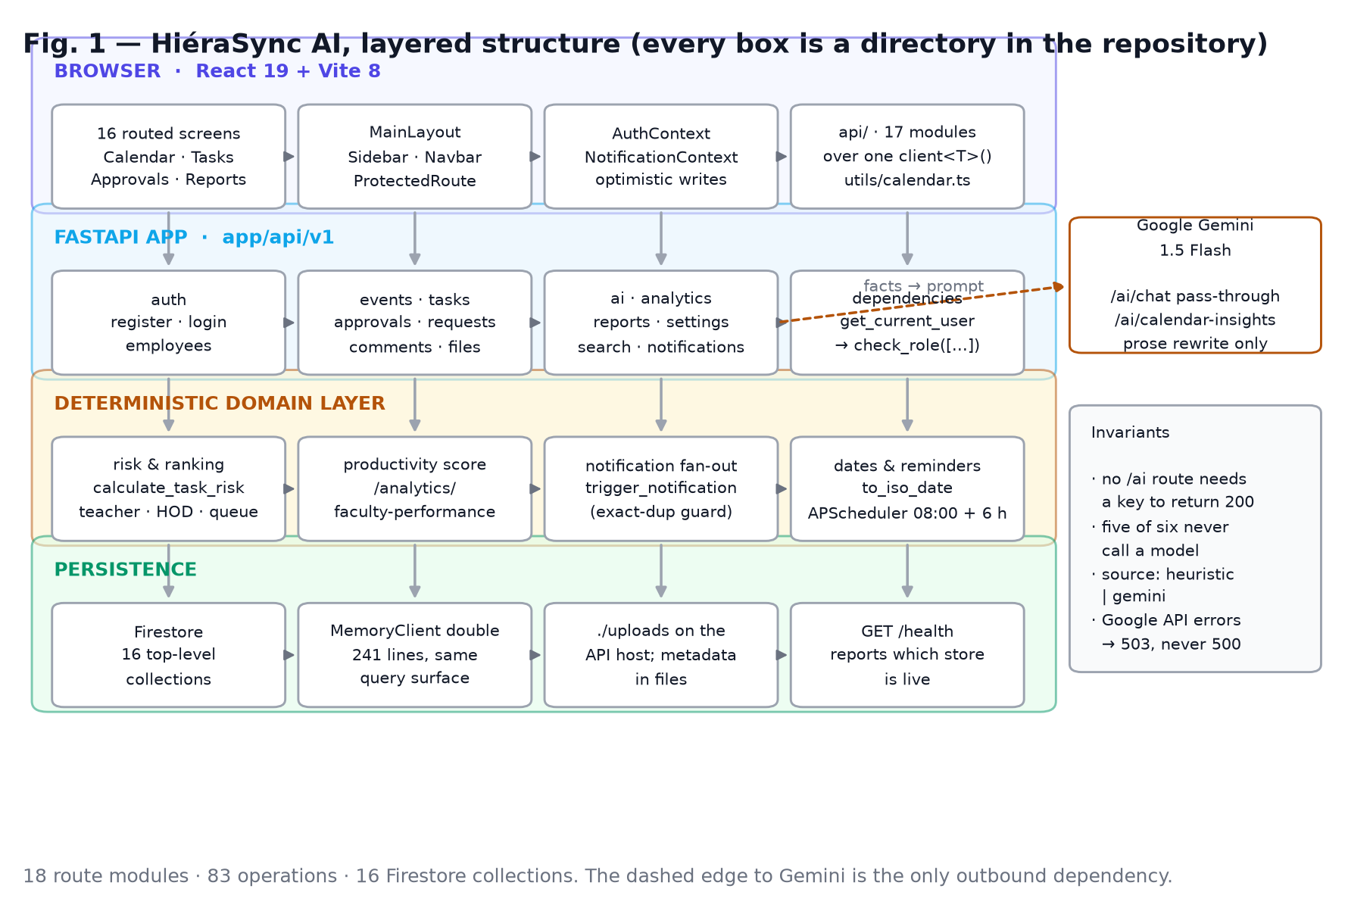
Fig. 1. Layered structure of HiéraSync AI. The optional Gemini edge is the only outbound dependency; every other arrow is in-repo code.
Two structural notes. First, there is no service layer: routers import each other directly (ai.py imports calculate_task_risk from tasks.py; requests.py imports create_task from tasks.py) rather than going through a services/ package. That keeps reuse concrete and dependency-light at 5.3 k lines, and it is the debt §8 asks to pay back. Second, every collection is top-level (events, tasks, approvals, …). Department isolation is therefore a query-time predicate, not a document path — a choice with consequences for both RBAC and scalability (§6.4).

4.2 Coordination state
Table II lists the 16 collections the application reads or writes. All document ids are either the Firebase uid, a uuid4, or a short prefixed token (notif_, evt_seed_, app_seed_). Timestamps are stored as ISO strings via datetime.utcnow().isoformat() — no server-side timestamps, no transactions, no batched writes.
Table II. Persistence model (16 collections).
Collection | Key | Carries | Written by | Read gating
users | Firebase uid / demo_<12 hex> | name, email (normalised), hashed_password, role, department_id, designation, status | register, POST/PUT /auth/employees, join approval, grant_access.py, first-department bootstrap | profile self; list to any active user
departments | uuid | name, unique 8-char code, hod_id, is_hod | POST /departments, PUT /departments/code | own department
join_requests | uuid | faculty_id, department_id, department_code, status ∈ Pending/Approved/Rejected, requested_at | POST /join/request; decision routes | requester's own; desk sees its department's
events | uuid (or evt_seed_n) | 12 schema fields (§4.3), plus reminded_at, overdue_notified_at, creator_id, created_at | POST/PUT/DELETE /events (desk only); scheduler markers | any active user, filtered
tasks | uuid | 17 schema fields incl. subtasks[], reminder, require_approval, goal_id, progress, deadline | POST/PUT/DELETE /tasks (desk only) | FACULTY sees only tasks whose assigned_id matches or whose assigned text contains their name
approvals | uuid | title, requested, assigned, priority, status, comments, created_at, reviewed_at | POST/PUT/DELETE /approvals | any active user (list is department-wide)
task_requests | uuid | request fields + requester_id, status ∈ PENDING/APPROVED/REJECTED/CANCELLED, rejection_reason, created_task_id, reviewed_by | POST /task-requests, decision routes | own for faculty, all for desk
notifications | notif_<8 hex> | user_id (or "department"), title, message, free-form type, priority, target_route, icon, status, is_read, created_at | 5 fan-out sites + POST /notifications | user_id ∈ {self, "department"}
task_comments | uuid | task_id, author_id/name, content, mentions[] | POST /comments/{task_id} | task participants
task_attachments | uuid | task_id, file_name/type/size, storage_path, uploaded_by | POST /attachments/{task_id} | task participants
files | uuid | filename, safe_filename, file_path, size, content_type, uploader_id/name | POST /files/upload (bytes to ./uploads) | any active user
department_goals | uuid | title, description, category, start/target date, owner_id, status | POST/PATCH/DELETE /goals | any active user reads
goal_milestones | uuid | goal_id, title, description, due_date, order, status, completed_at | milestone routes (desk only) | nested into goal reads
settings | uid | four booleans (ai_recommendation, task_analysis, deadline_alert, email_notifications) | lazily on first read; PUT /settings/me | self
activity_logs | auto | user_id/name, action, category, details, timestamp | create_task only | latest 5, any active user
test | auto | POST /test/firebase probe record | dev probe | dev probe

Identity is carried in the JWT as sub = email, signed HS256 with ACCESS_TOKEN_EXPIRE_MINUTES (30 by default; .env.example ships 60). Because the subject is the email and not the uid, changing an address invalidates live tokens — accepted deliberately so that a profile rename cannot leave two identities in flight, and recorded in §6.4 as a constraint.
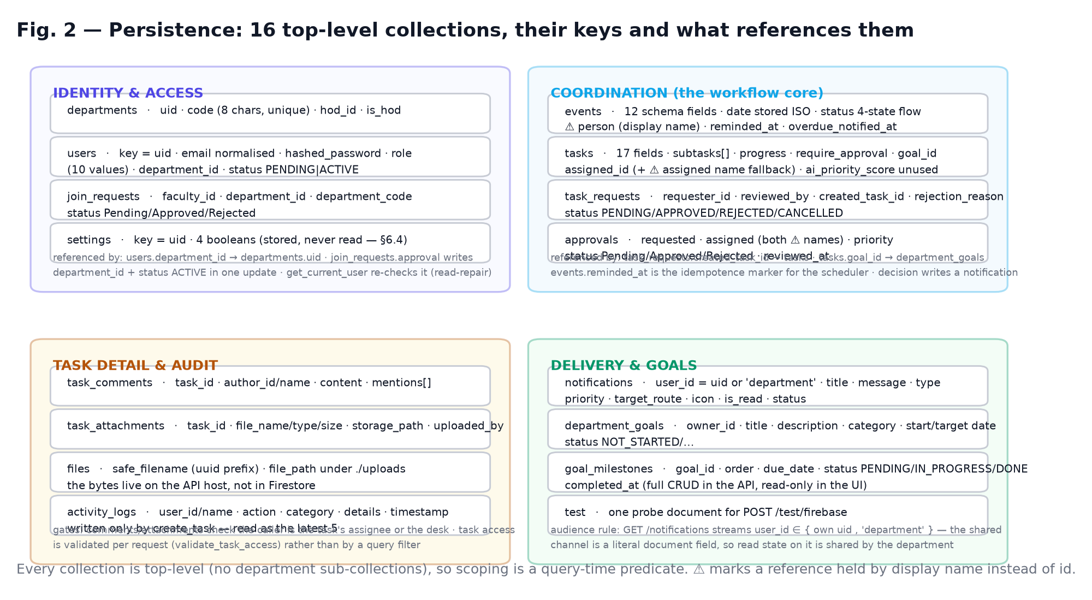
Fig. 2. Referential structure. Dashed-by-nature edges are the ones held by display name rather than id — approvals.requested, tasks.assigned as a fallback, and events.person — which is precisely where the name-based lookups in §4.3 and the fragility noted in §6.4 come from.

4.3 Coordination rules
Activity lifecycle. EventCreate accepts 12 fields (title, date, type, person, description, location, status, priority, start_time, end_time, all_day, notify_assignee). type is drawn from five values (Academic, Meeting, Workshop, Department Activity, Research), status from a four-state flow (Planned → Assigned → Review → Completed) and priority from Low/Medium/High, all declared once in app/schemas/schemas.py and mirrored in pages/calendarData.ts so the UI stepper and the API agree. Writes require ADMIN or HOD (MANAGE_ROLES); reads are open to any active user. A timed activity whose end_time is not after start_time is rejected with 422, and CLEARABLE = {description, location, start_time, end_time} makes an empty string an explicit clear rather than an ignored field. On a first read of an empty collection the API materialises eight sample activities relative to today's date — as real documents, so they can be edited and deleted instead of re-appearing forever.
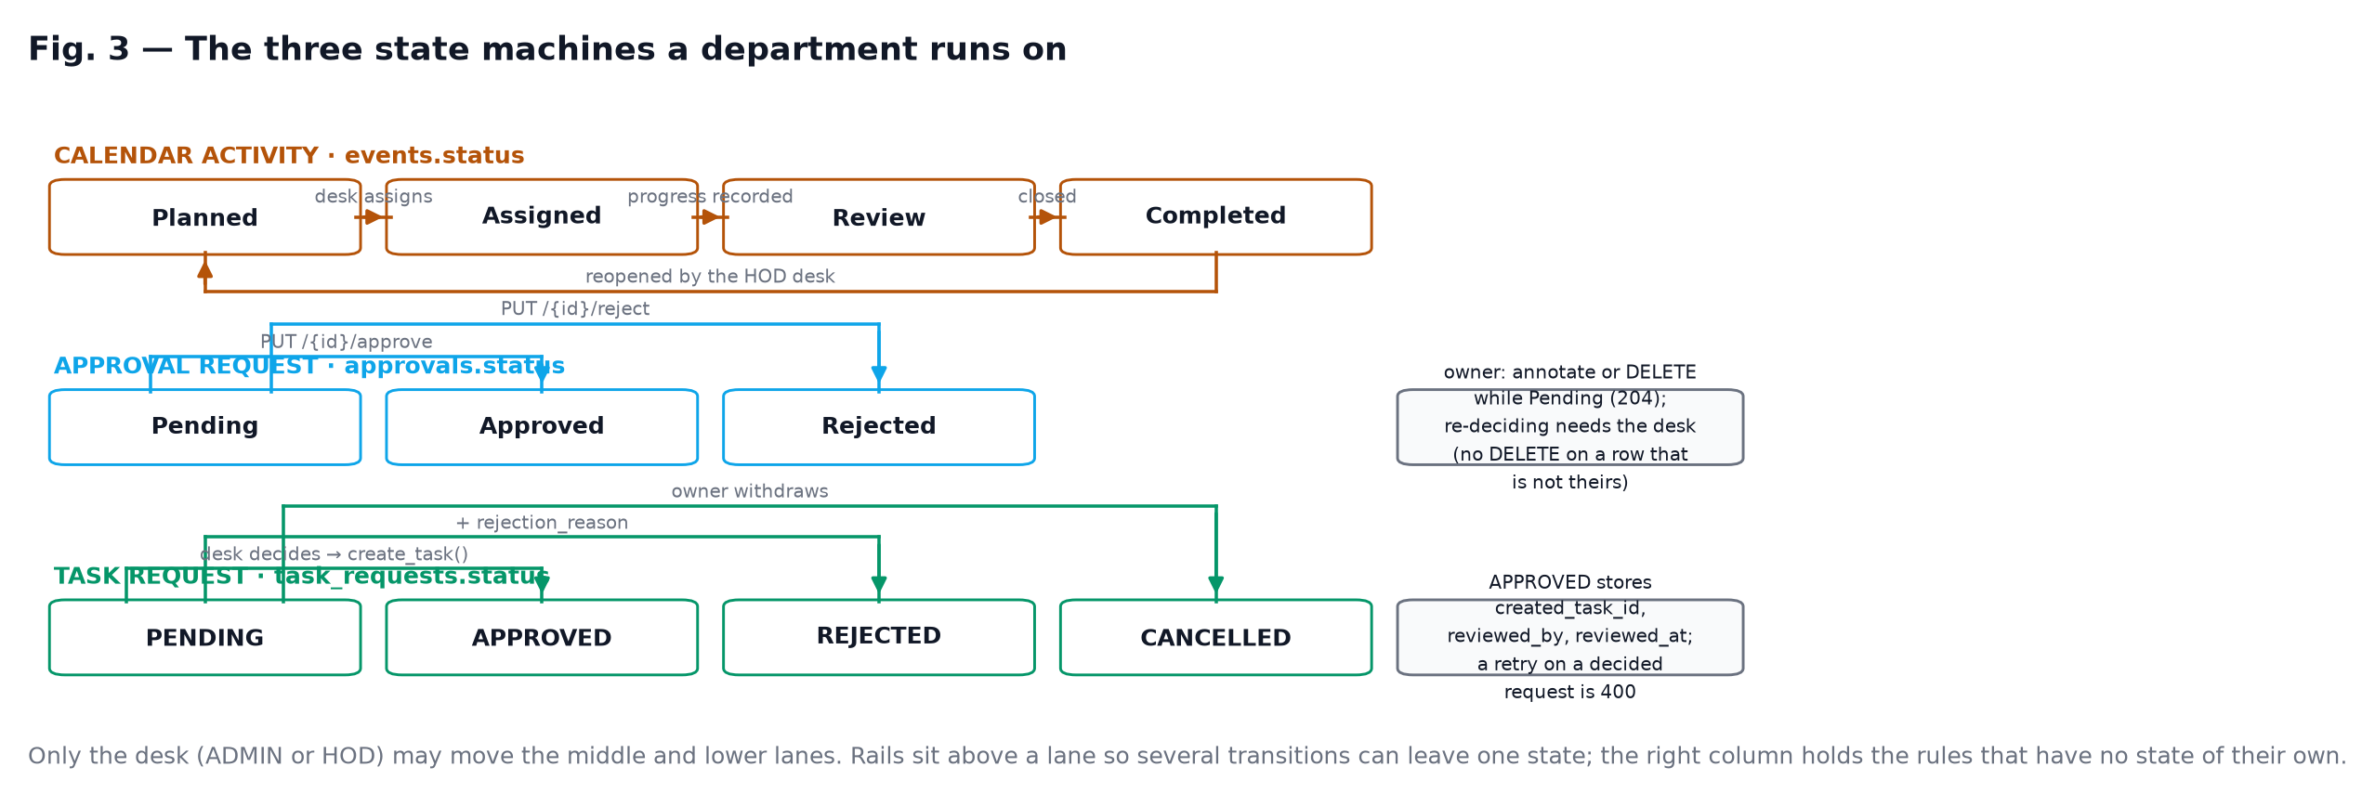
Fig. 3. The three state machines that a department actually runs on. Only the left one is a calendar object; the middle one is a decision, the right one converts into work.
Two approval queues, deliberately different. approvals is a flat desk queue: Pending → Approved|Rejected, one reviewer stage, with the requester allowed to annotate their own pending item and to withdraw it; a decision that does not change the value returns the document untouched, so a double-click cannot re-notify. task_requests is a conversion queue: PENDING → APPROVED|REJECTED|CANCELLED, where approval calls create_task in-process and records created_task_id, so the notification that says "a task was created" is true; approving an already-decided request is a 400, not a silent no-op. models/models.py also declares ApprovalStatusEnum with a two-stage PENDING → APPROVED_HOD → APPROVED_PRINCIPAL chain and a current_stage field; no route uses it, which we record as an unfinished capability rather than a feature (§6.4).
Membership. A department is created with a unique 8-character code from A–Z0–9, regenerable by its HOD. Join requests are validated against that code, refused if already a member, and refused while another request is pending; approval writes department_id and status: ACTIVE in a single update() and notifies. Two mechanisms exist so that the system can start at all: the first department may be claimed by whoever registers it even while PENDING, and that account is promoted to HOD in the same call; and get_current_user performs a read-repair, re-checking a PENDING account's approved join request and activating it. scripts/grant_access.py performs the same repair from the command line when there is no UI to sign in through.
Reminders. send_event_reminders() streams events, keeps those with an ISO date inside [today, today + REMINDER_WINDOW_DAYS] that are not Completed and have no reminded_at, writes one notification for the resolved owner and then stamps the marker. flag_overdue_events() mirrors it for dates in the past, escalating with priority: High and stamping overdue_notified_at. The window is a two-day horizon; cadence is a cron at 08:00 plus an interval sweep every six hours, so worst-case latency for an activity created at 08:01 is under six hours and the marker guarantees at-most-once per activity per category.
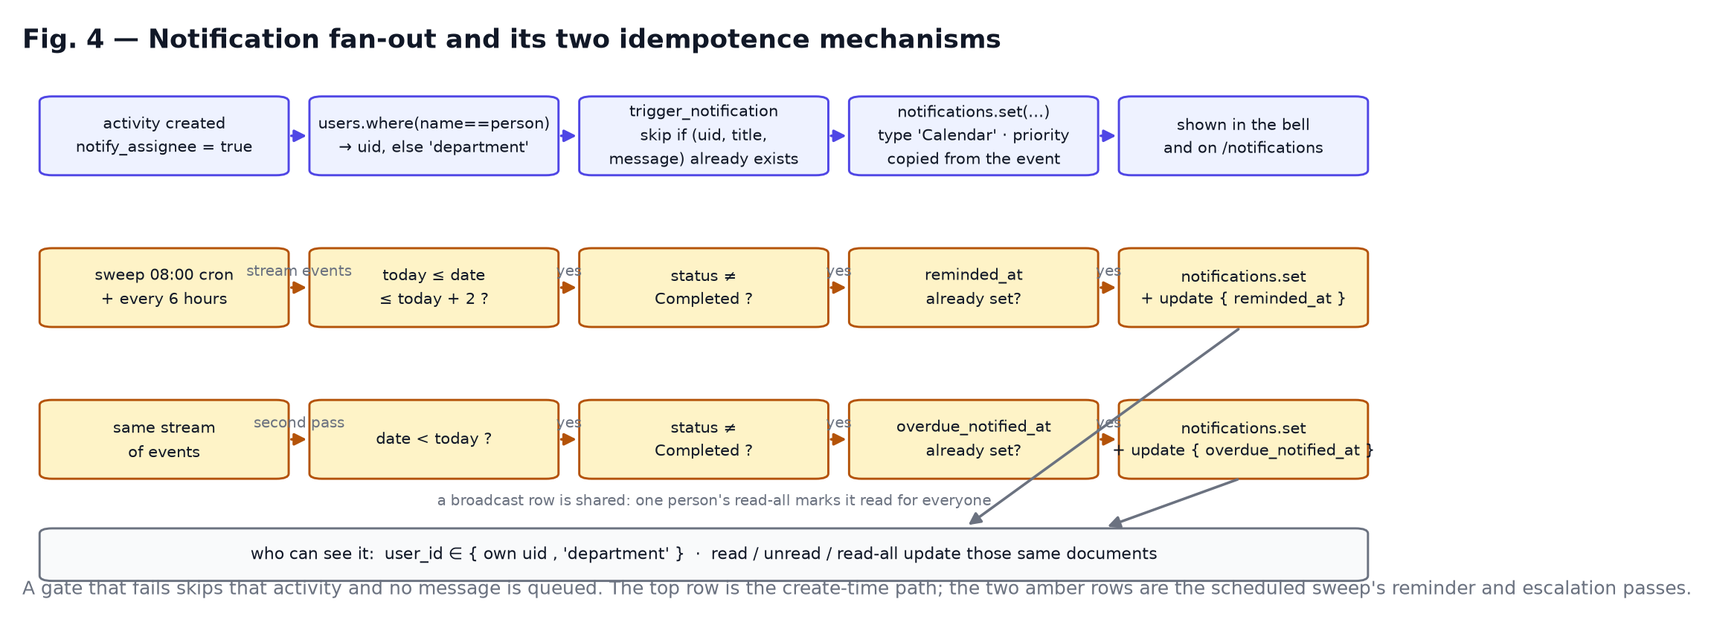
Fig. 4. Notification fan-out and its two idempotence mechanisms: a marker on the activity for scheduled sweeps, and an exact (user_id, title, message) match inside trigger_notification for immediate ones.

4.4 The deterministic prioritisation layer
Every number on the dashboard is arithmetic over stored documents. The core is calculate_task_risk(task, faculty_workload) in app/api/v1/tasks.py, applied on read so that a task's risk is always current with respect to today.
Table III. The additive risk model (capped to [5, 95] unless closed).
Condition | Δ | Note
status ∈ {Completed, Awaiting Approval} | → 0, level LOW | returns immediately, factor explains it
days_left < 0 | +90 | factor "Task is overdue by n days."
0 ≤ days_left ≤ 2 | +50 | "Only n days remaining."
3 ≤ days_left ≤ 5 | +30 | "n days remaining."
progress < 50 % and days_left ≤ 3 | +25 | "Progress is only x%."
priority == High | +15 | "…less margin for error."
faculty_workload > 3 | +20 | "k active tasks"
unparseable/absent deadline | — | days_left defaults to 10
after summation | min(max(s, 5), 95) | floor so nothing reads as zero
bands | > 70 HIGH, > 40 MEDIUM, else LOW

Three rules are then layered on top of it, all with their own explanations:
Faculty "today" list. score = 50·days_overdue + risk_score + (30|15|5 by priority) plus (4 − days_remaining)·10 when the deadline is within three days; items with status ∈ {Completed, Awaiting Approval} are dropped; the top five are returned with ranks assigned after sorting and a why[] list drawn from overdue-ness, imminent deadline, low progress, high risk and high priority.
HOD action queue (ADMIN/HOD only), four classes with explicit levels: CRITICAL = 100 + days_overdue; HIGH RISK = 80 + risk/10 when risk > 70; APPROVAL = 60 for a task awaiting approval; WORKLOAD = 50 + load for an assignee holding more than four active tasks. Sorted descending, truncated to ten.
Pending-approval ranking. score = {urgent 70, high 60, medium 30, low 10} + min(30, age_days × 4) + 8 if no reviewer note yet, top three returned with a composed reason string.
Faculty productivity (/analytics/faculty-performance, desk-only): 0.35·on_time_rate + 0.30·completion_rate + 0.20·mean_active_progress + 0.15·workload_balance, where workload balance is 100 for ≤3 active tasks, 70 for ≤5, 50 for zero (flagged as under-utilised) and max(0, 100 − 10·load) beyond that. average_completion_time is returned as null on purpose: completion is not timestamped, so the field would be a lie.
Fig. 5 draws the same rules as bands, so that the clamp, the floor and the two level lines are visible without reading the table; the figure doubles as the specification for a hand-drawn version (Appendix D).
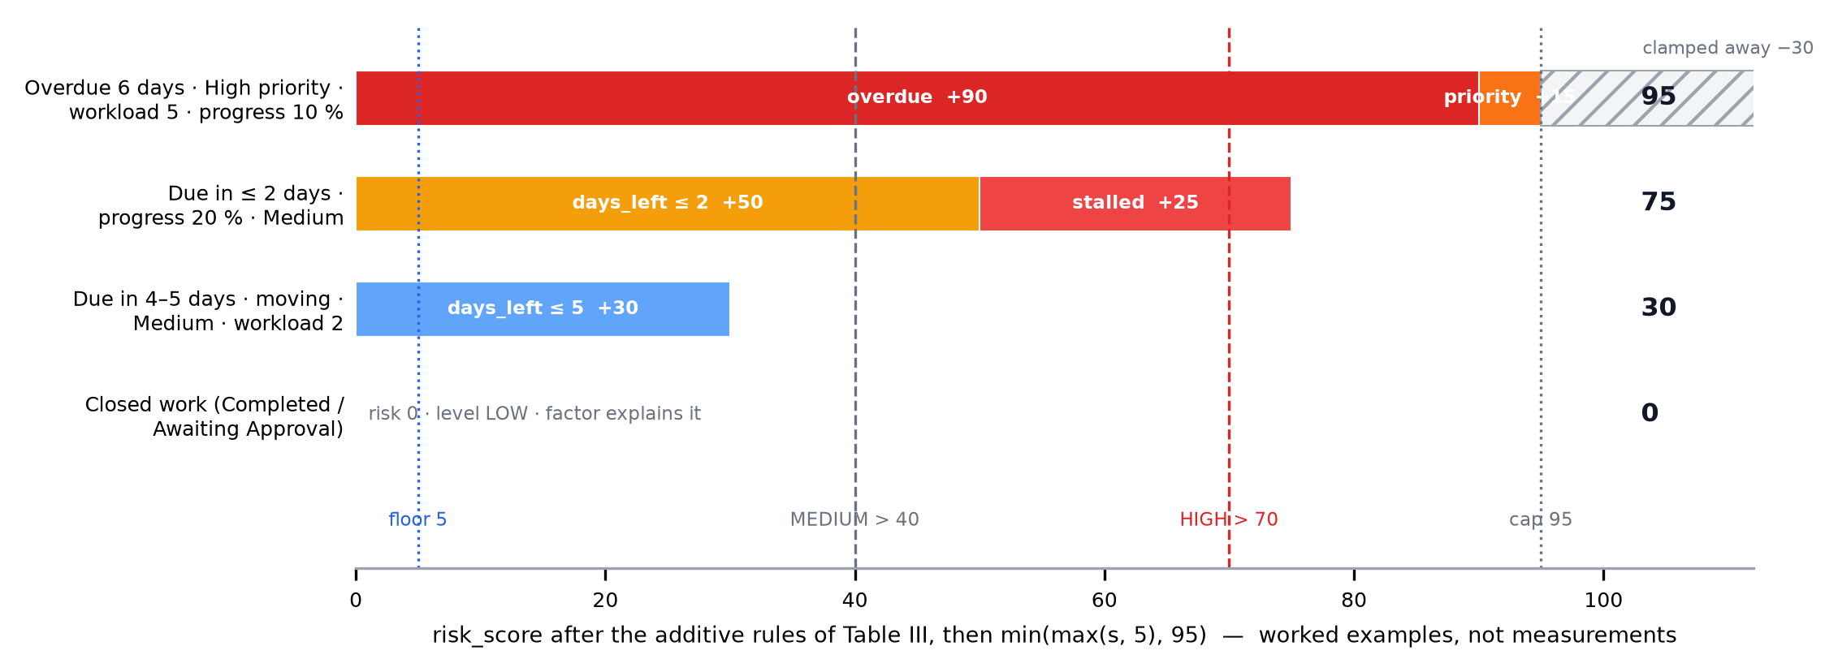
Fig. 5. The risk model of Table III as score bands: each rule's increment stacked left to right, cut off at the 95 cap, with the 5 floor and the 40/70 level thresholds marked.
Four figures the eye reads as measurements are not measurements, and we say so rather than leaving a reviewer to find it: ai_productivity "92 %" and ai_efficiency "92 %" are string literals in the response builders; the dashboard's productivity_score is the literal "95 %"; the greeting is always "Good Morning, name"; and the counters in /reports/dashboard-stats fall back to 124, 18, 5, 24, 18, 9 and 2 when a collection is empty. Each is pinned by a characterisation test so that turning a placeholder into a real metric will break the test and force a sentence in the paper.

4.5 The LLM boundary
Six routes sit under /ai; five never call a model:
GET /ai/dashboard-summary — the two rankings above, from Firestore reads.
GET /ai/approval-suggestions — the queue ranking, from stored priorities and ages.
POST /ai/notification-summary — counts, a per-type histogram and up to three high/urgent unread titles.
POST /ai/generate-report — a fixed template (title, one summary sentence, two recommendations) plus a fresh timestamp. It performs no aggregation; the paper does not describe it as if it did.
GET /ai/calendar-insights — deterministic facts (activities in the next seven days, the busiest day, the heaviest owner, crowded days with 3+ items, count past their date) which may then be rewritten.
The rewrite is the whole extent of generative use: when GEMINI_API_KEY is set, the highlight strings are handed to Gemini 1.5 Flash with an instruction to advise the HOD or the faculty member "based only on these facts", 20 s timeout, and on any exception the heuristic summary is returned with a warning log. The response carries source: "heuristic" | "gemini" so a caller can tell which it got. POST /ai/chat is a plain pass-through with no departmental context attached, and answers "…operating in simulated mode. Please add your GEMINI_API_KEY…" when unconfigured — an honest degradation we prefer to a confident hallucination. The invariant is a test: all six routes return 200 with no key configured.

4.6 Portability, exports and the demo double
Calendar data must leave the system. Both writers live in frontend/src/utils/calendar.ts and are exercised by the shipped unit tests:
ICS BEGIN:VCALENDAR · VERSION:2.0 · PRODID:-//HieraSync AI//Academic Calendar//EN · CALSCALE:GREGORIAN · METHOD:PUBLISH UID:<id>@hiera-sync · DTSTAMP:<UTC YYYYMMDDTHHMMSSZ> all-day: DTSTART;VALUE=DATE:<YYYYMMDD> · DTEND;VALUE=DATE:<day+1> (exclusive) timed: DTSTART:<YYYYMMDDTHHMMSS> (floating local) · DTEND from end_time, else start_time SUMMARY · DESCRIPTION (note · Owner: p · Type: t) · LOCATION (omitted if empty) escaping: backslash, then ';', then ',', newline → \n folding: every line to 74 chars + continuation space, CRLF between lines (RFC 5545) CSV every cell quoted, embedded quotes doubled, CRLF line ends (RFC 4180) columns: Date · Activity · Type · Responsible Faculty · Location · Start End · Priority · Status

Exports are scoped to the rows currently in view (hiera-sync-calendar-<range start>.ics|.csv), and a single activity can be downloaded as its own .ics from the day modal. Nothing about the calendar depends on the backend being reachable.
The same reasoning produced the demo double: app/database/memory.py is a 241-line, thread-locked MemoryClient that implements the subset of the Firestore surface the routers actually use (collection().document().get() / set(merge) / update() / delete(), where(field, op, value) and where(filter=FieldFilter(...)), order_by, limit, stream, plus seed and clear). init_firebase() probes the client after initialising it and falls back to that double on any failure, logging why; get_db() does the same if the lifespan never ran; is_memory_db() and GET /health expose the state. Combined with the calendar page's live/preview flag and its hiera:calendar:preview-events localStorage cache, this makes the whole product — including a reviewer's own laptop, an examination demo and the test suite in §6.1 — runnable with no project, no key and no network. It is a demonstration affordance, not offline synchronisation: there is no merge, no replay, and restarting clears it.

5. Implementation
Stack and volume. Back end: Python 3.11, FastAPI with uvicorn[standard], Pydantic v2 (pydantic[email]), firebase-admin, python-jose for JWT, APScheduler, bcrypt (reached through passlib[bcrypt], though the code imports bcrypt directly and never uses passlib). Front end: React 19.2, TypeScript 6, Vite 8.1, Tailwind 4.3, FullCalendar 6.1 (@fullcalendar/react 6.1.15 with the daygrid/timegrid/interaction plugins at 6.1.21), Recharts, Framer Motion, dnd-kit. Application volume: 5 287 lines across 36 Python files; 10 767 lines across 57 TS/TSX files; 8 129 lines of CSS; 18 route modules and 83 operations; 16 collections; 16 routed screens, 12 component modules and 3 layout modules. requirements.txt declares nine packages with no pins — reproducible in what it needs, not in what it gets; §8 treats that as debt, and Appendix B records the exact resolution this paper's numbers came from.
Authentication. Sign-in compares a bcrypt hash (gensalt() default cost, 12 rounds) held on the caller's users document. Firebase Auth is used to mint an account at registration (and to generate reset links) but is never consulted at sign-in, which keeps the department database authoritative and the system self-contained. The three failure modes are distinguished on purpose: no profile ("Incorrect email or password"), profile without a hash ("This account has no password on file in the department database…"), and a correct password with any casing of the address. Emails are trimmed and lowercased on write and resolved on read through one helper that tries the typed value, the normalised value and then a case-insensitive scan of users, so rows written before normalisation can still sign in and tokens issued from them keep authenticating.
Consistency details that turned out to matter. Every resource route is declared without a trailing slash, because a 307 between client and handler drops a PUT body in some clients. The task-request decision route is declared api_route(methods=["PATCH", "PUT"]) because the generated client uses the latter. Approval decisions and request approvals/rejections notify; task creation writes the audit entry that the dashboard's activity rail reads. The scheduler's sweeps are made idempotent by per-record markers (§4.3). Every one of these came from an observed failure, not a style preference, and each is now pinned by a named test.
Typed client layer. The front end reaches the API through 17 modules (authApi, eventsApi, tasksApi, approvalsApi, requestsApi, aiApi, …) layered on a single client<T>() wrapper that injects the bearer token, JSON-encodes the body, treats 204 as an empty object, re-raises the server's detail string as the message (which is why a failure on screen reads "Only the HOD desk can reschedule activities." rather than "403"), and on 401 clears the token and dispatches a global unauthorized event that AuthContext listens for. Tokens go to localStorage when "remember me" is checked and to sessionStorage otherwise; authorisation state is derived from the profile the token resolves to via GET /auth/me, so a stale local role cannot open a surface the server would refuse. In development the Vite server proxies /api/v1 to 127.0.0.1:8000, so the browser stays same-origin.
Graceful degradation, visibly. Pages track whether they are serving live or preview records; a failed calendar fetch flips to seeded preview data and the toolbar says so. In preview mode mutations persist to localStorage; in live mode a write is optimistic and reverted with a toast if the API rejects it, the same pattern the notification context uses for read-state toggles.
Design system as a usability requirement. Tokens in index.css define four variable families loaded from Google Fonts — Manrope (body), Roboto Slab (display and numerals), Saira (labels and controls) and Google Sans Flex (data, and the shared fallback) — plus a radius scale (4/6/8/10/12/14/16 px and --radius-pill: 999px) with Tailwind's xs…3xl remapped onto it, which is how "sharper bento corners everywhere" was achieved without editing 16 pages. Alignment is a contract, not a habit: pages use .hs-page or the full-bleed .hs-shell-pad, the layout's <main> carries no padding at all, --hs-content-max: 1440px and --hs-gutter are shared, and scrollbar-gutter: stable prevents a per-page horizontal jump. The calendar carries the affordances the workflow needs: month/week/day views at 30-minute slots, drag-to-reschedule gated by canManage with an optimistic update, a day rail for the selected date, per-day density classes, a workload ranking naming the heaviest-loaded person, a status stepper over the four lifecycle states, an Escape-dismissable detail modal, and range-scoped .ics/CSV export. The task surface splits by role into HODDashboard and TeacherDashboard, which is what lets the same /ai/dashboard-summary payload serve both audiences.

6. Verification

6.1 What is executed, and reproducibly
Verification here means software verification, and only of what ships in the repository: no number below depends on a throwaway script. Two suites, one command each.
cd backend && python -m pytest -q # 82 passed in ~6 s, no network cd frontend && npm run test:utils # 9 pass, 0 fail in ~0.2 s

Table IV. Verification assets and what each establishes.
Asset | Cases | Asserts | Establishes
tests/test_api_surface.py | 41 (27 functions) | 60 | /health mode reporting; 83 operations and the prefix set; five routes 401 without a token; canonical paths answer with no redirect and no history; PUT bodies survive; email normalisation on write and legacy-case read fallback; duplicate registration refused; the two distinct 401 messages; sub-is-email roundtrip through GET /auth/me; self-registration trusts role (documented finding); the shared default password Sbjit@123; employee search; three 403 gates; notification scoping to {self,'department'}; bulk-read mutating shared rows; helper dedupe vs. raw REST write; lazy settings document; the three placeholder constants; the export URL that is never written
tests/test_workflows.py | 41 (40 functions) | 138 | desk-only event writes; ISO normalisation for four input shapes; inverted time range → 422; explicit field clearing; first-read seeding of 8 editable documents; type/person/window filters; assignment reminder reaches the named account and /remind answers 400 without an owner; 404 instead of 500 for a missing activity; approval round-trip with requester notification; idempotent second decision; owner annotation vs. stranger 403 vs. withdrawal; queue filter and newest-first order; request→task conversion with the task title, assignee, created_task_id, reviewed_by and the 400 on retry; per-requester visibility; owner cancel cannot approve; rejection reason + notification; task creation notifies and writes the audit log; faculty task list is assignment-scoped; risk attached on read; milestone CRUD reachable by the desk only; five risk-model cases pinning cap 95, floor 5, closed-work zero, stacking of near-deadline+stall (75 vs 50) and the workload delta (exactly 20); graceful default on junk dates
frontend/tests/calendar-utils.test.mjs | 9 | 46 | toISODate accepts ISO/human/junk-prefixed forms and never renders "Invalid Date"; relative-day wording; upcoming/overdue respect status; double-booking detection; the all-day exclusive DTEND; ICS escaping, CRLF termination and folding; foldICSLine folds only what it must; CSV quoting of separators and embedded quotes
GET /health, /openapi.json | — | — | the persistence mode and the operation count asserted above are readable by any reviewer without the source

Total: 91 automated cases and 244 assertion statements, all passing, in under seven seconds on a laptop, with no cloud project, no credentials and no model key. A separate read-only sweep of all 35 GET operations under /api/v1 in demo mode returned 28 × 200 and 7 × 404 — the 404s are the deliberately absent document ids fed to parameterised routes — and no 5xx (/ and /health included). The snippet is in Appendix B.

6.2 Defect classes found, and what they teach
Every fix below is a commit on this branch, with the failing behaviour described first. The classes are generic enough to be the useful part of this section.
Configuration lying about identity. initialize_app(cred, {"projectId": settings.FIREBASE_PROJECT_ID}) let a stale .env default (my-firebase-project) point the app at an empty database: sign-in failed with "user not found" although the service-account file named a different project. Fixed by letting the credential file decide, warning on mismatch, and logging Firestore project: … at start (9ccaf48), plus /health refusing to name a project it is not connected to (506bbe9) and resolving the key path against backend/ as well as the CWD (d870b56). Lesson: an identity that is configured twice will eventually disagree with itself.
Deadlock in a permission model. An empty Firestore project could not be started from the UI: registration yields a PENDING FACULTY account, only an active HOD can approve, and only the approval creates the HOD. Fixed by the first-department claim rule with immediate activation and promotion, and by the get_current_user read-repair (2676d57), with scripts/grant_access.py for the headless case. Lesson: every ACL needs a bootstrap path; test the empty database, not the seeded one.
Case sensitivity in a human-entered key. A profile typed as Hod@SBJIT.edu.in could not sign in, and the message blamed the password (3bacfcd); fixing only the login path would have left get_current_user, whose subject is the email, broken — the fix normalises on write and makes every read path tolerant. Lesson: normalise at the boundary and audit every reader of the field.
Transport subtleties that look like logic bugs. Trailing-slash route declarations made PUT requests arrive as 307 + bodyless reissue, so the request-approval buttons appeared to do nothing; GET /api/v1/join/requests 404s because the resource is /join/pending (cebcf44, f060abd). A CORS_ORIGINS list in settings broke startup, and wildcard-plus-credentials is rejected by browsers (b6b7747). Lesson: check the wire before checking the algorithm.
A format assumption in a data layer. Calendar dates written as "05 August 2026" broke FullCalendar's cell matching and every range filter; rather than adding a validation error at the boundary, normalisation lives on both tiers — to_iso_date on the API, toISODate in the client — with the first-read seed producing only ISO (27911f1, now pinned by test_activity_dates_are_normalised_on_both_tiers). The same audit found that the "sample" activities were synthetic objects the UI could not edit, so the empty-collection path now persists real documents. Lesson: parse at the edges, store one canonical form, and let demo data be real data.
Silent placeholder drift. reports.py, ai.py and settings.py mix computed and literal values. The fix is not deletion — a demo needs a fallback — it is that every placeholder is now asserted, so promoting one to a measurement is a change that must be written up rather than slipped in.

6.3 Security posture as implemented
Enforced server-side: bearer token on every route but /, /health, /docs, POST /auth/register, POST /auth/login and POST /auth/forgot-password; allow-list role checks (check_role) on activity writes, task and goal writes, both approval decisions, employee management and analytics; identity-scoping predicates for tasks (FACULTY), task requests and join queues; owner-only annotation and withdrawal on approvals; department-ownership checks on join decisions and code regeneration; bcrypt (12 rounds) with a per-record salt; detail strings that name the missing permission but never the caller's role in another account; CORS restricted to an explicit origin list; a global exception handler that converts GoogleAPICallError/RetryError into 503 without leaking the Google payload. Not implemented, and therefore not claimed: rate limiting or lockout on repeated failures; token revocation (a 30-minute TTL is the only expiry mechanism); field-level encryption; any authorisation on GET /approvals beyond "is an active user", so any authenticated account reads the whole department queue; no Firestore security rules are shipped in the repository, so a direct client with the web API key bypasses all of the above — the deployment is intended to keep the API as the only client.

6.4 What has not been established, and what is known to be weak
This section is the honest part of the paper; a reviewer will find these properties either way.
No user study. Nothing in this draft measures whether the platform makes a department faster. §7's claims are about construction, not benefit.
No performance envelope. All read paths stream whole collections and filter in Python; there is no pagination, no composite index and no cache. That is correct at department scale and unexamined at faculty-wide scale, where GET /events and GET /tasks become O(corpus) per request. Appendix A specifies the latency sweep at 100/1 000/10 000 activities.
No model evaluation. The only generative behaviour is a prose rewrite; we have not measured its faithfulness, and no claim about "AI accuracy" is made.
Name-based identity edges. events.person, approvals.requested and the fallback half of the task-scoping predicate match display names, with "department" as the catch-all when a lookup fails. Two same-named accounts would misroute reminders, and a renamed account orphans its history. Ids exist (creator_id, assigned_id, requester_id); the migration is future work.
Vocabulary drift. Statuses and priorities are free-form strings on the wire, while models.py declares enums (four notification types, five task statuses, PENDING/APPROVED_HOD/APPROVED_PRINCIPAL/REJECTED) that the routes do not use; the seeded task data says "Pending Approval" while the AI layer filters on "Awaiting Approval", so a seeded approval-waiting task is skipped by the HOD queue. POST /notifications accepts any type string. These are latent defects, reported as such.
UI honesty gaps. NotificationCenter.tsx is a 41-line mockup with two hard-coded rows and a permanent red dot, while the real feed is pages/Notifications.tsx; two StatCard components coexist; the Notifications page opens with a hard-coded AI sentence before the digest is fetched; the four preference toggles are stored and never read; the Goals page renders milestones read-only although the API supports full milestone CRUD; @reduxjs/toolkit and react-redux are declared dependencies with no store in src/; GET /files/download/{id} returns metadata, not bytes; the mock notifications/email.py is never called; activity_logs is written only by create_task.
Credential hygiene. SECRET_KEY defaults to "supersecretkey" in config/settings.py if .env is absent; EmployeeCreate.password defaults to the shared "Sbjit@123"; a .env was tracked earlier in this project's history, so its SECRET_KEY must be rotated regardless of the current tree; any service-account JSON pasted into a chat or an issue must be revoked and reissued.

7. Uniqueness and discussion
What is unusual here, stated as claims and nothing more.
The intelligence is inspectable. Ranking, escalation and queue order come from a capped additive model whose every term, weight and band appears in Table III and in the risk_factors/why strings the client renders. The literature's caution about LLM planners (§2.2) is answered structurally: the model may rephrase, never decide.
The LLM is optional by construction, and provably so. Six AI routes, no key, five of them useful anyway, one honest refusal, and a source field that tells the caller which path ran. This is a test, not a design intent.
The department can start itself. The bootstrap rule plus read-repair plus a CLI script covers all three ways a first admin can arrive: through the UI, through an existing PENDING account, and through no UI at all.
Idempotence is per-record, not per-job. Because reminded_at lives on the activity, restarting the scheduler, re-running the sweep or adding an activity mid-cycle cannot produce a duplicate message. trigger_notification adds an exact-content guard for immediate fan-out, and the decision endpoint returns the untouched document when a decision does not change.
Two kinds of approval, distinguished by their effect. One queue records a decision; the other manufactures work (created_task_id). Naming the difference is what makes the "approved → task created" notification defensible rather than decorative.
It is demonstrable where it runs. The MemoryClient double, live/preview labelling, /health, the first-read seed and hand-written exports mean the artifact can be exercised — and audited — without a cloud project, which for a student deployment on a free tier is a research requirement, not a convenience.
Everything measurable is measured in-repo. 91 cases and 244 assertions ship with the source; the unverifiable half of the work is an empty protocol with named statistics, not a paragraph of adjectives.
What is not claimed. No improvement in task completion, no reduction in administrative burden (the institutional review of generative AI in higher education reports 62 % workload reductions for faculty administration (§2.4); ours is a system that could be measured for that, and has not been), no satisfaction score, no scale evidence, no statement that heuristics beat an LLM here (they are compared on auditability, not accuracy), and no comparison of the notification tiering against another system, because the tiering is a string field plus a client-side sort, not a scored model.
Read against §2.6, the contribution is a narrow but complete vertical: prior work supplies either a scheduling algorithm with no organisational state, a generative assistant with no deterministic core, or an enterprise suite with too much of both. A department-scale system whose every computed number is re-derivable — including by someone with no credentials and no key — is the gap this implementation occupies.

8. Limitations and future work
Ordered by how much they cost to fix relative to what they buy.
Run the study in Appendix A (n = 8–15, one session, no special equipment beyond the seeded demo) and replace §7's construction claims with effect claims.
Move membership and ownership to ids: store person_id on events and requester_uid on approvals, keep the name only as a display fallback, and make the reminder resolver refuse to guess when a name is ambiguous.
Unify the status vocabulary by making the routes read TaskStatusEnum, ApprovalStatusEnum and NotificationTypeEnum, or delete the enums; then decide whether the principal's stage from models.Approval is a requirement (it appears in FR-none today) and either implement it or drop it from the model.
Replace placeholders with measurements, or hide them: ai_productivity, ai_efficiency, productivity_score, the greeting, the empty-collection counters and the /reports/export link. A real PDF/CSV export is a backend job over the same aggregates.
Enforce the four preference toggles in _push/trigger_notification, and give department-broadcast rows per-recipient read state instead of mutating a shared document.
Guard registration against role self-assignment (allow STUDENT, STAFF, FACULTY, TA; require a desk call for the rest), stop minting accounts on a shared default password, and put a real SECRET_KEY check at startup so the default value refuses to boot outside demo mode.
Make the data layer scale before it needs to: pagination on stream() loops, composite indexes for the user_id ∈ {self,'department'} and department_id/status predicates, and either Firestore rules in the repository or an explicit note that the API is the only client.
Finish the UI honesty work: wire NotificationCenter.tsx to NotificationContext, delete the duplicate StatCard, expose milestone CRUD on the Goals page, remove unused dependencies, and serve bytes from /files/download/{id} (with a path-traversal guard on safe_filename).
Only then consider an LLM that proposes: the ICAPS finding (§2.2) suggests a planner that drafts a schedule for a human to accept, with the deterministic checker retained as the veto; the notification-interruption field experiment and the cognitive-load findings from Togedule (§2.2, §2.3) are the closest evidence for what to measure.

9. Conclusion
HiéraSync AI is a department-scale coordination system that keeps the two things most student projects conflate apart: a deterministic core that owns state, ordering and escalation, and a generative edge that is allowed to speak but not to decide. Its 83 operations over 16 Firestore collections enforce a ten-role model server-side, normalise dates on both tiers, convert approvals into tasks rather than into messages, write reminders idempotently onto the records they concern, and export the calendar in a form mainstream clients accept. It runs with no cloud project and no API key and says so out loud. The engineering defects that made it unusable first — a project id configured twice, a bootstrap deadlock, a capital letter in an email address, a trailing slash, a human-formatted date — are described here as named classes with named commits and named tests. What remains unproven is the part that matters most for people, and Appendix A is the instrument for proving it.

References
Academic Affairs Management System (AAMS). IJCRT, Dec 2025. https://www.ijcrt.org/papers/IJCRT2512536.pdf
Velásquez-Angamarca, V. et al. A Formal Document Approval Workflow for Business Process in Higher Education Institutions. LNNS 1747, Springer. https://doi.org/10.1007/978-3-032-12879-9_8
Juatchon, M. R. V., Nacino, J. Z. Optimizing Budget Request Flow Through WU-P Automate. IJAEMR 10(5), 2025. https://www.ijaemr.com/uploads/pdf/archivepdf/2025/IJAEMR_743.pdf
Waruwu, M. et al. Development of Digital-Based Academic Services System in Higher Education. IRJMS 6(4):92–103, 2025. https://doi.org/10.47857/irjms.2025.v06i04.04750
Shelke, K., Khan, Y., Kapse, A. S. Student Management System: A Web-Based Solution for Academic Administration. 2025. https://www.researchgate.net/publication/391478463
Pardeshi, A., Bari, P., Patil, L. Smart Campus Management System Using Modern Web and Networking Technologies. IJERT 15(2), 2026. https://doi.org/10.5281/zenodo.18815064
Wijerathne, O. et al. ScheduleMe: Multi-Agent Calendar Assistant. PACLIC 2025. https://aclanthology.org/2025.paclic-1.27/ · https://arxiv.org/abs/2509.25693
Song, J., Ashktorab, Z., Malone, T. W. Togedule: Scheduling Meetings with Large Language Models and Adaptive Representations of Group Availability. CSCW 2025. https://doi.org/10.1145/3757513
Emu, M., Ahmed, T., Choudhury, S. Automated Scheduling for Thematic Coherence in Conferences. AIware 2024. https://doi.org/10.1145/3664646.3665085
Pallagani, V. et al. On the Prospects of Incorporating LLMs in Automated Planning and Scheduling. ICAPS 2024. https://arxiv.org/abs/2401.02500
Artificial Intelligence for Real-Time Automated Timetable and Faculty Scheduling in Colleges. All Scientific Journal 10(3), 2025. https://allscientificjournal.com/assets/archives/2025/vol10issue3/10072.pdf
Adaptive Scheduler: AI Optimization of Academic Timetable. IJSDR, 2025. https://ijsdr.org/papers/IJSDR2504317.pdf
Guerreiro, R., Santos, G., Santos, A. S., Tereso, A. P. Allocation Model for Workload Balance: A Case Study. LNNIS 1226, Springer, 2025. https://doi.org/10.1007/978-3-031-78934-2_10
Naik, S., Gururaja, S. Machine Learning-Based Prediction System for Optimized Faculty Exam Duty Allocation. IJERT 14(01), 2026. https://doi.org/10.17577/IJERTCONV14IS010050
Chu, Z. et al. LLM Agents for Education: Advances and Applications. EMNLP 2025 Findings. https://arxiv.org/abs/2503.11733
AI-Powered Educational Agents: Opportunities, Innovations, and Ethical Challenges. Information 16(6):469, 2025. https://doi.org/10.3390/info16060469
López-Galisteo, A. J. Optimizing University Administrative Services with Generative AI. Information 17(6):587, 2026. https://doi.org/10.3390/info17060587
Institutional approaches to generative AI management in higher education: a systematic review. Frontiers in Education, 2026. https://doi.org/10.3389/feduc.2026.1814426
LLM-Augmented Academic Analytics (RAAF). JISEM, 2025. https://jisem-journal.com/index.php/journal/article/download/14598/7035/25171
Ohly, S., Bastin, L. Effects of task interruptions caused by notifications… J. Occupational Health 65(1):e12408, 2023. https://doi.org/10.1002/1348-9585.12408
Firestore: The NoSQL Serverless Database for the Application Developer. Google Research (industrial paper). https://storage.googleapis.com/gweb-research2023-media/pubtools/7076.pdf
Evaluation of NoSQL in the Energy Marketplace with GraphQL Optimization. 2024. https://arxiv.org/abs/2403.04935
Semma, A. B. et al. Cloud Computing: Google Firebase Firestore Optimization Analysis. IJEEEE 29(3), 2023. https://doi.org/10.11591/ijeecs.v29.i3.pp1719-1728
Securing Academic Social Platforms: Implementing RBAC in University-Based Digital Systems. IJRTI 10(5), 2025. https://www.ijrti.org/papers/IJRTI2505044.pdf
System Usability Scale in Information System Application Development: A Systematic Mapping Study. IJATIS 2(2), 2025. https://doi.org/10.57152/ijatis.v2i2.2275
Irawan, Y., Suryani, F. B., Wanabuliandari, S., Muzid, S. SUS Model in Evaluating Internal Quality Audit Systems. JAIC 9(2):511–516, 2025. https://doi.org/10.30871/jaic.v9i2.9210
Albalawi, O. H. Smart Innovation Hub: An AI-Enabled Information System… Information 17(6):588, 2026. https://doi.org/10.3390/info17060588

Appendix A — Evaluation protocol (fill in before submission)
Run after the system has been used for two weeks by one department. Every field below is a measurement to collect, not a result to report; leaving them blank is honest, inventing them is not.
A.1 Usability (instrument: SUS [25], [26]). 10 items, 5-point Likert, 15–20 respondents (target ≥5 HOD or coordinator, ≥10 faculty). Report mean ± SD, the adjective rating, Cronbach's α, and role splits.
Group | n | SUS mean | SD | Adjective band
Faculty | __ | __ | __ | __
HOD / coordinator | __ | __ | __ | __

A.2 Task effectiveness (compare against the manual baseline, as in [3], [4]).
Metric | Manual (spreadsheet/chat) | With HiéraSync | Δ
Median time to approve or reject a request (min) | __ | __ | __
Double-booking incidents per month (validated by §4.3 or by hand) | __ | __ | __
Requests older than 7 days at quarter end | __ | __ | __
Activities whose owner confirmed receipt (from read state, %) | __ | __ | __
Reschedules reaching the owner before the date (%, from reminded_at) | __ | __ | __
Activities exported to a personal calendar (%) | __ | __ | __

A.3 Suggestion quality. For N ≥ 30 real pending requests, compare the order returned by GET /ai/approval-suggestions with the HOD's final ordering: precision@1 on the top suggestion, Kendall's τ over the ranked list, and a 1–5 rating of each displayed reason ("did the stated reason match why you decided?"). Repeat for GET /ai/dashboard-summary: does the faculty top-5 overlap the list they would have written by hand? Then ablate: same queue ranked by score only, versus prose authored by Gemini over the same facts [17] — does the prose change what gets accepted, and does it ever contradict the score?
A.4 Performance and cost (method as in [21]–[23]). GET /api/v1/events latency (p50/p95) at 100 / 1 000 / 10 000 activity documents for one department, and GET /api/v1/tasks at the same three sizes; document-read count per page load from the Firebase console; projected monthly cost at the department's volume. Report the range-scan caveat explicitly — stream() over a whole collection is what makes the design argument credible and what bounds it.
A.5 Interruption budget. Because each activity can generate up to two messages (reminder, escalation) plus assignment traffic, log messages per user per day and pair it with a short NASA-TLX or the interruption instrument in [20]; if the notification layer raises perceived pressure, that is a finding about the design, not about the users.

Appendix B — Reproducibility
git clone https://github.com/Atulgupta07/Hiera_Sync && cd Hiera_Sync git checkout arena/01a0a489-hiera-sync
# demo mode, no credentials needed:
cd backend && python -m venv .venv && source .venv/bin/activate # Windows: .venv\Scripts\activate pip install -r requirements.txt pip install pytest httpx # for the suite only python -m pytest -q # 82 passed, ~6 s, no network python -m uvicorn app.main:app --port 8000 # terminal 1 → logs "in-memory demo database" python scripts/seed_demo.py --only-admin --password "Hiera@2026" # terminal 2 → prints the invite code cd ../frontend && npm install && npm run test:utils && npm run dev # terminal 3 → http://localhost:5173

Sign in as hod@sbjit.edu.in / Hiera@2026; GET http://127.0.0.1:8000/health reports which storage implementation is live. Against a real Firebase project, put firebase-credentials.json in backend/ (or set FIREBASE_PRIVATE_KEY_PATH) and use python scripts/grant_access.py --list, then --email … --password … --create-department, to create or repair the first account without the approval dance; the startup log must read Firestore project: <your-project>.
The read-only sweep behind the paragraph above (it fills path parameters with a sample id, and only a 5xx counts as a failure):
cd backend && python - <<'SWEEPEOF' import os, re, json, collections os.environ["FIREBASE_PRIVATE_KEY_PATH"] = "__none__" # force demo mode os.environ["GEMINI_API_KEY"] = "" from fastapi.testclient import TestClient from app.main import app

with TestClient(app) as c: c.post("/api/v1/auth/register", json={"name": "Sweep HOD", "email": "sweep@a.b", "password": "Hiera@Sweep1", "role": "HOD"}) tok = c.post("/api/v1/auth/login", json={"email": "sweep@a.b", "password": "Hiera@Sweep1"}).json()["access_token"] H = {"Authorization": f"Bearer {tok}"} spec = c.get("/openapi.json").json() ev = c.get("/api/v1/events", headers=H).json()[0]["id"] ap = (c.get("/api/v1/approvals", headers=H).json() or [{"id": "x"}])[0]["id"] samples = {"event_id": ev, "id": ev, "approval_id": ap, "task_id": "x", "employee_id": "x", "goal_id": "x", "milestone_id": "x", "request_id": ap, "req_id": "x", "comment_id": "x", "file_id": "x"} codes, bad = collections.Counter(), [] paths = [p for p, o in spec["paths"].items() if "get" in o and p.startswith("/api/v1")] for path in paths: filled = re.sub(r"\{(\w+)\}", lambda m: samples.get(m.group(1), "x"), path) r = c.get(filled, headers=H) codes[r.status_code] += 1 if r.status_code >= 500: bad.append((path, r.status_code, r.text[:120])) print("GET operations swept:", len(paths)) print("status distribution:", json.dumps(dict(sorted(codes.items())))) print("5xx:", bad or "none") SWEEPEOF

Expected on the current tree: 35 operations, {200: 28, 404: 7}, 5xx: none.
Environment the reported numbers came from. CPython 3.11.2 on Linux; pip install -r requirements.txt resolved to fastapi 0.141.1, pydantic 2.13.5, pydantic-settings 2.15.0, firebase-admin 7.5.0, google-cloud-firestore 2.30.0, APScheduler 3.11.3, bcrypt 5.0.0, python-jose 3.5.0, python-multipart 0.0.32, email-validator 2.3.0, uvicorn 0.53.0, pytest 9.1.1. Frontend: Node 22 with React 19.2.7, Vite 8.1.1, Tailwind 4.3.3, @fullcalendar/react 6.1.15 and plugins 6.1.21, TypeScript 6.0.2. Because requirements.txt is unpinned, a later resolution may differ; the suites assert behaviour, not versions, so they should stay green — and if they do not, §6.1 is the number to update.

Appendix C — Feature comparison (as described by each source)
Capability | AAMS [1] | Doc-workflow [2] | Timetable GA [11], [12] | ScheduleMe [7] | Togedule [8] | HiéraSync AI
Calendar as primary surface | no | no | partial (generated output) | yes, via Google Calendar | partial | yes, own store
Drag-and-drop reschedule with persistence | no | no | no | via natural language only | no | yes, optimistic with revert
Approval chain with audit trail | yes | yes | no | no | no | yes, and approval→task creation
Per-person workload legibility | partial | no | yes (solver objective) | no | no | yes, in view and ranked
Suggestion with an explicit reason | summary only | no | no | yes | yes | yes, deterministic core
Works with no model key / no cloud project | no | n/a | no | no | no | yes (double + heuristics)
Calendar export (.ics) | partial | no | PDF only | inherits Google | no | yes, RFC-tested
Cold start without an administrator | not addressed | not addressed | n/a | n/a | n/a | specified and tested
Verification that a reviewer can rerun | n/a | n/a | no | no | no | 91 cases, 244 asserts, in-repo

Appendix D — Figure and table assets
The repository carries the sources below under docs/figures/ and docs/tables/; every value in them is read off the code, so a hand-drawn version must keep the numbers exactly as written to stay true. Suggested typefaces for redrawing: a serif (Roboto Slab or Times) for panel titles, a humanist sans (Manrope) for labels, and the palette #4F46E5 (client band), #0EA5E9 (API band), #F59E0B (domain band), #10B981 (persistence band), greys #111827/#6B7280 for text.
Asset | Content that must appear | Where it is cited
fig1-architecture (SVG, PNG 300 dpi) | four bands and the arrows of Fig. 1, including the optional Gemini edge and the demo mode arrow to MemoryClient | §4.1
fig2-data-model | the 16 collections of Table II as nodes; the four name-based edges (events.person, approvals.requested/assigned, tasks.assigned) drawn dashed | §4.2
fig3-state-machines | three lanes: Planned→Assigned→Review→Completed (with the reopen arc); Pending→Approved/Rejected with the annotate self-loop; PENDING→APPROVED/REJECTED/CANCELLED with create_task() and created_task_id on the approval arc | §4.3
fig4-notification-flow | the create-time path (notify_assignee → name lookup → fallback department) and the sweep path (window test → status test → marker test → push → stamp), plus the escalation branch | §4.3
fig5-risk-bands | the additive rules of Table III as a horizontal stacked band chart from 0 to 100 with the [5, 95] clamp drawn as cut-off caps and the 40/70 level lines marked | §4.4
tables.xlsx, tables/*.csv | Tables I–IV and Appendix A's blank tables, one sheet per table, ready to restyle | §3.4–§6.1
screenshots (see docs/figures/SCREENSHOTS.md) | Calendar month view with the day rail; the day detail modal with the status stepper; the same page after stopping the API, showing "Offline preview data"; the exported .ics opened in a calendar client; Tasks as HOD vs. faculty; the Approvals desk with a ranked suggestion; GET /health in a browser showing the demo-mode line | §4.3, §4.6, §5

