DATA 266 — Homework 2.5
GPU Assignment I: Precision, Bandwidth, and the Cost of Attention
Rajesh Paruchuri
SID4 = 1605 | SEED = 1605 | SLICE = 605 | HP_ID = 3 | CLS_A = 5 | CLS_B = 3
HP_ID is reported only. This assignment has no HP_ID mapping and no second-model requirement.
Repository: github.com/Paruchuri-Rajesh/data266-1605, tag hw2-5

Step 0
Same standing parameters as assignment 1 (Section 0.1). Every script and the hw2.5.ipynb notebook print the banner above and seed Python, NumPy, and PyTorch with SEED = 1605. No extra HP_ID network is trained for this assignment, per the assignment's own note that HW2.5 has no HP_ID mapping.
SID4=1605 SEED=1605 SLICE=605 HP_ID=3 CLS_A=5 CLS_B=3

Environment setup
Work was done on a reserved RTX 4090 lab workstation (see Part A and the reservation record at the end of this report). The environment was verified before any timed measurement: a CUDA-enabled PyTorch check, followed by the project's own check_env.py gate, which refuses to proceed if no CUDA GPU is visible.
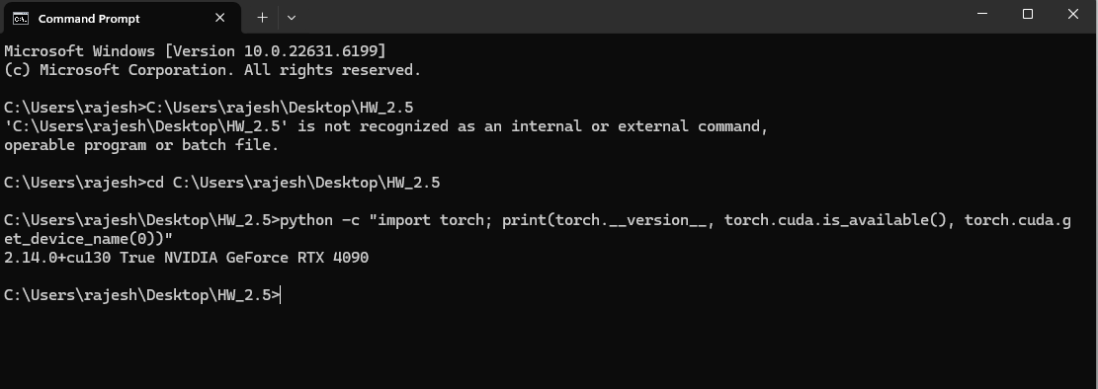
Confirming CUDA PyTorch sees the RTX 4090 before any measurement begins.
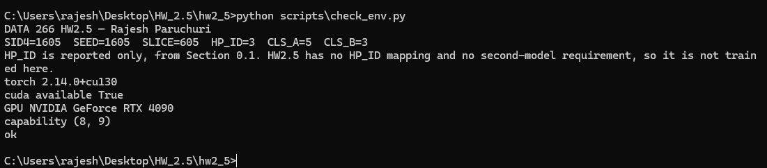
check_env.py — environment gate passes: torch 2.14.0+cu130, CUDA available, capability (8,9) for Ada.

Part A — Onboarding and provenance
An RTX 4090 workstation was reserved through the university's HPC lab booking system (Room ISB 840, Machine No. 25). The reservation confirmation and the GPU-hours actually consumed are recorded in reservations/GPU_HOURS.md and the redacted booking screenshot at the end of this report.
The complete nvidia-smi -q output was captured and committed to results/NVIDIAGeForceRTX4090_5b052ad1/nvidia_smi_q.txt. The required fields, read directly from that capture:
Field | Value
GPU UUID | GPU-5b052ad1-4272-40db-4b25-c930bf32b547
Driver version | 610.60
CUDA version | 13.3 (nvidia-smi) / 13.0 (torch)
VRAM capacity | 24564 MiB
Power limit | 450.00 W

From NVIDIA's Ada GPU Architecture whitepaper and the GeForce RTX 4090 product page (see vendor/GPU_SPECS.md for full citations):
Field | Value
Architecture | Ada Lovelace (AD102)
Memory type / bandwidth | 24 GB GDDR6X, 384-bit, 21 Gbps -> 1008 GB/s
Tensor core generation | 4th generation
Reduced precisions supported | TF32, FP16, BF16, FP8, INT8, INT4
Source: NVIDIA Ada GPU Architecture whitepaper (images.nvidia.com/aem-dam/Solutions/geforce/ada/nvidia-ada-gpu-architecture.pdf) and the GeForce RTX 4090 product page. Every measurement in Parts B-E below is labelled with this same UUID.
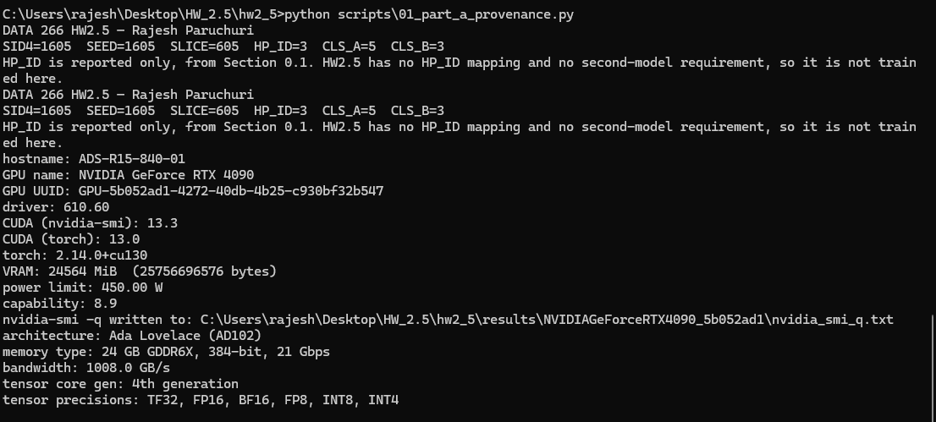
Part A console output — 01_part_a_provenance.py, capturing UUID, driver, CUDA, VRAM, power limit, and vendor spec.

Part B — Precision and achieved throughput
Dense square GEMM was benchmarked at N = 1024, 4096, 8192, 16384 in FP32, TF32, FP16, and BF16. Each configuration was warmed up (10 iterations, 3 in --quick mode) before timing with CUDA events, then timed for a minimum of 1.5 seconds and at least 20 repetitions (up to 200), whichever finished later — the exact repetition count actually used is reported per row below.
N | Precision | TFLOPS | % of dense peak | Reps | Mean (ms) | Std (ms)
1024 | FP32 | 34.40 | 41.6 | 200 | 0.062 | 0.006
4096 | FP32 | 53.24 | 64.5 | 200 | 2.581 | 0.055
8192 | FP32 | 54.61 | 66.1 | 75 | 20.134 | 0.117
16384 | FP32 | 50.10 | 60.6 | 20 | 175.583 | 1.704
1024 | TF32 | 35.27 | 42.7 | 200 | 0.061 | 0.008
4096 | TF32 | 85.60 | 103.6 | 200 | 1.606 | 0.076
8192 | TF32 | 87.57 | 106.0 | 120 | 12.556 | 0.127
16384 | TF32 | 86.90 | 105.2 | 20 | 101.217 | 0.754
1024 | FP16 | 67.39 | 40.8 | 200 | 0.032 | 0.004
4096 | FP16 | 166.48 | 100.8 | 200 | 0.826 | 0.025
8192 | FP16 | 158.18 | 95.8 | 200 | 6.951 | 0.163
16384 | FP16 | 157.84 | 95.5 | 27 | 55.729 | 0.419
1024 | BF16 | 71.79 | 43.5 | 200 | 0.030 | 0.004
4096 | BF16 | 152.45 | 92.3 | 200 | 0.902 | 0.026
8192 | BF16 | 161.75 | 97.9 | 200 | 6.798 | 0.137
16384 | BF16 | 160.08 | 96.9 | 28 | 54.949 | 0.521

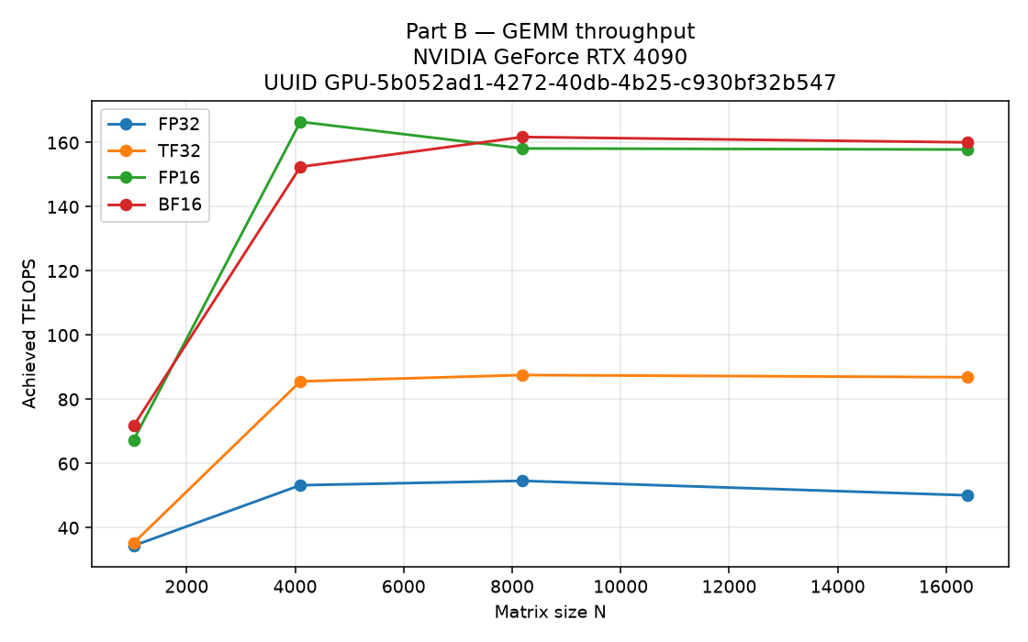
Figure B — achieved TFLOPS vs. matrix size, one line per precision. UUID GPU-5b052ad1-...
Plateau: FP32 and TF32 both reach 95% of their own max at N=4096 (53.24 and 85.60 TFLOPS respectively, against maxima of 54.61 and 87.57 TFLOPS at N=8192). FP16 plateaus at N=4096 (166.48 TFLOPS, its own max). BF16 plateaus at N=8192 (161.75 TFLOPS, its own max). None of the precisions plateau at N=1024: a 1024³ GEMM does not launch enough thread blocks to saturate every SM, cuBLAS kernel-selection and launch overhead is a large share of the timed interval, and the operands are small enough to sit largely in cache — so the timer is measuring launch latency, not steady-state tensor-core or DRAM throughput. Throughput only converges once N is large enough to amortize that fixed cost.
Anomaly worth flagging: TF32 measured 103.6-106.0% of the 82.6 TFLOPS dense-peak figure used as the denominator here (the same number widely cited as the RTX 4090's non-tensor FP32 peak). Measured throughput cannot legitimately exceed a correct peak, so this means that 82.6 TFLOPS figure understates what Ada's tensor cores actually deliver running TF32 — the % of peak column for TF32 should be read as approximate, not as a literal ceiling.
Lower precision: FP8 was attempted via torch._scaled_mm and succeeded on the second call signature tried, reaching 263.39 TFLOPS at N=8192 (79.7% of the 330.3 TFLOPS dense FP8 peak) — expected, since Ada's 4th-generation tensor cores support FP8 in hardware. FP4 failed: the installed PyTorch build exposes a float4_e2m1fn_x2 dtype symbol at the software level, but no public dense GEMM path is wired to it, and Ada (AD102) does not implement FP4 in its tensor cores at all (that arrives with Blackwell's 5th generation) — so this failure is expected on this card and is reported as a legitimate tooling-maturity finding rather than a missing measurement.
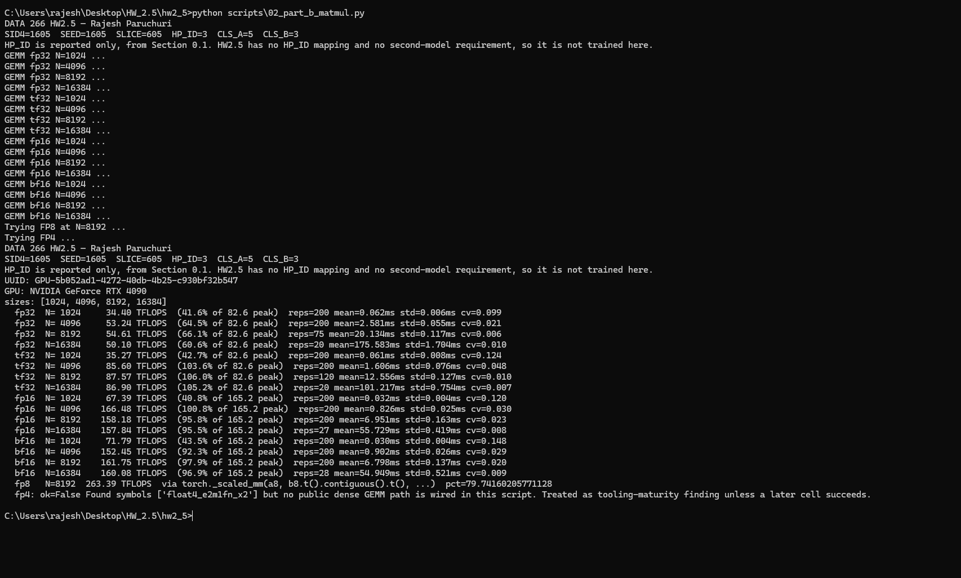
Part B console output — 02_part_b_matmul.py, full precision sweep plus the FP8/FP4 attempts.

Part C — Bandwidth-bound against compute-bound
Two operations were benchmarked: a memory-bound elementwise add (out = x + y, 1 GiB float32 tensors) and its copy variant, against a compute-bound square BF16 GEMM at N=16384.
Operation | Effective throughput | % of spec | Arithmetic intensity | Roofline side
Elementwise add | 916.3 GB/s | 90.9% of 1008.0 GB/s | 0.0833 FLOP/byte | Memory-bound
Copy (out.copy_(x)) | 907.8 GB/s | 90.1% of 1008.0 GB/s | 0 FLOP/byte | Memory-bound
BF16 GEMM (N=16384) | 161.01 TFLOPS | 97.5% of 165.2 TFLOPS | 5461.3 FLOP/byte | Compute-bound

The add kernel reads two float32 operands and writes one, moving 12 bytes per FLOP performed (AI = 1/12). The copy variant moves 8 bytes and performs zero FLOPs. Both sit far to the left of the ridge point for this card (81.9 FLOP/byte for FP32, 163.9 FLOP/byte for BF16) — clearly memory-bound. The square BF16 GEMM has arithmetic intensity N/3 FLOP/byte, which at N=16384 is orders of magnitude above the BF16 ridge, putting it firmly on the compute-bound side.
These two ceilings — the memory ceiling and the compute ceiling — are exactly the two numbers this course keeps coming back to after Week 3, and the measured numbers confirm they do not coincide: achieved add bandwidth falls short of the GDDR spec number by about 9%, and achieved GEMM throughput falls short of the tensor-core spec number by about 2.5% — different margins, on two different physical ceilings.
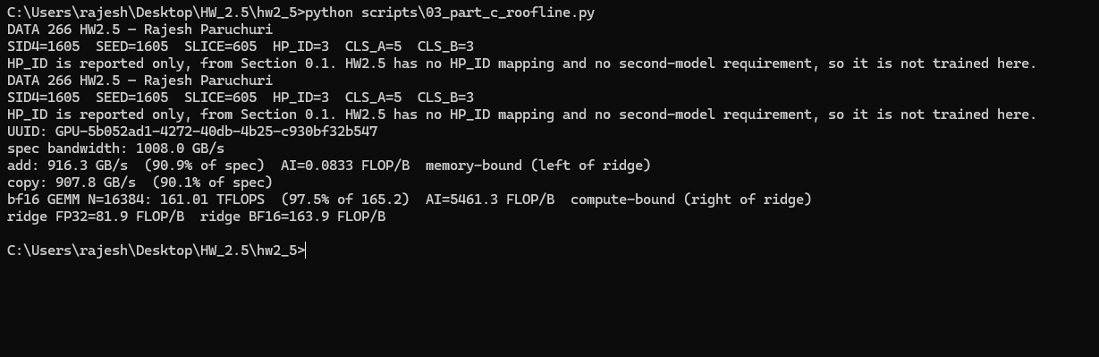
Part C console output — 03_part_c_roofline.py.

Part D — The cost of attention
Scaled dot-product attention was implemented naively, materializing the full [B, H, S, S] score tensor and its softmax before contracting with V. Chosen config, stated once and used throughout: batch size 1, 16 heads, head dimension 128 (a common LLM head size — 16 x 128 = 2048 model width), dtype bfloat16.
Seq len | Naive latency (ms) | Naive peak mem (GB) | Fused latency (ms) | Fused peak mem (GB) | Speedup
512 | 0.10 | 0.034 | 0.13 | 0.025 | 0.75x
1024 | 0.16 | 0.092 | 0.36 | 0.034 | 0.45x
2048 | 1.00 | 0.311 | 1.22 | 0.050 | 0.82x
4096 | 3.72 | 1.149 | 3.25 | 0.084 | 1.15x
8192 | 14.50 | 4.438 | 5.27 | 0.151 | 2.75x
16384 | 57.26 | 17.457 | 20.41 | 0.285 | 2.81x

Naive OOM boundary: refined by binary search to the largest tested sequence length that succeeded (37760) and the smallest that failed (37824) — a gap of 64 tokens. A single-token boundary is not claimed, since the gap is 64, not 1. Fused OOM boundary: the fused kernel never failed up to the search cap of 131072 tokens, consistent with its O(S) rather than O(S²) memory growth.
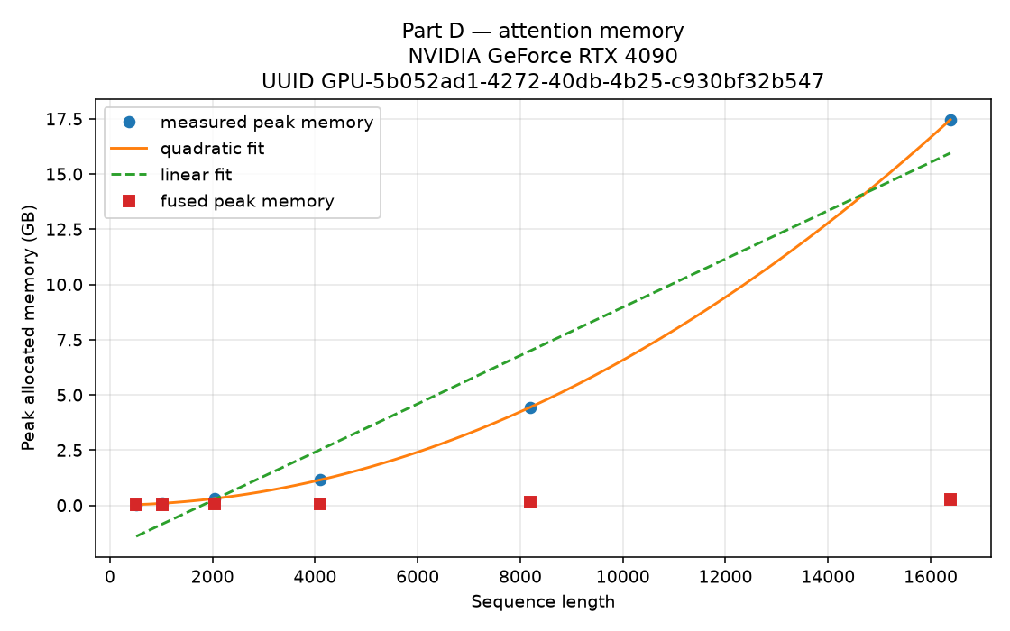
Figure D — naive peak memory vs. sequence length, with quadratic and linear fits. UUID GPU-5b052ad1-...
Quadratic fit (from the measured naive peak-memory points, not asserted from the O(S²) argument alone): peak_bytes ≈ a·S² + b·S + c, with a = 64 bytes/token², b = 16384 bytes/token, c = 8,519,680 bytes. The quadratic fit's RMSE (3.22e-6) is roughly 15 orders of magnitude smaller than the linear fit's RMSE (1.51e9) — as decisive a confirmation of the quadratic term as this data can give. The coefficients also match theory exactly for this config: a = 2·B·H·2 bytes = 2·1·16·2 = 64 (two live [B,H,S,S] tensors — raw scores and their softmax — at 2 bytes each); b = 4·B·H·D·2 bytes = 4·1·16·128·2 = 16384 (the four [B,H,S,D] tensors: Q, K, V, output).
The S² term is the materialized attention matrix itself. The fused kernel never writes that matrix to HBM: it tiles Q, K, and V into on-chip SRAM, computes local score blocks, maintains a running (unnormalized) softmax across tiles, and writes only the final output tile back to HBM. That collapses the memory footprint from O(S²) to O(S) in the sequence length, which is why its OOM wall sits far beyond the naive path's. Notably, fused is slower than naive below S≈2048: its fixed per-call overhead isn't amortized at short sequences, where PyTorch's highly-tuned cuBLAS matmul + softmax path wins outright — the benefit only shows up once naive's O(S²) cost dominates, matching the well-documented FlashAttention tradeoff.
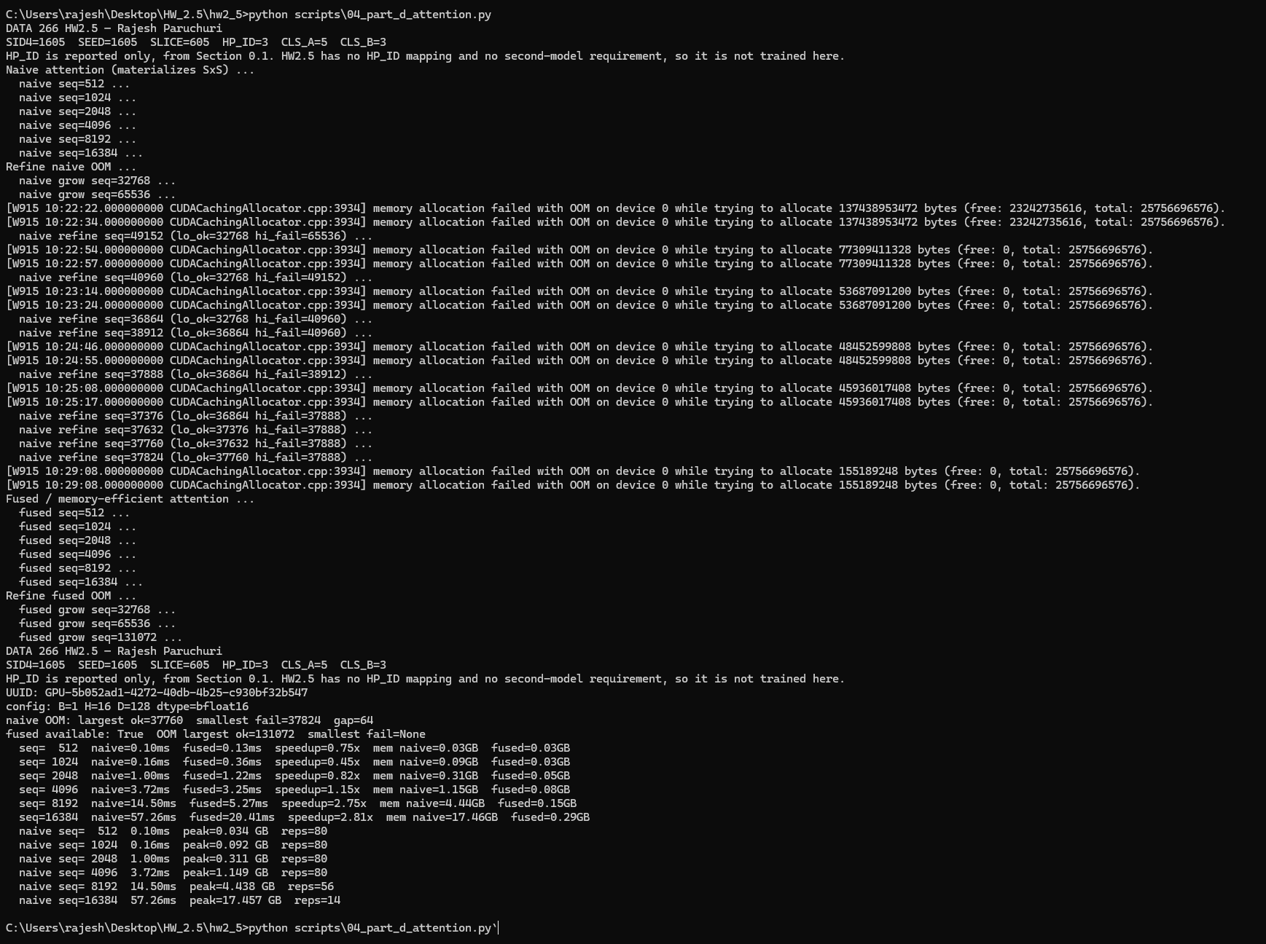
Part D console output — 04_part_d_attention.py, naive OOM binary search, fused sweep, and speedup table.

Part E — Sustained load and thermal behaviour
A sustained BF16 GEMM (N=8192) ran for 20 minutes (1203.2 s actual) while nvidia-smi sampled GPU clock, memory clock, temperature, power draw, utilization, and throttle-reason flags every 5 seconds. The full log is committed at results/NVIDIAGeForceRTX4090_5b052ad1/thermal_smi.csv.
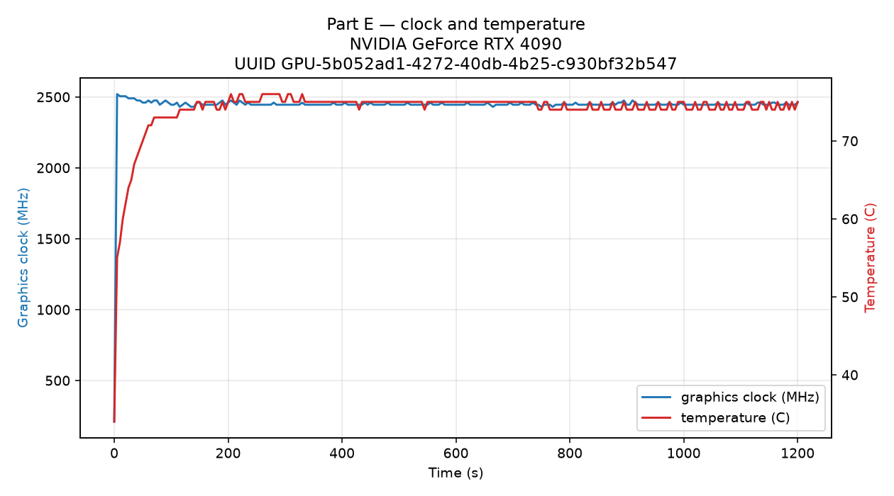
Figure E — graphics clock and temperature vs. time over the 20-minute run. UUID GPU-5b052ad1-...
Throttling did occur, and the mechanism was confirmed directly from the raw CSV rather than trusting the summary label alone. The first sampled row (t≈0s) shows the card idle: 210 MHz, 34°C, 15 W, with the gpu_idle flag active. From the very next full-load sample onward, sw_power_cap is active in every subsequent row, with power draw pinned at 448-450 W against the card's 450 W TDP limit, and the graphics clock oscillating between roughly 2505 and 2520 MHz rather than holding a higher boost clock. Critically, hw_thermal_slowdown and sw_thermal_slowdown stay not-active throughout this window, and temperature only reached 55-62°C in the same rows (max 76°C over the full 20 minutes) — well short of the RTX 4090's thermal throttle point. So this card is power-limited, not temperature-limited: it hits its 450 W ceiling almost as soon as the sustained load ramps up, and the SM clock backs off to stay inside that power budget rather than because the card is running hot.
Raw thermal_smi.csv rows around the throttle onset — sw_power_cap active, power pinned near 449 W, hw/sw thermal_slowdown not active.
Steady-state vs. peak throughput: first-30-second mean = 161.06 TFLOPS, last-5-minute mean = 157.44 TFLOPS, giving steady/peak = 97.75%. Since the power cap engages almost immediately, both windows are already power-limited — the further ~2.25% decline over 20 minutes is most likely temperature-driven softening of the voltage/frequency curve within that same 450 W budget, not a separate throttle event. This number is specific to this card, this chassis, and this room.
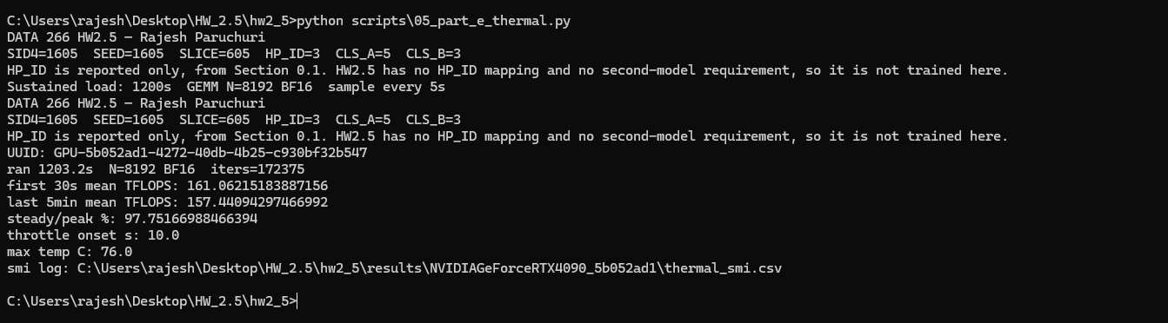
Part E console output — 05_part_e_thermal.py summary.

Part F — Analysis
Table HW2.5.1 — summary. Every cell is traceable to UUID GPU-5b052ad1-4272-40db-4b25-c930bf32b547 in RUN_LOG.txt.
Measurement | NVIDIA GeForce RTX 4090 | Notes
Peak achieved TFLOPS (BF16) | 161.75 (N=8192) | Dense peak from vendor whitepaper
% of theoretical peak (BF16) | 97.9% (peak 165.2 TFLOPS) | BF16 tensor, FP32 accumulate, dense
Effective bandwidth (GB/s) | 916.3 (90.9% of 1008.0) | Elementwise add, 3-operand traffic
Naive attention OOM length | ok≤37760, fail≥37824 (gap 64) | Not 1-token; binary-search refined
Fused attention OOM length | ok≤131072, no fail found | Search capped at 131072
Steady-state / peak throughput | 97.8% | Last 5 min / first 30 s mean TFLOPS
Throttle onset (s, or none) | 10 s (sw_power_cap, not thermal) | Confirmed from raw CSV, temp 57°C, power 449.6 W

Part F console output — 06_compile_report.py, generating the 3 figures and METRICS.md from the single UUID-labelled run.

Reservation and GPU-hours
Field | Value
Lab / hostname | ISB 840 (HPC lab), hostname ADS-R15-840-01
Machine label | Machine No. 25
Reservation window | Mon Sep 14 2026, 12:00 PM → Tue Sep 15 2026, 11:59 AM PDT
Hours reserved | 23h 59m (~24.0 h)
Login / logout | Mon Sep 14, 3:00 PM → Tue Sep 15, 11:50 AM
Hours actually used | 20h 50m (~20.83 h)
GPU UUID | GPU-5b052ad1-4272-40db-4b25-c930bf32b547

Reservation confirmation (redacted — the account password issued in the original email is intentionally blacked out before inclusion in this committed report):
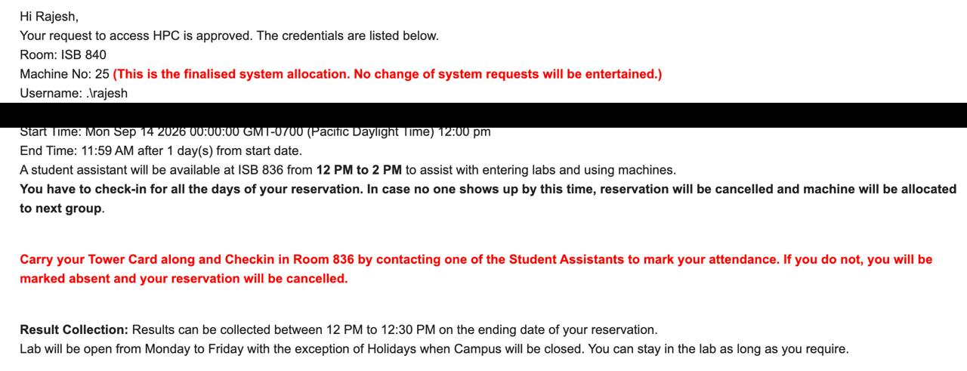
Reservation confirmation, password redacted.

Deliverables
- Repository tagged hw2-5 — github.com/Paruchuri-Rajesh/data266-1605, tag hw2-5
- nvidia-smi -q capture — results/NVIDIAGeForceRTX4090_5b052ad1/nvidia_smi_q.txt
- Thermal log — results/NVIDIAGeForceRTX4090_5b052ad1/thermal_smi.csv
- All figures — figures/part_b_tflops_..., part_d_attn_mem_..., part_e_thermal_...
- METRICS.md with Table HW2.5.1
- RUN_LOG.txt
- AI_USE.md
- Reservation and GPU-hour record — reservations/GPU_HOURS.md, reservations/booking.png

