AppVerse AI

Smart Educational App Marketplace
AppVerse AI is a full-stack AI-powered educational app marketplace platform where users can discover, review, and explore learning applications such as Java learning apps, AI tools, SQL practice platforms, React interview apps, and coding assistants.

Features

User Features
- User Registration & Login
- JWT Authentication
- Browse Educational Apps
- View App Details
- Ratings & Reviews
- Favorites System
- AI Chatbot Assistant
- User Dashboard
- Support System

Admin Features
- Admin Dashboard
- Add/Delete Apps
- Student Support Management
- Feedback Management
- Dashboard Statistics
- Review Monitoring

AI Features
- Gemini AI Chatbot Integration
- AI App Suggestions
- Smart Educational Assistance

Tech Stack

Frontend
- React JS
- React Router
- Axios
- CSS

Backend
- Spring Boot
- Spring Security
- JWT Authentication
- REST APIs
- JPA / Hibernate

Database
- MySQL

AI Integration
- Gemini API

Project Architecture
React Frontend
↓
REST APIs (Axios)
↓
Spring Boot Backend
↓
MySQL Database
↓
Gemini AI API

Main Modules
- Authentication Module
- App Marketplace Module
- AI Chatbot Module
- Admin Management Module
- Review System
- Support System

Installation

Frontend
npm install
npm start

Backend
mvn spring-boot:run

Database
Configure MySQL database in:
application.properties
Screenshots
User Login:
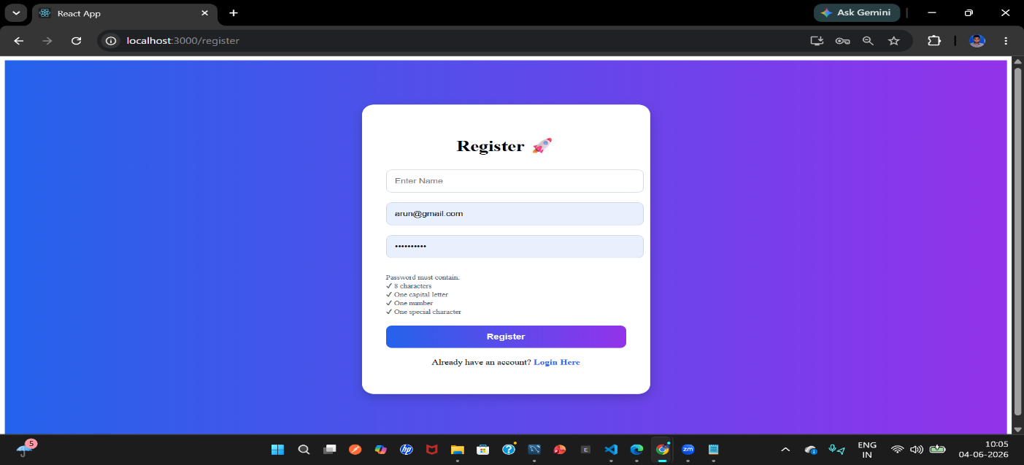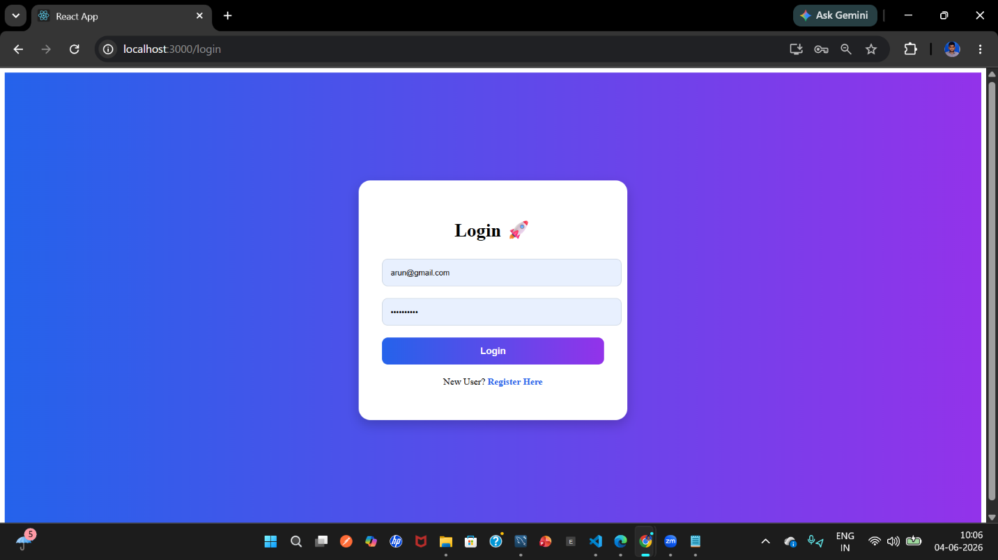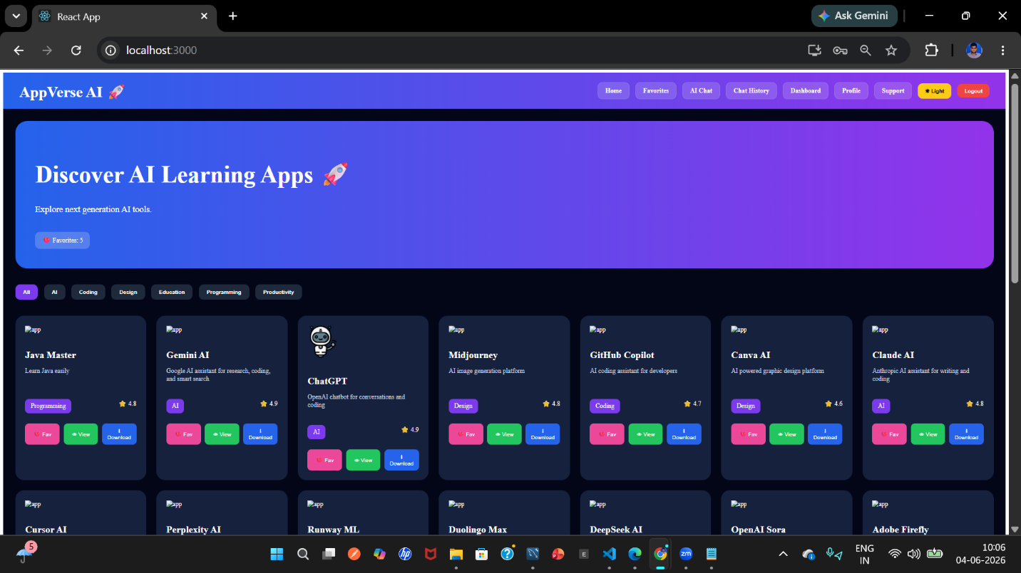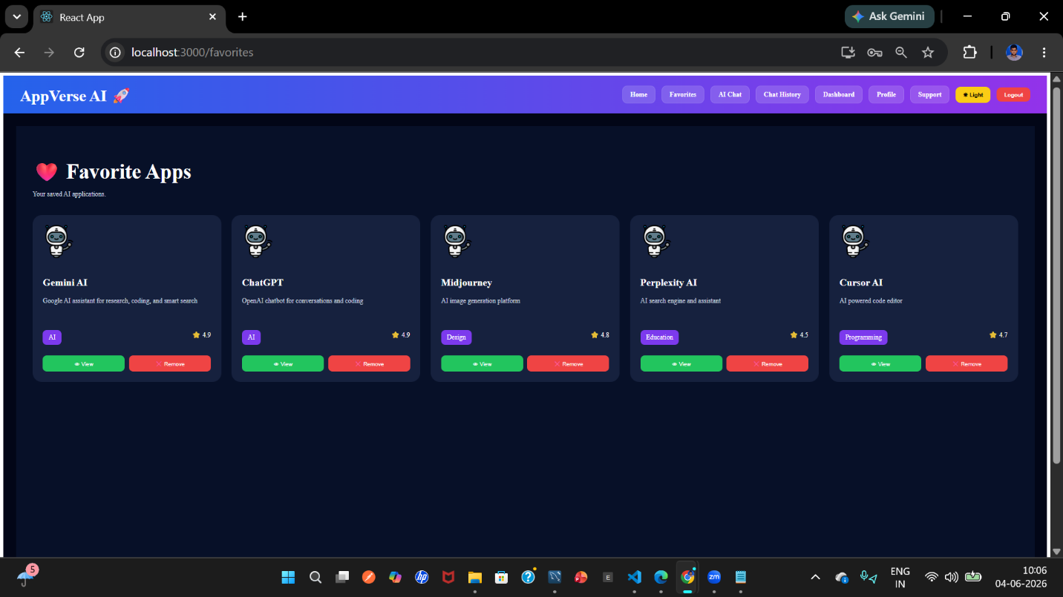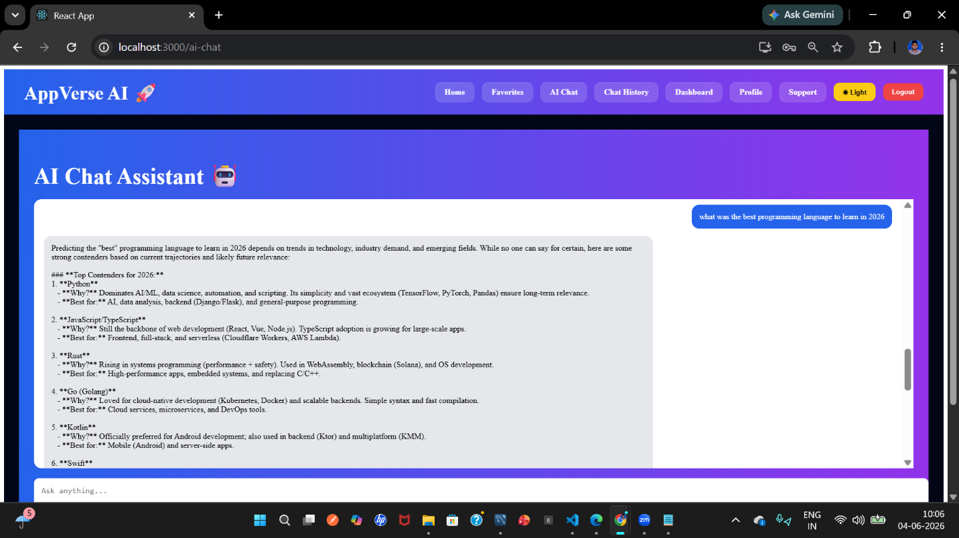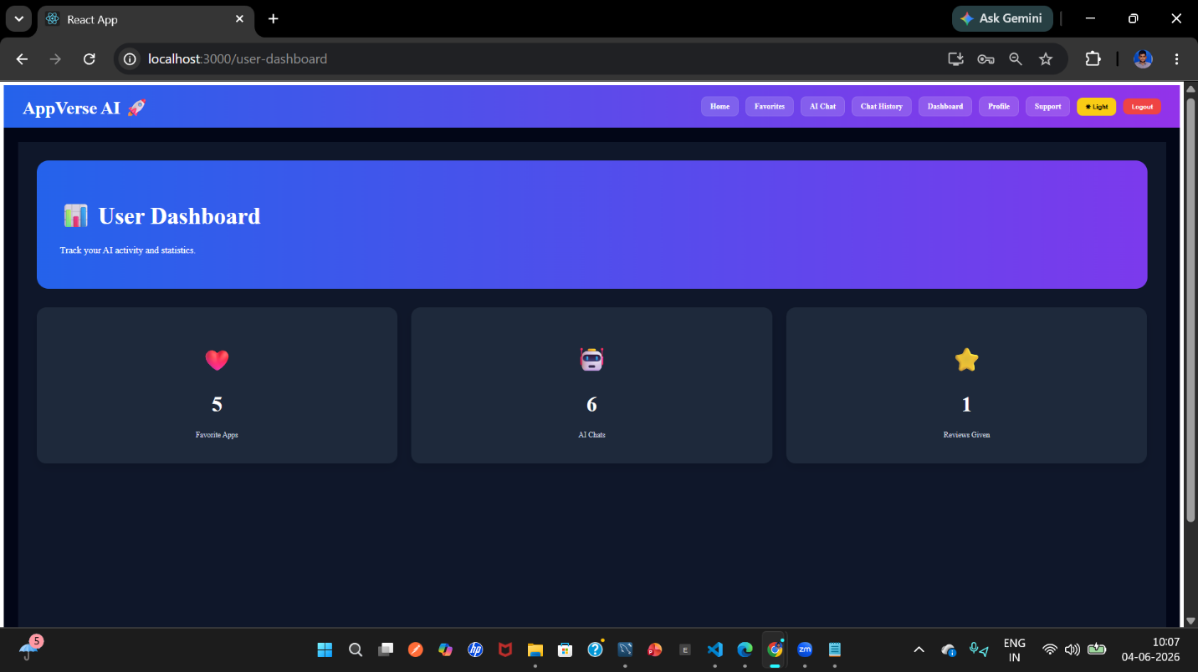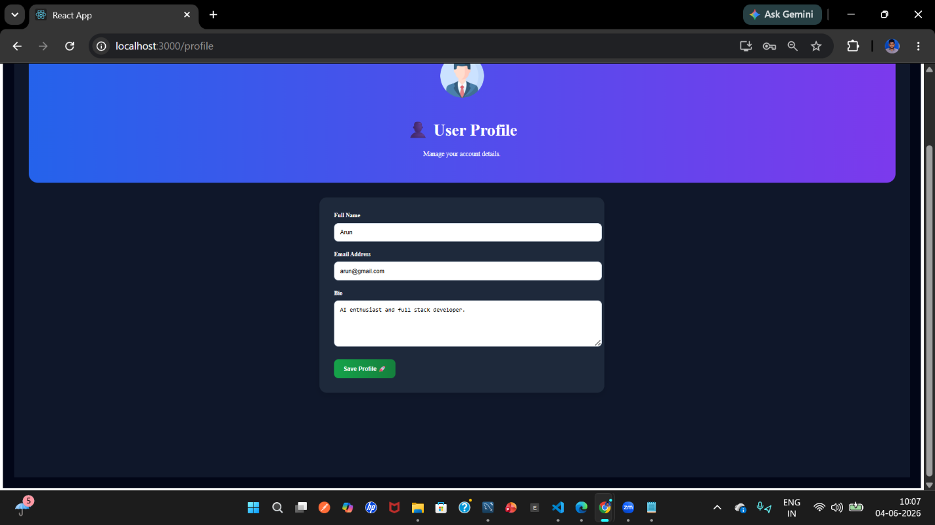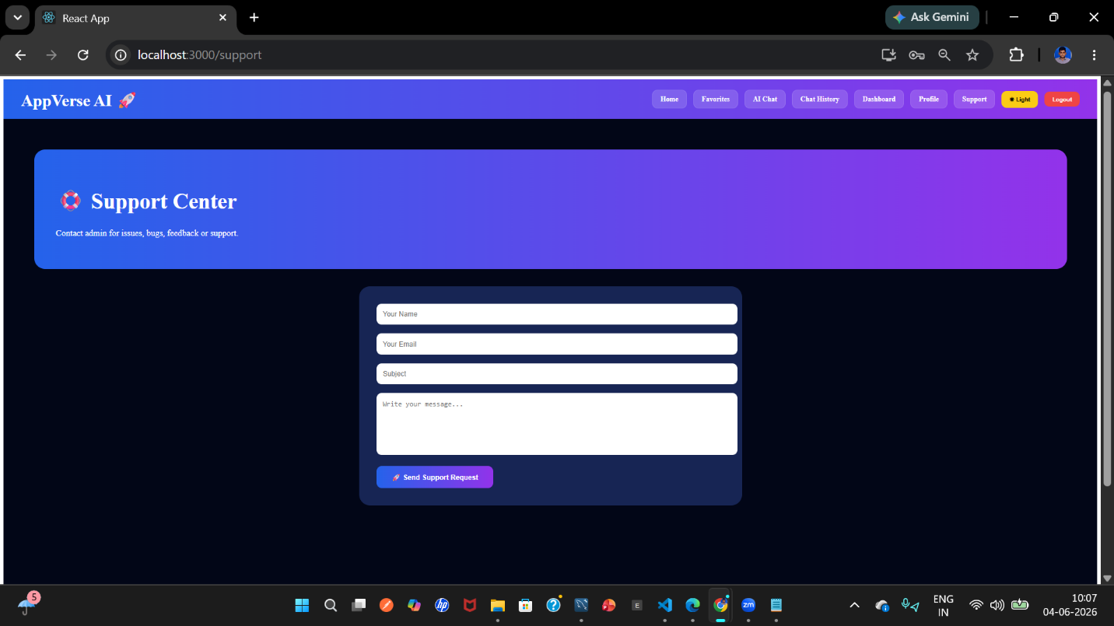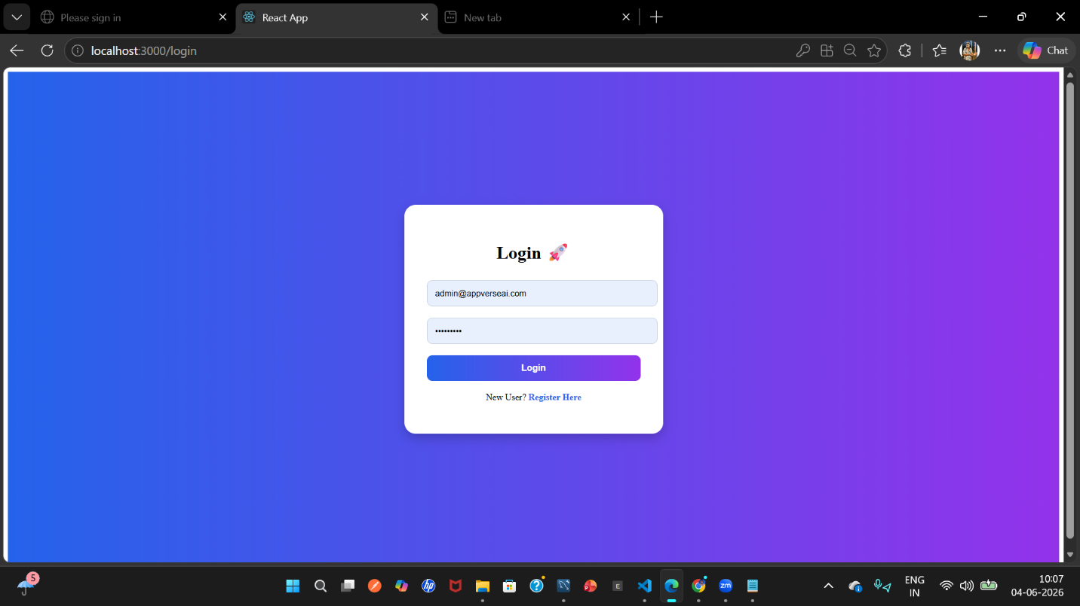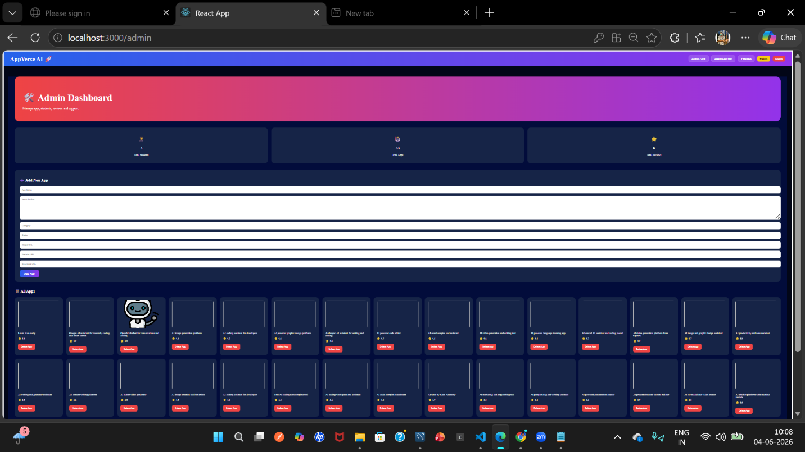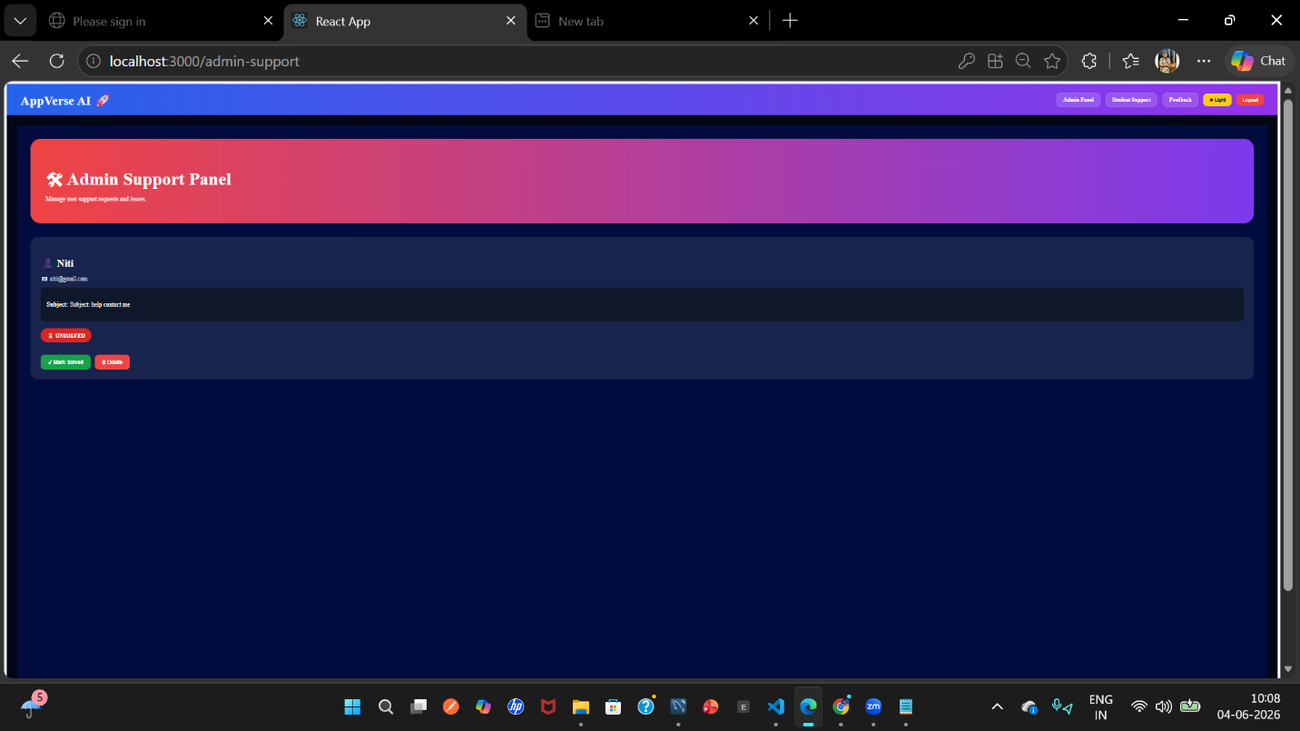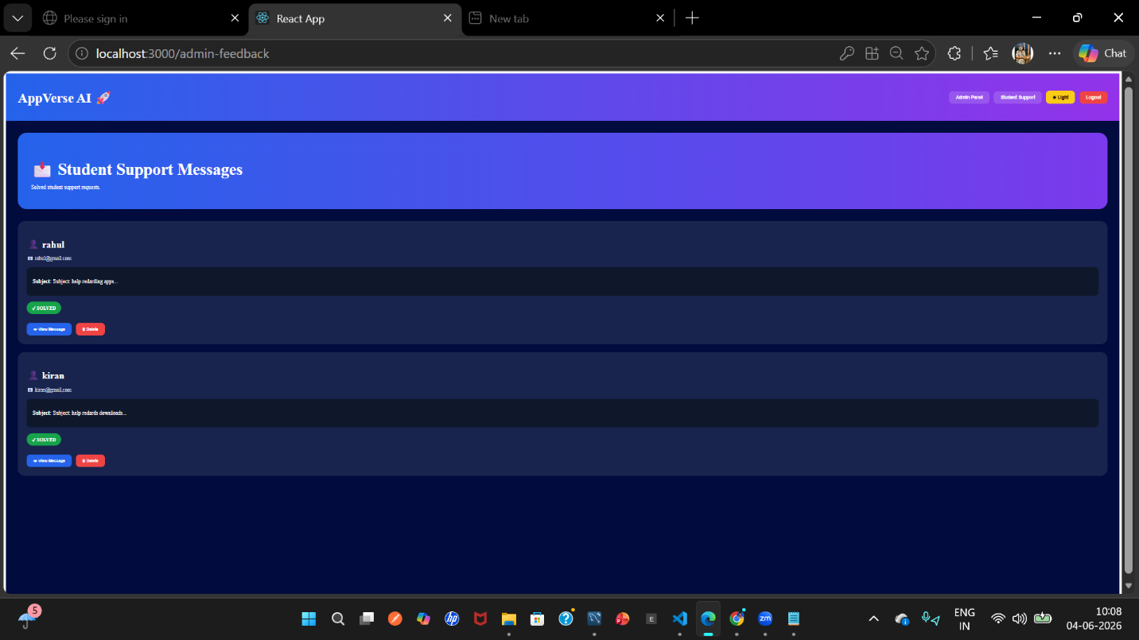
Admin Login:

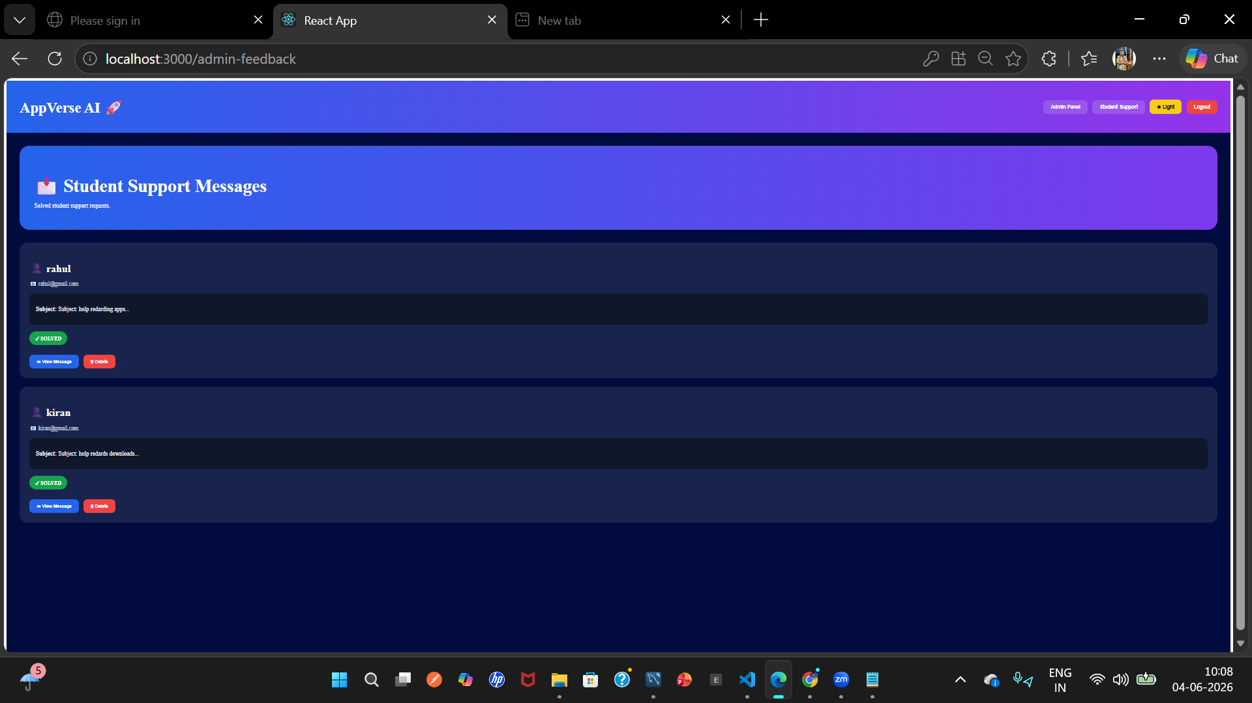

Author
Paruchuri Rahul Kumar

