Replication

Replication is the process that copies important data tables from the Server to the slave TOM’s.

How to check replication on any TOM:-

Log onto the TOM as Administrator

Open a CMD prompt

Type the following:-

**REPLAPP –status**

If it faulty then we have to repair it.

**REPLAPP -repair**

Close the CMD prompt

Log off

If this fails again, the app will go into an endless loop, press ctrl + c out of the routine and try the following

**REPLAPP –uninstall**

**REPLAPP -install -testsync 9999 -verbose –wait**

We also need to check SQL server agent if it is not running then we have to restart the agent via services.msc and try install the replication again.

Run via CMD

run: net start sqlserveragent and try again

**replapp –status (if it is faulty)**

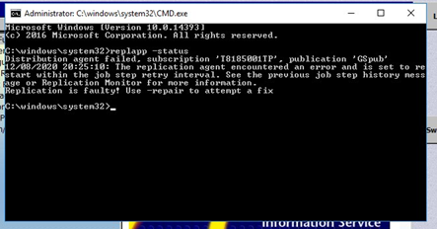

**replapp -status (if it is OK)**

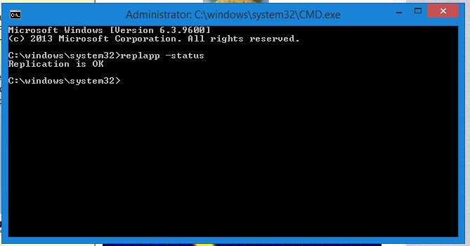

Scenario’s when to check replication

1. If the server is showing Red Cross and a message of ‘’Overnight Problem‘’ on the  
   bottom of the STAR Roadmap screen.

We need to log on the TOM via administrator and check replication and try to repair it.

1. If a user is not able to login the TOM and it gives a message ‘’Invalid User’’ even after password reset and user is able to login to different TOM then we need to check the replication on this TOM where user was not able to login.
2. If a user was not able to access back office application even after giving him the right permission then we need to check the replication on each and every TOM.
3. If on the slaves TOM TOP 24 is missing or not up to date then we need to check replication on that TOM.
4. Due to the cashing up data mismatch on server TOM sometimes the Till’s are not coming on server TOM database then we need to check the replication.