

CYCLISTIC

BIKE-SHARE ANALYSIS

CASE STUDY REPORT

Understanding Casual Riders and Annual Members
April 2021 – March 2022
Google Data Analytics Professional Certificate
Capstone Project

TABLE OF CONTENTS

- BUSINESS TASK ........................................ 3

- DATA SOURCES .......................................... 4

- DATA CLEANING AND PREPARATION ............. 5

- ANALYSIS SUMMARY .................................. 6

- VISUALIZATIONS AND KEY FINDINGS ........... 8

- ANNUAL DASHBOARD ..................................... 10

- RECOMMENDATIONS ................................ 11

- CONCLUSION ............................................. 12

1. BUSINESS TASK
Cyclistic is a bike-sharing company in Chicago that offers different pricing plans, including single-ride passes, full-day passes and annual memberships. Customers using single-ride or full-day passes are classified as casual riders, while customers with annual memberships are classified as annual members.
The main objective of this case study is to understand how casual riders and annual members use Cyclistic bikes differently. The analysis aims to identify differences in their riding patterns and behaviors to help Cyclistic develop effective marketing strategies that encourage casual riders to purchase annual memberships.
The key stakeholders include Lily Moreno, Director of Marketing; the Cyclistic marketing analytics team; and the Cyclistic executive team, which will review and decide whether to approve the proposed recommendations.

2. DATA SOURCES
The analysis uses publicly available historical bike-trip data provided by Motivate International Inc. The dataset is associated with Divvy, a real-world bike-sharing service in Chicago, and is used for the fictional Cyclistic case study.
The study covers a period of 12 months, from April 2021 to March 2022. The data was organized into 12 separate monthly CSV files, with each file containing individual bike-trip records for its respective month.
The dataset includes information such as ride ID, bike type, trip start and end times, station names and IDs, and rider type (member or casual). These details were used to compare the riding patterns and behaviors of casual riders and annual members.
The data was publicly available for analysis. Personal identifying information about riders was not included, allowing the analysis to focus on trip details and usage patterns while respecting rider privacy.

3. DATA CLEANING AND PREPARATION
The data was processed using WPS Spreadsheet. The 12 monthly CSV files were organized into separate working sheets so that each month's records could be examined and analyzed individually. The original trip records were retained throughout the process.
Several additional columns were created to prepare the data for analysis. Ride duration was calculated by subtracting the trip start time from the end time. The day of the week was extracted from the start date to examine riding patterns across different days.
Data validation checks were also performed to identify records with zero or negative ride duration, rides longer than 24 hours, and duplicate ride IDs. These records were flagged and counted for review, but no records were deleted or removed from the original datasets.
Missing station information was checked by counting blank values in the start station names, start station IDs, end station names, and end station IDs. These records were retained, and the missing values were documented rather than replaced or removed.
For the duration analysis, two separate averages were calculated: one using all positive-duration rides and another using valid rides up to 24 hours. These checks helped identify data quality issues and provided a consistent basis for comparing casual riders and annual members.

ANALYSIS SUMMARY

The analysis covered a total of 5,722,533 bike rides recorded between April 2021 and March 2022. Out of these, 2,546,370 rides (44.50%) were completed by casual riders, while 3,176,163 rides (55.50%) were completed by annual members. This shows that annual members accounted for a larger share of total rides during the study period.
Monthly Ride Trends
Monthly ride totals showed clear seasonal variations in bike usage. July 2021 recorded the highest number of rides, with 822,410 rides, followed by August with 804,352 rides. January 2022 recorded the lowest activity, with 103,770 rides. Overall, ride activity increased during the warmer months and declined considerably during the winter months.
Differences in Rider Behavior
The analysis showed that casual riders and annual members had different riding patterns. Casual riders consistently recorded longer average ride durations than annual members in every month. For example, in May 2021, the average ride duration was 31.63 minutes for casual riders, compared with 14.46 minutes for annual members. In January 2022, the averages were 17.43 minutes and 11.62 minutes, respectively. This suggests that casual riders generally spend more time on each ride.
Monthly Rider Distribution
The proportion of casual riders was highest in July 2021, when they accounted for 53.75% of total rides. Their share declined to its lowest point in January 2022, at 17.85%. Annual members made up a larger proportion of rides during the winter months, reaching 82.15% in January. This indicates that the balance between the two rider groups changed across seasons.
Day-of-Week Patterns
The day-of-week analysis also revealed differences in riding habits. Saturday was the busiest day for casual riders in 8 out of the 12 months analyzed. Annual members showed a more varied pattern, with Thursday being their busiest day in 4 out of the 12 months. These findings suggest that casual riders were more likely to use bikes during weekends, while annual members showed more variation in their weekly usage.
Overall, the analysis revealed differences in ride frequency, duration, monthly activity, and day-of-week patterns between casual riders and annual members. These findings provide a basis for understanding rider behavior and identifying opportunities to encourage casual riders to consider annual memberships.

5. VISUALIZATIONS AND KEY FINDINGS
The annual dashboard was created to present the analysis results in a clear and visual format. It includes four charts that compare rider activity, membership distribution, monthly trends, and average ride durations.
1. Monthly Ride Trends
The monthly ride trends chart compares the number of rides completed by casual riders and annual members throughout the study period. Overall, July 2021 recorded the highest ride volume, with 822,410 rides, while January 2022 recorded the lowest, with 103,770 rides. Both rider groups showed higher activity during the warmer months and lower activity during winter.
2. Overall Rider Mix
The overall rider mix chart shows the proportion of rides completed by each rider group during the year. Annual members accounted for 55.50% of total rides, while casual riders accounted for 44.50%. This shows that annual members contributed a larger share of total bike usage.
3. Monthly Rider Share
The monthly rider share chart compares the percentage contribution of casual riders and annual members in each month. Casual riders had their highest share in July 2021, at 53.75%, while their lowest share was in January 2022, at 17.85%. Annual members represented a larger share during the winter months, reaching 82.15% in January 2022.
4. Average Ride Duration
The average ride duration chart compares the average time spent per ride by casual riders and annual members. Casual riders had longer average ride durations than annual members in every month. For example, in May 2021, casual riders averaged 31.63 minutes per ride, compared with 14.46 minutes for annual members. This difference suggests that casual riders generally spend more time on each trip.
Key Findings
- Annual members completed more rides overall, accounting for 55.50% of total rides.
- Casual riders consistently had longer average ride durations than annual members.
- July 2021 recorded the highest monthly ride volume, while January 2022 recorded the lowest.
- Casual riders contributed their highest share of rides in July and their lowest share in January.
- Casual riders showed stronger weekend activity, with Saturday being their busiest day in 8 out of 12 months.
These visualizations highlight the differences in usage patterns between casual riders and annual members. They provide useful insights into seasonal activity, ride duration, and rider distribution, which can support the development of marketing strategies to encourage casual riders to become annual members.

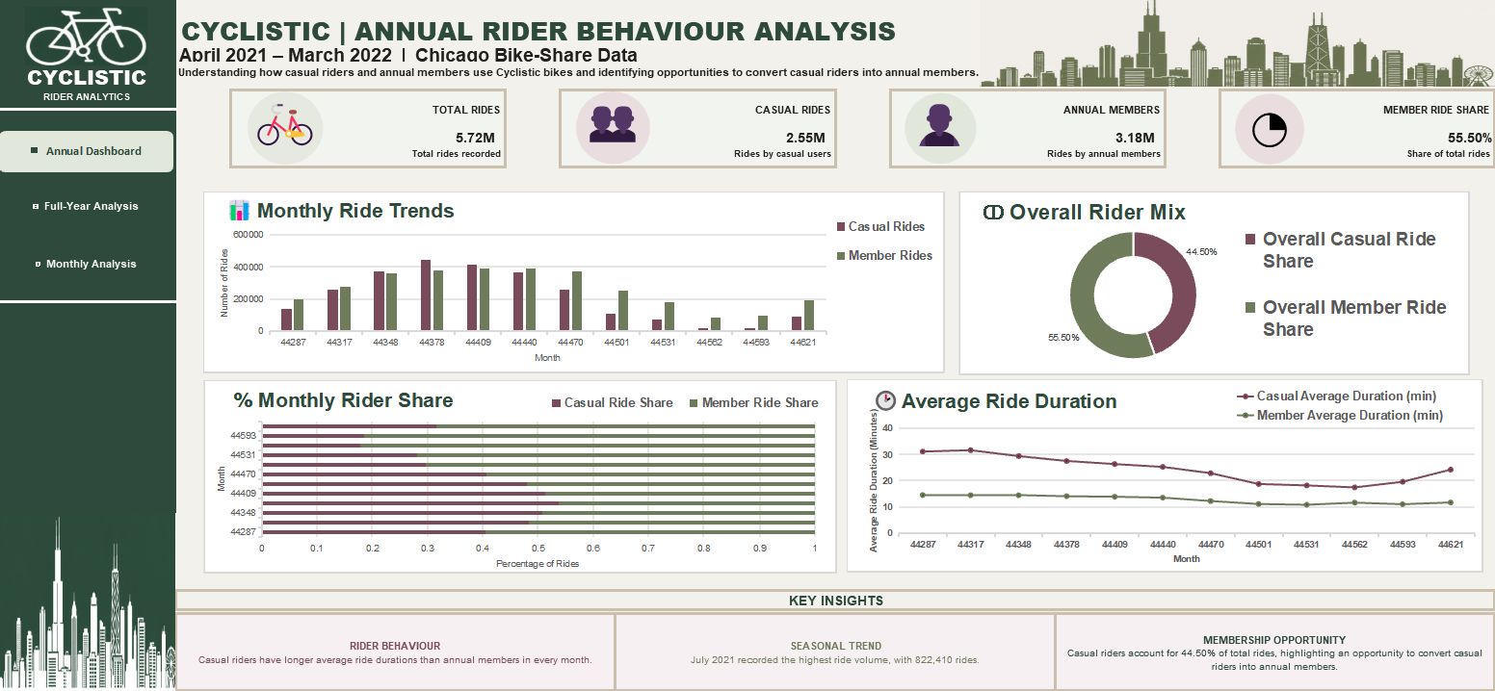
ANNUAL DASHBOARD
CYCLISTIC BIKE-SHARE ANALYSIS

Figure 1: Cyclistic Annual Dashboard (April 2021 – March 2022)

6. RECOMMENDATIONS
Based on the analysis of casual riders and annual members, the following three recommendations could help Cyclistic encourage more casual riders to purchase annual memberships.
1. Introduce Weekend Membership Promotions
Casual riders showed stronger weekend activity, with Saturday being their busiest day in 8 out of 12 months. Cyclistic could use this pattern to promote annual memberships through weekend-focused offers and campaigns. These promotions could highlight the convenience and benefits of having a membership for regular weekend rides.
2. Promote Membership Benefits Through Ride Duration
The analysis showed that casual riders consistently had longer average ride durations than annual members. Cyclistic could use this finding to create marketing messages that explain the benefits of annual membership for customers who spend more time riding. Digital advertisements and in-app messages could highlight membership value and encourage casual riders to consider switching to an annual plan.
3. Use Seasonal Digital Marketing Campaigns
Casual rider activity was highest during the warmer months, particularly in July 2021, when casual riders accounted for 53.75% of total rides. Cyclistic could increase its digital marketing efforts during spring and summer, when casual usage is higher. Social media advertisements, email campaigns, and app notifications could target casual riders with clear information about annual membership benefits.
These recommendations focus on rider behavior, membership value, and seasonal usage patterns. By using targeted promotions and digital communication, Cyclistic could create more opportunities to convert casual riders into annual members.

7. CONCLUSION
The analysis of Cyclistic's bike-sharing data from April 2021 to March 2022 revealed important differences between casual riders and annual members. A total of 5,722,533 rides were recorded during the study period. Annual members accounted for 55.50% of all rides, while casual riders contributed 44.50%.
The findings showed that casual riders consistently had longer average ride durations, while their usage was higher during warmer months and weekends. In contrast, annual members accounted for a larger share of rides overall and maintained a stronger share of usage during the winter months.
These differences provide useful insights into rider behavior and highlight an opportunity for Cyclistic to encourage casual riders to become annual members. By introducing targeted promotions, communicating membership benefits, and using seasonal digital marketing campaigns, Cyclistic could develop strategies to attract more annual members.
Overall, this case study demonstrates how data analysis can help a business understand customer behavior and make informed marketing decisions.

