  - Resource naming: Instead of verbs like getAllBooks or add_book, REST prefers nouns. For example:
    - GET /books → fetch all books
    - GET /books?author=xyz → filter by author
    - POST /books → create a new book
    - PUT /books/{id} → update a book
    - DELETE /books/{id} → delete a book
  - Status codes:
    - GET /books → 200 OK
    - POST /books → 201 Created
    - PUT /books/{id} → 200 OK or 204 No Content
    - DELETE /books/{id} → 204 No Content

For ex : missing required fields
(that

POST -> api req -> api gateway ->
(validation

Rate limiting --> A technique to control how many requests a user/system can make in a given time.
Purpose: Prevents bots spamming login attempts or scraping data) and keeps resources available for real users.

( CHECK IN API GATEWAY )

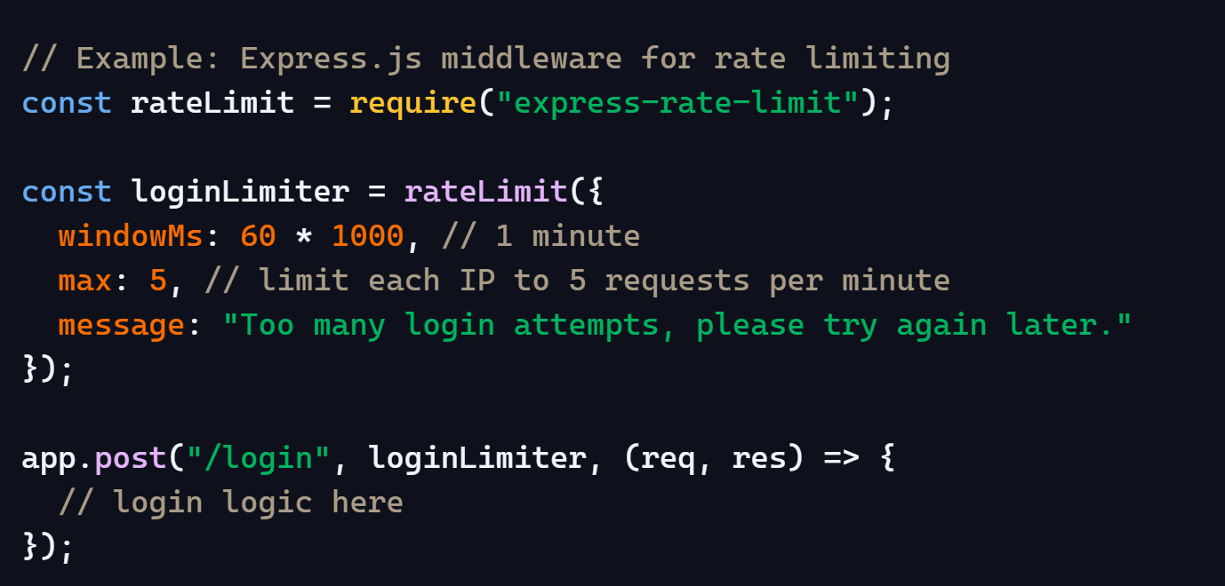

Types of Rate Limits

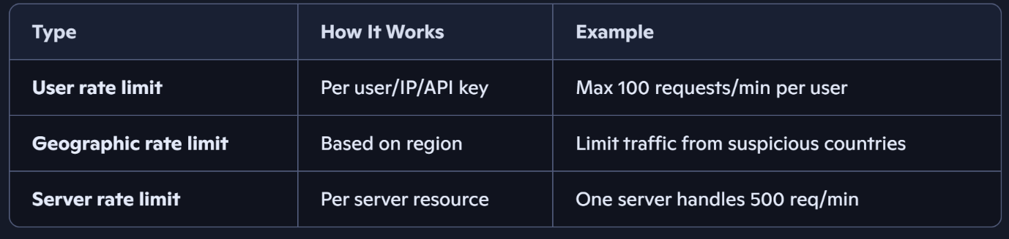
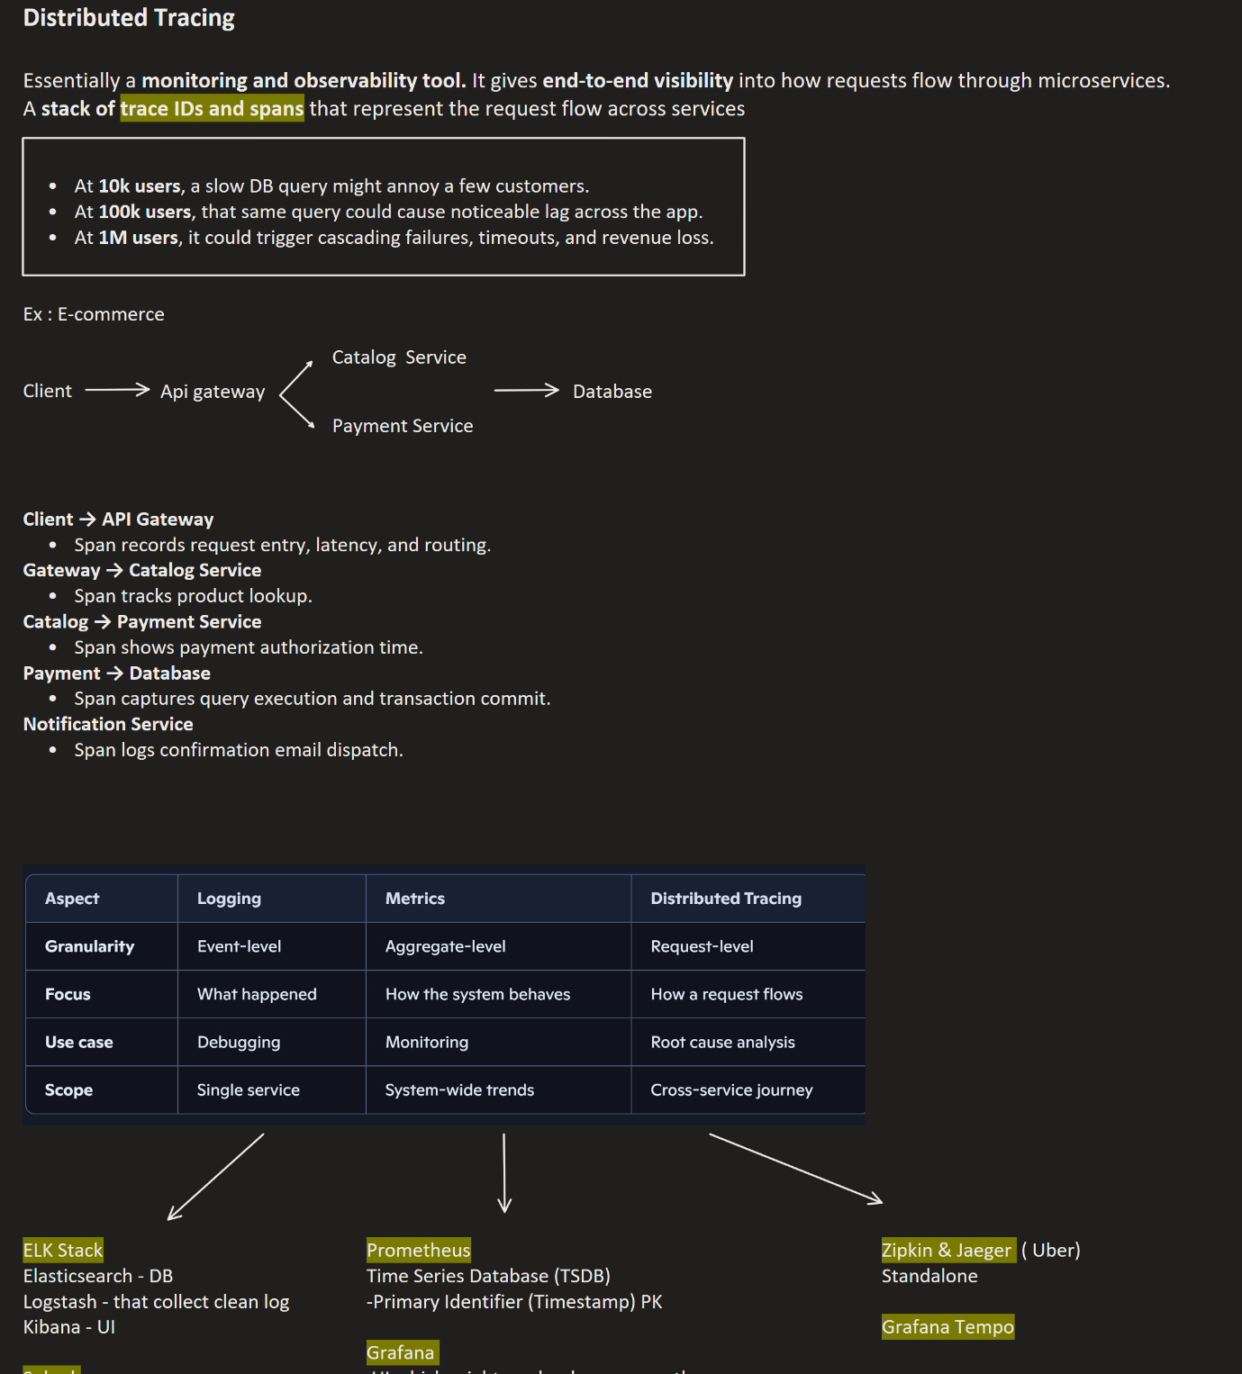

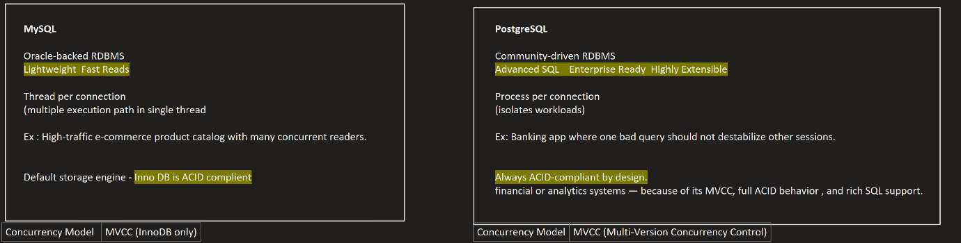
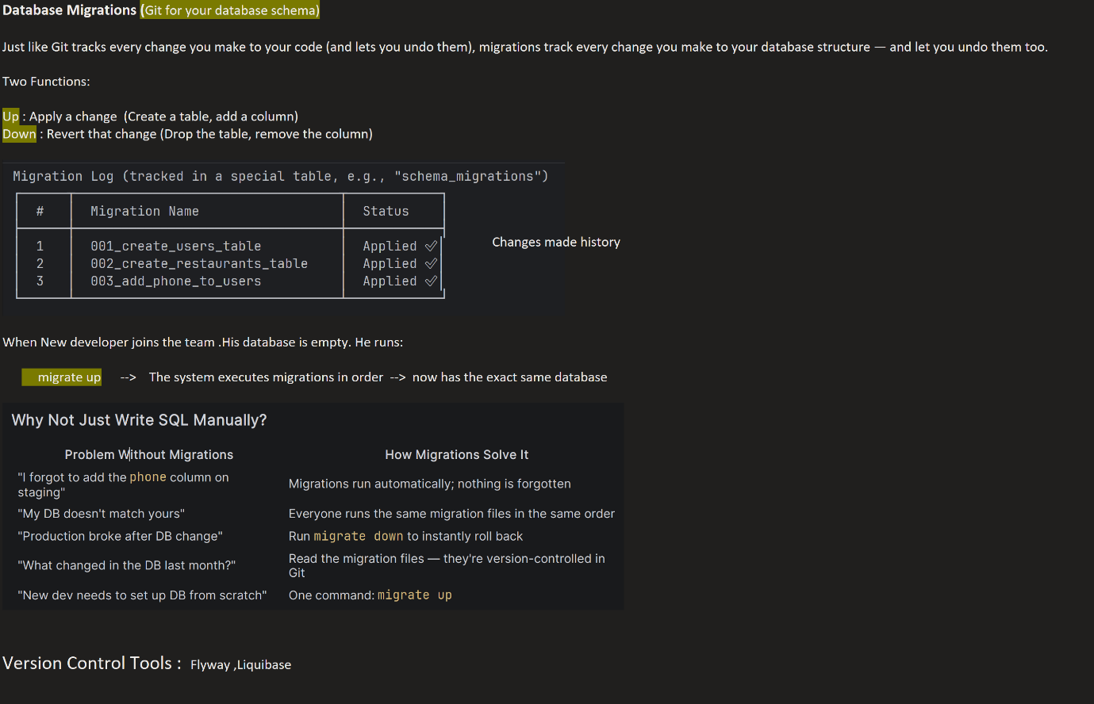

Seeding --- Writing script (different migration file ) -> putting some test data for testing purposes in dev env [ dbmate new seed_data ]

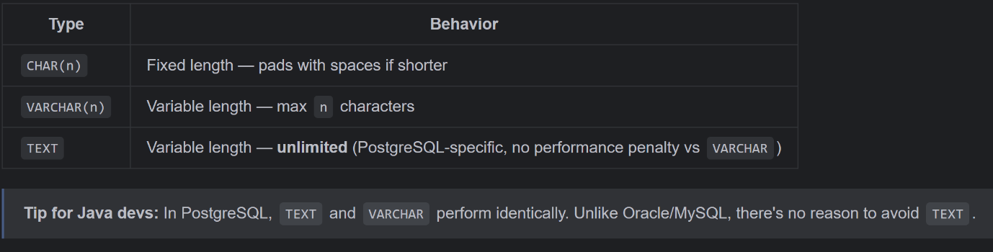
JSON stores as plain text — preserves formatting, slower to query.
JSONB stores in binary — discards whitespace/key order, but supports indexing and is much faster to query.
All constraint types: PRIMARY KEY, FOREIGN KEY, UNIQUE, NOT NULL, CHECK, DEFAULT, EXCLUDE

