
Elaborating the vision
When Harry Potter took that sip of butter beer we all craved it. There is something about all those enchanting magical drinks that we saw as a child and had an inclination towards even after becoming caffeine-concentrated young adults. Hence, we group of 3 friends came up with the idea of opening our magical coffee journey for caffeine-elixsippers just like us. Our venture will start with opening our wizard-themed café in Colaba (Mumbai), as that space is always concentrated on coffee lovers.

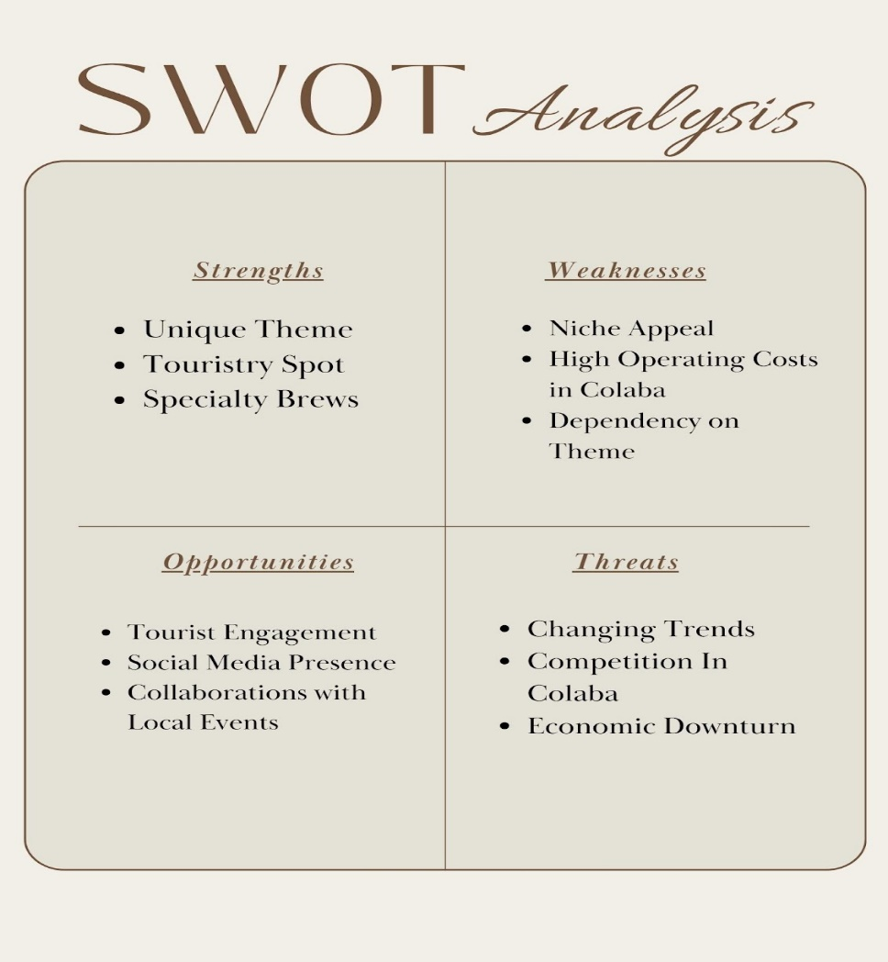

Porter's five forces is considered to be a strategically sound management tool to aid and facilitate analysis of the competitive landscape of an industry. We have analyzed the coffee industry using the Porter’s Frameworks:
Threat of New Entrants:(Moderate)
- There is a presence of loyalty towards brands in the case of coffee consumption so existing brands do restrict new entrants
- To gather a presence, immense marketing and quality assurance are required thus there is a need for significant capital investment.
- Established brands also restrict new entrants but unique blends and flavors can challenge old brands
Bargaining Power of Customer:(Moderate)
- Buyers constitute a varied range of people starting from coffee consumers to large retailers. And having loyalty towards the brand can be influential in case of purchase.
- But with unique alternatives buyers can switch their taste. For example, brands like Sleepy Owl and Bevzilla have become quite prominent even after being new.
- The new zeal for sustainability is also prominent in the bargaining power of consumers (Boydell).
Bargaining Power of Suppliers: (Moderate)
- High quality and unique bean supplier would have a higher power
- Environment plays a pivotal role and cultivation can impact the power of suppliers too
- And direct sourcing of coffee beans has limited the power of suppliers as such in the Industry.
The threat of substitute products
- Tea and other beverages, non caffeinated drinks can be considered as threats, and health restrictive consumers can shift to such drinks
- Tea-drinking nation and still doesn't have the appeal for coffee in the commons (“India Coffee Market: Industry Analysis and Forecast (2023-2029) by Source, Type, Process, and Region.”).
- Energy drinks which contain caffeine can also act as substitute
- But coffee is still highly popular and studies have associated coffee consumption with many benefits too (INDIA TODAY).
It has been noticed that Indians are getting inclined towards coffee consumption for the past two decades.And the reason behind the growth is urbanization,social media influence,globalization and shift in lifestyle.And the coffee consumers are mostly young adults.”The India coffee market is growing 10.15% year on year”. (“India Coffee Market: Industry Analysis and Forecast (2023-2029) by Source, Type, Process, and Region.”).
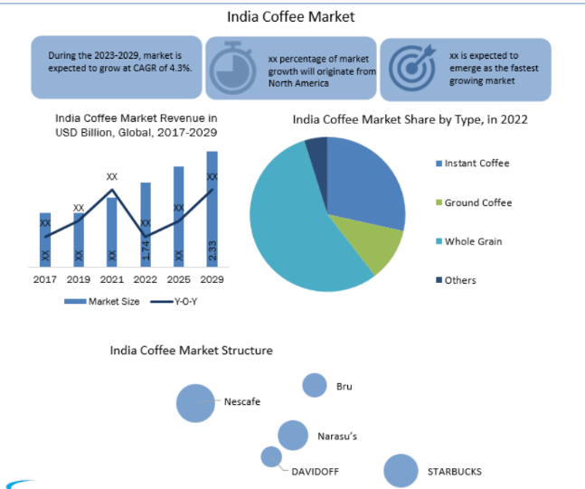
What will make us stand out:
Our Hocus-Focus espresso will take down the coffee lover into a magical ride ,and if you take a sip of Caramelelixir surely it will be irresistible. Apart from our two famous drinks, our Portionocinno , Mocamojo,Necroffine will make hearts jiggle and hence our ambience and coffee experience will make us stand out from the crowd.We source beans from Kerala which makes it fresh and premium in quality. We are valuing local coffee cultivators via sourcing it directly from them. Whenever such magical themed cafes come up , business has mostly focused on Harry potter and not subjugated in building its own brand , while our cafe is not just restricted to one but bringing out many wizardry nostalgia and coffee blends are unique of our own. We give room to our consumers to expand their imagination and customize their caffeinated drinks via a magic book mentioning various portions , and while purchasing our coffee bottles coffee recipes will be mentioned to create their own enchanted blend.

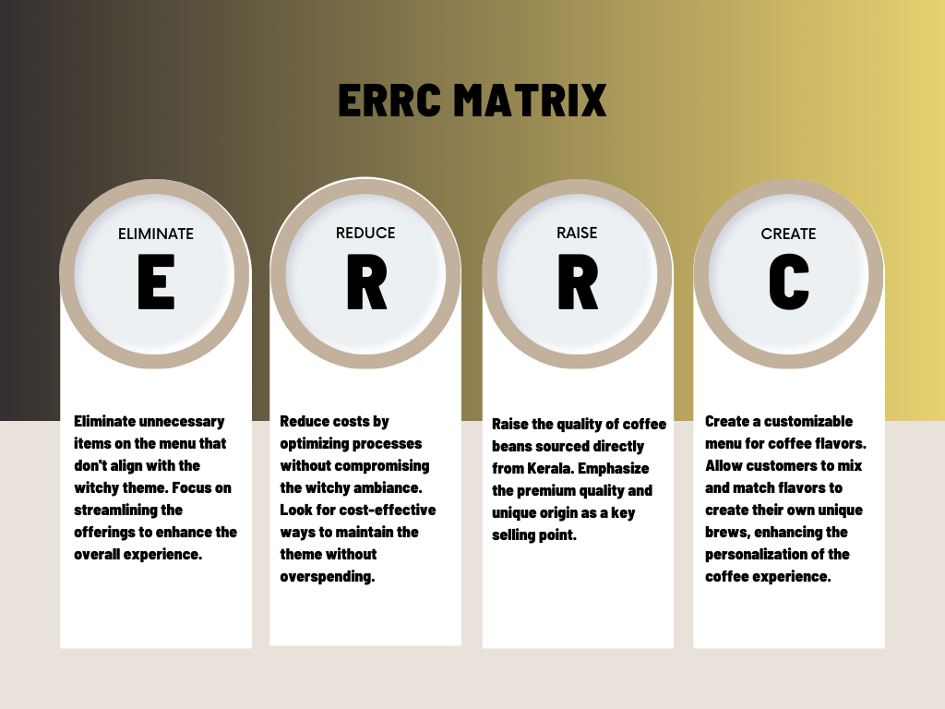

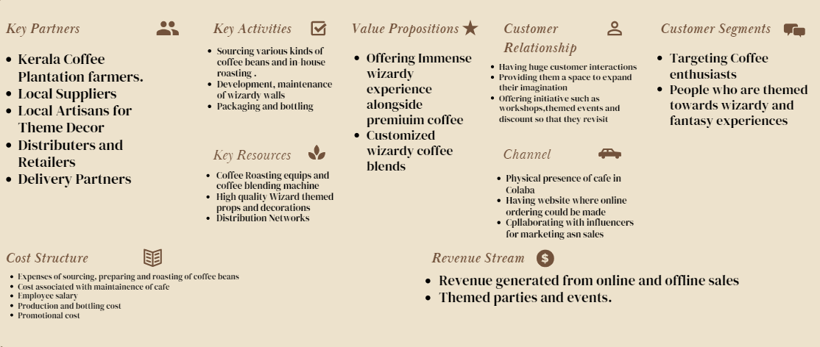

Works Cited
Boydell, Hazel. “Sustainability in Coffee: What Are The Main Issues?” Perfect Daily Grind, 2018, https://perfectdailygrind.com/
.

“India Coffee Market: Industry Analysis and Forecast (2023-2029) by Source, Type, Process, and Region.” Stellar Market Research, https://www.stellarmr.com/report/India-Coffee-Market/65. Accessed 1 December 2023.

INDIA TODAY. “How coffee in India is acquiring a whole new character.” https://www.indiatoday.in/india-today-insight/story/how-coffee-in-india-is-acquiring-a-whole-new-character-1922735-2022-03-09.

Founders: Soumili Chatterjee, Riya Rawat , Parul Godara

