**ASSIGNMENT 1 PYTHON**

1. **Program to enter length and breadth of a rectangle and calculate area and perimeter of the rectangle**

**PROGRAM**

l=input("Enter the length: ")

b=input("Enter the breadth: ")

a=l*b

p=2*(l+b)

print("Area of rectangle is %s") %(a)

print("Perimeter of rectangle is %s") %(p)

**OUTPUT:**

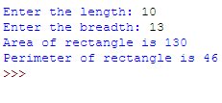

1. **WPP TO ENTER RADIUS OF CIRCLE AND CALCULATE AREA AND CIRCUMFERENCE OF CIRCLE**

**PROGRAM**

r=input("Enter the radius of circle: ")

a=3.14*r**2

c=2*3.14*r

print " "

print("Area of circle is %s") %(a)

print("Circumference of circle is %s") %(c)

**OUTPUT:**

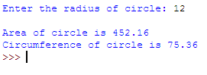

1. **WPP TO ENTER VALUE IN CENTIMETRE AND CONVERT IT TO METER AND KILOMETRE**

**PROGRAM**

c=float(input("Enter the length in centimeter: "))

m=c/100

km=c/100000

m=c/100

print("%s C.M = %f M") %(c,m)

print("%s C.M = %f K.M") %(c,km)

**OUTPUT:**

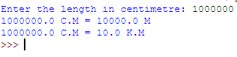

1. **WPP TO ENTER VALUE IN CELSIUS AND CONVERT IT TO FAHRENHEIT**

**PROGRAM**

c=float(input("Enter the temperature in celcius: "))

f=c*(9.0/5)+32

print("Temperature in terms of fahrenheit is %f") %(f)

**OUTPUT:**

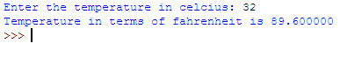

1. **WPP TO ENTER VALUE IN DAYS AND CONVERT IN FORM OF YEAR, MONTHS AND DAYS**

**PROGRAM**

d=int(input("Enter number os days: "))

y=d/360

d1=d%360

m=d1/30

d1=d1%30

print("Years: %d") %(y)

print("Month: %d") %(m)

print("Days : %d") %(d1)

**OUTPUT:**

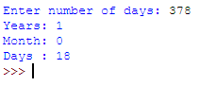

1. **WPP TO FIND POWER OF ANY NUMBER IN FORM OF X^Y WHERE X AND YARE USER INPUTS**

**PROGRAM**

print "Result will be displayed in the form of x^y"

x=float(input("Enter value of x: "))

y=float(input("Enter value of y: "))

p=x**y

print("x^y = %f") %(p)

**OUTPUT:**

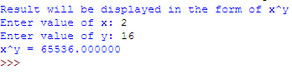

1. **WPP TO ENTER 2 ANGLES AND USING FUNCTION THIRDANGLE( ANGLE1, ANGLE2 ) CALCULATE THIRD ANGLE**

**PROGRAM**

defthirdangle(angle1,angle2):

angle3=180-(angle1+angle2)

return angle3;

angle1=float(input("Enter angle1: "))

if angle1<180:

angle2=float(input("Enter angle2: "))

if (angle1+angle2)>=180:

print("Sum of two angles should not be greater or equal to 180")

exit

else:

angle3=thirdangle(angle1,angle2)

print("Value of angle3 is %f ") %(angle3)

else:

print("Angle value should be less than 180")

**OUTPUT:**

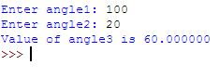

1. **WPP TO ENTER BASE AND HEIGHT OF TRIANGLE AND CALCULATE AREA OF TRIANGLE**

**PROGRAM**

b=float(input("Enter the base of triangle: "))

h=float(input("Enter the height of triangle: "))

a=(1.0/2)*b*h

print("Area of triangle is %f") %(a)

**OUTPUT:**

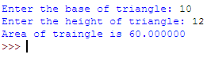

1. **WPP TO ENTER MARKS OF 5 SUBJECTS AND FIND THE MEAN OF 5 SUBJECTS, CALCULATE PERCENTAGE. IF PERCENTAGE IS LESS THAN 35 PRINT FAIL ELSE PRINT PASS**

**PROGRAM**

print("Enter marks received in subjects out of 50")

sub1=float(input("Enter the marks in subject1: "))

sub2=float(input("Enter the marks in subject2: "))

sub3=float(input("Enter the marks in subject3: "))

sub4=float(input("Enter the marks in subject4: "))

sub5=float(input("Enter the marks in subject5: "))

sum=sub1+sub2+sub3+sub4+sub5

avg=sum/5

pcnt=(sum/250.0)*100

print("Mean value is %f") %(avg)

print("Percentage is %f ") %(pcnt)

print "STATUS:"

ifpcnt<35:

print("fail")

else:

print("pass")

**OUTPUT:**

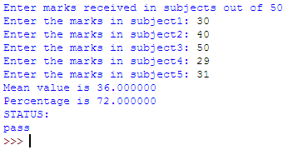

1. **WPP TO ENTER PRINCIPAL AMOUNT, TIME AND INTEREST RATE CREATE SIMPLE_INTEREST(PRINCIPAL, TIME, RATE) FUNCTION TO CALCULATE SIMPLE INTEREST**

**PROGRAM**

defsimple_interest(principal,time,rate):

s_int=(principal*rate*time)/100

returns_int;

pa=float(input("Enter the principal amount : "))

time=float(input("Enter time in terms of days: "))

rate=float(input("Enter rate : "))

s=simple_interest(pa,time,rate)

print("Simple Interest is %f") %(s)

**OUTPUT:**

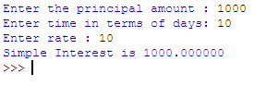

1. **WPP TO ENTER PRINCIPAL AMOUNT, TIME AND INTEREST RATE. CREATE COMPOUND_INTEREST(PRINCIPAL,TIME,RATE) FUNCTION TO CALCULATE COMPOND INTEREST**

**PROGRAM**

defcompund_interest(principal,time,rate):

n=int(input(" Number of times per year interest is compounded : "))

c1_int=principal*(1+(rate/(n*100)))**(n*time)

return c1_int;

pa=float(input("Enter the principal amount : "))

time=float(input("Enter time in terms of years: "))

rate=float(input("Enter rate : "))

c=compund_interest(pa,time,rate)

print("Compund interest is %f") %(c)

**OUTPUT:**

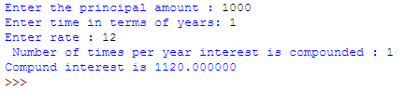

1. **WRITE A PYTHON PROGRAM THAT ACCEPTSAN INTEGER(N) AND COMPUTES THE VALUE n+nn+nnn**

**Sample value of n is 15**

**Expected Result :615**

**PROGRAM**

a = int(input("Input an integer : "))

n1 = int( "%s" % a )

n2 = int( "%s%s" % (a,a) )

n3 = int( "%s%s%s" % (a,a,a) )

print("Value of %d + %d%d + %d%d%d is %d") %(a,a,a,a,a,a,n1+n2+n3)

OUTPUT:

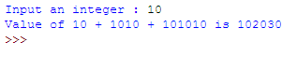

1. **WRITE A PYTHON PROGRAM TO FIND WHETHER A GIVEN NUMBER (ACCEPT FROM THE USER) IS EVEN OR ODD, PRINT OUT AN APPROPRIATE MESSAGE TO THE USER.**

**PROGRAM**

n=float(input("Enter the number to check whether the given number is even or odd :"))

if n%2==0:

print("%d is even")%(n)

else:

print("%f is odd")%(n)

**OUTPUT:**

C:\Users\DEVA\Pictures\P13.PNG