For detailed description and examples, consult your class notes

Stress
- Lazarus: Stress is a condition or feeling experienced when a person perceives that “demands exceed the personal and social resources the individual is able to mobilize.”

- An individual's response to any challenging, frightening, or difficult situation

- Stress is an individual’s response or reaction to a real or imagined threat, event or change.

- Stress can be stimulus , response or an interaction between an organism and its environment

- Stress may be embedded in the environment such as, noise pollution, crowding etc.

- Stress can be self created or self imposed

- Stress and culture

- Subjective Perception: Stress Lies in the eyes of beholder

  - Lazarus and Folkman (19840: Appraisal of Stress
  - Primary Appraisal: Refers to evaluation whether an event is irrelevant, relevant but not stressful or stressful
  - Secondary Appraisal: When an event is perceived as stressful it forces an individual to evaluate his/ her available coping resources to deal with the stress

- Stressors: Any threat, event or change

- Stressors can be internal (thoughts, beliefs, attitudes or external (loss, tragedy, change

- Hans Selye (1956): “stress is not necessarily something bad – it all depends on how you take it.”

- Stress: Two Aspects
  - Positive Aspect: Eustress
    - Outcome of Eustress
    - Enables concentration
    - Increases performance
    - Energizes you into motion
  - Negative Aspect: Distress
    - Outcome of distress
    - Loss of motivation
    - Reduces effectiveness
    - Physical, mental, and behavioral problems

Stress can produce four types of responses
- Emotional responses, such as, sadness, anger, irritation, frustration etc.
- Behavioral responses such as, difficulty in concentration, lack of motivation, aloofness, inability to participate in any group activity etc.
- Physiological responses such as, headache, elevated blood pressure. Long term exposure to stress may prone an individual for several chronic diseases such as, heart attack, cancer, irritable bowel syndrome etc.
- At cognitive level, an individual may start thinking himself/ herself in a way that may be threatening for his/ her self esteem. Long term exposure to stress may induce feeling of helplessness in the individual

Stress and Performance: Inverted u shape relationship has been found between stress and performance

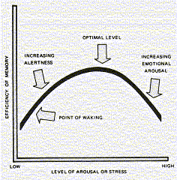
Types of Stress

Hans Seley (1956, 1976): General Adaptation Syndrome
- Stages of Stress Reaction
- Alarm reactions or Emergency Reactions
  - Initially, encounter or perception of a stressful event leads to physiological changes in body. It disrupts an individual’s It disrupts an individual’s homeostasis (body’s normal balance).
  - Signs: increased heart rate, increased respiration, increased stimulation of adrenaline, headache, loss of appetite etc.
- Resistance Stage
  - Attempt to Cope with Stress: During this stage an individual tries to cope or adapt to the stressors.
  - Signs
    - Behavioural: Lack of enthusiasm, Withdrawal, Change in eating habits, Insomnia, Anger, Fatigue
    - Cognitive: Poor problem solving, Confusion, Nightmares, Hyper-vigilance
    - Emotional: Tearfulness, Fear, Anxiety, Guilt, Agitation, depression etc.
- Exhaustion Stage
  - Decline of resistance
  - Exhaustion of Resources to Manage Stress
  - During this stage the stressor is not being managed effectively and the body and mind are not able to repair the damage
  - Signs: Digestive disorders, Withdrawal, Headaches, Tension, Insomnia, Loss of temper

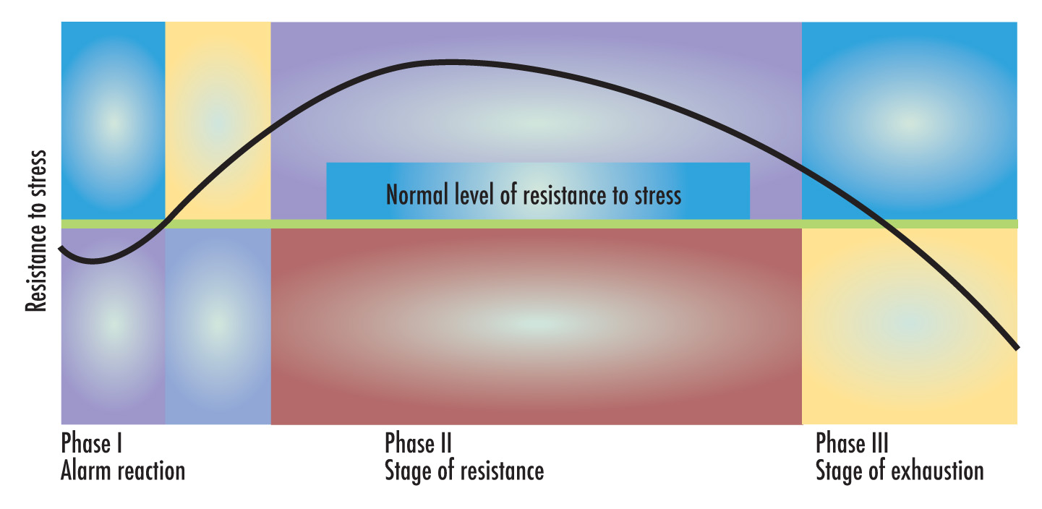
The General Adaptation Syndrome

Major Types of Stress: See class notes

Frustration:

Conflict:

Pressure

Change

Impact of Stress

Stress and Health: Stress has been found to be negatively associated with health. Stress has been understood as a “silent killer”. Stress has been found to be one of the causal factors in the occurrence of heart disease, hypertensive, hardening of the arteries, ulcers, cancer and diabetes.

Burnout: “It refers to physical and emotional exhaustion, cynicism, and a lowered sense of self-efficacy due to work related stress.”

Most jobs involve at least a degree of stress. Yet somehow the persons performing them manage to cope. They continue to function despite their daily encounters with various stressors. Some individual, over the period of time seem to be worn down by repeated encounters with stress. Such persons are said to be suffering from ‘burnout’.

Victims of burnout often suffer from physical exhaustion, feel low energy and easily get tired. They frequently complain various physical symptoms such as, headaches, nausea, insomnia, changes in eating habits. Burnout has also been found to be associated with occurrence of cardiovascular disease. Along with the physical exhaustion, people also feel emotion exhaustion such as, depression, feeling of hopelessness etc. Victims of burnout often show mental or attitudinal exhaustion, which is known as ‘depersonalization’. They become cynical, hold negative attitudes toward others, and tend to derogate themselves, their jobs and life in general.

Posttraumatic Stress Disorder (PTSD): It refers to enduring psychological disturbance attributed to the experience of a major traumatic event such as, war, accident, robbery, flood, hurricane etc.

Factors Influencing Stress Tolerance

Predictability: being able to predict the occurrence of a stressful event-even if the individual cannot control it usually reduces the severity of stress.

Control over Duration: Having control over the duration of a stressful event reduces the severity of the stress.

Cognitive Evaluation: The severity of any stressful event also depends on how person perceives and appraise it.

Social Support: The emotional support and concern of other people can make stress more bearable.

Feeling of Competency: A person’s confidence in his/ her ability to handle a stressful situation is a major factor in determining the severity of the stress.

Individual Differences in Reaction to Stress: Optimism, Pessimism and Hardiness: In general, it has been found that optimists (people who have general expectancies of good outcomes) seem to be much more stress resistant than pessimists (people who have general expectancies for poor outcome).

Hardiness is another characteristic that save an individual from harmful effect of stress. Hardy persons show three characteristics
- Exhibit higher levels of commitment
- They tend to perceive change as a challenge
- They have high sense of personal control over events.

Biofeedback

Verbal Self Instruction: Involves 4 steps
Preparation
Confrontation
Coping with feeling of overwhelmed
Self-Reinforcement

