

ANALYSIS AND DESIGN OF ALGORITHMS

Submitted By -> Name: Parv Arora
Roll Number: 2401420008
Course: B. Tech-CSE-DS(A)
Semester: 4TH Department: SOET
Submitted To -> DR. ARTI SANGWAN
Submission Date -> 02-04-2026

1. Objective
The objective of this lab is to implement and analyze fundamental graph algorithms—including BFS, DFS, Topological Sorting, Dijkstra, Bellman-Ford, Prim’s, and Kruskal’s—to solve real-world problems like social network analysis, task scheduling, and network optimization.

2. Real-World Problem Contexts
- Social Media (BFS/DFS): Identifying potential "Friend Suggestions" by exploring connectivity.
- Project Management (Topological Sort): Managing task dependencies to determine a valid execution order.
- Emergency Routing (Shortest Path): Finding the quickest path for ambulances using Dijkstra’s.
- Cost-Efficient Cabling (MST): Connecting multiple locations with minimum total cable length using Prim’s or Kruskal’s

3. Algorithm Implementation Summary
Task 1: Graph Representation
- Adjacency Matrix: Efficient for dense graphs, $O(V^2)$ space.
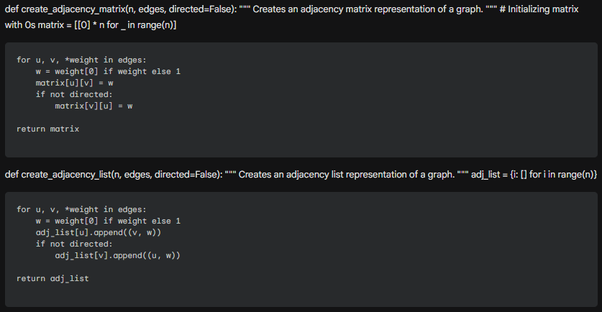
- Adjacency List: Efficient for sparse graphs, $O(V + E)$ space.
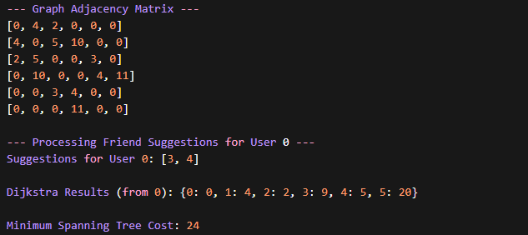

Task 2: Traversal (BFS & DFS)
- BFS: Used for finding the shortest path in unweighted graphs (level-order).
- DFS: Used for exploring deep into branches, useful for cycle detection and reachability.
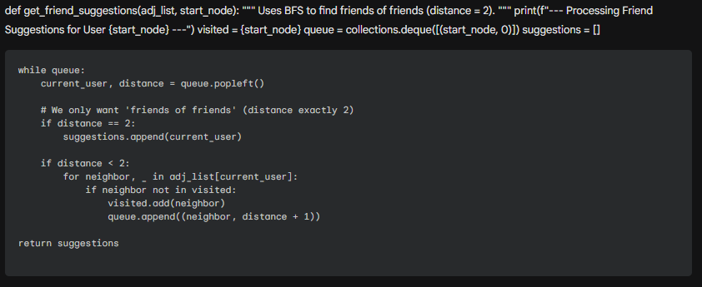



Task 3: Topological Sorting
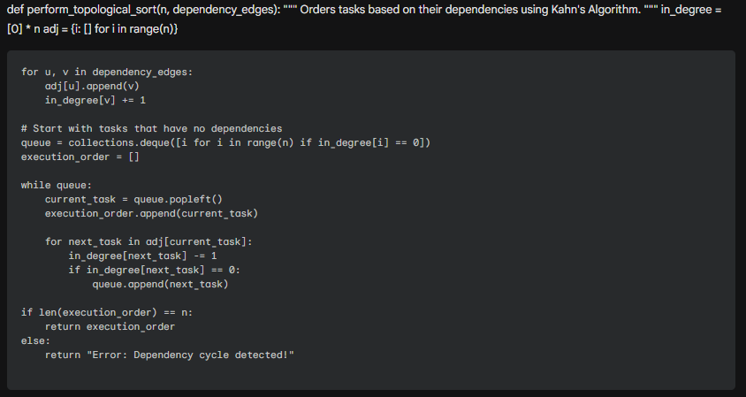
- Applied Kahn’s Algorithm (BFS-based) to resolve dependencies in a Directed Acyclic Graph (DAG).

Task 4: Shortest Path (Dijkstra vs. Bellman-Ford)
- Dijkstra: Faster ($O(E \log V)$) but fails with negative edge weights.
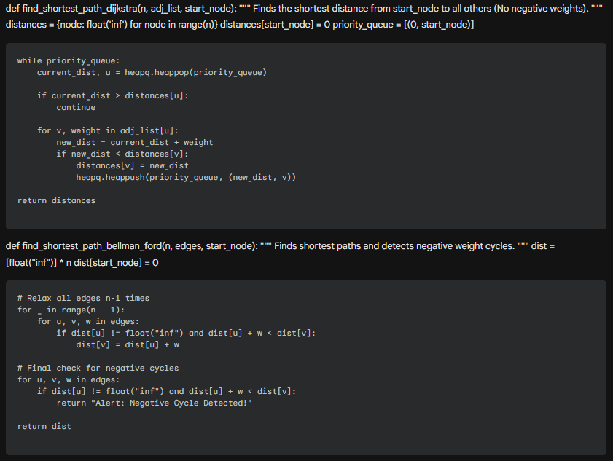
- Bellman-Ford: Slower ($O(VE)$) but handles negative weights and detects negative cycles.
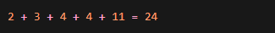

Task 5:
Minimum Spanning Tree (Prim & Kruskal)
- Prim’s: Grows the tree from a starting node.
- Kruskal’s: Sorts all edges and adds them if they don't form a cycle.
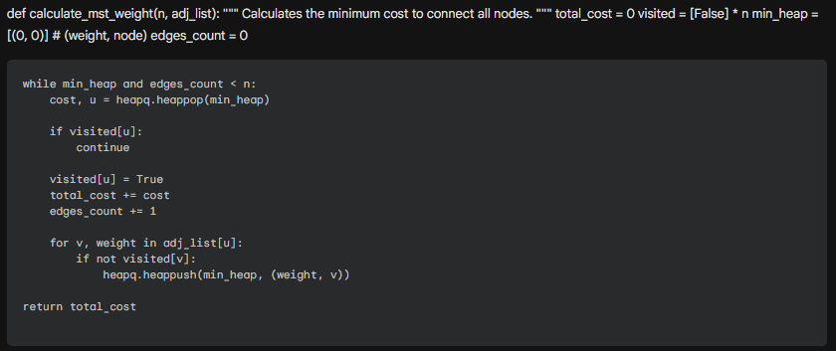
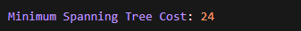

4. Reflection and Discussion
Which real-life problem benefited most from its algorithm?
Emergency path routing via Dijkstra's algorithm is arguably the most beneficial. In life-critical scenarios, the speed of the algorithm (logarithmic scaling) and the accuracy of finding the absolute shortest path are paramount.
Complexity vs. Scalability (BFS/DFS)
On sparse networks (like rural roads), BFS/DFS are highly efficient ($O(V+E)$). In dense networks (like high-frequency neural connections), the memory usage for the adjacency matrix can become a bottleneck, making adjacency lists preferable.
Kruskal vs. Prim for Cabling
Kruskal is generally easier to implement for edge-heavy data, while Prim's performs exceptionally well on dense graphs where we want to expand from a central hub. Both yield the same minimum cost, but Kruskal's is often preferred for distributed networks.

Negative Weight Cycles
Bellman-Ford addresses negative cycles by performing a final $V^{th}$ relaxation. If a distance can still be reduced, a negative cycle exists, which in route planning could mean an infinite "profit" loop—usually an error in the model that the algorithm must flag.
5. Conclusion
This experiment successfully demonstrated the utility of graph theory in solving structural and optimization problems. By implementing these algorithms in Python, I gained a deeper understanding of time-memory trade-offs and the importance of selecting the right algorithm based on specific constraints like negative weights or graph density.

