Game Design Document

Fill up the following document

1. Write the title of your project.

Collosal shower

1. What is the goal of the game?

To destroy all asteriods and level up using power ups and finding other players.

1. Write a brief story of your game.

James is an astronaut who has been sent out on a mission by the UK to destroy all asteriods on their way to hit the earth. Whilst destroying the asteroids he will possibly find other astronauts on the same mission but from other countries.

1. Which are the playing characters of this game?

* Playing characters are the ones who respond to the user based on the input from the user.
* Cars, monkeys, dinos, wizards, etc., are the playing characters in the game.

|  |  |  |
| --- | --- | --- |
| Number | Character Name | What can this character do? |
| 1 | James | Shoot rays |
| 2 | Charlie | Shoot rays |
| 3 | Jessica | Shoot rays |
| 4 | Bob | Shoot rays |
| 5 | Alien | Reduces health |
| 6 |  |  |
| 7 |  |  |
| 8 |  |  |

1. Which are the Non-Playing Characters of this game?

* Non-Playing characters are the ones that don't have an action or behavior when the user interacts with the game.
* Hurdles, stones, bananas, coins, etc., are non-playing characters in the game.

|  |  |  |
| --- | --- | --- |
| Number | Character Name | What can this character do? |
| 1 | asteroids | Targets and damage players |
| 2 | Black holes | Sucks in others |
| 3 |  |  |
| 4 |  |  |

Draw your imagination of this game. What does this game look like?

* Draw the game either on your computer or on paper.
* 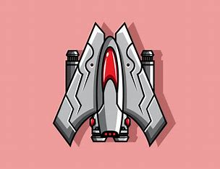Add images of the game scenes to show each of the playing and non-playing characters at least once.

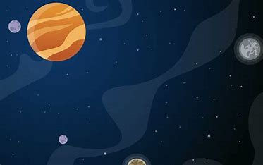

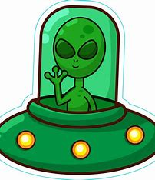

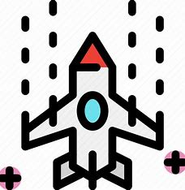

How do you plan to make your game engaging?

By adding different sizes of asteriods and including various black holes to try make sure the player pays attention and avoids them adding some abillities might entice the player to continue playing the game.