COMP 3133 Lab 03
MongoDB & Mongoose REST API
Name: Parvkumar Mehta
Student ID: 101501920

Screenshot 1 — Get All Restaurants API Output
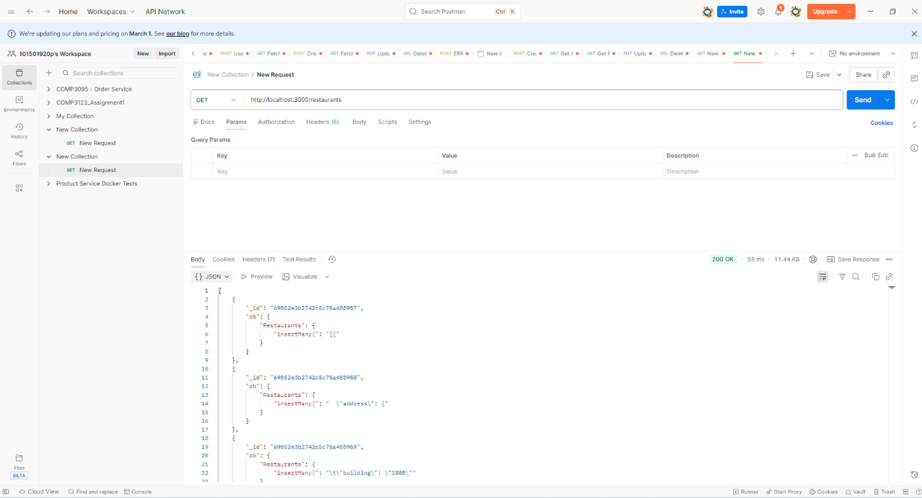

Screenshot 2 — Cuisine Filter API Output
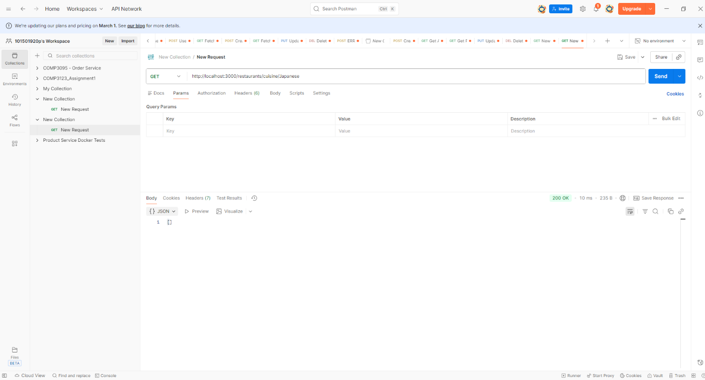
Screenshot 3 — Sorting ASC Output
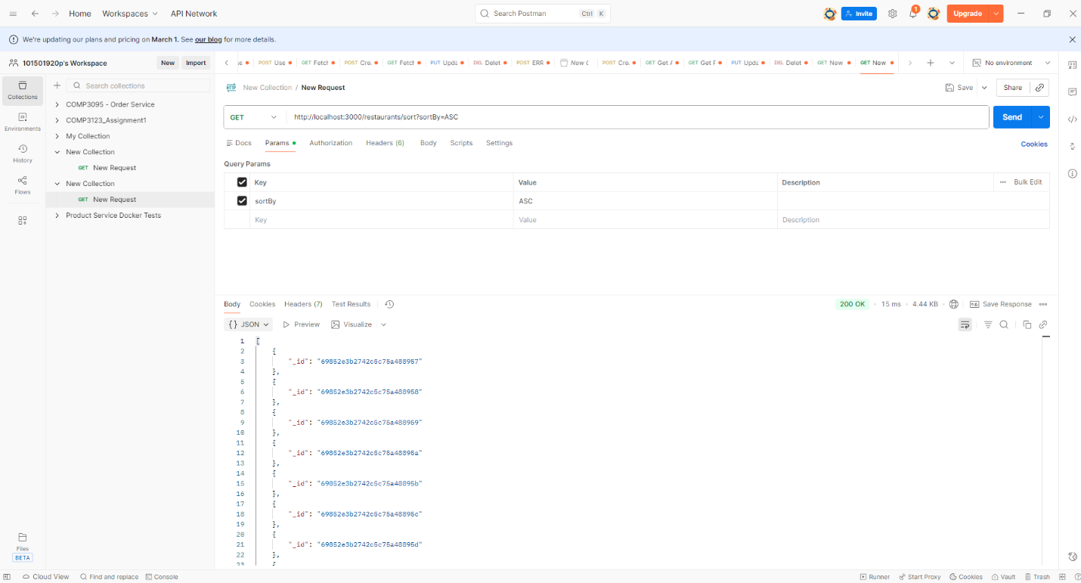

Screenshot 4 — Sorting DESC Output
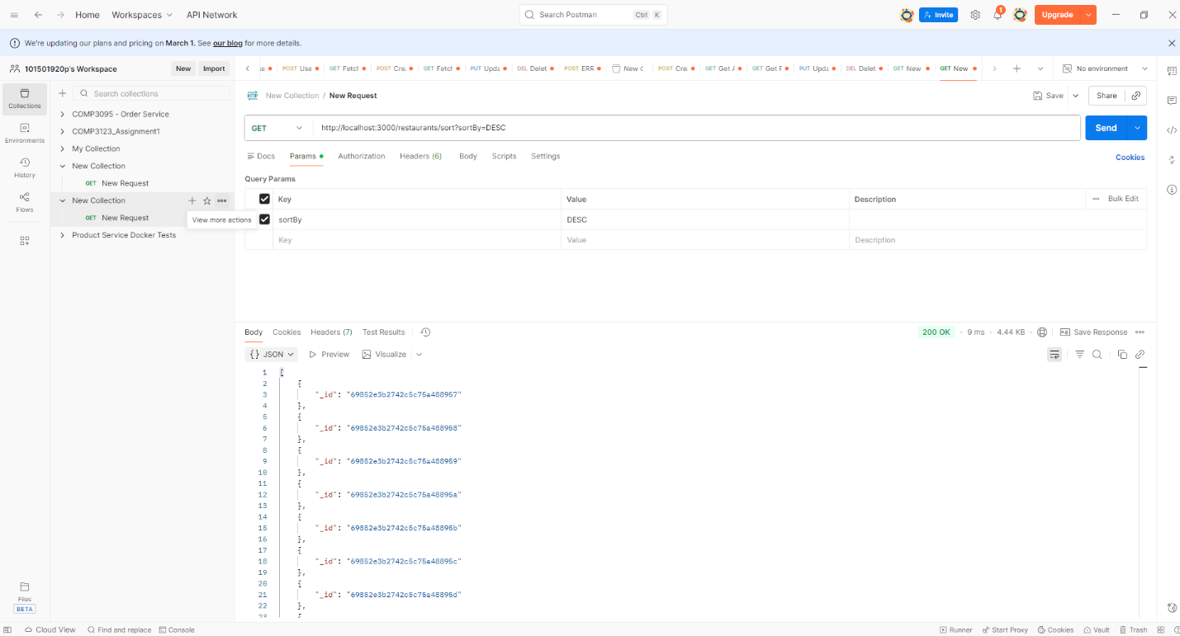
Screenshot 5 — Delicatessen Filter Output
