**Applied Linear Algebra in Data Analysis**

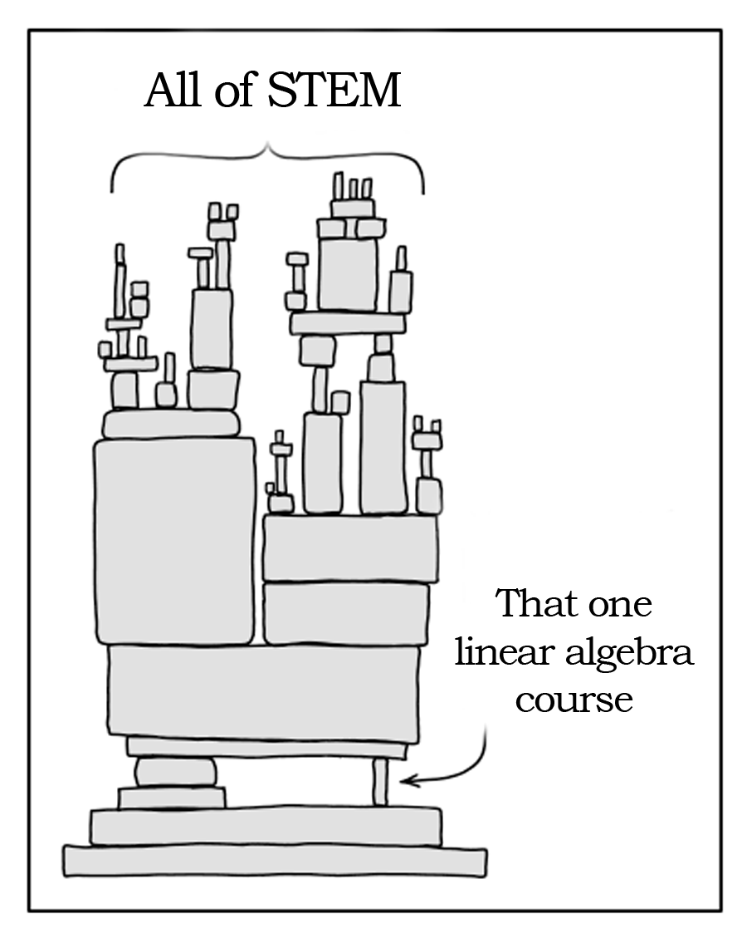

**Source**: <https://twitter.com/Quasilocal/status/1664701458200121351>

The above figure is not that far away from the truth. Linear algebra today is as important as calculus, if not more.

Linear algebra serves as the first step towards high-dimensional thinking, a prerequisite skill for modern data analysis. Paired with probability theory and optimization, it comprises a potent trio of tools driving the current machine learning revolution.

In this course, our mission is to lay a solid foundation in applied linear algebra, along with basic probability theory and optimization. But why these three topics?

* **Linear Algebra:** Think in high dimensions & visualize complex structures.
* **Probability Theory:** Navigate uncertainty with precision. Probability theory provides a principled approach to handling the unpredictable nature of real-world data.
* **Optimization:** Seek the best solutions. Optimization allows us to navigate the vast solution space and pinpoint the most efficient paths to solving problems.

Throughout this course, we will:

1. Introduce fundamental concepts in linear algebra, matrix methods, probability theory, and optimization.
2. Demonstrate the practical application of these concepts in real-world scenarios.
3. Provide hands-on experience for applying these concepts to solve real-world problems.

**Course GitHub Page**

All course-related documents will be available on the GitHub page: <https://github.com/siva82kb/ALADA-Course>

**Course Content**

(Modules in orange cover concepts and Modules in blue are applications)

Vectors and Vector Spaces; Matrices; Solving Linear Equations; Orthogonality; Matrix Inverses; Signal processing: Fourier and Wavelet Transforms; Eigenvectors and Eigenvalues; Systems theory: Linear Dynamical Systems; Positive Definiteness & Semi-definiteness; Matrix Norms; Singular Value Decomposition; Dimensionality Reduction: Principal Component Analysis; Image compression; Optimization: A brief introduction; Linear Least Squares and its Variants; Linear programing; Signal processing: Filtering; Machine learning: Cross-validation; Linear Regression Models; Linear Models for Classification; Neuromechanics: Linear Programming applied to neuromuscular control, and radiation planning. Probability and Statistics: Gaussian distribution.

**Assignments**

* This is a hands-on course heavy on pen-and-paper and programming assignments. Students are encouraged to use Python or Julia for their programming assignments.
* All assignments will need to be submitted using the submission link on the course GitHub page.
* All assignments will be released one after the other as we progress through the course
* You have a cumulative 3-day late submission grace period for your assignments for the entire course.
* If you use up your 3-day grace period, all subsequent late assignments will receive 0 marks.

**Resources**

The topics covered in this course are quite mature, so it’s no surprise that there are numerous wonderful resources. Here are some resources that cover the topics discussed in this course. There are several wonderful resources:

1. G Strang, Introduction to Linear Algebra. Wellesley, *MA: Wellesley-Cambridge Press*, 1993.
2. CD Meyer, Matrix Analysis and Applied Linear Algebra. *Siam*; 2000 Jun 1.
3. S Boyd and L Vandenberghe, Introduction to Applied Linear Algebra – Vectors, Matrices, and Least Squares. [Online Book](https://web.stanford.edu/~boyd/vmls/).
4. FJ Valero-Cuevas. Fundamentals of Neuromechanics. *Berlin: Springer,* 2016.
5. CM Bishop, and MN Nasrabadi. Pattern recognition and machine learning. *New York: Springer*, 2006.
6. Online lectures: [Linear Algebra](https://youtu.be/ZK3O402wf1c) by Prof. Gilbert Strang.
7. Selected online lectures: [Matrix Methods in Data Analysis, Signal Processing, and Machine Learning](https://youtu.be/Cx5Z-OslNWE), by Prof. Gilbert Strang.
8. Selected online lectures: [Linear Dynamical Systems](https://youtu.be/bf1264iFr-w) by Prof. Stephen Boyd.
9. Selected online lectures: [Convex Optimization](https://youtu.be/McLq1hEq3UY) by Prof. Stephen Boyd.

**Grading**

The final grade for the course will consider the performance on the assignments, quizzes, mid-term, and the final exam.

|  |  |
| --- | --- |
| **Assignments** | 15 |
| **Quizzes** | 10 |
| **Mid-term** | 20 |
| **Final** | 55 |
| Total | 100 |

An absolute grading scheme will be followed for the course:

**S:** >=90; **A**: >=80; **B**: >= 70; **C**: >= 60; **D**: >=50; **E**: >=40; **F**: <40

**Lectures Schedule (August – December 2024)**

**Lecture timings:**

**Thursday, Friday:** 7:30 – 9:00 AM

**Saturday:** 7:30 – 8:30 AM

|  |  |  |  |  |
| --- | --- | --- | --- | --- |
| **Week** | **Day** | **Date** | **Details** | **Details** |
| 1 | 1 | 2/8/24 | Concepts in Vector Spaces - 1 | Vector spaces, Subspace, Span, Linear Independence |
|  | 2 | 3/8/24 | Concepts in Vector Spaces - 2 | Norm, Inner Products, Basis, Orthonormal Basis, Linear Functions |
| 2 | 3 | 8/8/24 | Matrices – 1 | Matrices, Matrix Multiplication |
|  | 4 | 9/8/24 | Matrices – 2 | Rank of. Matrix, Matrix Inverse, Complex Vectors & Matrices |
|  | 5 | 10/8/24 | Tutorial 1 |  |
| 3 | 6 | 15/8/24 | Holiday |  |
|  | 7 | 16/8/24 | Solving linear equations 1 | Linear Equations, Understanding Solutions to Linear Equations |
|  | 8 | 17/8/24 | Tutorial 2 |  |
| 4 | 9 | 22/8/24 | Solving linear equations 2 | General Solution to Linear Equations, Four Fundamental Subspaces of a Matrix |
|  | 10 | 23/8/24 | Orthogonality | Orthogonality, Orthogonal Projections, Gram-Schmidt Procedure, QR Decomposition |
|  | 11 | 24/8/24 | Tutorial 3 |  |
| 5 | 12 | 29/8/24 | Matrix Inverses | Meaning of matrix inverses, Left and Right Inverses, Generalized Inverses |
|  | 13 | 30/8/24 | **Application**: Signal Processing – Fourier & Wavelet Transform |  |
|  | 14 | 31/8/24 | Tutorial 4 |  |
| 6 | 15 | 3/10/24 | Eigenvectors and Eigenvalues | Similarity Transformation, Eigenvectors and Eigenvalues, Diagonalization of a Matrix, Jordan Forms |
|  | 16 | 4/10/24 | **Application**: Linear Dynamical Systems |  |
|  | 17 | 5/10/24 | Tutorial 5 |  |
| 7 | 18 | 10/10/24 | Positive Definiteness and Matrix Norms | Positive Definite Matrices, Matrix Norms |
|  | 19 | 11/10/24 | **Application**: Dimensionality reduction, PCA and Image compression. | Introduction to PCA |
|  | 20 | 12/10/24 | Tutorial 6 |  |
| 8 | 21 | 17/10/24 | Optimization - 1 | Continuity, Derivatives, Taylor series, Univariate minimization (line search) |
|  | 22 | 18/10/24 | Optimization - 2 | Multivariate minimization |
|  | 23 | 19/10/24 | Tutorial 7 |  |
| 9 | 24 | 24/10/24 | Univariate optimization | Continuity, Derivatives, Taylor series, Univariate minimization (line search) |
|  | 25 | 25/10/24 | Multivariate, Unconstrained Optimization | Multivariate optimization and its different methods |
|  | 26 | 26/10/24 | Tutorial 8 |  |
| 10 | 27 | 31/10/24 | Constrained Optimization | Constrained optimization with equality constraints |
|  | 28 | 1/11/24 | Constrained Optimization | Constrained optimization with equality constraints |
|  | 29 | 2/11/24 | Tutorial 9 |  |
| 11 | 30 | 7/11/24 | Constrained Optimization | Constrained optimization with inequality constraints |
|  | 31 | 8/11/24 | Additional topics in Optimization | Multiobjective optimization, Introduction to Convex Optimization |
|  | 32 | 9/11/24 | Tutorial 10 |  |
| 12 | 33 | 14/11/24 | Linear Least Squares and its Variants | Linear Least Squares, Multiobjective Least Squares, Constrained Least Squares |
|  | 34 | 15/11/24 | **Application**: Signal Processing – Filtering, CT Image Reconstruction |  |
|  | 35 | 16/11/24 | Tutorial 11 |  |
| 13 | 36 | 21/11/24 | **Application**: Machine learning – Cross-validation; Linear regression models |  |
|  | 37 | 22/11/24 | Linear Programs | Definition, Basic Concepts |
|  | 38 | 23/11/24 | Tutorial 12 |  |
| 14 | 39 | 28/11/24 | Linear Programs | Simplex Algorithm |
|  | 40 | 29/11/24 | Linear Programs | Simplex Algorithm |
|  | 41 | 30/11/24 | Tutorial 13 |  |
| 15 | 42 | 5/12/24 | **Application**: Neuromechanics - Neuromuscular control, Radiation planning |  |
|  | 43 | 6/12/24 | Introduction to Probability |  |
|  | 44 | 7/12/24 | Tutorial 14 |  |
| 16 | 45 | 12/12/24 | Introduction to Probability |  |
|  | 46 | 13/12/24 | Introduction to Statistics |  |
|  | 47 | 14/12/24 | Tutorial 15 |  |

**Midsem Exam:** 7:30 – 8:30 AM, 15 October 2024

**Final Exam:** 7:30 – 10:30 AM, 21 December 2024

**Assignment Schedule**

Refer to the GitHub page.