Practical Submission
Student ID: | 24CS013 | Student Name:
Subject code & Name: | ITUE301 – Advanced Web Development Frameworks | Practical: | 13 – AI API Integration into a Web Application
Academic Year: | 2025-26
Task - 1
Aim
To integrate an external AI service into the existing application and understand responsible AI usage.
Add a backend route that asks the OpenAI API for a short task description from the task title, keep the API key in the server's .env only, degrade gracefully when the AI call fails, show the suggestion as editable text in the React form, and add the supplementary loading state, per-task rate limit and AI-generated disclaimer.
Code (Paste your GitHub Repository Link – Practical Wise)
GitHub Link Repository Link: https://github.com/<your-username>/AWDF-24CS013/tree/main/practical-13
Output
13.1 API run with an invalid key: graceful degradation, rate limit, auth
OpenAI rejected the invalid key (401); the route still answered 200 with fallback: true, the repeat request got 429, and task creation kept working. No response contains the key.
== Practical 13: AI route with an invalid OPENAI_API_KEY (graceful degradation) ==

$ POST /api/ai/generate-description {"title":"Prepare lab report"}
{"description":"","fallback":true,"message":"AI suggestions are unavailable right now. You can still write the description yourself."}
HTTP 200 in 4.415562s

$ POST /api/ai/generate-description (same title again within a minute)
HTTP/1.1 429 Too Many Requests
Retry-After: 56
{"error":"Please wait 56 s before asking again for this task.","retryAfterSeconds":56}

$ POST /api/ai/generate-description (no token)
{"error":"Missing or malformed Authorization header"}
HTTP 401

$ POST /tasks (the core app keeps working while AI is down)
HTTP 201

Does any response contain the API key? 0 matches

13.2 Server console
The failure reason is logged on the server only.
MongoDB connected
Server running on port 5000
POST /auth/register - 2026-10-21T11:14:45.166Z
POST /auth/login - 2026-10-21T11:14:45.414Z
POST /api/ai/generate-description - 2026-10-21T11:14:45.614Z
[AI] suggestion failed for "Prepare lab report": 401 Incorrect API key provided: sk-inval*******test. You can find your API key at https://platform.openai.com/account/api-keys.
POST /api/ai/generate-description - 2026-10-21T11:14:50.089Z
POST /api/ai/generate-description - 2026-10-21T11:14:50.184Z
POST /tasks - 2026-10-21T11:14:50.243Z
[API] Response sent at 2026-10-21T11:14:50.249Z
[Notification] listener started at 2026-10-21T11:14:50.255Z for "Prepare lab report"
POST /api/ai/generate-description - 2026-10-21T11:14:50.349Z
[AI] suggestion failed for "Another task": 401 Incorrect API key provided: sk-inval*******test. You can find your API key at https://platform.openai.com/account/api-keys.
[Notification] Task "Prepare lab report" created by ai-demo@example.com — notification finished at 2026-10-21T11:14:52.256Z
MongoDB connected
Server running on port 5000
POST /auth/login - 2026-10-21T11:15:23.853Z
GET /auth/me - 2026-10-21T11:15:24.332Z
GET /tasks - 2026-10-21T11:15:24.337Z
POST /api/ai/generate-description - 2026-10-21T11:15:26.000Z
[AI] suggestion failed for "Organise team meeting": 401 Incorrect API key provided: sk-inval*******test. You can find your API key at https://platform.openai.com/account/api-keys.
POST /tasks - 2026-10-21T11:15:27.558Z
[API] Response sent at 2026-10-21T11:15:27.583Z
[Notification] listener started at 2026-10-21T11:15:27.586Z for "Organise team meeting"
[Notification] Task "Organise team meeting" created by ai-demo@example.com — notification finished at 2026-10-21T11:15:29.589Z

13.3 Loading state while waiting for the AI response
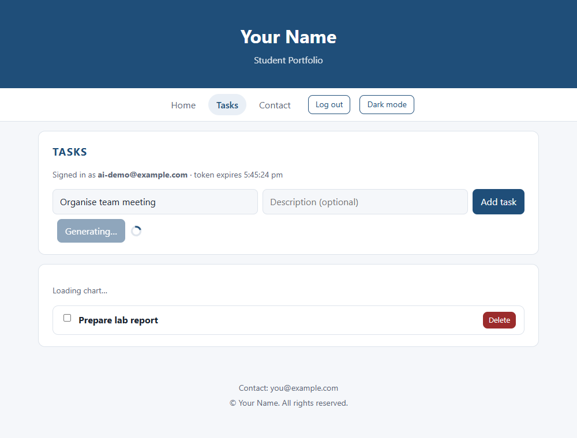
13.4 Fallback message when the AI service fails (real call, invalid key)
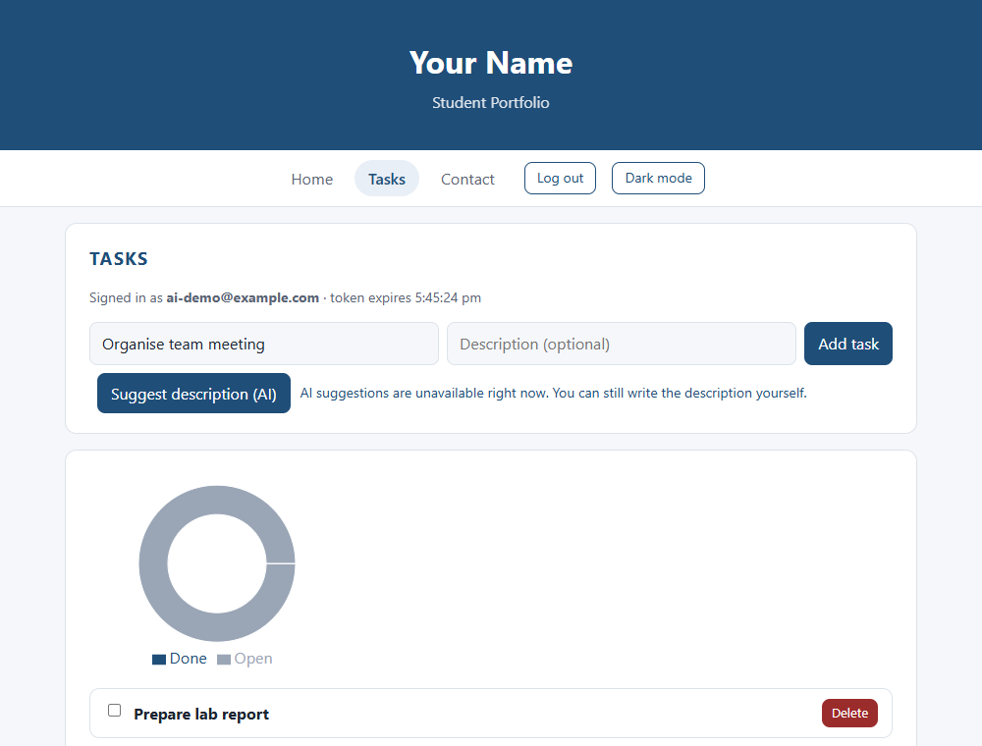
13.5 Suggestion shown as editable text with disclaimer (SIMULATED response)
No real API key was available, so this response was injected in the browser to show the display. Replace this with a screenshot taken with a real key.
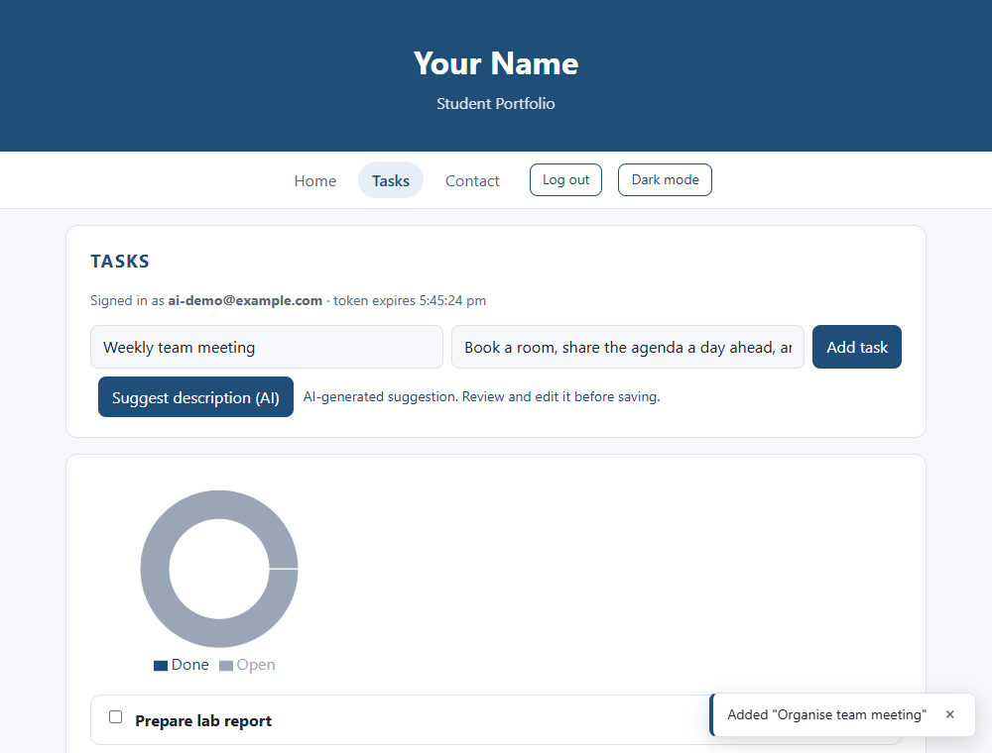
13.6 Browser run log
Clicked "Suggest description (AI)": button shows "Generating…" while waiting (loading state)
Real call with an invalid key -> fallback shown: "AI suggestions are unavailable right now. You can still write the description yourself."
Task was still created normally while AI is unavailable
SIMULATED success response: description field now holds "Book a room, share the agenda a day ahead, and note the action items with owners." with the disclaimer "AI-generated suggestion. Review and edit it before saving."
Hosts the browser contacted: localhost:4900, localhost:5000 (no request to api.openai.com from the browser)

13.7 Automated tests (12 passing, including AI fallback and rate limit)
$ npm test
✔ requires a token (8.9954ms)
✔ requires a title (14.3185ms)
✔ returns a fallback instead of an error when the AI service is unavailable (8.7284ms)
✔ limits each task title to one request per minute (5.9954ms)
✔ task creation still works while AI is unavailable (14.1266ms)
✔ AI description route (400.9947ms)
✔ GET /health returns 200 (29.3751ms)
✔ GET /tasks without a token returns 401 (10.6254ms)
✔ register then login returns a JWT (243.3914ms)
✔ GET /tasks returns 200 (15.1542ms)
✔ POST /tasks without a title returns 400 (9.0889ms)
✔ POST /tasks creates a task and GET /tasks lists it (19.1175ms)
✔ an unknown route returns a JSON 404 (5.4573ms)
✔ Task API (437.5709ms)
ℹ tests 12
ℹ pass 12
ℹ fail 0

