Practical Submission
Student ID: | 24CS013 | Student Name:
Subject code & Name: | ITUE301 – Advanced Web Development Frameworks | Practical: | 2 – State Management and Routing in React
Academic Year: | 2025-26
Task - 1
Aim
To implement reactive state management using useState and multi-page navigation using React Router in the existing portfolio application.
Add React Router v6 with a NavBar (Home, Projects, Contact), a controlled contact form tied to useState with a live character count, a help tooltip toggled by a second useState, a dark/light theme toggle that sets a class on the root element, and a 404 page for unknown routes.
Code (Paste your GitHub Repository Link – Practical Wise)
GitHub Link Repository Link: https://github.com/<your-username>/AWDF-24CS013/tree/main/practical-2/app
Output
2.1 Home page (light theme)
Route "/" renders Home (About and Skills). The NavBar uses Link/NavLink, not <a> tags.
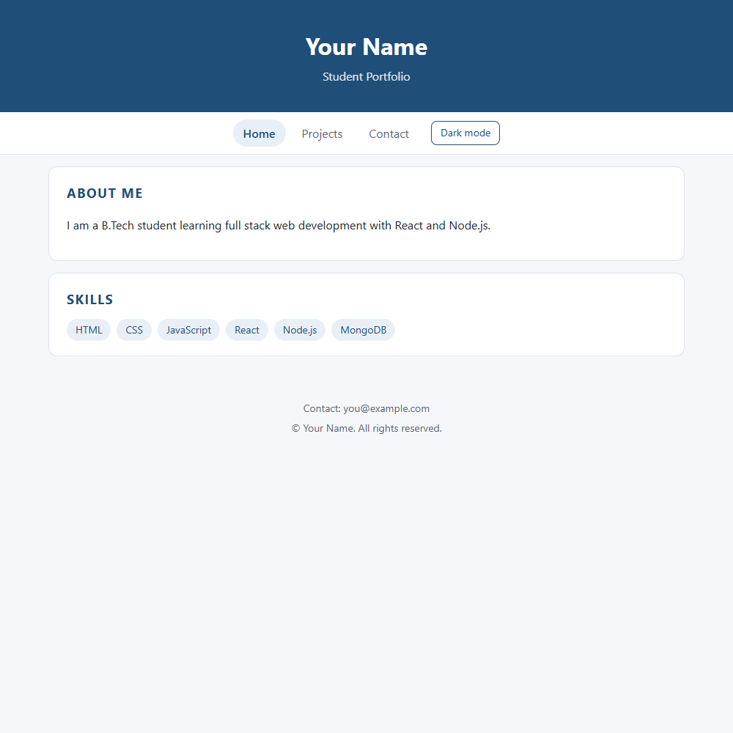
2.2 Dark mode toggle
Clicking Dark mode adds the class "dark" to <html>; the colours switch through CSS variables.
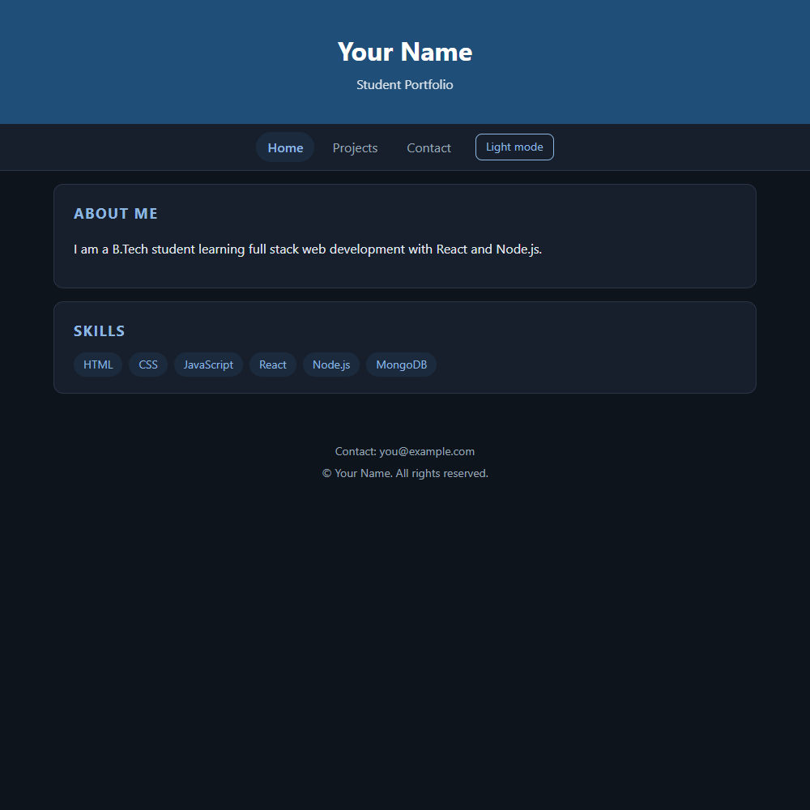
2.3 Contact page: controlled input and live character count
The input value and the counter both come from the message state.
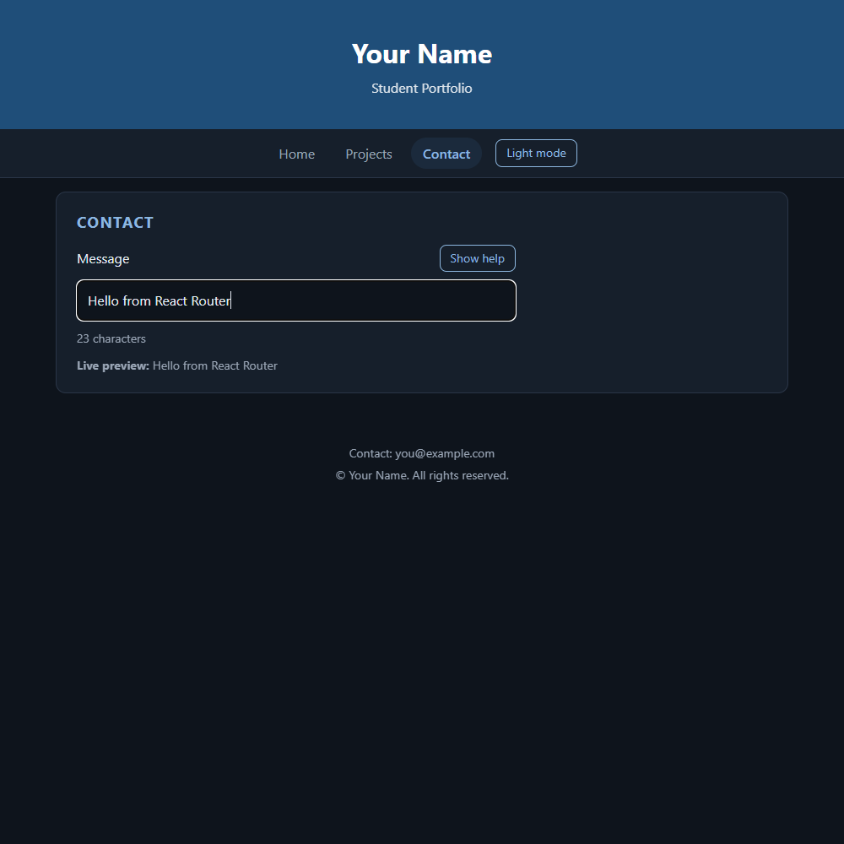
2.4 Contact page: help tooltip (second useState)
The Show help button toggles showHelp, which controls the tooltip.
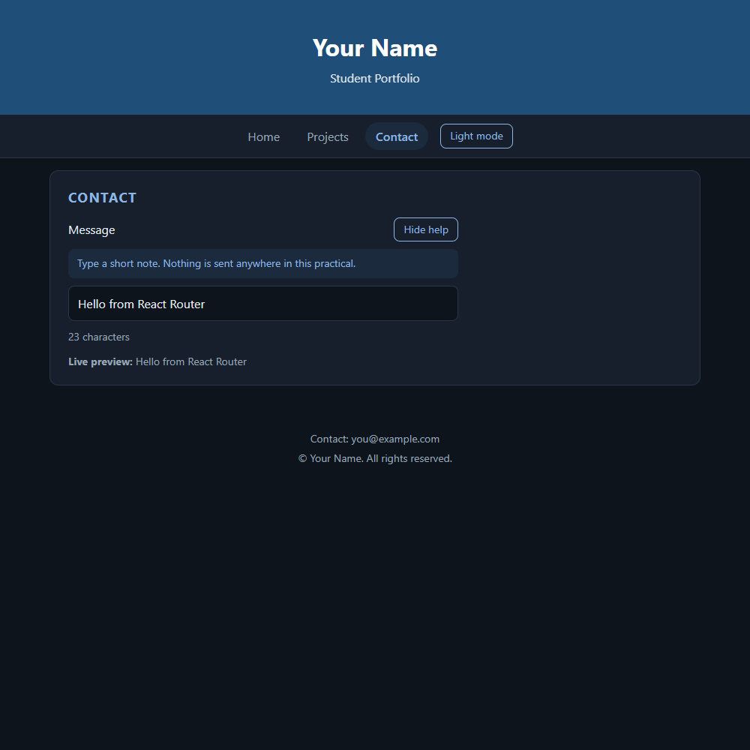
2.5 404 Not Found route
Unknown paths render the NotFound page through the path="*" route.
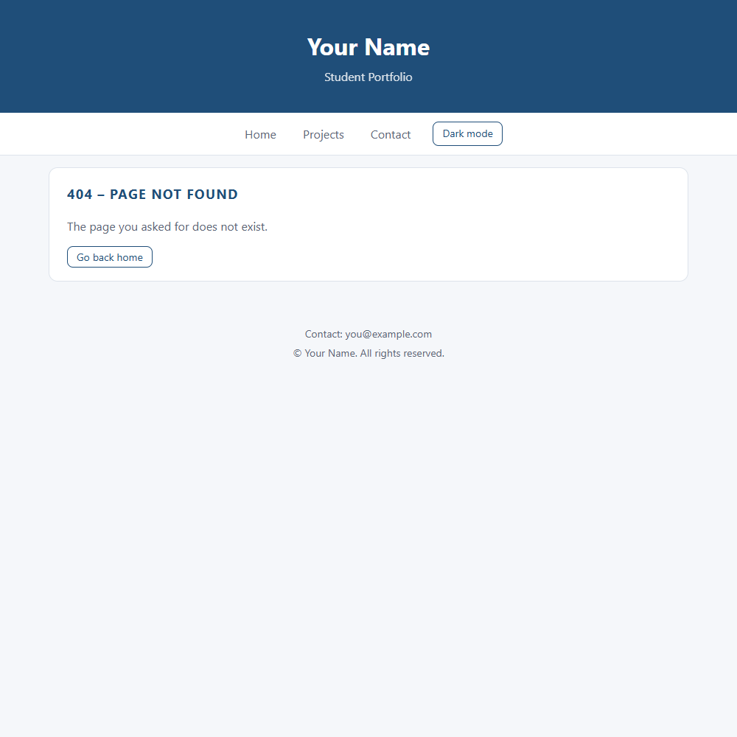
2.6 Test run: navigation and state checks
Output of the automated browser run (Edge) on the Practical 2 build.
GET / -> h2 "About Me"
After Dark mode click: <html class="dark">
Clicked Contact link -> URL /contact; window marker survived: yes (no full page reload)
Counter text: "23 characters"
Preview text: "Live preview: Hello from React Router"
Help toggle opened tooltip: "Type a short note. Nothing is sent anywhere in this practical."
GET /no-such-page -> h2 "404 – Page not found"

