Practical Submission
Student ID: | 24CS013 | Student Name: | Parva Chhatrola
Subject code & Name: | CSE304 – Full Stack Development | Practical: | 3 – API Integration and Data Rendering in React
Academic Year: | 2025-26
Task - 1
Aim
To consume a REST API in React and handle asynchronous data with loading and error states.
Fetch the public GitHub repositories API inside useEffect on the Projects page, show a spinner while loading and an error message on failure, render each repository's name, link and star count, and add a Retry button and a name filter.
Code (Paste your GitHub Repository Link – Practical Wise)
GitHub Link Repository Link: https://github.com/Parva-28/AWDF-24CS013/tree/main/practical-3/app
Output
3.1 Loading state
The request is held for 2.5 s to show the spinner (role="status").
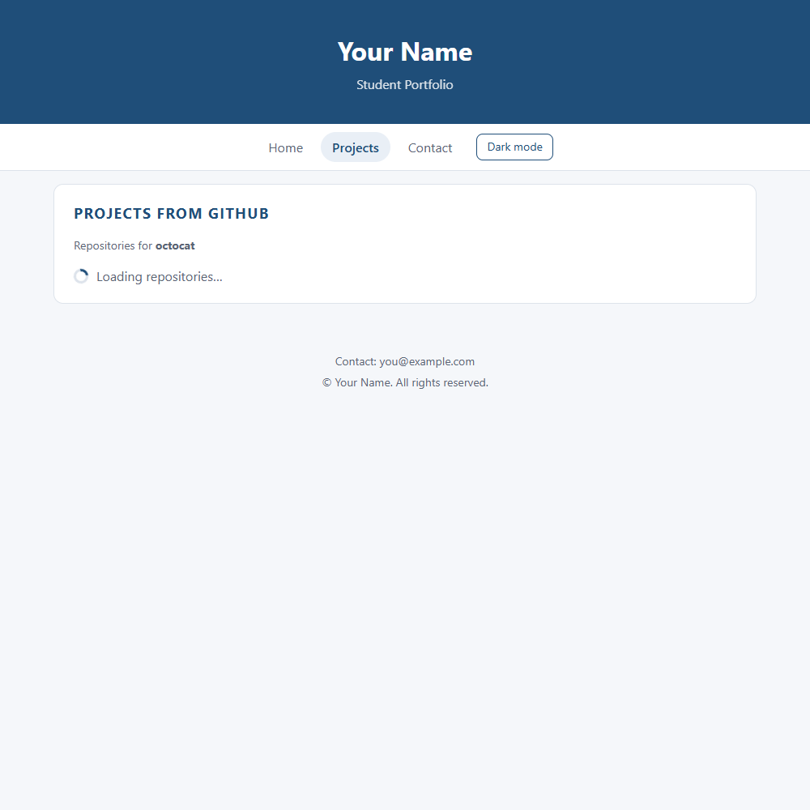
3.2 Happy path: repositories from the API
Each card shows the repository name (linked to html_url), description and stargazers_count.
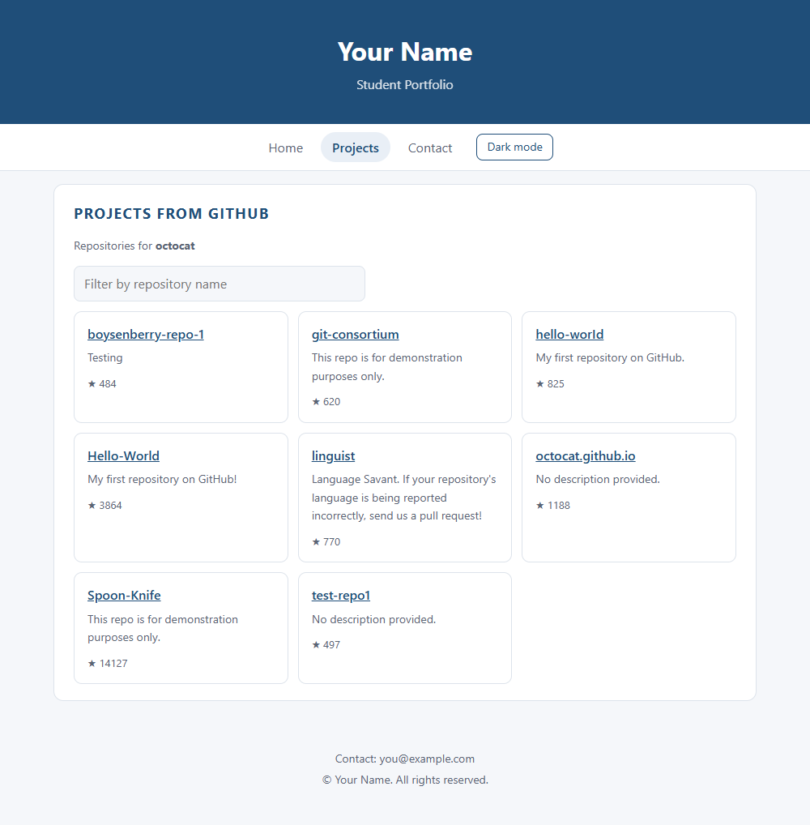
3.3 Search / filter by name (supplementary)
Typing "hello" filters the list in the browser without a new request.
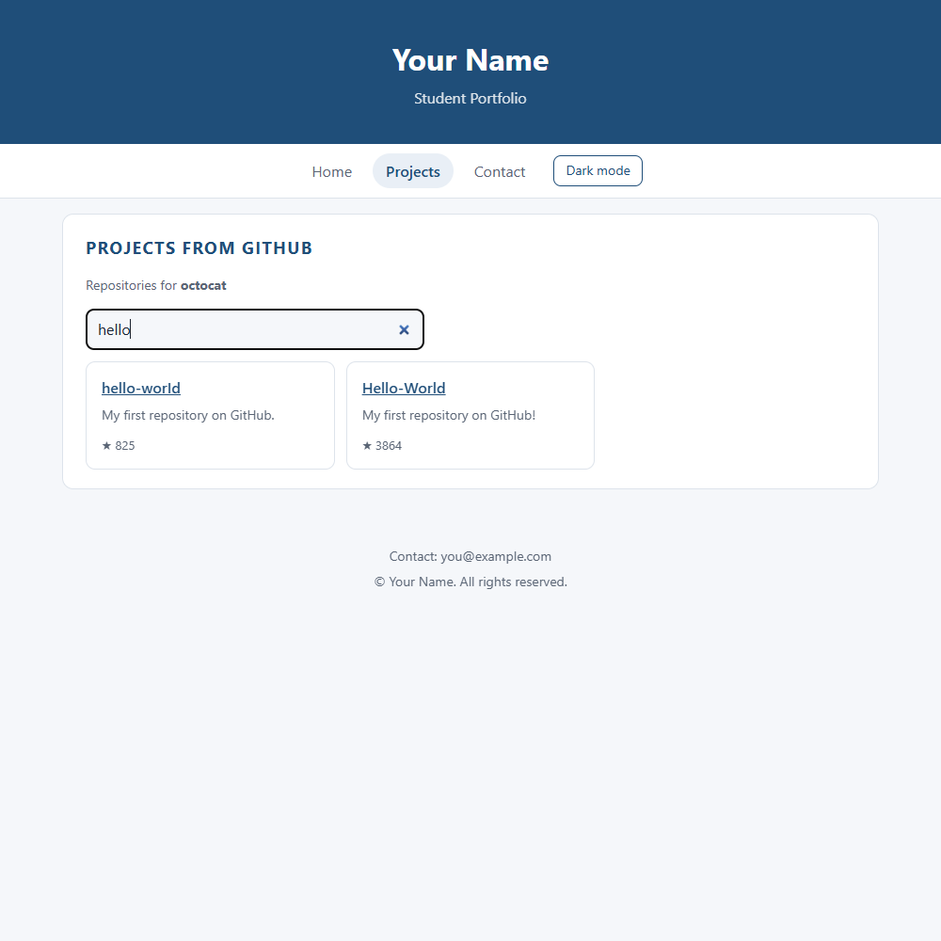
3.4 Error path with Retry
Opening /projects?user=zz-no-such-user-93817 makes GitHub return 404; the error component is shown instead of the list.
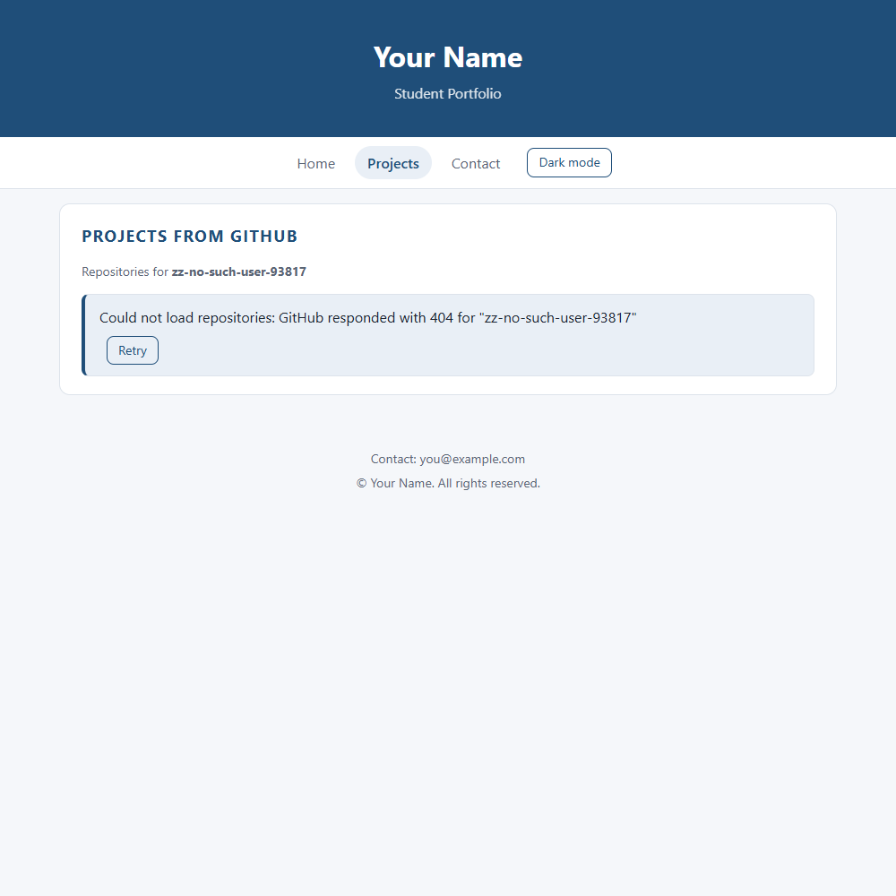
3.5 Test run log
Output of the automated browser run on the Practical 3 build (Edge).
Loading state shown: Loading repositories…
Repositories rendered: 8; first item: boysenberry-repo-1 -> https://github.com/octocat/boysenberry-repo-1; ★ 484
After typing "hello" the list shows: ["hello-worId","Hello-World"]
[console.error] Failed to load resource: the server responded with a status of 404 ()
Error state shown: Could not load repositories: GitHub responded with 404 for "zz-no-such-user-93817"
[console.error] Failed to load resource: the server responded with a status of 404 ()
Retry clicked: API requests before=2, after=3

