Practical Submission
Student ID: | 24CS013 | Student Name: | Parva Chhatrola
Subject code & Name: | CSE304 – Full Stack Development | Practical: | 8 – Performance Optimization and Lazy Loading in React
Academic Year: | 2025-26
Task - 1
Aim
To improve frontend performance using lazy loading and code splitting techniques.
Apply React.lazy() and Suspense to the route components (Tasks, Login, Contact), show a fallback while a chunk loads, measure bundle size and load time before and after with the browser tools on Slow 3G, and add the supplementary lazy-loaded chart and 300 ms minimum-delay fallback.
Code (Paste your GitHub Repository Link – Practical Wise)
GitHub Link Repository Link: https://github.com/Parva-28/AWDF-24CS013/tree/main/practical-8/client
Output
8.1 Build output BEFORE (all routes imported statically)
Command: npm run build — one 579 kB bundle.
dist/index.html 0.46 kB │ gzip: 0.30 kB
dist/assets/index-djgL8A4T.css 5.85 kB │ gzip: 1.63 kB
dist/assets/index-Dqak-JF6.js 579.04 kB │ gzip: 175.34 kB
✓ built in 231ms

8.2 Build output AFTER (React.lazy)
Separate chunks are generated for Contact, Login, TaskBoard and the TaskStats chart.
dist/index.html 0.46 kB │ gzip: 0.30 kB
dist/assets/index-djgL8A4T.css 5.85 kB │ gzip: 1.63 kB
dist/assets/taskApi-C-0EzTPS.js 0.87 kB │ gzip: 0.50 kB
dist/assets/Contact-DMLGmLct.js 1.05 kB │ gzip: 0.55 kB
dist/assets/Login-D9OR6CXv.js 1.51 kB │ gzip: 0.75 kB
dist/assets/TaskBoard-Dsiz80Yv.js 5.76 kB │ gzip: 2.11 kB
dist/assets/index-9-vH7YcP.js 248.80 kB │ gzip: 79.00 kB
dist/assets/TaskStats-ClwrFtGK.js 323.31 kB │ gzip: 94.95 kB
✓ built in 436ms

8.3 Load measurement on Slow 3G (cache disabled)
JS transferred on first load fell from 170.0 kB to 76.8 kB and the load event from about 7.6 s to 5.7 s.
BEFORE: all routes and chart imported statically (http://localhost:4801/)
JS files loaded: 1
index-Dqak-JF6.js 170.0 KB transferred
Total JS transferred: 170.0 KB
Load event (page timer): 7634 ms; wall clock to load: 7642 ms

AFTER: React.lazy + Suspense (route and chart chunks) (http://localhost:4800/)
JS files loaded: 1
index-9-vH7YcP.js 76.8 KB transferred
Total JS transferred: 76.8 KB
Load event (page timer): 5721 ms; wall clock to load: 5730 ms

8.4 Suspense fallback while the Contact chunk downloads (Slow 3G)
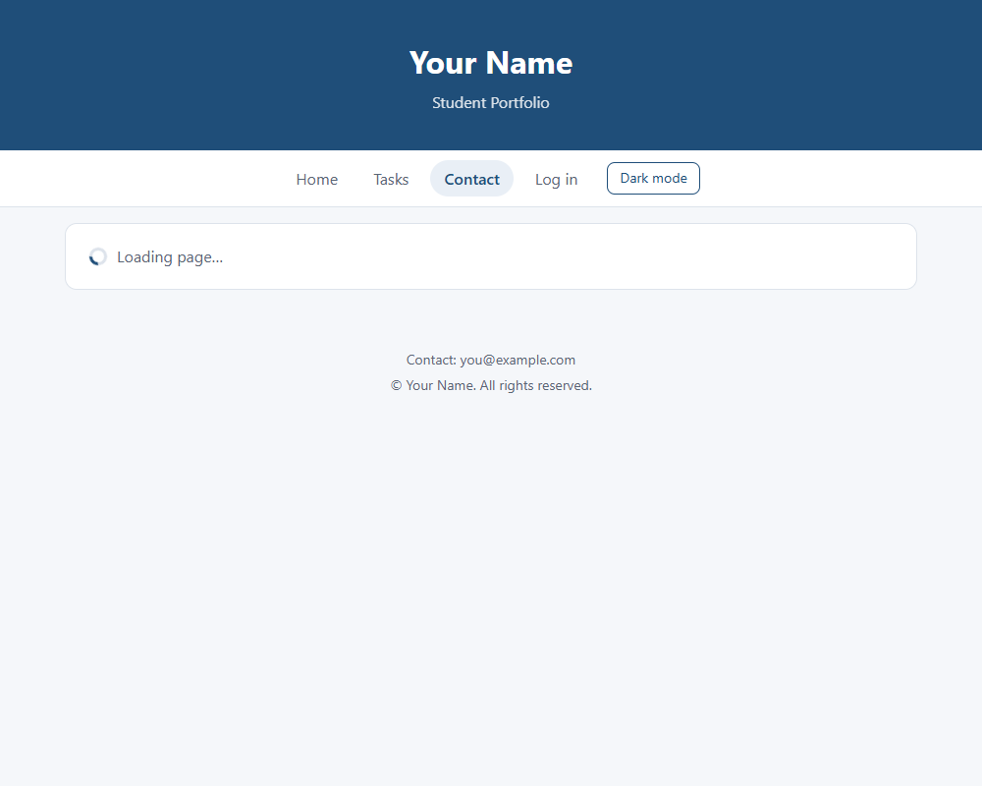
8.5 Contact page after its chunk has loaded
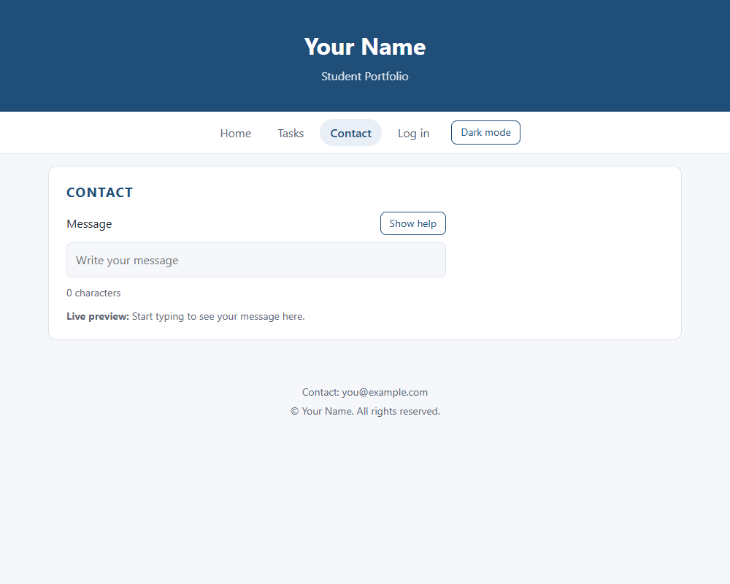
8.6 Network log: chunk loaded on demand
Home ("/") loaded. JS files so far: index-9-vH7YcP.js
700 ms after clicking Contact: fallback visible = yes ("Loading page…")
Contact page rendered. New JS downloaded on demand: Contact-DMLGmLct.js

8.7 Lazy-loaded chart on the Tasks page (supplementary)
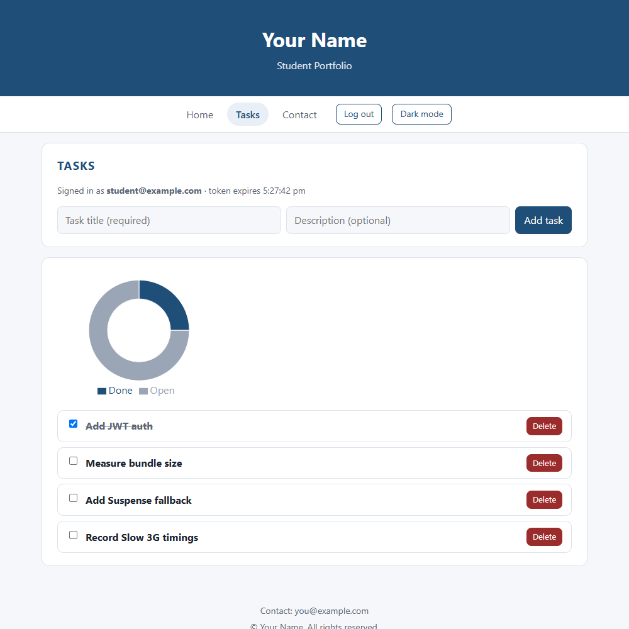
8.8 Network log: recharts chunk requested only on /tasks
Login page: JS loaded so far: index-9-vH7YcP.js, taskApi-C-0EzTPS.js, Login-D9OR6CXv.js
Tasks page with chart: JS loaded in total: index-9-vH7YcP.js, taskApi-C-0EzTPS.js, Login-D9OR6CXv.js, TaskBoard-Dsiz80Yv.js, TaskStats-ClwrFtGK.js
TaskStats (recharts) chunk was requested only after opening /tasks: yes

