Practical Submission
Student ID: | 24CS013 | Student Name:
Subject code & Name: | ITUE301 – Advanced Web Development Frameworks | Practical: | 6 – Full Stack Integration React + Node + MongoDB
Academic Year: | 2025-26
Task - 1
Aim
To wire the React frontend to the Node/Express/MongoDB backend into a fully functional full-stack application.
Enable CORS on Express, call the CRUD endpoints from React through one api.js module, update the UI from each server response, handle loading and error states for every request, and add the supplementary optimistic create, delete confirmation dialog and toast notifications.
Code (Paste your GitHub Repository Link – Practical Wise)
GitHub Link Repository Link: https://github.com/<your-username>/AWDF-24CS013/tree/main/practical-6
Output
6.1 Tasks page connected to the API (empty database)
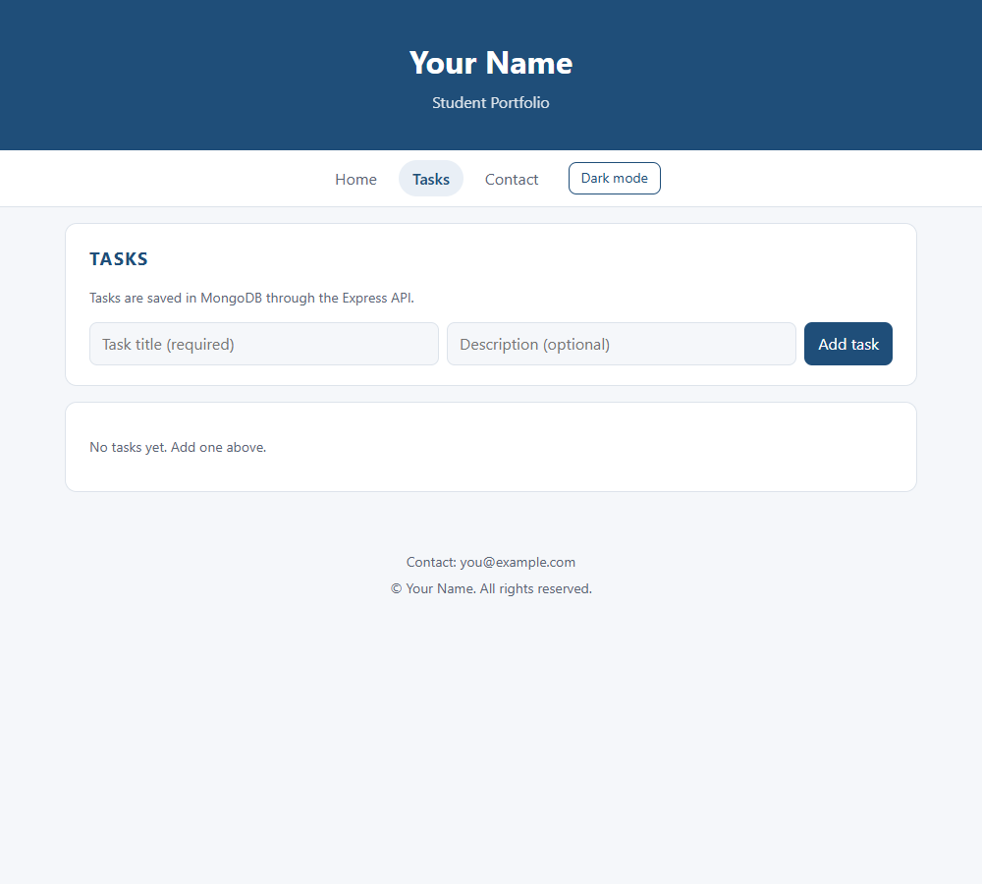
6.2 Optimistic create (POST held for 1.5 s)
The new task appears immediately with "Saving…" and is replaced by the server's copy when the 201 arrives.
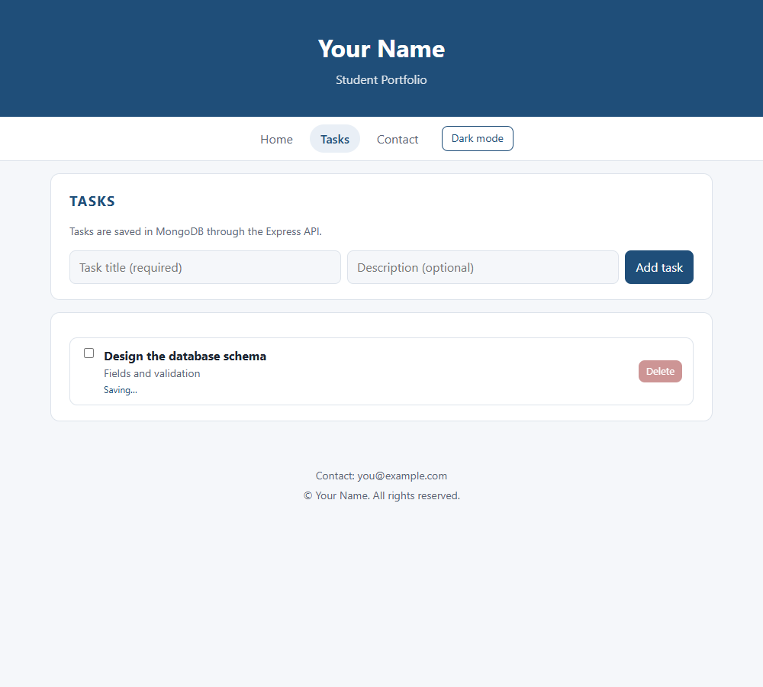
6.3 Tasks created, with toast notifications
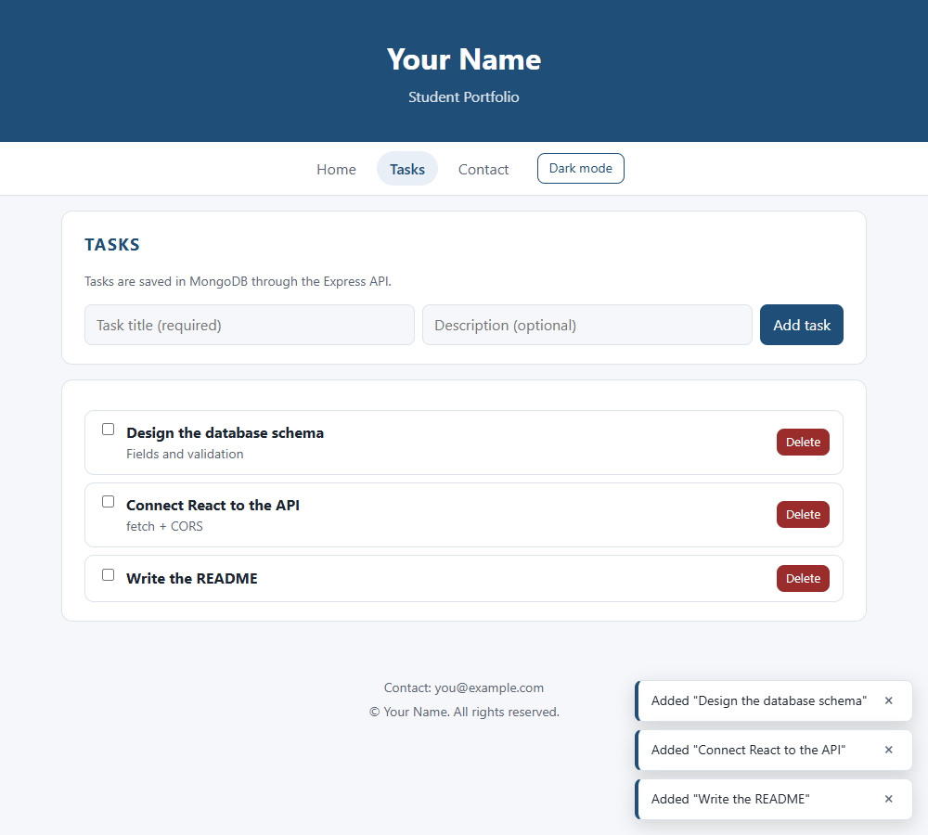
6.4 Update: task marked as done (PUT)
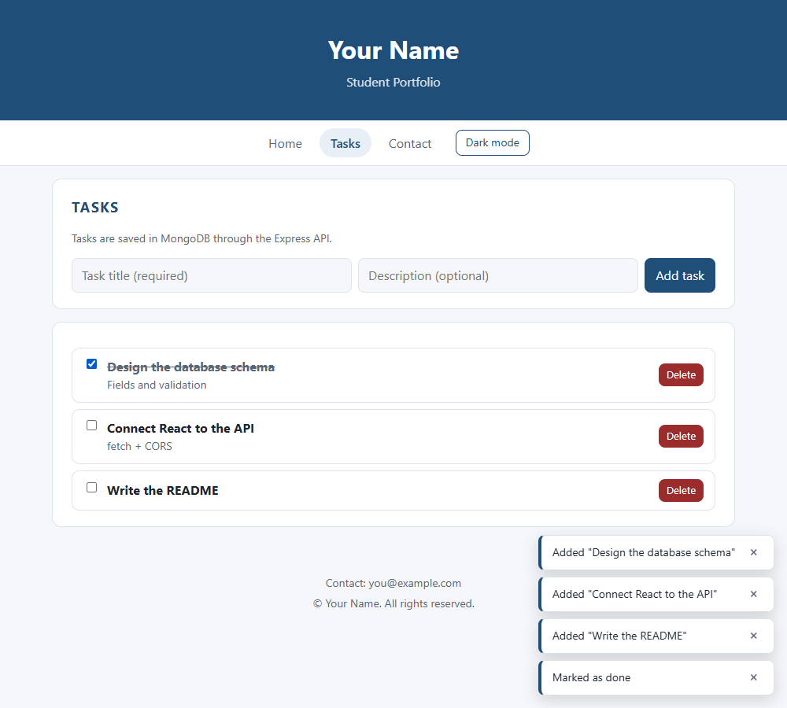
6.5 Delete with confirmation dialog
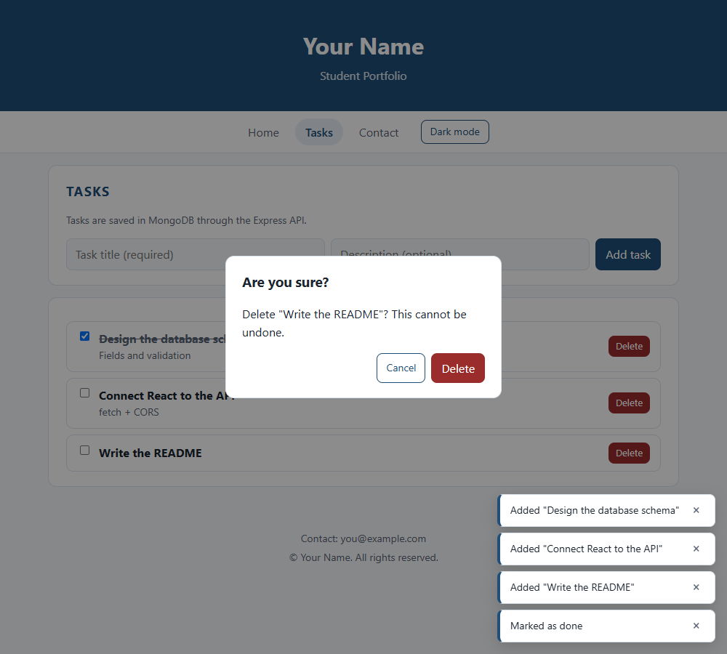
6.6 After refreshing the browser: data persisted in MongoDB
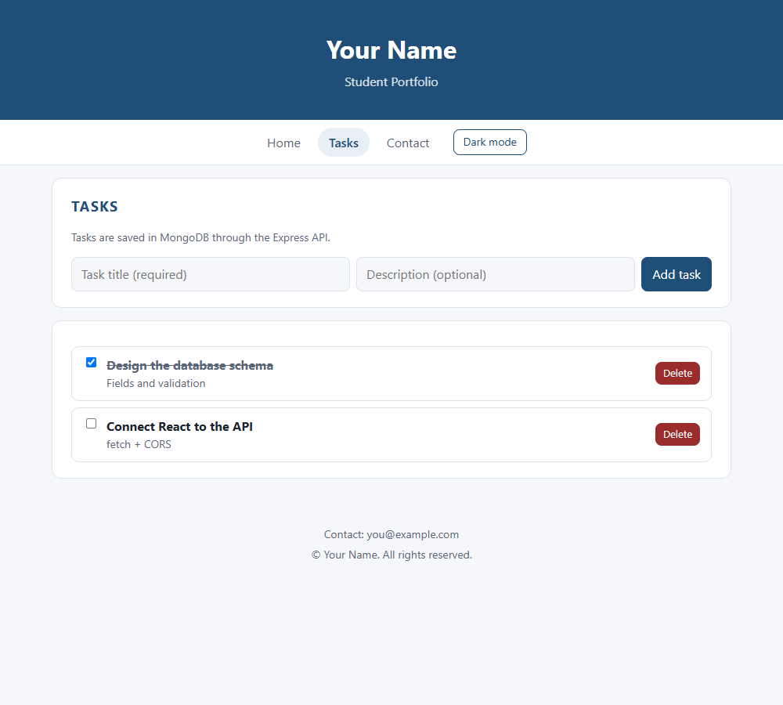
6.7 Backend stopped: error state with Retry
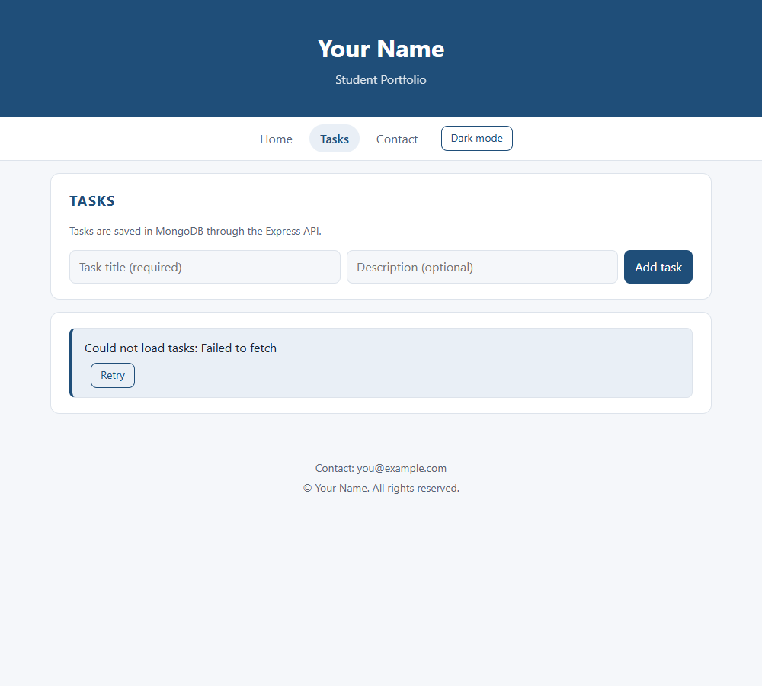
6.8 End-to-end run log (UI steps and API calls)
1. Open /tasks (GET from MongoDB through Express)
GET /tasks -> 200
2. Create a task while the POST is held for 1.5 s (optimistic UI)
Task shown before the server replied: ["Design the database schema"] (marked "Saving…")
POST /tasks -> 201
3. Create two more tasks
POST /tasks -> 201
POST /tasks -> 201
4. Mark the first task as done (PUT)
PUT /tasks/6ad89990b4f760ad9e374371 -> 200
5. Delete "Write the README" with the confirmation dialog (DELETE)
Dialog text: Delete "Write the README"? This cannot be undone.
DELETE /tasks/6ad89990b4f760ad9e374373 -> 200
6. Reload the browser: data comes back from MongoDB
GET /tasks -> 200
After reload: ["Design the database schema","Connect React to the API"]; done: ["Design the database schema"]
7. Stop the Express server and reload (error state)
Error shown: Could not load tasks: Failed to fetch
8. Start the server again and press Retry
GET /tasks -> 304
After Retry: ["Design the database schema","Connect React to the API"]

