Practical Submission
Student ID: | 24CS013 | Student Name:
Subject code & Name: | ITUE301 – Advanced Web Development Frameworks | Practical: | 1 – Introduction to React and Component Architecture
Academic Year: | 2025-26
Task - 1
Aim
To set up a React development environment using Vite and build a static UI using independently structured, reusable components.
Create a student portfolio page with at least four reusable components (Header, About, Skills, Footer), pass data with props, and add the NavBar, dynamic skills list and theme-colour supplementary problems.
Code (Paste your GitHub Repository Link – Practical Wise)
GitHub Link Repository Link: https://github.com/<your-username>/AWDF-24CS013/tree/main/practical-1/app
Output
1.1 Portfolio page (Header, NavBar, About, Skills, Projects, Footer)
Running Vite app: the header colour comes from the themeColor prop and the skills are rendered from the skillList array.
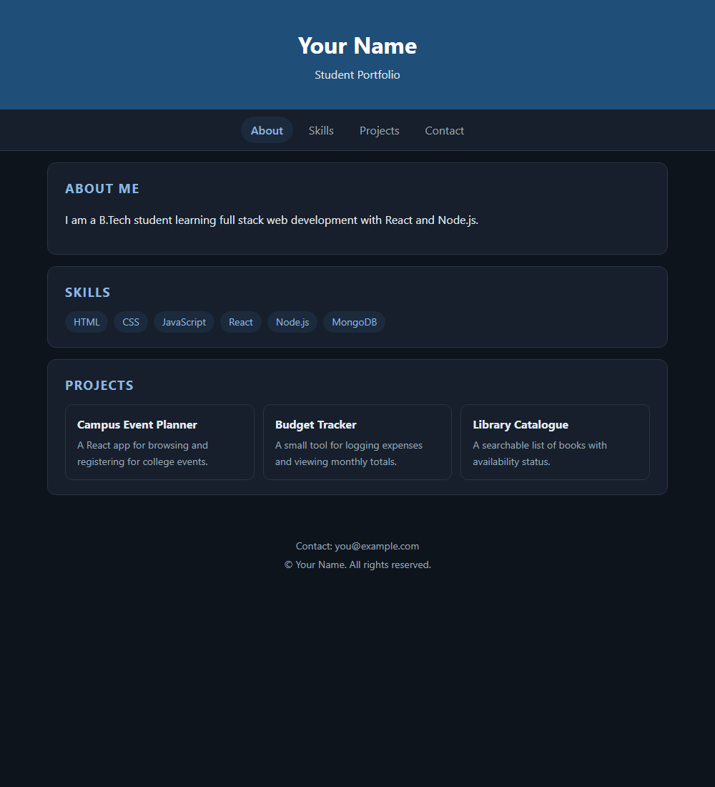
1.2 Production build
Command: npm run build
dist/index.html 0.46 kB │ gzip: 0.30 kB
dist/assets/index-Cg0VupjI.css 1.84 kB │ gzip: 0.80 kB
dist/assets/index-CWPRyiSk.js 222.09 kB │ gzip: 69.51 kB
✓ built in 109ms

