**Practical-4** Date :03-09-23

1.Echo: Output any text that we provide.

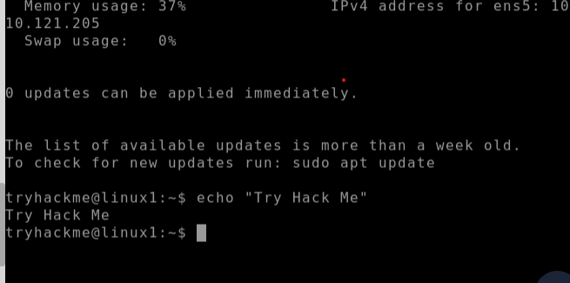

2.whoami : Find out what user we're currently logged in as!:

3.Listing Files in Our Current Directory **(ls command** ):

**NOTE:ls -l command is used to know all the permission of a file.**

4.Add new directories using **mkdir** command:

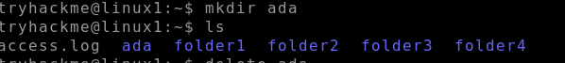

5.Removing directories using **rmdir** command:

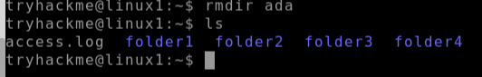

6.Read the contents of file using **CAT** command:

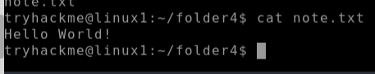

Practical 4 continued date:11-09-23

Creation of file using CAT:

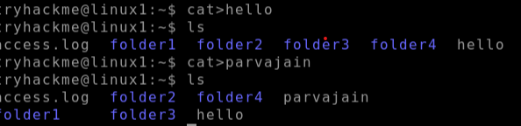

7. **Touch** command :we can create a file which we cannot edit (view only files), multiple file creation we use touch command

8.Know all related commands using **man (function/command name):**

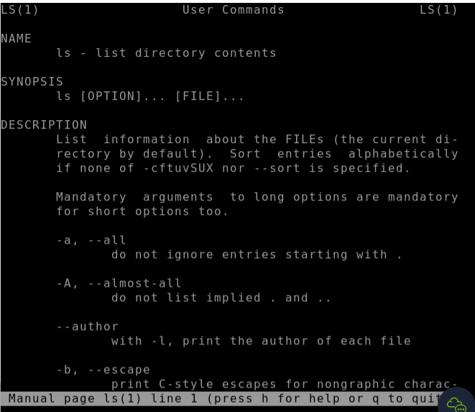

9.**rm** command: To delete created file.

Syntax: rm (filename)

10. **chmod** command: change mode of file .

U=user G=group O= others

