**Practical-4** Date :03-09-23

1.Echo: Output any text that we provide.

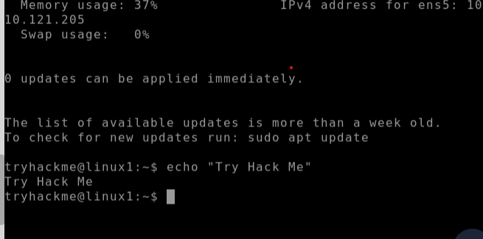

2.whoami : Find out what user we're currently logged in as!:

3.Listing Files in Our Current Directory **(ls command** ):

**NOTE:ls -l command is used to know all the permission of a file.**

4.Add new directories using **mkdir** command:

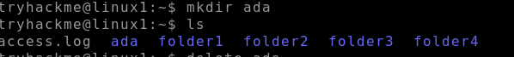

5.Removing directories using **rmdir** command:

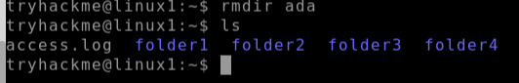

6.Finding out the full Path to our Current Working Directory (pwd)

7.Read the contents of file using **CAT** command:

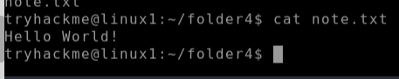

Practical 4 (continued) Date:11-09-23 **FILE OPERATIONS**

Creation of file using CAT:

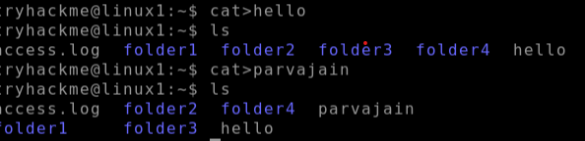

8. **Touch** command :we can create a file which we cannot edit (view only files), multiple file creation we use touch command

9.Know all related commands using **man (function/command name):**

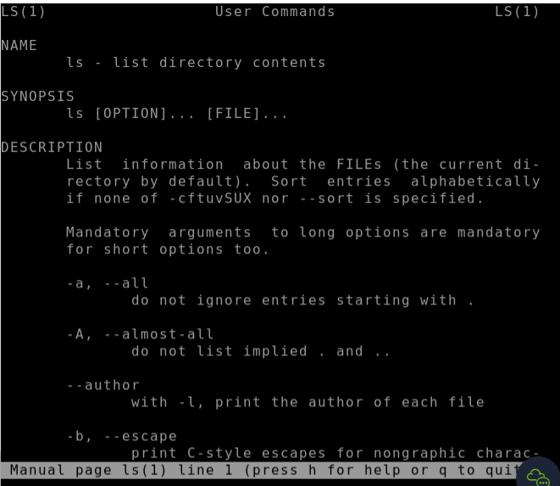

10.**rm** command: To delete created file.

Syntax: rm (filename)

11. **chmod** command: change mode of file .

U=user G=group O= others

1.“+”= add permissions(invoke) 2.“-“ = remove permissions (revoke)

3. “=”= assign permissions with values(assign)

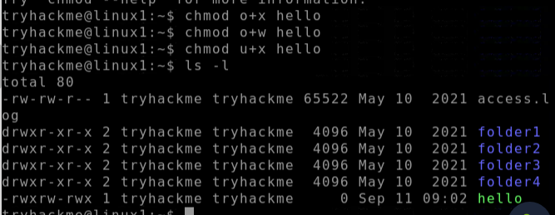

Ugo+rwx :all

Octal Representation of permissions:

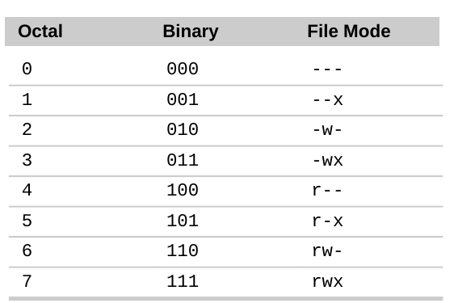

12. **WHATIS** command:

Syntax: **whatis (command name)**

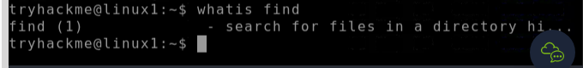

13.**Find** Command:



Date:9/10/23

Shell scripting:

1.Create a file using cat command

Cat> filename.sh

2.#!/bin/bash Echo “hello”

Chmod u+x fimlename.sh

./filename.sh

