**NSFW CONTENT DETECTION**

NSFW images and videos contain graphic nudity and this site helps users to detect such contains when they upload any image or video on it.

We have used concept of convolution neural network to predict percentage of nudity in the images.

Two different models are used for prediction which are Sequential model and UNET model.

Sequential Model:

It consists of three different layers. First is convolution layer which projects features on image matrix. Second is Activation layer introduces nonlinearity to a system that basically has just been computing linear operations during the conv layers. Third is Pooling layer which is also referred to as a downsampling layer. In this category, there are also several layer options, with maxpooling being the most popular. This basically takes a filter (normally of size 2x2) and a stride of the same length. It then applies it to the input volume and outputs the maximum number in every subregion that the filter convolves around. We use different combinations of this three layers to make our model.

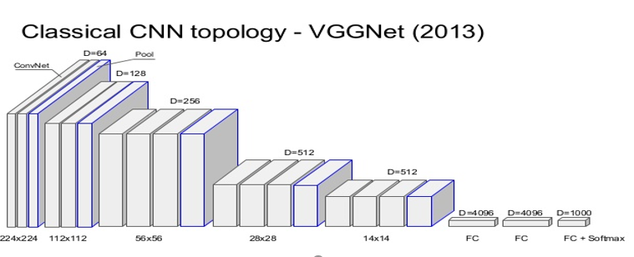

U-Net Model:

It is a network and training strategy that relies on the strong use of data augmentation to use the available annotated samples more efficiently. The architecture consists of a contracting path to capture context and a symmetric expanding path that enables precise localization. This network can be trained end-to-end from very few images and outperforms the prior best method. It has been most precise than other modules.

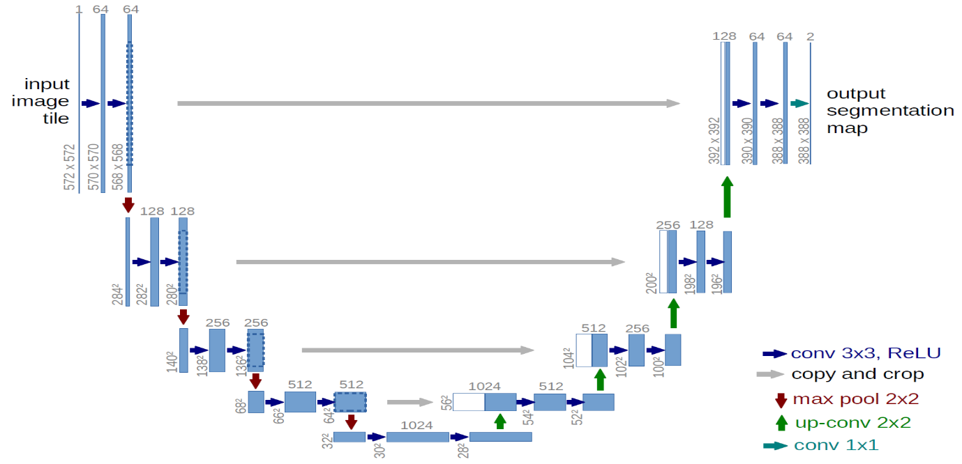

Model Performance:

Sequential Model: Accuracy- 91.96%

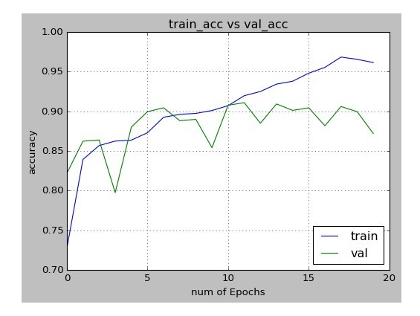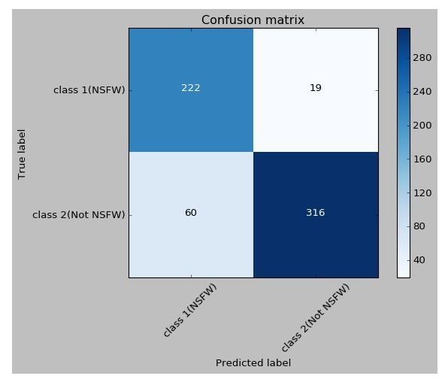

U-Net Model: Accuracy- 87.6%

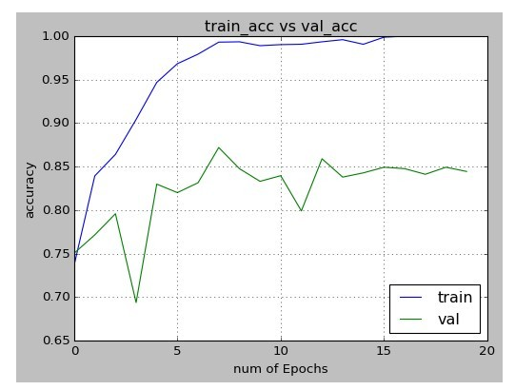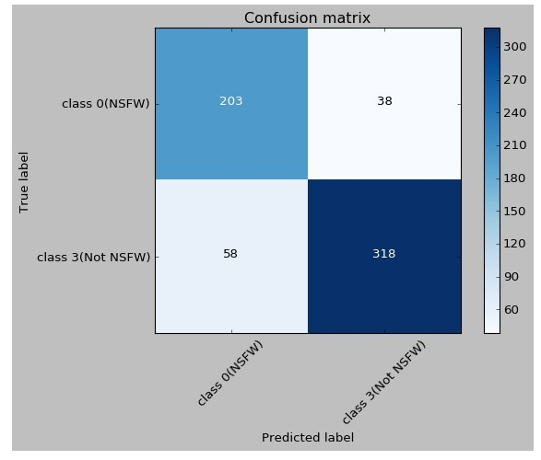

File Description:

1. Index.html – It’s the main html file which is our homepage.
2. Index1.html – It’s for image file
3. Viv.html – It’s for video file
4. Save_file.py – It preprocess the selected image and feeds it to our model. Output is prediction.
5. Viv.py – It preprocess the selected video and feeds it to our model. Output is prediction.
6. All hdf5 files are our trained models.

Website Screenshots:

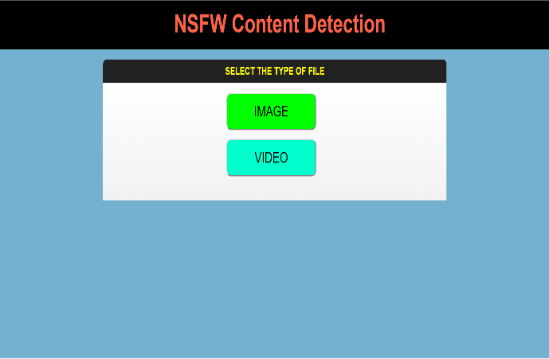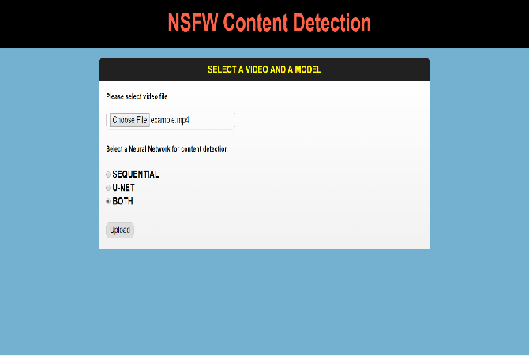

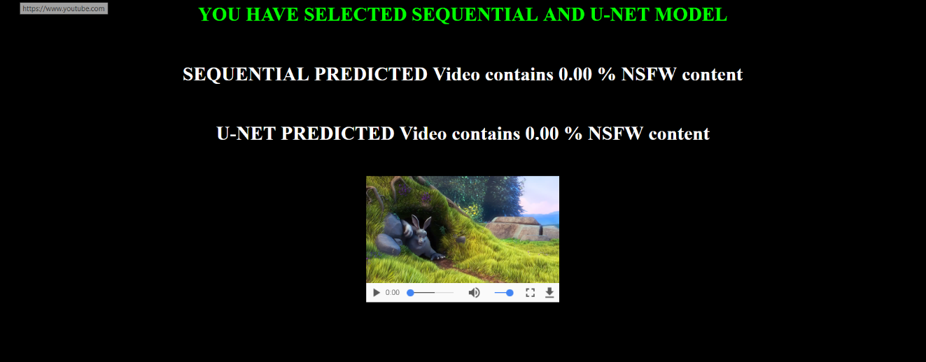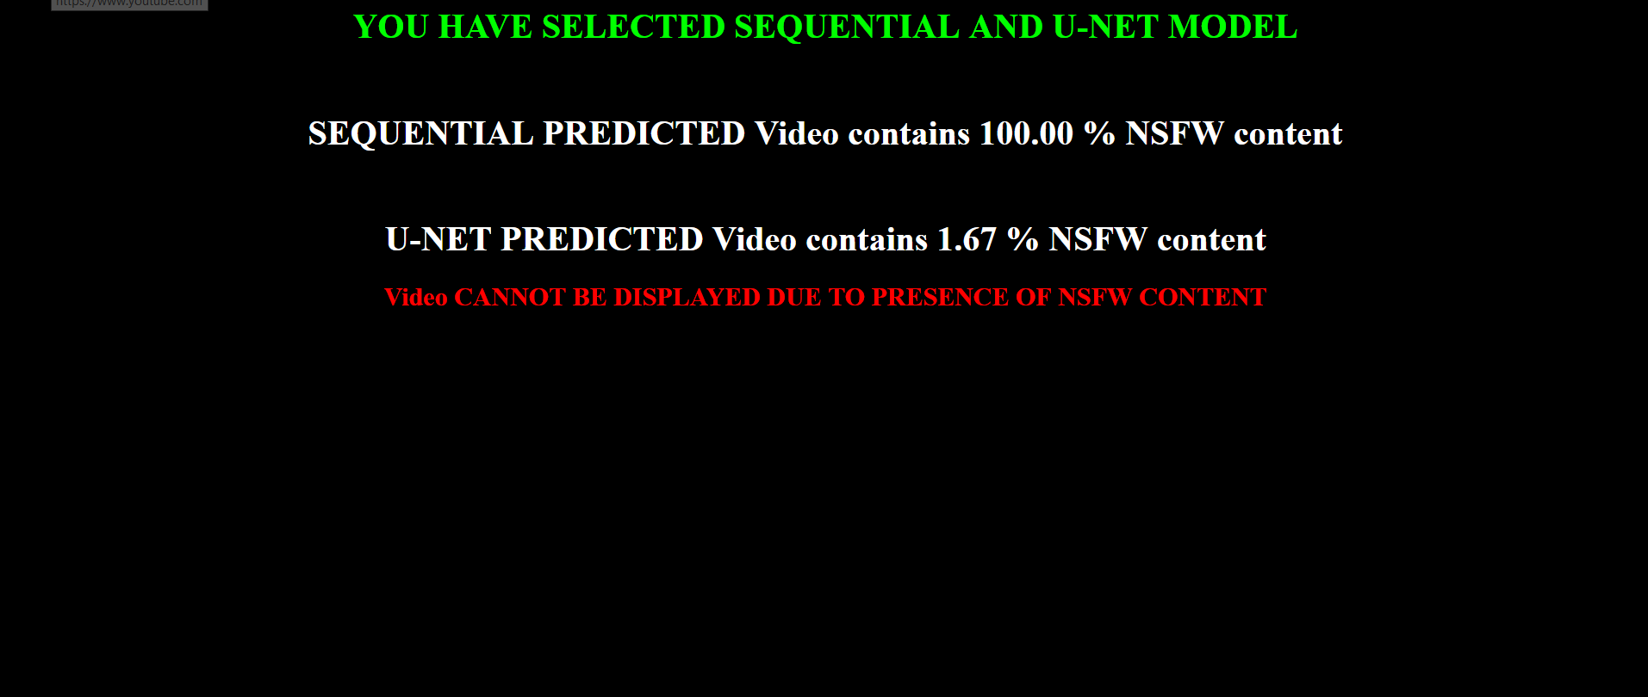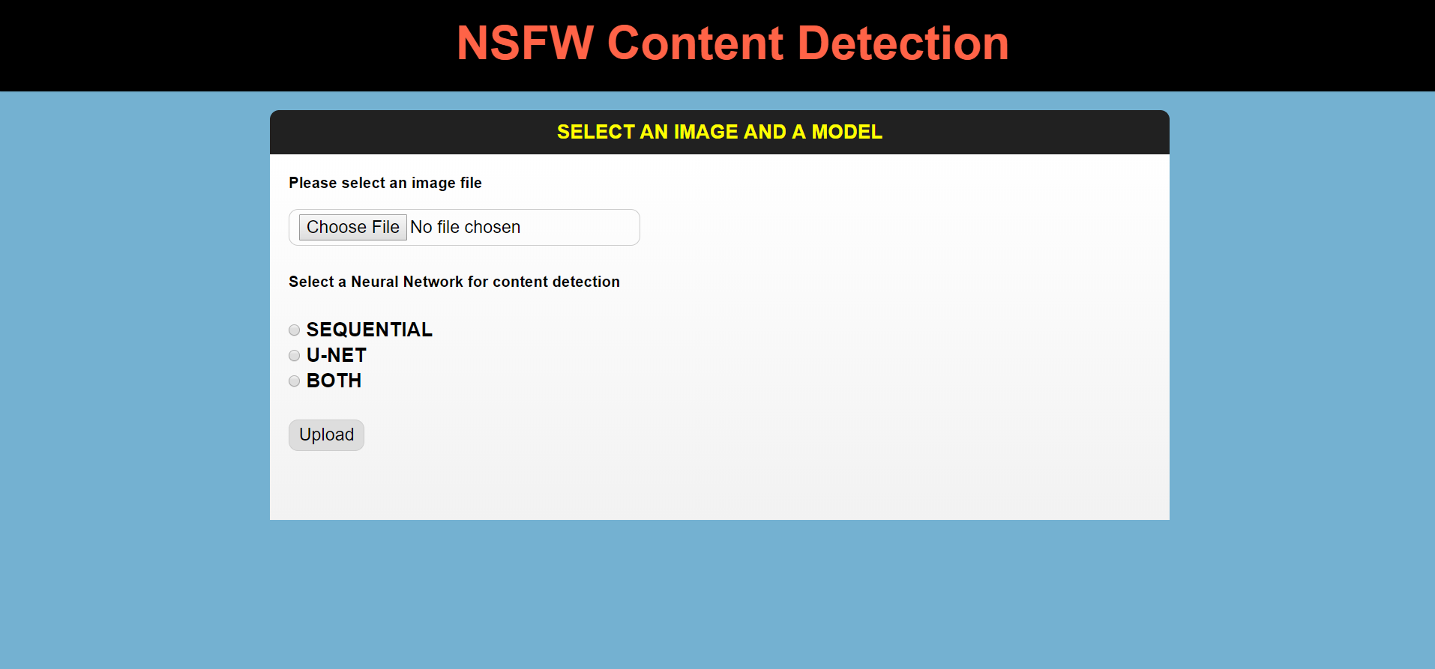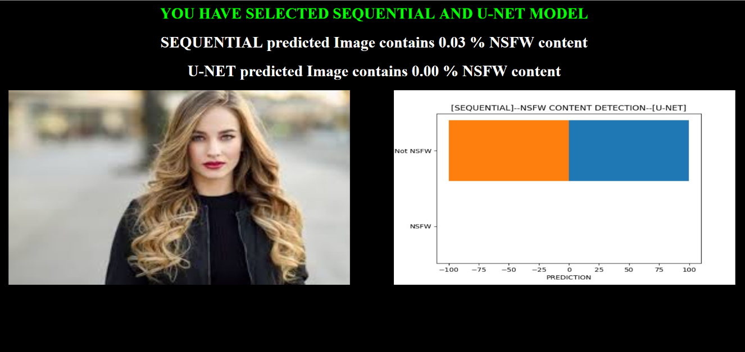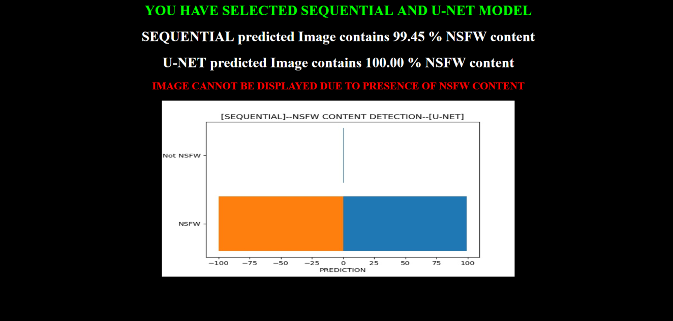

How code works:

Put the files in xampp folder and start your local host.

Adjust directory paths in python files to have proper outputs.