SVKM’s NMIMS
MPSTME, Mumbai Campus
Computer Engineering Department
Program: B Tech, Semester-IV

Design and Analysis of Algorithms
LAB Manual

PART A
(PART A: TO BE REFERRED BY STUDENTS)
Experiment No. 1
A.1 Aim:
Introduction to Lab, Experiment explanation, Programming tools required, Implementation and analysis of basic operations covering decision making, looping, array implementation, Sorting (Insertion Sort).

A.2 Prerequisite: Knowledge of basic programming constructs in C / C++.

A.3 Outcome:
After successful completion of this experiment, students will be able to translate algorithmic concepts into code for basic programming constructs like decision making, looping, arrays implementation etc.

A.4 Theory:
- Introduction: Algorithm:
- An algorithm is a set of rules that must be followed when solving a specific problem or accomplish a particular task. It is a well-defined computational procedure which will take some value or set of values as input and generate output.
- Algorithms serve as the blueprint for computational processes and form the basis for software development.
- It has finite sequence of computational steps.
- An algorithm is said to be correct if for an input it gives the desired output and terminates.

- Study of Algorithm: Study of an Algorithm involves:
- Design of Algorithms – Algorithmic design can be done by following algorithmic paradigms/ techniques. These are general approaches to the construction of efficient solutions to problems. Such methods are of interest because they provide templates suited to solving a broad range of diverse problems. Some of the design paradigms are Divide and Conquer, Greedy technique, Dynamic programming, Backtracking, Branch and Bound etc.
- Algorithm Validation - It checks the algorithm results for all legal set of inputs. In fact,
- Algorithm is not converted to a program till this phase. It can also be called as program proving. It requires that each statement should be precisely defined and all basic operations be correctly proved.
- Analysis of Algorithm - A situation may occur when many algorithms are there to solve a problem. It focuses on space and time complexity of the algorithm.
- Space complexity – The amount of memory needed by the program to run to completion.
- Time complexity - The amount of time needed by the program to run to completion. It depends on the size of input “n”
- It should be noted that different time can arise for the same algorithm. Usually we deal with the best, average and worst case of time required for an algorithm
- Algorithm Testing - It involves Debugging and Performance Measurement. Debugging is the process of finding and correcting the cause of variance with the desired and observed behavior. Performance measurement or profiling describes the correct program execution for all possible datasets and it takes time and space to compute the result.

**********************
PART B
(PART B : TO BE COMPLETED BY STUDENTS)
(Students must submit the soft copy as per following segments within two hours of the practical. The soft copy must be uploaded on the MS Teams)

SAP ID/Roll No. C172 | Student Name : parva gaglani
Program : BTI | Semester : 8
Batch : D2
Date of Experiment : 2/1/2026 | Date of Submission : 2/1/2026

B.1 Answers of Task to be written by student:
(Paste your answers completed during the 2 hours of practical in the lab here)
Instruction for Students:
1. Clearly understand the problem you are trying to solve.
2. Write the algorithm to depict a systematic procedure to solve the task in hand. Each step should be clearly defined and unambiguous.
3. Implement the algorithm in C/C++ programming language.
4. Handle edge cases and exceptional scenarios in your implementation.
5. Add appropriate comments to explain complex section of your code and to clarify the purpose of the step.
6. Show the output.
7. Analyze the codes for its time and space requirement.
8. Conclude the learning done through the tasks that are implemented.

Tasks to be implemented:
- Write a program in C to store elements in an array and print it.
Test Data :
Input 10 elements in the array :
element - 0 : 1
element - 1 : 1
element - 2 : 2
.......
Expected Output :
Elements in array are: 1 1 2 3 4 5 6 7 8 9
- Write a program in C to read n number of values in an array and display it in reverse order.
Test Data :
Input the number of elements to store in the array :3
Input 3 number of elements in the array :
element - 0 : 2
element - 1 : 5
element - 2 : 7
Expected Output :
The values store into the array are :
2 5 7
The values store into the array in reverse are :
7 5 2
- Write a program in C to find the sum of all elements of the array.
Test Data :
Input the number of elements to be stored in the array :3
Input 3 elements in the array :
element - 0 : 2
element - 1 : 5
element - 2 : 8
Expected Output :
Sum of all elements stored in the array is : 15
- Task 1: Illustrate the operation of INSERTION-SORT on the array A = [32, 45, 29, 66, 41, 58, your roll no]
Task2: Implementation of Insertion Sort
Task 3: Comment on the performance of Insertion Sort, after filling up the following table
Array Size(n) | Data | No. of Comparisons | No. of Swaps
4
8
16

Task 4: Find out number of times each step will be executed if array is almost sorted. Demonstrate with an example.

B.2 Observations and learning:
(Students are expected to comment on the output obtained with clear observations and learning for each task/ sub part assigned)
1.
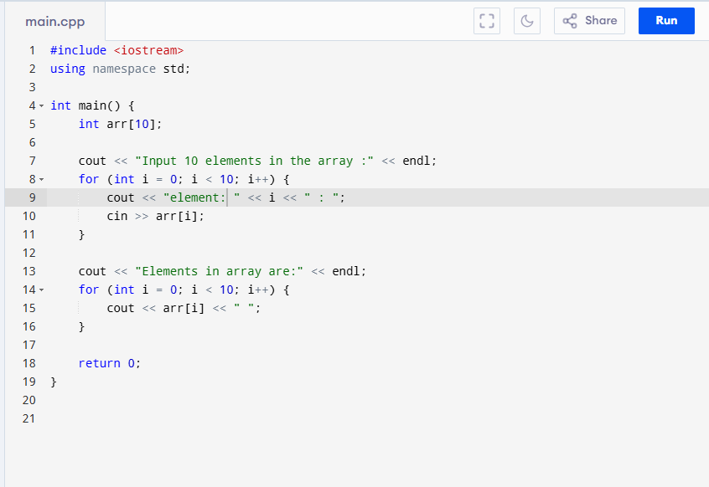
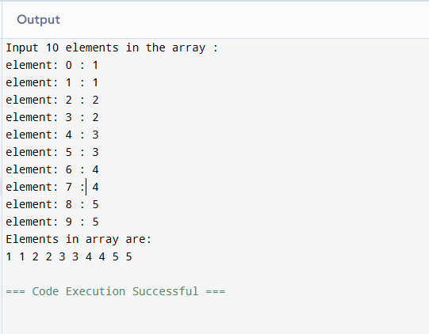
2.
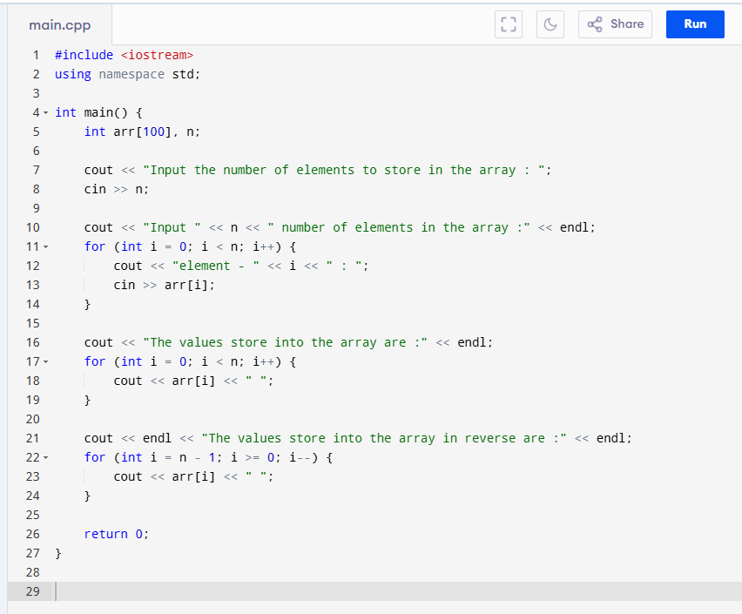
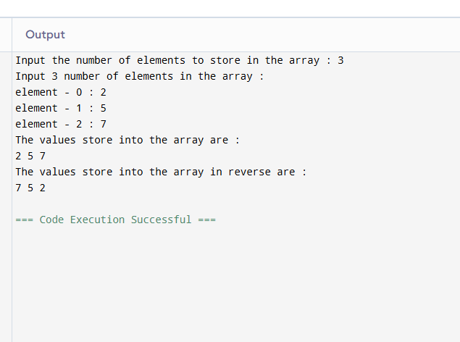
3.
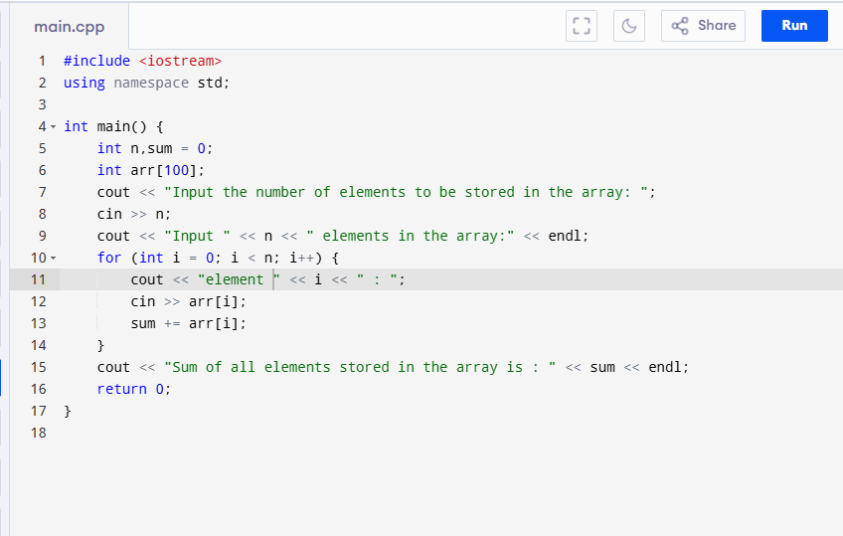
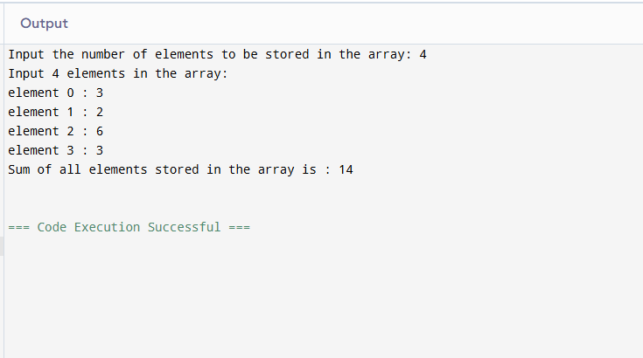
4.
task 1:
Initial Array : 32 45 29 66 41 58 165
Pass 1 : 32 45 29 66 41 58 165
Pass 2 : 29 32 45 66 41 58 165
Pass 3: 29 32 45 66 41 58 165
Pass 4 : 29 32 41 45 66 58 165
Pass 5 : 29 32 41 45 58 66 165
Pass 6 : 29 32 41 45 58 66 165
Final Array: 29 32 41 45 58 66 165
Task 2:
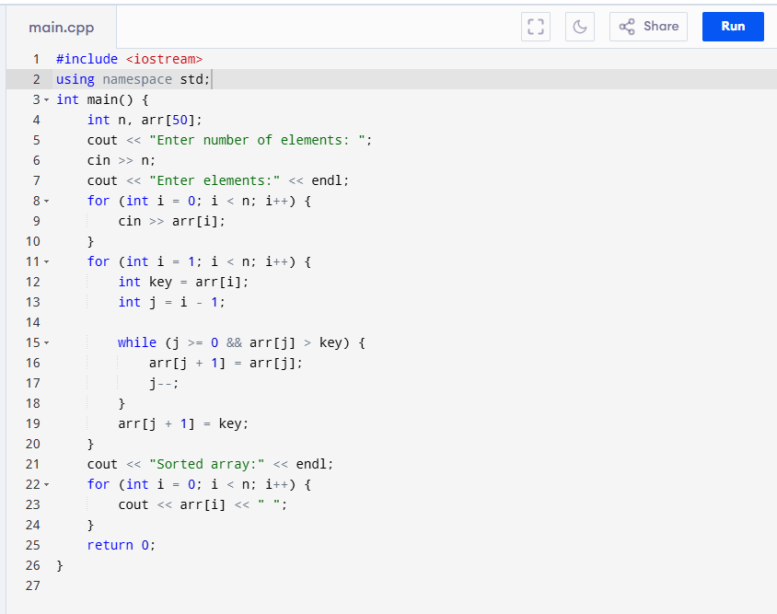
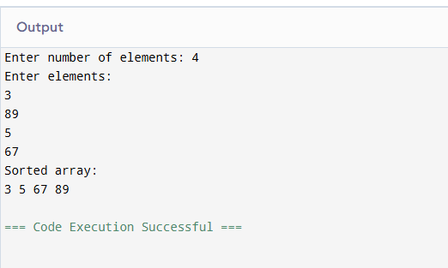

Task 3:
Array Size(n) | Data Type | No. of Comparisons | No. of Swaps
4 | Integer | 6 | 5
8 | Integer | 28 | 20
16 | Integer | 120 | 80

Comments
Best Case: O(n) (already sorted)
Average Case: O(n²)
Worst Case: O(n²) (reverse order)
Efficient for small and nearly sorted arrays
Task 4:
Array: 1 2 3 5 4
Only element 4 is out of order
Requires one comparison and one shift

Conclusion
Insertion Sort is highly efficient when the array is almost sorted because fewer comparisons and swaps are required.

B.3 Conclusion:
(Students must write the conclusion as per the attainment of individual outcome listed above and learning/observation noted in section B.3)
After successful completion of this experiment, I am able to translate algorithmic concepts into code for basic programming constructs like decision making, looping, arrays implementation etc.

B.4 Question of Curiosity

1. What are algorithms? What are the characteristics of a good algorithm?
An algorithm is a finite set of well-defined steps used to solve a problem.
Characteristics:
- Finiteness
- Definiteness
- Input
- Output
- Effectiveness
- Efficiency

2. Importance of algorithmic problem solving in real-world applications
Algorithmic problem solving helps in:
- Efficient use of time and resources
- Automation of tasks
- Handling large data
- Improving accuracy and performance
- Solving real-world problems in areas like healthcare, finance, and technology

3. Why is optimality important in algorithmic design?
Optimality ensures that an algorithm:
- Uses minimum time and memory
- Works efficiently for large inputs
- Reduces computational cost
- Improves system performance

