SVKM’s NMIMS
MPSTME/School of Technology Management & Engineering,
Computer Engineering Department
Program: MBA Tech/BTECH. Sem IV

Design and Analysis of Algorithms
LAB Manual
PART A
(PART A: TO BE REFERRED BY STUDENTS)
Experiment No.09
A.1 Aim:
Analyse and Implement the solution for n queen problem (n*n) using Backtracking Algorithm.
The n-queens puzzle is the problem of placing n queens on an n x n chessboard such that no two queens attack each other.
Given an integer n, return all distinct solutions to the n-queens puzzle. You may return the answer in any order.
Each solution contains a distinct board configuration of the n-queens' placement, where 'Q' and '.' both indicate a queen and an empty space, respectively.
A.2 Prerequisite:
1. Knowledge of Array Handling and
2. Concept of Backtracking.
3. Knowledge of recursive programming.
A.3 Outcome:
After successful completion of this experiment students will be able to,

- Analyse Backtracking approach.
- Understand and Implement n queen problem using backtracking

A.4 Theory:

Backtracking
In this topic, we will learn about the backtracking, which is a very important skill set to solve recursive solutions. Recursive functions are those that calls itself more than once. Consider an example of Palindrome:
Initially, the function isPalindrome(S, 0, 8) is called once with the parameters isPalindrome(S, 1, 7). The recursive call isPalindrome(S, 1, 7) is called once with the parameters isPalindrome(S, 2, 6).
Backtracking is one of the techniques that can be used to solve the problem. We can write the algorithm using this strategy. It uses the Brute force search to solve the problem, and the brute force search says that for the given problem, we try to make all the possible solutions and pick out the best solution from all the desired solutions. This rule is also followed in dynamic programming, but dynamic programming is used for solving optimization problems. In contrast, backtracking is not used in solving optimization problems. Backtracking is used when we have multiple solutions, and we require all those solutions.
Backtracking name itself suggests that we are going back and coming forward; if it satisfies the condition, then return success, else we go back again. It is used to solve a problem in which a sequence of objects is chosen from a specified set so that the sequence satisfies some criteria.

When to use a Backtracking algorithm?
When we have multiple choices, then we make the decisions from the available choices. In the following cases, we need to use the backtracking algorithm:
- A piece of sufficient information is not available to make the best choice, so we use the backtracking strategy to try out all the possible solutions.
- Each decision leads to a new set of choices. Then again, we backtrack to make new decisions. In this case, we need to use the backtracking strategy.

N-Queens Problem
- N - Queens problem is to place n - queens in such a manner on an n x n chessboard that no queens attack each other by being in the same row, column or diagonal.
- It can be seen that for n =1, the problem has a trivial solution, and no solution exists for n =2 and n =3. So first we will consider the 4 queens problem and then generate it to n - queens problem.
- Given a 4 x 4 chessboard and number the rows and column of the chessboard 1 through 4.
- 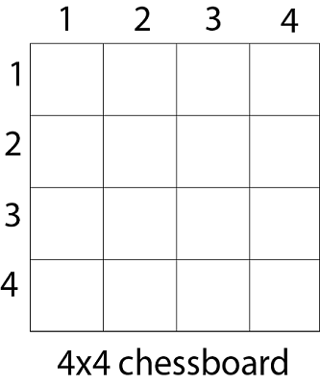

Since, we have to place 4 queens such as q₁ q₂ q₃ and q₄ on the chessboard, such that no two queens attack each other. In such a conditional each queen must be placed on a different row, i.e., we put queen "i" on row "i."
Now, we place queen q₁ in the very first acceptable position (1, 1). Next, we put queen q₂ so that both these queens do not attack each other. We find that if we place q₂ in column 1 and 2, then the dead end is encountered. Thus the first acceptable position for q₂ in column 3, i.e. (2, 3) but then no position is left for placing queen 'q₃' safely. So we backtrack one step and place the queen 'q₂' in (2, 4), the next best possible solution. Then we obtain the position for placing 'q₃' which is (3, 2). But later this position also leads to a dead end, and no place is found where 'q₄' can be placed safely. Then we have to backtrack till 'q₁' and place it to (1, 2) and then all other queens are placed safely by moving q₂ to (2, 4), q₃ to (3, 1) and q₄ to (4, 3). That is, we get the solution (2, 4, 1, 3). This is one possible solution for the 4-queens problem. For another possible solution, the whole method is repeated for all partial solutions. The other solutions for 4 - queens problems is (3, 1, 4, 2) i.e.
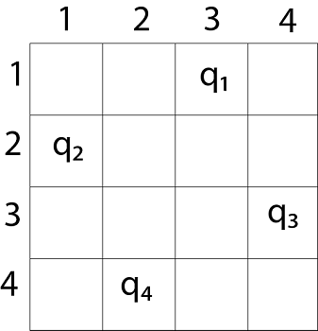
The implicit tree for 4 - queen problem for a solution (2, 4, 1, 3) is as follows:
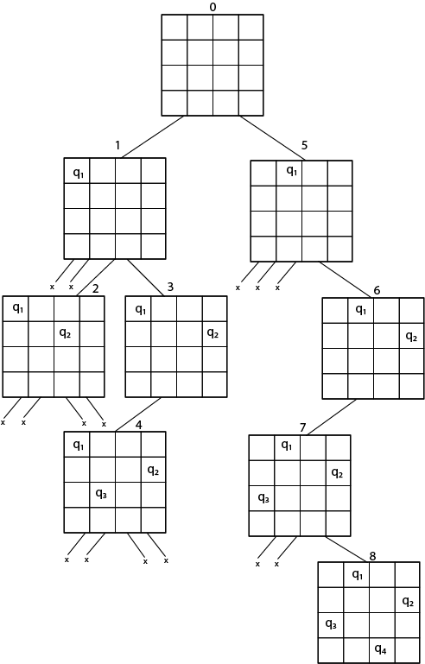
Fig shows the complete state space for 4 - queens problem. But we can use backtracking method to generate the necessary node and stop if the next node violates the rule, i.e., if two queens are attacking.
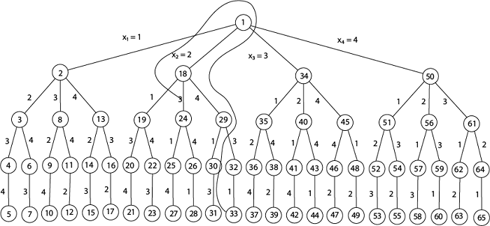
4 - Queens solution space with nodes numbered in DFS
It can be seen that all the solutions to the 4 queens problem can be represented as 4 - tuples (x₁, x₂, x₃, x₄) where x_{i} represents the column on which queen "q_{i}" is placed.
One possible solution for 8 queens problem is shown in fig:
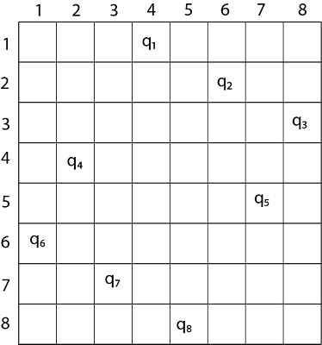
- Thus, the solution for 8 -queen problem for (4, 6, 8, 2, 7, 1, 3, 5).
- If two queens are placed at position (i, j) and (k, l).
- Then they are on same diagonal only if (i - j) = k - l or i + j = k + l.
- The first equation implies that j - l = i - k.
- The second equation implies that j - l = k - i.
- Therefore, two queens lie on the duplicate diagonal if and only if |j-l|=|i-k|
Place (k, i) returns a Boolean value that is true if the kth queen can be placed in column i. It tests both whether i is distinct from all previous costs x₁, x₂,....x_{k-1} and whether there is no other queen on the same diagonal.
Using place, we give a precise solution to then n- queens problem.
- Place (k, i)
- {
- For j ← 1 to k - 1
- do if (x [j] = i)
- or (Abs x [j]) - i) = (Abs (j - k))
- then return false;
- return true;
- }
Place (k, i) return true if a queen can be placed in the kth row and ith column otherwise return is false.
x [] is a global array whose final k - 1 values have been set. Abs (r) returns the absolute value of r.
- N - Queens (k, n)
- {
- For i ← 1 to n
- do if Place (k, i) then
- {
- x [k] ← i;
- if (k ==n) then
- write (x [1....n));
- else
- N - Queens (k + 1, n);
- }
- }

PART B
(PART B : TO BE COMPLETED BY STUDENTS)
(Students must submit the soft copy as per following segments within two hours of the practical.
The soft copy must be uploaded on the Portal.)

Program: BTI | Sem:VIII
Roll No. C172 | Name: Parva Gaglani
Division: D | Batch : D2
Date of Experiment: | Date of Submission:
Grade :

B.1 Software Code written by student:
#include <iostream>
using namespace std;

#define MAX 20

char board[MAX][MAX]; //r,c
bool col[MAX]; //iterate through r so only need to store c
bool diagP[2*MAX]; //2*max - 1 positive n diagonals (starting from each R of C1 and then each C of Rn)
bool diagN[2*MAX]; //2*max - 1 negative n diagonals (starting from each C of R1 and then each R of Cn)
int n;

void printBoard()
{
for(int i = 0; i < n; i++)
{
for(int j = 0; j < n; j++)
cout << board[i][j] << " ";
cout << "\n";
}
cout << "\n";
}
//iterate through matrix of board

void backtrack(int r)
{
if(r == n)
{
printBoard();
return;
}
//all boxes covered hence print board matrix

for(int c = 0; c < n; c++)
{
if(col[c] || diagP[r + c] || diagN[r - c + n - 1])
continue;
//r identifies a single row
//c identifies a single column
//r+c identifies a single positive diagonal(l2r b2t)
//r-c identifies a single negative diagonal (l2r t2b)
//so if true, then exit because cannot place Q in current r,c box

col[c] = true;
diagP[r + c] = true;
diagN[r - c + n - 1] = true;
board[r][c] = 'Q';
//placing queen occupies r,c,and both diagonals so make them true

backtrack(r + 1);
//now attempt to place in next row of board. ie all rows in a config

//backtrack
col[c] = false;
diagP[r + c] = false;
diagN[r - c + n - 1] = false;
board[r][c] = '.';
//clear current initial placement
// start with a diff initial placement in same start row
}
}

int solveNqueen(int size)
{
n = size;

//initialise
for(int i = 0; i < n; i++)
for(int j = 0; j < n; j++)
board[i][j] = '.';

for(int i = 0; i < n; i++)
col[i] = false;

for(int i = 0; i < 2*n; i++)
{
diagP[i] = false;
diagN[i] = false;
}

//call to solve
backtrack(0);
return 0;
}

int main()
{
int n;
cout << "Enter value of N: ";
cin >> n;
solveNqueen(n);
return 0;
}

B.2 Input and Output:
(Paste your commented program input and output in following format, If there is error then paste
the specific error in the output part. In case of error with due permission of the faculty extension
can be given to submit the error free code with output in due course of time.)

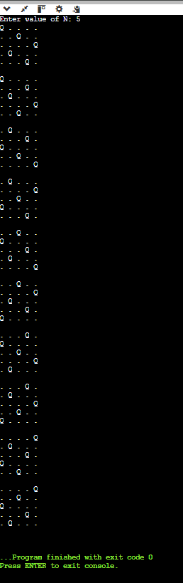

B.3 Observations and learning:
(Students are expected to comment on the output obtained with clear observations and learning for each task/ sub part assigned)
B.4. Practice Questions:
Q.1. Given 4 x 4 chessboard, arrange four queens in a way, such that no two queens attack each other. That is, no two queens are placed in the same row, column, or diagonal.
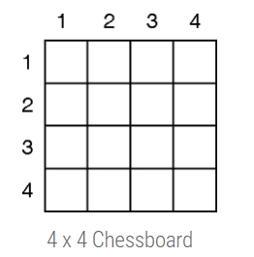
1)
. Q . .
. . . Q
Q . . .
. . Q .

2)
. . Q .
Q . . .
. . . Q
. Q . .

Q.2. Given an 8 x 8 chessboard, arrange 8 queens in a way such that no two queens attack each other.
Two queens are attacking each other if they are in the same row, column, or diagonal. Cells attacked by queen Q are shown in fig. (e).

Q . . . . . . .
. . . . Q . . .
. . . . . . . Q
. . . . . Q . .
. . Q . . . . .
. . . . . . Q .
. Q . . . . . .
. . . Q . . . .

Q . . . . . . .
. . . . . Q . .
. . . . . . . Q
. . Q . . . . .
. . . . . . Q .
. . . Q . . . .
. Q . . . . . .
. . . . Q . . .

Q . . . . . . .
. . . . . . Q .
. . . Q . . . .
. . . . . Q . .
. . . . . . . Q
. Q . . . . . .
. . . . Q . . .
. . Q . . . . .

Q . . . . . . .
. . . . . . Q .
. . . . Q . . .
. . . . . . . Q
. Q . . . . . .
. . . Q . . . .
. . . . . Q . .
. . Q . . . . .

. Q . . . . . .
. . . Q . . . .
. . . . . Q . .
. . . . . . . Q
. . Q . . . . .
Q . . . . . . .
. . . . . . Q .
. . . . Q . . .

. Q . . . . . .
. . . . Q . . .
. . . . . . Q .
Q . . . . . . .
. . Q . . . . .
. . . . . . . Q
. . . . . Q . .
. . . Q . . . .

. Q . . . . . .
. . . . Q . . .
. . . . . . Q .
. . . Q . . . .
Q . . . . . . .
. . . . . . . Q
. . . . . Q . .
. . Q . . . . .

. Q . . . . . .
. . . . . Q . .
Q . . . . . . .
. . . . . . Q .
. . . Q . . . .
. . . . . . . Q
. . Q . . . . .
. . . . Q . . .

. Q . . . . . .
. . . . . Q . .
. . . . . . . Q
. . Q . . . . .
Q . . . . . . .
. . . Q . . . .
. . . . . . Q .
. . . . Q . . .

. Q . . . . . .
. . . . . . Q .
. . Q . . . . .
. . . . . Q . .
. . . . . . . Q
. . . . Q . . .
Q . . . . . . .
. . . Q . . . .

. Q . . . . . .
. . . . . . Q .
. . . . Q . . .
. . . . . . . Q
Q . . . . . . .
. . . Q . . . .
. . . . . Q . .
. . Q . . . . .

. Q . . . . . .
. . . . . . . Q
. . . . . Q . .
Q . . . . . . .
. . Q . . . . .
. . . . Q . . .
. . . . . . Q .
. . . Q . . . .

. . Q . . . . .
Q . . . . . . .
. . . . . . Q .
. . . . Q . . .
. . . . . . . Q
. Q . . . . . .
. . . Q . . . .
. . . . . Q . .

. . Q . . . . .
. . . . Q . . .
. Q . . . . . .
. . . . . . . Q
Q . . . . . . .
. . . . . . Q .
. . . Q . . . .
. . . . . Q . .

. . Q . . . . .
. . . . Q . . .
. Q . . . . . .
. . . . . . . Q
. . . . . Q . .
. . . Q . . . .
. . . . . . Q .
Q . . . . . . .

. . Q . . . . .
. . . . Q . . .
. . . . . . Q .
Q . . . . . . .
. . . Q . . . .
. Q . . . . . .
. . . . . . . Q
. . . . . Q . .

. . Q . . . . .
. . . . Q . . .
. . . . . . . Q
. . . Q . . . .
Q . . . . . . .
. . . . . . Q .
. Q . . . . . .
. . . . . Q . .

. . Q . . . . .
. . . . . Q . .
. Q . . . . . .
. . . . Q . . .
. . . . . . . Q
Q . . . . . . .
. . . . . . Q .
. . . Q . . . .

. . Q . . . . .
. . . . . Q . .
. Q . . . . . .
. . . . . . Q .
Q . . . . . . .
. . . Q . . . .
. . . . . . . Q
. . . . Q . . .

. . Q . . . . .
. . . . . Q . .
. Q . . . . . .
. . . . . . Q .
. . . . Q . . .
Q . . . . . . .
. . . . . . . Q
. . . Q . . . .

. . Q . . . . .
. . . . . Q . .
. . . Q . . . .
Q . . . . . . .
. . . . . . . Q
. . . . Q . . .
. . . . . . Q .
. Q . . . . . .

. . Q . . . . .
. . . . . Q . .
. . . Q . . . .
. Q . . . . . .
. . . . . . . Q
. . . . Q . . .
. . . . . . Q .
Q . . . . . . .

. . Q . . . . .
. . . . . Q . .
. . . . . . . Q
Q . . . . . . .
. . . Q . . . .
. . . . . . Q .
. . . . Q . . .
. Q . . . . . .

. . Q . . . . .
. . . . . Q . .
. . . . . . . Q
Q . . . . . . .
. . . . Q . . .
. . . . . . Q .
. Q . . . . . .
. . . Q . . . .

. . Q . . . . .
. . . . . Q . .
. . . . . . . Q
. Q . . . . . .
. . . Q . . . .
Q . . . . . . .
. . . . . . Q .
. . . . Q . . .

. . Q . . . . .
. . . . . . Q .
. Q . . . . . .
. . . . . . . Q
. . . . Q . . .
Q . . . . . . .
. . . Q . . . .
. . . . . Q . .

. . Q . . . . .
. . . . . . Q .
. Q . . . . . .
. . . . . . . Q
. . . . . Q . .
. . . Q . . . .
Q . . . . . . .
. . . . Q . . .

. . Q . . . . .
. . . . . . . Q
. . . Q . . . .
. . . . . . Q .
Q . . . . . . .
. . . . . Q . .
. Q . . . . . .
. . . . Q . . .

. . . Q . . . .
Q . . . . . . .
. . . . Q . . .
. . . . . . . Q
. Q . . . . . .
. . . . . . Q .
. . Q . . . . .
. . . . . Q . .

. . . Q . . . .
Q . . . . . . .
. . . . Q . . .
. . . . . . . Q
. . . . . Q . .
. . Q . . . . .
. . . . . . Q .
. Q . . . . . .

. . . Q . . . .
. Q . . . . . .
. . . . Q . . .
. . . . . . . Q
. . . . . Q . .
Q . . . . . . .
. . Q . . . . .
. . . . . . Q .

. . . Q . . . .
. Q . . . . . .
. . . . . . Q .
. . Q . . . . .
. . . . . Q . .
. . . . . . . Q
Q . . . . . . .
. . . . Q . . .

. . . Q . . . .
. Q . . . . . .
. . . . . . Q .
. . Q . . . . .
. . . . . Q . .
. . . . . . . Q
. . . . Q . . .
Q . . . . . . .

. . . Q . . . .
. Q . . . . . .
. . . . . . Q .
. . . . Q . . .
Q . . . . . . .
. . . . . . . Q
. . . . . Q . .
. . Q . . . . .

. . . Q . . . .
. Q . . . . . .
. . . . . . . Q
. . . . Q . . .
. . . . . . Q .
Q . . . . . . .
. . Q . . . . .
. . . . . Q . .

. . . Q . . . .
. Q . . . . . .
. . . . . . . Q
. . . . . Q . .
Q . . . . . . .
. . Q . . . . .
. . . . Q . . .
. . . . . . Q .

. . . Q . . . .
. . . . . Q . .
Q . . . . . . .
. . . . Q . . .
. Q . . . . . .
. . . . . . . Q
. . Q . . . . .
. . . . . . Q .

. . . Q . . . .
. . . . . Q . .
. . . . . . . Q
. Q . . . . . .
. . . . . . Q .
Q . . . . . . .
. . Q . . . . .
. . . . Q . . .

. . . Q . . . .
. . . . . Q . .
. . . . . . . Q
. . Q . . . . .
Q . . . . . . .
. . . . . . Q .
. . . . Q . . .
. Q . . . . . .

. . . Q . . . .
. . . . . . Q .
Q . . . . . . .
. . . . . . . Q
. . . . Q . . .
. Q . . . . . .
. . . . . Q . .
. . Q . . . . .

. . . Q . . . .
. . . . . . Q .
. . Q . . . . .
. . . . . . . Q
. Q . . . . . .
. . . . Q . . .
Q . . . . . . .
. . . . . Q . .

. . . Q . . . .
. . . . . . Q .
. . . . Q . . .
. Q . . . . . .
. . . . . Q . .
Q . . . . . . .
. . Q . . . . .
. . . . . . . Q

. . . Q . . . .
. . . . . . Q .
. . . . Q . . .
. . Q . . . . .
Q . . . . . . .
. . . . . Q . .
. . . . . . . Q
. Q . . . . . .

. . . Q . . . .
. . . . . . . Q
Q . . . . . . .
. . Q . . . . .
. . . . . Q . .
. Q . . . . . .
. . . . . . Q .
. . . . Q . . .

. . . Q . . . .
. . . . . . . Q
Q . . . . . . .
. . . . Q . . .
. . . . . . Q .
. Q . . . . . .
. . . . . Q . .
. . Q . . . . .

. . . Q . . . .
. . . . . . . Q
. . . . Q . . .
. . Q . . . . .
Q . . . . . . .
. . . . . . Q .
. Q . . . . . .
. . . . . Q . .

. . . . Q . . .
Q . . . . . . .
. . . Q . . . .
. . . . . Q . .
. . . . . . . Q
. Q . . . . . .
. . . . . . Q .
. . Q . . . . .

. . . . Q . . .
Q . . . . . . .
. . . . . . . Q
. . . Q . . . .
. Q . . . . . .
. . . . . . Q .
. . Q . . . . .
. . . . . Q . .

. . . . Q . . .
Q . . . . . . .
. . . . . . . Q
. . . . . Q . .
. . Q . . . . .
. . . . . . Q .
. Q . . . . . .
. . . Q . . . .

. . . . Q . . .
. Q . . . . . .
. . . Q . . . .
. . . . . Q . .
. . . . . . . Q
. . Q . . . . .
Q . . . . . . .
. . . . . . Q .

. . . . Q . . .
. Q . . . . . .
. . . Q . . . .
. . . . . . Q .
. . Q . . . . .
. . . . . . . Q
. . . . . Q . .
Q . . . . . . .

. . . . Q . . .
. Q . . . . . .
. . . . . Q . .
Q . . . . . . .
. . . . . . Q .
. . . Q . . . .
. . . . . . . Q
. . Q . . . . .

. . . . Q . . .
. Q . . . . . .
. . . . . . . Q
Q . . . . . . .
. . . Q . . . .
. . . . . . Q .
. . Q . . . . .
. . . . . Q . .

. . . . Q . . .
. . Q . . . . .
Q . . . . . . .
. . . . . Q . .
. . . . . . . Q
. Q . . . . . .
. . . Q . . . .
. . . . . . Q .

. . . . Q . . .
. . Q . . . . .
Q . . . . . . .
. . . . . . Q .
. Q . . . . . .
. . . . . . . Q
. . . . . Q . .
. . . Q . . . .

. . . . Q . . .
. . Q . . . . .
. . . . . . . Q
. . . Q . . . .
. . . . . . Q .
Q . . . . . . .
. . . . . Q . .
. Q . . . . . .

. . . . Q . . .
. . . . . . Q .
Q . . . . . . .
. . Q . . . . .
. . . . . . . Q
. . . . . Q . .
. . . Q . . . .
. Q . . . . . .

. . . . Q . . .
. . . . . . Q .
Q . . . . . . .
. . . Q . . . .
. Q . . . . . .
. . . . . . . Q
. . . . . Q . .
. . Q . . . . .

. . . . Q . . .
. . . . . . Q .
. Q . . . . . .
. . . Q . . . .
. . . . . . . Q
Q . . . . . . .
. . Q . . . . .
. . . . . Q . .

. . . . Q . . .
. . . . . . Q .
. Q . . . . . .
. . . . . Q . .
. . Q . . . . .
Q . . . . . . .
. . . Q . . . .
. . . . . . . Q

. . . . Q . . .
. . . . . . Q .
. Q . . . . . .
. . . . . Q . .
. . Q . . . . .
Q . . . . . . .
. . . . . . . Q
. . . Q . . . .

. . . . Q . . .
. . . . . . Q .
. . . Q . . . .
Q . . . . . . .
. . Q . . . . .
. . . . . . . Q
. . . . . Q . .
. Q . . . . . .

. . . . Q . . .
. . . . . . . Q
. . . Q . . . .
Q . . . . . . .
. . Q . . . . .
. . . . . Q . .
. Q . . . . . .
. . . . . . Q .

. . . . Q . . .
. . . . . . . Q
. . . Q . . . .
Q . . . . . . .
. . . . . . Q .
. Q . . . . . .
. . . . . Q . .
. . Q . . . . .

. . . . . Q . .
Q . . . . . . .
. . . . Q . . .
. Q . . . . . .
. . . . . . . Q
. . Q . . . . .
. . . . . . Q .
. . . Q . . . .

. . . . . Q . .
. Q . . . . . .
. . . . . . Q .
Q . . . . . . .
. . Q . . . . .
. . . . Q . . .
. . . . . . . Q
. . . Q . . . .

. . . . . Q . .
. Q . . . . . .
. . . . . . Q .
Q . . . . . . .
. . . Q . . . .
. . . . . . . Q
. . . . Q . . .
. . Q . . . . .

. . . . . Q . .
. . Q . . . . .
Q . . . . . . .
. . . . . . Q .
. . . . Q . . .
. . . . . . . Q
. Q . . . . . .
. . . Q . . . .

. . . . . Q . .
. . Q . . . . .
Q . . . . . . .
. . . . . . . Q
. . . Q . . . .
. Q . . . . . .
. . . . . . Q .
. . . . Q . . .

. . . . . Q . .
. . Q . . . . .
Q . . . . . . .
. . . . . . . Q
. . . . Q . . .
. Q . . . . . .
. . . Q . . . .
. . . . . . Q .

. . . . . Q . .
. . Q . . . . .
. . . . Q . . .
. . . . . . Q .
Q . . . . . . .
. . . Q . . . .
. Q . . . . . .
. . . . . . . Q

. . . . . Q . .
. . Q . . . . .
. . . . Q . . .
. . . . . . . Q
Q . . . . . . .
. . . Q . . . .
. Q . . . . . .
. . . . . . Q .

. . . . . Q . .
. . Q . . . . .
. . . . . . Q .
. Q . . . . . .
. . . Q . . . .
. . . . . . . Q
Q . . . . . . .
. . . . Q . . .

. . . . . Q . .
. . Q . . . . .
. . . . . . Q .
. Q . . . . . .
. . . . . . . Q
. . . . Q . . .
Q . . . . . . .
. . . Q . . . .

. . . . . Q . .
. . Q . . . . .
. . . . . . Q .
. . . Q . . . .
Q . . . . . . .
. . . . . . . Q
. Q . . . . . .
. . . . Q . . .

. . . . . Q . .
. . . Q . . . .
Q . . . . . . .
. . . . Q . . .
. . . . . . . Q
. Q . . . . . .
. . . . . . Q .
. . Q . . . . .

. . . . . Q . .
. . . Q . . . .
. Q . . . . . .
. . . . . . . Q
. . . . Q . . .
. . . . . . Q .
Q . . . . . . .
. . Q . . . . .

. . . . . Q . .
. . . Q . . . .
. . . . . . Q .
Q . . . . . . .
. . Q . . . . .
. . . . Q . . .
. Q . . . . . .
. . . . . . . Q

. . . . . Q . .
. . . Q . . . .
. . . . . . Q .
Q . . . . . . .
. . . . . . . Q
. Q . . . . . .
. . . . Q . . .
. . Q . . . . .

. . . . . Q . .
. . . . . . . Q
. Q . . . . . .
. . . Q . . . .
Q . . . . . . .
. . . . . . Q .
. . . . Q . . .
. . Q . . . . .

. . . . . . Q .
Q . . . . . . .
. . Q . . . . .
. . . . . . . Q
. . . . . Q . .
. . . Q . . . .
. Q . . . . . .
. . . . Q . . .

. . . . . . Q .
. Q . . . . . .
. . . Q . . . .
Q . . . . . . .
. . . . . . . Q
. . . . Q . . .
. . Q . . . . .
. . . . . Q . .

. . . . . . Q .
. Q . . . . . .
. . . . . Q . .
. . Q . . . . .
Q . . . . . . .
. . . Q . . . .
. . . . . . . Q
. . . . Q . . .

. . . . . . Q .
. . Q . . . . .
Q . . . . . . .
. . . . . Q . .
. . . . . . . Q
. . . . Q . . .
. Q . . . . . .
. . . Q . . . .

. . . . . . Q .
. . Q . . . . .
. . . . . . . Q
. Q . . . . . .
. . . . Q . . .
Q . . . . . . .
. . . . . Q . .
. . . Q . . . .

. . . . . . Q .
. . . Q . . . .
. Q . . . . . .
. . . . Q . . .
. . . . . . . Q
Q . . . . . . .
. . Q . . . . .
. . . . . Q . .

. . . . . . Q .
. . . Q . . . .
. Q . . . . . .
. . . . . . . Q
. . . . . Q . .
Q . . . . . . .
. . Q . . . . .
. . . . Q . . .

. . . . . . Q .
. . . . Q . . .
. . Q . . . . .
Q . . . . . . .
. . . . . Q . .
. . . . . . . Q
. Q . . . . . .
. . . Q . . . .

. . . . . . . Q
. Q . . . . . .
. . . Q . . . .
Q . . . . . . .
. . . . . . Q .
. . . . Q . . .
. . Q . . . . .
. . . . . Q . .

. . . . . . . Q
. Q . . . . . .
. . . . Q . . .
. . Q . . . . .
Q . . . . . . .
. . . . . . Q .
. . . Q . . . .
. . . . . Q . .

. . . . . . . Q
. . Q . . . . .
Q . . . . . . .
. . . . . Q . .
. Q . . . . . .
. . . . Q . . .
. . . . . . Q .
. . . Q . . . .

. . . . . . . Q
. . . Q . . . .
Q . . . . . . .
. . Q . . . . .
. . . . . Q . .
. Q . . . . . .
. . . . . . Q .
. . . . Q . . .

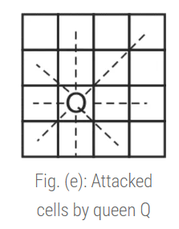
B.5 Conclusion:
***********************

