SVKM’s NMIMS
MPSTME/School of Technology Management & Engineering,
Computer Engineering Department
Program: MBA Tech/BTECH. Sem IV

Design and Analysis of Algorithms
LAB Manual
PART A
(PART A: TO BE REFERRED BY STUDENTS)
Experiment No.08
A.1 Aim:
Given a source vertex s from set of vertices V in a weighted graph where its edge weights w(u, v) can be negative, find the shortest-path weights d(s, v) from given source s for all vertices v present in the graph. If the graph contains negative-weight cycle, report it.

A.2 Prerequisite:
1. Knowledge of Array Handling and
2. Concept of Dynamic Approach.
3. Knowledge of recursive programming.
A.3 Outcome:
After successful completion of this experiment students will be able to,

- Analyse Bellman – Ford Algorithm.
- Understand and Implement Single Source Shortest Path Bellman-Ford Algorithm using Dynamic Programming.

A.4 Theory:
Introduction to Bellman - Ford Algorithm:

This algorithm solves the single source shortest path problem of a directed graph G = (V, E) in which the edge weights may be negative. Moreover, this algorithm can be applied to find the shortest path, if there does not exist any negative weighted cycle.

The idea is to use Bellman–Ford algorithm to compute the shortest paths from a single source vertex to all of the other vertices in given weighted digraph. Bellman–Ford algorithm is slower than Dijkstra’s Algorithm but it is capable of handling negative weights edges in the graph unlike Dijkstra’s.

Note that if a graph contains a “negative cycle” (i.e. a cycle whose edges sum to a negative value) that is reachable from the source, then there is no shortest path. Any path that has a point on the negative cycle can be made cheaper by one more walk around the negative cycle. Bellman–Ford algorithm can easily detect any negative cycles in the graph.

The algorithm initializes the distance to the source to 0 and all other nodes to infinity. Then for all edges, if the distance to the destination can be shortened by taking the edge, the distance is updated to the new lower value. At each iteration i that the edges are scanned, the algorithm finds all shortest paths of at most length i edges.

Since the longest possible path without a cycle can be V-1 edges, the edges must be scanned V-1 times to ensure the shortest path has been found for all nodes. A final scan of all the edges is performed and if any distance is updated, then a path of length |V| edges has been found which can only occur if at least one negative cycle exists in the graph.

Algorithm:
function BellmanFord(list vertices, list edges, vertex source distance[], parent[])

// Step 1 – initialize graph. At the beginning, all vertices have a weight of infinity and a null parent, except for the Source, where the weight is 0

for each vertex v in vertices
distance[v] = INFINITY
parent[v] = NULL

distance[source] = 0

// Step 2 – relax edges repeatedly

for i = 1 to V-1 // V – No. of vertices
for each edge (u, v) with weight w
if (distance[u] + w) is less than distance[v]
distance[v] = distance[u] + w
parent[v] = u

// Step 3 – check for negative-weight cycles

for each edge (u, v) with weight w
if (distance[u] + w) is less than distance[v]
return “Graph contains a negative-weight cycle”
return distance[], parent[]
PART B
(PART B : TO BE COMPLETED BY STUDENTS)
(Students must submit the soft copy as per following segments within two hours of the practical.
The soft copy must be uploaded on the Portal.)

Program: BTI | Sem: VIII
Roll No. C172 | Name:Parva Gaglani
Division:D | Batch :2
Date of Experiment: | Date of Submission:
Grade :

B.1 Software Code written by student:
#include <iostream>
using namespace std;
struct Edge
{
int u;
int v;
int w;
};
int main()
{
int V, E;
cout << "Enter number of vertices: ";
cin >> V;
cout << "Enter number of edges: ";
cin >> E;
Edge edge[E];
int dist[V];
cout << "Enter edges (source destination weight):" << endl;
for(int i = 0; i < E; i++)
{
cin >> edge[i].u >> edge[i].v >> edge[i].w;
}
int source;
cout << "Enter source vertex: ";
cin >> source;
for(int i = 0; i < V; i++)
{
dist[i] = 9999;
}
dist[source] = 0;
for(int i = 1; i <= V - 1; i++)
{
for(int j = 0; j < E; j++)
{
if(dist[edge[j].u] != 9999 &&
dist[edge[j].u] + edge[j].w < dist[edge[j].v])
{
dist[edge[j].v] = dist[edge[j].u] + edge[j].w;
}
}
}
for(int j = 0; j < E; j++)
{
if(dist[edge[j].u] != 9999 &&
dist[edge[j].u] + edge[j].w < dist[edge[j].v])
{
cout << "Graph contains negative weight cycle";
return 0;
}
}
cout << "\nShortest distances from source:\n";
for(int i = 0; i < V; i++)
{
cout << "Vertex " << i << " -> Distance = " << dist[i] << endl;
}
return 0;
}

B.2 Input and Output:
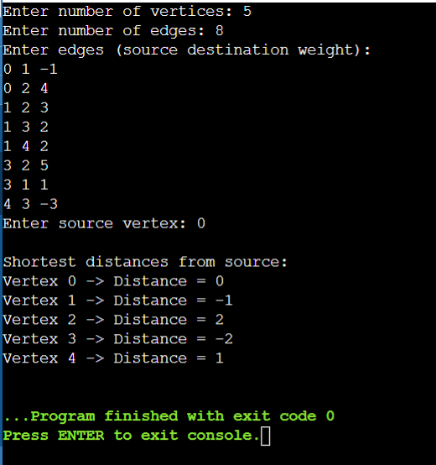

B.3 Observations and learning:
Bellman-Ford algorithm is used to find the shortest path from a single source to all other vertices. It works even when the graph contains negative edge weights.The algorithm repeatedly relaxes edges V-1 times to ensure shortest paths are found.
B.4.Practice Questions:
- Implement and analyze the time and space complexity of theBellman – Ford Algorithm through the dynamic approach.
Time Complexity – O(V*E) Space Complexity – O(V+E)
- Find out the Single Source Shortest Path for the Graph given below, using Bellman – Ford Algorithm. (Consider Vertex A as Source Vertex)
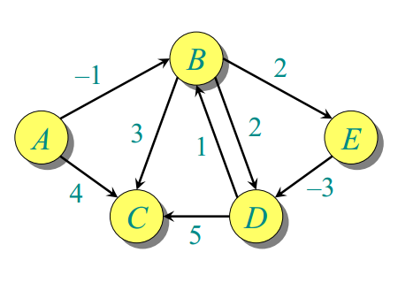
VERTEX DISTANCE FROM A
A 0
B -1
C 2
D -2
E 1

B.5 Conclusion:
The Bellman-Ford algorithm successfully computes the shortest path from a single source vertex to all other vertices in a weighted graph, even when negative edge weights are present. It also detects negative weight cycles, making it more reliable than Dijkstra’s algorithm in such cases.
B.6 Question of Curiosity
1. Can you think of a real-world scenario where detecting a negative-weight cycle would be useful?
Negative cycle detection can be useful in currency exchange systems. If a sequence of currency conversions results in profit, it forms a negative cycle and indicates an arbitrage opportunity.
2. Why does Bellman-Ford work even when there are negative-weight edges, but Dijkstra’s algorithm fails?
Dijkstra’s algorithm assumes that once a vertex is visited, its shortest distance is finalized. Negative edges can later reduce that distance, breaking this assumption.
Bellman-Ford repeatedly relaxes edges, allowing it to correctly update distances even when negative weights exist.

************************

