SVKM’s NMIMS
Mukesh Patel School of Technology Management & Engineering
Computer Engineering Department

Program: B Tech (CS)

Course: Design and Analysis of Algorithms

LAB Manual
PART A
(PART A : TO BE REFFERED BY STUDENTS)
Experiment No.02- Part 2

A.1 Aim:
To understand the types of algorithms, time complexity of a problem and the concept of asymptotic growth of functions.

A.2 Prerequisite:
1. Knowledge of complexity analysis
2. Knowledge of Array Handling.

A.3 Outcome:
After successful completion of this experiment students will be able to
- Understand the types of algorithms,
- Derive the time complexity of a problem based on a given situation
- Understand the concept of asymptotic growth of functions

A.4 Theory:
Types of Algorithms:

In algorithm design, problems are commonly classified based on the strategy used to solve them, leading to four major algorithmic paradigms: Divide and Conquer, Greedy Algorithms, Dynamic Programming, and Backtracking.
Divide and Conquer:
The Divide and Conquer paradigm solves a problem by dividing it into smaller, independent sub-problems, solving each sub-problem recursively, and then combining their solutions to obtain the final result. This approach is effective when sub-problems do not overlap and can be solved independently. It typically relies on recursion and well
suited for large problem sizes. Common examples include merge sort, quick sort, and binary search, where the problem size is repeatedly reduced, leading to efficient time complexities that are often expressed using recurrence relations.
Greedy Algorithm:
Greedy algorithms construct a solution incrementally by making the locally optimal choice at each step with the hope that these choices lead to a globally optimal solution. Once a choice is made, it is never reconsidered. Greedy algorithms are simple, fast, and memory-efficient, but they work correctly only for problems that satisfy the greedy-choice property and optimal substructure. Typical applications include activity selection, minimum spanning tree algorithms such as Kruskal’s and Prim’s, and shortest path algorithms like Dijkstra’s.
Dynamic Programming:
Dynamic Programming is used for problems that can be broken down into overlapping subproblems and that exhibit optimal substructure. Instead of solving the same subproblems repeatedly, dynamic programming stores the results of subproblems and reuses them, thereby significantly improving efficiency. This paradigm can be implemented using a top-down approach with memoization or a bottom-up approach with tabulation. Dynamic programming is commonly applied to optimization problems such as the knapsack problem, matrix chain multiplication, and longest common subsequence.
Backtracking:
Backtracking is a problem-solving technique that systematically explores all possible solutions by building a solution step-by-step and abandoning a partial solution as soon as it violates the given constraints. It follows a depth-first search approach and particularly useful for constraint satisfaction problems. Although backtracking can be computationally expensive due to its exponential time complexity in the worst case, it is an effective method for problems such as the N-Queens problem, Sudoku solving, subset sum, and graph colouring.

Asymptotic Growth of Functions
Asymptotic growth of functions is a mathematical concept used to describe the behaviour of an algorithm’s time or space complexity as the input size tends toward infinity. Instead of focusing on exact execution time, which may vary depending on hardware, programming language, or implementation details, asymptotic analysis provides an abstract and machine-independent way to compare algorithms based on their growth rates. It helps in understanding how efficiently an algorithm scales when the size of the input increases significantly.
Functions are commonly classified into asymptotic categories such as logarithmic, linear, linear logarithmic, polynomial, exponential, and factorial growth rates.
Logarithmic functions grow very slowly and are considered highly efficient, while exponential and factorial functions grow extremely fast and are generally impractical for large inputs. Polynomial-time algorithms are typically acceptable for most real-world applications, whereas exponential-time algorithms are usually feasible only for small input sizes.
Understanding asymptotic growth of functions enables developers and researchers to predict algorithm performance, choose appropriate algorithms for given problem sizes, and design scalable systems. It forms the theoretical foundation for analyzing algorithm efficiency and is an essential concept in the study of Design and Analysis of Algorithms.
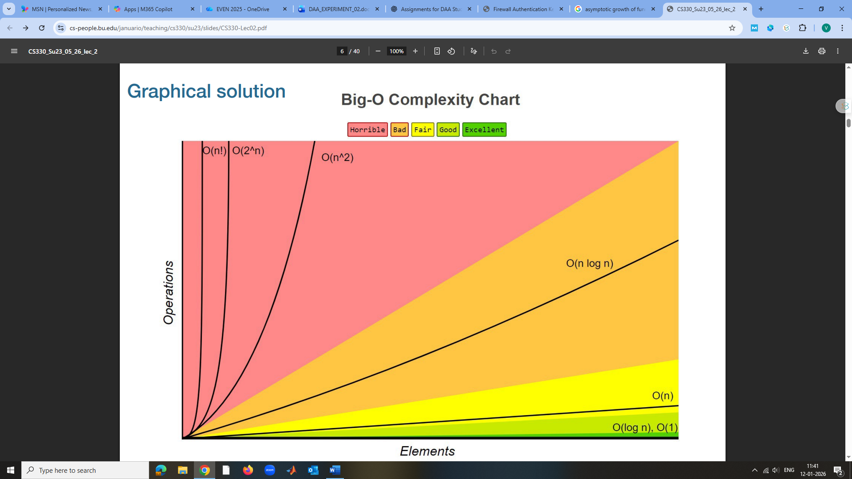

PART B
(PART B : TO BE COMPLETED BY STUDENTS)
(Students must submit the soft copy as per following segments within two hours of the practical.
The soft copy must be uploaded on the Portal.)

Program: BTI | Sem: VIII
Roll No. : C172 | Name: Parva Gaglani
Division: D2 | Batch : D2
Date of Experiment: 12/01/26 | Date of Submission: 12/01/26
Grade :

Task 1: By understanding Unit-1 concepts in our course, we have learnt so far that there are four types of algorithm categories:
- Divide and Conquer
- Greedy Algorithm
- Dynamic Programming
- Backtracking

Considering the knowledge gained, identify the types of algorithm each of the following scenario belongs to, along with a proper justification for your answer:
- A large stack of 2000 exam papers must be evaluated quickly. The stack is divided into two equal piles. Each pile is further divided among teachers until each teacher receives a small manageable bundle. All evaluated papers are finally collected together.

Divide and Conquer
The stack of papers is repeatedly divided into smaller independent piles, evaluated separately, and then combined. This follows the divide → solve → combine strategy.

- A student wants to divide study hours across subjects to maximize marks. The student calculates the best possible score for smaller sets of subjects first and reuses these results while planning the full schedule.

Dynamic Programming
The student computes optimal results for smaller subsets of subjects and reuses them while planning the full schedule, indicating overlapping subproblems and optimal substructure.

- You need to make ₹87 using the least number of coins. You always pick the largest denomination available first.

Greedy Algorithm
Choosing the largest denomination coin at every step without reconsidering previous choices is a greedy approach aiming for a locally optimal solution

- While preparing an exam timetable, a scheduler assigns subjects to time slots. If two subjects clash for the same students, the scheduler removes the assignment and tries a different combination.

Backtracking
When a clash occurs, the scheduler removes the current assignment and tries another combination, systematically exploring alternatives while rejecting invalid ones.

- A navigation app tries all possible routes between two locations but abandons a route immediately when it becomes longer than the shortest route found so far.

Backtracking
The app explores all possible routes but abandons a route as soon as it exceeds the shortest path found so far, which is characteristic of backtracking with pruning.

- A music app suggests a playlist that maximizes user enjoyment within a time limit by reusing satisfaction values computed for shorter playlists.

Dynamic Programming
The app reuses satisfaction values computed for smaller playlists to construct a larger optimal playlist, showing reuse of overlapping subproblems.

- A robot fills shelves by always placing the largest available box that fits into the remaining space.

Greedy Algorithm
The robot always places the largest box that fits at the moment, making a locally optimal decision without reconsideration.

- An online platform splits answer sheets among multiple servers. Each server grades its assigned answers independently, and results are merged at the end.

Divide and Conquer
Answer sheets are split among servers, processed independently, and merged at the end—matching the divide, solve, and combine paradigm.

Task 2: Identifying Complexity Classes
For each of the following scenarios, determine the Time Complexity in Big O notation (Justify your answers):
- Scenario A: An algorithm searches for a specific name in a sorted list of n names by repeatedly dividing the search interval in half.
O(log n) – The search interval is halved each time, similar to binary search

- Scenario B: A function uses a nested loop to compare every element in an array of size n with every other element in the same array.
O(n²) – A nested loop compares every element with every other element

- Scenario C: A script iterates through a string of length n exactly once to count the number of vowels.
O(n) – The string is traversed only once

- Scenario D: A recursive function generates all possible permutations of a set of n unique numbers.
O(n!) – Generating all permutations of n elements results in factorial growth.

- Scenario E: An algorithm checks whether a given number exists in an unsorted array of size nnn by scanning elements one by one.
O(n) – Each element of the unsorted array is checked once in the worst case.

- Scenario F: A brute-force algorithm tests every arrangement of n keys to find the correct order that opens a lock.
O(n!) – Every possible arrangement of keys is tried, leading to factorial time complexity.

Task 3: Arrange the functions in the increasing order of asymptotic growth rate. (Show hand calculations):
i. f₁ = n² , f₂ = n³
ii. f₁ = 1/n² , f₂ = 1/n³
iii. f₁ = n² , f₂ = nlogn
iv. 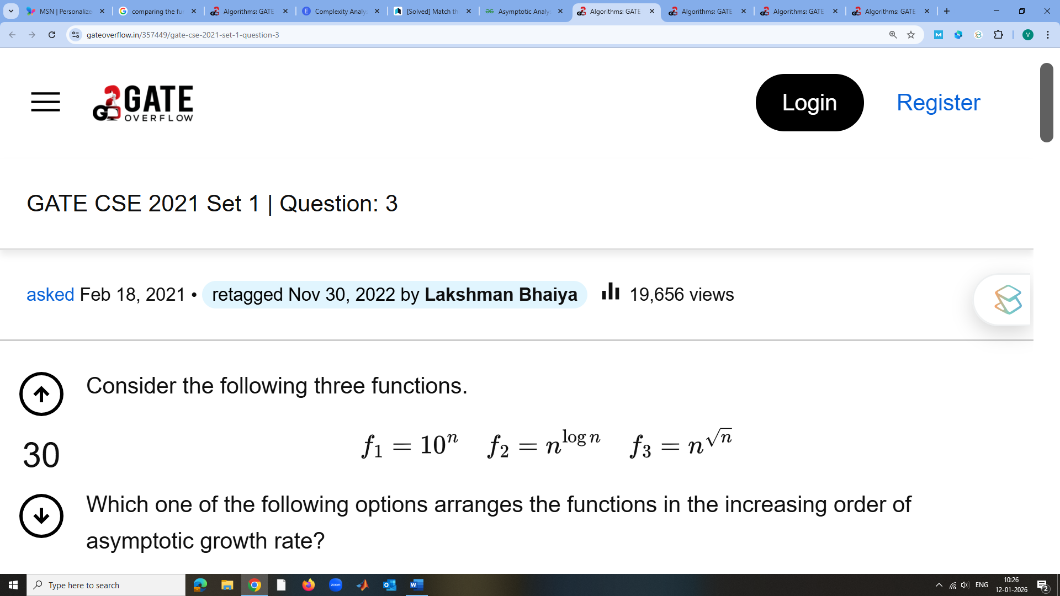
v. 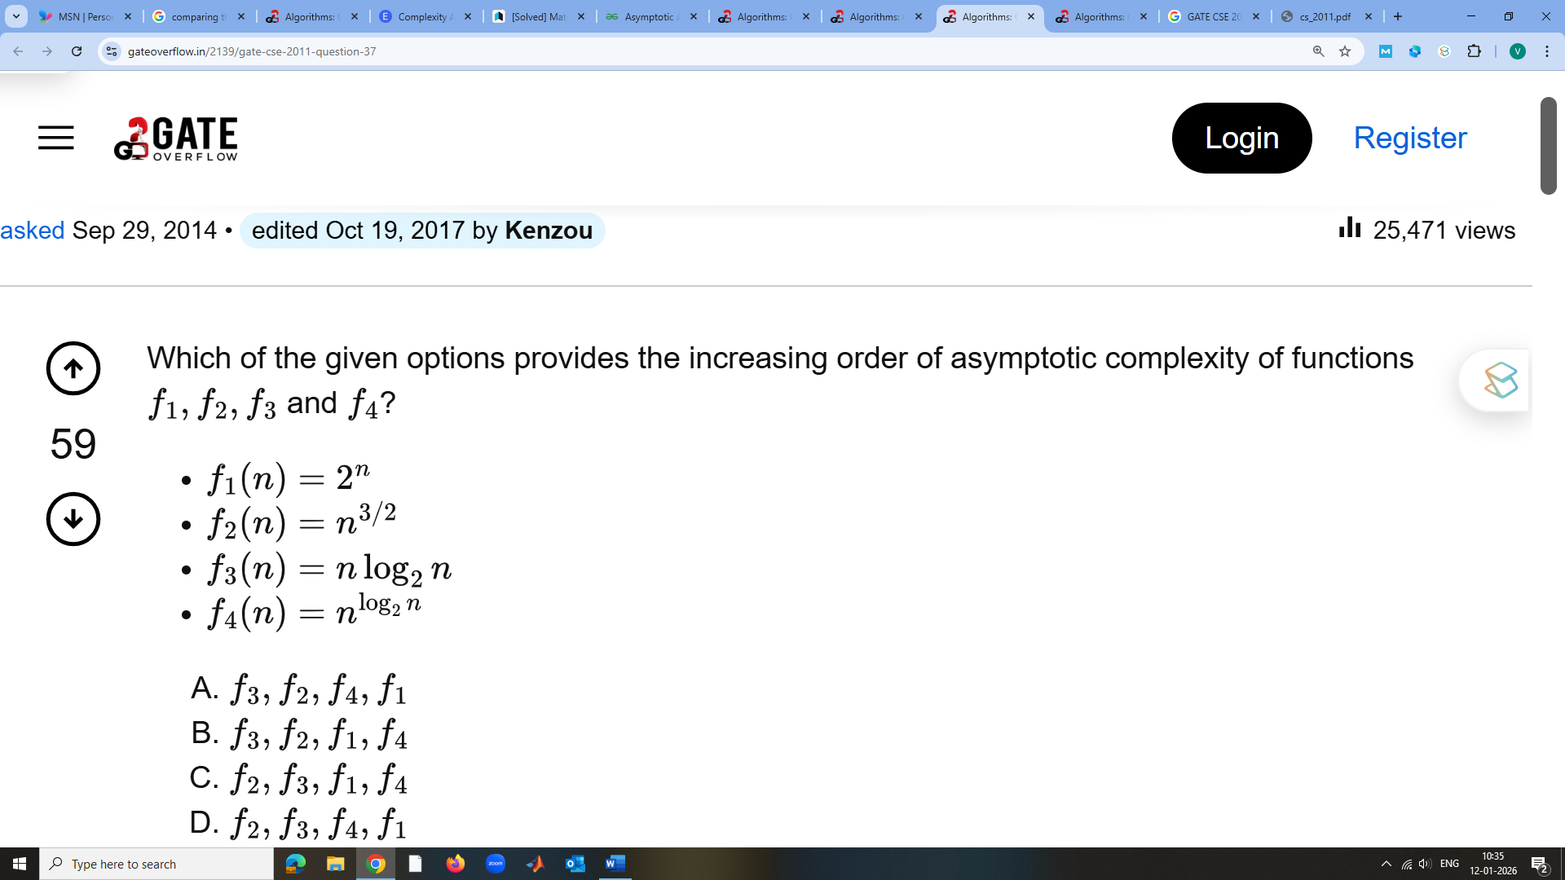
vi. 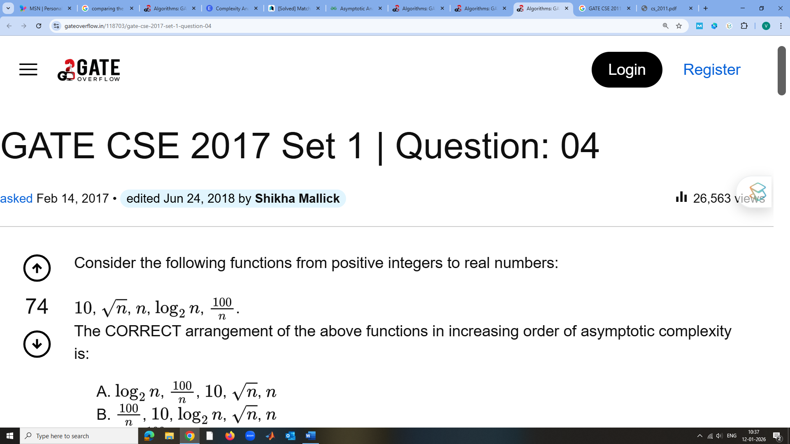

SOLUTIONS:
i.
Given:
f₁ = n², f₂ = n³
As n → ∞, n³ grows faster than n²
Increasing order:
n² < n³

ii.
Given:
f₁ = 1/n², f₂ = 1/n³
As n → ∞,
1/n³ decreases faster than 1/n²
Increasing order:
1/n³ < 1/n²

iii.
Given:
f₁ = n², f₂ = n log n
lim (n→∞) (n log n) / n² = lim (log n) / n = 0
So, n log n grows slower than n²
Increasing order:
n log n < n²

iv.
Given:
f₁ = 10ⁿ, f₂ = n^(log n), f₃ = n^(√n)
n^(log n) < n^(√n) < 10ⁿ
Increasing order:
n^(log n) < n^(√n) < 10ⁿ

v.
Given:
f₁(n) = 2ⁿ
f₂(n) = n^(3/2)
f₃(n) = n log₂ n
f₄(n) = n^(log₂ n)
Growth comparison:
n log n < polynomial < super-polynomial < exponential
Increasing order:
n log₂ n < n^(3/2) < n^(log₂ n) < 2ⁿ

vi.
Given:
10, √n, n, log₂ n, 100/n
As n → ∞:
100/n < constant < log n < √n < n
Increasing order:
100/n < 10 < log₂ n < √n < n

