SVKM’s NMIMS
School of Technology Management & Engineering, Navi Mumbai
Computer Engineering Department
Program: MBA Tech / BTECH. Semester-IV

Design and Analysis of Algorithms
LAB Manual
PART A
(PART A: TO BE REFERRED BY STUDENTS)
Experiment No. 2
A.1 Aim:
Problem solving and implementation of Computational Complexity.

A.2 Prerequisite:
Knowledge of basic programming constructs in C / C++ and complexity analysis.

A.3 Outcome:
After successful completion of this experiment, students will be able to
- Understand the concept of computational complexity for analysing algorithms
- Derive best case and worst-case complexity for given problems

A.4 Theory:
- Introduction: Algorithm Analysis:
The term "analysis of algorithms" was coined by Donald Knuth. Algorithm analysis is an important part of computational complexity theory, which provides theoretical estimation for the required resources of an algorithm to solve a specific computational problem.
Most algorithms are designed to work with inputs of arbitrary length. Analysis of algorithms is the determination of the amount of time and space resources required to execute it. Usually, the efficiency or running time of an algorithm is stated as a function relating the input length to the number of steps, known as time complexity, or volume of memory, known as space complexity.

Algorithmic complexity/ Asymptotic Analysis:
In theoretical analysis of algorithms, it is common to estimate their complexity in the asymptotic sense, i.e., to estimate the complexity function for arbitrarily large input. When complexity of an algorithm is estimated in asymptotic sense, it focusses on understanding the behaviors of the algorithm as the input size approaches infinity. Hence,the complexity of an algorithm M is the function f(n) which gives the running time and/or storage space requirement of the algorithm in terms of the size ‘n’ of the input data. Mostly, the storage space required by an algorithm is simply a multiple of the data size ‘n’.

Algorithms may exhibit different performance characteristics depending on the nature of the input.
- Worst-case analysis considers the maximum resource consumption
- Best-case analysis looks at the minimum
- Average-case analysis considers the expected resource usage over all possible inputs.

- Space complexity - The amount of memory needed by the program to run to completion. It measures the amount of memory space an algorithm requires as a function of the input size.
Code No. | - Code | Space Complexity | - Explanation
- 1 | - {  - int z = a + b + c;  - return(z);  - } | Constant | Variables a, b, c and z are all integer types, hence they will take up 4 bytes each, so total memory requirement will be (4(4)) and because this space requirement is fixed for the above example, hence it is called Constant Space Complexity.
- 2 | - // n is the length of array a[]  - int sum (int a[], int n)  - {  - int x = 0; // 4 bytes for x  - for (int i = 0; i < n; i++)  - {  - x = x + a[i];  - }  - return(x);  - } | Linear | In the given code, 4*n bytes of space is required for the array a[] elements. 4 bytes each for x, n, and i. Hence the total memory requirement will be (4n + 12), which is increasing linearly with the increase in the input value n

- Time complexity - The amount of time needed by the program to run to completion. It depends on the size of input “n”. Time Complexity is most commonly estimated by counting the number of elementary steps performed by any algorithm to finish execution.
Code No. | - Code | Time Complexity | Explanation
- 1 | - for(i=0; i < n; i++)  - {  - statement;  - } | Linear | The running time of the loop is directly proportional to n.
- 2 | - for (i=0; i < n; i++)  - {  - for (j=0; j < n; j++)  - {  - statement;  - }  - } | Quadratic | The running time of the two loops is proportional to the square of n.
- 3 | while (low <= high)  {  mid = (low + high) / 2;  if (target < list[mid])  high = mid - 1;  else if (target > list[mid])  low = mid + 1;  else break; } | Log | The running time of the algorithm is proportional to the number of times N can be divided by 2. This is because the algorithm divides the working area in half with each iteration.

PART B
(PART B : TO BE COMPLETED BY STUDENTS)
(Students must submit the soft copy as per following segments within two hours of the practical. The soft copy must be uploaded on the MS Teams)

SAP ID/Roll No.: 70322200086 C172 | Student Name : Parva Gaglani
Program : BTI | Semester : 8
Batch : D2
Date of Experiment : 9/01/26 | Date of Submission : 9/01/26

B.1 Answers of Task to be written by student:
(Paste your answers completed during the 2 hours of practical in the lab here)
Instruction for Students:
1. Clearly understand the problem you are trying to solve.
2. Write the algorithm to depict a systematic procedure before implementing the codes. Each step should be clearly defined and unambiguous.
3. Implement the algorithm in C/C++ programming language, wherever asked.
4. Handle edge cases and exceptional scenarios in your implementation.
5. Add appropriate comments to explain complex section of your code and to clarify the purpose of the step.
6. Show the output.
7. Analyze the codes for its time and space requirement.
8. Conclude the learning done through the tasks that are implemented.

Tasks to be implemented:
- Find the time complexity and space complexity of all the below code snippets.

- Sum(A,n)  {  S=0;  for(i=0; i<n; i++)  {  s= s+A[i];  }  Return s;  } | - Add(A,B,n)  {  for(i=0; i<n; i++)  {  for(j=0; j<n;j++)  {  C[i,j]=A[i,j]+B[i,j];  }  }  }
- Multiply(A,B,n)  {  for (i=0; i<n, i++)  {  for(j=0; j<n; j++)  {  C[i,j]=0;  for(k=0;k<n; k++)  {  C[i,j]= c[i,j]+A[i,k]*B[k,j]  }  } }}  - for(i=n; i>0;i--)  {  stmt;  } | - for (i=0; i<n;i++)  {  stmt;  }  - for(i=0; i<n;i+2)  {  stmt;  }
- for(i=1; i<n; i*2)
{
stmt ;
}

Ans:
1)Time complexity : O(n)
Space complexity: O(1)

2)Time complexity : O(n^2)
Space complexity: O(n)

3)Time complexity : O(n^3)
Space complexity: O(1)

4)Time complexity : O(n)
Space complexity: O(1)

5)Time complexity : O(n)
Space complexity: O(1)

6)Time complexity : O(n)
Space complexity: O(1)

7)Time complexity : O(log2n)
Space complexity: O(1)

- Let us assume two algorithms A and B that solve the same class of problems. The time complexity of A is 5,000n, the one for B is ⎡1.1^{n}⎤ for an input with n elements. Write a program to calculate for different sizes of input, n = 10, 100, 1000, 10,00,000.
State your observations based on the growth of complexity functions, such as linear, exponential etc.

Code:
#include <iostream>
#include <cmath>
using namespace std;
int main()
{
int n,m;
cout<<"Enter value of n: ";
cin>>n;

cout<<"Enter loop length: ";
cin>>m;

for(int i=0; i<m; i++) {
double a = 5000*n;
double b = 1 * pow(1.1, n);

cout<<"A : "<< a<<endl;
cout<<"B : "<< b<<endl;
}
return 0;
}
Output:
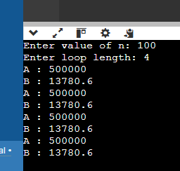
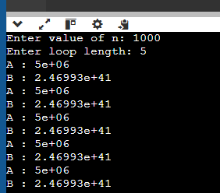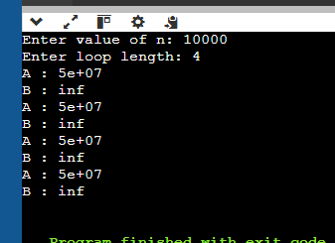

Observations

1. Growth Type
- Algorithm A is linear:Growth increases proportionally with input size.
- Algorithm B is exponential:Growth multiplies rapidly as nnn increases.

2. Small Inputs
- For very small nnn, Algorithm B may appear faster.
- Exponential algorithms can look harmless initially.

3. Large Inputs
- Algorithm B becomes computationally infeasible very quickly.
- At n=1000n = 1000n=1000, B already exceeds all practical computation limits.
- At n=1,000,000n = 1,000,000n=1,000,000, B is astronomically large, while A remains manageable.

- a) Write a program to complete the following table, values of Log n are given in the first column.

Log₂(n) | n | nlogn | n² | n³ | 2^{n}
0
1
2
3
4
5

Code:
#include <iostream>
#include <cmath>
using namespace std;

int main() {
cout << "log2(n)\t n\t nlogn\t n^2\t n^3\t 2^n" << endl;

for (int logn = 0; logn <= 5; logn++) {
double n = pow(2, logn);

cout << logn << "\t "
<< n << "\t "
<< n * logn << "\t "
<< n * n << "\t "
<< n * n * n << "\t "
<< pow(2, n) << endl;
}
return 0;
}
Output:
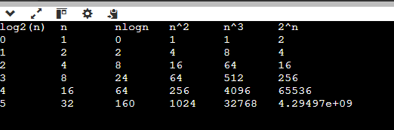
b) Plot the graph of the complexity functions: O(1), O(log n), O(n), O(n log n), O(n²), O(2^{n}).
O(1)
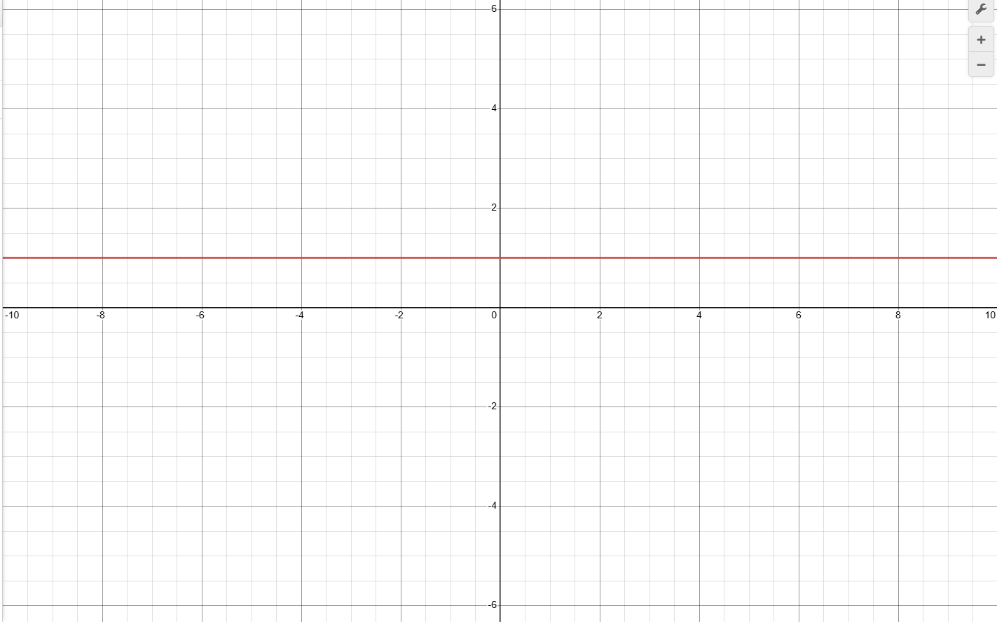

O(log n)
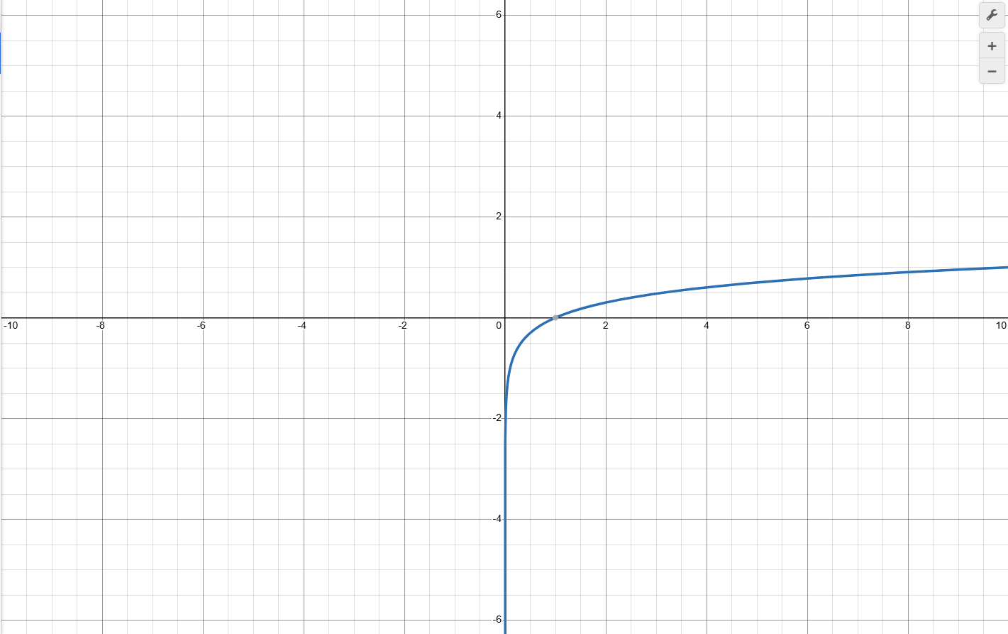
O(n)
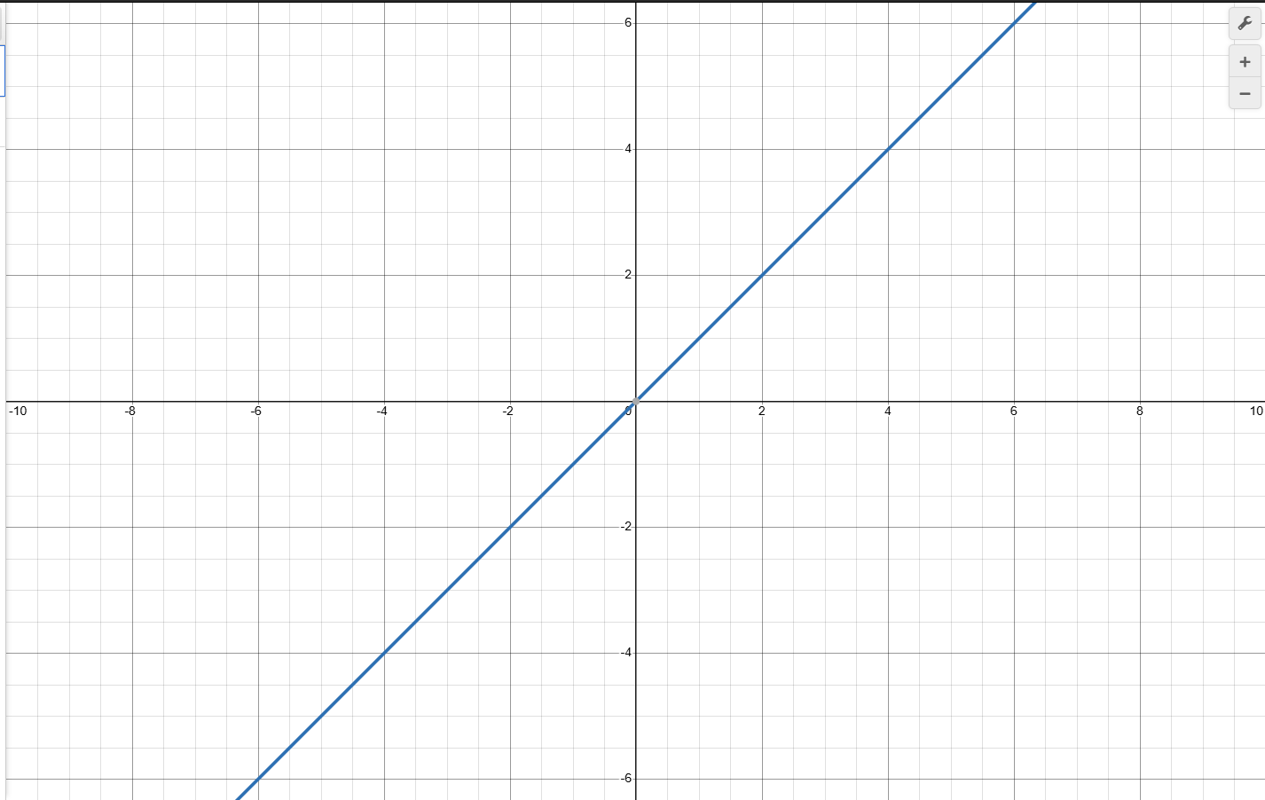

O(n log n)
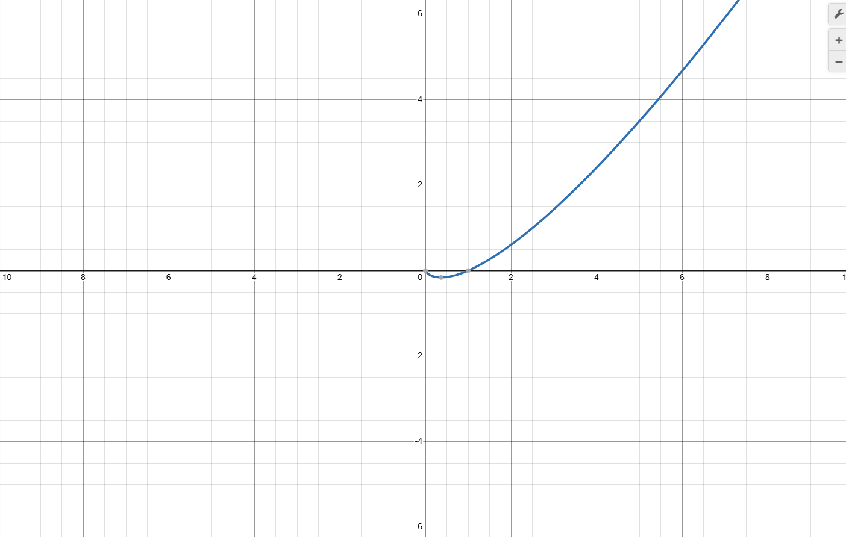
O(n²)
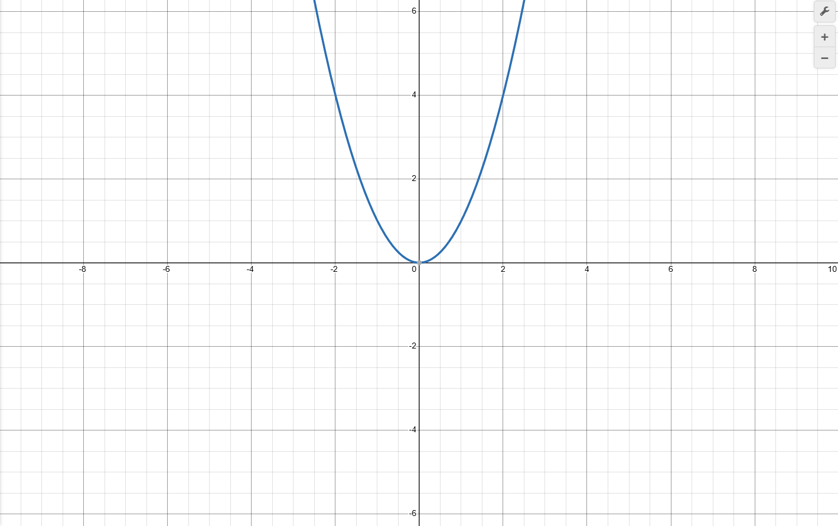

O(2^{n}).
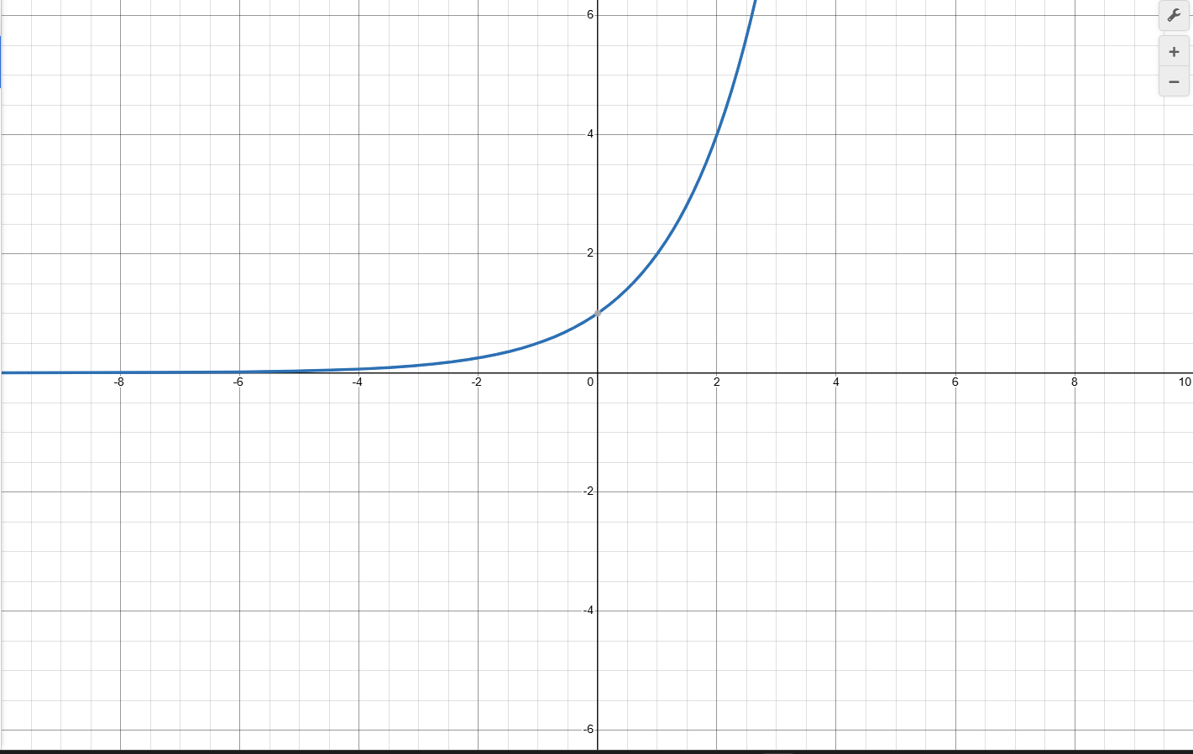

- Design and implement an algorithm that searches an unsorted array a[1:n] for the element X. If X occurs, then return a position in the array; else return zero. Write a program and find the time and space complexity.

Code:
#include <iostream>
#include <cmath>
using namespace std;

int main() {
int n,target;
cout<<"Enter n: ";
cin>>n;

int arr[n];
cout<<"Enter elements: "<<endl;
for(int i=0; i<n; i++) {
cin>>arr[i];
}
cout<<"Enter target: ";
cin>>target;

for(int i=0; i<n; i++) {
if(arr[i] == target) {
cout<<"Found at index "<<i<<endl;
break;
}
}

return 0;
}
Output:
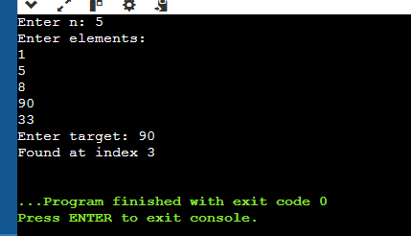

Time complexity: O(n)
Space complexity: O(1)

- Write both recursive and an iterative algorithm to compute n! of a number n. Write a program and find the time and space complexity.

ALGORITHM:

IterativeFactorial(n)
1. fact ← 1
2. for i = 1 to n
3. fact ← fact × i
4. return fact

RecursiveFactorial(n)
1. if n == 0
2. return 1
3. else
4. return n × RecursiveFactorial(n−1)

PROGRAM:

#include <iostream>
using namespace std;

int main() {
int n;
long long fact = 1;

cout << "Enter a number: ";
cin >> n;

for (int i = 1; i <= n; i++) {
fact = fact * i;
}

cout << "Factorial (Iterative) = " << fact << endl;

return 0;
}

#include <iostream>
using namespace std;

long long factorial(int n) {
if (n == 0)
return 1;
else
return n * factorial(n - 1);
}

int main() {
int n;

cout << "Enter a number: ";
cin >> n;

cout << "Factorial (Recursive) = " << factorial(n) << endl;

return 0;
}

Time complexity :
Iterative: O(n)
Recursive: O(n)

Space Complexity:
Iterative: O(1)
Recursive: O(n)

- For each function f(n) and time t in the following table, determine the largest size n of a problem that can be solved in time t, assuming that the algorithm to solve the problem takes f(n) milliseconds.
Assume: 1 month = 30 days and 1 year = 365 days.
You may write a C or C++ code to complete this table.
f(n) | 1 sec. | 1 min. | 1hour | 1day | 1month | 1year | 1century
Log n
$$√n$$
n
n log n
n²
n³
2^{n}
n!

f(n) \ Time | 1 sec | 1 min | 1 hour | 1 day | 1 month | 1 year | 1 century
log n | 2¹⁰⁰⁰ | 2⁶⁰⁰⁰⁰ | 2³·⁶×10⁶ | 2⁸·⁶⁴×10⁷ | 2²·⁵⁹×10⁹ | 2³·¹⁵×10¹⁰ | 2³·¹⁵×10¹²
√n | 10⁶ | 3.6×10⁹ | 1.3×10¹³ | 7.5×10¹⁵ | 6.7×10¹⁸ | 1×10²¹ | 1×10²⁵
n | 1,000 | 60,000 | 3.6×10⁶ | 8.64×10⁷ | 2.59×10⁹ | 3.15×10¹⁰ | 3.15×10¹²
n log n | ~140 | ~3,000 | ~130,000 | ~4,000,000 | ~100,000,000 | ~1,000,000,000 | ~30,000,000,000
n² | 31 | 245 | 1,897 | 9,295 | 50,911 | 177,583 | 1,776,000
n³ | 10 | 39 | 153 | 442 | 1,372 | 3,160 | 14,600
2ⁿ | 9 | 15 | 21 | 26 | 31 | 35 | 41
n! | 6 | 8 | 9 | 10 | 11 | 12 | 13

- Derive the best case and worst-case complexity for insertion sort, selection sort quick sort and merge sort and compare for same input size = 10.

Insertion Sort
- Best case: O(n) (already sorted)
- Worst case: O(n²) (reverse sorted)

Selection Sort
- Best case: O(n²)
- Worst case: O(n²)

Quick Sort
- Best case: O(n log n) (balanced partitions)
- Worst case: O(n²) (already sorted, poor pivot)

Merge Sort
- Best case: O(n log n)
- Worst case: O(n log n)

Algorithm | Best Case | Worst Case
Insertion Sort | 10 | 100
Selection Sort | 100 | 100
Quick Sort | ~33 | 100
Merge Sort | ~33 | ~33

B.2 Observations and learning:
(Students are expected to comment on the output obtained with clear observations and learning for each task/ sub part assigned)

Observations
- Theoretical complexity gives a general, machine-independent view of algorithm performance.
- Experimental results vary with hardware, compiler, and input size.
- Linear vs exponential growth differences are clearly visible in theory, but may be hidden in small experimental tests.

Learnings
- Asymptotic analysis helps predict scalability.
- Experimental testing is useful to measure actual runtime, but cannot replace theory.
- Choosing efficient algorithms early saves time and resources.

B.3 Conclusion:
(Students must write the conclusion as per the attainment of individual outcome listed above and learning/observation noted in section B.3)
Theoretical analysis is more reliable for understanding algorithm efficiency, while experiments are supportive for practical verification.
B.4 Question of Curiosity
(To be answered by student based on the practical performed and learning/observations)
- Is theoretical approach better than experimental approach to calculate computational complexity? Justify.

Yes, the theoretical approach is better than the experimental approach for calculating computational complexity.

Justification:
- It is machine independent and does not depend on hardware or software.
- It analyzes algorithms before implementation.
- It predicts performance for all input sizes, especially large inputs.
- It allows fair comparison using asymptotic notations like Big-O.
The experimental approach depends on system configuration and specific inputs, so it is less reliable for general complexity analysis.

