SVKM’s NMIMS
MPSTME/School of Technology Management & Engineering,
Computer Engineering Department
Program: MBA Tech / BTech. Sem IV

Design and Analysis of Algorithms
LAB Manual
PART A
(PART A: TO BE REFERRED BY STUDENTS)
Experiment No.05
A.1 Aim:
In this lab we are implementing Quick Sort which is based on Divide & Conquer Algorithm Design paradigm.
Task 1: Show the working of Quick Sort on following numbers
3; 41; 52; 26; 38; 57; 9; 49; 25; 19; 23
Task2: Write a program to implement Quick sort Algorithm using divide and conquer approach for the following problem statement.
Problem Statement:

College would like to prepare the merit list based on CET score of the students. In order to do that they read the data of n number of students with Name, CET score, 12th Percentage. Apply merge sort algorithm to prepare the merit list, where highest test score with appear at the top (list will be in decreasing order of the CET score). Analyze your program for time and space complexity.

A.2 Prerequisite:
1. Knowledge of Array Handling and
2. Concept of divide and conquer paradigm
3. Knowledge of recursive programming

A.3 Outcome:
After successful completion of this experiment students will be able to
- Understand the concept of divide and conquer paradigm with the help of Quick sort Algorithm
- Write complex program based on recursion.

A.4 Theory:
A.4.1.
Divide & Conquer Paradigm:

- Given a function to compute on n inputs, the divide-and-conquer strategy consists of:
  - splitting the inputs into k distinct subsets, 1<k≤n, yielding k subproblems.
  - solving these subproblems
  - combining the subsolutions into solution of the whole.
  - if the subproblems are relatively large, then divide_Conquer is applied again.
  - if the subproblems are small, they are solved without splitting.

The Divide and Conquer Abstraction:

Divide_Conquer(problem P)
{
if Small(P) return S(P);
else {

divide P into smaller instances P₁, P₂, …, P_{k}, k≥1;

Apply Divide_Conquer to each of these subproblems;

return Combine(Divide_Conque(P₁), Divide_Conque(P₂),…, Divide_Conque(P_{k}));
}
}

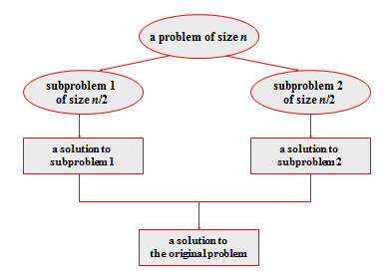
Figure 1: Divide & Conquer Technique

Quick Sort is an efficient divide and conquer sorting algorithm. It works by selecting a "pivot" element from the array and partitioning the other elements into two sub-arrays, according to whether they are less than or greater than the pivot.

Steps:
1. Pick a pivot element.
2. Partition the array into two halves around the pivot.
3. Recursively apply Quick Sort to the two halves.

Pseudocode for Quick Sort:

QuickSort (arr, low, high)
{
if (low < high)
{
pi = Partition(arr, low, high);
QuickSort(arr, low, pi - 1);
QuickSort(arr, pi + 1, high);
}
}

Partition (arr, low, high)
{
pivot = arr[high];
i = low - 1;
for j = low to high - 1
{
if (arr[j] <= pivot)
{
i++;
swap (arr[i], arr[j]);
}
}
swap (arr[i + 1], arr[high]);
return (i + 1);
}

PART B
(PART B : TO BE COMPLETED BY STUDENTS)
(Students must submit the soft copy as per following segments within two hours of the practical.
The soft copy must be uploaded on the Portal.)

Program: BTI | Sem: 8
Roll No: C172 | Name: Parva Gaglani
Division: D | Batch: D2
Date of Experiment: 30/1/26 | Date of Submission: 30/1/26
Grade :

Task 1:
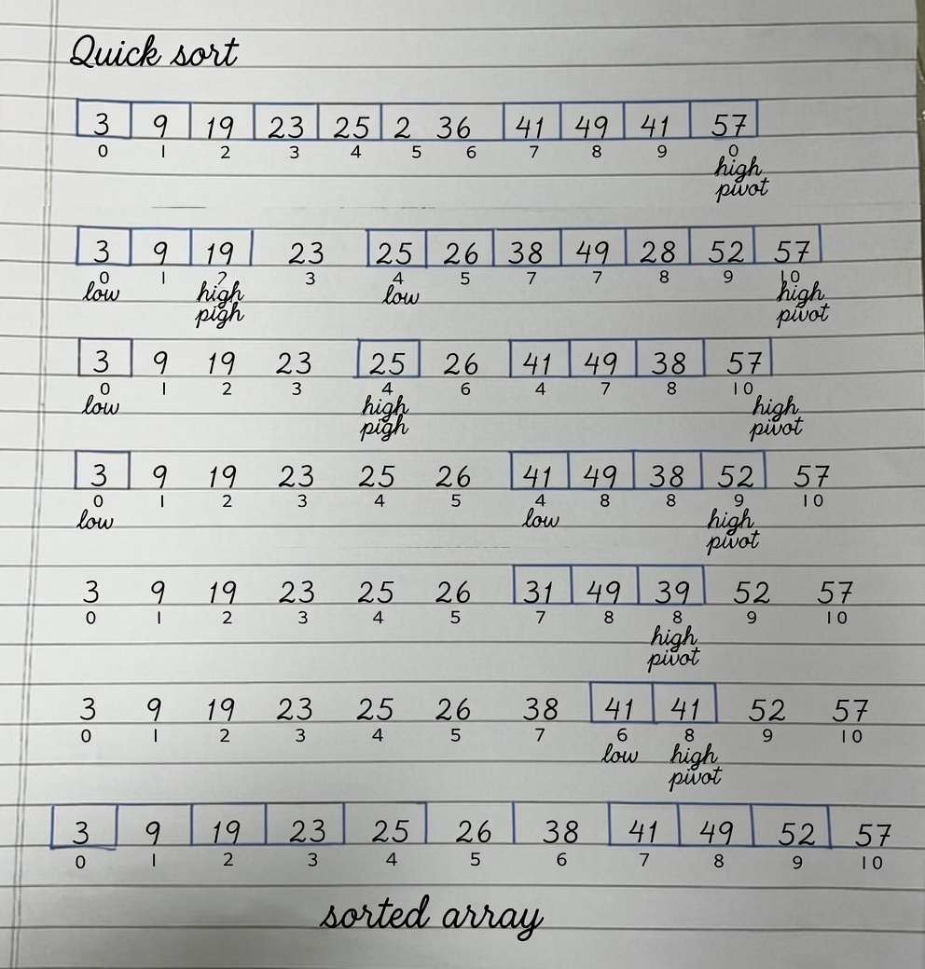
B.1 Software Code written by student:
#include <iostream>
using namespace std;

/* Structure to store student details */
struct Student
{
string name;
int cetScore;
float percentage12th;
};

int partitions(Student students[], int low, int high)
{
int pivot = students[high].cetScore;
int i = low - 1;
for(int j = low; j < high; j++)
{
if(students[j].cetScore > pivot)
{
i++;
swap(students[j],students[i]);
}
}
swap(students[i+1],students[high]);
return i+1;
}

/* Recursive Quick Sort function */
void quickSort(Student students[], int low, int high)
{
if (low < high)
{
int pivot = partitions(students,low,high);

quickSort(students,low,pivot-1);

quickSort(students,pivot+1,high);
}
}

int main()
{
int numberOfStudents;

cout << "Enter number of students: ";
cin >> numberOfStudents;

/* Dynamically allocate array of students */
Student* students = new Student[numberOfStudents];

/* Input student details */
for (int i = 0; i < numberOfStudents; i++)
{
cout << "\nEnter details of student " << i + 1 << endl;

cout << "Name: ";
cin >> students[i].name;

cout << "CET Score: ";
cin >> students[i].cetScore;

cout << "12th Percentage: ";
cin >> students[i].percentage12th;
}

quickSort(students, 0, numberOfStudents - 1);

/* Display Merit List */
cout << "\n--- Merit List (Sorted by CET Score in Descending Order) ---\n";
cout << "Name\t\tCET Score\t12th Percentage\n";

for (int i = 0; i < numberOfStudents; i++)
{
cout << students[i].name << "\t\t"
<< students[i].cetScore << "\t\t"
<< students[i].percentage12th << endl;
}

/* Free allocated memory */
delete[] students;

return 0;
}

B.2 Input and Output:
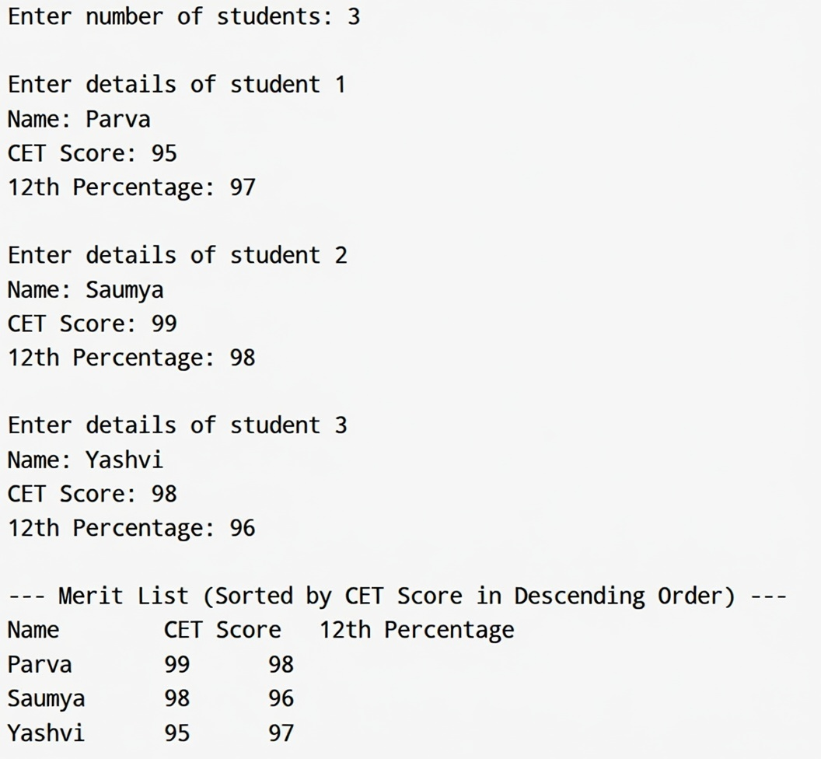

B.3 Observations and learning: Implemented quick sort
B.4. Practice Questions:
Perform Time and Space Complexity Analysis of Quick Sort using recurrence relation and substitution method, compare that with the master theorem.
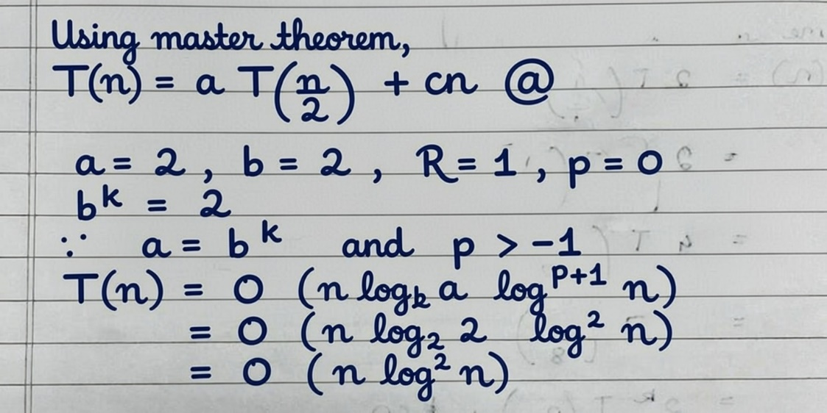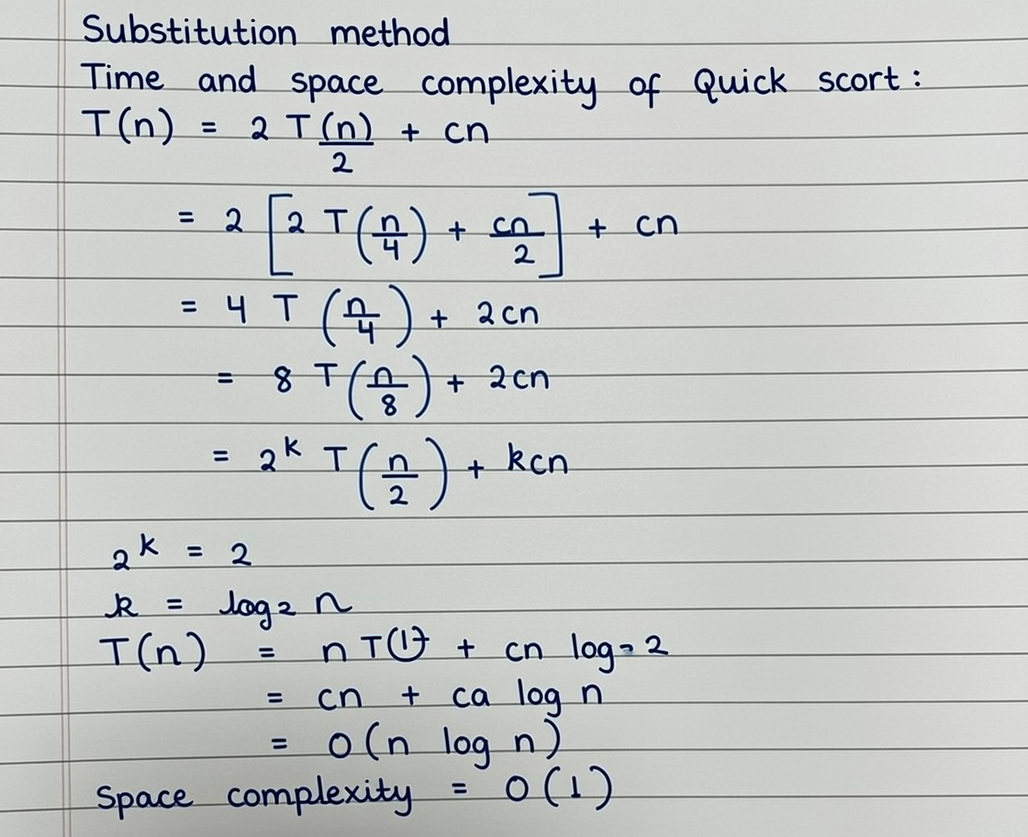

B.5 Conclusion:
Understood the working od quick sort.

B.6 Question of Curiosity
1. When does the worst case occur in Quick Sort?
The worst case of Quick Sort occurs when:
- The pivot chosen is always the smallest or largest element
- This causes highly unbalanced partitions
Examples:
- Array already sorted
- Array sorted in reverse order
- All elements are equal (with poor pivot choice)
Time Complexity in worst case: O(n^2)

2. How can we improve the efficiency of Quick Sort?
Quick Sort can be made faster and safer using:
🔹 Better pivot selection
- Randomized pivot
- Median-of-three (first, middle, last element)
🔹 Hybrid approaches
- Use Insertion Sort for small subarrays
- Switch to Heap Sort (IntroSort)
🔹 Reduce recursion depth
- Always recurse on the smaller partition
- Tail recursion optimization

3. What types of datasets are ideal for Quick Sort?
Quick Sort performs best on:
- Large datasets
- Random or unsorted data
- Data that fits in memory
- Datasets where average-case performance matters more than worst-case
Not ideal for:
- Already sorted data (without pivot optimization)
- Systems requiring stable sorting

4. How does Quick Sort differ from Merge Sort?
Feature | Quick Sort | Merge Sort
Time Complexity | Avg: O(n log n), Worst: O(n²) | Always O(n log n)
Memory | In-place (O(log n)) | Extra memory (O(n))
Stability | Not stable | Stable
Speed (practical) | Faster in practice | Slightly slower
Use Case | Internal sorting | External sorting

5. Real-world examples where Quick Sort is preferred
🔹 System-level sorting
- Used in C/C++ standard libraries (optimized versions)
- Sorting arrays of primitives
🔹 Databases & search engines
- Sorting records in memory
- Index creation (when data fits RAM)
🔹 Competitive programming
- Fast average performance
- Low memory usage
🔹 Embedded systems
- Limited memory availability
- In-place sorting advantage

************************

