Experiment 10
PART A
TITLE: Implementation and Analysis of Sum of Subsets Problem.
AIM: Given a set of non-negative integers and a value sum, the task is to check if there is a subset of the given set whose sum is equal to the given sum.

OUTCOME:
After successful completion of this experiment students will be able to,

- Understanding the dynamic programming strategy significance
- Analyse the time and space complexities of the dynamic programming approach for the Sum of Subsets Problem
- With Implementation finds the Sum of Subsets Problem

THEORY:

It is one of the most important problems in complexity theory. The problem is given an A set of integers a1, a2,…., an upto n integers. The question arises that is there a non-empty subset such that the sum of the subset is given as M integer?. For example, the set is given as [5, 2, 1, 3, 9], and the sum of the subset is 9; the answer is YES as the sum of the subset [5, 3, 1] is equal to 9.
We have a set of 5 integers given below:
N = 4, -2, 2, 3, 1
There are many solutions to this problem.
The naïve approach, i.e., brute-force search generates all the possible subsets of the original array, i.e., there are 2n possible states. Here the running time complexity would be exponential. Then, we consider all these subsets in O(N) linear running time and checks whether the sum of the items is M or not.
The dynamic programming has pseudo-polynomial running time.
Statement: Given a set of positive integers, and a value sum, determine that the sum of the subset of a given set is equal to the given sum.
- Example 1:
- Input: set[] = {4, 16, 5, 23, 12}, sum = 9
- Output = true
- Subset {4, 5} has the sum equal to 9.

- Example 2:
- Input: set[] = {2, 3, 5, 6, 8, 10}, sum = 10
- Output = true
- There are three possible subsets that have the sum equal to 10.
- Subset1: {5, 2, 3}
- Subset2: {2, 8}
- Subset3: {10}

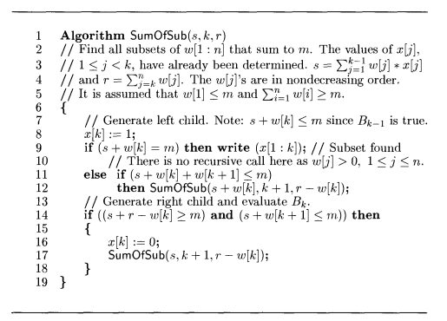

Complexity Analysis:
- Time Complexity: O(sum*n), where sum is the ‘target sum’ and ‘n’ is the size of array.
- Auxiliary Space: O(sum*n) + O(n) -> O(sum*n) = the size of 2-D array is sum*n and O(n)=auxiliary stack space.

Experiment # 10 PART-B
Date of Performance:- 20/3/26 | Date of Submission:- 20/3/26
Class:- D2
Student SAP Id:- 70322200086
Student Roll No:- C172
Student Name:- Parva Gaglani

B.1 Answers of Task to be written by student:

Instructions for the Students:
- Implement Algorithm in C++ Language.
- Copy and Paste Code as per instructions.
- Compute Time complexity of Algorithm.
- Write Conclusion.
- Answer all the Questions.

- Source Code :
#include <iostream>
using namespace std;

int w[50]; // weights (input array)
int x[50]; // solution array (0/1)
int n, m; // n = size, m = target sum

void SumOfSub(int s, int k, int r) {
// Include current element
x[k] = 1;

// If subset found
if (s + w[k] == m) {
cout << "{ ";
for (int i = 1; i <= k; i++) {
if (x[i] == 1)
cout << w[i] << " ";
}
cout << "}" << endl;
}
// Continue searching left subtree
else if (s + w[k] + w[k + 1] <= m) {
SumOfSub(s + w[k], k + 1, r - w[k]);
}

// Exclude current element (right subtree)
if ((s + r - w[k] >= m) && (s + w[k + 1] <= m)) {
x[k] = 0;
SumOfSub(s, k + 1, r - w[k]);
}
}

int main() {
cout << "Enter number of elements: ";
cin >> n;

cout << "Enter elements (in increasing order): ";
for (int i = 1; i <= n; i++) {
cin >> w[i];
}

cout << "Enter target sum: ";
cin >> m;

// Calculate total sum (r)
int total = 0;
for (int i = 1; i <= n; i++)
total += w[i];

cout << "Subsets are:\n";
SumOfSub(0, 1, total);

return 0;
}

- Input and output :
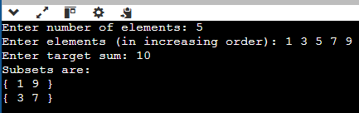

- Time Complexity Analysis:

T(n) = 2T(n-1) + O(1)
T(n) = 2^k T(n-k) + (2^k - 1)c
T(n) = 2^n T(0) + (2^n - 1)c
T(n) = O(2^n)

Questions:
- Implement and analyze the time and space complexity of the sum of subset problem through the dynamic approach.
- Find the sum of subset problem for below given input strings and
Input: arr[] = {2,6,5,3,10}, sum = 8

#include <iostream>
using namespace std;

bool subsetSum(int arr[], int n, int sum) {
bool dp[n + 1][sum + 1];

// Base cases
for (int i = 0; i <= n; i++)
dp[i][0] = true;
for (int j = 1; j <= sum; j++)
dp[0][j] = false;

// Fill DP table
for (int i = 1; i <= n; i++) {
for (int j = 1; j <= sum; j++) {
if (arr[i - 1] <= j)
dp[i][j] = dp[i - 1][j] || dp[i - 1][j - arr[i - 1]];
else
dp[i][j] = dp[i - 1][j];
}
}
return dp[n][sum];
}

int main() {
int arr[] = {2, 6, 5, 3, 10};
int sum = 8;
int n = 5;

if (subsetSum(arr, n, sum))
cout << "Subset exists";
else
cout << "Subset does not exist";

return 0;
}

Time Complexity: O(n × sum)
Space Complexity: O(n × sum)

B.2. Observations and Learning

B.3. Conclusion:

